

**DONE BY (TEAM NO 33)**

* Team Member 1: P. Venkata Girish
* Team Member 2: U. Praveen
* Team Member 3: P. Sai Srinivas

|  |
| --- |
|  |
| PROJECT REPORT  **MUESEUMMANAGEMENT SYSTEM** |
| |  |  |  | | --- | --- | --- | |  |  |  | |

Abstract

The Museum Management System (MMS) is a comprehensive software solution designed to modernize and streamline the operations of museums. Museums play a crucial role in preserving cultural heritage and providing educational experiences to the public.

However, traditional management methods often suffer from inefficiencies, leading to challenges in collection management, visitor engagement, and financial sustainability.

The MMS addresses these challenges by providing a centralized platform for managing exhibits, visitors, collections, events, memberships, donations, and staff.

The system provides an efficient way to store, retrieve and manage information related to artifacts, visitors, exhibitions, and museum staff.

It simplifies tasks such as artifact cataloging, visitor registration, exhibition scheduling, and staff management.

This project report provides an overview of the system, its features, and the underlying database design.

Additionally, it supports robust visitor engagement through streamlined access to information and services.

The implementation of an MMS not only enhances operational efficiency but also enriches the visitor experience and supports the museum's core mission of cultural preservation and education.

This system addresses the multifaceted needs of museums by providing tools for efficient collections management, exhibit planning, visitor services, ticketing, membership administration, and educational program coordination.

By centralizing and automating these critical functions, the MMS enhances the accuracy of artifact cataloging, facilitates seamless exhibition organization, and improves conservation tracking.

INTRODUCTION

Museums are vital cultural institutions that serve as custodians of our collective heritage. However, the management of museums is a complex task that involves curating collections, organizing exhibitions, engaging visitors, and ensuring financial sustainability. Traditional museum management methods, which rely heavily on manual processes and disparate systems, are increasingly inadequate in meeting the demands of the modern era.

The Museum Management System (MMS) represents a paradigm shift in how museums operate. By leveraging technology, the MMS aims to enhance efficiency, accessibility, and engagement across all aspects of museum management. This project report provides an overview of the MMS, its objectives, significance, architecture, features, and implementation details.

Museums play a significant role in preserving and showcasing our cultural heritage. However, managing a museum involves various complex activities that require careful planning and organization.

By centralizing data and automating processes, an MMS enables museum staff to effectively catalog artifacts, plan and manage exhibitions, track conservation efforts, and engage with the public. This system not only improves internal workflows but also enhances the visitor experience through improved access to information and services, ultimately supporting the museum's mission of preserving and presenting cultural heritage.

A Museum Management System (MMS) is a comprehensive software solution designed to streamline and enhance the operational efficiency of museums. \

It integrates various functions such as collections management, exhibit planning, visitor services, ticketing, membership management, and educational program coordination.

Functional Requirements

**Visitor Registration :**  
  
The system must allow visitors to register for an account, providing details such as name, email, and contact number. The system must store visitor information in the database.

**Ticket Booking :**Registered visitors must be able to book tickets for museum visits, specifying the date and number of tickets. The system must ensure that the number of tickets booked does not exceed the maximum capacity for any given day.

**Visitor Feedback :**  
  
The system must allow visitors to provide feedback on exhibits and overall museum experience. Feedback must be stored in the database for review by museum staff.

**Exhibit Reports :**  
The system must generate reports on exhibit attendance, including metrics such as number of visitors, peak visiting hours, and visitor demographics.  
The system must allow administrators to export reports in various formats (e.g., PDF, Excel).

**Artifact Management:**  
  
The system must allow curators to add artifacts to the system, including details like name, description, origin, date, and associated exhibit.

Curators must be able to update and delete artifact details.

**Technical Implementation Details :-**

**Database Management :**

The system must use a relational DBMS (e.g., MySQL, PostgreSQL) to store all data related to users, exhibits, artifacts, tickets, and reports.

All database interactions must be performed using SQL queries embedded in Java code or using an ORM (Object-Relational Mapping) framework.

**Java Application :**  
  
The system must be implemented using Java, leveraging frameworks such as Spring for backend development.

The user interface must be built using JavaFX or a web framework (e.g., Spring MVC) to provide a responsive and user-friendly experience.

**Security :**  
  
The system must implement secure password storage, using hashing algorithms (e.g., bcrypt).

The system must use SSL/TLS to encrypt data transmitted between the client and server.

**By adhering to these functional requirements, the museum management system will be well-equipped to manage exhibits, artifacts, visitors, and other critical aspects efficiently and effectively.**

ER- Diagram

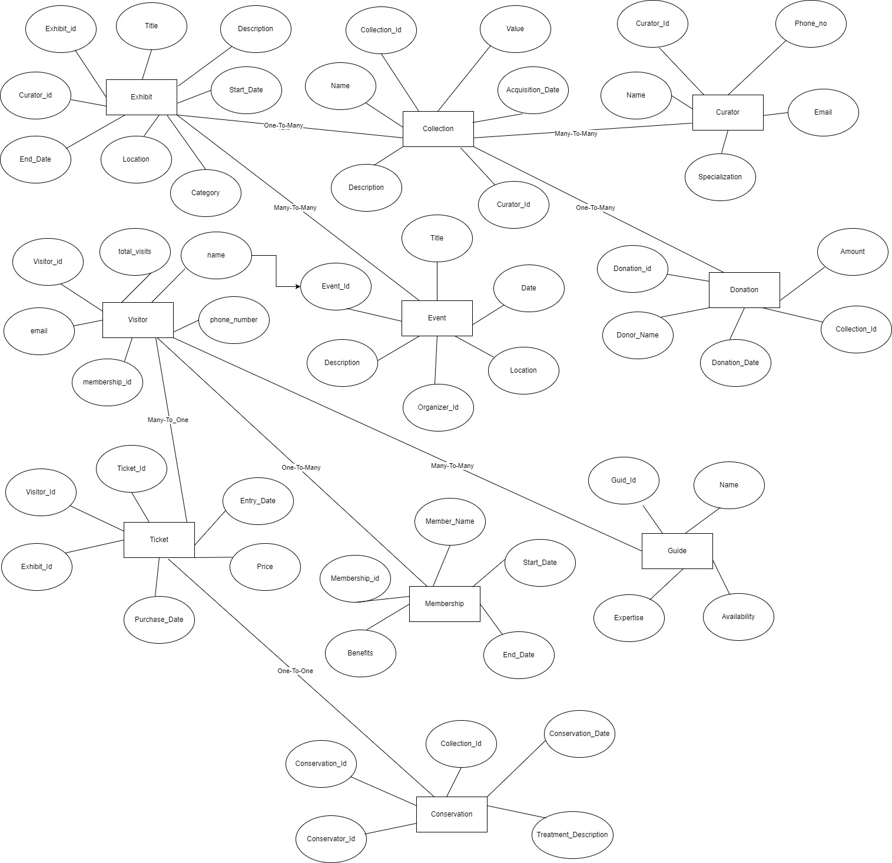

Queries To Create Database

**Query To Create Database And Selecting The Database :**

create database Mueseum_Management_System;

use mueseum_management_system;

**Query To Create Tables :**

create table exhibit(exhibitId int, Title varchar(30),Description varchar(30), startDate date, endDate date);

create table visitor (visitorId int, First varchar (20), LastName varchar (20), Email varchar (20), TotalVisits int);

create table ticket (ticketId int, Name varchar (20), price int, Purchase_Date date, Entrydate date);

create table event (eventId int, Title varchar (20), description varchar (20), evenDate date, Location varchar (20));

create table collection (collId int, Name varchar (30), Description varchar (30), Value int);

create table guide (guiId int, Name varchar (30), Expertise varchar (30), Availability date);

**Queries To Insert Data into Table:**

**1. Exhibit:**

insert into exhibit values (201,'Tutankhamun Mask','Famous in Egypt','2023-07-09','2023-07-12');

insert into exhibit values (202,'The Rosetta Stone','Famous in Egypt','2023-07-08','2023-07-12');

insert into exhibit values (203,'The Terracotta Army', 'China Army Image', '2023-08-09','2023-08-10')

insert into exhibit values (204,'The Elgin Marbles', 'The Greece Marbles','2023-08-10','2023-08-10');

insert into exhibit values (205,'The Dead Sea Scrolls', 'The Israel King Scrolls','2023-09-19','2023-09-20');

insert into exhibit values (206,'The Shroud of Turin', 'The Italy Shroud','2023-10-20','2023-10-23');

insert into exhibit values (207,'The Mona Lisa', 'The Famous Painting','2023-11-20','2023-12-21');

insert into exhibit values (208,'The Statue of Liberty', 'USA Famous Statue','2023-11-21','2023-11-22');

insert into exhibit values (209,'The Hope Diamond', 'USA Famous Diamond','2023-11-21','2023-11-22');

insert into exhibit values (210,'The Venus de Milo', 'Greece Famous Statue','2023-11-22','2023-11-23');

**2. Visitor:**

insert into visitor values (301,'Sai','Srinivas', 'ping2sai@gmail.com',2);

insert into visitor values (302,'Bhavyas','Eshwar', 'ping2bavi@gmail.com',3);

insert into visitor values (303,'Venu','Madhav', 'ping2venu@gmail.com',3);

insert into visitor values (304,'Rajani','Kumari', 'ping2rajani@gmail.com',3);

insert into visitor values (305,'Rithvik','Kumar', 'rithvik01@gmail.com',1);

insert into visitor values (306,'Sathvik','Kumar', 'sathik02@gmail.com',4);

insert into visitor values (307,'Varun','Kumar', 'varun123@gmail.com',5);

insert into visitor values (308,'Bharath','Reddy', 'bharat145@gmail.com',4);

insert into visitor values (309,'Venkat','Girish', 'venkat07@gmail.com',2);

insert into visitor values (310,'Praveen','Kumar', 'praveen123@gmail.com',1);

**3. Ticket:**

insert into ticket values (101, 'Sai Srinivas', 200, '2023-08-22', '2023-08-25');

insert into ticket values (102,'Bhavyas Eshwar',300,'2023-08-23','2023-08-25');

insert into ticket values (103,'Venu Madhav', 400,'2023-08-24','2023-08-25');

insert into ticket values (104,'Rithvik Kumar',500,'2023-08-22','2023-08-25');

insert into ticket values (105,'Sathvik Kumar',200,'2023-08-23','2023-08-25');

insert into ticket values (106,'Raj Kumar',300,'2023-08-24','2023-08-25');

insert into ticket values (107,'Anudeep Kumar',400,'2023-08-22','2023-08-25');

insert into ticket values (108,'Anurag Deva',500,'2023-08-23','2023-08-25');

insert into ticket values (109,'SatyaKanth',200,'2023-08-24','2023-08-25');

insert into ticket values (110,'Satya Narayana',300,'2023-08-22','2023-08-25');

**4. Event:**

insert into event values (401,'Craft Exhibition', 'Monuments Exhibition','2023-08-25','Hyderabad');

insert into event values (402,'HandiCraft Exhibits', 'Best Handicrafts','2023-08-26','Hyderabad');

insert into event values (403,'Vintage Exhibition', 'Vintages exhibited','2023-08-27','Warangal');

insert into event values (404,'Paintings Exhibition', 'Famous Paintings','2023-08-28','Warangal');

insert into event values (405,'Jewellery Exhibition', 'Famous Jewellery','2023-08-29','Mumbai');

insert into event values (406,'Coins Exhibitions', 'Kingdoms Currency','2023-08-30','Mumbai');

insert into event values (407,'Weapons Exhibition', 'Olden Days Weapons','2023-08-25','New Delhi');

insert into event values (408,'Outfits Exhibition', 'Olden Days Outfits','2023-08-26','New Delhi');

insert into event values (409,'Gems Exhibition', 'Precious Gems','2023-08-27','Lucknow');

insert into event values (410,'Dinosaur Exhibition', 'Dinosaur Skeletons', '2023-08-28','Lucknow');

insert into event values (411,'Swords Exhibition', 'Kings Swords','2023-08-29','Jaipur');

insert into event values (412,'Concerts','Great Talents','2023-08-30','Jaipur');

**insert into event values (413,'ArtWorks Exhibition', 'Famous ArtWorks','2023-08-25','Thirchi');**

**5. Collection:**

insert into collection values (01,'Art Collection', 'Famous Arts Collection',6000);

insert into collection values (02,'Craft Collection', 'Famous Crafts Collection',7000);

insert into collection values (03,'HandiCrafts Collection', 'Famous HandiCrafts',8000);

insert into collection values (04,'Outfits Collection', 'Famous Outfits',9000);

insert into collection values (05,'Weapons Collection', 'Famous Weapons Collection',10000);

insert into collection values (06,'Architecture Collection', 'Famous Architecture Works',11000);

insert into collection values (07,'Archaeology Collection', 'Famous Archaeology Works',12000);

insert into collection values (08,'Botanical Collection', 'Various Plants Collection',13000);

insert into collection values (09,'Planetary Collection', 'Planets Information',14000);

insert into collection values (10,'Biography Collection', 'Person Biography Collection',15000);

**6. Guide:**

insert into guide values (501,'Vishnu','Expertise in Arts','2023-08-09');

insert into guide values (502,'Shiva','Expertise in Weapons','2023-08-10');

insert into guide values (503,'Chaitanya','Expertise in Vehicles','2023-08-11');

insert into guide values (504,'Narayana','Expertise in Science','2023-08-12');

insert into guide values (505,'Moksha','Expertise in History','2023-08-13');

insert into guide values (506,'Rudra','Expertise in Planets','2023-08-09');

insert into guide values (507,'Shivaay','Expertise in Books','2023-08-10');

insert into guide values (508,'Krishna','Expertise in Vintage Items','2023-08-11');

insert into guide values (509,'Balrama','Expertise in Rocks','2023-08-12');

insert into guide values (510,'Sam','Expertise in Knowledge','2023-08-13');

insert into guide values (511,'Yuva','Expertise in Calligraphy','2023-08-13');

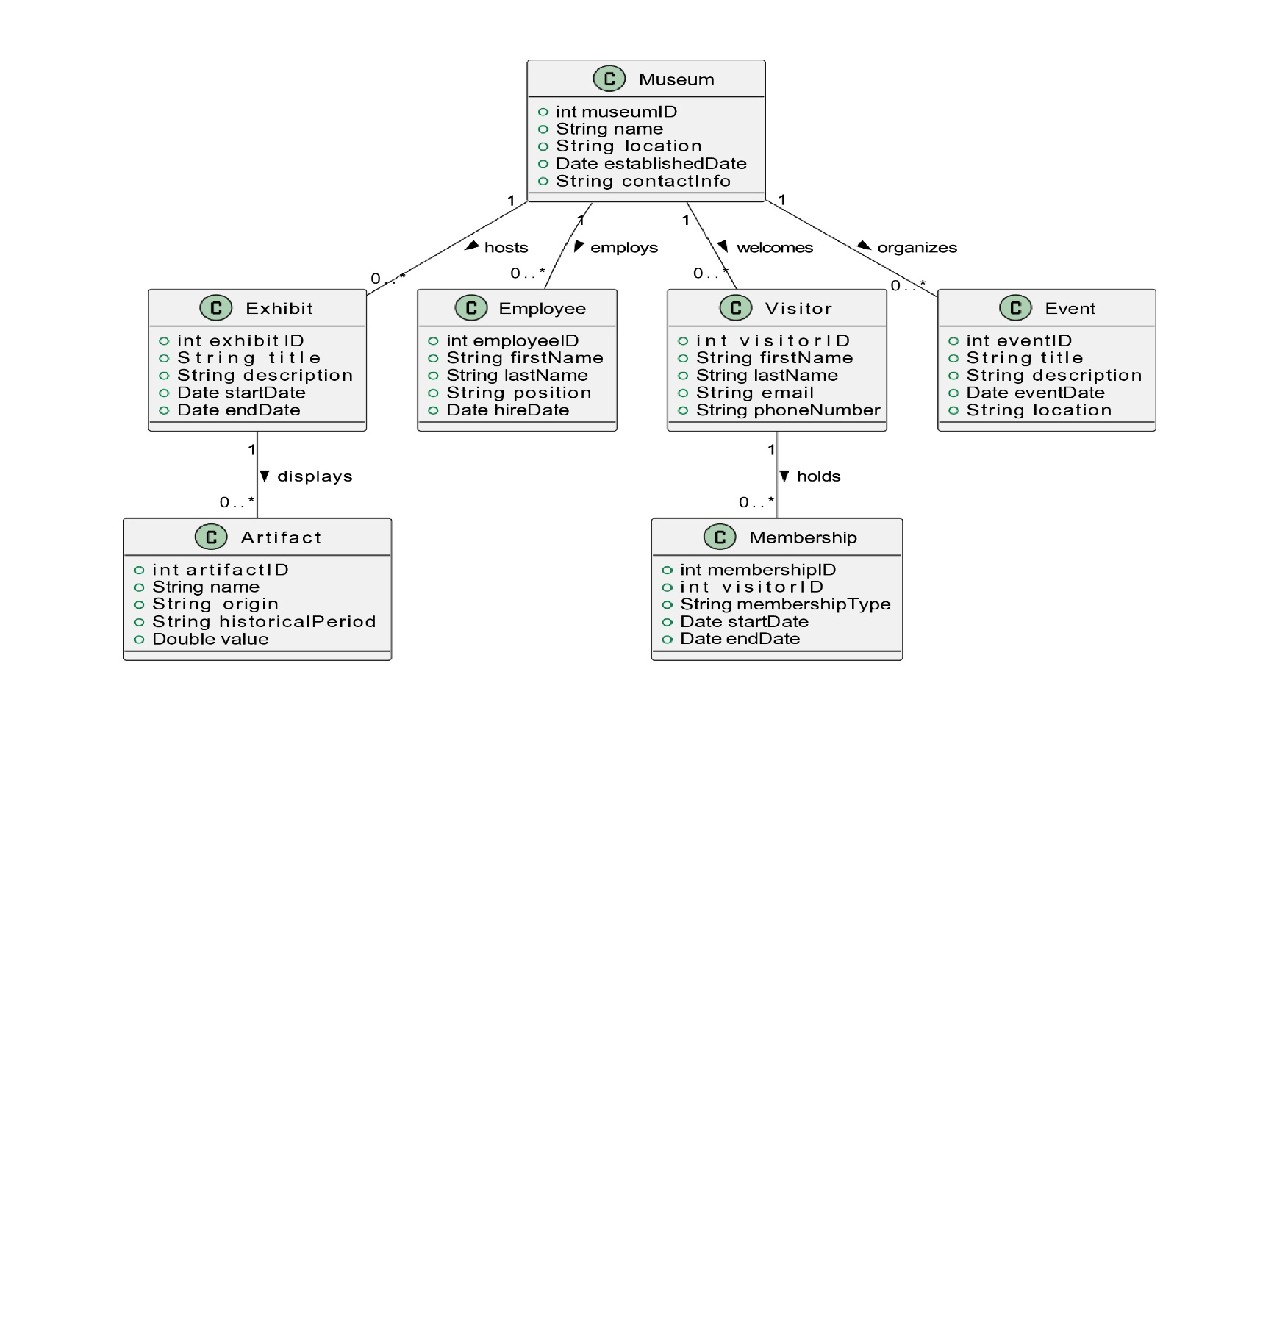UML DIAGRAM

Java File Codes:

1) Collection.Java:

package java_programs.Museum_Management_System;

public class visitor {

private int v_id, t_visits;

private String name, email;

private long pn_no;

public visitor(int v_id, int t_visits, String name, String email, long pn_no) {

this.v_id = v_id;

this.t_visits = t_visits;

this.name = name;

this.email = email;

this.pn_no = pn_no;

}

public void display2() {

System.out.println("The visitor id is : " + v_id);

System.out.println("The total number of visits in event is : " + t_visits);

System.out.println("The name of the person whose id is " + v_id + " is" + name);

System.out.println("The email of the " + name + " is " + email);

System.out.println("The mobile number of the " + name + " is " + pn_no);

}

}

2) Event.Java:

package java_programs.Museum_Management_System;

public class Event

{

private int E_id, O_id;

private String title, desc, date, location;

public Event (int E_id, int O_id, String title, String desc, String date, String location)

{

this.E_id = E_id;

this.O_id = O_id;

this.title = title;

this.desc = desc;

this.date = date;

this.location = location;

}

public void display5()

{

System.out.println("The Event id of the person is : " + E_id);

System.out.println("The organization id of the Event is : " + O_id);

System.out.println("The title of the event is **********" + title + "************");

System.out.println("The date of the Event is :" + date);

System.out.println("The location of the Event :" + location);

}

}

3. Exhibit.Java:

package java_programs.Museum_Management_System;

public class Exhibit

{

private int exhibit_id, curator_id;

private String title, desc, st_date;

public Exhibit(int exhibit_id, int curator_id, String title, String desc, String st_date)

{

this.exhibit_id = exhibit_id;

this.curator_id = curator_id;

this.title = title;

this.desc = desc;

this.st_date = st_date;

}

public void display1()

{

System.out.println("The Exhibit Id is: " + exhibit_id);

System.out.println("The curator id is : " + curator_id);

System.out.printf("The title of the event is %s%n : the description of event is %s%n::: ", title, desc);

System.out.println("The starting date of the event is : " + st_date);

}

}

4. Guide.Java:

package java_programs.Museum_Management_System;

public class Guide

{

private int g_id, exp, aval;

private String name;

public Guide(int g_id, String name, int exp, int aval)

{

this.g_id = g_id;

this.exp = exp;

}

public void display6() {

System.out.println("The guide id for the event guide is :" + g_id);

System.out.println("The name of the person Who has Guide id" + g_id + " is " + name);

System.out.println("The Expertise of the guide is " + exp);

System.out.println("The avalability of the Guide is " + aval);

}

}

this.aval = aval;

}

public void display6() {

System.out.println("The guide id for the event guide is :" + g_id);

System.out.println("The name of the person Who has Guide id" + g_id + " is " + name);

System.out.println("The Expertise of the guide is " + exp);

System.out.println("The avalability of the Guide is " + aval);

}

}

5. Ticket.Java:

package java_programs.Museum_Management_System;

public class Ticket

{

private int t_id, v_id, e_id, price;

private String pu_date, entry_date;

public Ticket(int t_id, int v_id, int e_id, int price, String pu_date, String entry_date)

{

this.t_id = t_id;

this.v_id = v_id;

this.e_id = e_id;

this.price = price;

this.pu_date = pu_date;

this.entry_date = entry_date;

}

public void display3()

{

System.out.printf("The ticket id is %d\n the visitor id of that person is %d\n The exhibit id of the person is %d\n Finally the total price of the event is %d\n",t_id, v_id, e_id, price);

System.out.println("The purchase date of the ticket is : " + pu_date);

System.out.println("The entry date of the event is : " + entry_date);

}

}

6. Visitor.Java:

package java_programs.Museum_Management_System;

public class visitor

{

private int v_id, t_visits;

private String name, email;

private long pn_no;

public visitor (int v_id, int t_visits, String name, String email, long pn_no)

{

this.v_id = v_id;

this.t_visits = t_visits;

this.name = name;

this.email = email;

this.pn_no = pn_no;

}

public void display2()

{

System.out.println("The visitor id is : " + v_id);

System.out.println("The total number of visits in event is : " + t_visits);

System.out.println("The name of the person whose id is " + v_id + " is" + name);

System.out.println("The email of the " + name + " is " + email);

System.out.println("The mobile number of the " + name + " is " + pn_no);

}

}

7. Main.Java:

package java_programs.Museum_Management_System;

import java.io.BufferedReader;

import java.io.IOException;

import java.io.InputStreamReader;

import java.util.*;

public class Main {

public static void main(String[] args) throws IOException {

Scanner sc = new Scanner(System.in);

System.out.println("Enter the title of the Event ");

String t = sc.nextLine();

System.out.println("Enter the description of the Event ");

String d = sc.nextLine();

System.out.println("The Starting date of the Event is ");

String s_date = sc.nextLine();

System.out.println("Enter the Acquisition date of the event is ");

String ac_date = sc.nextLine();

System.out.println("Enter the purchase date of the ticket ");

String p = sc.nextLine();

System.out.println("enter the entry date of the person in the event ");

String ed = sc.nextLine();

System.out.println("/////////////////ENter the personal details//////////////// ");

System.out.println("Enter the name of the person ");

String name = sc.nextLine();

System.out.println("Enter the email of the person ");

String email = sc.nextLine();

System.out.println("Enter the location of the event ");

String loca = sc.nextLine();

System.out.println("Enter the Event id");

int e_id = sc.nextInt();

System.out.println("Enter The oraganization id");

int o_id = sc.nextInt();

System.out.println("Enter the phone number of the person");

long pn = sc.nextLong();

System.out.println("*******************END OF THE PERSONAL DETAILS*****************************");

System.out.println("Enter the exihibit id ");

int e = sc.nextInt();

System.out.println("Enter the curator id of the person");

int c = sc.nextInt();

System.out.println("Enter the collection id ");

int co = sc.nextInt();

System.out.println("Enter the value of the event");

int val = sc.nextInt();

System.out.println("Enter the visitor id of an event ");

int v = sc.nextInt();

System.out.println("Enter the total visits in an event ");

int to = sc.nextInt();

System.out.println("Enter the ticket id ");

int ti = sc.nextInt();

System.out.println("Enter the total price of the event ");

int pr = sc.nextInt();

System.out.println(":::::::::The exhibit DEtails are:::::::");

Exhibit ex = new Exhibit(e, c, t, d, ac_date);

ex.display1();

System.out.println("*******The tic detials for the event is::**********");

Ticket tic = new Ticket(ti, v, e, pr, p, ed);

tic.display3();

System.out.println("************ The Collection details of the event****************");

Collection coll = new Collection(co, c, val, name, d, ac_date);

coll.display4();

System.out.println("****************The visitor details of the Event***************");

visitor vis = new visitor(v, to, name, email, pn);

vis.display2();

System.out.println("*************The Event details ******************");

Event ev = new Event(e_id, o_id, t, d, s_date, loca);

ev.display5();

BufferedReader br = new BufferedReader(new InputStreamReader(System.in));

System.out.println("Enter the choice that the guide is required or not (Y/N)");

String choice = br.readLine();

if (choice.equals("Y") || choice.equals("y"))

{

System.out.println("Enter the Guide id ");

int g_id = sc.nextInt();

System.out.println("Enter the name of the guide ");

String gname = br.readLine();

System.out.println("Enter the expenses of the guide in RS");

int exp = sc.nextInt();

System.out.println("Enter the avalability of the Guide in hours ");

int h = sc.nextInt();

Guide g = new Guide(g_id, gname, exp, h);

g.display6();

}

}

}

CHALLENGES FACED

1) **Scope Creep:** Uncontrolled changes or continuous growth in a project's scope, often resulting in project delays and budget overruns.

2) **Resource Allocation:** Difficulty in securing and effectively utilizing resources, such as manpower, equipment, and materials, which can lead to project delays.

3) **Time Management:** Struggles in meeting project deadlines due to poor planning, unrealistic timelines, or unforeseen delays.

4) **Communication Issues:** Ineffective communication among team members, stakeholders, or clients, leading to misunderstandings and misalignment.

5) **Risk Management:** Identifying, assessing, and mitigating risks can be challenging, particularly when unforeseen issues arise that impact the project.

6) **Stakeholder Engagement:** Ensuring that all stakeholders are engaged, informed, and satisfied with the project's progress and outcomes can be difficult.

7) **Quality Control:** Maintaining high standards and ensuring that project deliverables meet required quality criteria can be a constant challenge.

8) **Change Management:** Handling changes in project scope, objectives, or team dynamics efficiently without disrupting the project's progress.

9) **Team Dynamics:** Managing team conflicts, maintaining motivation, and ensuring effective collaboration among diverse team members can be challenging.

10) These challenges occurred in our project and effectively managing them is crucial for project success.