Sravani Musunuri

August 7th , 2022

IT FDN 110 A Su 22: Foundations of Programming: Python

Assignment 05

List of Dictionaries as 2D table

# Introduction

This assignment provides all the knowledge required to write my CD Inventory Python script to convert inner datatypes from list to dictionaries, load the existing data from file and deleting an item from 2D table. By watching module videos and reading book chapter-03 gave clear understanding of Lists, Dictionaries, loading data to and from a file, Separation of concerns into separate functions and experience on Github. I used Spyder to execute all my lab programs.

# Course Work

Assignment 05 starts with a challenge of understanding and modifying/adding to someone else program. I first initialized a dictionary dicRow = {} to hold CD Inventory data. Then converted all the list inner data structures to dictionary to hold the data. Second task is to add the functionality to load existing data from file, for that I opened file in read mode and iterated through all the rows and use the keys in the dicRow variable and append the rows from file to a 2D list of dictionaries.

Then last part of the project is to add deletion of an item. For that I choose to use remove() method using the index of the list. User can input the Inventory ID to delete, later I will identify the index of Inventory ID and delete the item from the list using the remove(index) method. In case there are multiple items with same ID, this approach will delete the item with first matching ID in the list.

Deletion of an item can be done in other ways; one such way is deleting the item directly from the list using delete function. But I choose to go via index deletion. After deleting the item, I printed the list with all the remaining items in the list.

1. deleteItem **=** int(input("\nEnter the Inventory ID to delete: "))
3. **for** item **in** lstTbl:
4. **if** deleteItem **==** item['ID']:
5. index **=** lstTbl.index(item)
6. lstTbl.remove(lstTbl[index])
7. **break**

Listing 1 Delete code

# Code dump

Here is full code of the program to store CD inventory details to a list of dictionaries. I updated the header details and also provided the proper comments which make sense to other programmers.

1. #------------------------------------------#
2. # Title: CDInventory.py
3. # Desc: Starter Script for Assignment 05
4. # Change Log: (Who, When, What)
5. # DBiesinger, 2030-Jan-01, Created File
6. # Sravani Musunuri, 2022-Aug-07, Updating the file
7. #------------------------------------------#
9. # Declare variables
11. strChoice **=** '' # User input
12. lstTbl **=** []  # list of lists to hold data
13. dicRow **=** []  #replace list of lists with list of dicts
14. lstRow **=** []  # list of data row
15. strFileName **=** 'CDInventory.txt'  # data storage file
16. objFile **=** None  # file object
18. # Get user Input
19. print('The Magic CD Inventory\n')
20. **while** True:
21. # 1. Display menu allowing the user to choose:
22. print('[l] load Inventory from file\n[a] Add CD\n[i] Display Current Inventory')
23. print('[d] delete CD from Inventory\n[s] Save Inventory to file\n[x] exit')
24. strChoice **=** input('l, a, i, d, s or x: ').lower()  # convert choice to lower case at time of input
25. print()
27. **if** strChoice **==** 'x':
28. # 5. Exit the program if the user chooses so
29. **break**
30. **if** strChoice **==** 'l':
31. #Add the functionality of loading existing data
32. objFile **=** open(strFileName, 'r')
33. **for** row **in** objFile:
34. lstRow **=** row.strip().split(',')
35. dicRow **=** {'ID': int(lstRow[0]), 'Title': lstRow[1], 'Artist Name': lstRow[2]}
36. lstTbl.append(dicRow)
37. objFile.close()
39. print('ID, CD Title, Artist')
40. **for** row **in** lstTbl:
41. print(**\***row.values() ,sep **=** ', ')
43. print()
44. **pass**
45. **elif** strChoice **==** 'a':  # no elif necessary, as this code is only reached if strChoice is not 'exit'
46. # 2. Add data to the table (2d-list) each time the user wants to add data
47. strID **=** input('Enter an ID: ')
48. strTitle **=** input('Enter the CD\'s Title: ')
49. strArtist **=** input('Enter the Artist\'s Name: ')
50. intID **=** int(strID)
52. dicRow **=** {'ID': intID, 'Title': strTitle, 'Artist': strArtist}
53. lstTbl.append(dicRow)
54. print()
56. **elif** strChoice **==** 'i':
57. # 3. Display the current data to the user each time the user wants to display the data
58. print('ID, CD Title, Artist')
59. **for** row **in** lstTbl:
60. print(**\***row.values() ,sep **=** ', ')
61. print()
63. **elif** strChoice **==** 'd':
64. #Add functionality of deleting an entry
66. print("Please select from available Inventories:")
67. **for** item **in** lstTbl:
68. print("Index:",lstTbl.index(item)," Item:", item)
70. deleteItem **=** int(input("\nEnter the Inventory ID to delete: "))
72. **for** item **in** lstTbl:
73. **if** deleteItem **==** item['ID']:
74. index **=** lstTbl.index(item)
75. lstTbl.remove(lstTbl[index])
76. **break**
78. print("\nCD Inventory after deletion....")
80. print()
82. print('ID, CD Title, Artist')
83. **for** row **in** lstTbl:
84. print(**\***row.values() ,sep **=** ', ')
85. print()
86. **pass**
88. **elif** strChoice **==** 's':
89. # 4. Save the data to a text file CDInventory.txt if the user chooses so
90. objFile **=** open(strFileName, 'w')
91. **for** row **in** lstTbl:
92. strRow **=** ''
93. **for** item **in** row.values():
94. strRow **+=** str(item) **+** ','
95. strRow **=** strRow[:**-**1] **+** '\n'
96. objFile.write(strRow)
97. objFile.close()
98. print()
99. print("Saved data to a file.\n")
101. **else**:
102. print('Please choose either l, a, i, d, s or x!')
103. print()

Figure 1 - Full Code of loading and deleting items from list of dictionaries..

# Running python script on terminal

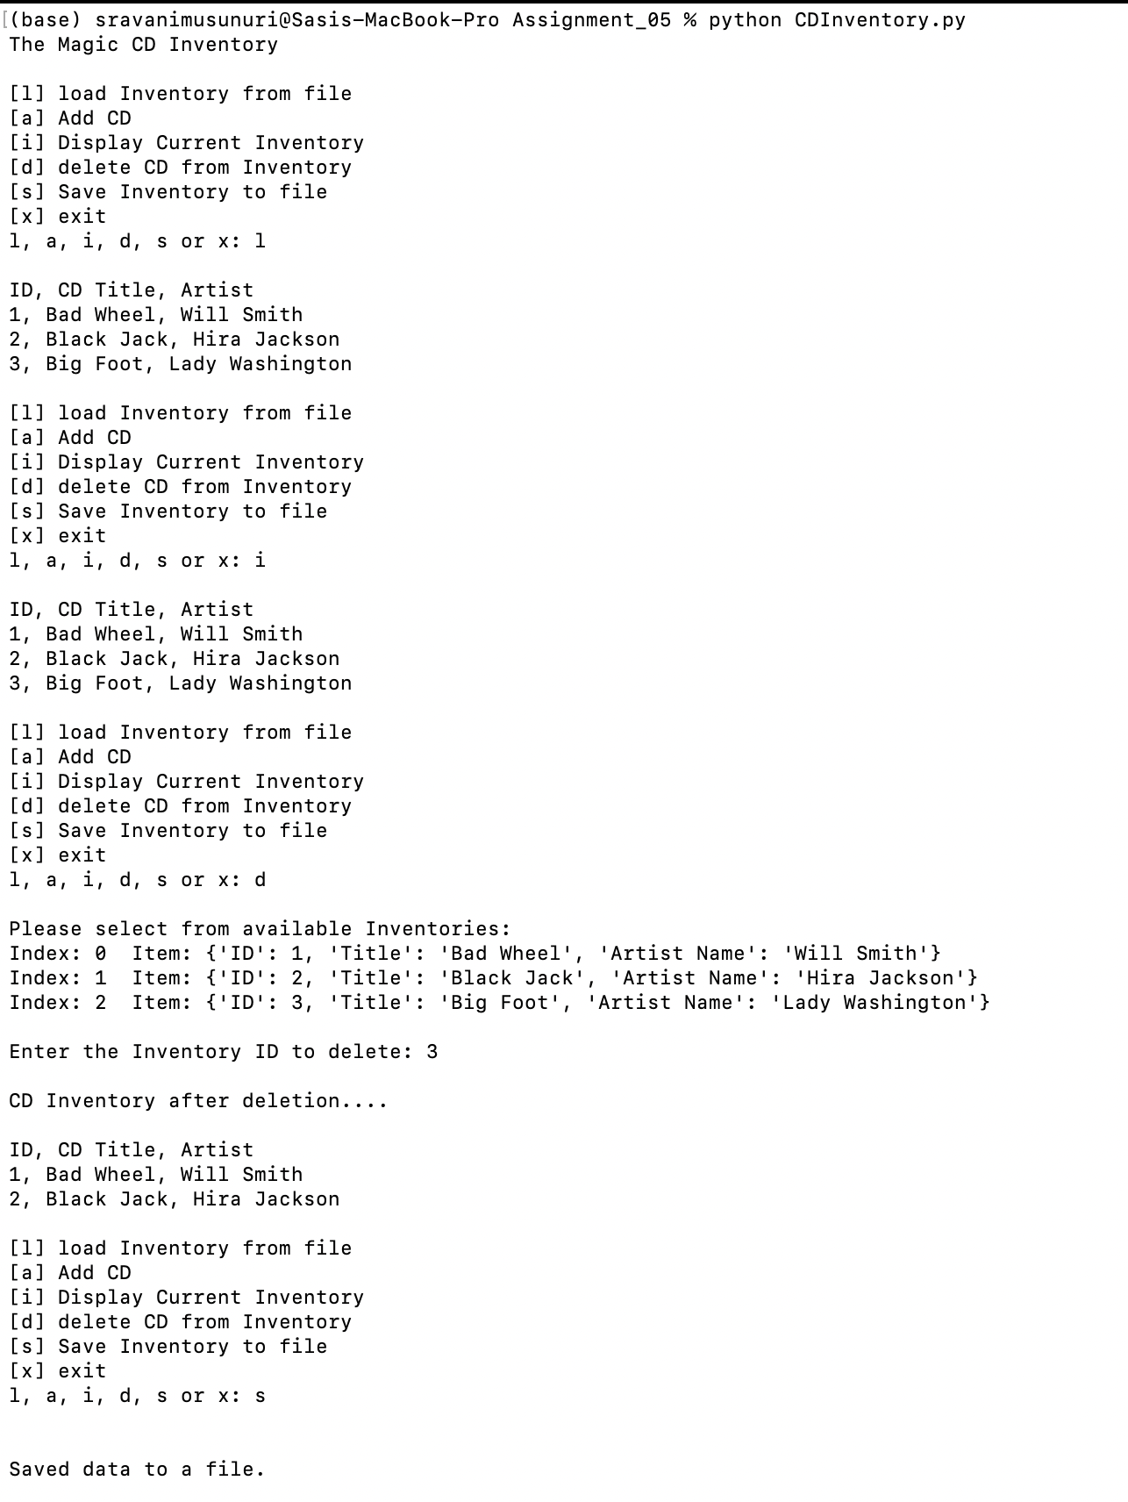

Figure 2 - Screenshot of output of python script running on terminal

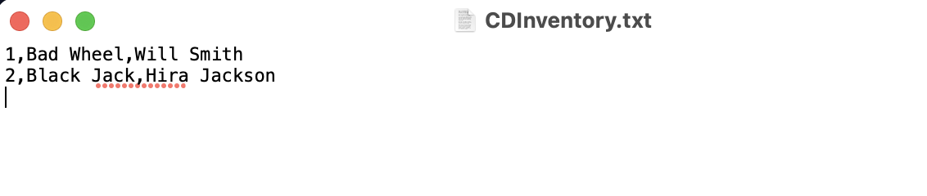

Figure 3 - Screenshot of 2D List saving to a output file

# Running the python script on Spyder

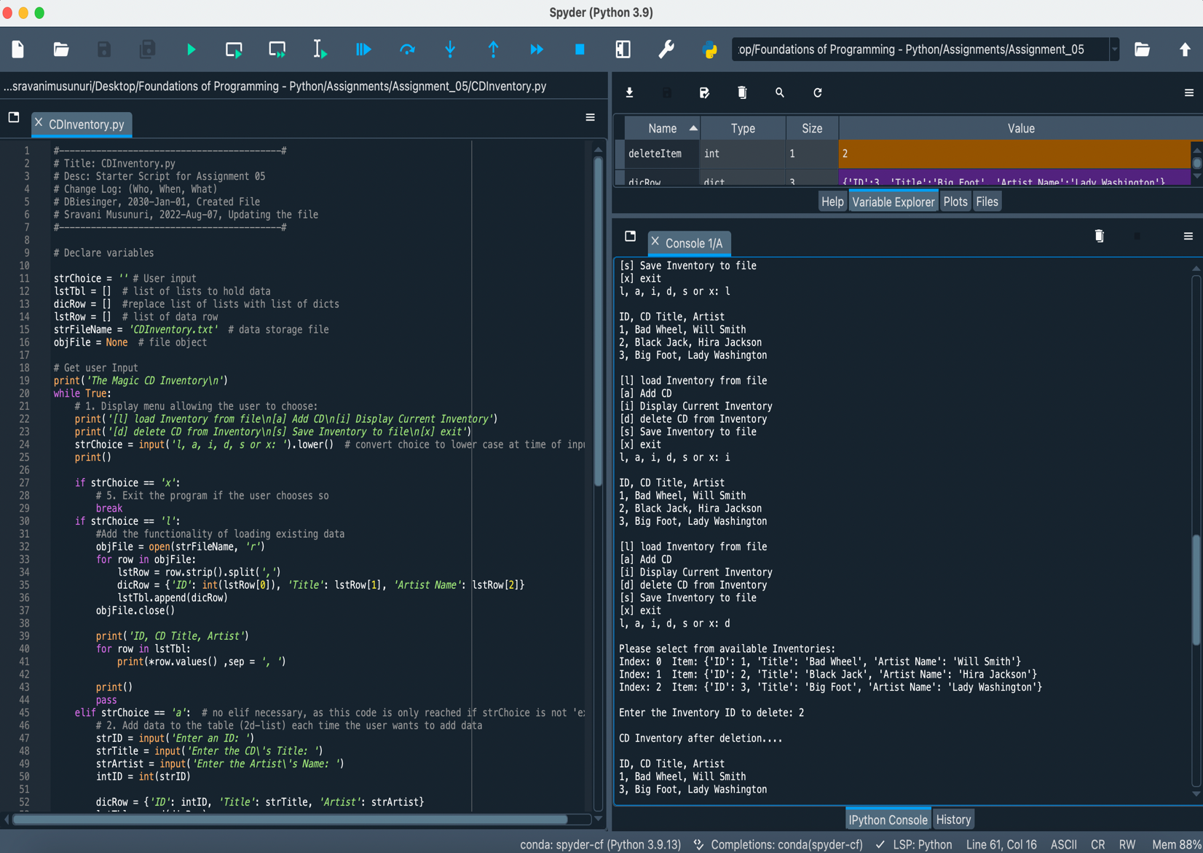

*Figure 4 - Screenshot of output of python script running on Spyder.*

# GitHub Link

<https://github.com/sravanimusunuri6/Assignment_05>

# Summary

In this module, I got chance to learn:

* Dictionaries – Fields names can be retrieved using keys() and values using values().
* Replacing inner data structure with dictionary and making a list of dictionaries as 2D table
* Loading data from a file and saving it to a file.
* Deleting items in the list using ‘del’ or remove(index).
* Checking in code to the GitHub repository.