Sravani Musunuri

August 28th , 2022

IT FDN 110 A Su 22: Foundations of Programming: Python

Assignment 08

OOPS - Instantiating Objects from Classes

# Introduction

This assignment provides all the knowledge required to modify the CD Inventory Python script from last week to define Objects in the Classes, write getters and setters for attributes in the class , instantiate the Objects from classes. By watching module videos and reading book chapter gave clear understanding of working with text files, reading data options, pickling, structured error handling and creating custom GitHub readme files. I used Spyder to execute all my lab programs.

# Course Work

I started with creating a Class and a constructor. A dunder init method is used to declare the attributes. Then I went ahead with creating the properties with getters and setters for these attributes – cd_id, cd_title, cd_artist. Followed the pseudocode and copied the code from my previous assignment to make it work with OOPS concept.

I added the docstrings to all classes and methods/functions and retained the error handling from my previous assignment for user input , files access and value errors.

I updated the add_inventory method to use the CD class to instantiate the Object. And also, I updated the code at places – load_inventory(), save_intentory() , delete_inventory(), show_inventory() to use the CD class.

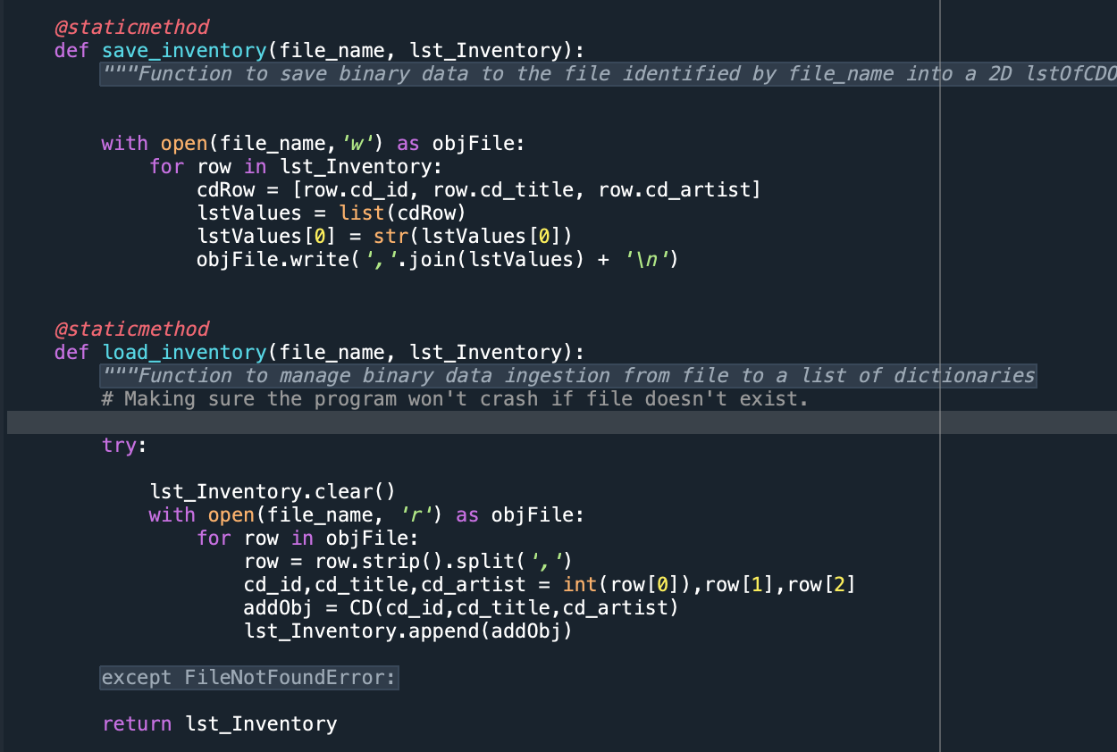

Figure 1 - Screenshot of output of python script running on terminal

# Running python script on terminal

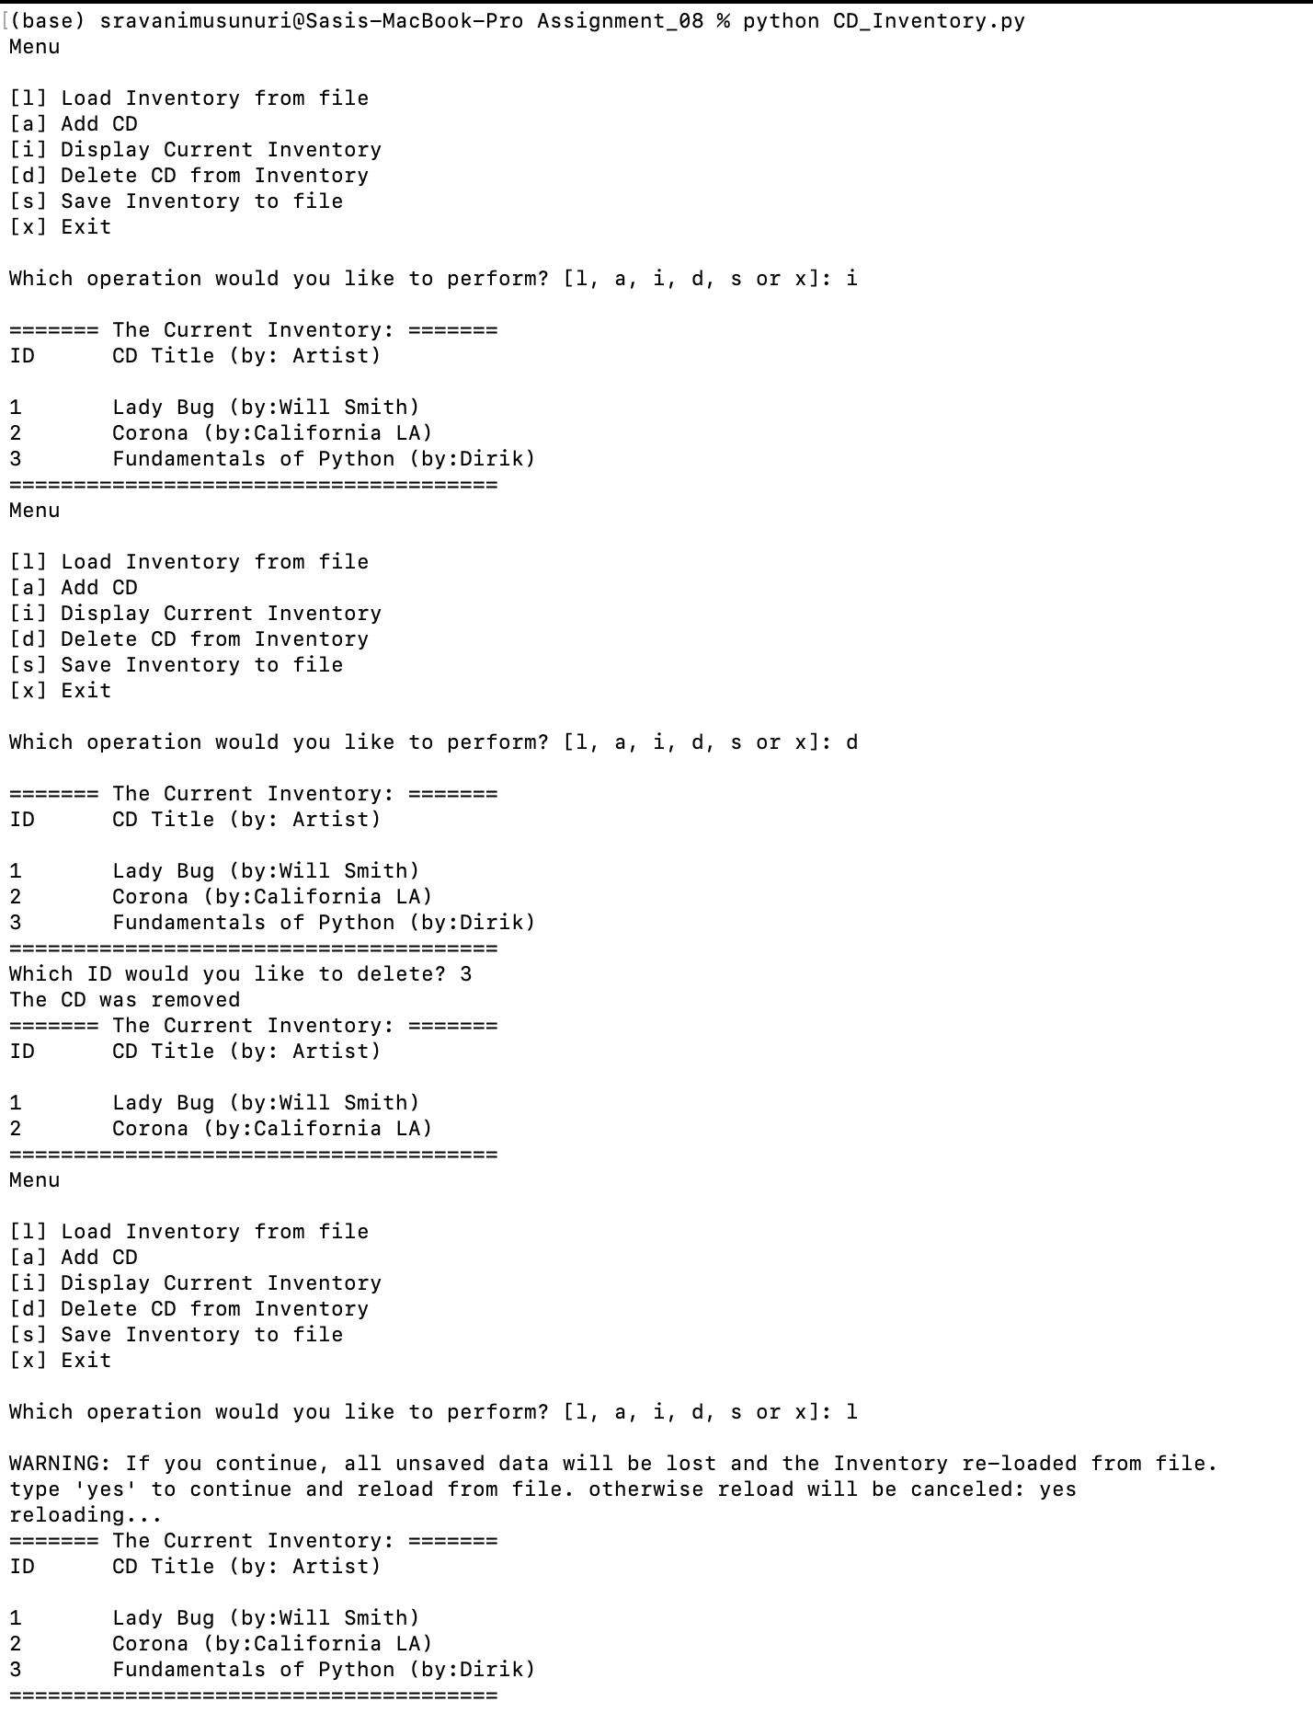

Figure 2 - Screenshot of output of python script running on terminal

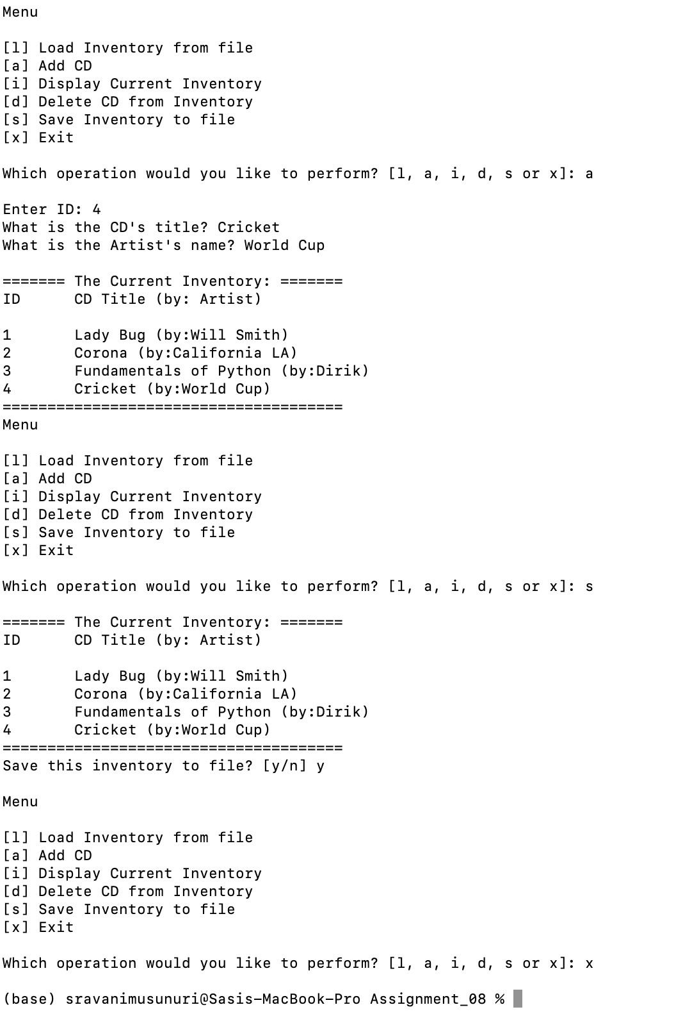

Figure 3 - Screenshot of output of python script running on terminal

# Running the python script on Spyder

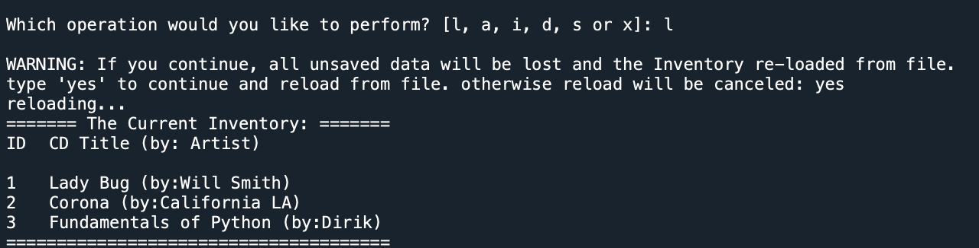

*Figure 4 - Load Inventory from file*

*.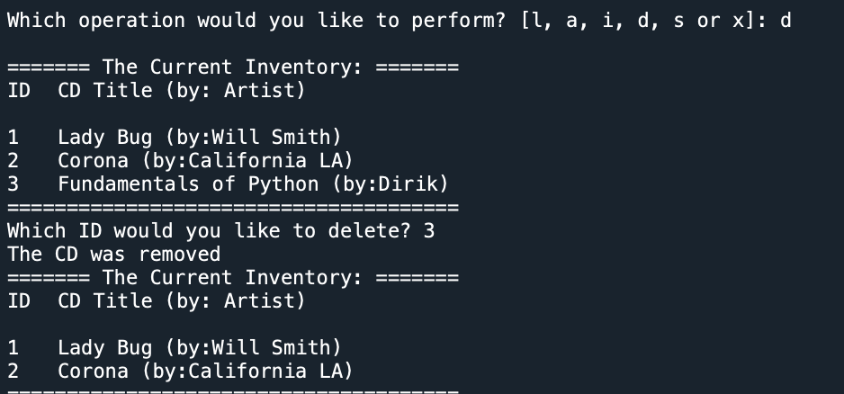*

*Figure 5 - Delete CD from Inventory*

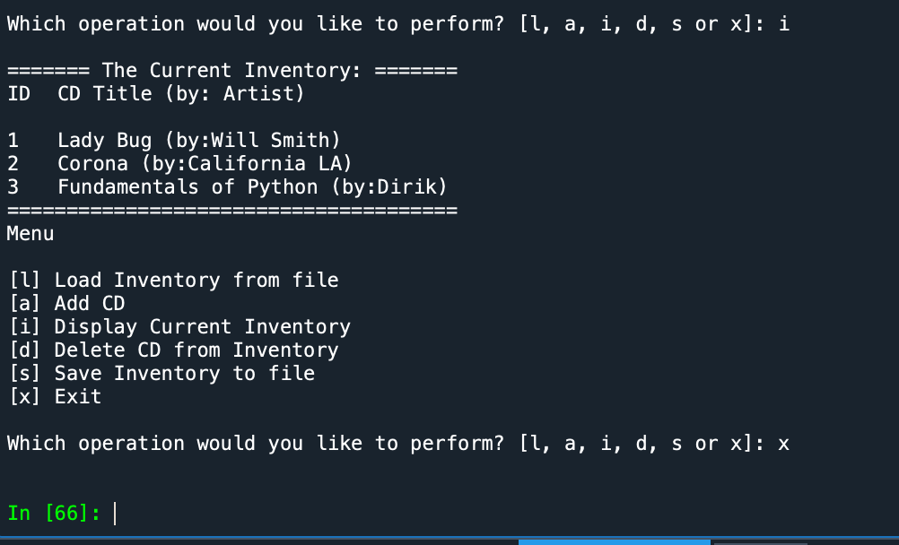

*Figure 6 - Save Inventory to File*

**

*Figure 7 - Add CD Inventory*

**

*Figure 8 - Display Current Inventory and Exit*

# GitHub Link

<https://github.com/sravanimusunuri6/Assignment_08>

# Summary

In this module, I got chance to learn:

* Difference between a class and class with instantiating Objects
* Constructors and Destructors
* Keyword self and Decorators
* Attributes, properties and methods.