**Use Chef and Chef Cookbooks to create, bootstrap and provision LAMP on new and existing instances**

1. Installing a chef-server:

* Launch an EC2 instance and make sure to select at least 4GB memory for the instance in order to run the chef-server.
* Add SSH, HTTP, HTTPS for the inbound rule in the security group for this instance.
* Connect to the instance using putty to install and configure the chef-server. Run the following commands
* sudo yum update
* curl -L https://omnitruck.chef.io/install.sh | sudo bash -s -- -P chef-server
* cd /etc/opscode
* ls -l
* sudo vim chef-server.rb (drop the below text in the file where server_name = “your server FQDN”)

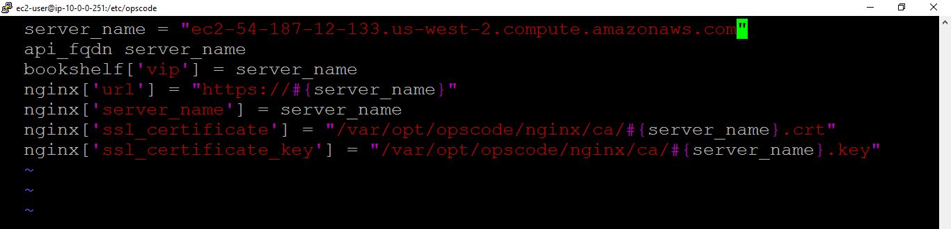

* sudo chef-server-ctl reconfigure
* Installing chef management console using chef-server ctl
* sudo chef-server-ctl install chef-manage
* sudo chef-server-ctl reconfigure
* sudo chef-manage-ctl reconfigure
* Installing chef opscode reporting feature using chef-server ctl
* sudo chef-server-ctl install opscode-reporting
* sudo chef-server-ctl reconfigure
* sudo opscode-reporting-ctl reconfigure
* Create the administrator account for the admin and organization
* sudo chef-server-ctl user-create admin sravani parimi schowdary1710@gmail.com mypassword --filename admin.pem
* ls –l (Check if the admin.pem is created)
* sudo chef-server-ctl org-create myorg "my organization" --association_user admin
* Now launch the chef-server in web browser using the Public DNS of the instance to see the chef management console.
* Log in to the chef management console using the credentials created. Download the chef starter kit from the management console to set up the chef workstation.

1. Setting up the chef workstation:

* Chef work station can be set up in the same instance as the chef-sever or launch another EC2 instance to set up workstation.
* Using any FTP tool like WinSCP, transfer the starter kit downloaded and also the .pem file from your local to the chef workstation server. Make sure to copy the .pem file into ~/.ssh directory.
* Run the following commands to set up the work station
* cd chef-repo/.chef
* ls -l
* sudo vim knife.rb (Check if the chef_server_url is same as mentioned in the chef-server.rb file)
* sudo curl -L https://www.opscode.com/chef/install.sh | sudo bash

(Install chef to run knife commands)

* Fetching SSL certificate from the chef-server. Run these commands when you are inside the chef-repo directory.
* knife ssl fetch
* knife ssl check
* knife client list

1. Create cookbook, recipe to bootstrap the node

* knife cookbook create lamp-stack
* cd cookbooks/lamp-stack/recipes
* sudo vim default.rb

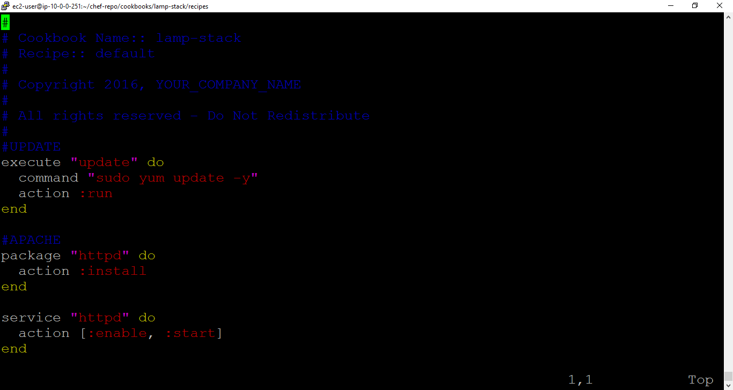

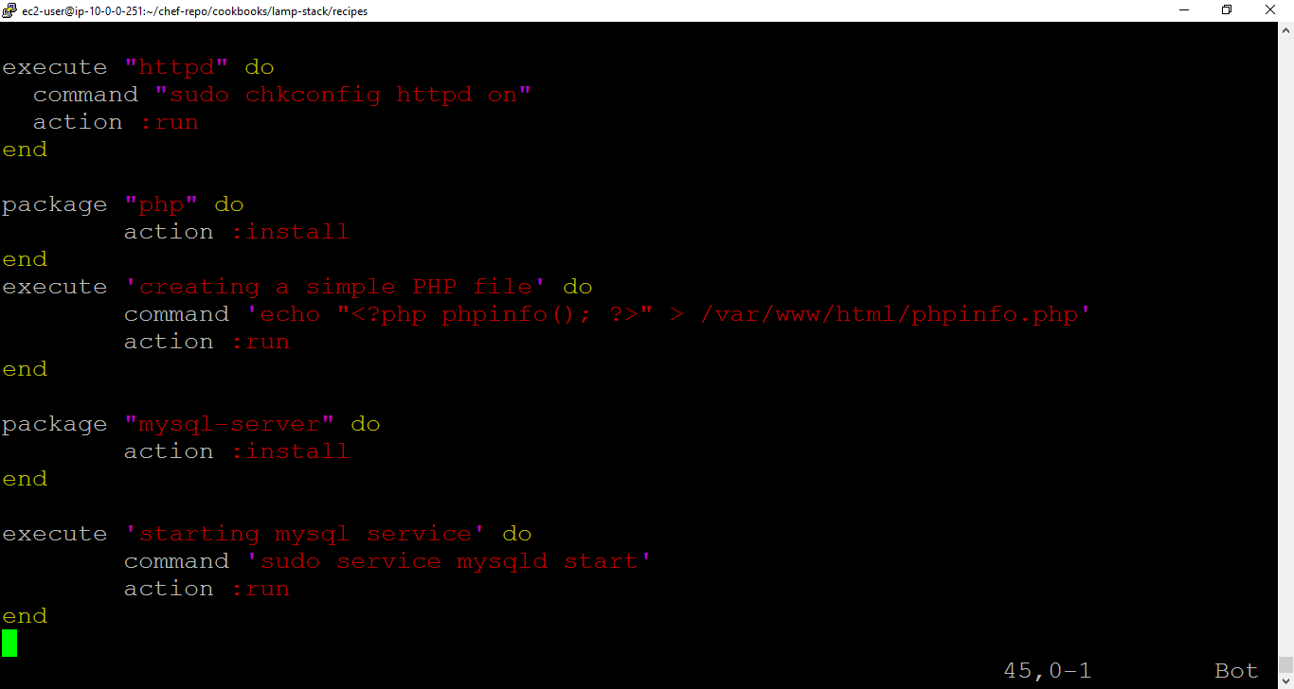

* knife cookbook upload lamp-stack
* knife bootstrap 54.149.177.116 --ssh-user ec2-user --sudo --identity-file /home/ec2-user/AWSPublicKey.pem --node-name node1 --run-list 'recipe[lamp-stack]'
* knife bootstrap 54.187.3.205 --ssh-user ec2-user --sudo --identity-file /home/ec2-user/AWSPublicKey.pem --node-name node2 --run-list 'recipe[lamp-stack]'
* knife node list

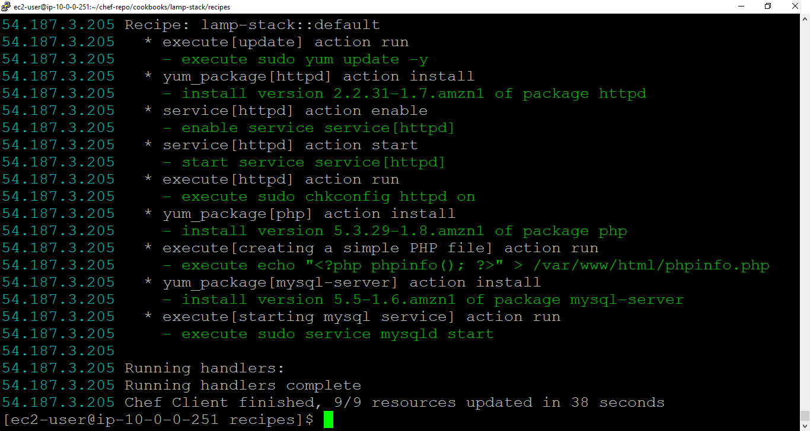

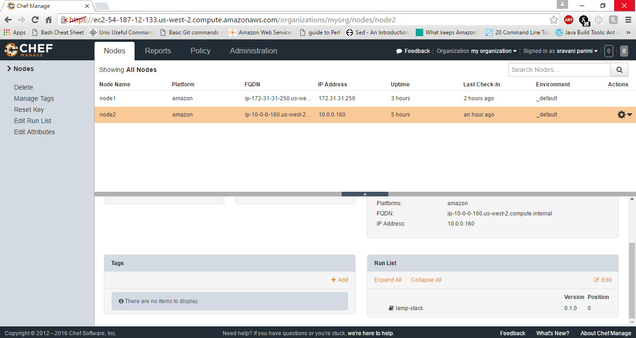

* knife ssh 54.149.177.116 'sudo chef-client -d -i 300 -s 13' --manual-list --ssh-user ec2-user --identity-file ~/.ssh/AWSPublicKey.pem

(Enabling chef-client auto check for 300 seconds on the node)