***Setting-up CHEF to configure and manage the infrastructure***

This document include a step-by-step tutorial to set up the CHEF Configuration Management tool environment on AWS cloud platform using the computing service EC2.

Below is the pictorial representation of basic CHEF architecture:

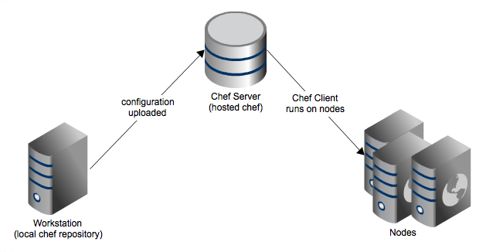

***Pre-requisites to install a chef-server***

1. Choose AMI : I have taken Ubuntu server

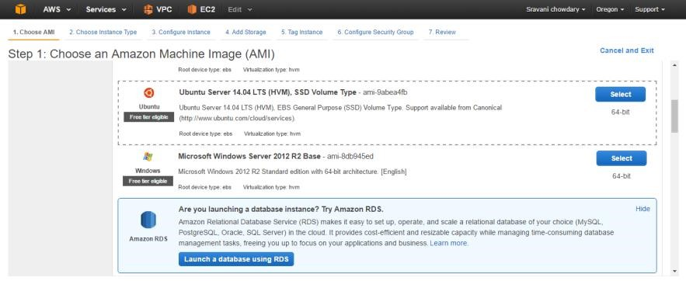

1. The server must have at least 4 GB memory : I have taken a t2.large instance

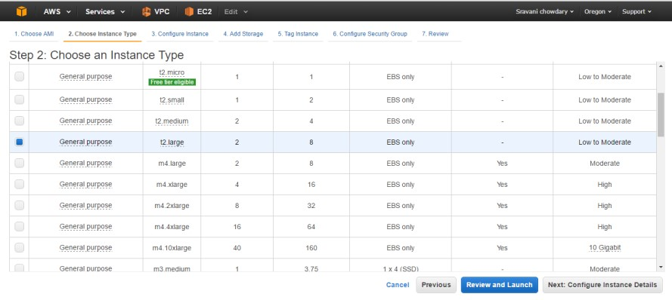

1. Add SSH and HTTPS ports in the security group

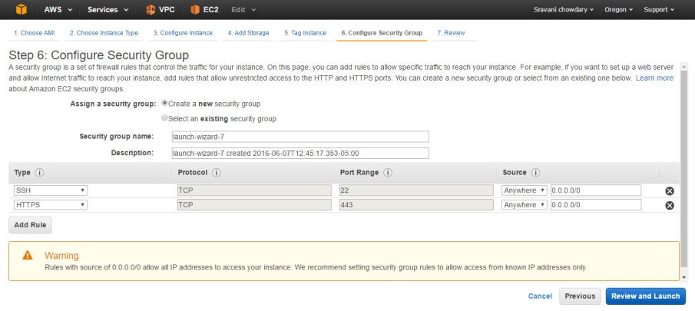

1. Allocate an EIP to the chef-server instance

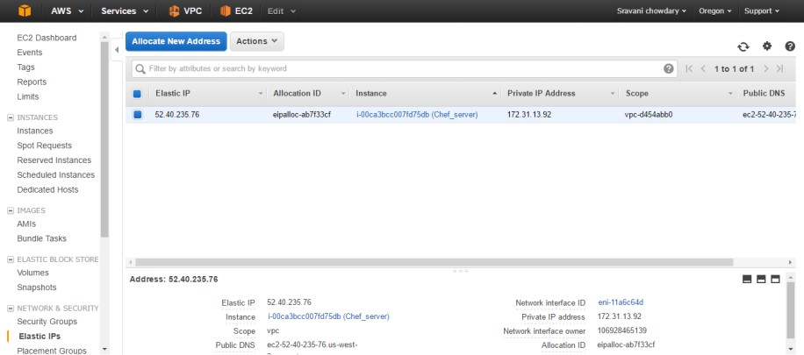

***Steps to install and configure the chef-server:***

1. Update the system and install chef-server
   * sudo apt-get update
   * curl -L https://omnitruck.chef.io/install.sh | sudo bash -s -- -P chef-server
2. Edit chef-server.rb file to configure the chef-server
   * cd /etc/opscode
   * ls
   * sudo vim chef-server.rb (drop the below text in the file where server_name = “your server FQDN”)

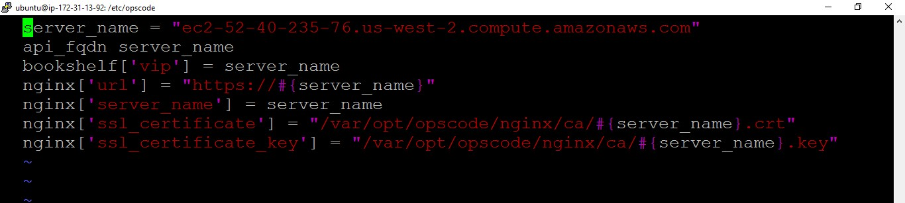

1. Reconfigure the chef-server
   * cd ~
   * sudo chef-server-ctl reconfigure
2. Run these commands on your Chef server to install the management console
   * sudo chef-server-ctl install chef-manage
   * sudo chef-server-ctl reconfigure
   * sudo chef-manage-ctl reconfigure
3. run these commands to install the reporting feature
   * sudo chef-server-ctl install opscode-reporting
   * sudo chef-server-ctl reconfigure
   * sudo opscode-reporting-ctl reconfigure
4. Create the administrator account
   * sudo chef-server-ctl user-create protekadmin sravani parimi schowdary1710@gmail.com protekadmin --filename protekadmin.pem
   * ls

(Check if the protekadmin.pem is created)

1. Create the organization account
   * sudo chef-server-ctl org-create pro-tek "pro-tek consulting" --association_user protekadmin
2. Now launch the chef-server in web browser to see the chef management console. (add a HTTP port here to launch)
3. Login using the administrator account

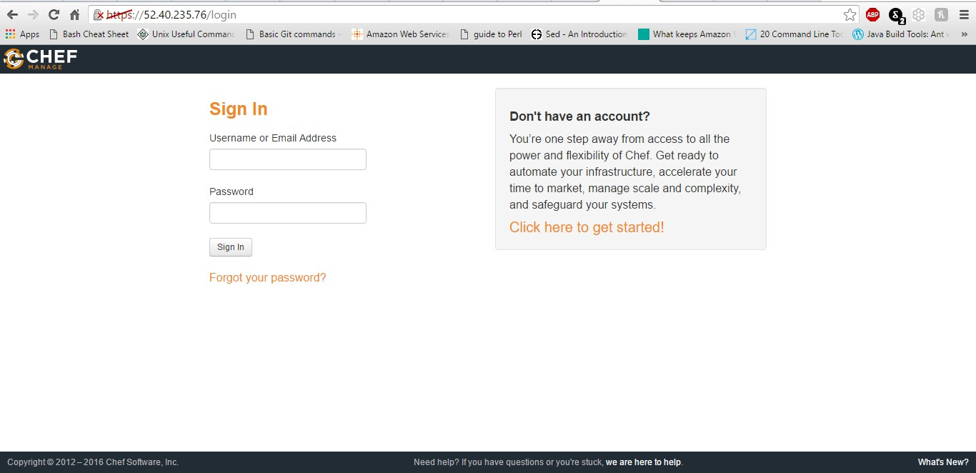

To download the chef starter kit for Chef WorkStation.

1. Click on the administration and select the organization
2. Click on the starter kit on the left side options bar

12. Download the starter kit to your local.

***Setting up the chef workstation:***

1. Launch another EC2 instance to set up workstation. (Can be a free-tier): I have taken Amazon Linux server, t2.micro type instance.
2. Using any FTP tool like File Zilla or WinSCP, transfer the starter kit and also the .pem file from your local to the chef workstation server. Make sure to copy the .pem file into ~/.ssh directory (authorization to fetch SSL certificate)
3. Steps to set up the work station
   * + sudo yum update
     + cp AWSPublicKey.pem ~/.ssh
     + cd ~

To configure the chef work station

* + - cd chef-repo
    - ls -a
    - cd .chef
    - ls
    - sudo vim knife.rb

(Check if the chef_server_url is same as mentioned in the chef-server.rb file)

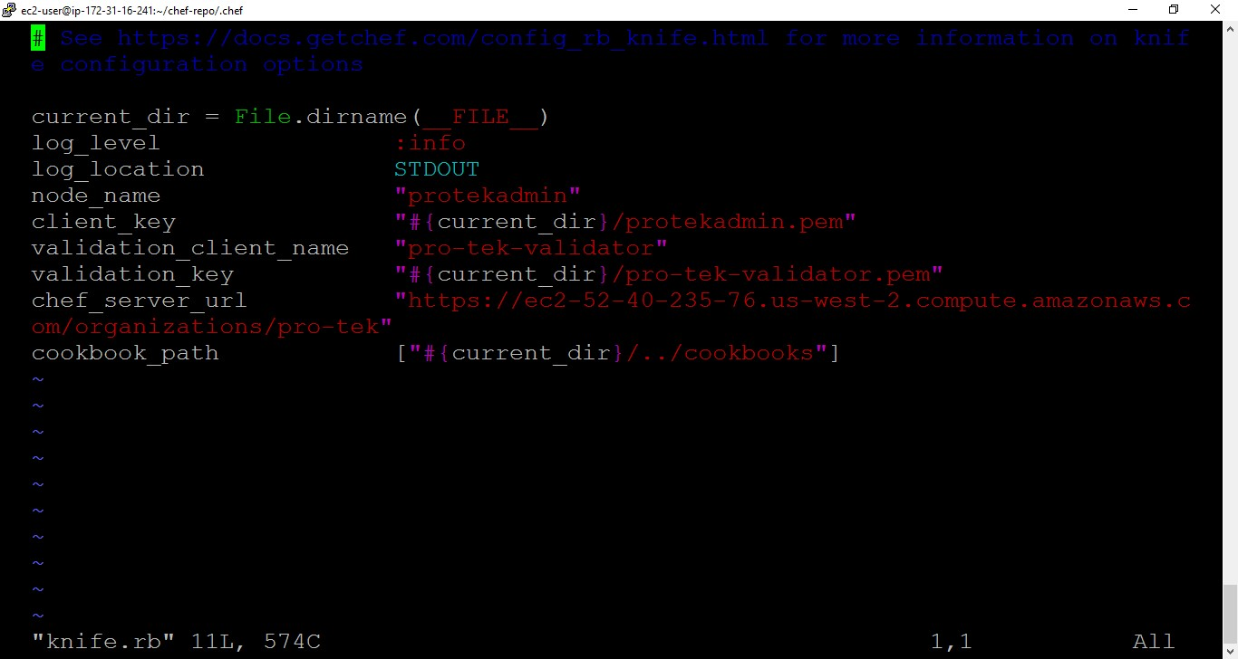

Installing chef to run knife commands:

* + - sudo curl -L https://www.opscode.com/chef/install.sh | sudo bash

Fetching SSL certificate from the chef-server

* + - knife ssl fetch
    - knife ssl check

Test the connection to chef-server

* + - knife client list

(Shows the organizations associated with chef-server)

1. Managing the nodes

Create nodes that need to be managed: I have taken Amazon Linux server as my node here. (t2.micro type instance)

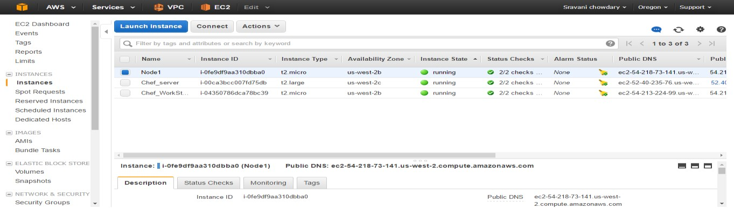

Create cookbooks to manage the node

* + knife cookbook create sample
  + cd /chef-repo/cookbooks/sample
  + cd recipes
  + sudo vim default.rb

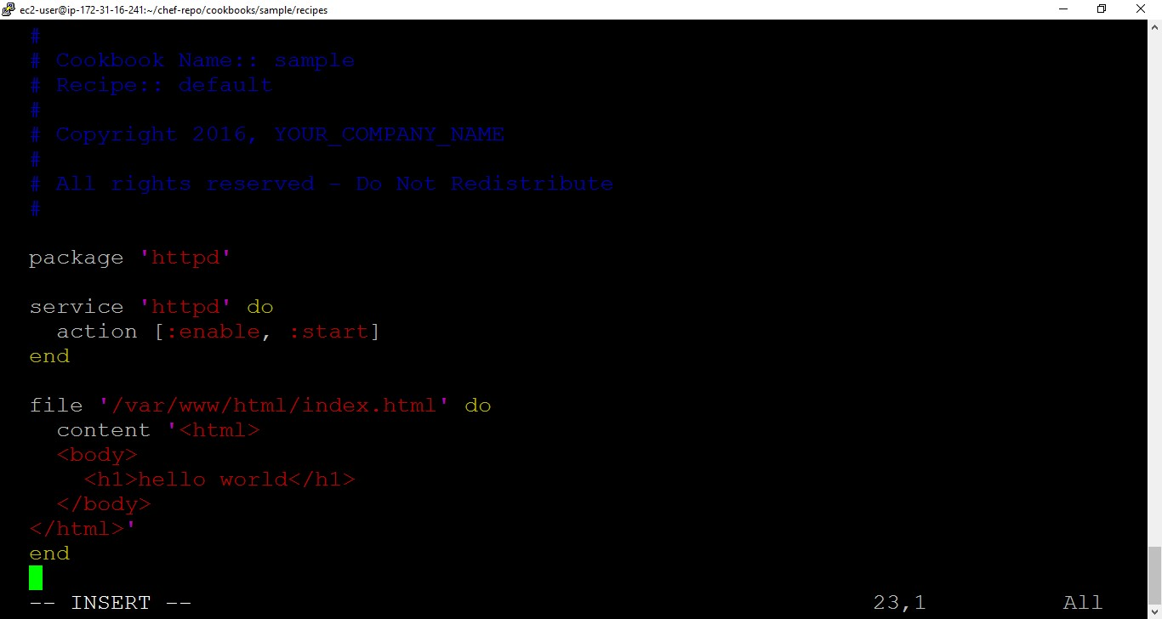

* + knife cookbook upload sample
  + knife cookbook list

(To see all the uploaded cookbooks)

The chef management console provides us with a detailed information of all the uploaded cookbooks under the policy.

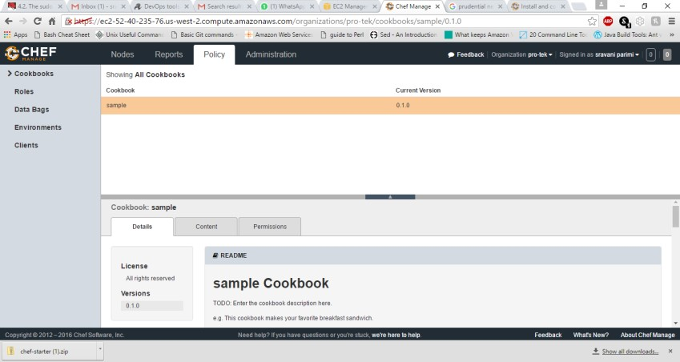

Bootstrap the node

* + knife bootstrap 54.218.73.141 --ssh-user ec2-user --sudo --identity-file ~/.ssh/AWSPublicKey.pem --node-name node1 --run-list ‘recipe [sample]'

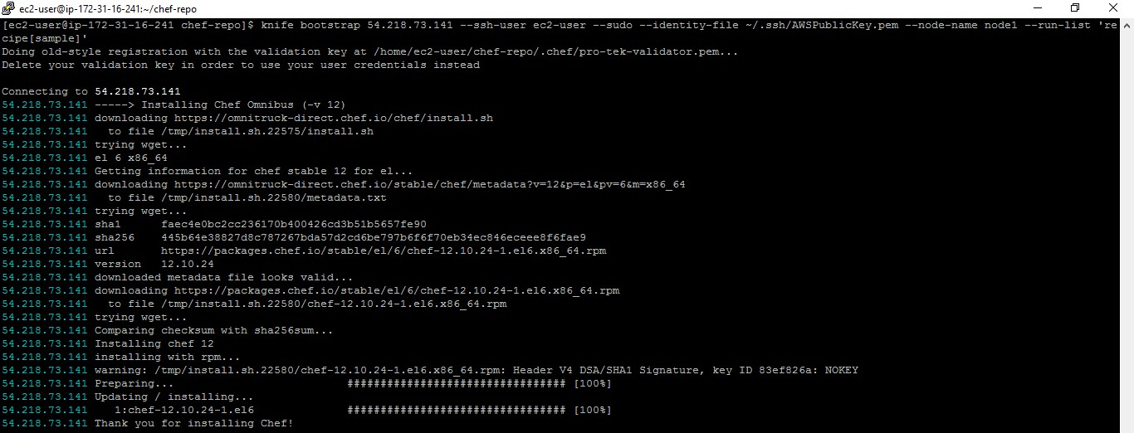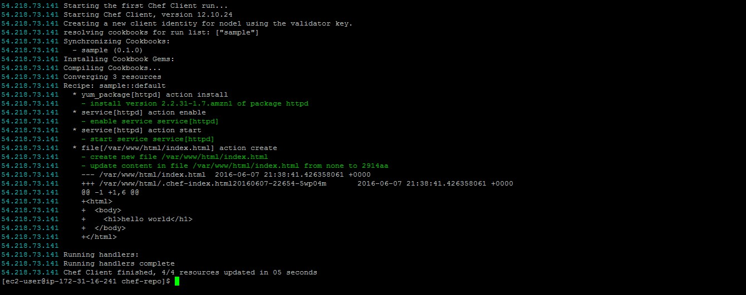

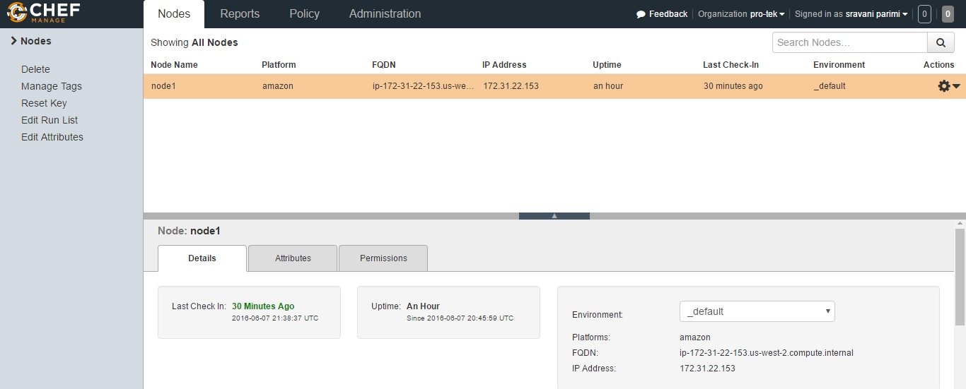

This is the output when the node is launched on the web server (Make sure to open the http port for the node to launch)

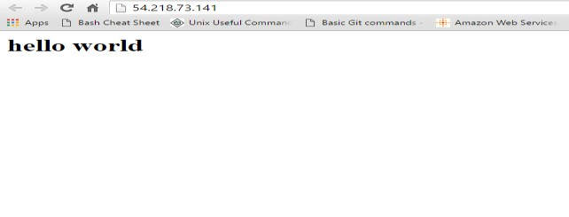

***Enable chef-client auto check:***

Run these command in Chef Work Station

* + cd chef-repo
  + sudo mkdir -p /etc/chef
  + Knife configure client ./
  + cd ~
  + sudo cp client.rb /etc/chef
  + sudo cp validation.pem /etc/chef
  + knife node show node1
  + knife ssh 54.218.73.141 'sudo chef-client' --manual-list --ssh-user ec2-user --identity-file ~/.ssh/AWSPublicKey.pem
  + knife ssh 54.218.73.141 'sudo chef-client -d -i 300 -s 13' --manual-list --ssh-user ec2-user --identity-file ~/.ssh/AWSPublicKey.pem

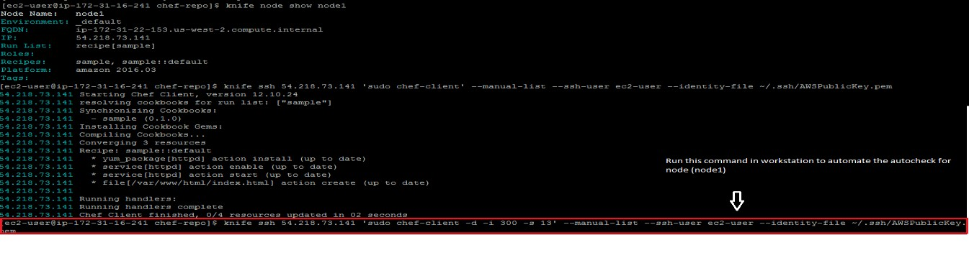

***Validation:***

Tracking the results after enabling auto-check on node1

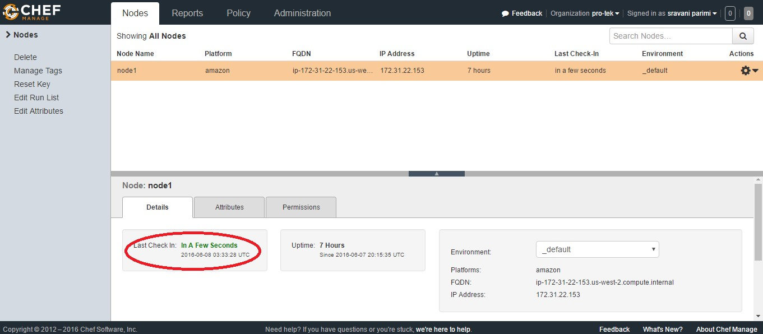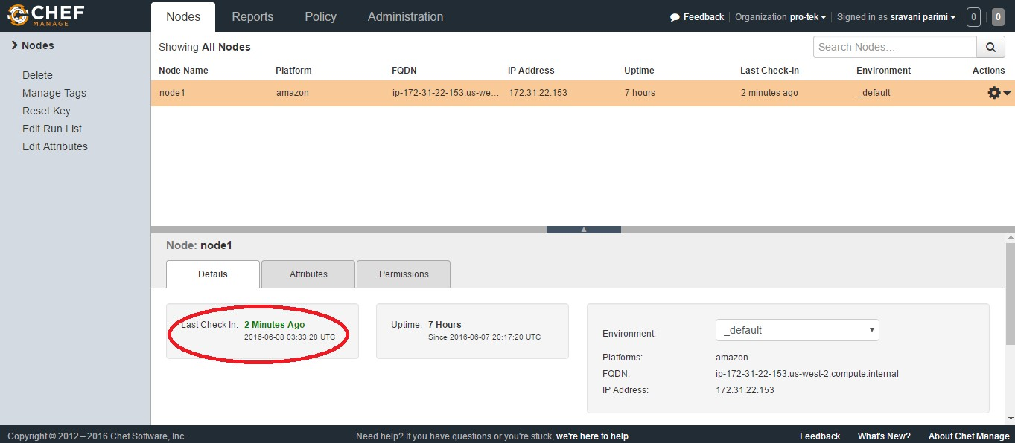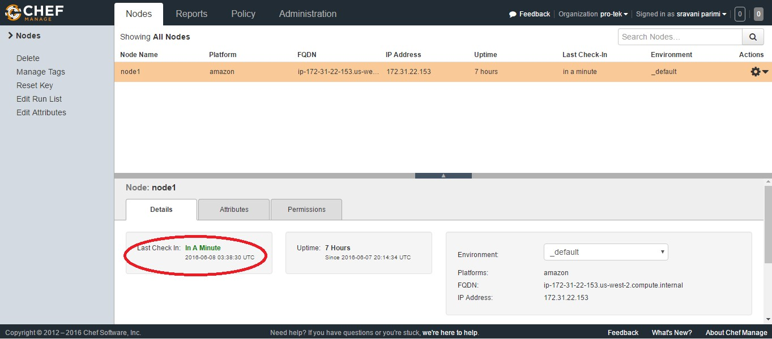

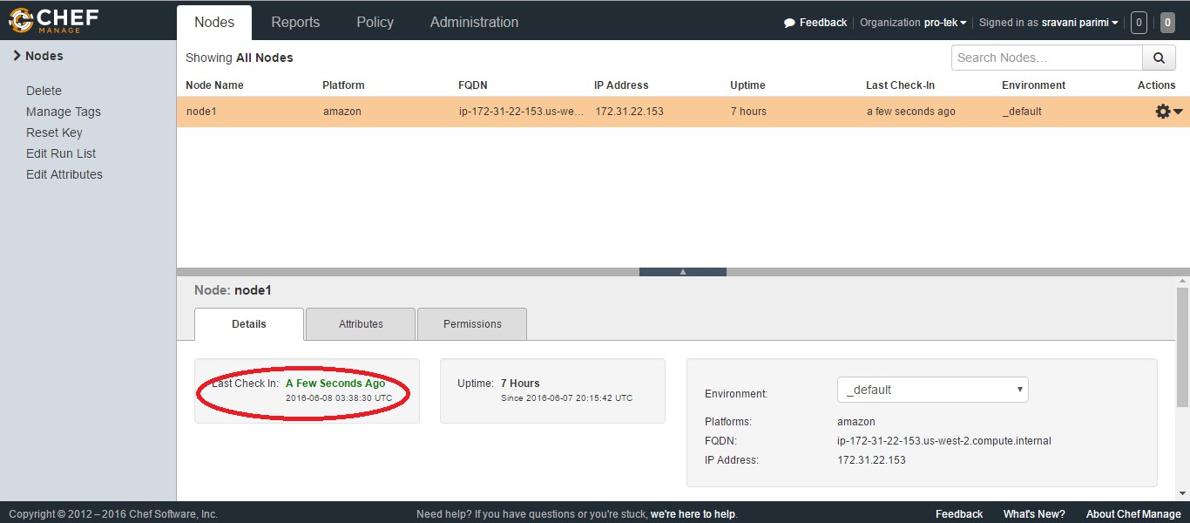

The detailed report of the node management can be viewed in the Chef Management console under the Reports tab by selecting Dashboard/Run history options on the left bar.

