**VPC with a public and private subnet, a manually configured LAMP instance in the private subnet, and a publicly accessible Elastic Load Balancer in the public subnet**

Lucid chart: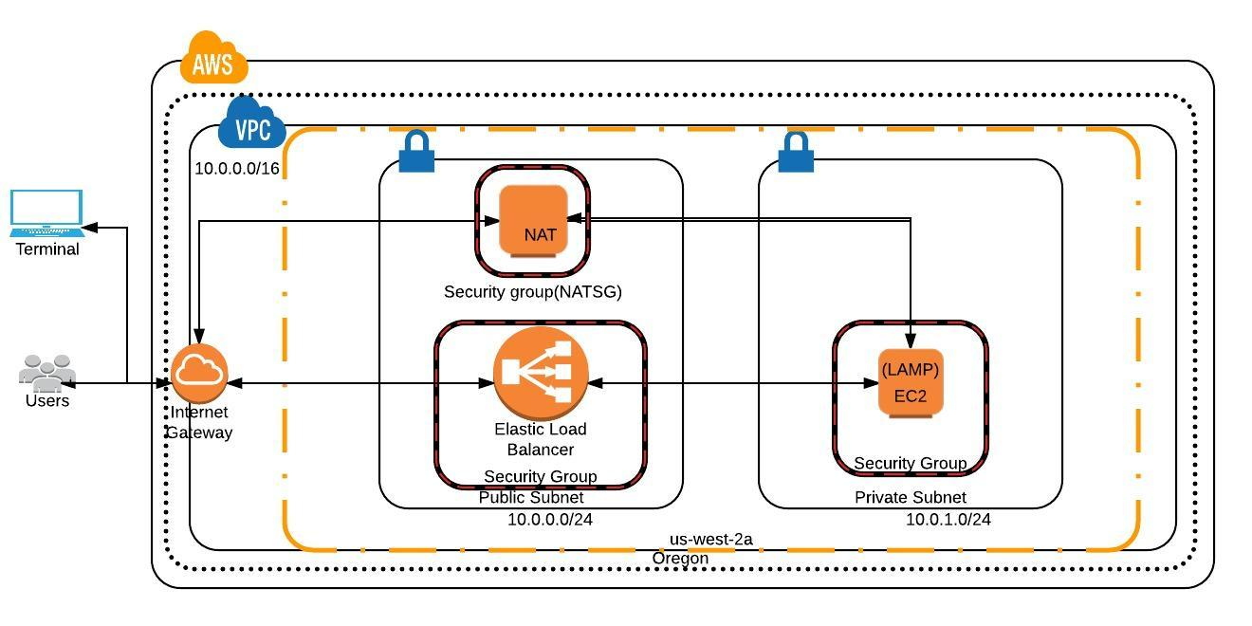

1. Create a Custom VPC (10.0.0.0/16) with private (10.0.1.0/24) and public (10.0.0.0/24)
2. launch an instance in the private subnet (10.0.1.0/24) and choose the security group created for instances in private subnet
3. Since we have the instance is in private subnet, we need NAT (Network address translation) instance in order SSH into this instance from our terminal to install LAMP manually.

* Launch an instance using NAT AMI (amzn-ami-vpc-nat-pv-2014.09.1.x86_64-ebs - ami-030f4133) from AWS Market place community AMIs in the public subnet to run as a NAT instance.
* Ensure to attach a security group (NATSG) to NAT instance with inbound rules HTTP, HTTPS, SSH for private subnet IP 10.0.1.0/24 and outbound rules HTTP, HTTPS.
* Select the NAT instance, go to Actions 🡪 Networking 🡪 Change Source/Dest. Check 🡪 Click Yes, Disable.

1. Launch an EC2 instance in the private subnet 10.0.1.0/24 and ensure that instance security group includes an inbound rule that allows SSH access from your NAT instance's private IP and allow HTTP rule from NATSG.
2. Add route to the private subnet 0.0.0.0/0 with destination as NAT instance
3. Connect to the NAT instance using putty
4. Now connect to the instance created in private subnet from the NAT instance by using its private IP address

* Transfer the .pem file (public key of the instance) to NAT instance using WinSCP and place it /home/ec2-user/.ssh directory
* Give permission to the .pem file : chmod 600 AWSPublicKey.pem
* Connect to the private instance : ssh –v –i AWSPublicKey.pem ec2-user@ ec2-54-149-210-105.us-west-2.compute.amazonaws.com

1. Now we are inside the private instance. Install LAMP manually by executing these steps

* sudo yum update –y
* sudo yum install -y httpd24 php56 mysql55-server php56-mysqlnd
* sudo service httpd start
* sudo chkconfig httpd on
* sudo echo "<?php phpinfo(); ?>" > /var/www/html/phpinfo.php
* sudo service mysqld start
* sudo mysql -u root mysql (to access the database)

1. Create Load Balancer

* Create a Load Balancer with the custom VPC (10.0.0.0/16). Under Select Subnets, select the public subnet (10.0.0.0/24).
* Select the existing security group created for the instances in public subnet.
* In the Step 4, make sure that the Ping target is TCP: 80 and keep the default values for the other configuration.
* Add the EC2 (LAMP) created in the above steps which is in the private subnet (make sure that they are in the same availability zone) and create the Load Balancer.
* After the instance attached to this Load Balancer becomes InService, we can be able to see the Apache Test Page on the browser using the DNS or the A Record of the Load Balancer.

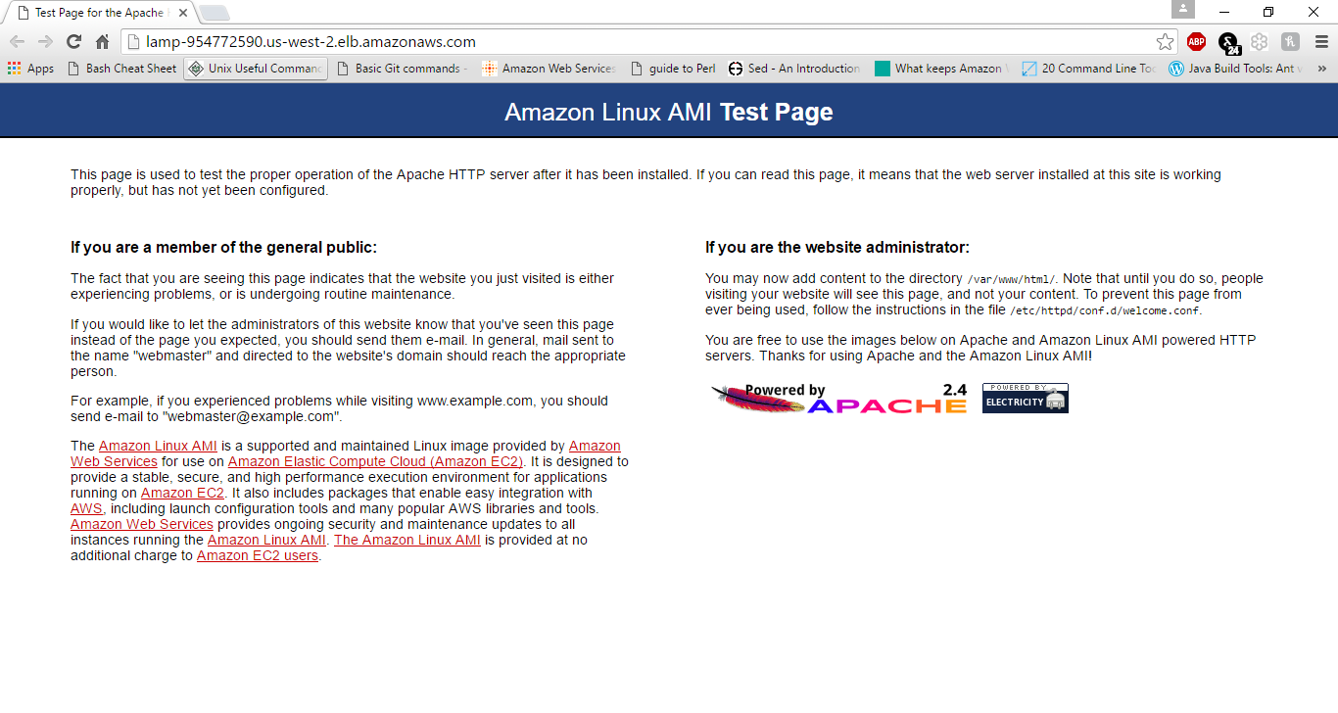

* Load lamp-954772590.us-west-2-elb.amazonaws.com/phpinfo.php on the web browser

