**Create VPC with a public and private subnet, a Bitnami Wordpress instance in the private subnet, and a publicly accessible with Elastic Load Balancer in the public subnet**

Lucid chart:

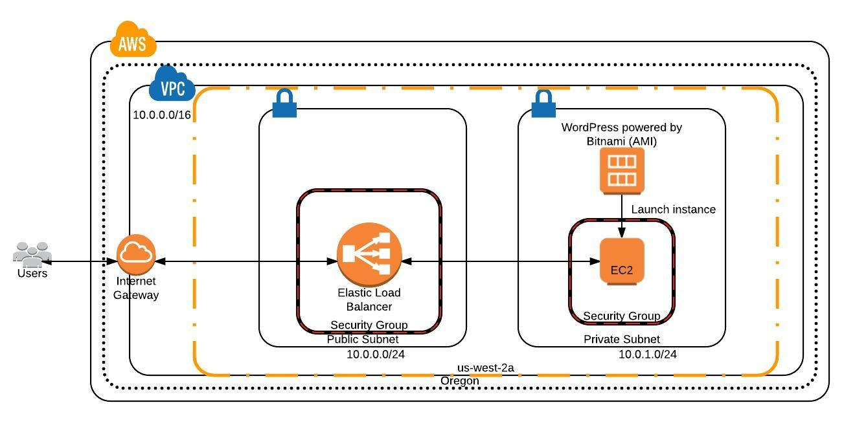

1. Create a custom VPC with a public and private subnet

* Create a virtual private cloud (VPC) of size /16 with CIDR: 10.0.0.0/16
* Create a public subnet of size /24 with CIDR: 10.0.0.0/24 and a private subnet of size /24 with CIDR: 10.0.1.0/24
* Create Internet Gateway and attach it to the VPC created in the above steps
* Create a Route Table for this VPC and add the Internet Gateway (0.0.0.0/0) under the Routes. Also associate the public subnet to this route table under subnet associations.
* The private subnet uses default route table (or Main route table) generated while the VPC is created which does not have the internet connection but to make sure associate the private subnet to the Main Route Table.
* Create a security group in this VPC with HTTP, HTTPS under inbound rules for the instance in the public subnet or ELB in this case
* Create another security group in this VPC with HTTP, HTTPS under inbound rules for the instance in the private subnet.

1. Launch EC2 instance (using WordPress powered by Bitnami AMI from AWS Market Place) in the private subnet (10.0.1.0/24). Choose the security group created for instance in private subnet while launching.
2. Create Load Balancer

* Create a Load Balancer with the custom VPC (10.0.0.0/16). Under Select Subnets, select the public subnet (10.0.0.0/24).
* Select the existing security group created for the instances in public subnet.
* Make sure that the Ping target is TCP: 80 and keep the default values for the other configuration.
* Add the EC2 created in the above step which is in the private subnet (make sure that they are in the same availability zone) and create the Load Balancer.
* After the instance attached to this Load Balancer becomes InService, we can be able to see the Home page of the WordPress (bitnami) instance on the browser using the DNS or the A Record of the Load Balancer.

