Payment Gateway Integration :

Overview :

Payment gateway integration is the merchant doing the payments using a payment gateway simulator. In this, I have created two microservices, like a payment gateway simulator and a merchant. The payment gateway simulator API here provides a set of endpoints to manage merchants and payments in a simulated payment gateway system. This API allows users to perform operations such as registering merchants, adding payments, and retrieving the payment status based on the payment ID.

Code Flow :

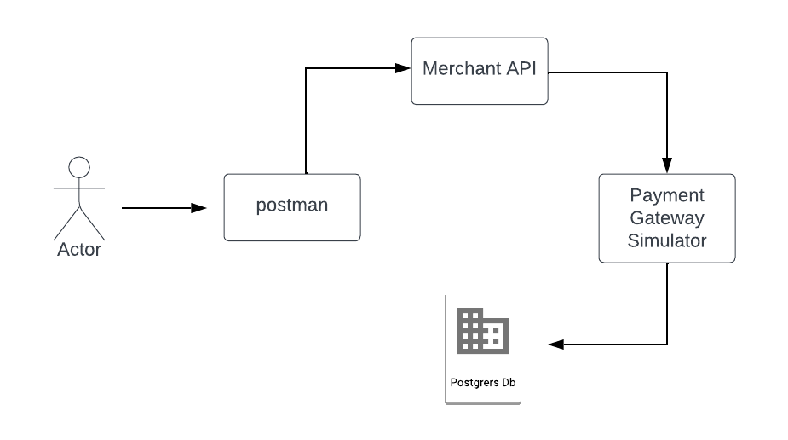

Project Structure :

Merchant Application
- Controller
  - Merchant Controller
- Service
  - Merchant Service
- Model
  - Merchant
  - Payment
  - PaymentGatewayRequest
  - PaymentGatewayResponse
  - CheckPaymentStatusResponse

Payment Gateway Simulator
- Controller
  - PaymentGatewayController
- Service
  - PaymentGatewayService
- Dao
  - PaymentGatewayDao

- Model
  - Payment
  - Merchant
  - CheckPaymentStatusResponse
  - MerchantPaymentRequest
  - MerchantPaymentResponse
- Database interaction
  - Payments Table
  - Merchant Table

Prerequisites :
- Software Requirements
- Java
- Maven
- Spring Boot
- Databased(Sql Developer - postgresql)
- Postman(for Testing)

- Database Setup

Create a database schema and a user with appropriate privileges. Create a payments table and a merchant table based on the requirements.

- Environment Setup
Create the project repositories from the extracted zip files provided. Please make sure you have the required project files and dependencies.

Project Setup :

Create Spring Boot Projects

1.Merchant Application
- Create a new spring boot project using the spring initializer or preferred IDE.
- Add the required dependencies (spring web, spring dev tools).

2.Payment Gateway Simulator Application
- Create a new spring boot project using the spring initializer or preferred IDE.
- Add the required dependencies for web development and database integration.(spring web, spring dev tools,postgresql,jdbc driver)

Maven Configuration :
The pom.xml files in both projects have the necessary Maven dependencies, including spring boot starter web,spring boot starter data-jdbc, and postgresql (only if required database-related dependencies).

Database Configuration :
Configure the database connection in the application.properties (or application.yml) files for both applications. Specify the url, username, and password (port if connecting to the other application).
Example :

Url : jdbc:postgresql://localhost:5432/your_database_name
Username : db_username
Password : db_password

Overview of Payment Gateway Integration Project

1.Payment Gateway Simulator Application

Payment Gateway Controller: It is designed to handle HTTP requests related to managing merchants and payment gateway simulations system.It interacts with a service layer (PaymentGatewayService) to perform various operations related to registering merchants, retrieving merchant information,processing payments, and retrieving payment status based on the payment ID.

Payment Gateway Service: It is designed to handle the merchant and payment related operations.This Service is integrated with a database to perform various tasks related to merchant management and payment processing.here i created the add merchant, get all merchant details,add payments,get all payment details and get payment status based on payment id method for returning the payment status of the particular payment id. This Service layer takes data from the Dao layer and gives it to the controller.

Payment Gateway Dao : It is a Java component designed to interact with a database for handling merchant and payment related operations. This layer is a crucial part of the payment gateway simulator,responsible for the database communication.It is designed to provide efficient and reliable database interaction for the application. For this Dao layer

Payment Gateway Model : In this Model i have created the Payment id request ,response, merchant, payment and payment status models.In this we can create the instance of the model class. Use the constructor with parameters to initialize the required attributes, and then use the getters and setters methods to access or modify the attributes information as needed.

2.Merchant Application

Merchant Controller : Merchant Controller is a part of Merchant Applications and it provides RESTful API endpoints for various operations related to merchant and payment gateway applications.It describes the overview of the available endpoints and their functionality.It interacts with service layer(Merchant Service) for getting information from Payment Gateway Simulator micro service and it will give data from the merchant end.

Merchant Service : It is designed to handle the url for the payment gateway service using REST API calls.Using resttemplate with http status codes we need to call the other service operations like registering the merchant , processing payments and checking payment status.i have created the payment id generated method for generating the payment id with some alphanumeric string it will return while doing the payment.

Merchant Service Models : In this Model i have created the Payment id request ,response, merchant, payment and payment status models.In this we can create the instance of the model class. Use the constructor with parameters to initialize the required attributes, and then use the getters and setters methods to access or modify the attributes information as needed.

Thanks

