ASSIGNMENT-06

1. Construct LR(0), SLR(1), LR(1) parser and LALR(1) parser for following grammar

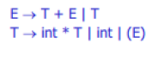

1. Construct LR(0), SLR(1), LR(1) parser and LALR(1) parser for following grammar

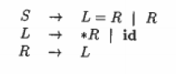

1. Construct LR(0), SLR(1), LR(1) parser and LALR(1) parser for following grammar

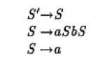

1. Construct LR(0), SLR(1), LR(1) parser and LALR(1) parser for following grammar

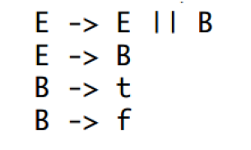

1. Construct LR(0), SLR(1), LR(1) parser and LALR(1) parser for following grammar

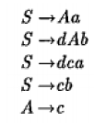

1. Construct LR(1) parser and LALR(1) parser for following grammar.

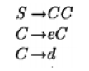

1. Write about the conflicts occurred in LALAR(1) parser.
2. Construct LL(1) , LR(0), SLR(1), LR(1), LALR(1) parse tables for following grammar.

And check which type of grammar it is.



1. Check the following grammar is operator grammar or not. If not convert it into operator grammar.



1. Construct LR(1) parser and LALR(1) parser for following grammar.

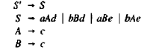

1. Write an algorithm to construct LR(1) parse table
2. Write an algorithm to construct LALR(1) parse table
3. Write an algorithm to construct SLR(1) parse table
4. Write an algorithm to construct LR(0) parse table

.