CRUD Operations:

Requirement:

1.signup – name, email, phone number, password (backend API)

Link to login (frontend)

2. SignIn – JWT Token , access (Backend)

Forgot password link, new member register link (frontend)

3. settings: profile (User can change name, phone number, add address), logout

4. Dashboard – Products needs to display

- Add products, update products, delete products (backend, frontend)

Filter products, search products

If product is out of stock, display as out of stock

Click on product display product details, price, availability, add in cart

Below buy option

If user clicks on buy then needs payment integration, can get the address which is saved

And also needs to ask to add address

If buy then print the user details, buyed product details in pdf format

And create tracker for the order

5. needs to display all orders in orders tab

This application

Signup Entity

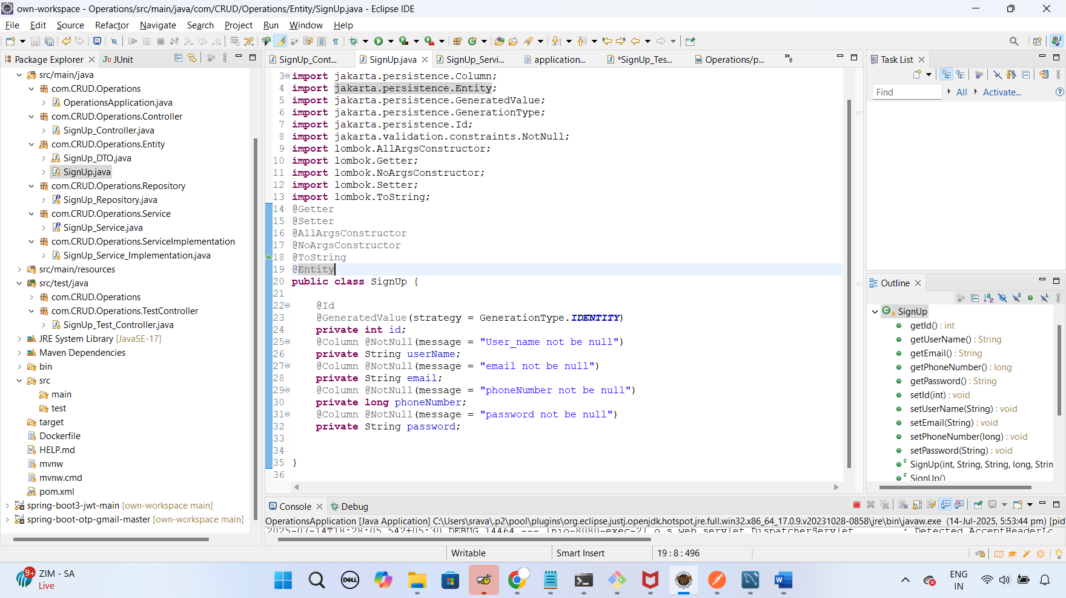

SignUp Repository to save the signup data in database

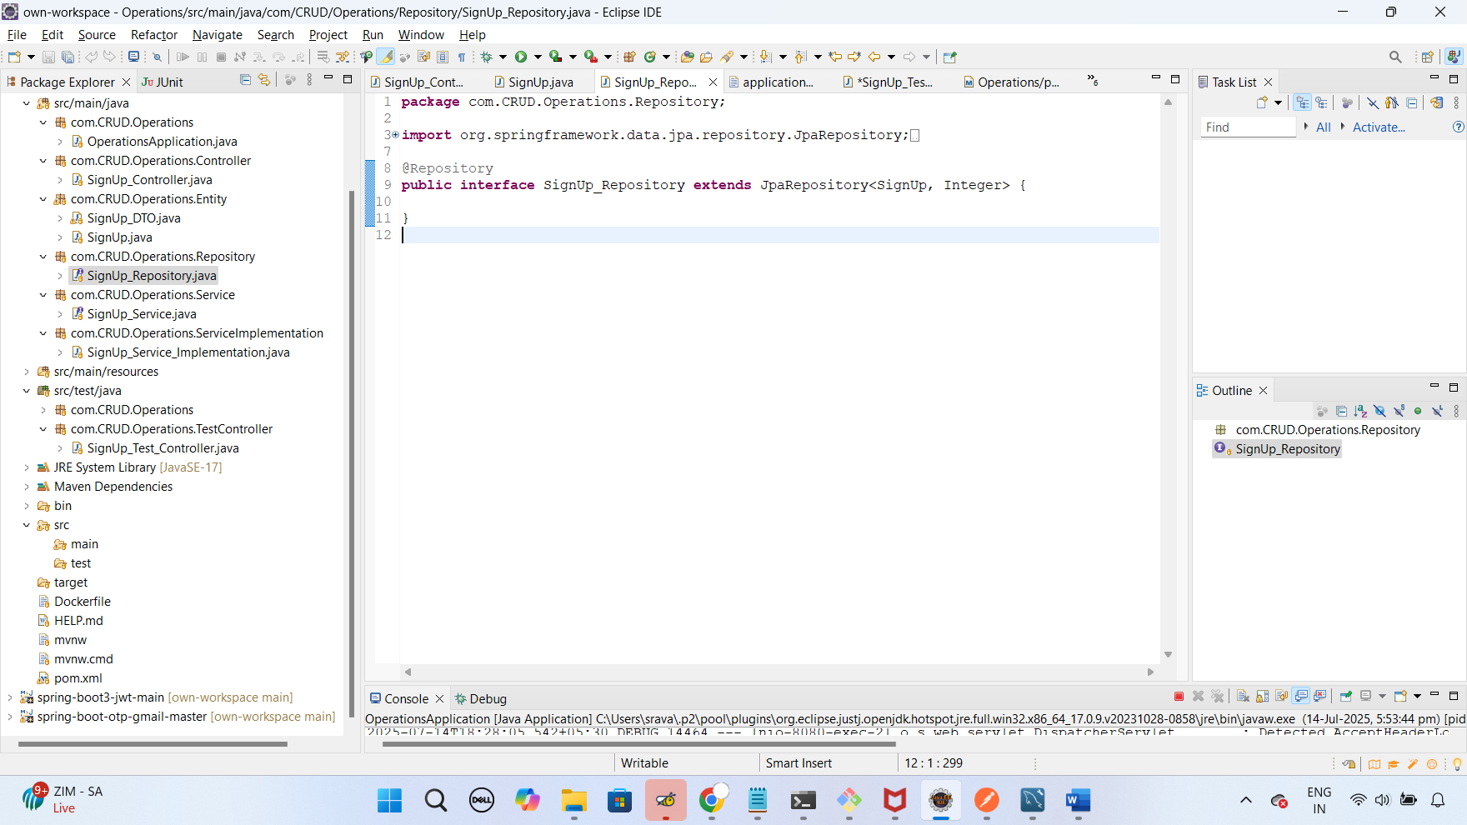

Application properties to connect the database URL, name, pswd

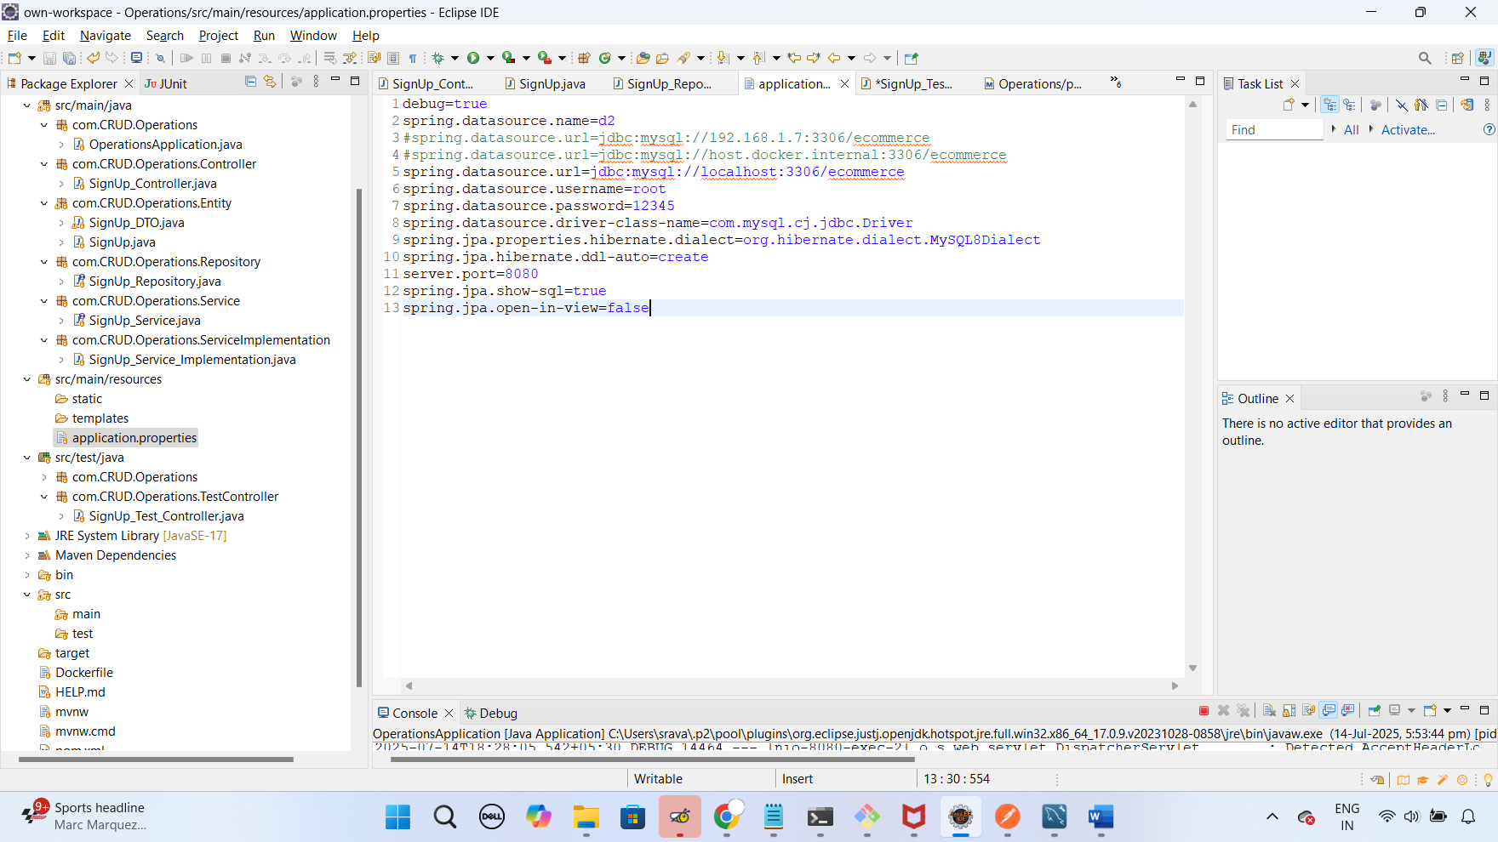

Signup Service interface to add a method

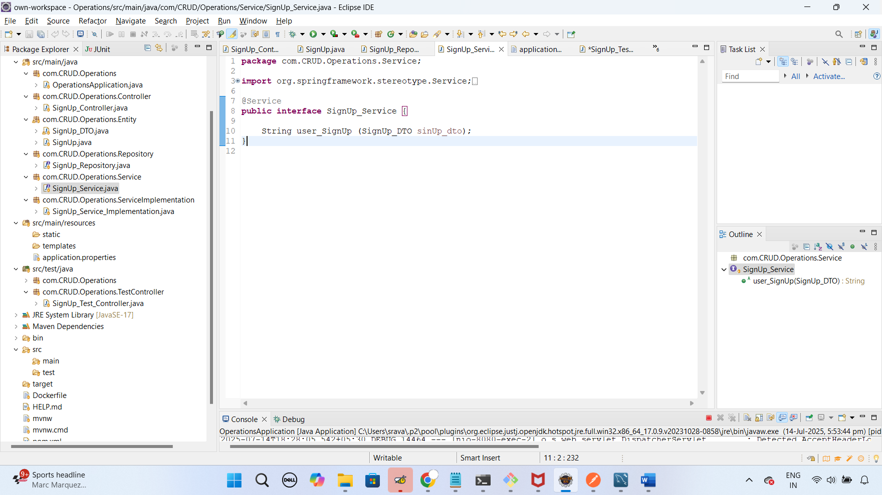

signUp Service Impl to write a logic,

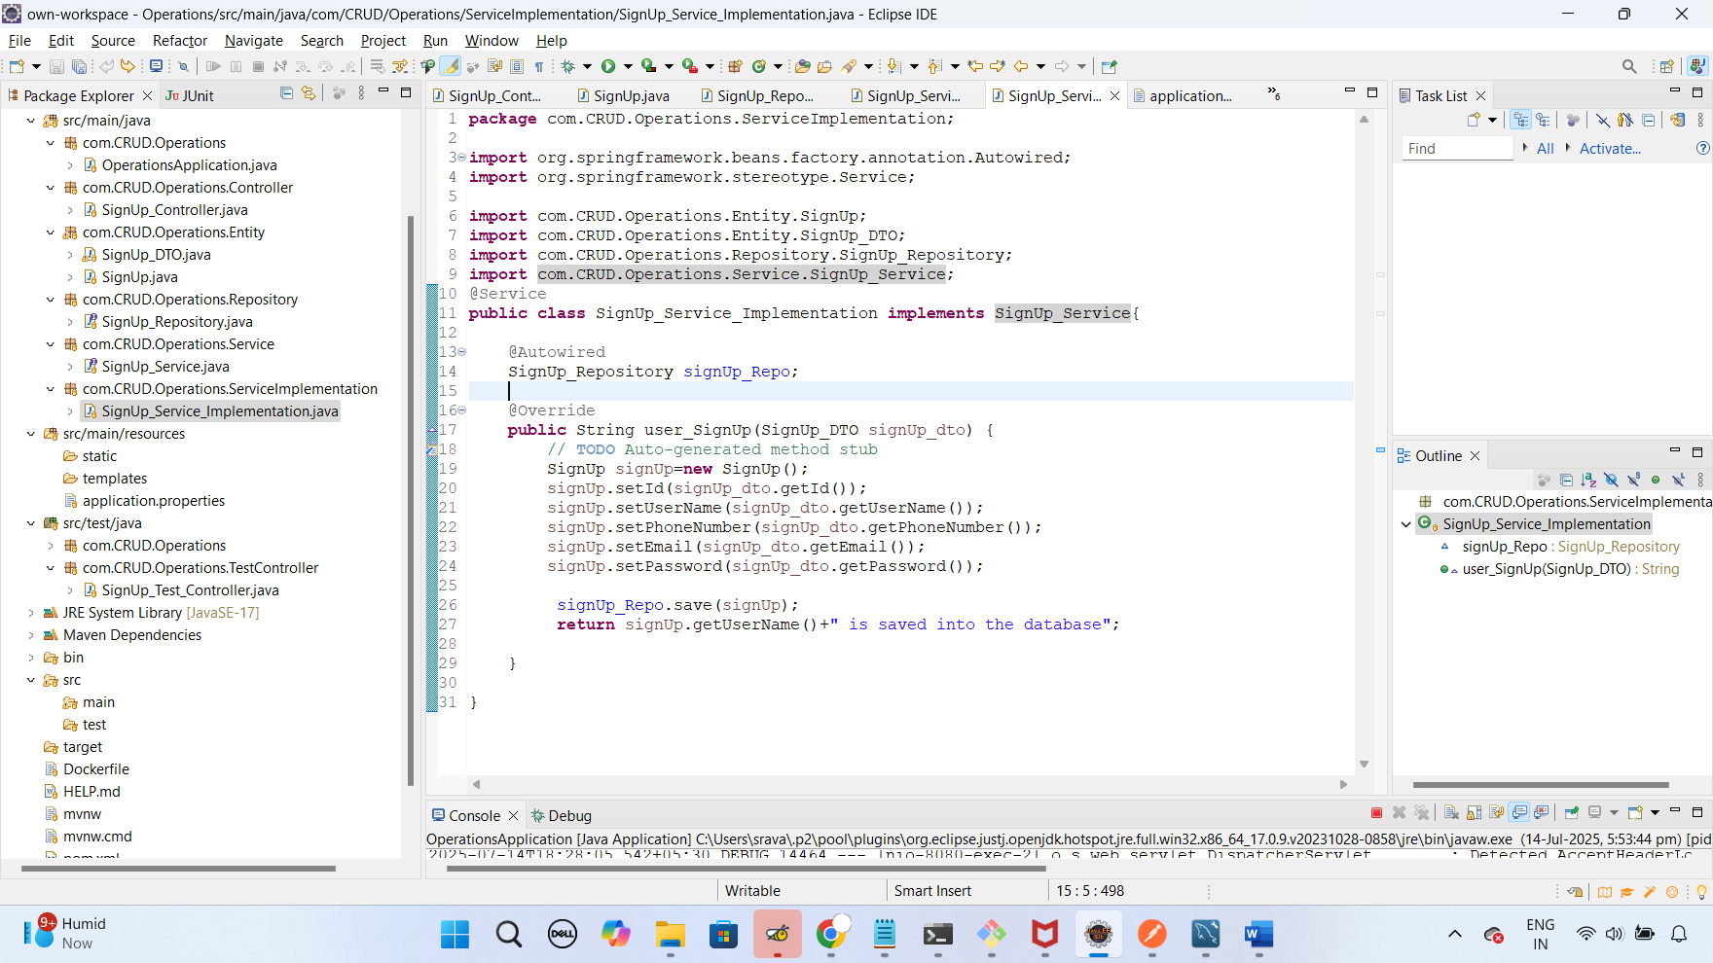

Signup controller to create restAPI’s:

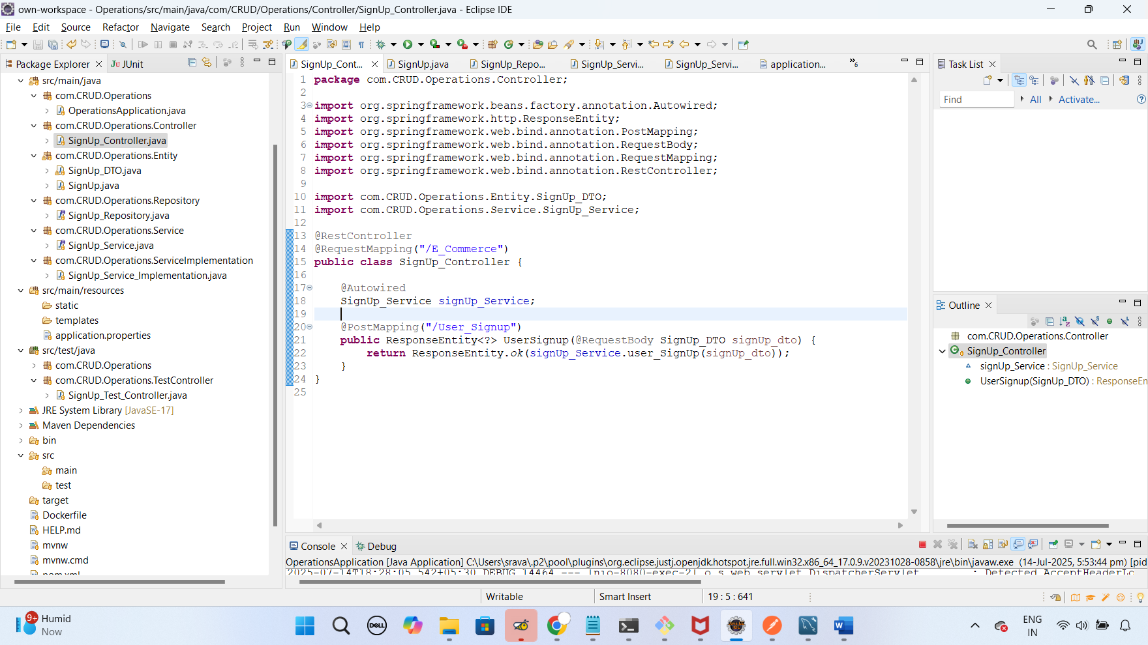

Run the application, then it will go to the repository to create the entities(tables) in database, then loads the method to create data, after that execute the rest api’s in postman,

If user signup’s with their data, then it will saves into the database, for login. It will display in postman as below:

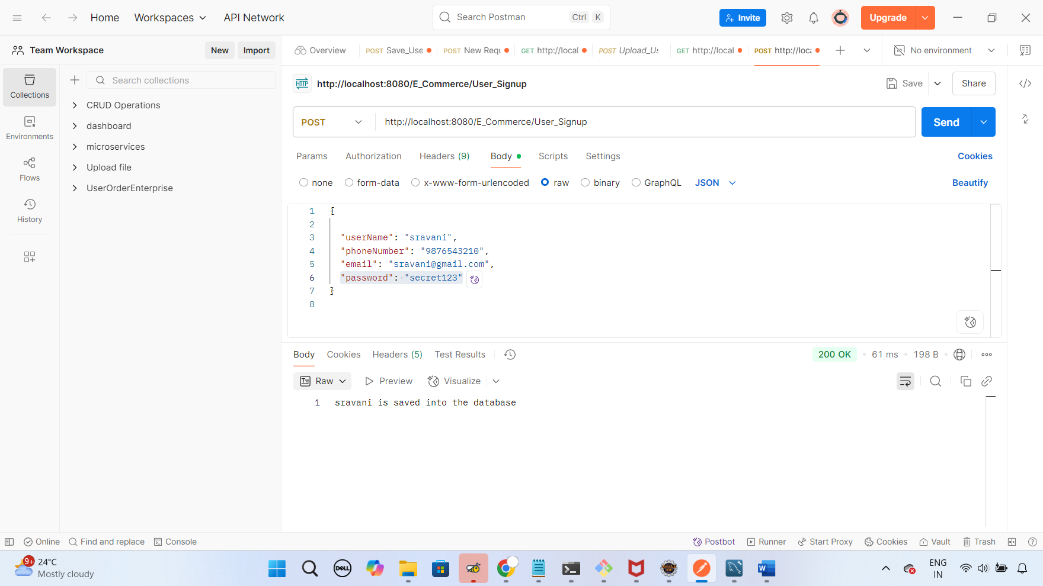

If phone number, user name, email already exists then duplicate data will not be entered into database, it needs to display message like below

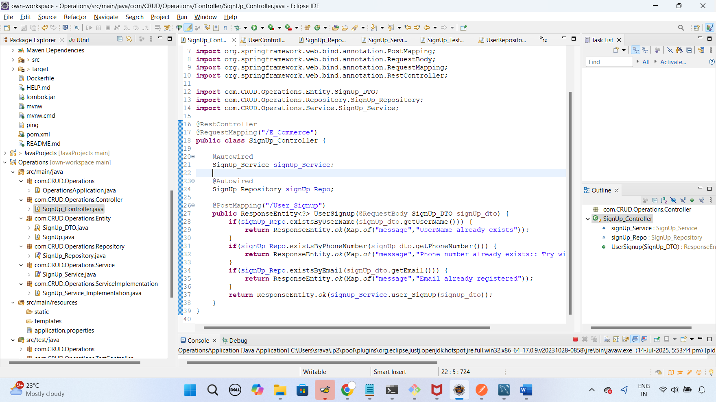

In postman:

