Table of Contents
Table of Contents 2
Introduction 3
Case Study 3
Architecture 3
MVC 4
Frontend: 4
Key Features 4
1. CRUD Operations 4
2. Search Functionality 5
4. Web Interface 6
5. Database Management 6
7. Data Validation 6
Requirements Analysis 6
Non-Functional Requirements: 6
Folder Description 7
GITHUB 7
Future Consideration 8

Introduction
The Employement management is an application that is implemented on Nodejs environment to manage employees in an organization. This application has features which helps the employer to manage employees and has proper authentication system with password hashing. This application has been created in html, css as a frontend technology and Nodejs, mongodo db as backend technology. This application considered multiple ways to manage database like it integrates the sorting feature to sort the employees on the basis of name, last name, email, salary and date which helps the users to find out the employees quickly. This application has searching functionality to helps the employers to find out the employees quickly. This application also implemented a CRUD operations which stands for create, read, delete and updation of an app.

Case Study
There are so many firms and organization which face difficulty in managing users and data over database but our application helps the organization in managing employees in a perfect manners like employees not only managed on database but also can be created, updated and deleted. This application implemented on the basis of CRUD operation which helps the user to create, read, update and delete and employees in a database. User can manipulates the data more easily. All emloyees when created can stores with a creation date like on which data they have been created.

Architecture
The application implements reusable components for header and add employee sections which reduces the repetitive coding within various web pages. The development process becomes more efficient by dividing the user interface into specific components for individual responsibility. Such an architectural also helps in better code organization and element reuse mechanisms that prove exceptionally beneficial during application growth and complexity increases. The structure works with current web development standards because it helps developers organize their code functions independently while keeping projects easy to maintain.
Backend:
Backend comprised of main frameworks which is MongoDB and Nodejs which helps in creating a web application in more structured and modular way.
If we talk about server part which plays an important role on web browser and for that we have user express library over NodeJS. It also works locally and dynamically.
We have used a modular structure which also consider as industrial structure known as MVC which stands for models, views and controller. Views contains a ejs templates, model contains a database schema and controller contains core functionality of application. This structure helps in creating a scalable application
MongoDB library based on Mongoose which helps in creating a database, tables and fields in an database. This library or plugin can be integrated on nodejs platform easily by running npm. This library we can create multiple schemas and models which can be further used to manage users and various fields.

MVC
The application functions based on MVC known as model, views and controller architectural rules while also helps in code clarity and understanding. In this structure:

- The Model functions to design and handle database management operations for storing employee data.
- The View presents interface pages consisting of the homepage as well as the update and delete pages which users can access.
- In the Controller section stands the main unit which connects front and backend components while enabling data handling functionality.

Frontend:

This frontend comprised of three HTML, CSS and Javascript which helps in creating a tempaltes of an webapplication more easy and attractive way.
HTML has been used to create stuctural pages with basic designing whereas CSS has been used to stylize the pages in more advancing ways.
Javascript has been used to do API calls with backend and frontend in which any manipulation done on backend can be done through javascript with the help DOM stands for document manipulation.
Below is the image of frontpage in which shows the basic view of an web application.
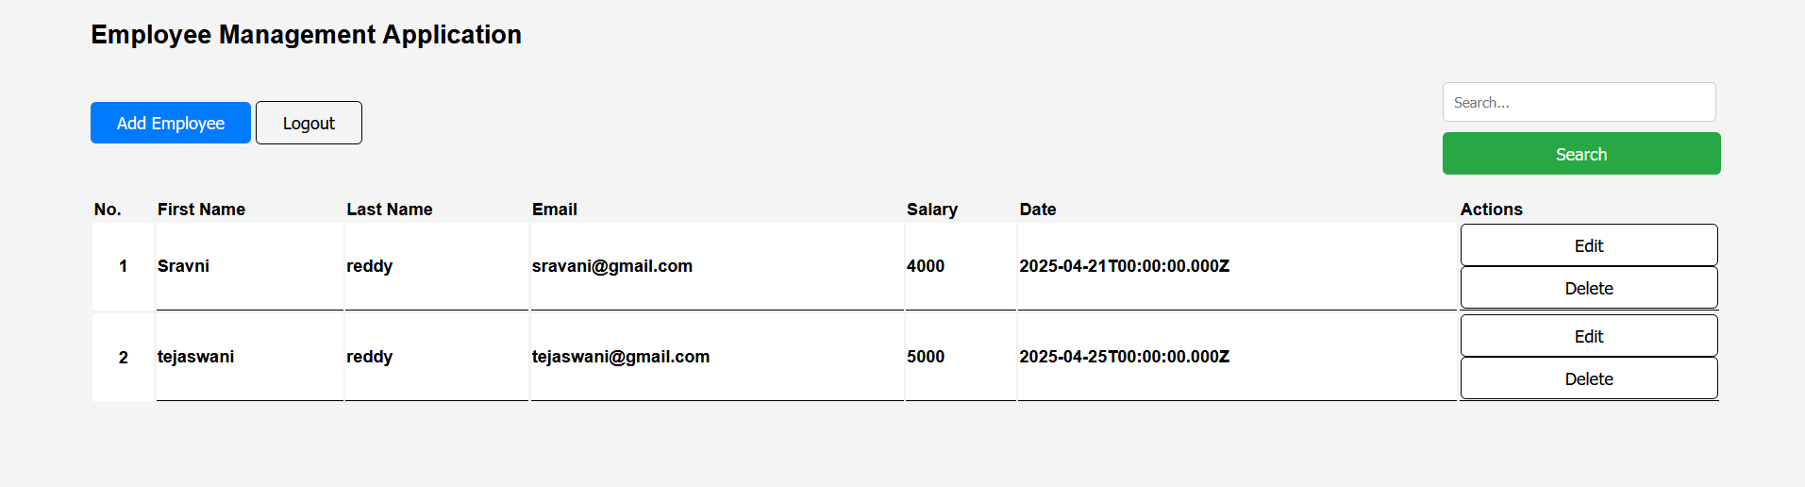
FrontPage(HTML,CSS and javascript)

Key Features

1. CRUD Operations
- Create: Add new employees with basic details like first name, last name, email, salary, date.
- Read: This operation has been done to read all data from tables within database such as employees fetching from employees tables to show on front page which can be further used to manipulate.
- Update: Update operation can be used to reedit the employees to correct the details of it for that PUT method has been used in database.
- Delete: This operation has been used to delete the employees from employees table who are not required.

2. Search Functionality
The application integrates a search function that helps to locate personnel using first name and last name data or email contact, salary and date information. Employee search becomes faster when we input the required information into the application which generates immediate matching results as we are sorting on frontend only.
The application allows users to sort their search results similar to how names can be arranged from A to Z order.

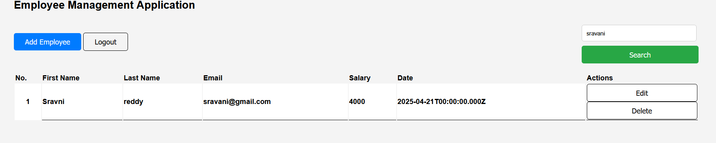
Searching a user on a page
3. Restful API
API configured for external integrations.
- router.get('/',loginPageRender); : This route renders a login page
- router.post('/login',login): This route is used to authenticate user to open login page
- router.get('/homepage',homePageRender): This route renders homepage
- router.get('/register',registerPageRender): This route renders a register page
- router.post('/register',register) : This used post methods to add new user in register table.
- router.get('/fetchemployees',fetchEmployees): This used get method to fetch all the employees from a employees table.
- router.post('/addemployee',getEmployees): This method is used to add a new employee in employees table
- router.put('/updateemployee',updateEmployee): This method uses put method to update a employee in an employees table.
- router.delete('/deleteemployee',deleteEmployee) : This method is use to delete a employee which is not required.
- router.get('/search/:id',searchFunctionality) : This method helps in finding a user in a database.

4. Web Interface
The application places its pages in the views folder where they display content through the EJS template engine. The application divides customer viewing and adding functions from updating into individual folders for better organization. A clear layout structure exists throughout the application because the application uses reusable elements for header and footer sections.

5. Database Management
- Data manipulation like updating, creating, reading and deleting of data through MongoDB database
- Through database queries the application enables storing, updating activities and erasing information about employees. The application uses schema validation to verify correct and consistent data input at every opportunity.

7. Data Validation
A check system confirms the proper completion of employees details before storing on database. The application displays a validation error when important data fields remain empty. Email addresses need to match specific requirements by containing a proper format of “@” and finishing with “.com”. Also it checks if salary should be in number format, date to be in date format etc which is essential for an organization for a data flow.

Requirements Analysis

Non-Functional Requirements:

- Performance: The page avoids complete refreshes each time an event occurs through its current feature design. The software programming language communicates with the server to obtain data directly while displaying data results on the page. The page skips refreshing when errors occur and displays direct error messages that speed up user experience.
- Scalability: Vertical scaling is enabled on the application through its use of MongoDB database. The system maintains scalability because upgrading the server allows the database to store additional data and handle expanding user groups.
- Structure: The application implements an MVC framework in its design structure. The application stores its all frontend pages within views while controller and model contain the main logic and define database structure respectively. Such organization enables smoother management of all elements.
- User Experience: A user-friendly interface characterizes this system. Users can access application details with ease through a seamless interface design which requires none of their efforts or confusion.

Folder Description
- app.js: This is the main part of the folder which integrates server functionality to run the server on specific port.
- Static: This folder stores all the frontend components like css stylesheets and javascript functionality.
- Views: This folder contains all the template files which displays on the browser
- Routes: This files contains a files where all the api end points exist which specific url
- .env.development: This file has been created to store database information, port information etc
- database.js: It contains Mongodb connection information to connect with the database which can be further use to data manipulation.
- Components: This folder consists of components of a templates which can be reuse again to complete the pages.

Folder structure is given below:
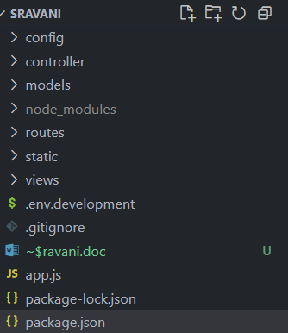

GITHUB

The project gets uploaded to GitHub by making commits which enable systematic saving of code changes through versions. Every commit logs which changes have been performed so development teams can track projects easily and identify authors of specific modifications.As this also suitable single developer to commit changes on github as it helps in both cases mutlipe and single as main objective is to know when changes has been made on github.

Future Consideration

- Employers can conduct faster searches through advanced filters along with full text functionality to find employees in the application.
- A login system together with permission control methods should be implemented to help authorized users access parts of the application platform.
- The system should use database indexing alongside caching to achieve search optimization and server load reduction because data growth occurs.
- The application will enhance data validation features to provide instant feedback for specific data cases while improving data accuracy during entry processes.

