Table of Contents
Introduction 3
Case Study 3
Architecture 3
Backend 3
MVC 3
Frontend: 4
Key Features 4
1. CRUD Operations 4
2. Search Functionality 4
4. Web Interface 5
5. Database Management 5
7. Data Validation 5
Requirements Analysis 5
Functional Requirements: 5
Non-Functional Requirements: 6
Folder Description 6
GITHUB 7
Future Consideration 7

Introduction
The Customer diary is an application that is implemented on Nodejs environment to manage customer details in an organization. It is simple and light weight app which integrates CRUD operations and some extra features like searching with sorting and validation of customer details. It integrates MySQL database which is based on oracle and it gives capabilities to users to search customers if in case list of customers are more. It uses HTML, CSS, and JavaScript for the frontend to interact with.

Case Study
In small scale organisation, they face difficulties in storing customer details such as their name, address, phone, and email address which is highly required to know which customers are taking services in an organization. To solve the problem of storing customer data we create a small app based on crud operations which is the base of web technology and it allows users to create, read, modify customer details, and delete them if not required anymore. But this app is not limited to crud as it also provides searching of users with their name, phone, email, and their address which comes up with sorted order.

Architecture
A component based or modular design approach is followed in this web which allows components such as Header, footer which can be reused every time when we create webpages. Each component handles a part of the user interface. This structure helps the developer to develop web pages on scalable basis as it does require much efforts to write code again and instead header and footer can be reuses.
Backend:
Backend comes with two main libraries in which one is for database mysql2 and express
Framework used in backend is NodeJS which integrates all libraries which is responsible for server creation
It follows MVC model, views, and controller structure to accomplish routes or API endpoint functionality
MySQL2 library based on oracle which is responsible for creating a database using structured query language in which user will create database using command line of MySQL and then do crud in server part.

MVC
MVC stands for model, view, controllers which is generally followed in many organized to make code simplified and easy so that file structure not be much compresses instead it is divided into small parts so that code can be readable and easy to manipulate. Controller consists of functionality or logic and views consists of files for frontend use like homepage, updatepage, and deletepage. Model is use to create different schemas of database.

Frontend:
- Frontend created with HTML, CSS, and JavaScript.
- API calls handle CRUD, search, and sorting operations.
- Dynamically displays results in the DOM (Document Object Model).

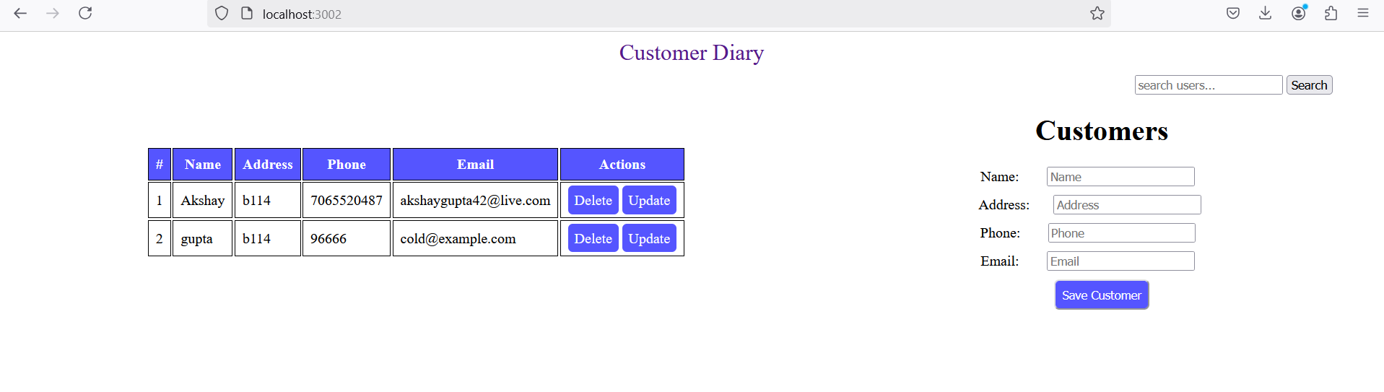
FrontPage(HTML,CSS and javascript)

Key Features

1. CRUD Operations
- Create: Add new customers with details like name, email, address, and phone
- Retrieve: Fetching of details of all the customers on the frontpage.
- Update: Modification or reedit the details of customers in case it forgotten.
- Delete: It allows users to delete the customer in an app.

2. Search Functionality
- It allows users to search customers bases on their names, email, addresses and phone.
- Sorting with searching allows customers details to come up in sorting order like we have used name in case of sorting
3. Restful API
- API configured for external integrations.
- Routes separated for each action:
  - /updateuser/:id: Updating or editing of customers
  - /delete/:id: Deleting of customers
  - /search/:id: Searching of customers
  - /add: Creating a new customer
  - /: Fetching of all customers on landing page.

4. Web Interface
- All pages are in views folder and uses a module called EJS
- view, add, and update customer are in separate folders and uses components as header and footer

5. Database Management
- Data storage and fetching information is done through MySQL based on oracle.
- Schema validation is present which ensures data consistency.
- It takes care of customer entry creation, deletion through queries.

7. Data Validation
- It checks for the customer details and if it is not present then throws validation error.
- Email must use a standard format which includes @ . com

Requirements Analysis

Functional Requirements:
- Customer creation: New customer can be added using post method and API endpoint
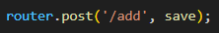
- Customer Updating: Allow users to reedit and modify customer details. It uses PUT method to update the details
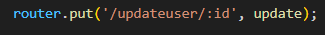
- Customer Retrieval: Users can view a list of all users using the GET method.
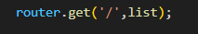
- Customer Deletion: Customers can be deleted based on their id using DELETE method.
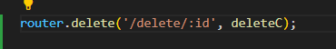
- Search: Customer can be searched by specific method GET /search/:ID


Non-Functional Requirements:
- Performance: As we are using post refresh feature in which our frontend directly not interacted with server but instead JavaScript will interact with server and fetch details. If in case error comes up then page will not reload or throws error instead error message will print on page and reduce the latency of the page.
- Scalability: Vertical scaling in there in this database as MySQL is structured database
- Structure: Structure includes MVC which stands for Model View controller in which we created pages in views folder and functionality or logic and controller folder and model is used to create database structure
- User Experience: Interface which is user friendly and can be interacted without much efforts by identifying details.

Folder Description
- app.js: This is the main entry point for the server in which server will start using a port
- Static: Stores the files in different subfolders such as CSS, HTML, and JavaScript
- Views: This contains EJS files for customer creation or updating and deleting.
- Routes: It defines a set of API routes for a set of the actions which is like to be performed.
- .env: It is created to store environment variables for the application setup such as port information
- database.js: It contains MySQL connection details to connect to a database.
- Components: This is another sub folder in views which consists of files such as header and footer

Folder structure is given below:
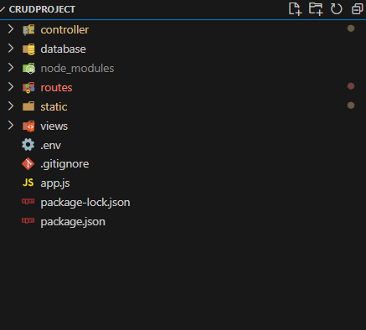

GITHUB
I have pushed the code to GitHub using commits, a version control process of saving the changes that are done to the code into the repository. Since each commit is a snapshot a point in time of code changes, the changes are described. Tracking project history this helps it also permits people to work on the project development and results to easy rollback if one version is not functioning properly. Using GitHub, we can push commits to it as it will sync our local changes in the remote repository, so that the project is always up to date and available to all contributors.

Future Consideration

Enhanced Search Functionality: By enhancing customer lookups by multiple attributes with advanced filtering and full text search.
User Authentication and Authorization: Customer diary can be secured with a login system and authorization system to manage permissions and allow user access.
Performance Optimizations: To speed up the search and reduce the server load you we will use database indexing and caching as database scales up .
Data Validation Enhancements: Extend validation rules to handle edge cases while giving real time feedback for better data entry.

