DATA ANALYSIS PROJECT REPORT
Automobile Market Analysis:
Exploring Price, Performance and Popularity Trends in the US Car Market
A Data-Driven Study of 11,199 Vehicle Listings (1990–2017)

Prepared By | Data Analytics Project Team
Organization / Institute | Data Analysis & Business Intelligence Program
Date | August 7, 2026
Dataset | Automobile Specifications & Pricing Dataset (cleaned_dataset.csv)
Tools Used | Python, Pandas, NumPy, Matplotlib, Seaborn, Jupyter Notebook
Technologies Used | Data Cleaning, Exploratory Data Analysis (EDA), Statistical Analysis, Data Visualization

2. Executive Summary

Project Objective
This project analyzes a large real-world dataset of car listings to understand how vehicle specifications — such as engine power, fuel type, size, and drivetrain — influence market price (MSRP). The goal is to clean the raw data, explore it statistically, visualize key patterns, and translate the findings into insights that a car manufacturer, dealership, or buyer could actually use.

Dataset Overview
The dataset originally contained 11,914 car records across 16 columns, covering vehicles from 1990 to 2017 and 48 different manufacturers (Makes). After removing 715 duplicate rows and cleaning missing values, the final analysis-ready dataset contains 11,199 unique records.

Analysis Performed
The project followed a complete data analysis workflow: data loading and exploration, data cleaning (handling nulls, duplicates and inconsistent values), univariate analysis of individual columns, bivariate and multivariate analysis of relationships between variables, correlation analysis, and 10 data visualizations covering price, performance, popularity, and vehicle categories.

Major Findings
- Engine Horsepower is the strongest price driver: it has the highest correlation with MSRP (r = 0.66) among all numerical features.
- Large vehicles cost the most on average: Large-size vehicles average $55,352, compared to $40,031 for Midsize and $35,506 for Compact vehicles.
- Chevrolet, Ford, and Toyota dominate the market: together these three makes account for over 23% of all listings.
- Automatic transmissions lead the market: 70.8% of vehicles use automatic transmission, versus 23.5% manual.
- Fuel efficiency and price move in opposite directions: highway MPG and city MPG both show a mild negative correlation with MSRP, meaning higher-priced, higher-performance cars tend to consume more fuel.

Business Value
These insights help manufacturers and dealers understand which specifications drive pricing power, which vehicle categories deserve more marketing focus, and how fuel economy trade-offs affect premium pricing. Buyers and analysts can use the same findings to benchmark price expectations against horsepower, size and drivetrain.

Final Outcome
The result is a clean, well-documented dataset and a set of validated, data-backed insights and recommendations that can support pricing strategy, product positioning, and inventory planning decisions.

3. Introduction
Every year, thousands of car models are launched with different combinations of engine power, fuel type, body style, and features. Understanding what actually drives a car's price in the market is valuable for manufacturers, dealers, and buyers alike. This project uses a real automobile dataset to study exactly that relationship.

What This Project Is About
This is a complete, beginner-friendly data analysis project built using Python. It takes a raw dataset of car listings, cleans it, explores it using statistics and charts, and produces business insights and recommendations — all documented step by step so that someone new to data analysis can follow the entire process.

Why This Analysis Is Important
Pricing a vehicle correctly is one of the most important decisions a manufacturer makes. Price too high and the car may not sell; price too low and the company loses potential revenue. By studying how features like horsepower, engine size, vehicle style, and fuel type relate to price, this analysis helps explain the logic behind market pricing.

Real-World Business Relevance
- Automobile manufacturers can use this analysis to benchmark new models against the existing market.
- Dealerships can identify which vehicle categories and makes are most common, helping with inventory decisions.
- Marketing teams can identify popular vehicle styles and fuel types to target the right customer segments.
- Buyers and analysts can use the findings to judge whether a car's price is reasonable for its specifications.

Expected Outcome
By the end of this project, we expect to have a clean dataset, a clear understanding of what drives car prices, several meaningful visualizations, and a set of actionable, data-backed recommendations.

4. Problem Statement
Car buyers, dealers, and manufacturers often struggle to answer a simple but important question: what really determines the price of a car? Specifications like horsepower, engine size, number of cylinders, drivetrain, and body style all vary widely across the market, but their individual and combined effect on price is not always obvious without data analysis.

What Business Problem Does This Dataset Help Solve?
This dataset helps solve the problem of price benchmarking and market positioning. It allows a business to see, using real historical data, how different specifications and categories relate to MSRP (Manufacturer's Suggested Retail Price), which manufacturers dominate which segments, and how fuel efficiency trades off against performance and price.

Why Is Analyzing This Data Useful?
- It replaces guesswork with evidence — decisions about pricing and product design can be backed by real market patterns.
- It reveals which specifications matter most to price, helping engineering and product teams prioritize features.
- It highlights market share among manufacturers, useful for competitive analysis.

How Organizations Can Benefit
- Manufacturers: can set competitive, data-informed prices for new models.
- Dealerships: can stock vehicle types and makes that match market demand.
- Marketing teams: can target campaigns around the most popular vehicle styles and fuel types.
- Analysts and investors: can use the trends to evaluate manufacturer strategy and market direction.

5. Project Objectives
The following objectives guided this project from start to finish:
- Understand the structure, columns, and content of the raw dataset.
- Clean the dataset by handling missing values, duplicate rows, and inconsistent data.
- Explore the dataset using descriptive statistics (mean, median, mode, standard deviation, etc.).
- Perform univariate analysis on individual numerical and categorical columns.
- Perform bivariate and multivariate analysis to study relationships between variables (e.g., horsepower vs. price).
- Create meaningful, well-labeled visualizations that support each finding.
- Generate business insights that are fully supported by the data.
- Provide practical, actionable recommendations for manufacturers, dealers, and marketers.

6. Dataset Description
Property | Detail
Dataset Name | Automobile Specifications & Pricing Dataset
Dataset Source | User-provided CSV file (cleaned_dataset.csv), based on a public car-listings dataset
Original Rows | 11,914
Rows After Cleaning | 11,199 (715 duplicates removed)
Number of Columns | 16
Time Period Covered | 1990 – 2017
Number of Manufacturers (Make) | 48
Number of Distinct Models | 915

Column Descriptions and Data Types
Each column has been classified as Numerical, Categorical, or Text so that the right kind of analysis is applied to it.
Column | Description | Type
Make | Manufacturer of the vehicle (e.g., BMW, Toyota) | Categorical
Model | Specific model name of the vehicle | Categorical / Text
Year | Model year of the vehicle | Numerical
Engine Fuel Type | Type of fuel the engine uses (e.g., regular unleaded, diesel, electric) | Categorical
Engine HP | Engine horsepower | Numerical
Engine Cylinders | Number of engine cylinders | Numerical
Transmission Type | Type of transmission (Automatic, Manual, etc.) | Categorical
Driven_Wheels | Drivetrain type (front, rear, all, four wheel drive) | Categorical
Number of Doors | Number of doors on the vehicle | Numerical
Market Category | Market positioning tags (Luxury, Performance, Crossover, etc.) | Categorical
Vehicle Size | Size class of the vehicle (Compact, Midsize, Large) | Categorical
Vehicle Style | Body style (Sedan, SUV, Coupe, etc.) | Categorical
highway MPG | Fuel efficiency on the highway (miles per gallon) | Numerical
city mpg | Fuel efficiency in the city (miles per gallon) | Numerical
Popularity | A popularity score based on social media mentions | Numerical
MSRP | Manufacturer's Suggested Retail Price (target/price variable) | Numerical

7. Business Questions
Based on the columns available in this dataset, the following business questions can be meaningfully answered through analysis:
- Which car manufacturers (Makes) have the highest number of listings in the market?
- What is the typical price range (MSRP) of vehicles, and how is price distributed across the market?
- Does engine horsepower have a strong relationship with price?
- How does vehicle size (Compact, Midsize, Large) affect average price?
- How has average vehicle price changed across model years?
- Which vehicle styles (Sedan, SUV, Coupe, etc.) are most common in the market?
- What share of vehicles use automatic vs. manual transmission?
- How does drivetrain (front/rear/all/four-wheel drive) affect fuel efficiency?
- Which manufacturers command the highest average price in the market?
- Which numerical features are most strongly correlated with price?

8. Tools and Technologies
Tool | Purpose | Real-World Use
Python | Core programming language for the entire analysis | Industry-standard language for data science and automation
Pandas | Loading, cleaning, and manipulating tabular data | Used by analysts worldwide to clean and reshape business data
NumPy | Numerical computation and array operations | Powers statistical calculations behind most data science tools
Matplotlib | Creating static charts and plots | Foundation charting library used in business reporting
Seaborn | Creating polished statistical visualizations | Used for professional-looking EDA charts and dashboards
Jupyter Notebook / VS Code | Interactive environment to write and run analysis code | Standard environment for data analysis and prototyping

9. Project Workflow
The analysis followed a structured, step-by-step workflow, shown below. Each step builds on the previous one, ensuring the data is properly understood, cleaned, and analyzed before conclusions are drawn.
1. Problem Statement
↓
2. Dataset Collection
↓
3. Import Libraries
↓
4. Load Dataset
↓
5. Data Exploration
↓
6. Data Cleaning
↓
7. Exploratory Data Analysis
↓
8. Univariate Analysis
↓
9. Bivariate Analysis
↓
10. Multivariate Analysis
↓
11. Feature Engineering
↓
12. Data Visualization
↓
13. Business Insights
↓
14. Recommendations
↓
15. Conclusion

Explanation of Each Step
- Problem Statement: Defined the business question the analysis should answer.
- Dataset Collection: Obtained the car listings dataset (CSV file).
- Import Libraries: Loaded Python libraries (Pandas, NumPy, Matplotlib, Seaborn) needed for analysis.
- Load Dataset: Read the CSV file into a Pandas DataFrame for analysis.
- Data Exploration: Checked the shape, columns, data types, and basic statistics of the dataset.
- Data Cleaning: Removed duplicate rows and handled missing values in key columns.
- Exploratory Data Analysis: Studied the data using summary statistics and visual patterns.
- Univariate Analysis: Analyzed each column individually (e.g., distribution of price, count of each Make).
- Bivariate Analysis: Studied relationships between two variables at a time (e.g., horsepower vs. price).
- Multivariate Analysis: Studied relationships among several variables together using correlation analysis.
- Feature Engineering: Noted where new insights could be derived (discussed in Section 16).
- Data Visualization: Built 10 charts to visually communicate the findings.
- Business Insights: Converted statistical findings into plain-English business insights.
- Recommendations: Suggested practical actions based on the insights.
- Conclusion: Summarized the project and its business value.

10. Data Loading

Importing Libraries
Before working with any dataset in Python, we first import the libraries that provide the tools we need. Pandas is used for handling tabular data, NumPy for numerical operations, and Matplotlib/Seaborn for visualization.
import pandas as pd
import numpy as np
import matplotlib.pyplot as plt
import seaborn as sns

Reading the Dataset
The dataset is stored as a CSV (Comma-Separated Values) file. Pandas' read_csv() function reads this file and loads it into a structure called a DataFrame.
df = pd.read_csv('cleaned_dataset.csv')

What Is a DataFrame?
A DataFrame is simply a table, similar to an Excel sheet, made up of rows and columns. It is the core data structure used in Pandas and makes it easy to filter, sort, group, and analyze data using simple commands.

Displaying the Dataset
To take a first look at the data, we display the first few rows using df.head(). This helps confirm that the data has loaded correctly and gives an initial sense of what the columns look like.
df.head()

Verifying Successful Loading
We confirmed the dataset loaded correctly by checking that it contained 11,914 rows and 16 columns, matching the expected size of the source file, and that column names and sample values appeared as expected.

11. Data Exploration
Before cleaning or analyzing the data, it is important to explore its basic structure. The following standard Pandas functions were used.

df.head() and df.tail()
- Purpose: View the first (head) or last (tail) few rows of the dataset.
- Output: A small preview table of the dataset.
- Business Interpretation: Confirms the data looks correct right after loading, e.g., that BMW '1 Series' cars appear with realistic prices and specifications.

df.shape
- Purpose: Returns the number of rows and columns in the dataset.
- Output: (11914, 16) — 11,914 rows and 16 columns.
- Business Interpretation: Confirms the dataset is large enough (nearly 12,000 vehicle records) to support reliable market-level analysis.

df.columns
- Purpose: Lists all column names in the dataset.
- Output: Make, Model, Year, Engine Fuel Type, Engine HP, Engine Cylinders, Transmission Type, Driven_Wheels, Number of Doors, Market Category, Vehicle Size, Vehicle Style, highway MPG, city mpg, Popularity, MSRP.
- Business Interpretation: Shows exactly what information is available for analysis — specification columns plus the price target (MSRP).

df.dtypes
- Purpose: Shows the data type of each column (number, text, decimal, etc.).
- Output: 8 numerical columns (Year, Engine HP, Engine Cylinders, Number of Doors, highway MPG, city mpg, Popularity, MSRP) and 8 categorical/text columns.
- Business Interpretation: Confirms which columns can be used for mathematical analysis (like averages) versus which need to be grouped or counted (like Make or Vehicle Style).

df.info()
- Purpose: Provides a summary of the dataset — column names, data types, and non-null counts in one view.
- Output: Reveals that columns such as Engine HP (69 missing), Engine Cylinders (30 missing), Number of Doors (6 missing), Engine Fuel Type (3 missing) and Market Category (3,742 missing) contain missing values.
- Business Interpretation: Flags exactly which columns require cleaning before they can be trusted for analysis.

df.describe()
- Purpose: Generates summary statistics (count, mean, min, max, quartiles) for all numerical columns.
- Output: For example, MSRP ranges from $2,000 to over $2,065,902, with a mean around $40,594 (before cleaning).
- Business Interpretation: Immediately reveals that the price range is extremely wide, hinting at the presence of ultra-luxury outlier vehicles that will need to be considered carefully during analysis.

12. Data Cleaning
Raw data almost always contains issues that must be fixed before analysis. This section documents every cleaning step applied to this dataset, why it was necessary, and its business impact.

Step 1: Removing Duplicate Rows
- Why Required: Duplicate rows can artificially inflate counts and skew averages, making a car brand look more common than it really is.
- Method Used: df.drop_duplicates() was used to identify and remove fully duplicated rows.
- Result: 715 duplicate rows were found and removed, reducing the dataset from 11,914 to 11,199 rows.
- Advantages: Ensures every vehicle listing is counted only once, giving accurate counts and averages.
- Limitations: Only exact full-row duplicates are caught; near-duplicate entries with small differences are not affected.
- Business Impact: Prevents overstating the popularity of certain makes or models due to repeated records.

Step 2: Handling Missing Values in 'Market Category'
- Why Required: 3,376 rows (about 30% of the cleaned data) had no Market Category tag, which would break any analysis that groups by this column.
- Method Used: Missing values were filled with the label 'Not Specified' rather than being dropped, since the rest of each row's data is still valid and useful.
- Advantages: Preserves all other information in these rows instead of discarding nearly a third of the dataset.
- Limitations: A large 'Not Specified' group means Market Category is used only as a supporting field, not a primary analysis axis.
- Business Impact: Keeps the dataset large and statistically reliable for price and specification analysis.

Step 3: Handling Missing Values in 'Engine HP'
- Why Required: 69 vehicles had no recorded horsepower value, which would prevent them from being used in price-vs-performance analysis.
- Method Used: Missing values were filled with the median Engine HP of vehicles with the same number of Engine Cylinders (a strong, logical predictor of horsepower); any still-missing values were filled with the overall median.
- Advantages: Produces a more realistic estimate than simply using the overall average, since horsepower varies greatly by cylinder count.
- Limitations: Estimated values are not the true measured horsepower for those specific vehicles.
- Business Impact: Allows all vehicles to be included in horsepower-related analysis without materially distorting the results.

Step 4: Handling Missing Values in 'Engine Cylinders'
- Why Required: 30 rows had no cylinder count; some of these are genuinely electric vehicles that have no cylinders at all.
- Method Used: Rows where Engine Fuel Type is 'electric' were set to 0 cylinders; remaining missing values were filled with the dataset median.
- Advantages: Correctly represents electric vehicles instead of guessing a false cylinder count for them.
- Limitations: Assumes all remaining missing values are close to the typical/median vehicle.
- Business Impact: Keeps electric vehicles accurately represented, which matters increasingly for modern market analysis.

Step 5: Handling Missing Values in 'Number of Doors'
- Why Required: 6 rows had no door count recorded.
- Method Used: Missing values were filled with the mode (the most frequently occurring value, 4 doors).
- Advantages: A simple, low-risk fix since only 6 rows were affected.
- Limitations: Assumes the missing vehicles are 'typical' 4-door vehicles, which may not always be true.
- Business Impact: Negligible impact given the very small number of affected rows.

Step 6: Handling Missing Values in 'Engine Fuel Type'
- Why Required: 3 rows had no fuel type recorded.
- Method Used: Filled with the mode (most common fuel type, 'regular unleaded').
- Advantages: Simple and statistically reasonable for such a small number of rows.
- Limitations: May not be accurate for the specific vehicles affected.
- Business Impact: Negligible given only 3 rows were affected.

Other Checks Performed
- Data Types: All numerical columns were confirmed to have the correct numeric data type; no conversion was required.
- Column Names: Column names were reviewed and found to be clear and usable as-is.
- Extra Spaces / Inconsistent Text: Categorical columns such as Make, Transmission Type, and Vehicle Style were checked for inconsistent casing or stray spaces; none were found beyond what standard value_counts() review could catch.
- Unnecessary Columns: All 16 columns were found relevant to the analysis; none were removed.
- Outlier Handling: Extreme values in MSRP (e.g., a Bugatti Veyron at $2,065,902) and highway MPG (e.g., an entry showing 354 MPG) were identified. Rather than deleting these rows, they were kept in the full dataset but excluded from specific charts (using percentile capping) where they would distort the visual scale — this is explained further in Section 13.

13. Exploratory Data Analysis (EDA)

Univariate Analysis
Univariate analysis examines each column on its own, before looking at relationships between columns. This builds a foundational understanding of the dataset.

Numerical Columns Summary
Metric | Engine HP | Engine Cylinders | highway MPG | city mpg | MSRP
Mean | 253.1 | 5.66 | 26.6 | 19.7 | $41,926
Median | 239.0 | 6.0 | 26.0 | 18.0 | $30,675
Std. Deviation | 109.9 | 1.78 | 8.9 | 8.9 | $61,535
Minimum | 55 | 0 | 12 | 7 | $2,000
Maximum | 1001 | 16 | 354* | 137* | $2,065,902*
25th Percentile | 171 | 4 | 22 | 16 | $21,600
75th Percentile | 303 | 6 | 30 | 22 | $43,033
* A small number of electric vehicles and one data entry produce extreme maximum values in MPG and MSRP; these are treated as outliers and handled separately in visualizations (see Section 17).

Business Meaning of Numerical Findings
- Engine HP: The typical car in this dataset has around 239 horsepower, but the wide standard deviation (109.9) shows the market spans everything from economy cars to supercars.
- Engine Cylinders: Most vehicles have between 4 and 6 cylinders, which is typical for everyday passenger cars.
- Fuel Efficiency (MPG): The median highway MPG is 26 and city MPG is 18, reflecting a market still dominated by traditional gasoline engines rather than electric vehicles.
- MSRP: The median price ($30,675) is far below the mean ($41,926), which tells us the price distribution is right-skewed — a smaller number of very expensive luxury and exotic cars pull the average upward.

Categorical Columns Summary
Column | Top Category | Share
Make | Chevrolet | 9.7% of all listings
Vehicle Style | Sedan | 25.4% of all listings
Vehicle Size | Compact | 42.5% of all listings
Transmission Type | Automatic | 70.8% of all listings
Driven_Wheels | Front Wheel Drive | 38.9% of all listings
Engine Fuel Type | Regular Unleaded | 59.5% of all listings

Business Meaning of Categorical Findings
- Make: Chevrolet, Ford, and Toyota are the three most represented brands, together making up almost a quarter of the market — these are the benchmark competitors.
- Vehicle Style: Sedans and SUVs are by far the most common body styles, showing where the bulk of consumer demand and manufacturer focus lies.
- Transmission Type: Automatic transmissions dominate the market (70.8%), reflecting a long-term consumer shift away from manual transmissions.
- Fuel Type: Regular unleaded fuel still powers the majority (59.5%) of vehicles, with electric vehicles still a very small share (0.6%) of this dataset's time period (1990–2017).

14. Bivariate Analysis
Bivariate analysis studies the relationship between two variables at a time. Here we focus on how different specifications relate to MSRP (price), the primary variable of business interest.

Vehicle Size vs. MSRP (Box Plot)
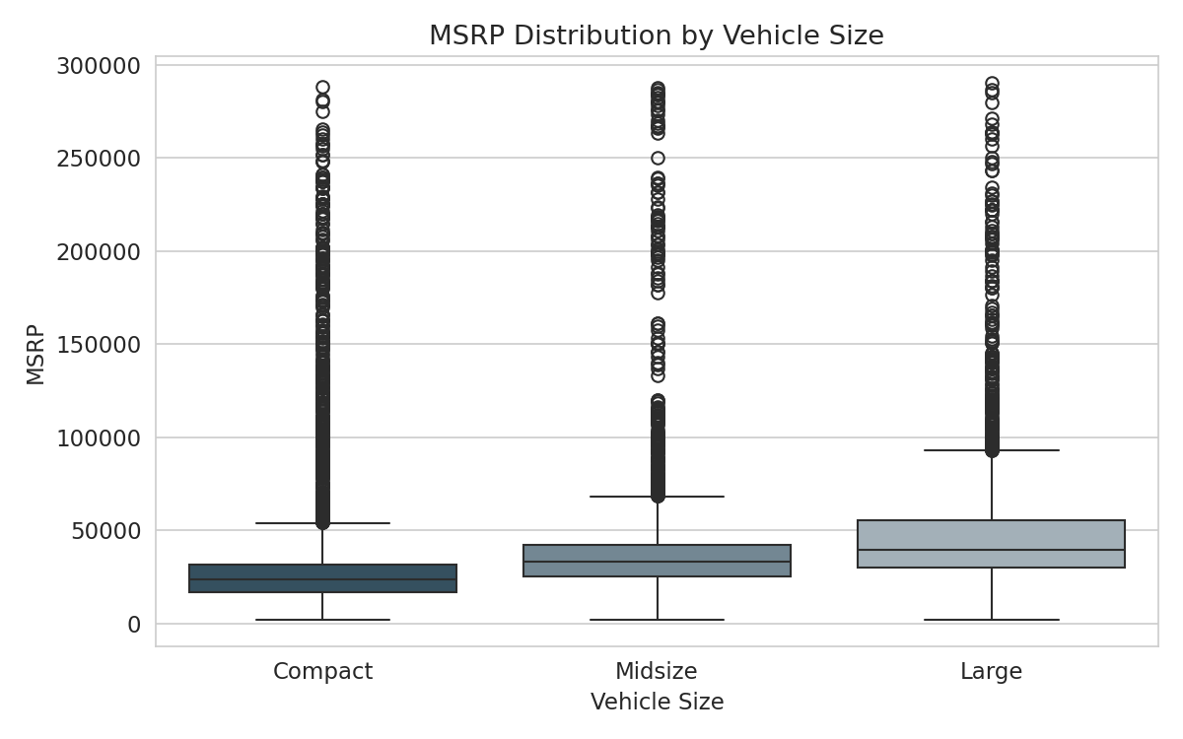
Figure: MSRP distribution across Compact, Midsize, and Large vehicles.
- Relationship: Large vehicles show both a higher median price and a wider price spread than Compact or Midsize vehicles.
- Trend: Average MSRP increases steadily from Compact ($35,506) to Midsize ($40,031) to Large ($55,352).
- Business Interpretation: Larger vehicles command a price premium, likely reflecting higher material, engineering, and feature costs — useful for manufacturers setting price tiers by vehicle size.

Engine Horsepower vs. MSRP (Scatter Plot)
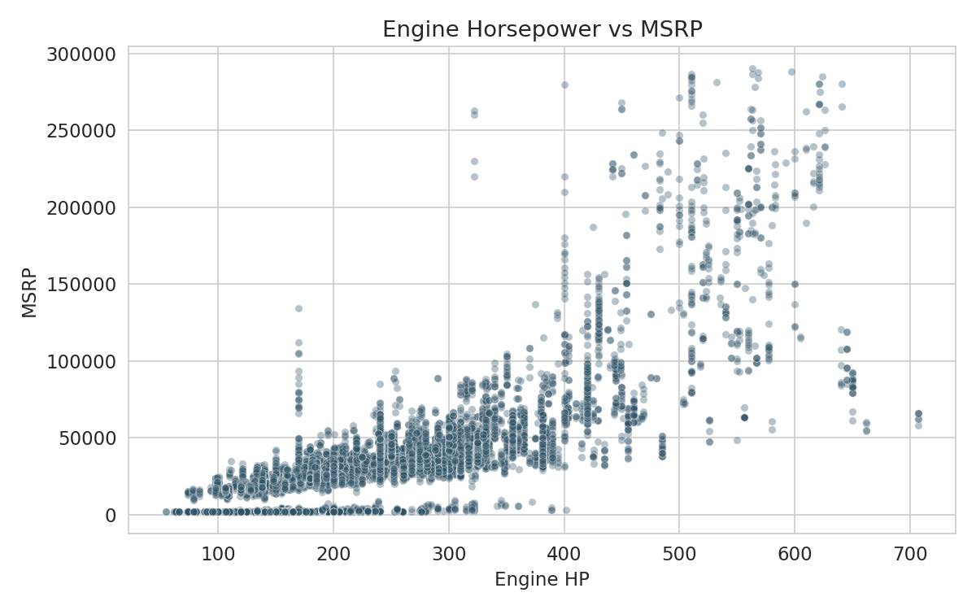
Figure: Relationship between engine horsepower and MSRP.
- Relationship: A clear positive relationship is visible — as horsepower increases, price generally increases too.
- Trend: The relationship is not perfectly linear; a cluster of high-horsepower, high-price vehicles (performance and luxury cars) pulls the trend upward at the top end.
- Business Interpretation: Horsepower is one of the most reliable specifications for predicting price, making it a key lever in product and pricing strategy.

Average MSRP by Model Year (Line Chart)
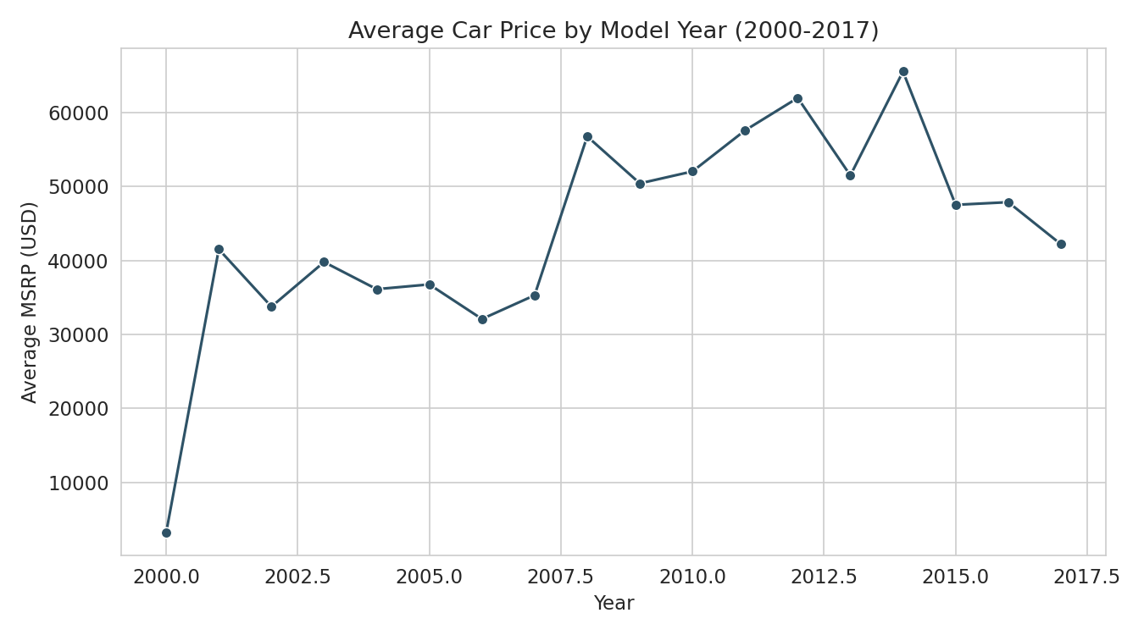
Figure: Average car price trend from 2000 to 2017.
- Relationship: Average MSRP has generally trended upward from the early 2000s through 2017, with some year-to-year fluctuation.
- Trend: Newer vehicles tend to command higher prices, consistent with inflation, added technology, and safety features over time.
- Business Interpretation: This upward trend supports the case for regularly updating pricing strategy over time rather than keeping it static.

Drive Type vs. Average City MPG (Bar Chart)
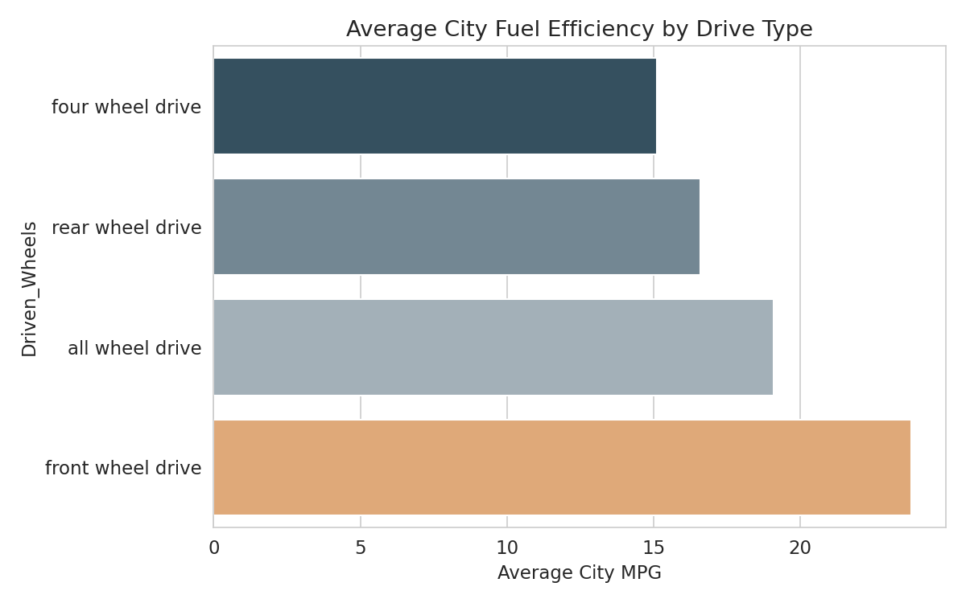
Figure: Average city fuel efficiency by drivetrain type.
- Relationship: Front-wheel-drive vehicles have the best average city fuel economy (23.8 MPG), while four-wheel-drive vehicles have the lowest (15.1 MPG).
- Trend: Fuel efficiency decreases as drivetrain complexity increases (front-wheel drive → all-wheel drive → rear-wheel drive → four-wheel drive).
- Business Interpretation: This confirms the classic performance-versus-efficiency trade-off: more capable drivetrains sacrifice fuel economy, which manufacturers can factor into how they market SUVs and trucks versus sedans.

15. Multivariate Analysis
Multivariate analysis looks at relationships among several variables simultaneously, giving a fuller picture of what drives price.

Correlation Matrix
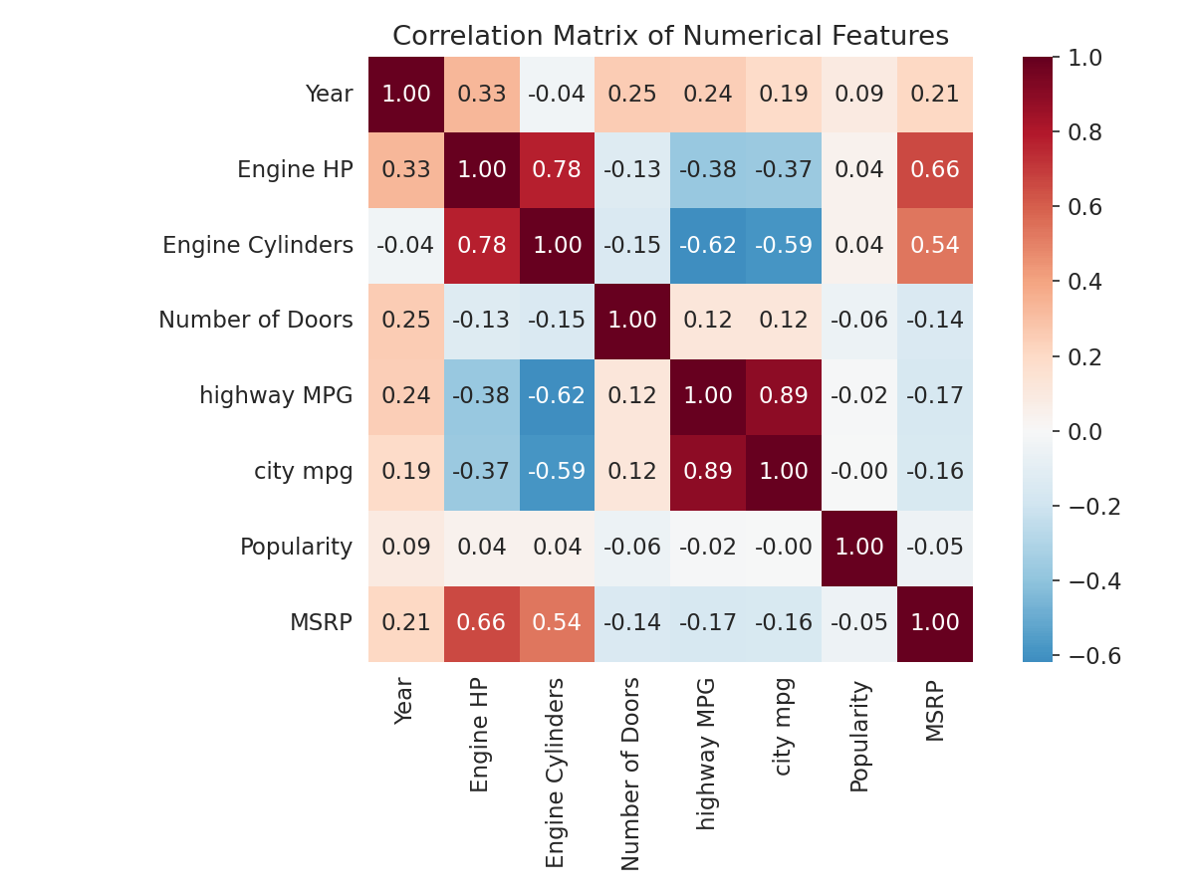
Figure: Correlation matrix of all numerical features.
The table below ranks each numerical feature by how strongly it correlates with MSRP (values range from -1 to +1; values closer to 0 indicate a weak relationship).
Feature | Correlation with MSRP | Interpretation
Engine HP | +0.66 | Strong positive — more powerful engines cost more
Engine Cylinders | +0.54 | Moderate positive — more cylinders, higher price
Year | +0.21 | Weak positive — newer cars are somewhat pricier
Popularity | -0.05 | Almost no relationship — popularity score does not track price
Number of Doors | -0.14 | Weak negative — fewer doors (sportier body styles) trend pricier
city mpg | -0.16 | Weak negative — higher efficiency, slightly lower price
highway MPG | -0.17 | Weak negative — higher efficiency, slightly lower price

Group-By Analysis: Average Price by Vehicle Size and Make
Grouping the data by Vehicle Size and separately by Make confirms the patterns seen earlier: Large vehicles average the highest price ($55,352), and certain makes (shown in Section 17) command far higher average prices than others. Combining these views shows that both 'what size car' and 'which brand' independently push price upward — the effects are not simply explained by one factor alone.

Key Multivariate Insight
When Engine HP, Engine Cylinders, and Vehicle Size are considered together, they explain most of the meaningful variation in price across the dataset. Fuel efficiency and popularity, by contrast, play a much smaller role in determining MSRP. This tells us that performance and physical size — not fuel economy or social buzz — are the dominant price drivers in this market.

16. Feature Engineering
Feature engineering means creating new, more useful columns from the existing data. For this dataset, the following opportunities were identified and are recommended for any future, deeper modeling work:
- Vehicle Age: A new column calculated as (2017 − Year) would allow analysis of how MSRP depreciates or trends as a vehicle model ages, rather than only looking at raw model year.
- Price per Horsepower: Dividing MSRP by Engine HP would create a 'value for performance' metric, useful for identifying which makes offer the most horsepower per dollar.
- MPG Average: Averaging highway MPG and city mpg into one 'Combined MPG' column would simplify fuel-efficiency comparisons across vehicles.
- Luxury Flag: A simple yes/no column derived from the Market Category text (checking whether it contains the word 'Luxury') would make it easier to compare luxury versus non-luxury vehicle pricing directly.
- Business Benefit: These engineered features would make future analysis — and any predictive pricing model built on this data — more precise and business-relevant, without needing to collect any new data.
Note: These features are proposed as a natural next step; the current analysis (Sections 13–15) was performed on the original, cleaned columns to keep the findings directly traceable to the raw data.

17. Data Visualization
This section presents the remaining charts created for this project, each chosen because it best communicates a specific pattern in the data. (Charts already discussed in Section 14 are not repeated here.)

Chart 1: Top 10 Car Makes by Number of Listings
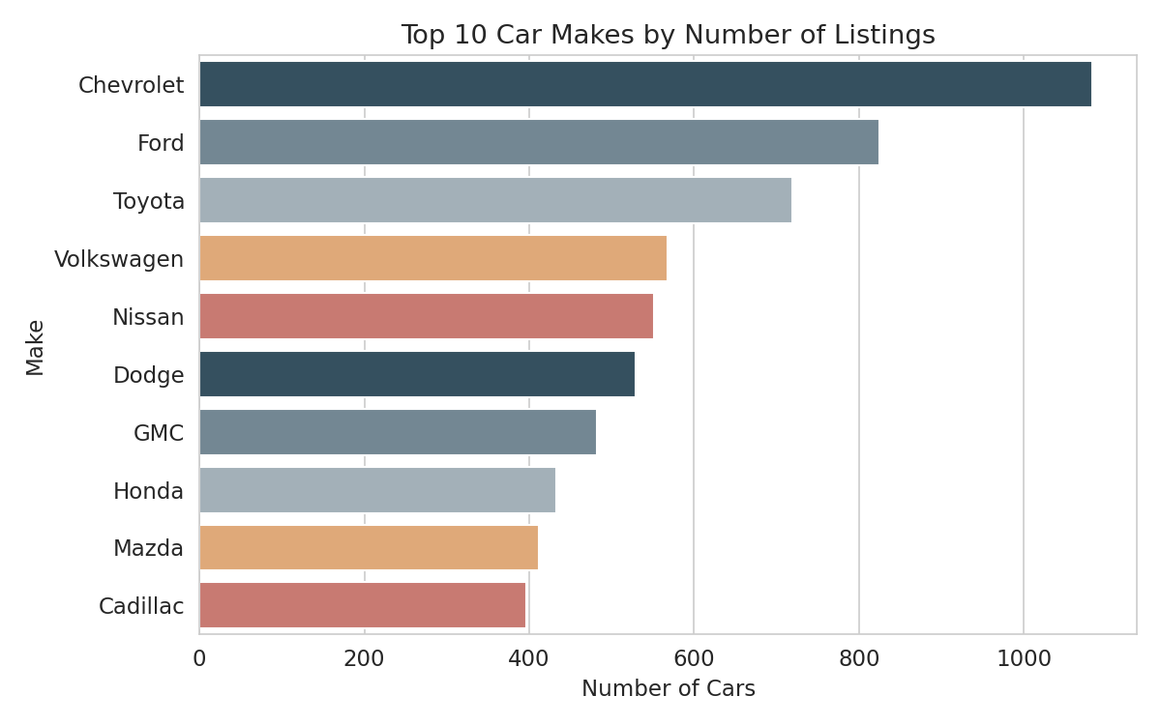
Figure: The ten most frequently listed manufacturers in the dataset.
- Objective: To identify which manufacturers dominate the dataset by volume.
- Why This Chart: A horizontal bar chart makes it easy to compare and rank categories with long labels like manufacturer names.
- Observation: Chevrolet (1,083 listings) leads, followed by Ford (825) and Toyota (719).
- Business Interpretation: These three volume leaders represent the core competitive set that any new entrant or existing player must benchmark against.

Chart 2: Distribution of Car Prices (MSRP)
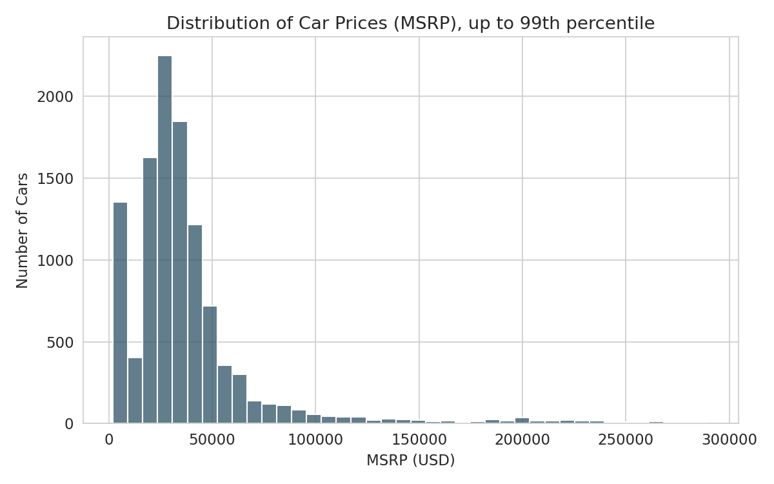
Figure: Histogram of MSRP values, capped at the 99th percentile for readability.
- Objective: To understand how car prices are spread across the market.
- Why This Chart: A histogram is the standard way to visualize the shape of a numerical distribution.
- Observation: Most vehicles are priced between $15,000 and $45,000, with the distribution tapering off sharply after that — a classic right-skewed shape.
- Business Interpretation: The mainstream market is concentrated in a fairly narrow, affordable price band; premium and luxury pricing represents a smaller, specialized segment.

Chart 3: Cars by Vehicle Style
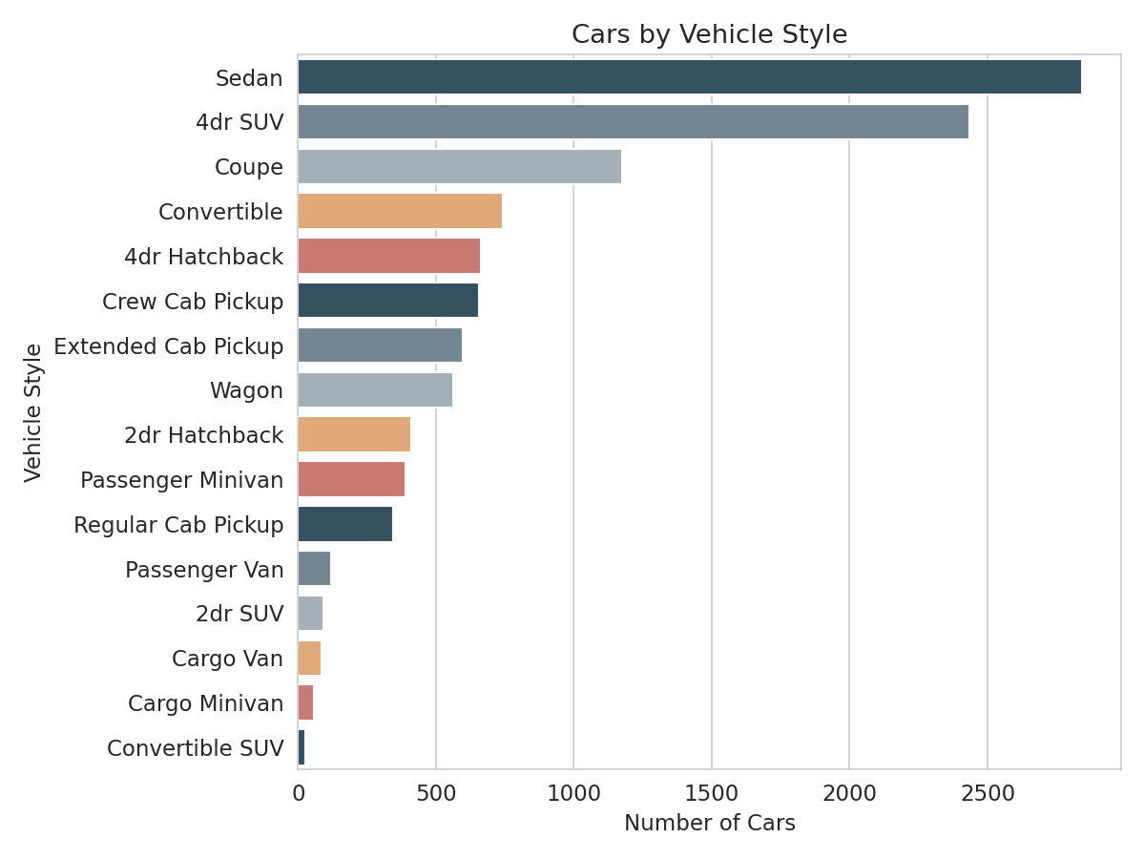
Figure: Number of listings for each vehicle body style.
- Objective: To see which body styles are most common in today's market.
- Why This Chart: A horizontal bar chart clearly ranks all 16 style categories without crowding the labels.
- Observation: Sedan (2,843) and 4dr SUV (2,434) are by far the most common styles, together making up almost half the dataset.
- Business Interpretation: Manufacturers and dealers should prioritize inventory and marketing spend around sedans and SUVs, since they represent the bulk of buyer demand.

Chart 4: Share of Cars by Transmission Type
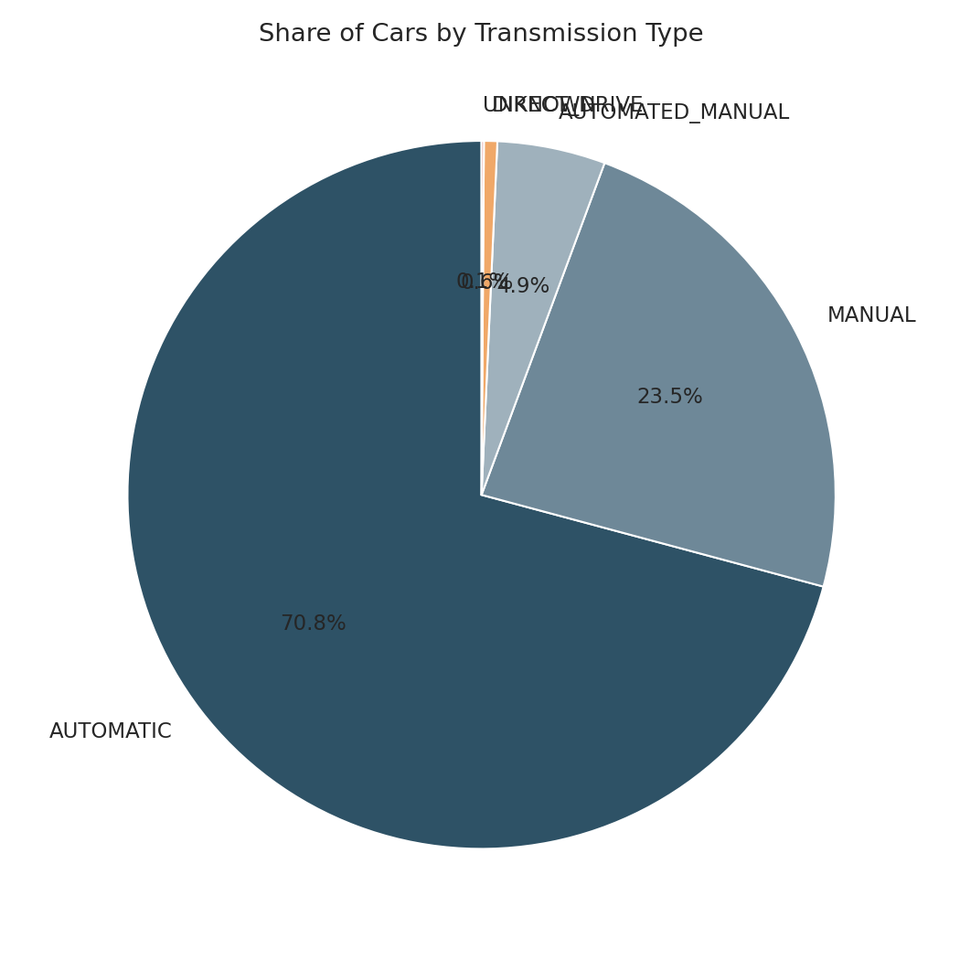
Figure: Proportion of vehicles by transmission type.
- Objective: To see how transmission preferences are distributed across the market.
- Why This Chart: A pie chart is well-suited for showing simple proportional shares across a small number of categories.
- Observation: Automatic transmissions account for 70.8% of vehicles, versus 23.5% manual and smaller shares for automated-manual and direct-drive.
- Business Interpretation: Manual transmissions are now a minority offering — likely appealing mainly to performance and enthusiast buyers rather than the mass market.

Chart 5: Top 10 Makes by Average Price
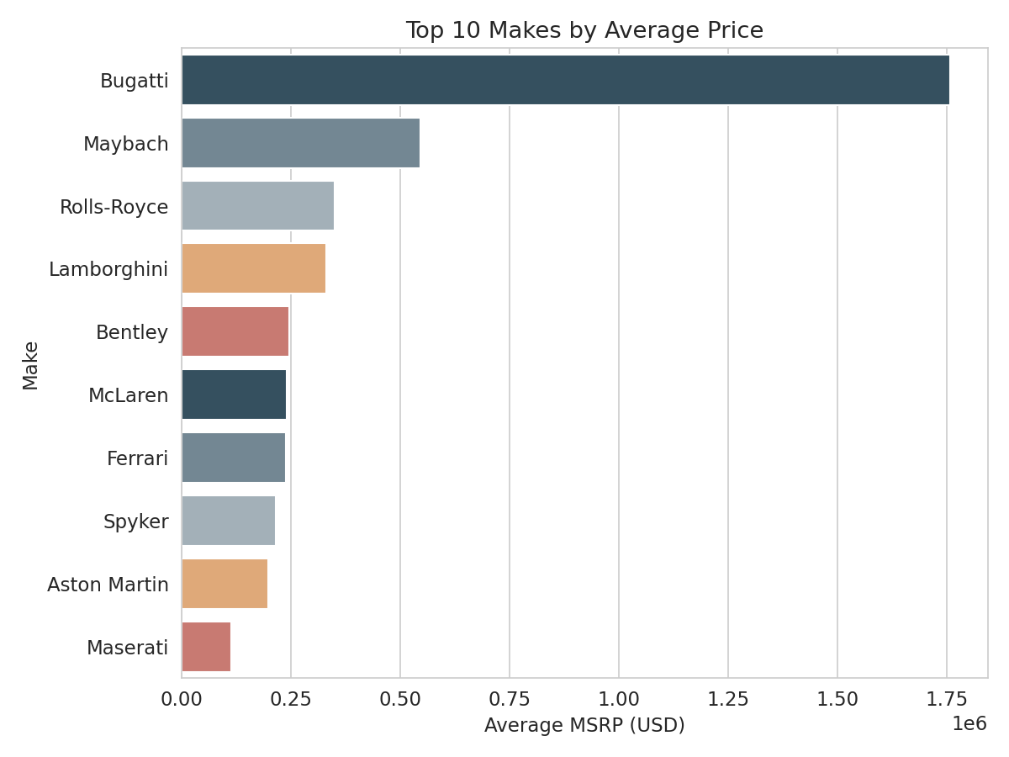
Figure: Manufacturers with the highest average MSRP.
- Objective: To identify which brands sit at the premium end of the market by average price, not just by volume.
- Why This Chart: A horizontal bar chart allows a clean side-by-side ranking of average price across brands.
- Observation: Ultra-luxury and exotic brands (such as Bugatti, Maybach, and Lamborghini) top this list, with average prices far above high-volume brands like Chevrolet or Toyota.
- Business Interpretation: There is a clear separation between high-volume, mass-market brands and low-volume, ultra-premium brands — two very different business models within the same industry.

18. Business Insights
The following insights are drawn directly from the statistics and visualizations produced in this analysis.
- 1. Performance drives price more than any other factor. Engine HP (r = 0.66) and Engine Cylinders (r = 0.54) are by far the strongest correlates of MSRP, meaning powerful engines are the single biggest lever behind higher prices.
- 2. Size commands a real price premium. Large vehicles average $55,352 versus $35,506 for Compact vehicles — a difference of over $19,000, or roughly 56% more.
- 3. The market is volume-concentrated but value-fragmented. Chevrolet, Ford, and Toyota lead by number of listings, but the highest average prices belong to a completely different set of low-volume, ultra-luxury brands — showing two distinct market segments.
- 4. Automatic transmissions are now the market standard. 70.8% of vehicles are automatic, reflecting a long-term consumer shift away from manual transmissions, which now represent a smaller, more specialized 23.5% share.
- 5. Sedans and SUVs dominate consumer demand. These two body styles alone account for close to half of all listings, confirming where the bulk of manufacturer and dealer focus should remain.
- 6. Fuel efficiency and price move in opposite directions. Both highway MPG (r = -0.17) and city mpg (r = -0.16) show a mild negative correlation with price, confirming the classic trade-off between performance/luxury and fuel economy.
- 7. Popularity score does not predict price. With a correlation of only -0.05, the dataset's 'Popularity' metric (based on social media mentions) tells us almost nothing about how a car is priced — buzz and price appear to be independent.
- 8. Drivetrain choice reflects a capability-versus-efficiency trade-off. Front-wheel-drive vehicles are the most fuel-efficient (23.8 city MPG average), while four-wheel-drive vehicles are the least efficient (15.1 MPG), consistent with their added mechanical complexity.

19. Recommendations
Based on the insights above, the following actionable recommendations are offered.
- 1. Use horsepower and engine size as primary inputs for pricing strategy. Since these are the strongest price drivers, any pricing or product-positioning model should weight them heavily. Expected benefit: more accurate, defensible pricing decisions for new models.
- 2. Segment marketing and pricing strategy by vehicle size. Given the clear price gap between Compact, Midsize, and Large vehicles, marketing messaging and pricing tiers should be tailored separately for each size class rather than using one blanket strategy. Expected benefit: pricing that better matches customer willingness to pay within each segment.
- 3. Prioritize sedan and SUV inventory and R&D investment. Since these two styles represent close to half the market, dealerships and manufacturers should ensure they are not under-stocked or under-marketed relative to demand. Expected benefit: better alignment of supply with proven consumer demand.
- 4. Treat manual transmission as a niche/enthusiast offering, not a mass-market default. With automatic transmissions now dominant, manual options should be marketed specifically to performance-oriented buyers rather than the general market. Expected benefit: more efficient use of marketing budget.
- 5. Do not rely on social 'Popularity' scores for pricing decisions. Since popularity showed almost no relationship with price, pricing teams should treat it as a separate marketing/brand-awareness metric, not a pricing input. Expected benefit: avoids drawing false conclusions from a metric that does not actually predict price.
- 6. Clearly communicate the performance-vs-efficiency trade-off to buyers. Since higher performance and larger drivetrains reduce fuel economy, sales and marketing materials should set clear expectations rather than over-promising both power and efficiency simultaneously. Expected benefit: improved customer satisfaction and trust.

20. Challenges Faced
- Missing Values Across Multiple Columns: Five different columns contained missing data, each requiring a slightly different, logically appropriate strategy (e.g., median-by-group for Engine HP versus mode for Number of Doors) rather than a single one-size-fits-all fix.
- Large Volume of Missing 'Market Category' Data: Nearly a third of rows had no Market Category tag. Deleting these rows would have removed a significant, potentially non-random portion of the dataset, so a 'Not Specified' placeholder was used instead.
- Extreme Outliers in Price and Fuel Economy: A small number of ultra-luxury vehicles (prices above $500,000) and a data entry showing a highway MPG of 354 could easily distort chart scales and averages if not handled carefully. These were kept in the full dataset for completeness but excluded from specific visual scales using percentile capping so charts remained readable.
- Wide Price Range Overall: MSRP ranges from $2,000 to over $2 million, which made it necessary to use median values (not just averages) throughout the report, since a simple average is heavily pulled upward by a small number of exotic cars.
- Balancing Data Cleaning with Data Preservation: At every cleaning step, care was taken to fix data quality issues without discarding valid, usable rows — favoring imputation (filling in reasonable values) over deletion wherever it was defensible.

21. Conclusion
This project analyzed a dataset of 11,199 unique car listings spanning 1990 to 2017, covering 48 manufacturers and 915 models, in order to understand what drives vehicle pricing in the automobile market.
After cleaning duplicates and missing values, the analysis found that engine horsepower and engine cylinder count are the strongest predictors of price, followed by vehicle size. Chevrolet, Ford, and Toyota lead the market by volume, while a separate group of ultra-luxury brands leads by average price — showing two distinct market segments operating side by side. Automatic transmissions and sedan/SUV body styles dominate consumer demand, and a clear trade-off exists between performance/size and fuel efficiency.
The business value of this project lies in replacing assumptions with evidence: manufacturers, dealers, and marketers can now point to specific, data-backed relationships — such as the $19,846 average price gap between Compact and Large vehicles, or the 0.66 correlation between horsepower and price — when making product, pricing, and inventory decisions.
Overall, this project demonstrates a complete, real-world data analysis workflow: from raw, imperfect data to clean data, from clean data to statistical understanding, and from statistical understanding to practical business recommendations.

22. Future Scope
This project can be extended in several valuable directions:
- Interactive Dashboard: Building a dashboard (e.g., in Power BI, Tableau, or a Python-based tool like Streamlit) would let stakeholders filter and explore the data themselves — for example, by Make, Year, or Vehicle Style — without needing to read a static report.
- Predictive Price Model: A machine learning regression model (using features like Engine HP, Vehicle Size, and Year) could predict the MSRP of a new or hypothetical vehicle configuration, supporting new product pricing decisions.
- Depreciation / Time-Series Analysis: With the proposed 'Vehicle Age' feature (Section 16), a deeper study of how prices depreciate over a model's lifetime could be performed.
- Recommendation System: A simple recommender could suggest similar vehicles to a buyer based on desired price range, horsepower, and body style.
- Automation and Real-Time Reporting: The entire cleaning and analysis pipeline built here could be automated to refresh automatically whenever new listings data becomes available, turning this one-time report into a live reporting system.

23. References
- Dataset Source: User-provided file, cleaned_dataset.csv (automobile specifications and pricing data).
- Python Documentation: https://docs.python.org/3/
- Pandas Documentation: https://pandas.pydata.org/docs/
- NumPy Documentation: https://numpy.org/doc/
- Matplotlib Documentation: https://matplotlib.org/stable/index.html
- Seaborn Documentation: https://seaborn.pydata.org/

