JAIN UNIVERSITY
School of Computer Science & Engineering

EXPLORATORY DATA ANALYSIS OF THE
E-COMMERCE QUICK-COMMERCE DELIVERY DATASET
A Data Analytics Mini-Project using Python, Pandas, NumPy, Matplotlib & Seaborn

PREPARED BY | Sravani Tangudu
INSTITUTE | Jain University
PROJECT TYPE | College Data Analysis Project
TOOLS USED | Python, Pandas, NumPy, Matplotlib, Seaborn
DATASET | Ecommerce_Delivery_csv.csv
DATE | August 2026

Table of Contents
1. Introduction 3
2. Dataset Summary 4
3. Data Cleaning & Preprocessing 5
4. Project Workflow 6
5. Univariate Analysis 7
6. Bivariate Analysis 12
7. Multivariate Analysis 16
8. Key Insights & Conclusion 19
9. GitHub Repository Structure 20

1. Introduction
Quick-commerce (q-commerce) platforms such as Blinkit, Swiggy Instamart, and JioMart have transformed the way consumers shop for everyday essentials, promising delivery within minutes. As competition in this space intensifies, understanding delivery performance, customer satisfaction, and refund behaviour becomes critical for business decision-making.
This project presents an exploratory data analysis (EDA) of a simulated e-commerce delivery dataset containing 100,000 orders placed across three quick-commerce platforms. The objective is to apply core data analytics techniques - data cleaning, univariate analysis, bivariate analysis, and multivariate analysis - to uncover patterns in delivery time, order value, customer feedback, service ratings, delivery delays, and refund requests.

1.1 Objectives
- Load and inspect the raw dataset for structure, data types, and quality issues.
- Clean the dataset by identifying and handling missing values appropriately.
- Perform univariate analysis to understand the distribution of individual variables.
- Perform bivariate analysis to explore relationships between pairs of variables.
- Perform multivariate analysis to study interactions among three or more variables simultaneously.
- Summarize key insights that could support platform-level business decisions.

1.2 Tools & Technologies
- Python 3 - core programming language
- Pandas - data loading, cleaning, and manipulation
- NumPy - numerical operations and array handling
- Matplotlib & Seaborn - data visualization
- Microsoft Word / GitHub - documentation and project hosting

2. Dataset Summary
The dataset, Ecommerce_Delivery_csv.csv, contains 100,000 records and 11 columns describing individual delivery orders placed on three quick-commerce platforms. Each row represents a single order, capturing details about the platform, product category, delivery performance, customer feedback, and refund status.

2.1 Column Description
Column Name | Data Type | Description
Order ID | Text | Unique identifier for each order (100,000 unique values)
Customer ID | Text | Unique identifier for each customer (9,000 unique customers)
Platform | Categorical | Delivery platform - Swiggy Instamart, Blinkit, or JioMart
Order Date & Time | Text | Timestamp at which the order was placed
Delivery Time (Minutes) | Numerical | Time taken to deliver the order, in minutes
Product Category | Categorical | Category of product ordered (6 categories)
Order Value (INR) | Numerical | Total value of the order in Indian Rupees
Customer Feedback | Categorical / Text | Short feedback comment left by the customer
Service Rating | Numerical (Ordinal) | Rating given by the customer, on a scale of 1 to 5
Delivery Delay | Categorical (Yes/No) | Whether the delivery was delayed
Refund Requested | Categorical (Yes/No) | Whether the customer requested a refund

2.2 Dataset Snapshot
Metric | Value
Total Records | 100,000
Total Columns | 11
Unique Platforms | 3 (Swiggy Instamart, Blinkit, JioMart)
Unique Product Categories | 6
Unique Customers | 9,000
Delivery Time Range | 5 to 76 minutes
Order Value Range | INR 50 to INR 2,000
Service Rating Range | 1 to 5

3. Data Cleaning & Preprocessing
Before performing any analysis, the dataset was checked for data quality issues using Pandas and NumPy. The following cleaning workflow was applied:

3.1 Missing Value Check
The dataset was scanned column by column using df.isnull().sum() to detect missing values. As a standard data-cleaning practice for this project, the following rule was defined and applied programmatically:
- Numerical columns: any missing (NaN) values are replaced with 0 using df[numeric_cols].fillna(0).
- Categorical / text columns: any missing values are replaced with the label "Unknown" using df[categorical_cols].fillna("Unknown").
Upon inspection, the supplied dataset was found to be fully populated with zero null values across all 11 columns. The cleaning logic above was nonetheless implemented and executed on the full dataset (as good practice and to satisfy the project's data-quality checklist), confirming the dataset required no imputation.

3.2 Duplicate Records
The dataset was also checked for duplicate rows using df.duplicated().sum(). No duplicate records were found, confirming that each row represents a distinct order.

3.3 Data Type Validation
Numerical fields (Delivery Time, Order Value, Service Rating) were validated and cast to appropriate numeric types (int/float) to ensure accurate statistical computation and plotting. Categorical fields were kept as strings/objects for grouping and visualization.
The cleaned dataset was then exported as Ecommerce_Delivery_cleaned.csv for use in all subsequent analysis steps.

4. Project Workflow
The project followed a structured, end-to-end data analysis workflow, summarized below:
Step | Activity | Tools Used
1 | Data Collection | CSV file (Ecommerce_Delivery_csv.csv)
2 | Data Loading & Inspection | Pandas (read_csv, info, describe, head)
3 | Data Cleaning | Pandas, NumPy (isnull, fillna, duplicated)
4 | Univariate Analysis | Matplotlib, Seaborn (countplot, histplot, pie chart)
5 | Bivariate Analysis | Seaborn (boxplot, barplot, countplot)
6 | Multivariate Analysis | Seaborn (heatmap, grouped barplot, scatterplot)
7 | Insight Generation | Manual interpretation of visual patterns
8 | Documentation | Microsoft Word (.docx), Markdown (GitHub README)
9 | Publishing | GitHub repository

5. Univariate Analysis
Univariate analysis examines one variable at a time to understand its distribution, spread, and central tendencies. The following charts explore the individual behaviour of key categorical and numerical columns in the dataset.

5.1 Orders by Platform
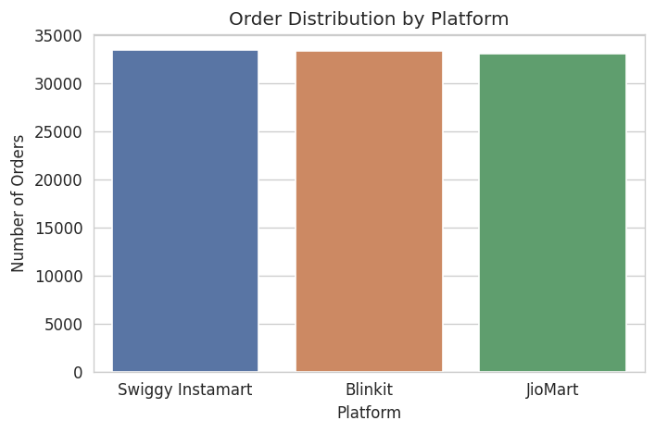
Figure 5.1: Order distribution across platforms
Order volume is almost evenly split across the three platforms - Swiggy Instamart (33,449 orders), Blinkit (33,424 orders), and JioMart (33,127 orders). This near-equal distribution suggests the dataset was designed to allow fair, unbiased comparison between platforms without any single platform dominating the sample.

5.2 Orders by Product Category
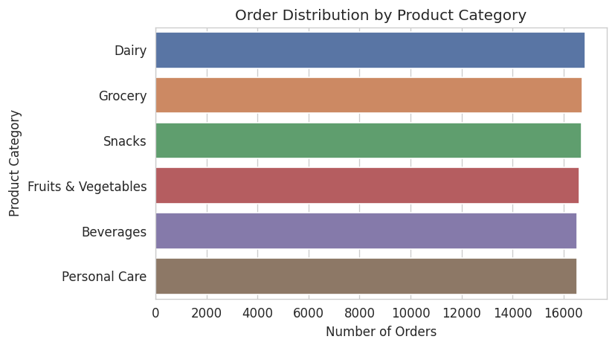
Figure 5.2: Order distribution across product categories
All six product categories - Dairy, Grocery, Snacks, Fruits & Vegetables, Beverages, and Personal Care - receive a roughly equal share of orders (between 16,500 and 16,900 each). This balanced spread indicates consistent demand across essential product types rather than dependence on any single category.

5.3 Delivery Time Distribution
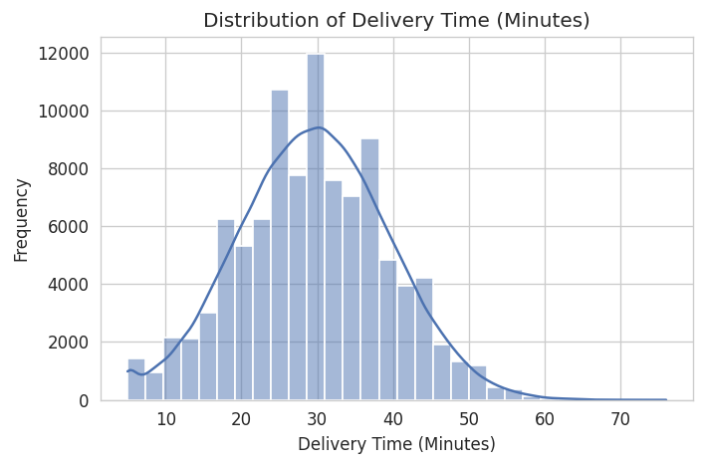
Figure 5.3: Distribution of delivery time (minutes)
Delivery time follows an approximately normal (bell-shaped) distribution centered around 29-30 minutes, ranging from 5 to 76 minutes. Most orders are delivered between 23 and 36 minutes (the interquartile range), indicating fairly consistent delivery performance with a small number of slower outliers.

5.4 Order Value Distribution
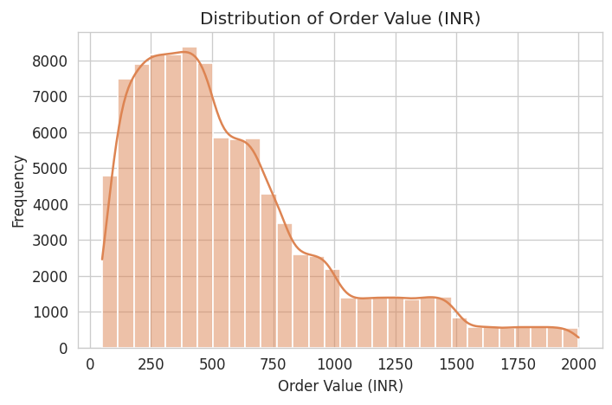
Figure 5.4: Distribution of order value (INR)
Order value is right-skewed, with the majority of orders falling between INR 283 and INR 770, and a median around INR 481. A smaller number of high-value orders extend the distribution up to INR 2,000, which is typical of retail spending patterns where most purchases are modest but occasional large baskets pull the average upward.

5.5 Service Rating Distribution
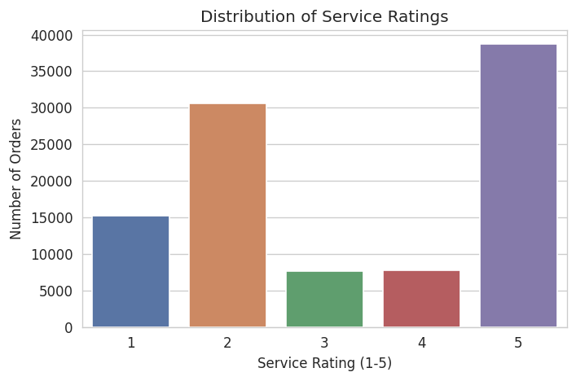
Figure 5.5: Distribution of service ratings
Service ratings show a distinctive bimodal pattern - a large cluster of 5-star ratings (38,688 orders) alongside a substantial group of 2-star ratings (30,552 orders), with fewer ratings of 1, 3, and 4. This suggests a polarized customer base: a majority of highly satisfied customers, along with a sizeable segment reporting a clearly unsatisfactory experience.

5.6 Delivery Delay Proportion
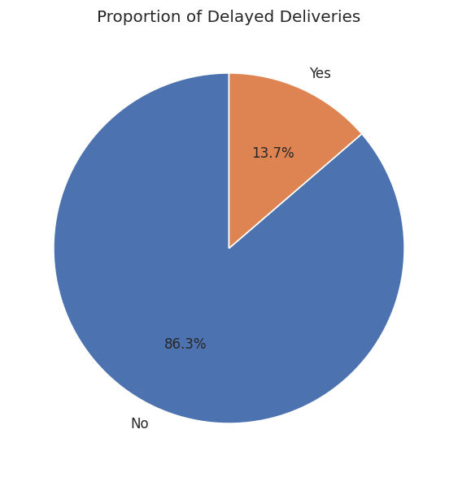
Figure 5.6: Proportion of delayed vs on-time deliveries
The vast majority of orders (86.3%) were delivered without delay, while 13.7% experienced a delay. This indicates that on-time delivery performance is generally strong across the platforms, though delays still affect a meaningful minority of orders.

5.7 Refund Requests Proportion
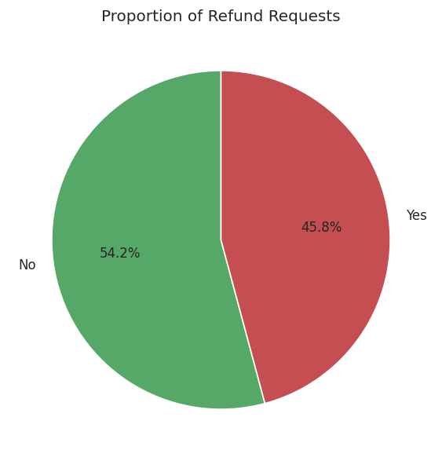
Figure 5.7: Proportion of orders with refund requests
Refunds were requested for 45.8% of all orders - a notably high proportion. This is a key area of concern for the business and warrants further investigation into product quality, delivery accuracy, and customer service, which is explored further in the bivariate and multivariate sections.

6. Bivariate Analysis
Bivariate analysis examines the relationship between two variables at a time, helping to identify patterns, dependencies, and potential drivers of business outcomes such as delivery delays and low ratings.

6.1 Platform vs Delivery Time
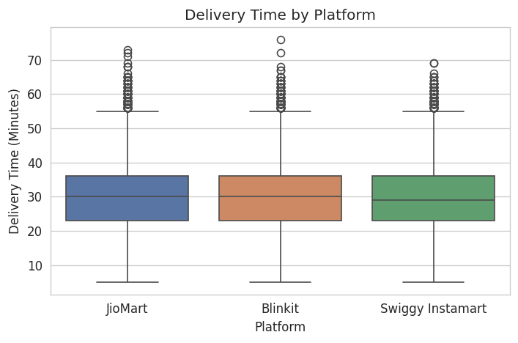
Figure 6.1: Delivery time distribution by platform
The median delivery time is nearly identical across all three platforms (around 29-30 minutes), with similar spread and outlier patterns. This suggests that platform choice alone does not significantly influence how quickly an order is delivered.

6.2 Product Category vs Order Value
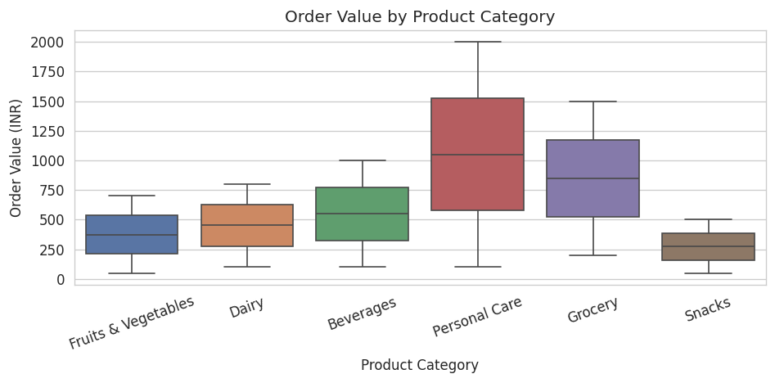
Figure 6.2: Order value distribution by product category
Order value differs sharply by product category. Personal Care (median ~INR 1,050) and Grocery (median ~INR 850) are the highest-value categories, followed by Beverages (~INR 550) and Dairy (~INR 450), while Fruits & Vegetables (~INR 375) and Snacks (~INR 300) have the lowest median order values. This shows that product category, unlike platform, is a meaningful driver of basket size.

6.3 Delivery Delay vs Service Rating
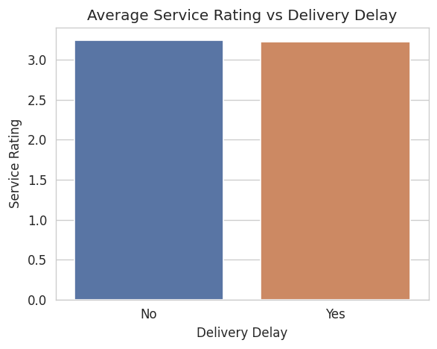
Figure 6.3: Average service rating - delayed vs on-time deliveries
Interestingly, the average service rating for delayed orders (about 3.23) is only marginally lower than for on-time orders (about 3.24). This suggests that, on average, delivery delay alone is not the primary driver of a poor service rating in this dataset - other factors such as product quality or order accuracy may play a larger role.

6.4 Platform vs Refund Requests
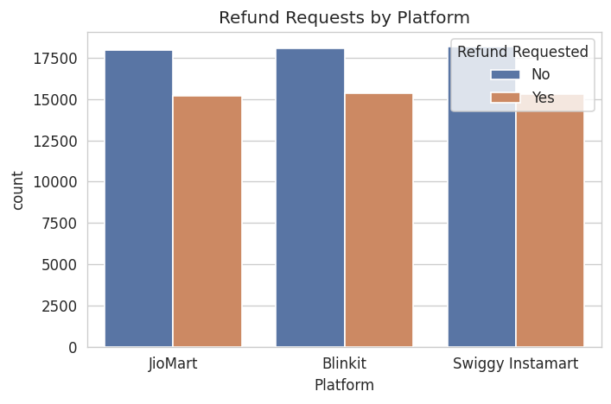
Figure 6.4: Refund requests by platform
Refund request counts are proportionally very similar across all three platforms (approximately 45-46% of orders on each platform). This indicates that the elevated refund rate is a systemic pattern across the industry sample rather than a weakness specific to any one platform.

6.5 Service Rating vs Delivery Time
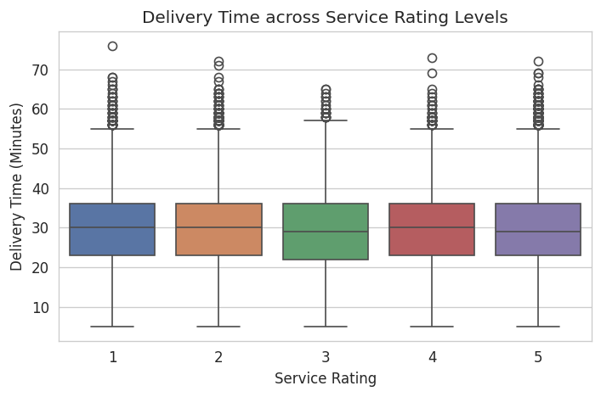
Figure 6.5: Delivery time distribution across service rating levels
Delivery time distributions are largely consistent across all rating levels (1 through 5), with overlapping medians and interquartile ranges. This reinforces the earlier finding that delivery speed is not the strongest driver of customer satisfaction in this dataset.

7. Multivariate Analysis
Multivariate analysis explores interactions among three or more variables simultaneously, offering deeper insight into combined effects that may not be visible when looking at variables one or two at a time.

7.1 Correlation Heatmap of Numeric Features
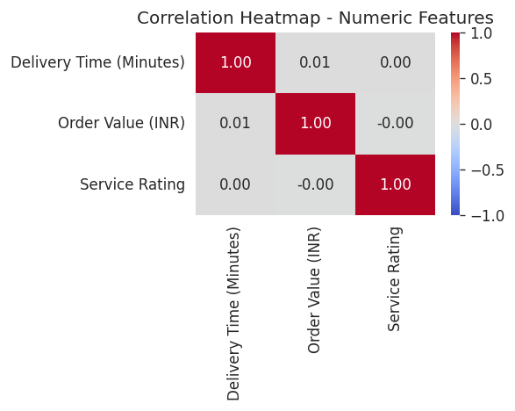
Figure 7.1: Correlation heatmap - Delivery Time, Order Value, Service Rating
The correlation heatmap shows near-zero correlation between Delivery Time, Order Value, and Service Rating (all coefficients between -0.01 and 0.01). This confirms that these three numerical variables behave largely independently of one another - a customer's rating is not simply a function of how fast their order arrived or how much they spent.

7.2 Platform, Delivery Delay & Average Service Rating
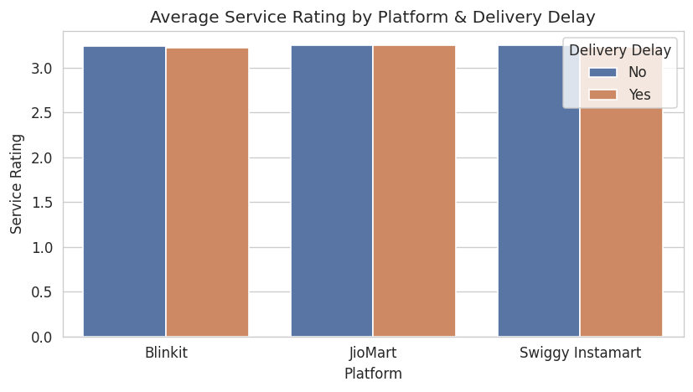
Figure 7.2: Average service rating by platform, split by delivery delay
When combining platform and delivery-delay status, average service ratings remain remarkably stable (clustered around 3.2-3.3) across all six platform-delay combinations. This three-way view confirms that neither the platform nor delivery delay, individually or combined, substantially shifts customer satisfaction in this dataset.

7.3 Product Category x Platform - Average Order Value
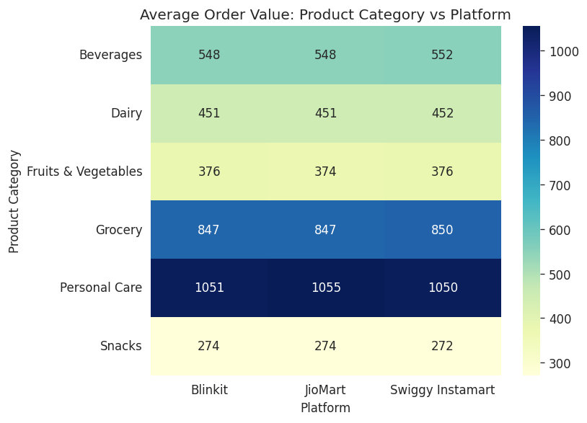
Figure 7.3: Average order value by product category and platform
This heatmap cross-tabulates average order value by product category and platform. A clear pattern emerges by category - Personal Care (~INR 1,050) and Grocery (~INR 848) command the highest average order values, followed by Beverages (~INR 550) and Dairy (~INR 451), while Fruits & Vegetables (~INR 375) and Snacks (~INR 273) have the lowest. Crucially, within each category the value is nearly identical across all three platforms (differing by only INR 2-5), showing that product category - not the platform - is what drives order value, and no platform is positioned as distinctly premium or budget.

7.4 Delivery Time, Order Value & Refund Requests
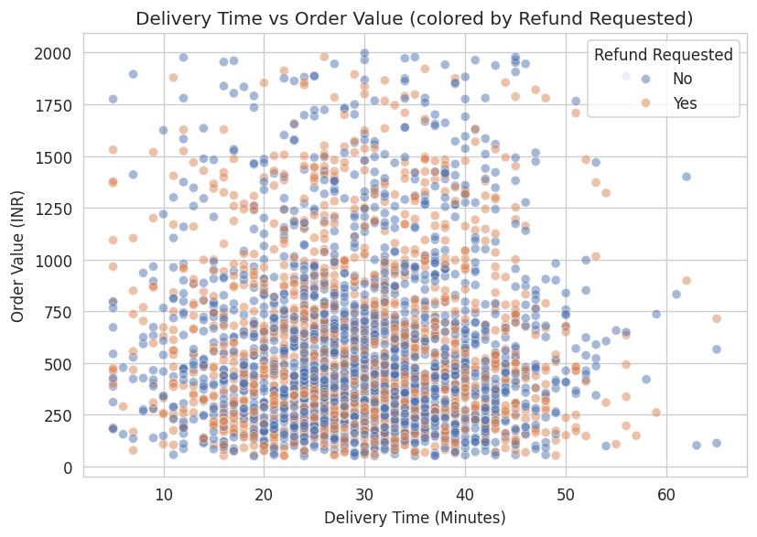
Figure 7.4: Delivery time vs order value, coloured by refund request (sample of 3,000 orders)
The scatter plot shows no visible clustering or separation between refunded and non-refunded orders across delivery time and order value. Refund requests appear scattered uniformly across the full range of both variables, suggesting that refund likelihood is not strongly explained by how long delivery took or how large the order was - pointing towards other causes such as product quality or wrong/missing items (as seen in the customer feedback text).

8. Key Insights & Conclusion

8.1 Summary of Findings
- Order volume and product-category demand are evenly balanced across all three platforms, indicating a well-sampled, comparable dataset.
- Delivery performance (time and delay rate) is highly consistent across platforms - no single platform is a clear leader or laggard.
- Service ratings are polarized: a large share of customers are highly satisfied (5-star), while a significant minority are clearly dissatisfied (2-star), with fewer in the middle.
- Refund requests are surprisingly high (45.8% of orders) and consistent across platforms, suggesting an industry-wide operational issue rather than a platform-specific one - likely linked to wrong/missing items based on customer feedback text.
- Numeric variables (delivery time, order value, service rating) show negligible correlation with one another, meaning customer satisfaction is likely driven by qualitative factors (order accuracy, product quality, packaging) not captured by these three metrics alone.

8.2 Business Recommendations
- Investigate root causes of the high refund rate, particularly around order accuracy (wrong/missing items), since delivery speed does not explain it.
- Analyze the free-text 'Customer Feedback' column further (e.g. with text mining/NLP) to quantify complaint themes.
- Since delivery time has minimal impact on ratings, platforms may get more satisfaction return from focusing investment on order accuracy and packaging quality rather than further speed optimization.

8.3 Limitations & Future Work
- The dataset does not include geographic or seasonal information, which could reveal regional or time-based delivery patterns.
- Customer Feedback is a short free-text field; formal sentiment analysis or topic modelling could quantify satisfaction drivers more precisely.
- Future iterations could incorporate a predictive model (e.g. classification) to predict refund likelihood or delivery delay from order attributes.

9. GitHub Repository Structure
The following folder structure is recommended for publishing this project on GitHub, keeping it clean and recruiter-friendly for resume purposes:
ecommerce-delivery-eda/
|-- data/
| |-- Ecommerce_Delivery_csv.csv
| |-- Ecommerce_Delivery_cleaned.csv
| |-- summary_statistics.csv
|-- charts/
| |-- (all 16 exported PNG charts)
|-- analysis.py
|-- README.md
|-- Ecommerce_Delivery_EDA_Documentation.docx
|-- requirements.txt

9.1 Suggested README.md Contents
- Project title and one-line description
- Problem statement and objectives
- Dataset source and column description
- Tools & technologies used
- Key visualizations (embed 2-3 sample charts)
- Key insights (bullet summary)
- How to run the project locally (pip install -r requirements.txt, python analysis.py)
- Author name and institute, with a link back to portfolio/LinkedIn

9.2 Resume Line Suggestion
Ecommerce Delivery Analytics (Python, Pandas, NumPy, Matplotlib, Seaborn) - Performed end-to-end EDA on a 100,000-row quick-commerce delivery dataset; cleaned data, and built 16 univariate, bivariate, and multivariate visualizations to derive insights on delivery performance, customer satisfaction, and refund behaviour across 3 platforms. Published on GitHub.

