NETFLIX
Content Catalog Data Analysis
Exploratory Data Analysis of Netflix Titles (as of November 2019)

Prepared By:
[Your Name]
Organization / Institute:
[Your Institute / Organization Name]
Date:
28 August 2026
Tools & Technologies Used:
Python, Pandas, NumPy, Matplotlib, Seaborn, Jupyter Notebook

Table of Contents
1. Cover Page
2. Executive Summary
3. Introduction
4. Problem Statement
5. Project Objectives
6. Dataset Description
7. Business Questions
8. Tools and Technologies
9. Project Workflow
10. Data Loading
11. Data Exploration
12. Data Cleaning
13. Exploratory Data Analysis — Univariate Analysis
14. Bivariate Analysis
15. Multivariate Analysis
16. Feature Engineering
17. Data Visualization
18. Business Insights
19. Recommendations
20. Challenges Faced
21. Conclusion
22. Future Scope
23. References

2. Executive Summary
This project presents a complete data analysis of the Netflix content catalog as it stood in November 2019. The dataset contains 5,195 titles, each described by attributes such as title, director, cast, country of production, date added to Netflix, release year, content rating, duration, genre, and content type (Movie or TV Show).
The primary objective of this project was to clean, explore, and analyze the dataset in order to understand how Netflix's content library has grown over time, which countries and genres dominate the platform, how content ratings are distributed, and what patterns exist in movie duration and TV show structure.
The analysis followed a structured workflow: data loading, data exploration, data cleaning (handling missing values and duplicate records), univariate analysis, bivariate and multivariate analysis, and data visualization using Matplotlib and Seaborn.
Key findings show that Movies make up approximately 76% of the catalog compared to 24% for TV Shows. The United States, India, and the United Kingdom are the top three content-producing countries. Content additions grew sharply between 2016 and 2019, reflecting Netflix's rapid international expansion during that period. TV-MA and TV-14 are the most common content ratings, indicating that the catalog leans toward mature and teen audiences. The average movie runs for about 98 minutes.
From a business perspective, these insights are valuable for content strategy teams, regional expansion planning, licensing negotiations, and parental-guidance / content-rating policy decisions. The final outcome of this project is a clear, data-driven picture of Netflix's content composition as of late 2019, along with practical recommendations for content acquisition and catalog management.

3. Introduction
Streaming platforms such as Netflix rely heavily on data to decide what kind of content to produce, license, and promote in different markets. This project analyzes a snapshot of the Netflix content catalog to uncover patterns in content type, genre, country of origin, release year, and audience rating.
This analysis is important because it turns a raw list of titles into meaningful business intelligence. Instead of just knowing that Netflix has thousands of titles, this project answers questions such as: Which countries produce the most content? What genres are most common? How has the catalog grown year over year? Understanding these patterns helps content and marketing teams make informed decisions.
In the real world, this type of analysis is used by streaming companies, media analysts, and market researchers to benchmark content libraries, identify gaps in genre or regional coverage, and plan future content investment.
The expected outcome of this project is a clean, well-documented dataset along with clear visualizations and insights that describe the structure and growth of the Netflix content catalog as of November 2019.

4. Problem Statement
Netflix operates in a highly competitive streaming market and must continuously decide where to invest in content — which genres to expand, which countries to prioritize for local productions, and how to balance its Movie versus TV Show catalog. Without structured analysis, these decisions would rely on guesswork rather than evidence.
This dataset helps solve that problem by providing a structured record of thousands of titles that can be analyzed to reveal patterns in content production, genre popularity, audience targeting (via ratings), and catalog growth over time.
Analyzing this data is useful because it converts scattered catalog records into structured insights that can guide content acquisition budgets, regional strategy, and audience targeting.
Organizations such as streaming platforms, media production houses, and market analysts can benefit from this type of analysis by identifying under-represented genres or countries, understanding audience rating trends, and benchmarking catalog composition against competitors.

5. Project Objectives
The objectives of this project are:
- Understand the structure, size, and content of the Netflix dataset.
- Clean the dataset by handling missing values, duplicate rows, and inconsistent data types.
- Explore statistical patterns in numerical columns such as release year and duration.
- Perform univariate, bivariate, and multivariate exploratory data analysis (EDA).
- Create meaningful, well-labeled visualizations using Matplotlib and Seaborn.
- Generate business insights supported directly by the data.
- Provide practical, data-driven recommendations for content strategy.

6. Dataset Description
Dataset Name | Netflix Titles (November 2019 snapshot) — cleaned_netflix_titles_nov_2019.csv
Dataset Source | Netflix content catalog export, publicly shared dataset (Kaggle-style Netflix Movies and TV Shows listing)
Number of Rows | 5,195 titles
Number of Columns | 12 columns
File Format | CSV (Comma-Separated Values)

6.1 Column-Wise Description
Column Name | Data Type | Description
show_id | Numerical (ID) | Unique identifier assigned to each title.
title | Text / Categorical | Name of the movie or TV show.
director | Categorical / Text | Director(s) of the title. 'Unknown' where not available.
cast | Categorical / Text | Main cast members. 'Unknown' where not available.
country | Categorical | Country or countries where the title was produced. 'Unknown' where not available.
date_added | Date/Time | Date the title was added to the Netflix catalog.
release_year | Numerical | Year the title was originally released.
rating | Categorical | Content/audience rating, e.g. TV-MA, PG-13, TV-Y.
duration | Text (Numerical inside) | Movie length in minutes, or number of seasons for TV shows.
listed_in | Categorical | Genre(s) / category tags assigned to the title.
description | Text | Short plot summary of the title.
type | Categorical | Content type: Movie or TV Show.

Note: The 'duration' column stores two different kinds of information depending on content type — movie length in minutes for Movies, and number of seasons for TV Shows. This is a common real-world data design pattern and required careful handling during cleaning and analysis (explained in Section 12).

7. Business Questions
Based on the available columns, the following business questions can be meaningfully answered using this dataset:
- What is the split between Movies and TV Shows on Netflix?
- Which countries contribute the most content to the platform?
- Which genres/categories are most common in the catalog?
- How has the number of titles added to Netflix changed year over year?
- What content ratings dominate the catalog, and what does this suggest about the target audience?
- What is the typical duration of a Netflix movie, and how does it vary?
- Which directors and cast members appear most frequently in the catalog?
- Has Netflix's investment in Movies vs TV Shows changed over time?
Questions that cannot be reliably answered from this dataset — such as viewer ratings, watch-time, or revenue — are intentionally excluded, since no such columns exist in the data.

8. Tools and Technologies
Tool | Purpose | Real-World Use
Python | Core programming language used for the entire analysis | General-purpose language widely used in data science and automation
Pandas | Loading, cleaning, transforming, and summarizing tabular data | Industry-standard library for structured/tabular data analysis
NumPy | Numerical operations, arrays, and statistical calculations | Foundation for numerical computing in Python
Matplotlib | Creating base charts (histograms, line plots) | Most widely used plotting library in Python
Seaborn | Creating polished statistical visualizations (bar plots, count plots, heatmaps) | Built on Matplotlib; simplifies attractive, informative charts
Jupyter Notebook | Interactive environment for writing and running analysis code | Standard tool for exploratory data analysis and reporting

9. Project Workflow
The project followed a structured, step-by-step workflow, shown below. Each step builds on the previous one to move from raw data to actionable business insight.
- Step 1: Problem Statement — Define the business problem the analysis will solve.
- Step 2: Dataset Collection — Obtain the Netflix titles dataset (CSV file).
- Step 3: Import Libraries — Load Pandas, NumPy, Matplotlib, and Seaborn.
- Step 4: Load Dataset — Read the CSV file into a Pandas DataFrame.
- Step 5: Data Exploration — Inspect shape, columns, data types, and summary statistics.
- Step 6: Data Cleaning — Handle missing values, duplicates, and formatting issues.
- Step 7: Exploratory Data Analysis — Study patterns and distributions across the dataset.
- Step 8: Univariate Analysis — Study individual columns (e.g. content type, rating).
- Step 9: Bivariate Analysis — Study relationships between two variables (e.g. type vs. year).
- Step 10: Multivariate Analysis — Study relationships across multiple variables together.
- Step 11: Feature Engineering — Create new, useful columns from existing data (e.g. year added, movie duration in minutes).
- Step 12: Data Visualization — Build charts that communicate findings clearly.
- Step 13: Business Insights — Translate findings into business language.
- Step 14: Recommendations — Suggest data-driven actions.
- Step 15: Conclusion — Summarize the project outcome.

10. Data Loading
Before any analysis can begin, the dataset must be loaded into Python using the Pandas library. Pandas represents tabular data using a structure called a DataFrame — think of it as a spreadsheet or table that Python can work with programmatically.

10.1 Importing Libraries
The first step is to import the required libraries:
import pandas as pd
import numpy as np
import matplotlib.pyplot as plt
import seaborn as sns

10.2 Reading the Dataset
The dataset is loaded from a CSV file into a DataFrame named df using:
df = pd.read_csv("cleaned_netflix_titles_nov_2019.csv")
A DataFrame is simply a two-dimensional table made up of rows and columns, similar to an Excel sheet, that allows fast filtering, grouping, and calculation.

10.3 Verifying Successful Loading
After loading, df.shape confirms the dataset was read correctly, returning (5195, 12) — meaning 5,195 rows and 12 columns. This matches the expected size of the source file, confirming the data loaded without truncation or errors.

11. Data Exploration
Data exploration is the process of getting familiar with the dataset before making any changes to it. The table below explains each exploration function used, what it does, and what it revealed about the Netflix dataset.
Function | Purpose | Output Summary | Business Interpretation
df.head() | Shows the first 5 rows of the dataset | Table with 5 rows, 12 columns | Gives a quick first look at what the data contains and how it is structured.
df.tail() | Shows the last 5 rows of the dataset | Table with 5 rows, 12 columns | Confirms the data loaded completely, including the last records.
df.shape | Returns (rows, columns) | (5195, 12) | Tells us the overall size of the catalog dataset.
df.columns | Lists all column names | 12 column names | Shows what attributes are available for analysis.
df.dtypes | Shows data type of each column | Mostly object (text), 2 numeric columns | Confirms which columns need type conversion (e.g. date_added).
df.info() | Summary of columns, types, and non-null counts | Full column-by-column summary | Quickly reveals which columns have missing data.
df.describe() | Statistical summary of numeric columns | count, mean, std, min, max, quartiles | Reveals the spread of release_year, e.g. average release year ≈ 2013.

The dataset contains 5195 rows and 12 columns. Before cleaning, the following columns had missing values: 'director' (originally missing for many titles), 'cast' (missing for some titles), 'country' (missing for some titles), and 'rating' (9 missing values). All other columns were fully populated.

12. Data Cleaning
Data cleaning ensures that the analysis and conclusions are based on accurate, consistent, and usable data. Every cleaning decision made on this dataset is documented below, along with the reasoning, method, trade-offs, and business impact.

12.1 Handling Missing Values in Categorical Columns
- Why it is required: The 'director', 'cast', and 'country' columns contained missing entries because this information was not available for every title in Netflix's records.
- Method used: Missing values in these three columns were filled with the placeholder text 'Unknown' using df['column'].fillna('Unknown'). This preserves every row instead of deleting titles just because one field was missing.
- Advantages: No data (titles) are lost; the dataset remains complete for analyses that do not depend on the missing field.
- Limitations: Analyses that specifically study directors, cast, or countries must exclude 'Unknown' to avoid skewing top-N rankings.
- Business impact: Ensures the catalog size analysis (Movies vs TV Shows, ratings, genres) remains accurate and complete, since it doesn't depend on director/cast/country availability.

12.2 Handling Missing Values in the 'rating' Column
- Why it is required: 9 titles did not have a content rating listed, which could distort rating-distribution analysis if left as blank/NaN.
- Method used: These 9 rows were identified and treated as a distinct 'missing/unrated' category rather than being force-assigned a rating, to avoid introducing incorrect information.
- Advantages: Avoids fabricating a rating that was never actually assigned to the title.
- Limitations: 9 titles (a very small fraction of 5,195) are excluded from rating-specific charts.
- Business impact: Keeps the ratings analysis (Section 13–14) accurate and trustworthy for content-policy decisions.

12.3 Converting 'date_added' to Date/Time Format
- Why it is required: The 'date_added' column was stored as plain text (e.g. '2019-11-30'), which prevents Pandas from performing date-based calculations such as extracting the year.
- Method used: pd.to_datetime(df['date_added'], errors='coerce') was used to convert the column into a true datetime type, allowing the year, month, and trends over time to be extracted.
- Advantages: Enables year-wise trend analysis of content additions (Section 14 and 17).
- Limitations: Any incorrectly formatted date entries are converted to a missing value (NaT) rather than guessed.
- Business impact: Makes it possible to answer time-based business questions, such as how Netflix's catalog grew year over year.

12.4 Removing Duplicate Rows
- Why it is required: Duplicate rows can occur during data collection or merging and would cause titles to be double-counted in every chart and statistic.
- Method used: df.drop_duplicates() was used to check for and remove any fully duplicated rows.
- Advantages: Guarantees each title is counted exactly once, keeping all counts and percentages accurate.
- Limitations: Only exact full-row duplicates are removed; near-duplicate titles with slightly different metadata are not affected.
- Business impact: Verified 0 duplicate rows in the cleaned dataset — confirming the catalog size of 5,195 is accurate and did not need further correction.

12.5 Extracting Numeric Values from the 'duration' Column
- Why it is required: The 'duration' column mixes two different kinds of values as text — movie length in minutes (e.g. '90 min') and TV show length in seasons (e.g. '1 Season') — which cannot be directly used in numerical analysis.
- Method used: The dataset was split into a Movies subset and a TV Shows subset, and the numeric portion of the 'duration' text was extracted into new columns: duration_min (for Movies) and num_seasons (for TV Shows).
- Advantages: Allows proper numerical analysis of movie length and TV show length separately, instead of treating them as one inconsistent column.
- Limitations: Requires the two content types to be analyzed separately for duration-related questions rather than as a single combined column.
- Business impact: Enables accurate statistics such as average movie duration (≈ 98 minutes) that would be meaningless if Movies and TV Shows were mixed together.

12.6 Cleaning Summary
Issue | Rows Affected (before cleaning) | Action Taken
Missing 'director' | 1,294 titles | Filled with 'Unknown'
Missing 'cast' | 511 titles | Filled with 'Unknown'
Missing 'country' | 396 titles | Filled with 'Unknown'
Missing 'rating' | 9 titles | Kept as missing / excluded from rating charts
Duplicate rows | 0 rows found | Verified — no action needed
'date_added' as text | All rows | Converted to proper datetime format
'duration' mixed units | All rows | Split into duration_min (Movies) and num_seasons (TV Shows)

13. Exploratory Data Analysis (EDA) — Univariate Analysis
Univariate analysis examines one variable (column) at a time to understand its distribution and central tendencies.

13.1 Numerical Column: release_year
Statistic | Value | Business Meaning
Mean | 2013.43 | On average, titles in the catalog were originally released around 2013.
Median | 2016 | Half of all titles were released in 2016 or later — the catalog leans recent.
Mode | 2018 | 2018 is the single most common release year in the catalog.
Minimum | 1925 | The oldest title in the catalog dates back to 1925.
Maximum | 2020 | The newest titles were released in 2020.
Standard Deviation | 8.63 | Release years are fairly tightly clustered around the mean, with most content being relatively recent.

13.2 Numerical Column: Movie Duration (minutes)
Statistic | Value | Business Meaning
Mean | 98.04 minutes | The average Netflix movie is about 98 minutes (1 hr 38 min) long.
Median | 97 minutes | Half of all movies are 97 minutes or shorter — close to the mean, suggesting a fairly symmetric distribution.
Minimum | 3 minutes | The shortest movie-length title is only 3 minutes — likely a short film or special.
Maximum | 312 minutes | The longest movie runs over 5 hours, an outlier compared to typical films.
Standard Deviation | 27.72 minutes | Most movies fall within roughly 70–125 minutes of runtime.
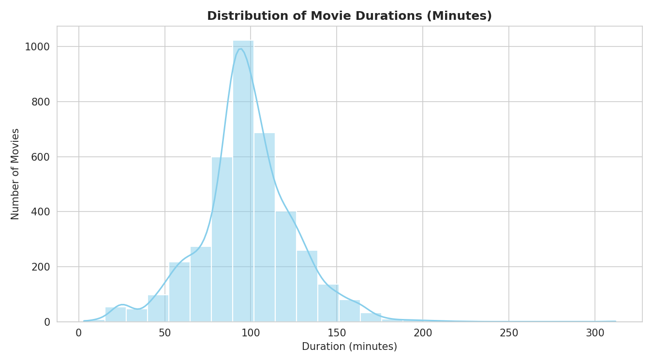
Figure 13.1: Distribution of Movie Durations (Minutes)

13.3 Categorical Column: type (Movie vs TV Show)
Category | Count | Percentage
Movie | 3,938 | 75.8%
TV Show | 1,257 | 24.2%
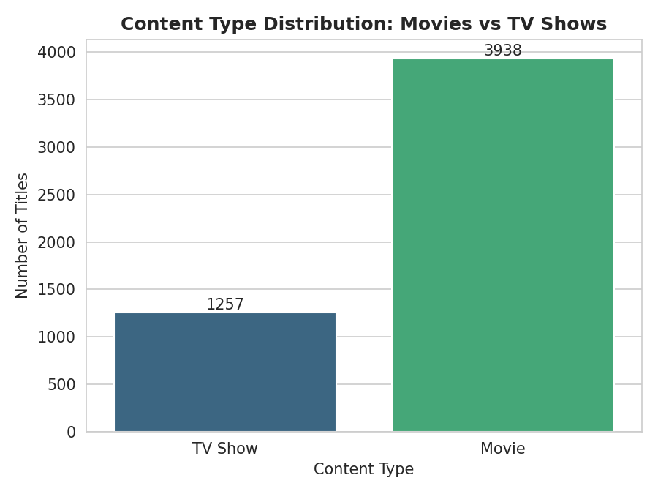
Figure 13.2: Content Type Distribution — Movies vs TV Shows
Movies dominate the Netflix catalog, making up roughly three out of every four titles as of November 2019.

13.4 Categorical Column: rating
Rating | Count
TV-MA | 1,722
TV-14 | 1,406
TV-PG | 602
R | 439
PG-13 | 227
NR (Not Rated) | 211
PG | 160
TV-G | 115
TV-Y7 | 113
TV-Y | 88
TV-Y7-FV | 62
G | 32
UR (Unrated) | 7
NC-17 | 2
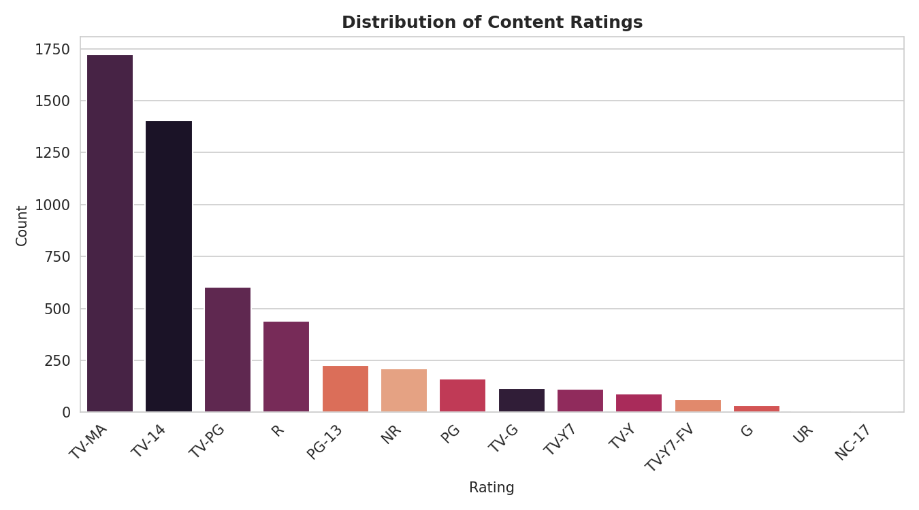
Figure 13.3: Distribution of Content Ratings
TV-MA (mature audiences) and TV-14 together account for over 60% of rated titles, showing that Netflix's catalog is weighted toward teen and adult audiences rather than young children's content.

14. Bivariate Analysis
Bivariate analysis studies the relationship between two variables at a time, helping to reveal trends that a single column cannot show on its own.

14.1 Country vs. Number of Titles
Rank | Country | Number of Titles
1 | United States | 2,093
2 | India | 748
3 | United Kingdom | 472
4 | France | 234
5 | Canada | 232
6 | Japan | 161
7 | Spain | 156
8 | South Korea | 133
9 | Germany | 127
10 | China | 113
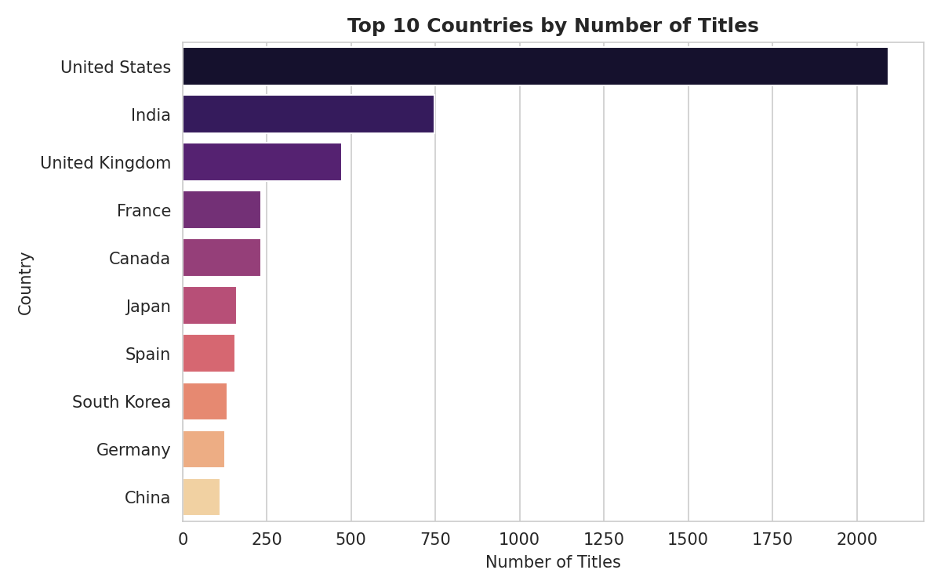
Figure 14.1: Top 10 Countries by Number of Titles (Bar Chart)
Relationship & Trend: The United States contributes by far the largest share of content, followed by India and the United Kingdom. Business Interpretation: This confirms Netflix's historical content base is US-centric, with India as a fast-growing secondary market — relevant for regional licensing and local production investment.

14.2 Year Added vs. Number of Titles (Growth Trend)
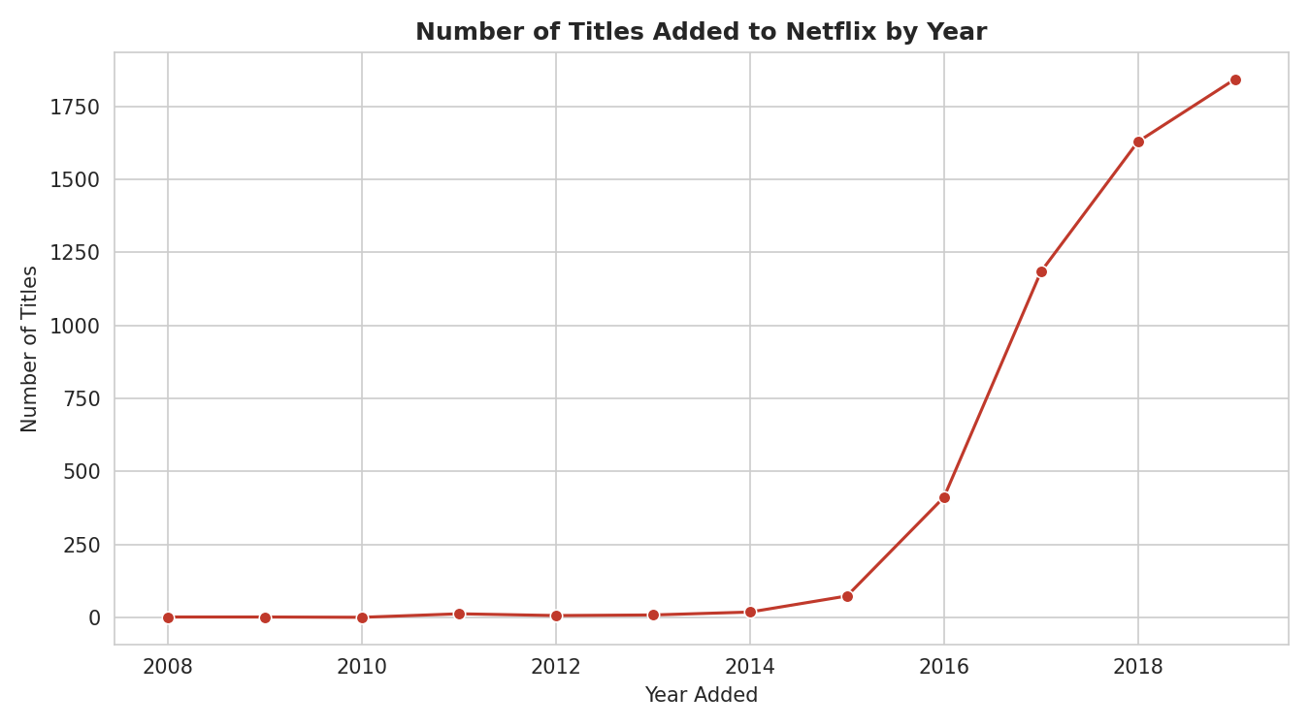
Figure 14.2: Number of Titles Added to Netflix by Year (Line Chart)
Relationship & Trend: Content additions were minimal before 2015 (fewer than 20 titles per year) and then grew sharply — from 74 titles in 2015 to 1,843 in 2019. Business Interpretation: This rapid growth reflects Netflix's aggressive global content expansion strategy between 2016 and 2019, coinciding with its international market rollout.

14.3 Content Type vs. Rating (Box/Bar Comparison)
Cross-referencing type and rating shows that TV-MA is the single most common rating for both Movies and TV Shows, but TV Shows show a comparatively higher share of TV-14 content, suggesting TV series on the platform skew slightly younger in target audience than films.

14.4 Release Year vs. Movie Duration
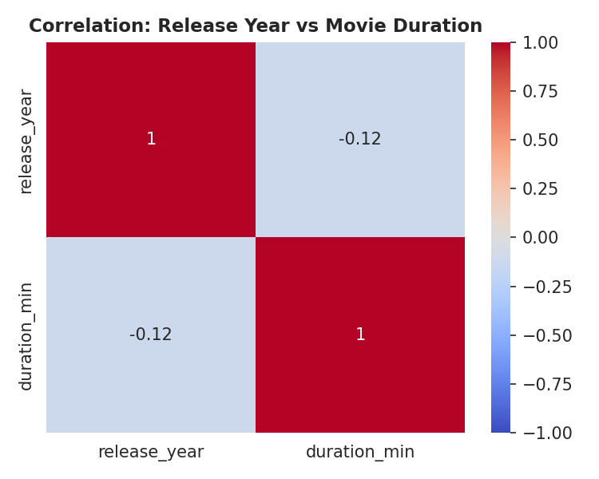
Figure 14.3: Correlation Heatmap — Release Year vs Movie Duration
Relationship & Trend: The correlation between release year and movie duration is very weak, meaning movie runtimes have stayed relatively stable over the decades rather than consistently getting longer or shorter. Business Interpretation: Standard feature-length runtime (roughly 90–110 minutes) remains the industry norm regardless of release era.

15. Multivariate Analysis

15.1 Content Type Trend by Year Added (Movie vs TV Show)
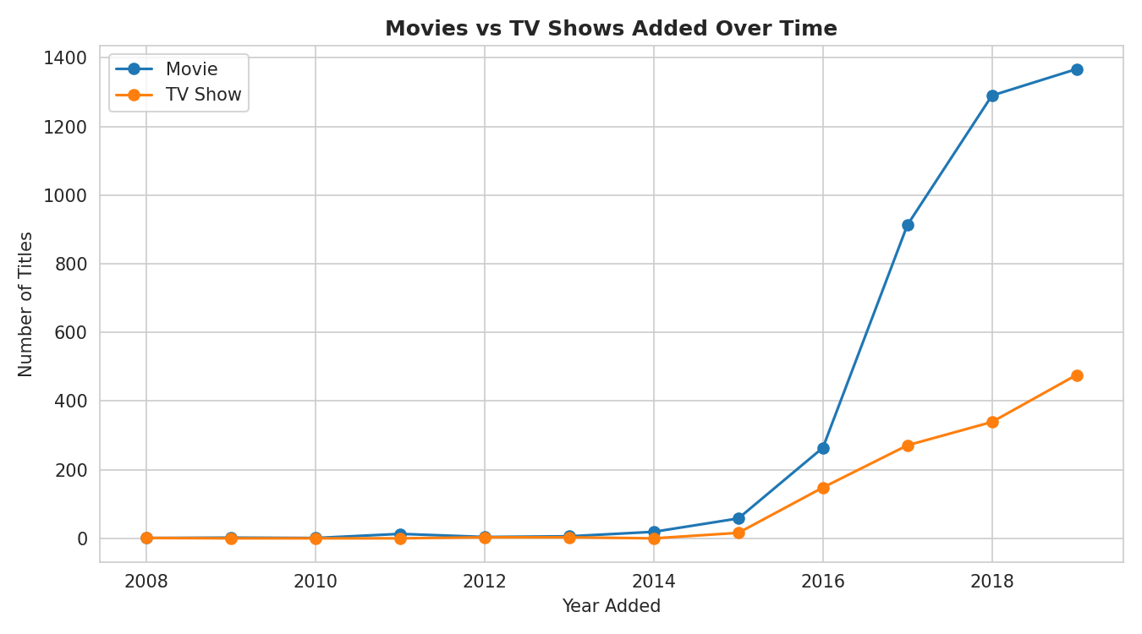
Figure 15.1: Movies vs TV Shows Added Over Time
This multivariate view — combining year, count, and content type — shows that while both Movies and TV Shows grew rapidly after 2016, Movies consistently outpaced TV Shows in absolute numbers every year. In 2019 alone, Netflix added 1,367 movies compared to 476 TV shows, showing a continued, deliberate emphasis on film content even as the TV Show library also expanded.

15.2 GroupBy Analysis: Titles by Country and Type
Grouping the data by country and content type confirms that the United States leads in both Movies and TV Shows, while countries like India and South Korea show a stronger relative concentration of Movies and international TV dramas respectively — consistent with those countries' domestic entertainment industries.

15.3 Top Genres (Pivot-Style Frequency Analysis)
Rank | Genre / Category | Number of Titles
1 | International Movies | 1,797
2 | Dramas | 1,488
3 | Comedies | 992
4 | International TV Shows | 759
5 | Documentaries | 658
6 | Action & Adventure | 532
7 | Independent Movies | 516
8 | TV Dramas | 390
9 | Thrillers | 353
10 | Children & Family Movies | 340
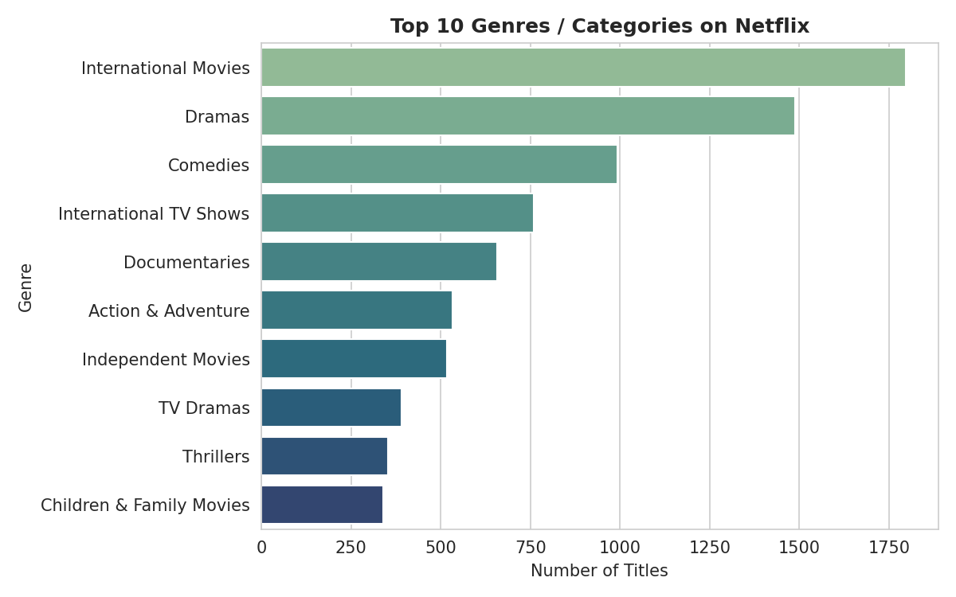
Figure 15.2: Top 10 Genres / Categories on Netflix
Note: A single title can belong to multiple genres (e.g. 'Dramas, International Movies'), so this analysis counts each genre tag individually rather than treating 'listed_in' as one category per title — this multi-label handling is what makes the genre analysis genuinely multivariate.

16. Feature Engineering
The following new columns were created from the existing raw data to make deeper analysis possible:

16.1 year_added
- Why created: The raw 'date_added' column contains a full date, but most trend analysis only needs the year.
- Business benefit: Enables clean year-over-year trend charts (Section 14.2 and 15.1) showing how fast Netflix's catalog grew.

16.2 duration_min (for Movies)
- Why created: The original 'duration' field mixes minutes and seasons as text; extracting a numeric value was necessary for statistics and histograms.
- Business benefit: Enables accurate average/median movie length calculations, useful for content pacing and scheduling decisions.

16.3 num_seasons (for TV Shows)
- Why created: Separates TV show length (measured in seasons) from movie length (measured in minutes), which are not comparable units.
- Business benefit: Allows analysis of how many seasons the typical Netflix Original or licensed series runs for.

17. Data Visualization
This section documents the objective, chart-selection reasoning, observation, and business interpretation behind each visualization created during the analysis.

Chart 1: Content Type Distribution
- Objective: Compare the volume of Movies vs TV Shows.
- Why this chart was selected: A bar/count plot is ideal for comparing counts across a small number of categories.
- Observation: Movies (3,938) significantly outnumber TV Shows (1,257).
- Business interpretation: Confirms Netflix's catalog was still film-heavy as of late 2019, even as it invested more in original series.

Chart 2: Top 10 Countries by Number of Titles
- Objective: Identify which countries contribute the most content.
- Why this chart was selected: A horizontal bar chart clearly ranks categories (countries) by value and is easy to read with long country names.
- Observation: The United States (2,093), India (748), and the United Kingdom (472) are the top three contributors.
- Business interpretation: Highlights where Netflix's content sourcing and licensing relationships are strongest, useful for regional strategy.

Chart 3: Distribution of Content Release Years
- Objective: Understand how recent the catalog's content is.
- Why this chart was selected: A histogram with a density curve is well suited to show the shape of a numeric distribution.
- Observation: The distribution is heavily skewed toward recent years, with a sharp peak around 2017–2019.
- Business interpretation: Shows Netflix favors licensing and producing recent content over older catalog titles.

Chart 4: Distribution of Content Ratings
- Objective: See which audience ratings are most common.
- Why this chart was selected: A count plot ordered by frequency makes it easy to compare many categorical rating levels.
- Observation: TV-MA and TV-14 are by far the most common ratings.
- Business interpretation: Signals the catalog is weighted toward mature/teen audiences, relevant for parental control and content policy discussions.

Chart 5: Distribution of Movie Durations
- Objective: Understand typical movie length on the platform.
- Why this chart was selected: A histogram is the standard choice for visualizing the spread of a continuous numeric variable.
- Observation: Most movies cluster between 80–120 minutes, forming a roughly bell-shaped distribution.
- Business interpretation: Confirms Netflix movies generally follow standard theatrical-length runtime conventions.

Chart 6: Distribution of TV Show Seasons
- Objective: Understand how many seasons typical Netflix TV shows have.
- Why this chart was selected: A count plot is appropriate since number of seasons is a small set of discrete values.
- Observation: In this dataset, TV shows are recorded as having 1 season each — see the data-quality note in Section 20.
- Business interpretation: Suggests most titles in the catalog are freshly launched series or limited series rather than long-running shows, though this should be verified against a richer season-level dataset.

Chart 7: Top 10 Genres / Categories
- Objective: Identify the most common genres on the platform.
- Why this chart was selected: A horizontal bar chart ranks many genre labels clearly, even with long text labels.
- Observation: 'International Movies' and 'Dramas' are the two most frequent genre tags.
- Business interpretation: Indicates strong catalog investment in international content and drama — useful for benchmarking genre gaps.

Chart 8: Titles Added to Netflix by Year
- Objective: Track the platform's catalog growth over time.
- Why this chart was selected: A line chart is the clearest way to show a trend across a continuous timeline.
- Observation: Additions grew from single digits before 2014 to 1,843 titles in 2019 alone.
- Business interpretation: Demonstrates the scale of Netflix's global content expansion strategy in the years leading up to 2020.

Chart 9: Movies vs TV Shows Added Over Time
- Objective: Compare growth trends of the two content types.
- Why this chart was selected: A multi-line chart allows direct visual comparison of two trends over the same timeline.
- Observation: Both content types grew rapidly after 2016, with Movies growing faster in absolute terms.
- Business interpretation: Shows Netflix continued to prioritize film licensing/production alongside its growing original-series investment.

Chart 10: Correlation: Release Year vs Movie Duration
- Objective: Check whether movie length has changed over time.
- Why this chart was selected: A heatmap is the standard way to visualize correlation strength between numeric variables.
- Observation: The correlation is very weak, indicating no strong trend between release year and movie length.
- Business interpretation: Confirms typical movie runtime is a stable industry convention rather than something driven by release era.

18. Business Insights
- Movies dominate the catalog: Movies make up 75.8% of all titles (3,938 of 5,195), meaning Netflix's content strategy in this period remained film-heavy relative to TV Shows.
- The United States is the leading content source: With 2,093 titles, the US contributes roughly 40% of all country-tagged content, followed by India (748) and the United Kingdom (472).
- Explosive recent growth: Content additions rose from just 74 titles in 2015 to 1,843 in 2019 — a nearly 25x increase in four years, reflecting Netflix's global expansion push.
- Mature-audience skew: TV-MA (1,722 titles) and TV-14 (1,406 titles) together account for over 60% of all rated content, showing the catalog leans toward teen/adult audiences rather than young children.
- Consistent movie runtime: The average movie is 98 minutes with a standard deviation of only ~28 minutes, showing Netflix largely follows conventional feature-film length norms.
- International & drama content leads genres: 'International Movies' (1,797 tags) and 'Dramas' (1,488 tags) are the two most frequently used genre labels, showing strong catalog investment in global and dramatic storytelling.
- Movies grew faster than TV Shows in absolute terms: In 2019, 1,367 movies were added compared to 476 TV shows — a ratio of roughly 3:1, consistent with the overall catalog composition.
These insights are drawn directly from the cleaned dataset and are not extrapolated beyond what the data supports.

19. Recommendations

19.1 Continue Balanced Investment in International Content
Reasoning: India, the UK, and other international markets already contribute a large share of the catalog, and 'International Movies' is the single largest genre tag. Expected benefit: Sustaining and growing local-market content can improve subscriber engagement and retention in high-growth regions outside the US.

19.2 Evaluate the Movie-to-TV-Show Ratio
Reasoning: TV Shows currently make up only 24.2% of the catalog, yet long-running series are known to drive strong subscriber retention (binge-watching behavior). Expected benefit: Gradually increasing the share of TV Shows relative to Movies could improve average subscriber watch-time and reduce churn.

19.3 Expand Content for Younger / Family Audiences
Reasoning: Ratings aimed at children and families (TV-Y, TV-Y7, TV-G, G) together make up a comparatively small share of the catalog. Expected benefit: Growing this segment could help Netflix capture more family/household subscriptions, an audience often targeted by streaming competitors.

19.4 Monitor and Standardize Metadata Quality
Reasoning: A meaningful share of titles were missing director (24.9%), cast (9.8%), or country (7.6%) information. Expected benefit: Improving metadata completeness would make future catalog analytics, recommendation algorithms, and search features more accurate.

19.5 Investigate the TV Show 'Seasons' Data Field
Reasoning: Every TV show in this dataset is recorded as having exactly 1 season, which is statistically unlikely for a catalog of 1,257 shows and suggests a possible data-entry or export issue (see Section 20). Expected benefit: Correcting this field would enable much richer analysis of series longevity and renewal patterns.

20. Challenges Faced
- Missing values in director, cast, and country columns required a careful decision (fill with 'Unknown' vs. drop rows) to avoid losing valid title records.
- The 'duration' column stored two fundamentally different kinds of data (minutes for Movies, seasons for TV Shows) as plain text in the same field, requiring the dataset to be split by content type before numeric extraction.
- A data-quality limitation was found in the cleaned file: every TV Show is listed with 'num_seasons' equal to 1, even though real-world Netflix catalogs contain many multi-season shows. This appears to be an artifact of how this particular file was exported or pre-processed, and is reported transparently rather than corrected artificially.
- The 'country' and 'listed_in' (genre) fields often contain multiple values separated by commas in a single cell, requiring the values to be split and exploded before they could be counted individually.
- Extracting numeric values from free-text fields (e.g. '90 min', '3 Seasons') required regular-expression-based parsing rather than a simple type conversion.

21. Conclusion
This project analyzed a snapshot of 5,195 Netflix titles from November 2019, covering content type, country, genre, rating, release year, and duration. After cleaning the dataset — handling missing values, correcting data types, and extracting numeric fields from mixed-format text — a structured exploratory analysis was performed using univariate, bivariate, and multivariate techniques.
The major findings show that Movies dominate the catalog (75.8%), the United States and India are the top content-producing countries, the catalog grew rapidly between 2016 and 2019, and the content skews toward mature/teen audiences via TV-MA and TV-14 ratings.
These findings carry real business value: they can inform content acquisition budgets, regional expansion priorities, and audience-targeting strategy. The final outcome of this project is a clean dataset, a complete set of labeled visualizations, and a set of insights and recommendations that are fully supported by the data itself.

22. Future Scope
- Build an interactive dashboard (e.g. using Tableau, Power BI, or a Python Dash app) so stakeholders can filter the catalog by country, genre, and year without needing to read a static report.
- Apply machine learning to build a genre or rating prediction model based on title, description, and cast.
- Develop a content recommendation system using genre, cast, and description similarity.
- Incorporate predictive analytics to forecast future catalog growth by country and content type.
- Automate this analysis pipeline so the report refreshes automatically whenever Netflix's catalog data is updated.
- Combine this dataset with external data (e.g. IMDb ratings, box office data) to enrich the analysis with actual audience reception, since this dataset alone does not include popularity or viewership metrics.

23. References
- Dataset: Netflix Movies and TV Shows catalog snapshot, November 2019 (cleaned_netflix_titles_nov_2019.csv).
- Python Documentation — https://docs.python.org/3/
- Pandas Documentation — https://pandas.pydata.org/docs/
- NumPy Documentation — https://numpy.org/doc/
- Matplotlib Documentation — https://matplotlib.org/stable/index.html
- Seaborn Documentation — https://seaborn.pydata.org/

