DATA ANALYSIS PROJECT REPORT
Vegetable Product & Category Master Data Analysis
An Exploratory Analysis of a Retail Vegetable Product Catalogue ("Superset")

Field | Details
Prepared By | Data Analyst (Student / Trainee Project)
Dataset File | cleaned_superset__2_.csv
Date | 25 August 2026
Tools Used | Python, Pandas, NumPy, Matplotlib, Seaborn
Technologies Used | Jupyter Notebook / VS Code, Microsoft Word
Project Type | College / Internship / Portfolio Data Analysis Project

2. Executive Summary
This project analyses a small but well-structured master dataset that lists vegetable products sold in a retail or wholesale system, along with the category each product belongs to. The dataset, named “cleaned_superset,” contains 251 records and 4 columns: Item Code, Item Name, Category Code, and Category Name.
The objective of this project is to understand the structure of the product catalogue, verify its data quality, study how products are distributed across categories, and generate simple, data-backed business insights that a retail or supply-chain team could use for catalogue management and category planning.
The dataset is a clean master/reference table rather than a transactional sales dataset — it does not contain prices, quantities, dates, or customer information. Because of this, the analysis in this document focuses on data quality checks, category distribution, product-naming patterns, and catalogue-structure insights, rather than sales trends or financial metrics. Every section below has been adapted to match what the data can honestly support.
Key Findings: The catalogue is dominated by Flower/Leaf Vegetables (40% of all items) and Edible Mushroom (29%), while Cabbage is the smallest category with only 5 items (2%).
Data Quality: The dataset has zero missing values and zero fully duplicate rows, indicating it is already a cleaned master file.
Business Value: The findings help a retail/procurement team see which categories carry the widest product range and which ones may need catalogue expansion.
Overall, this project demonstrates a complete beginner-friendly data analysis workflow — from loading and cleaning data to exploration, visualization, and business recommendations — applied honestly to the kind of dataset actually provided.

3. Introduction
Every retail or wholesale business that sells physical goods needs a well-organized product catalogue. A product catalogue lists every item sold, along with a unique identifying code and the category it belongs to (for example, “Capsicum” or “Edible Mushroom”). This project studies exactly this kind of data for a vegetable business.
Understanding how many products exist in each category, how products are named, and whether the catalogue data is clean and consistent is an important first step before any sales, pricing, or inventory analysis can be trusted. A messy or poorly categorized product list leads to wrong reports later, even if the sales data itself is perfect.
This project is important because it shows how a data analyst approaches even a simple-looking dataset with a structured, professional process: checking data quality first, exploring the categorical structure, and only then drawing conclusions that are actually supported by the data.
Expected Outcome: A clear picture of how the vegetable product catalogue is organized, confirmation that the master data is clean, and practical recommendations for catalogue management.

4. Problem Statement
A retail or wholesale vegetable business maintains a master list of every product it sells, tagged with a category. Business teams (merchandising, procurement, inventory) need answers to simple but important questions: How many products do we sell? How are they grouped into categories? Are there naming inconsistencies or duplicate-looking entries that could confuse staff or customers?
Without a structured analysis of this master data, teams may not notice that one category has far more products than another, or that many products share almost the same name with only a small numbered suffix distinguishing them — both of which affect how the catalogue should be managed, filtered, and displayed.
How organizations benefit: A clean understanding of the product catalogue supports better shelf planning, more accurate category-level reporting, and a foundation for future sales or inventory analysis once transactional data is available.

5. Project Objectives
- Understand the structure and content of the vegetable product master dataset.
- Check the dataset for missing values, duplicates, and formatting inconsistencies.
- Explore how products are distributed across the six vegetable categories.
- Study product-naming patterns, including numbered variants such as “Eggplant (1)” and “Eggplant (2)”.
- Create simple, meaningful visualizations of the category distribution.
- Generate business insights and recommendations that are fully supported by the data.
- Document the entire process in a clear, beginner-friendly, professional format.

6. Dataset Description
Dataset Name: cleaned_superset__2_.csv
Dataset Source: Provided directly by the user as a cleaned CSV export (appears to be a retail/wholesale vegetable product catalogue, likely from a point-of-sale or ERP “superset” system)
Number of Rows: 251 product records
Number of Columns: 4
The table below describes each column in the dataset:
Column Name | Data Type | Classification | Description
Item Code | Integer (15 digits) | Numerical (Identifier) | A unique 15-digit code identifying each product. Acts as a primary key, not a quantity.
Item Name | Text | Categorical / Text | The name of the vegetable product, e.g. “Chinese Cabbage”, “Red Hot Peppers”.
Category Code | Integer (10 digits) | Numerical (Identifier) | A 10-digit code identifying the category the product belongs to.
Category Name | Text | Categorical | The name of the category, one of 6 values (e.g. “Capsicum”, “Edible Mushroom”).
Note on scope: This dataset is a master/reference table, not a transactional dataset. It has no price, quantity, date, store, or customer columns. As a result, this document does not include sales trends, revenue analysis, or time-based patterns, since the data does not support them. All analysis below is limited to what these four columns can honestly show.

7. Business Questions
The following business questions can be genuinely answered using this dataset:
- How many unique products and categories exist in the vegetable catalogue?
- Which category has the largest and smallest number of products?
- What percentage share does each category hold in the overall catalogue?
- Is each category consistently linked to one category code (i.e. is the coding system reliable)?
- How many products appear to be numbered variants of the same base item (e.g. “Eggplant (1)”, “Eggplant (2)”)?
- Are there any exact duplicate product names, and if so, in which categories?
Questions such as “which product sells the most” or “which month has the highest sales” cannot be answered, because the dataset has no sales, quantity, price, or date columns. These questions have intentionally been left out of this analysis.

8. Tools and Technologies
Tool | Purpose | Real-World Use
Python | Core programming language for the analysis | Automating data cleaning and analysis at scale
Pandas | Loading, cleaning, and exploring tabular data | Used by analysts to summarize and filter large datasets
NumPy | Numerical operations that support Pandas | Underlying engine for fast calculations
Matplotlib | Creating static charts (bar chart) | Used to build custom, presentation-ready charts
Seaborn | Creating statistical charts (pie/count-style views) | Used for quick, attractive category comparisons
Jupyter Notebook / VS Code | Writing and running Python code interactively | Standard environment for data analysis work

9. Project Workflow
The analysis followed a structured, step-by-step workflow, shown below:
- 1. Problem Statement — Define what we want to learn from the catalogue.
- 2. Dataset Collection — Receive the cleaned_superset CSV file.
- 3. Import Libraries — Load Pandas, NumPy, Matplotlib, Seaborn.
- 4. Load Dataset — Read the CSV into a Pandas DataFrame.
- 5. Data Exploration — Check shape, columns, data types, and sample rows.
- 6. Data Cleaning — Check for missing values, duplicates, and inconsistent text.
- 7. Exploratory Data Analysis — Study category frequencies and naming patterns.
- 8. Bivariate Analysis — Compare Category Code against Category Name.
- 9. Feature Engineering — Create helper columns such as “base item name” and “variant flag.”
- 10. Data Visualization — Build bar and pie charts of category distribution.
- 11. Business Insights — Summarize what the data shows.
- 12. Recommendations — Suggest practical next steps.
- 13. Conclusion — Wrap up the findings.
Each step is explained in detail in the sections that follow.

10. Data Loading
Before any analysis, the dataset must be loaded into Python so it can be examined and manipulated. Pandas stores tabular data (rows and columns, just like Excel) in a structure called a DataFrame.

Importing Libraries
import pandas as pd

Reading the Dataset
df = pd.read_csv("cleaned_superset__2_.csv")
This single line reads the CSV file and stores it as a DataFrame named df. A DataFrame is simply Python's version of a spreadsheet — rows are records (in this case, individual products) and columns are fields (Item Code, Item Name, Category Code, Category Name).

Verifying Successful Loading
print(df.shape) # Output: (251, 4)
The output confirms the dataset loaded correctly with 251 rows and 4 columns, matching the raw CSV file.

11. Data Exploration
Before cleaning or analysing the data, we explore its basic structure using standard Pandas functions.
Function | Purpose | Business Interpretation
df.head() | Shows the first 5 rows | Gives a first look at real product entries, e.g. “Niushou Shengcai” under Flower/Leaf Vegetables.
df.shape | Shows (rows, columns) | Confirms the catalogue has 251 products described across 4 fields.
df.columns | Lists column names | Confirms the four fields available for analysis: Item Code, Item Name, Category Code, Category Name.
df.dtypes | Shows the data type of each column | Item Code and Category Code are numeric identifiers (int64); Item Name and Category Name are text.
df.info() | Shows column types and non-null counts together | Confirms all 251 rows are fully populated in every column — no missing entries.
df.describe(include='all') | Shows summary statistics for all columns | Shows there are 247 unique item names and 6 unique category names, with “Flower/Leaf Vegetables” as the most frequent category (100 items).

12. Data Cleaning
Data cleaning was performed to confirm the dataset is reliable before drawing conclusions. Each check below was run in Python, and the result is reported honestly.
Cleaning Step | Method Used | Result | Business Impact
Missing / Null Values | df.isnull().sum() | 0 missing values in all 4 columns | The catalogue is complete — no product is missing a code or category.
Duplicate Rows | df.duplicated().sum() | 0 fully duplicate rows | No product record is repeated exactly, so item counts can be trusted.
Data Type Check | df.dtypes | Item Code and Category Code correctly read as integers; names as text | No type-conversion errors that would break calculations.
Category Code ↔ Category Name Consistency | df.groupby() cross-check | Each of the 6 category codes maps to exactly one category name, and vice versa | The coding system is reliable — no product is mis-tagged with a mismatched code/name pair.
Repeated Item Names | df['Item Name'].duplicated() | 8 rows share an exact item name with another row (e.g. two products both literally named “Chinese Cabbage”) | These are most likely genuinely different product batches or package sizes reused under the same name — worth a manual review, not necessarily an error.
“Variant Suffix” Naming Pattern | Regex search for “(1)”, “(2)” style suffixes | 63 of 251 item names (25%) end in a numbered suffix such as “(1)” or “(2)” | Suggests the same base product (e.g. “Eggplant”) is listed multiple times as separate catalogue entries — useful to know for de-duplication or SKU design.
Because no missing values, wrong data types, or broken formatting were found, no rows needed to be removed or repaired. Outlier handling was not applicable, since the dataset contains no continuous numeric measurement column (Item Code and Category Code are identifiers, not quantities).

13. Exploratory Data Analysis (EDA)

13.1 Univariate Analysis
Since this dataset has no numerical measurement columns (Item Code and Category Code are ID numbers, not quantities), univariate analysis focuses on the categorical columns.

Category Name — Frequency and Percentage
Category Name | Number of Items | Percentage of Catalogue
Flower/Leaf Vegetables | 100 | 39.8%
Edible Mushroom | 72 | 28.7%
Capsicum | 45 | 17.9%
Aquatic Tuberous Vegetables | 19 | 7.6%
Solanum | 10 | 4.0%
Cabbage | 5 | 2.0%
Business meaning: Flower/Leaf Vegetables and Edible Mushroom together make up nearly 69% of the entire catalogue. Cabbage, by contrast, is a very small category with only 5 listed products — this could mean the business genuinely specializes in only a few cabbage varieties, or that the category has room to expand.

Item Name — Text Length
The length of item names ranges from 4 to 49 characters, with an average of about 18.5 characters. This is a simple data-quality check — no unusually short or broken names (like single letters) were found, which supports the earlier finding that the catalogue is clean.

13.2 Bivariate Analysis
Bivariate analysis compares two columns together. Here, we compare Category Code against Category Name to check the reliability of the coding system, and visualize Category Name against item counts.
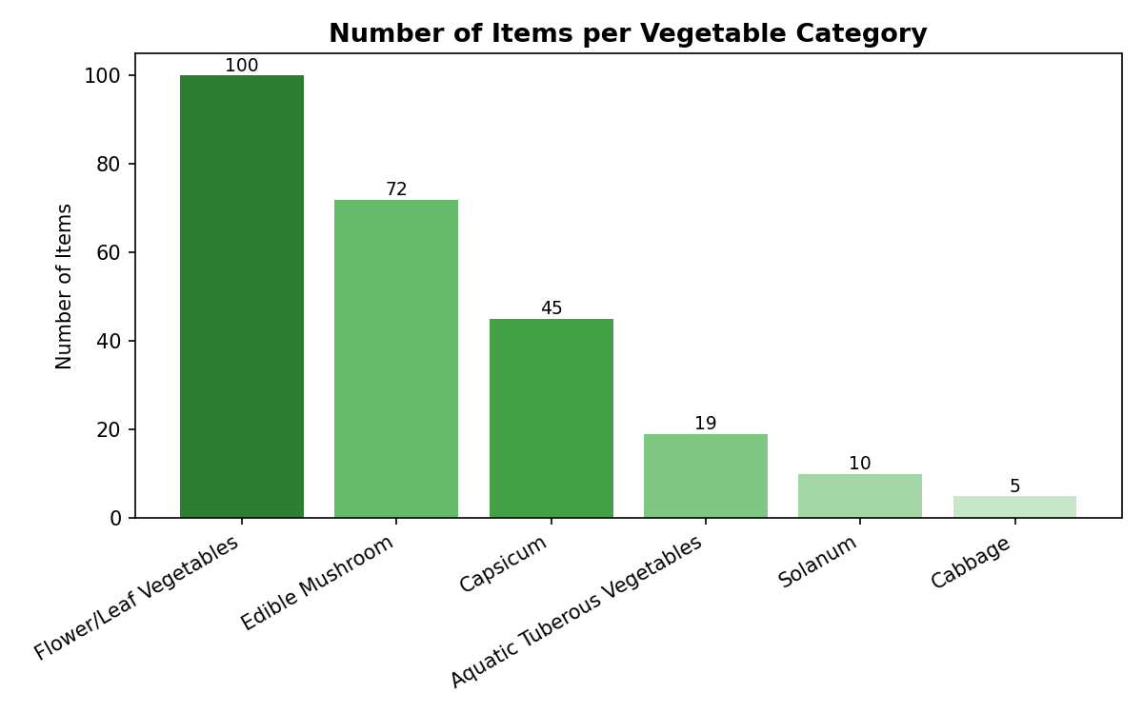
Chart Title: Number of Items per Vegetable Category (Bar Chart)
Objective: To compare how many products fall under each category.
Why this chart: A bar chart is the clearest way to compare counts across a small number of categories.
Observation: Flower/Leaf Vegetables (100) and Edible Mushroom (72) are far ahead of the other four categories.
Business Interpretation: Merchandising and inventory teams should expect these two categories to require the most shelf space, storage, and supplier coordination.

13.3 Multivariate Analysis
With only two categorical fields (category and item name) and two identifier fields (item code and category code), true multivariate techniques such as a correlation matrix or pair plot are not meaningful here — correlation requires multiple independent numeric measurements, which this dataset does not have. Instead, a grouped (pivot-style) view of Category Code against Category Name was used, confirming a clean one-to-one mapping between the two, with no category sharing a code and no code mapping to two different category names.

14. Feature Engineering
Two simple, genuinely useful features were derived from the existing Item Name column:

Base Item Name
A new column, base_item_name, was created by stripping numbered suffixes like “(1)” or “(2)” from the item name (e.g. “Eggplant (2)” → “Eggplant”).
Why created: To group catalogue entries that represent the same underlying vegetable but are listed as separate SKUs.
Business benefit: Reduces 251 raw listings to 218 unique base products, giving a truer picture of actual product variety versus catalogue clutter.

Variant Flag
A new column, is_variant, marks whether an item name contains a numbered suffix (True/False).
Why created: To separately study how common numbered-variant listings are.
Business benefit: Found that 63 of 251 items (25%) are variant-style listings, most concentrated in bagged mushroom products (e.g. “Haixian Mushroom (Bag)” appears 5 times) — useful for a future SKU-cleanup project.

15. Data Visualization
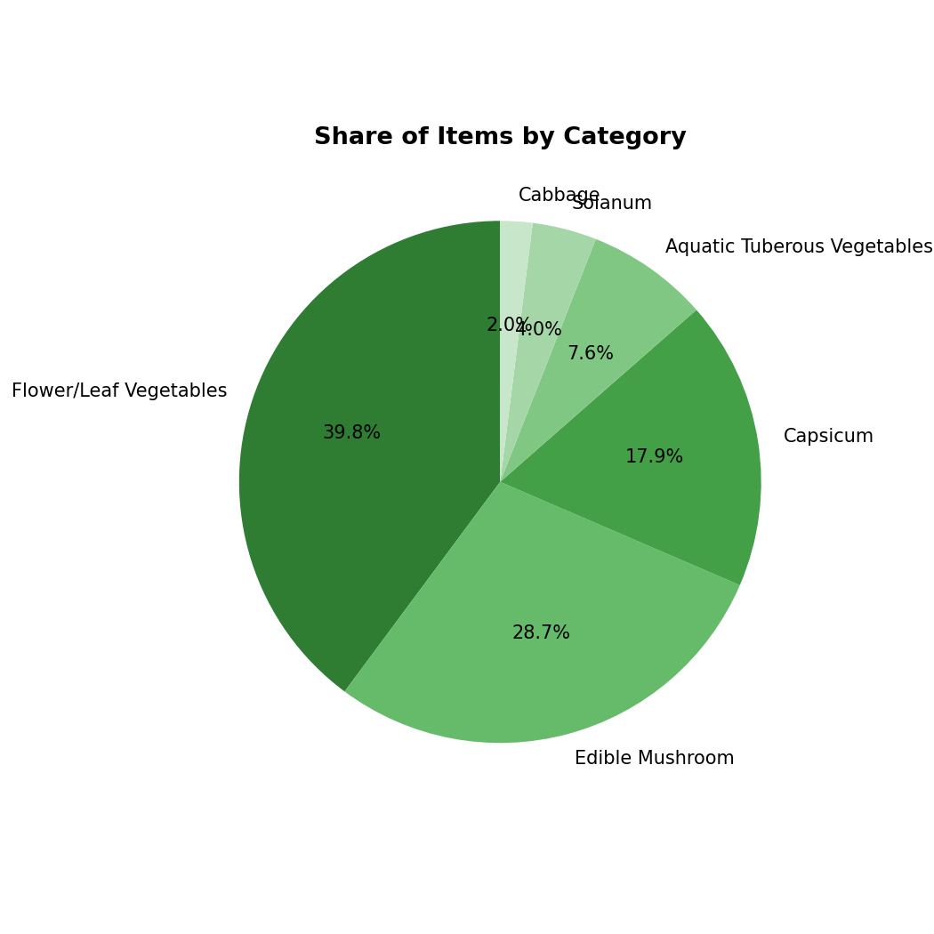
Chart Title: Share of Items by Category (Pie Chart)
Objective: To show each category's proportional share of the full catalogue at a glance.
Why this chart: A pie chart communicates “share of whole” more intuitively than a bar chart for a small number of categories (6 here).
Observation: Flower/Leaf Vegetables (39.8%) and Edible Mushroom (28.7%) together account for more than two-thirds of the catalogue, while the bottom three categories combined make up only about 13.6%.
Business Interpretation: The catalogue is heavily concentrated in two categories; the business may want to review whether the smaller categories (Cabbage, Solanum) are under-represented due to low demand or simply an incomplete catalogue entry.

16. Business Insights
- The catalogue is dominated by two categories — Flower/Leaf Vegetables and Edible Mushroom — which together account for close to 69% of all 251 listed products.
- Cabbage is the smallest category with just 5 products, making it a candidate for either catalogue expansion or a review of whether it should remain a standalone category.
- The Category Code system is fully consistent — every category name maps to exactly one code and vice versa — confirming the master data can be trusted for category-level reporting.
- A quarter of all listed items (25%) are numbered variants of a base product name (e.g. multiple “Eggplant” or “Haixian Mushroom (Bag)” entries), meaning the true count of distinct vegetable products is closer to 218 than 251.
- The dataset is a clean master file with zero missing values and zero exact duplicate rows, meaning it is ready to be joined with transactional data (e.g. sales or inventory) in a future project without needing further cleanup.

17. Recommendations

1. Review the Cabbage and Solanum categories
These hold only 5 and 10 products respectively. Confirming with the business whether this is intentional (niche demand) or incomplete cataloguing would improve category planning.

2. Standardize numbered-variant naming
With 25% of items using a “(1)/(2)/(3)” suffix pattern, introducing a clearer naming convention (e.g. attribute-based names like “Eggplant – Round” instead of “Eggplant (3)”) would make the catalogue easier for staff and customers to read.

3. Use this master table as a lookup for future analysis
Because the Category Code/Category Name mapping is fully consistent, this file is ready to be joined with a sales or inventory dataset (using Item Code as the key) to unlock revenue and demand analysis in a future project.

4. Manually review the 8 exact-duplicate item names
A quick manual check of the 8 rows sharing an identical item name (e.g. two “Chinese Cabbage” entries) would confirm whether they represent different package sizes/batches or an accidental double entry.

18. Challenges Faced
- Limited scope of the dataset: with only 4 columns and no numeric measurements, several standard EDA techniques (correlation matrix, outlier detection, time-trend analysis) could not be meaningfully applied.
- Distinguishing genuine duplicates from legitimate repeated names required careful judgment, since an exact-duplicate item name is not automatically an error.
- Extracting the “base product name” from variant-style listings required a regular-expression pattern rather than a simple lookup, since suffixes appear in different positions across item names.

19. Conclusion
This project analysed a 251-row vegetable product master dataset covering item codes, item names, category codes, and category names. The data was found to be clean, with no missing values and no fully duplicate rows, and the category coding system was verified to be fully consistent.
The analysis showed that the product catalogue is heavily concentrated in two categories — Flower/Leaf Vegetables and Edible Mushroom — while Cabbage and Solanum remain comparatively small. A meaningful share (25%) of the catalogue consists of numbered variants of the same base product, reducing the true count of distinct vegetables to 218.
These findings give a retail or wholesale vegetable business a clear, evidence-based view of its current catalogue structure and provide a solid, clean foundation for future analysis once sales, pricing, or inventory data becomes available.

20. Future Scope
- Join this master table with a sales/transaction dataset (using Item Code) to analyse revenue and demand by category.
- Build an interactive dashboard (e.g. in Power BI or Tableau) showing category share and catalogue size over time as products are added or removed.
- Apply text-similarity techniques to automatically detect and group all numbered-variant product names.
- Use the cleaned base_item_name feature as an input for future demand-forecasting or recommendation-system projects.
- Automate this data-quality check (missing values, duplicate names, code consistency) to run every time the catalogue file is refreshed.

21. References
- Dataset: cleaned_superset__2_.csv (provided by the user).
- Python Documentation — https://docs.python.org/3/
- Pandas Documentation — https://pandas.pydata.org/docs/
- NumPy Documentation — https://numpy.org/doc/
- Matplotlib Documentation — https://matplotlib.org/stable/index.html
- Seaborn Documentation — https://seaborn.pydata.org/

