**FINAL PROJECT REPORT**

ON

PROJECT TITLE :

**FAKE NEWS DETECTION**

By

SRAVANI VANGALA

STUDENT ID: 11412414

**INTRODUCTION:**

Fake news on the internet includes but are not limited to deliberately fabricated news, click baits, fake ads to increase traffic to websites. With an increase in the amount of time we are spending on social media, our lives are being affected by the content we see, this raises the obvious question that if the news or content we are viewing, or reading is genuine. As social media has no central governance, the content can be shared by any individual or group, this causes the spread of unwanted or fake news. With the increase in social media sites the rate of spreading rumours and fake news is increasing alarmingly. What can be worse is that if Anti-social groups like terrorists and other dangerous organizations exploit these platforms to spread widespread disorder and try to influence people on a large magnitude. Anti-psychological warfare is not only extremely difficult to control as the effects because they cannot be traced, nor a complete insight can be gained.  These issues gave rise to the idea of classifying the news into genuine or fake. By using data mining techniques and proposed methods we can predict if the news is from a trusted source or has been modified or tampered with. The purpose of the `idea is to come up with a working model which can successfully predict fake news by finding the source of the news and to filter out them from actual and genuine news. The proposed method has an accuracy 90% as tested from the experimental results.

**PROJECT PROBLEM STATEMENT:**

Fake news has existed for seemingly forever, almost a similar measure of time as news coursed broadly after the print machine was invented in 1439. Notwithstanding, there is no concurred meaning of the expression "fake news". Subsequently, we initially talk about and analyse some broadly utilized meanings of fake news in the current writing and give our meaning of fake news that will be utilized for the rest of this overview. A thin meaning of fake news will be news stories that are purposefully and evidently bogus and could misdirect people. There are two vital provisions of this definition: credibility and purpose. To start with, fake news incorporates bogus data that can be checked all things considered. Second, fake news is made with an unscrupulous aim to delude purchasers. In recent times, when the first news of Covid-19 virus spread around the areas of Wuhan, the news immediately spread like wildfire, there was an overabundance of information spreading throughout social media sites. Although major web search engines like google use powerful search algorithms to show users the most relevant information as they, have the ability to capture larger amount of information. The web searches can sometimes be irrelevant if there is any misleading information. The queries can be analysed by using malicious URL (Uniform Resource Locators). Host based features and lexical features are extracted from the URLs from news to improve the effectiveness and efficiency of the model.

The main motivation of this project is to build a model to identify unreliable news articles. Most of the earlier models were primarily focused on classifier enhancements and not feature engineering. In this report I have a focused on a new direction of fake news prediction. The main purpose of feature engineering is to feed the original data with new and meaningful feature representations and Machine Learning (ML) algorithms for the classifications.

**RELATED WORK:**

**1. Fake News Detection on Social Media**

**Summary**

**Reference:** Shu, K., Sliva, A., Wang, S., Tang, J., & Liu, H. (2017). Fake news detection on social media: A data mining perspective. ACM SIGKDD explorations newsletter, 19(1), 22-36

**Purpose:** In this research, the authors attempted to explore the aspect of fake news and the existing studies that have presented methods for the detection of fake news on social media. In this case, it is important to note that research questions are: What is fake news? What methods have other studies proposed for the detection of fake news on social media? What issues currently exist in it?

**Related Literature:** In his research, a number of other related concepts have been identified and explored. For instance, social media has been considered and discussed in association with fake news. Authors have evaluated different techniques that are available for the detection and identification of fake news on social media. As far as the number of explored researches are considered, authors have included 102 other studies in their own research.

**Research Strategy:** In this research, the authors have considered a qualitative approach for the exploration of the topic. For instance, the researchers have relied on literature review for the identification of existing techniques on fake news detection on social media. The data acquired in this study relates to the methods that are used for the detection of fake news on different social media platforms. This paper has attempted to explore the findings of other studies and researches.

**Results:** Authors have determined that fake news is created intentionally for misleading people into believing in false information. It tends to make it quite difficult to identify it on the basis of news content. Thus, there is a need for including auxiliary information for facilitating the identification of fake news. In the discussion, other studies have not really been cited.

**Contributions:** This research has contributed significantly to the existing literature base. For instance, it has identified the gaps that exist in the current methods for the detection of fake news together with what should be done in the future.

**Critical Analysis**

**Overall Assessment:** Overall, it can be said that the paper is quite simple to read. The author explained all the research problems thoroughly, which served to facilitate the comprehension of the concepts. This research has been accepted because it adds to the existing literature base and offers insights into how fake news detection can be improved for social media.

**Research Methodology:** I comprehended the research design and techniques properly and I believe that the design was suitable according to the nature of the research. In fact, it enabled the researcher to explore the problem in an efficient manner. The author has evaluated the results a number of times to ensure the validity and reliability of the results.

**Future Research:** Future research can be performed into automatic detection of fake news on the web (Shu, Sliva, Wang, Tang, & Liu, 2017).

**New Knowledge Acquired:** I have learned different existing techniques for the detection of fake news on social media and what problems they are facing.

**2. Automatic Detection of Fake News**

**Summary**

**Reference:** Pérez-Rosas, V., Kleinberg, B., Lefevre, A., & Mihalcea, R. (2017). Automatic detection of fake news. *arXiv preprint arXiv:1708.07104.*

**Purpose:** The purpose of this research was to present and propose an automatic technique or framework for the detection of fake news. It is quite important to note that a number of research questions have been included and addressed in this study including How data is to be collected for fake news? How is the information validated? How can fake and legitimate news be differentiated from each other?

**Related Literature:** When it comes to the related literature, it should be noted that a number of other studies have been explored by the authors. For instance, associated concepts of datasets, frameworks, social media, and legitimate news have been included and explored. Exactly, 23 other studies have been involved in this research, and data from these researches have been included in this study for evaluation and analysis.

**Research Strategy:** Primary and secondary research methods were utilized by the authors in this study. For instance, other than the literature review itself, the authors have collected and analysed news with the use of their own proposed method or technique. The authors began by acquiring a dataset of actual or legitimate news and then generated fake news. The authors used a five-cross validation and a linear SVM classifier.

**Results:** Authors have obtained great differences between actual and fake news with the use of their framework for the detection of fake news. Authors have observed that classifiers depending specifically on the semantic information in the lexicon of LIWC show good performance across the considered domains.

**Contributions:** In the case of contributions, it is quite important to note that this research contributes and adds value significantly to the existing base of studies on the topic of fake news detection. For instance, it proposes an automatic technique of identifying and detecting fake news and differentiating them from actual news. It allows this method to be deployed for determining fake news on different platforms.

**Critical Analysis**

**Overall Assessment:** The paper is quite simple to read. However, there is a need for the reader to possess fundamental knowledge of computer science in order to properly comprehend what the author is attempting to explain in the paper.

**Research Methodology:** In addition to it, the design of the study is suitable to the research because it suits nature and also allows the researcher to answer all the research questions in an efficient manner. The author has considered a number of tests for ensuring the reliability and even the validity of the results acquired.

**Future Research:** It is possible for the paper to be further improved. For instance, the authors can consider their framework and they can utilize their framework on different platforms. They can analyse the use of their framework on different platforms and then enhance it in such a manner that it generates only the required results or outcomes without experiencing any problems and issues. It would not be possible for this research to be mimicked to evaluate any other problem because this research has been designed specifically for evaluating and designing an automatic system for the identification of fake news (Pérez-Rosas, Kleinberg, Lefevre, & Mihalcea, 2017).

**New Knowledge Acquired:** I have acquired some new concepts and have gained new knowledge. For instance, I have been enabled to comprehend how fake news can be collected from the web. In addition to it, through this research, I have come to know that there exist a number of lexical and structural differences between real and fake news. I have also come to understand just how a framework can be designed for detecting fake news automatically.

**3. Fake news Detection using Naïve Bayes classifier**

**Summary**

**Reference:** M. Granik and V. Mesyura, "Fake news detection using naive Bayes classifier," 2017 IEEE First Ukraine Conference on Electrical and Computer Engineering (UKRCON), 2017, pp. 900-903, doi: 10.1109/UKRCON.2017.8100379.

**Purpose:** the purpose of this research is to demonstrate an approach for fake news detection using naïve bayes classifier.

**Related Literature:** this paper has reviewed more than ten related articles on how to avoid fake news and methods and approaches to detect fake news.

**Research Strategy:** this research is carried out by implementing a software system testing against a dataset of Facebook news posts, by applying the naïve bayes algorithm.

**Results:** using the classifier model for the research problem, an accuracy of 74% was achieved on the test set data. Considering the relative simplicity of the model the result is said to be decent.

**Contributions:** this article contributes a new approach using naïve bayes classifier to detect fake news.

**Critical Analysis**

**Overall Assessment:** the study has detailed a simple approach of detecting fake news using naïve bayes classifier. The research simple yet efficient enough. The authors have achieved seventy four percent accuracy which is a decent number considering the simplicity of the model.

**Research Methodology:** the methodology behind this research is to use the naïve bayes classifier algorithm on the Facebook dataset containing information related to news posts and find the accuracy of the truthfulness of the posts.

**Future Research:** this research addresses several ways the results can be improved with new models developing which can give more accuracy. By studying the results, the authors suggest that this research problem can be addressed using artificial intelligence methods.

**New knowledge Learned:** this research helped me learn another approach to solving the fake news detection problem using naïve bayes algorithm.

**4. Fake News Detection with Generated Comments for news articles**

**Summary**

**Reference:** Y. Yanagi, R. Orihara, Y. Sei, Y. Tahara and A. Ohsuga, "Fake News Detection with Generated Comments for News Articles," 2020 IEEE 24th International Conference on Intelligent Engineering Systems (INES), 2020, pp. 85-90, doi: 10.1109/INES49302.2020.9147195.

**Purpose:** the purpose of this study is to make early fake news detection by generating fake social contexts which can help detect fake news at early stage before its diffusion.

**Related Literature:** this article has reviewed almost thirty related articles on how to implement machine learning models in the research.

**Research Strategy:** this research uses the method of generating fake social contexts to track and detect the spread of fake news on social media platforms like twitter, facebook etc,., these social contexts help find and spot the fake news effectively but they are not immediately available when a post or article comes out, making it difficult to find them at early stages. Thus a detector with the ability to generate fake social contexts is proposed in this research.

**Results:**  this research has trained the model to generate comments using a dataset consisting of news articles and their social contexts. The effectiveness of the model was examined by the performance of generated comments with real comments. As a result, it was concluded that the generated comments were much helpful in detecting the fake news than the real ones.

**Contributions:** this study contributes a working model of a detector which can automatically generate social contexts for the articles published on the social media.

**Critical Analysis**

**Overall Assessment:** this research proposes a new approach to eradicate fake news, by developing a detector which can generate comments for any news article or post on social networks, which can help spot fake news effectively. The performance examination of the detectors social contexts in comparison to the real contexts are found highly effective which makes it a better approach for solving this problem.

**Research Methodology:**  to detect fake news at early stage its important to analyse the social contexts of that news. Sometimes the spread of such news is so fast that it get diffused even before there are real social contexts on that news. To address this problem the research proposes a detector that can generate comments at an early stage using which fake news can detected much faster and effectively.

**Future Research:** the techniques and approaches mentioned in this paper can be further improved to increase the effectiveness of the model.

**New Knowledge Learned:** this study helped me learn a new concept of generating comments for an article using a detector at early stage which can help stop diffusion of the fake news even before the damage has been done.

**5. FakeDetector : Effective Fake News Detection with Deep Diffusive Neural Network**

**Summary**

**Reference:** J. Zhang, B. Dong and P. S. Yu, "FakeDetector : Effective Fake News Detection with Deep Diffusive Neural Network," 2020 IEEE 36th International Conference on Data Engineering (ICDE), 2020, pp. 1826-1829, doi: 10.1109/ICDE48307.2020.00180.

**Purpose:** the purpose of this research is to build a model to detect fake news using neural networks.

**Related Literature:** this research has reviewed all related articles to fake news detection using convolutional neural networks, recurrent neural networks and many other models. Spam detection and review fraud detection articles were also studied to find the methodologies of those researches.

**Research Strategy:** this paper introduces a novel gated graph neural network, named as FakeDetector. This network builds deep diffusive network model based on the features extracted from the textual information.

**Results:** As part of the research, experiments were conducted

**Contributions:** this paper contributes a new research methodology in fake news detection by proposing a neural network graph called fakedetector.

**Critical Analysis**

**Overall Assessment:** the neural network model is effective in detecting the fake news as it learns about the representations, creators and subjects simultaneously. It is one of the best approaches to solving the fake news problem. The authors have detailed the working and experiments on the fakedetector model.

**Research Methodology:** this research uses fakedetector neural network graph to identify fake news articles by extracting explicit features from the textual information and building a diffusive network model from those features.

**Future Research:** the proposed neural network graph, fakedetector can be improved with neural network efficiency. This research can further be used for any context online and find the truthfulness of the information provided.

**New Knowledge Learned:** this research has helped me learn a new approach to detect fake news using gated neural network graph.

**OBJECTIVES:**

The main objective of this project is to build a model to identify unreliable news articles. This research is to determine the truthfulness of major claims in a news article to decide the news veracity. The drastic increase of amount spent on social media platforms, more individuals consume news from social media than the traditional media. One of the reasons for this is because it has become much easier to share, comment and discuss on the news with other readers on social media. Despite the advantages, the quality of news on social media is lower compared to traditional news sources. These extensively spread fake news can have serious negative impact on individuals and society. To help reduce the negative effects of fake news, it is important to have effective methods to automatically detect fake news on social media.

**DATA COLLECTION:**

The dataset I have used for this project is very closely similar to the LIAR16 dataset. The data used in the project is collected from the following link: <https://www.kaggle.com/c/fake-news/data?select=train.csv>

The dataset is a csv file which contains five columns of data. They are:

* **Id** – a unique id for each news article,
* **Title** – the title of the news article,
* **Author** – the name of the author for each news article,
* **Text** – the content text of the news article,
* **label** – a label indicating if the news article is fake or real.

**1**: fake news (unreliable data)

**0**: real news (reliable data)

the test dataset is the same as the training dataset with all the attributes except for the label attribute.

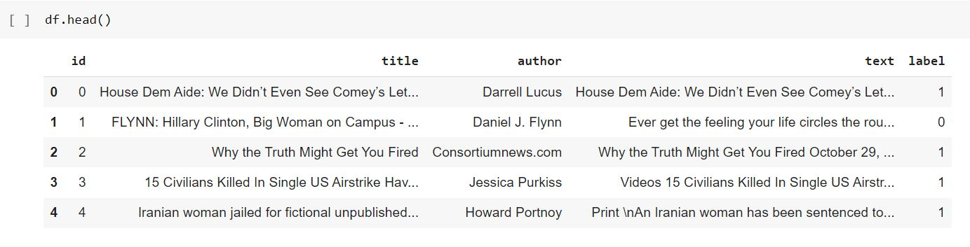

**RESEARCH DESIGN AND METHODOLOGY:**

Social media being economically accessible to every individual and easy to create accounts, there are many malicious accounts which are specifically created to spread fake news and false information. For detecting fake news I want to use data mining concepts which includes feature extraction and model construction. Before extracting features the data from which features are to be extracted, i.e., the news content in this dataset, has to be pre-processed to avoid errors and increase accuracy. The cleaned data is then used to extract features. The feature extraction phase is to represent news content and its related auxiliary information in a formatted mathematical structure, while the model construction phase is to build a machine learning model which can differentiate between fake and real news based on the features extracted.

The basic attributes of a news content are: source, headline, content of the headline, related images and videos. Since most of the false information interpreted on social media are opinionated and linguistic , it is appropriate to exploit linguistic features. Linguistic features include characters, words, sentences and documents. They are all part of the typical linguistic features known as lexical features and syntactic features. In addition to the features related to the news context, we can also extract social context features. These features infer the veracity of the news articles. Finding the credibility and reliability of all such features will help recognize fake news effectively. Using machine learning models we can detect fake news by predicting the credibility of the news content through interrelations of relevant social media posts. It is assumed that the credibility of the news event is highly related to the credibilities of relevant social media contents.

I used the TFIDF known as Term Frequency- Inverse Document Frequency and count vectorizer as features from the dataset. Using this methods the models have been built by extracting most real and most fake feature names. the training set is used to train the model using the features extracted from the data. Using the machine learning models The machine learning models have been used to build the confusion matrix to validate the true labels from the dataset and the predicted labels extracted from the model. I have used Naïve Bayes classifier, Passive Aggressive Classifier and Multinomial Naïve Bayes Classifier. The Passive Aggressive Classifier is found to give the best result on this dataset. The accuracy for Passive Aggressive Classifier was over 90%.

**EXPLORATIVE DATA ANALYSIS:**

The fake news detection dataset used for this project has almost twenty one thousand records with five attributes as columns.

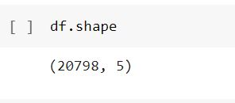

From the dataset, I have separated the independent column features. The id, title, author, text attributes are independent of other attributes.

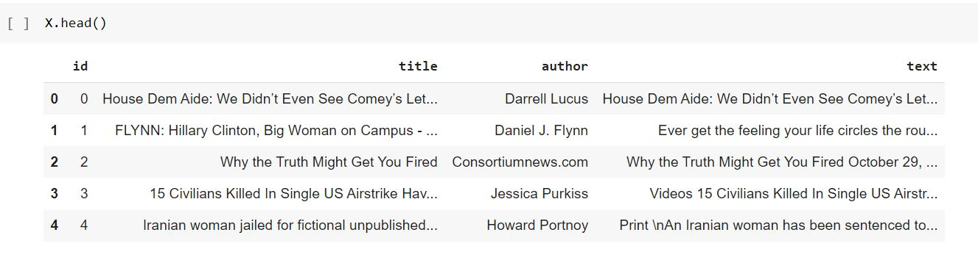

The independent features in the dataset are label.

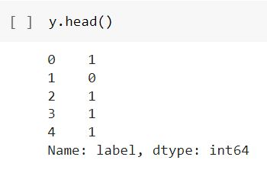

**DATA VISUALIZATION:**

From the dataset we can see that the number of records of news articles labelled as unreliable and reliable are almost equal.

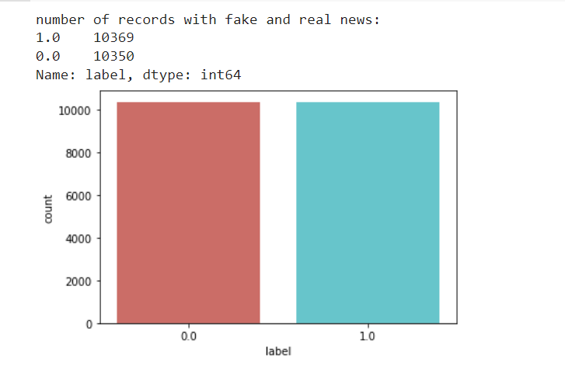

From the features extracted using the classifier coefficient, I have plotted a graph to see how the features are distributed in the coefficient range. As we can see the most fake features are classified towards the right end and most real features are classified towards left end.

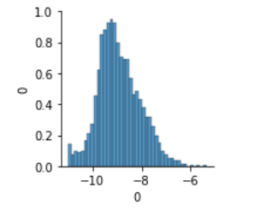

**RESULTS:**

**Naïve Bayes Algorithm**

Using Naïve Bayes classifier algorithm the test set data has been predicted and the accuracy has been calculated. A confusion matrix has been plotted against the true labels from the original label data and the predicted label data from the model. As we can see in the image below the accuracy of the model is 89.6%. from the 33% test data of train dataset, in the confusion matrix, the true labels have been identified for almost ninety percent of the data. 457 records of real news articles were predicted as fake and 168 fake news articles were predicted as real.

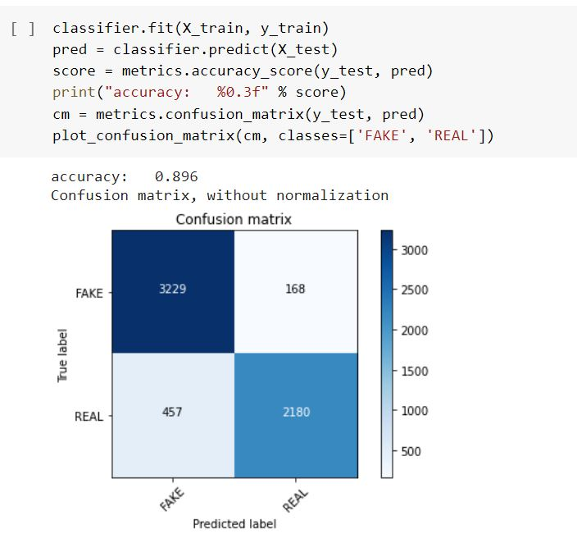

**Passive Aggressive Algorithm**

Similar to the Naïve Bayes algorithm a confusion matrix is plotted. And accuracy has been calculated. For this algorithm the accuracy has been high at 94.3%. the wrong prediction of true real label records has been reduced in this classifier.

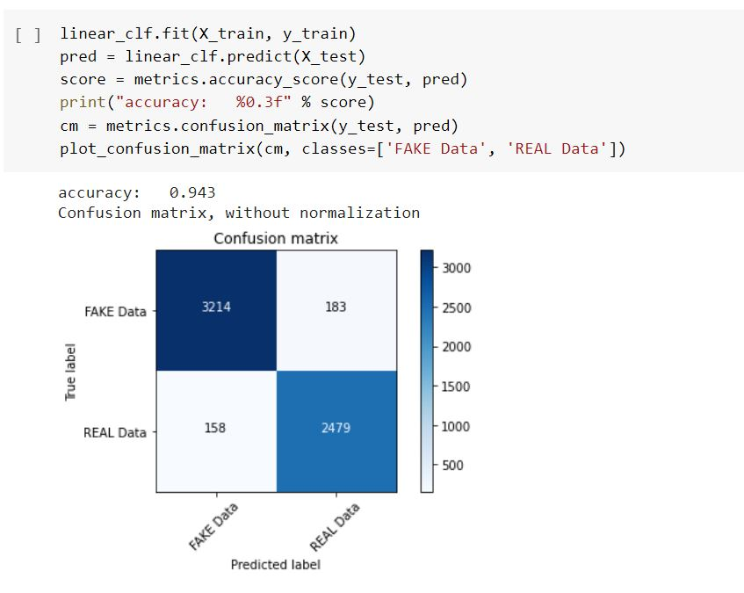

**Multinomial Naïve Bayes Classifier**

In this classifier, the accuracy of the model differs from the alpha value. The alpha value at 0.0 has the highest accuracy score. By extracting the feature names, the most real feature names are extracted by calculating the classifier co-efficient. The most fake features are also extracted using the same classifier co-efficient value. All those are depicted in the following images. The accuracy of the classifier is 87.5%. the true labels predicted as fake labels

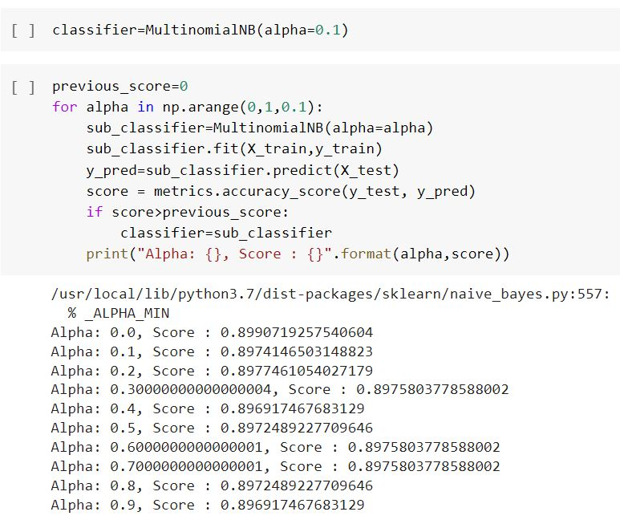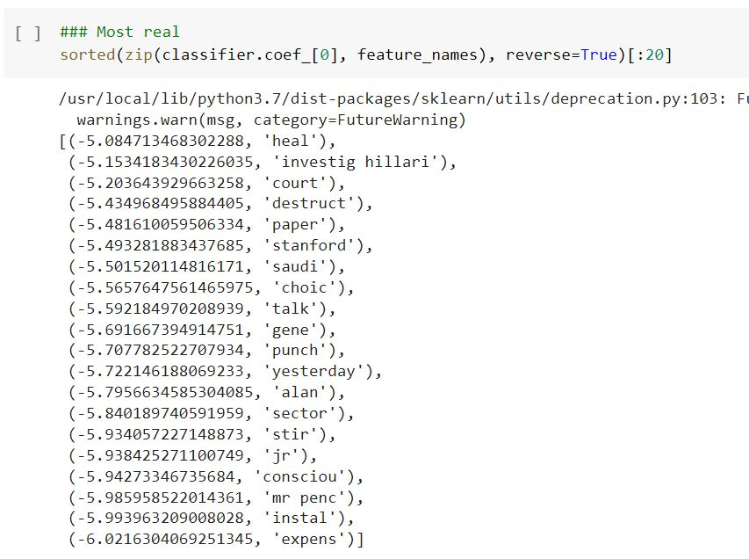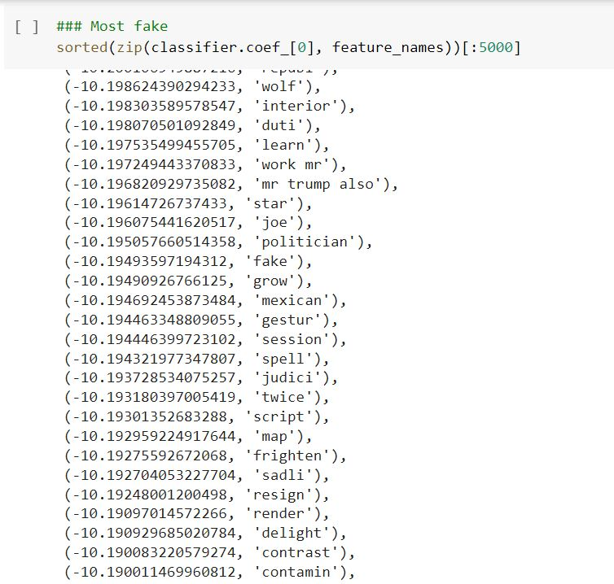

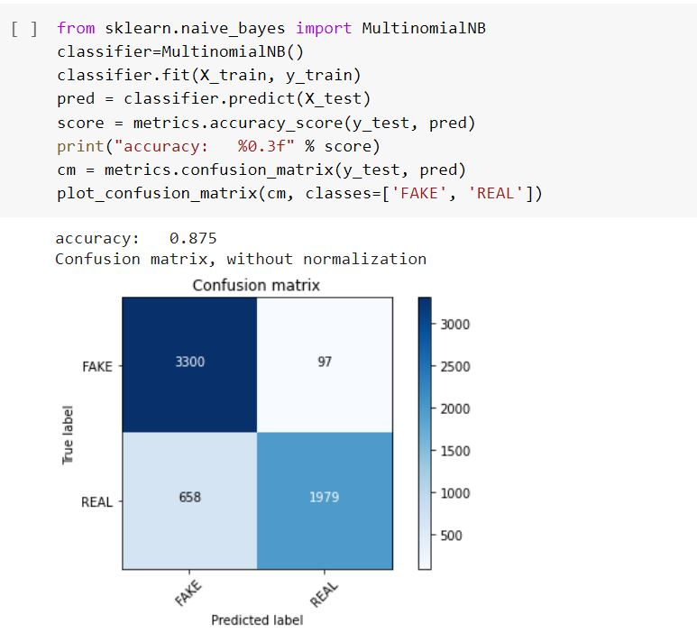

**DATASETS:**

The data sets can be collected from various sources available with internet. This includes search engines, social media and related news websites. However, the data sets are not readily available and gets very complex to obtain. Manually doing this task is tedious too. Hence for the project I am willing to use some of the following available datasets:

* **BuzzFeedNews15**: This dataset comprises a complete sample of news published in Facebook from 9 news agencies over a week close to the 2016 U.S. election from September 19 to 23 and September 26 and 27. Every linked article and posts were fact-checked claim-by-claim by at least 5 BuzzFeed journalists. This dataset is further enriched by adding the linked articles, attached media, and relevant metadata. It contains 1,627 articles–826 mainstream, 356 left-wing, and 545 right-wing articles.
* **LIAR16**: This dataset is collected from fact-checking website PolitiFact through its .It includes 12,836 human-labelled short statements, which are sampled from various contexts, such as news releases, TV or radio interviews, campaign speeches, etc. The labels for news truthfulness are fine-grained multiple classes: pants-fire, false, barely-true, half-true, mostly true, and true.
* **BS Detector 17**: This dataset is collected from a browser extension called BS detector developed for checking news veracity18. It searches all links on a given webpage for references to unreliable sources by checking against a manually complied list of domains. The labels are the outputs of BS detector, rather than human annotators.

Some challenges with these datasets include:

LIAR16 only includes short statements and not complete story, and furthermore these statements are published by collecting data from various speakers. This is similar with BuzzfeedNews15 which is mostly headlines. The BS Detector works by a tool with validating software with no human validation. Using these datasets and different other attributes related to the news articles the research can be further improved to identify unreliable information at more detailed level.

**CONCLUSION:**

With increasing popularity of the social media, the exposure to false content or what we call the “fake news” is becoming common. The need to explore into this subject is very important, the model proposed in this paper focuses mainly on two phrases, characterization and detection. The characterisation phase consists of basic concepts and principles of fake news and about the impact of social media. The detection phase consists of reviewing existing fake detection approaches in data mining perspective. This field has a promising future and research opportunities.

The source files of this project can be accessed on my github account with the following link: <https://github.com/sravanivangala/Fake_news_detection>

**BIBLIOGRAPHY:**

1. M. Granik and V. Mesyura, "Fake news detection using naive Bayes classifier," 2017 IEEE First Ukraine Conference on Electrical and Computer Engineering (UKRCON), 2017, pp. 900-903, doi: 10.1109/UKRCON.2017.8100379.
2. J. Zhang, B. Dong and P. S. Yu, "FakeDetector : Effective Fake News Detection with Deep Diffusive Neural Network," 2020 IEEE 36th International Conference on Data Engineering (ICDE), 2020, pp. 1826-1829, doi: 10.1109/ICDE48307.2020.00180.
3. Y. Yanagi, R. Orihara, Y. Sei, Y. Tahara and A. Ohsuga, "Fake News Detection with Generated Comments for News Articles," 2020 IEEE 24th International Conference on Intelligent Engineering Systems (INES), 2020, pp. 85-90, doi: 10.1109/INES49302.2020.9147195.
4. Pérez-Rosas, V., Kleinberg, B., Lefevre, A., & Mihalcea, R. (2017). Automatic detection of fake news. *arXiv preprint arXiv:1708.07104.*
5. Shu, K., Sliva, A., Wang, S., Tang, J., & Liu, H. (2017). Fake news detection on social media: A data mining perspective. ACM SIGKDD explorations newsletter, 19(1), 22-36
6. Konagala, V., & Bano, S. (2021). Fake news detection using Deep Learning. *Research Anthology on Fake News, Political Warfare, and Combatting the Spread of Misinformation*, 440–451. <https://doi.org/10.4018/978-1-7998-7291-7.ch025>
7. N. Snell, W. Fleck, T. Traylor and J. Straub, "Manually Classified Real and Fake News Articles," 2019 International Conference on Computational Science and Computational Intelligence (CSCI), 2019, pp. 1405-1407, doi: 10.1109/CSCI49370.2019.00262.
8. E. Elsaeed, E. El-Daydamony, M. Elmogy, A. Atwan and O. Ouda, "Detecting Fake News in Social Media Using Voting Classifier," in IEEE Access, doi: 10.1109/ACCESS.2021.3132022.
9. N. X. Nyow and H. N. Chua, "Detecting Fake News with Tweets’ Properties," 2019 IEEE Conference on Application, Information and Network Security (AINS), 2019, pp. 24-29, doi: 10.1109/AINS47559.2019.8968706.
10. S. I. Manzoor, J. Singla and Nikita, "Fake News Detection Using Machine Learning approaches: A systematic Review," 2019 3rd International Conference on Trends in Electronics and Informatics (ICOEI), 2019, pp. 230-234, doi: 10.1109/ICOEI.2019.8862770.