Write a Java Program to iterate ArrayList using for-loop, while-loop, and advance for-loop to get the result:

Program

import java. util.*;

public class DifferentLoops

{

public static void main(String[] args)

{

ArrayList<Integer> al = new ArrayList<Integer>();

al.add(20);

al.add(30);

al.add(40);

System. out. println("Iterating ArrayList using loops\n");

/* For Loop*/

System.out.println("For Loop\n");

for (int i = 0; i < al.size(); i++)

{

System.out.println(al.get(i)+"\n");

}

/* Advanced For Loop*/

System.out.println("Advanced For Loop\n");

for (Integer num : al)

{

System.out.println(num+"\n");

}

/* While Loop*/

System.out.println("While Loop\n");

int count = 0;

while(al.size() > count)

{

System.out.println(al.get(count)+"\n");

count++;

}

}

}

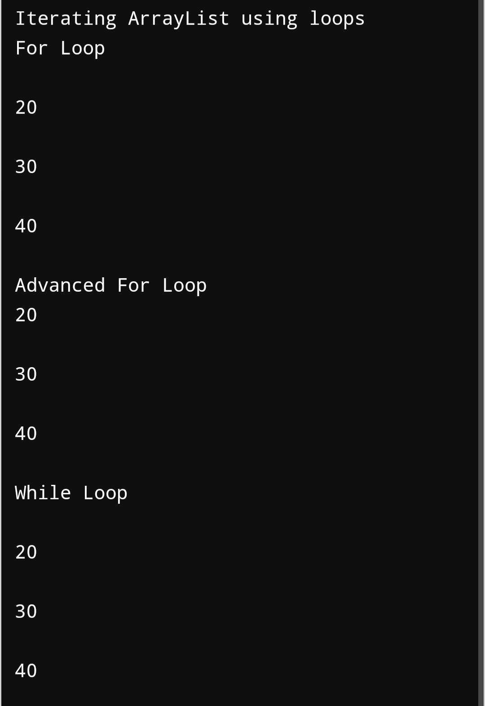Output:

2. Create a linkedlist.......

**public** **class** RList

{

**class** Node

{

**int** data;

 Node previous;

 Node next;

**public** Node(**int** data)

{

**this**.data = data;

         }

   }

**int** size = 0;

     Node head, tail = **null**;

**public** **void** addNode(**int** data)

{

         Node newNode = **new** Node(data);

**if**(head == **null**)

{

            head = tail = newNode;

             head.previous = **null**;

        tail.next = **null**;

         }

**else**

 {

            tail.next = newNode;

            newNode.previous = tail;

            tail = newNode;

            tail.next = **null**;

       }

        size++;

    }

**public** **void** rotateList(**int** n) {

        Node current = head;

**if**(n == 0 || n >= size)

**return**;

**else** {

**for**(**int** i = 1; i < n; i++)

                current = current.next;

            tail.next = head;

            head = current.next;

            head.previous = **null**;

            tail = current;

          tail.next = **null**;

        }

    }

**public** **void** display()

 {

        Node current = head;

**if**(head == **null**) {

            System.out.println("List is empty");

**return**;

        }

**while**(current != **null**) {

            System.out.print(current.data + " ");

            current = current.next;

        }

        System.out.println();

    }

**public** **static** **void** main(String[] args) {

       RList dList = **new** RList();

        dList.addNode(1);

        dList.addNode(2);

        dList.addNode(3);

        dList.addNode(4);

        dList.addNode(5);

        System.out.println("Original List: ");

        dList.display();

dList.rotateList(3);

        System.out.println("Updated List: ");

dList.display();

  }

}

3. At St. Xavier’s College, a faculty has the following data in My SQL in database named as Class Having table student related to Semester Examination

create table semester(eno integer, sname varchar(100), section varchar(10),subid integer, marks integer);

insert into semester values(1,'A','A', 1,70);

insert into semester values(2,'B','A', 2,75);

insert into semester values(3,'C','B', 3,65);

insert into semester values(2,'D','B', 4,77);

insert into semester values(2,'E','C', 5,60);

insert into semester values(2,'F','C', 1,82);

insert into semester values(2,'G','B', 2,76);

insert into semester values(2,'H','C', 5,68);

insert into semester values(2,'I','B', 3,71);

insert into semester values(2,'J','A', 4,79);

Query: select section, count(marks>=75) as no_of_candidates_greater_than_or_equal_to_75 from semester group by section;

Result:

