REPORT ON DATA MATRIX DETECTION.

Abstract:

A model that could detect compact sized data matrix codes which has a side around ~ 200 pixel on a transparent film. The codes are printed in black on a transparent plastic roll and contain the corresponding location information. The model is then evaluated on a test dataset that contains 800 images. The metrics are discussed to arrive at the reasons of failing.

Task Objective:

The plastic roll (web) sometimes comes with defective regions. When there is a defective region in the web, the location for the defective region will already be supplied. It is monotonous and error prone to always watch at the web for the defected zone manually before it is fed into the Laser system. There is a data matrix printed on the web at regular intervals which contains the location information of the web.

Main objective for the task is to scan the data matrix codes and learn about the location information, so when the web is fed into the roll-to-roll laser system it is possible to identify the defective regions and therefore additional machine features like monitoring and dynamic processing could be added.

Introduction:

Data Matrix is a two-dimensional code consisting of black and white dots or cells arranged in either a square or rectangular pattern. It is composed of two solid adjacent borders in an “L” shape (known as Finder Pattern) and two other borders consisting of alternate dark and light cells (known as timing pattern). The finder pattern helps in locating the data matrix and find its orientation and the timing pattern provides a count of the number of rows and columns in the matrix. It can store alphanumeric characters and could be very compact.

Code Development:

Preprocessing:

Development of code is centered on detecting the “L” shaped solid adjacent borders (finder pattern of data matrix). The image is run through several image processing steps to achieve this. We start with gray scaling the image, then running horizontal and vertical edge detecting kernels on the image. A gradient image(d) is then obtained by subtracting both horizontal(b) and vertical image(c) outputs.

Contour Detection:

This image is then converted into black and white by applying Otsu thresholding technique.

The thresholded image is run through eroded and dilated in various sequence of steps to give a closed image. Contours are found in the closed image. The height and width of the matrix code is already a known variable which is about 200 pixels. Therefore, the detected contours which obey this size +/- 30 pixels are selected.

Decoding the Region of Interest:

After finding a region of interest (ROI), a border of about 50 pixels is added on each side of bounding rectangle of the contour to prevent any loss of matrix code. This gives a new bounding box which is little larger than the matrix code. The original image is then sliced with the new bounding to get the region of interest. ROI which is a sliced original 3-dimensional image, then follows gray scaling, thresholding, eroding techniques sequentially. Finally, the Black and white image is passed into the Pylibdmtx function which decodes the matrix code. The detected data matrix code is displayed on the console.

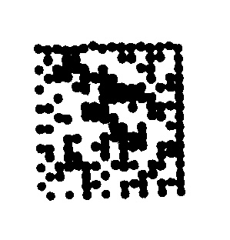

Metrics:

803 images containing data matrix are collected and are fed into the matrix detector program. for which the following data is observed.

Total number of JPEG files: 803

Number of files where data matrix is detected and decoded successfully: 734

Number of files where data matrix is not detected is:

Number of files where data is not present: 2

true positives = 734

false positives = 0

true negatives = 51

false negatives = 69

The model is able to detect the codes from the following group of images.

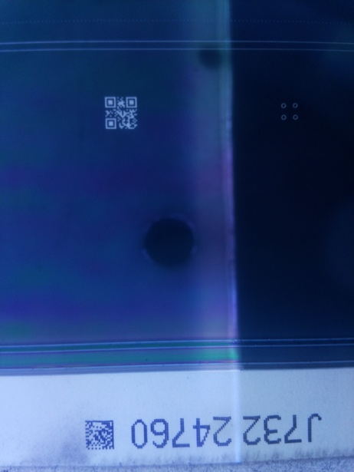

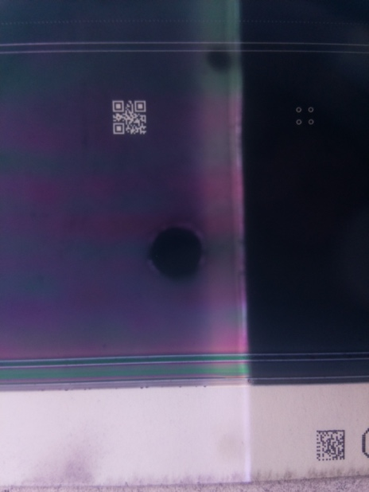

The model could not detect codes from the following images

The undetected data matrices like the following

The problem with the decoding of the data matrix is that the code is distorted in the image or unclear matrix code. When tested using an online decoder, the data matrix could not be decoded.