**Simplified ER Diagram according to the Data Provided:**

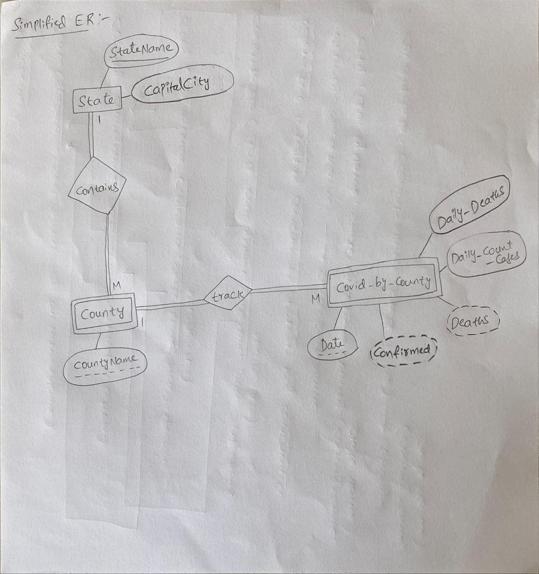

**We can calculate Total Confirmed(Confirmed) and Total Deaths(Deaths) from Daily_Count_Case and Daily_Deaths, That’s why made confirmed and deaths as derived attributes**

**Relational Schema:**

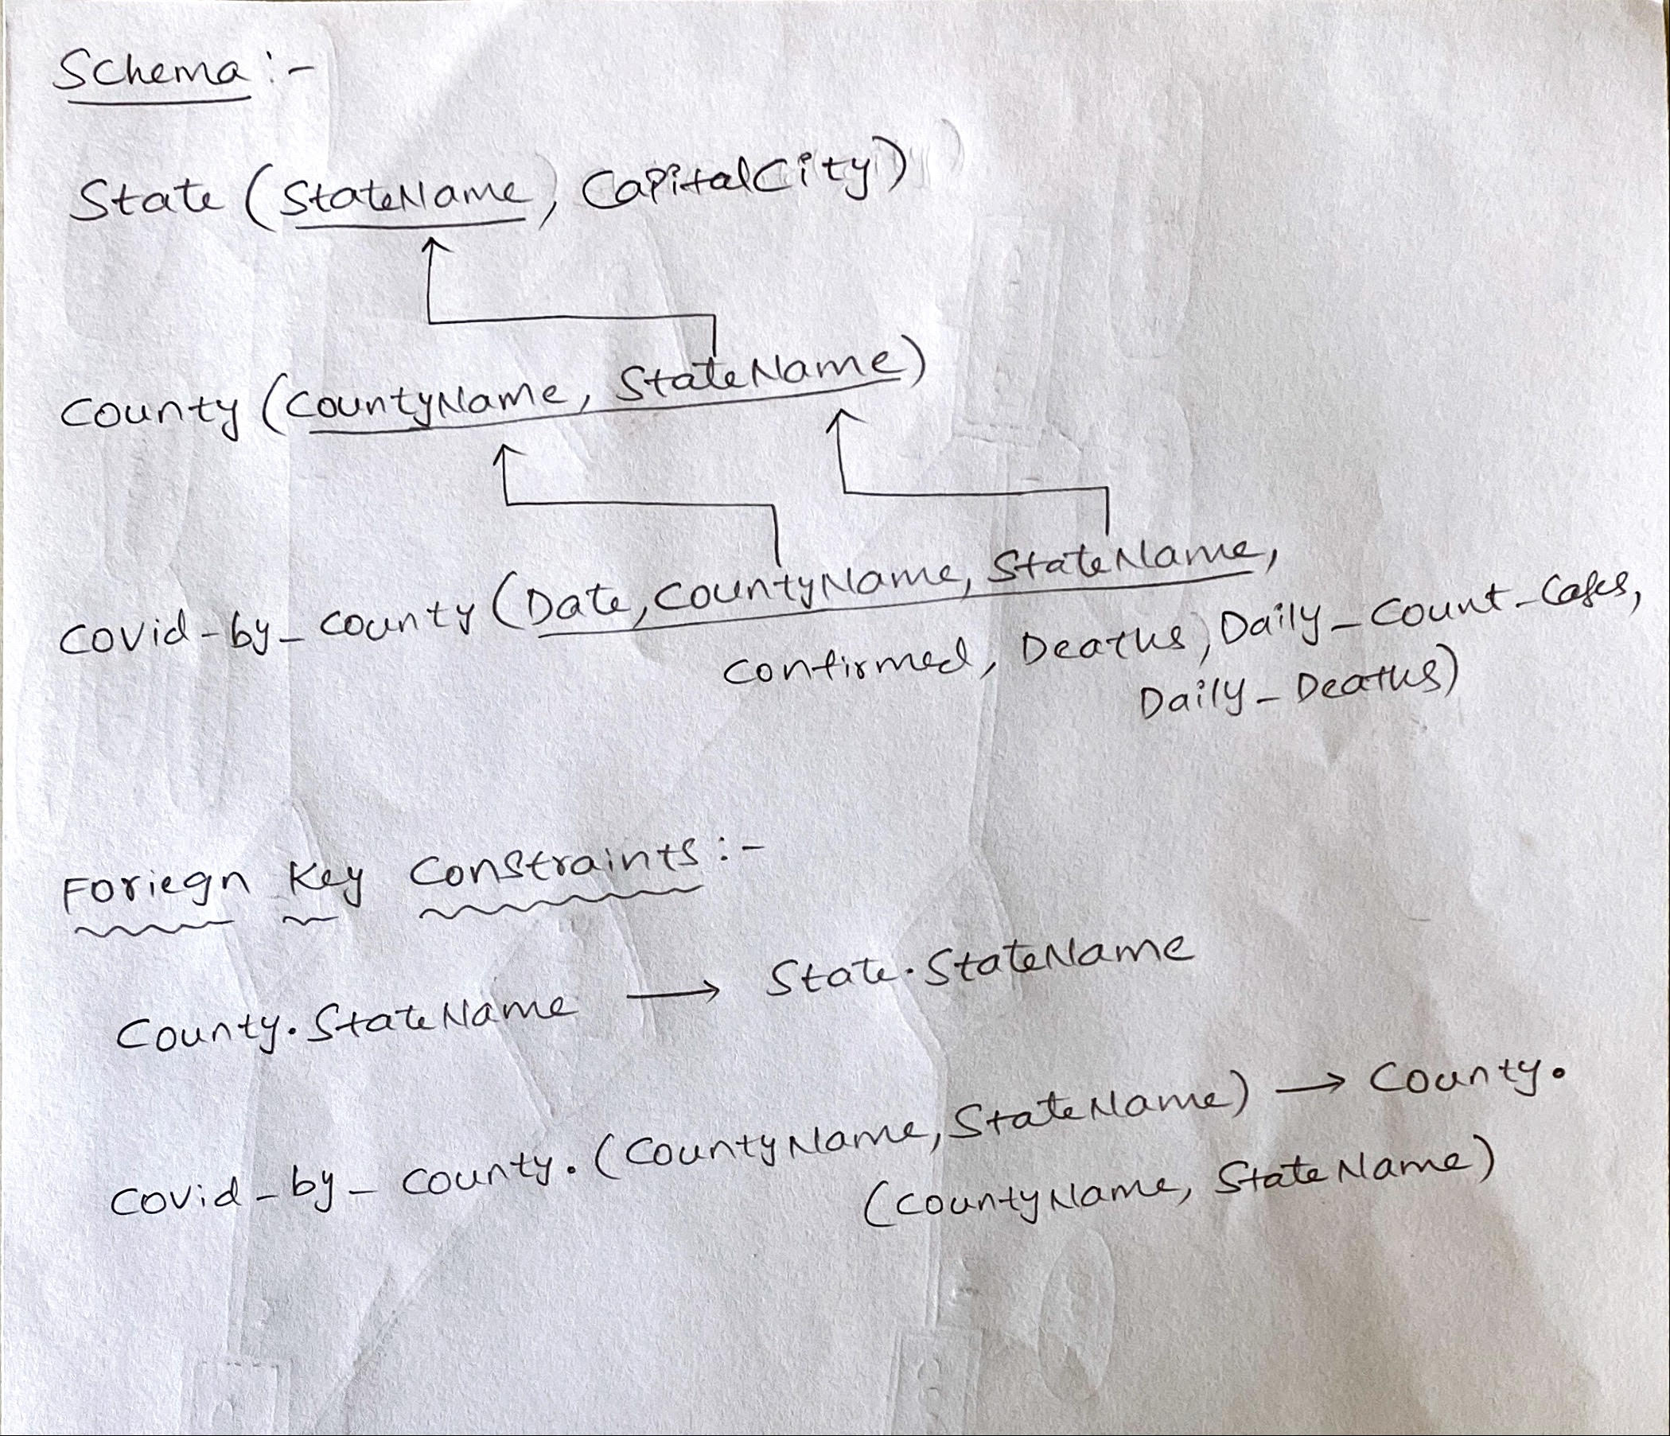

**Creating Tables:**

Create table STATE(

StateName varchar(50) not null,

CapitalCity varchar(50),

primary key(StateName)

);

Create table COUNTY(

CountyName varchar(50) not null,

StateName varchar(50) not null,

primary key(CountyName,StateName)

);

Create table COVID_BY_COUNTY(

Date_ Date,

CountyName varchar(50) not null,

StateName varchar(50) not null,

Confirmed int,

Deaths int,

Daily_Count_Cases int,

Daily_Deaths int,

primary key(Date_,StateName,CountyName)

);

**Insert Data to State and County Tables:**

Inserting Date to COVID_BY_COUNTY_TABLE (Screen Shot):

insert into state(StateName)

select distinct StateName from covid_by_county;

insert into county(CountyName,StateName)

select distinct CountyName,StateName from covid_by_county;

**Adding Foreign Key constraints:**

ALTER TABLE county

ADD CONSTRAINT FK_county_state

FOREIGN KEY (StateName) REFERENCES State(StateName);

ALTER TABLE covid_by_county

ADD CONSTRAINT FK_county_covid_by_county

FOREIGN KEY (CountyName,StateName) REFERENCES county(CountyName,StateName);

**Tools Used:**

MySQL Work Bench -> for Loading the data, creating tables and writing queries.

**Query Results:**

**1) Create a view COVID_BY_STATE that has the following attributes: Date, State_Name, SumConfirmed, SumDeaths. The SumConfirmed and SumDeaths attributes will be the SUM for all the counties in each state (Hint: use GROUP BY Date, State on the original COVID_BY_COUNTY table.**

CREATE VIEW COVID_BY_STATE AS

SELECT date_,StateName,sum(Daily_Count_Cases) as Confirmed,sum(Daily_Deaths) as Deaths

FROM covid_by_county

GROUP BY date_,StateName;

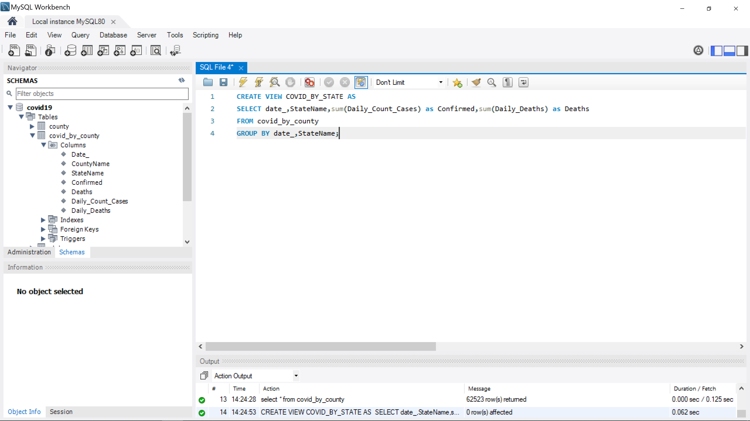

**1)Result:**

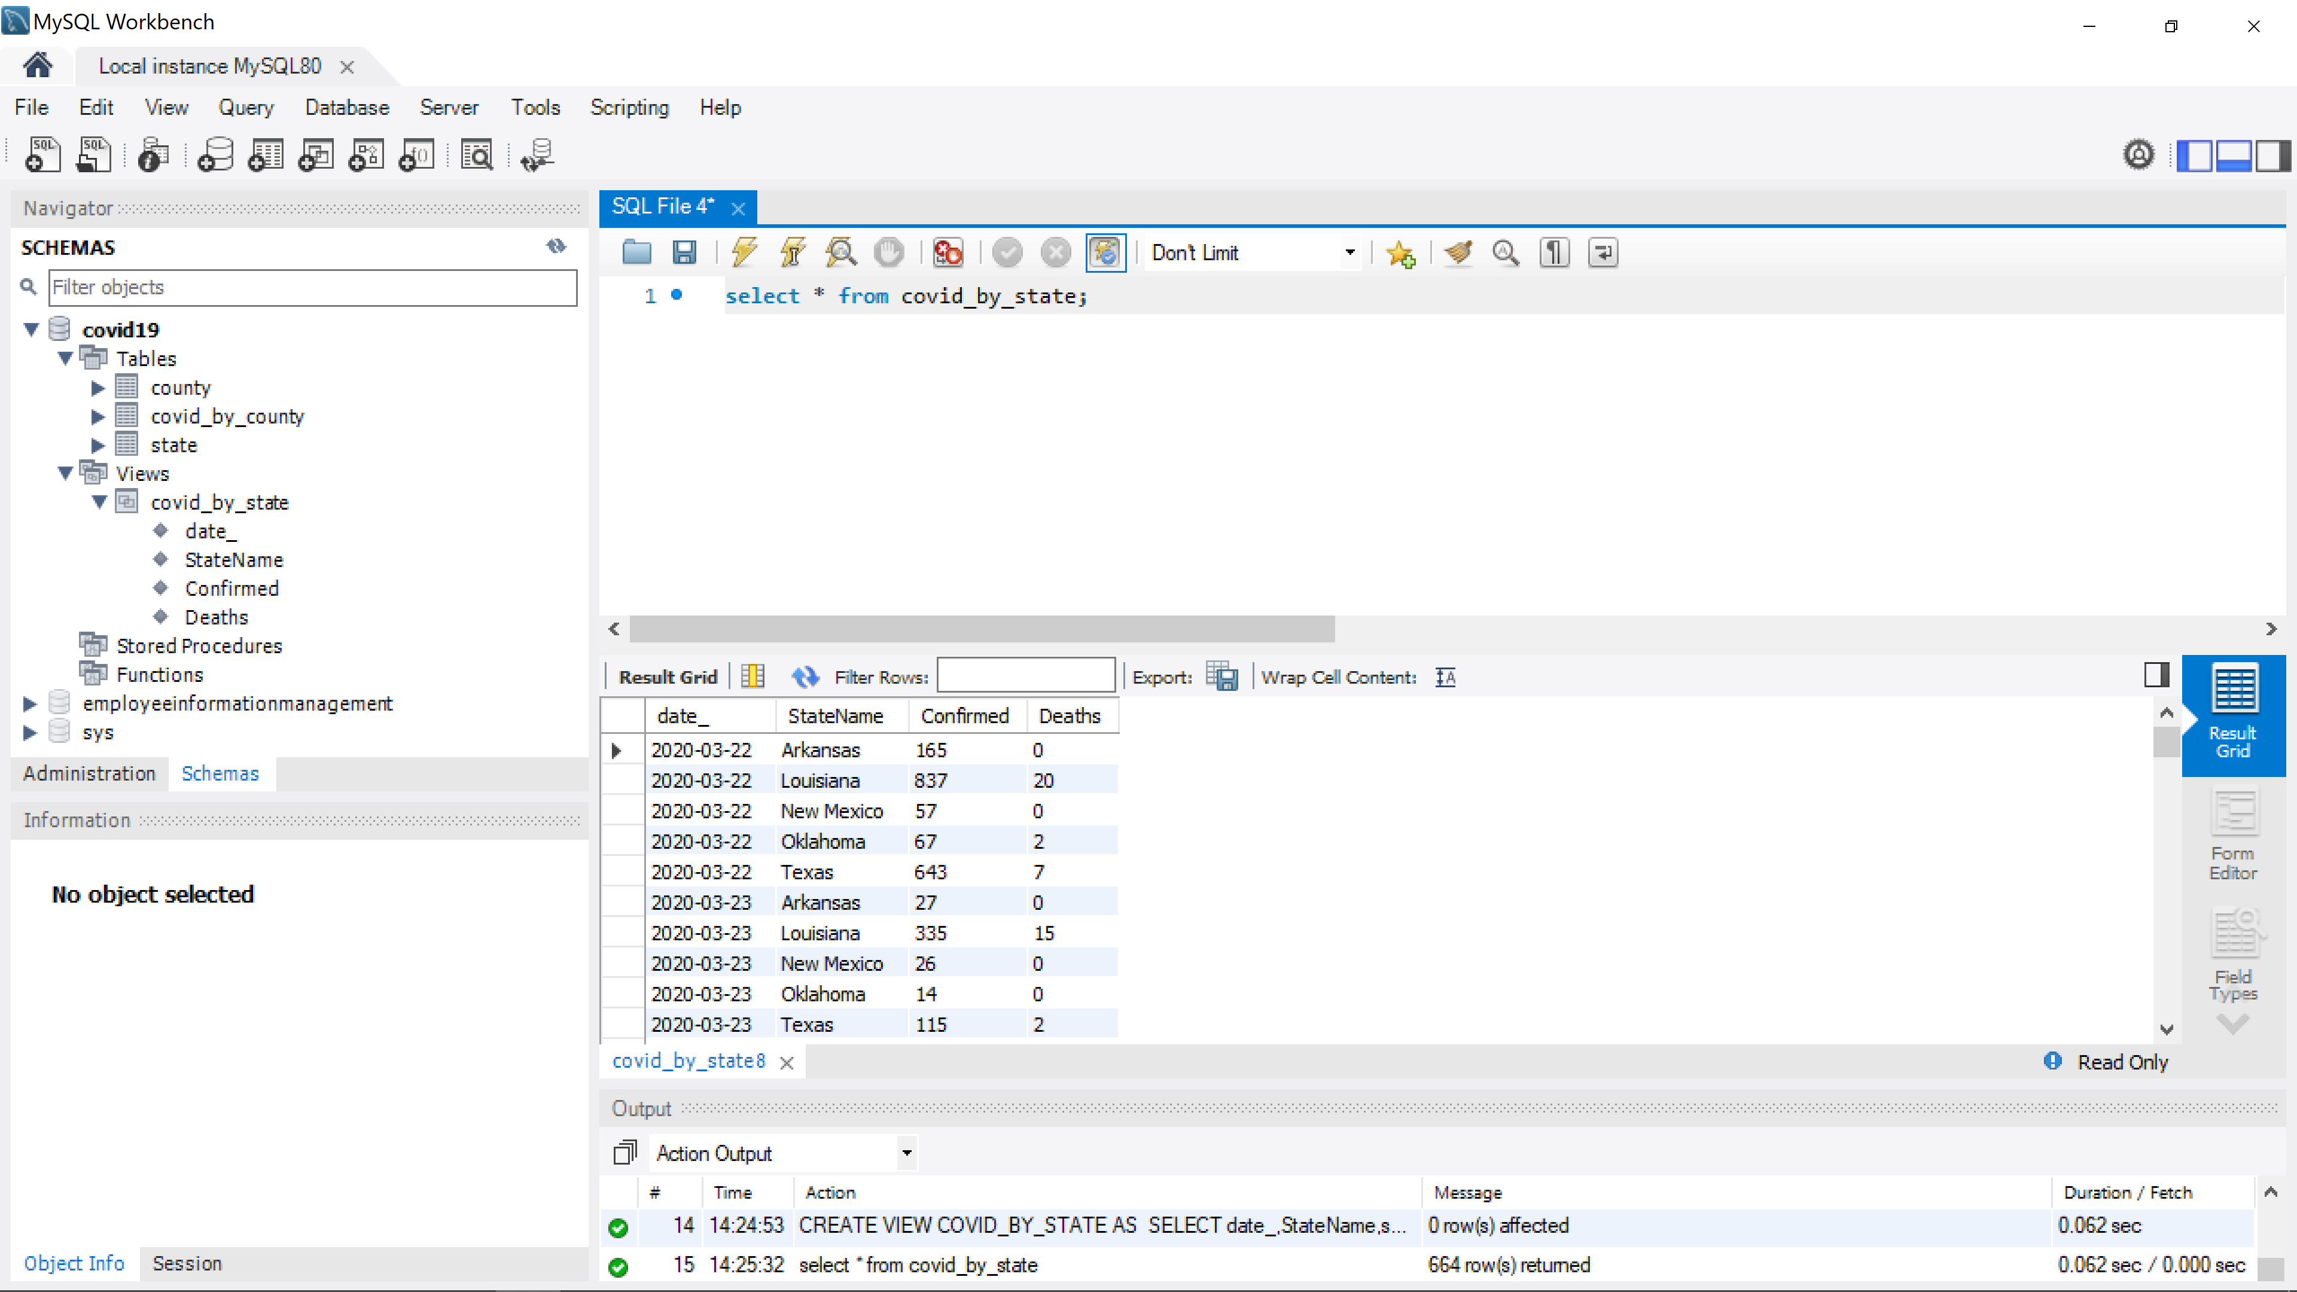

**2) Write 5 queries on the view. Each query will retrieve for one of the states the State_Name, Date, MAX(SumConfirmed) – the date with the highest number of confirmed cases in each state.**

2_1)

select date_, StateName, Confirmed from covid_by_state

where StateName = "Texas" and Confirmed in

(select Max(Confirmed) from covid_by_state where StateName="Texas");

**2_1) Result:**



**2_2)**

select date_, StateName, Confirmed from covid_by_state

where StateName = "Arkansas" and Confirmed in

(select Max(Confirmed) from covid_by_state where StateName="Arkansas");

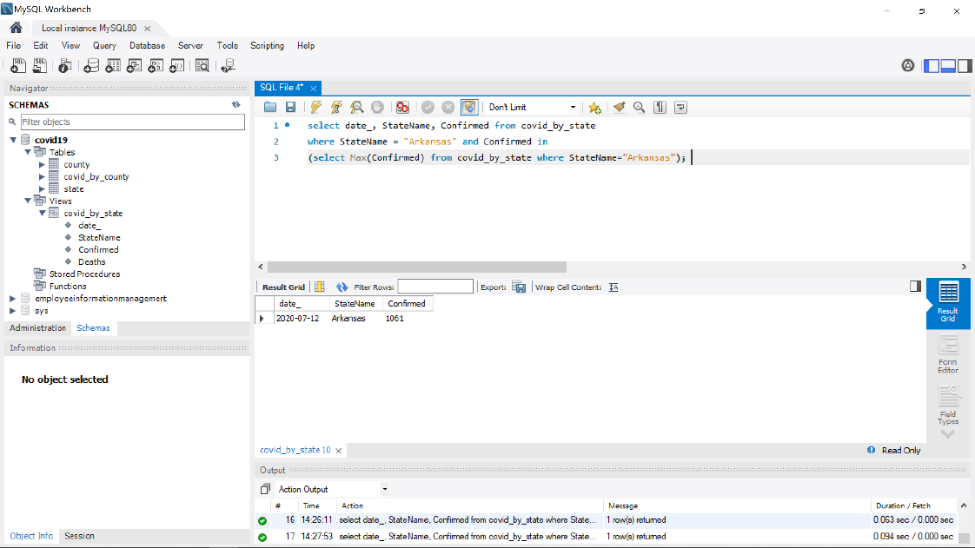

**2_3)**

select date_, StateName, Confirmed from covid_by_state

where StateName = "Louisiana" and Confirmed in

(select Max(Confirmed) from covid_by_state where StateName="Louisiana");



**2_4)**

select date_, StateName, Confirmed from covid_by_state

where StateName = "New Mexico" and Confirmed in

(select Max(Confirmed) from covid_by_state where StateName="New Mexico");



**2_5)**

select date_, StateName, Confirmed from covid_by_state

where StateName = "Oklahoma" and Confirmed in

(select Max(Confirmed) from covid_by_state where StateName="Oklahoma");



**3) Extra Credit (10 points): Instead of 5 queries, write one query to get the result for all 5 states for item 2. above.**

select date_,StateName,confirmed from covid_by_state

where confirmed in

(select max(Confirmed) from covid_by_state

group by StateName);

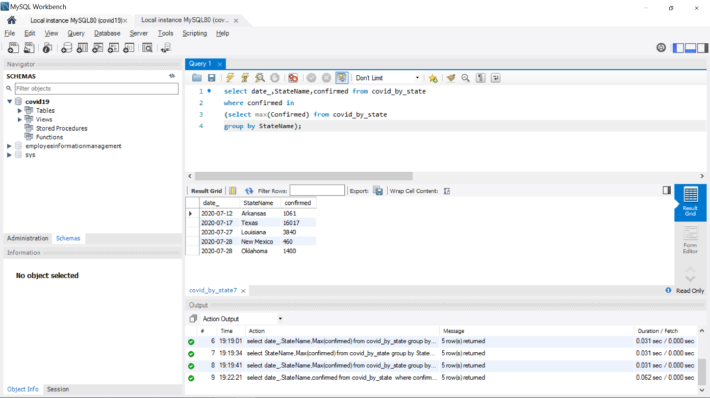

4) **Write a query on the view that sums the date for each state by using GROUP BY – that is, the result will have one record for each state State_Name, Sum_Confirmed, and Sum_Deaths for the dates provided in the data file.**

select StateName, sum(Confirmed) as sum_confirmed, sum(Deaths) as sum_deaths from covid_by_state group by StateName;

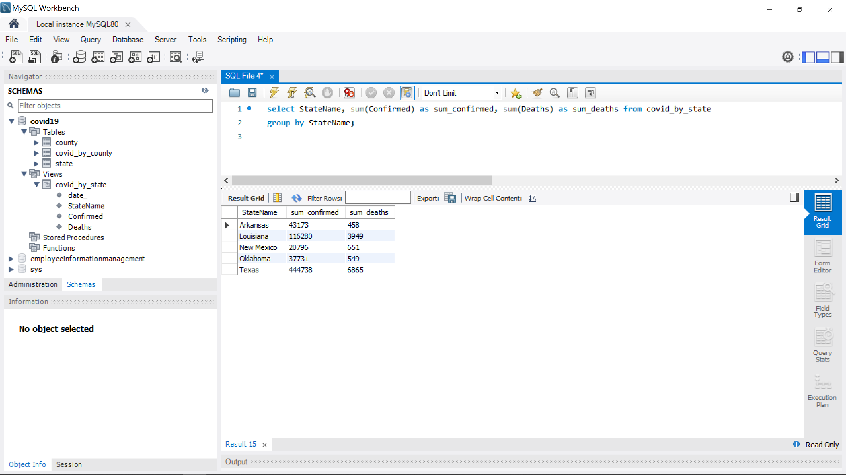

**Task Assigned:**

**Both the team members worked on all aspects of the project.**

**Query 1) Full Query Result for Select \***

Create a view COVID_BY_STATE that has the following attributes: Date, State_Name, SumConfirmed, SumDeaths. The SumConfirmed and SumDeaths attributes will be the SUM for all the counties in each state (Hint: use GROUP BY Date, State on the original COVID_BY_COUNTY table.

|  |  |  |  |
| --- | --- | --- | --- |
| date_ | StateName | Confirmed | Deaths |
| 3/22/2020 | Arkansas | 165 | 0 |
| 3/22/2020 | Louisiana | 837 | 20 |
| 3/22/2020 | New Mexico | 57 | 0 |
| 3/22/2020 | Oklahoma | 67 | 2 |
| 3/22/2020 | Texas | 643 | 7 |
| 3/23/2020 | Arkansas | 27 | 0 |
| 3/23/2020 | Louisiana | 335 | 15 |
| 3/23/2020 | New Mexico | 26 | 0 |
| 3/23/2020 | Oklahoma | 14 | 0 |
| 3/23/2020 | Texas | 115 | 2 |
| 3/24/2020 | Arkansas | 27 | 2 |
| 3/24/2020 | Louisiana | 216 | 11 |
| 3/24/2020 | New Mexico | 17 | 0 |
| 3/24/2020 | Oklahoma | 25 | 1 |
| 3/24/2020 | Texas | 197 | 3 |
| 3/25/2020 | Arkansas | 61 | 0 |
| 3/25/2020 | Louisiana | 407 | 19 |
| 3/25/2020 | New Mexico | 13 | 1 |
| 3/25/2020 | Oklahoma | 58 | 2 |
| 3/25/2020 | Texas | 274 | 3 |
| 3/26/2020 | Arkansas | 55 | 0 |
| 3/26/2020 | Louisiana | 509 | 18 |
| 3/26/2020 | New Mexico | 0 | 0 |
| 3/26/2020 | Oklahoma | 84 | 2 |
| 3/26/2020 | Texas | 334 | 6 |
| 3/27/2020 | Arkansas | 46 | 1 |
| 3/27/2020 | Louisiana | 440 | 36 |
| 3/27/2020 | New Mexico | 23 | 0 |
| 3/27/2020 | Oklahoma | 74 | 1 |
| 3/27/2020 | Texas | 374 | 5 |
| 3/28/2020 | Arkansas | 28 | 2 |
| 3/28/2020 | Louisiana | 571 | 18 |
| 3/28/2020 | New Mexico | 72 | 0 |
| 3/28/2020 | Oklahoma | 55 | 7 |
| 3/28/2020 | Texas | 518 | 4 |
| 3/29/2020 | Arkansas | 17 | 1 |
| 3/29/2020 | Louisiana | 225 | 14 |
| 3/29/2020 | New Mexico | 29 | 1 |
| 3/29/2020 | Oklahoma | 52 | 1 |
| 3/29/2020 | Texas | 337 | 7 |
| 3/30/2020 | Arkansas | 47 | 1 |
| 3/30/2020 | Louisiana | 485 | 34 |
| 3/30/2020 | New Mexico | 0 | 0 |
| 3/30/2020 | Oklahoma | 52 | 0 |
| 3/30/2020 | Texas | 355 | 8 |
| 3/31/2020 | Arkansas | 50 | 1 |
| 3/31/2020 | Louisiana | 1213 | 54 |
| 3/31/2020 | New Mexico | 78 | 2 |
| 3/31/2020 | Oklahoma | 87 | 7 |
| 3/31/2020 | Texas | 662 | 9 |
| 4/1/2020 | Arkansas | 61 | 2 |
| 4/1/2020 | Louisiana | 1187 | 34 |
| 4/1/2020 | New Mexico | 25 | 1 |
| 4/1/2020 | Oklahoma | 153 | 7 |
| 4/1/2020 | Texas | 546 | 12 |
| 4/2/2020 | Arkansas | 59 | 2 |
| 4/2/2020 | Louisiana | 2725 | 37 |
| 4/2/2020 | New Mexico | 48 | 1 |
| 4/2/2020 | Oklahoma | 160 | 4 |
| 4/2/2020 | Texas | 714 | 11 |
| 4/3/2020 | Arkansas | 61 | 0 |
| 4/3/2020 | Louisiana | 1147 | 60 |
| 4/3/2020 | New Mexico | 146 | 4 |
| 4/3/2020 | Oklahoma | 109 | 4 |
| 4/3/2020 | Texas | 665 | 23 |
| 4/4/2020 | Arkansas | 39 | 2 |
| 4/4/2020 | Louisiana | 2199 | 39 |
| 4/4/2020 | New Mexico | 0 | 0 |
| 4/4/2020 | Oklahoma | 172 | 4 |
| 4/4/2020 | Texas | 833 | 16 |
| 4/5/2020 | Arkansas | 94 | 2 |
| 4/5/2020 | Louisiana | 514 | 68 |
| 4/5/2020 | New Mexico | 136 | 2 |
| 4/5/2020 | Oklahoma | 92 | 4 |
| 4/5/2020 | Texas | 642 | 20 |
| 4/6/2020 | Arkansas | 38 | 0 |
| 4/6/2020 | Louisiana | 1857 | 35 |
| 4/6/2020 | New Mexico | 87 | 0 |
| 4/6/2020 | Oklahoma | 75 | 5 |
| 4/6/2020 | Texas | 834 | 14 |
| 4/7/2020 | Arkansas | 71 | 2 |
| 4/7/2020 | Louisiana | 1417 | 70 |
| 4/7/2020 | New Mexico | 119 | 1 |
| 4/7/2020 | Oklahoma | 145 | 16 |
| 4/7/2020 | Texas | 882 | 10 |
| 4/8/2020 | Arkansas | 54 | 0 |
| 4/8/2020 | Louisiana | 746 | 70 |
| 4/8/2020 | New Mexico | 26 | 0 |
| 4/8/2020 | Oklahoma | 52 | 12 |
| 4/8/2020 | Texas | 852 | 29 |
| 4/9/2020 | Arkansas | 119 | 3 |
| 4/9/2020 | Louisiana | 1253 | 50 |
| 4/9/2020 | New Mexico | -37 | 3 |
| 4/9/2020 | Oklahoma | 160 | 1 |
| 4/9/2020 | Texas | 1431 | 21 |
| 4/10/2020 | Arkansas | 52 | 0 |
| 4/10/2020 | Louisiana | 970 | 53 |
| 4/10/2020 | New Mexico | 216 | 1 |
| 4/10/2020 | Oklahoma | 108 | 8 |
| 4/10/2020 | Texas | 897 | 28 |
| 4/11/2020 | Arkansas | 57 | 4 |
| 4/11/2020 | Louisiana | 761 | 51 |
| 4/11/2020 | New Mexico | 10 | 2 |
| 4/11/2020 | Oklahoma | 74 | 6 |
| 4/11/2020 | Texas | 918 | 28 |
| 4/12/2020 | Arkansas | 52 | 2 |
| 4/12/2020 | Louisiana | 581 | 34 |
| 4/12/2020 | New Mexico | 154 | 7 |
| 4/12/2020 | Oklahoma | 102 | 2 |
| 4/12/2020 | Texas | 654 | 17 |
| 4/13/2020 | Arkansas | 130 | 2 |
| 4/13/2020 | Louisiana | 421 | 44 |
| 4/13/2020 | New Mexico | 17 | 0 |
| 4/13/2020 | Oklahoma | 99 | 3 |
| 4/13/2020 | Texas | 598 | 22 |
| 4/14/2020 | Arkansas | 88 | 3 |
| 4/14/2020 | Louisiana | 502 | 129 |
| 4/14/2020 | New Mexico | 83 | 5 |
| 4/14/2020 | Oklahoma | 115 | 9 |
| 4/14/2020 | Texas | 740 | 37 |
| 4/15/2020 | Arkansas | 71 | 1 |
| 4/15/2020 | Louisiana | 433 | 90 |
| 4/15/2020 | New Mexico | 139 | 5 |
| 4/15/2020 | Oklahoma | 79 | 15 |
| 4/15/2020 | Texas | 892 | 33 |
| 4/16/2020 | Arkansas | 51 | 4 |
| 4/16/2020 | Louisiana | 581 | 53 |
| 4/16/2020 | New Mexico | 0 | 0 |
| 4/16/2020 | Oklahoma | 94 | 8 |
| 4/16/2020 | Texas | 969 | 39 |
| 4/17/2020 | Arkansas | 75 | 0 |
| 4/17/2020 | Louisiana | 586 | 57 |
| 4/17/2020 | New Mexico | 113 | 8 |
| 4/17/2020 | Oklahoma | 108 | 5 |
| 4/17/2020 | Texas | 973 | 37 |
| 4/18/2020 | Arkansas | 49 | 1 |
| 4/18/2020 | Louisiana | 462 | 54 |
| 4/18/2020 | New Mexico | 201 | 9 |
| 4/18/2020 | Oklahoma | 0 | 0 |
| 4/18/2020 | Texas | 855 | 25 |
| 4/19/2020 | Arkansas | 37 | 1 |
| 4/19/2020 | Louisiana | 348 | 29 |
| 4/19/2020 | New Mexico | 47 | 2 |
| 4/19/2020 | Oklahoma | 131 | 4 |
| 4/19/2020 | Texas | 556 | 14 |
| 4/20/2020 | Arkansas | 192 | 2 |
| 4/20/2020 | Louisiana | 595 | 32 |
| 4/20/2020 | New Mexico | 126 | 3 |
| 4/20/2020 | Oklahoma | 84 | 3 |
| 4/20/2020 | Texas | 491 | 17 |
| 4/21/2020 | Arkansas | 17 | 1 |
| 4/21/2020 | Louisiana | 331 | 77 |
| 4/21/2020 | New Mexico | 0 | 0 |
| 4/21/2020 | Oklahoma | 127 | 21 |
| 4/21/2020 | Texas | 823 | 26 |
| 4/22/2020 | Arkansas | 286 | 0 |
| 4/22/2020 | Louisiana | 404 | 68 |
| 4/22/2020 | New Mexico | 239 | 13 |
| 4/22/2020 | Oklahoma | 87 | 6 |
| 4/22/2020 | Texas | 747 | 23 |
| 4/24/2020 | Arkansas | 323 | 3 |
| 4/24/2020 | Louisiana | 481 | 126 |
| 4/24/2020 | New Mexico | 169 | 7 |
| 4/24/2020 | Oklahoma | 123 | 9 |
| 4/24/2020 | Texas | 1329 | 48 |
| 4/25/2020 | Arkansas | 211 | 2 |
| 4/25/2020 | Louisiana | 401 | 61 |
| 4/25/2020 | New Mexico | 142 | 6 |
| 4/25/2020 | Oklahoma | 104 | 9 |
| 4/25/2020 | Texas | 992 | 20 |
| 4/26/2020 | Arkansas | 101 | 1 |
| 4/26/2020 | Louisiana | 372 | 47 |
| 4/26/2020 | New Mexico | 139 | 9 |
| 4/26/2020 | Oklahoma | 73 | 6 |
| 4/26/2020 | Texas | 511 | 14 |
| 4/27/2020 | Arkansas | 90 | 3 |
| 4/27/2020 | Louisiana | 261 | 22 |
| 4/27/2020 | New Mexico | 66 | 6 |
| 4/27/2020 | Oklahoma | 60 | 1 |
| 4/27/2020 | Texas | 814 | 13 |
| 4/28/2020 | Arkansas | 68 | 0 |
| 4/28/2020 | Louisiana | 295 | 11 |
| 4/28/2020 | New Mexico | 99 | 0 |
| 4/28/2020 | Oklahoma | 27 | 2 |
| 4/28/2020 | Texas | 354 | 15 |
| 4/29/2020 | Arkansas | 58 | 6 |
| 4/29/2020 | Louisiana | 218 | 61 |
| 4/29/2020 | New Mexico | 149 | 6 |
| 4/29/2020 | Oklahoma | 129 | 10 |
| 4/29/2020 | Texas | 1036 | 53 |
| 4/30/2020 | Arkansas | 66 | 0 |
| 4/30/2020 | Louisiana | 374 | 44 |
| 4/30/2020 | New Mexico | 239 | 7 |
| 4/30/2020 | Oklahoma | 63 | 7 |
| 4/30/2020 | Texas | 900 | 35 |
| 5/1/2020 | Arkansas | 88 | 4 |
| 5/1/2020 | Louisiana | 341 | 60 |
| 5/1/2020 | New Mexico | 198 | 11 |
| 5/1/2020 | Oklahoma | 145 | 8 |
| 5/1/2020 | Texas | 1470 | 58 |
| 5/2/2020 | Arkansas | 56 | 3 |
| 5/2/2020 | Louisiana | 710 | 65 |
| 5/2/2020 | New Mexico | 102 | 8 |
| 5/2/2020 | Oklahoma | 130 | 8 |
| 5/2/2020 | Texas | 965 | 28 |
| 5/3/2020 | Arkansas | 35 | 8 |
| 5/3/2020 | Louisiana | 429 | 23 |
| 5/3/2020 | New Mexico | 219 | 7 |
| 5/3/2020 | Oklahoma | 103 | 8 |
| 5/3/2020 | Texas | 1225 | 23 |
| 5/4/2020 | Arkansas | 65 | 4 |
| 5/4/2020 | Louisiana | 200 | 19 |
| 5/4/2020 | New Mexico | 118 | 13 |
| 5/4/2020 | Oklahoma | 121 | 0 |
| 5/4/2020 | Texas | 1081 | 15 |
| 5/5/2020 | Arkansas | 54 | 4 |
| 5/5/2020 | Louisiana | 333 | 52 |
| 5/5/2020 | New Mexico | 181 | 5 |
| 5/5/2020 | Oklahoma | 72 | 0 |
| 5/5/2020 | Texas | 785 | 23 |
| 5/6/2020 | Arkansas | 34 | 3 |
| 5/6/2020 | Louisiana | 323 | 51 |
| 5/6/2020 | New Mexico | 107 | 6 |
| 5/6/2020 | Oklahoma | 83 | 9 |
| 5/6/2020 | Texas | 1129 | 24 |
| 5/7/2020 | Arkansas | 86 | 4 |
| 5/7/2020 | Louisiana | 403 | 52 |
| 5/7/2020 | New Mexico | 153 | 7 |
| 5/7/2020 | Oklahoma | 75 | 6 |
| 5/7/2020 | Texas | 1016 | 29 |
| 5/8/2020 | Arkansas | 92 | 0 |
| 5/8/2020 | Louisiana | 253 | 41 |
| 5/8/2020 | New Mexico | 202 | 3 |
| 5/8/2020 | Oklahoma | 128 | 7 |
| 5/8/2020 | Texas | 1108 | 31 |
| 5/9/2020 | Arkansas | 44 | 1 |
| 5/9/2020 | Louisiana | 203 | 19 |
| 5/9/2020 | New Mexico | 180 | 9 |
| 5/9/2020 | Oklahoma | 94 | 6 |
| 5/9/2020 | Texas | 1210 | 40 |
| 5/10/2020 | Louisiana | 562 | 40 |
| 5/10/2020 | New Mexico | 105 | 10 |
| 5/10/2020 | Oklahoma | 66 | 4 |
| 5/10/2020 | Texas | 1148 | 41 |
| 5/11/2020 | Arkansas | 265 | 3 |
| 5/11/2020 | Louisiana | 183 | 19 |
| 5/11/2020 | New Mexico | 85 | 9 |
| 5/11/2020 | Oklahoma | 99 | 2 |
| 5/11/2020 | Texas | 864 | 28 |
| 5/12/2020 | Arkansas | 31 | 3 |
| 5/12/2020 | Louisiana | 215 | 22 |
| 5/12/2020 | New Mexico | 206 | 8 |
| 5/12/2020 | Oklahoma | 24 | 2 |
| 5/12/2020 | Texas | 1297 | 23 |
| 5/13/2020 | Arkansas | 121 | 1 |
| 5/13/2020 | Louisiana | 235 | 39 |
| 5/13/2020 | New Mexico | 143 | 11 |
| 5/13/2020 | Oklahoma | 119 | 4 |
| 5/13/2020 | Texas | 877 | 29 |
| 5/14/2020 | Arkansas | 72 | 2 |
| 5/14/2020 | Louisiana | 612 | 34 |
| 5/14/2020 | New Mexico | 152 | 12 |
| 5/14/2020 | Oklahoma | 126 | 0 |
| 5/14/2020 | Texas | 1588 | 26 |
| 5/15/2020 | Arkansas | 130 | 1 |
| 5/15/2020 | Louisiana | 827 | 36 |
| 5/15/2020 | New Mexico | 139 | 11 |
| 5/15/2020 | Oklahoma | 105 | 6 |
| 5/15/2020 | Texas | 1460 | 63 |
| 5/16/2020 | Arkansas | 97 | 0 |
| 5/16/2020 | Louisiana | 348 | 31 |
| 5/16/2020 | New Mexico | 159 | 11 |
| 5/16/2020 | Oklahoma | 124 | 1 |
| 5/16/2020 | Texas | 1241 | 45 |
| 5/17/2020 | Arkansas | 115 | 0 |
| 5/17/2020 | Louisiana | 280 | 31 |
| 5/17/2020 | New Mexico | 185 | 6 |
| 5/17/2020 | Oklahoma | 150 | 3 |
| 5/17/2020 | Texas | 1731 | 38 |
| 5/18/2020 | Arkansas | 181 | 0 |
| 5/18/2020 | Louisiana | 315 | 12 |
| 5/18/2020 | New Mexico | 91 | 6 |
| 5/18/2020 | Oklahoma | 73 | 0 |
| 5/18/2020 | Texas | 944 | 25 |
| 5/19/2020 | Arkansas | 54 | 2 |
| 5/19/2020 | Louisiana | 277 | 72 |
| 5/19/2020 | New Mexico | 158 | 5 |
| 5/19/2020 | Oklahoma | 88 | 0 |
| 5/19/2020 | Texas | 781 | 7 |
| 5/20/2020 | Arkansas | 110 | 2 |
| 5/20/2020 | Louisiana | 329 | 18 |
| 5/20/2020 | New Mexico | 96 | 6 |
| 5/20/2020 | Oklahoma | 91 | 5 |
| 5/20/2020 | Texas | 1375 | 38 |
| 5/21/2020 | Arkansas | 80 | 5 |
| 5/21/2020 | Louisiana | 278 | 27 |
| 5/21/2020 | New Mexico | 125 | 7 |
| 5/21/2020 | Oklahoma | 43 | 6 |
| 5/21/2020 | Texas | 1121 | 38 |
| 5/22/2020 | Arkansas | 455 | 3 |
| 5/22/2020 | Louisiana | 1188 | 21 |
| 5/22/2020 | New Mexico | 155 | 11 |
| 5/22/2020 | Oklahoma | 148 | 5 |
| 5/22/2020 | Texas | 1380 | 34 |
| 5/23/2020 | Arkansas | 154 | 3 |
| 5/23/2020 | Louisiana | 421 | 39 |
| 5/23/2020 | New Mexico | 153 | 8 |
| 5/23/2020 | Oklahoma | 169 | 3 |
| 5/23/2020 | Texas | 486 | 10 |
| 5/24/2020 | Arkansas | 163 | 2 |
| 5/24/2020 | Louisiana | 0 | 0 |
| 5/24/2020 | New Mexico | 0 | 0 |
| 5/24/2020 | Oklahoma | 111 | 4 |
| 5/24/2020 | Texas | 1237 | 8 |
| 5/25/2020 | Arkansas | 147 | 1 |
| 5/25/2020 | Louisiana | 244 | 23 |
| 5/25/2020 | New Mexico | 318 | 15 |
| 5/25/2020 | Oklahoma | 77 | 0 |
| 5/25/2020 | Texas | 1085 | 50 |
| 5/26/2020 | Arkansas | 107 | 1 |
| 5/26/2020 | Louisiana | 640 | 0 |
| 5/26/2020 | New Mexico | 83 | 3 |
| 5/26/2020 | Oklahoma | 53 | 2 |
| 5/26/2020 | Texas | 548 | 5 |
| 5/27/2020 | Arkansas | 151 | 2 |
| 5/27/2020 | Louisiana | 245 | 11 |
| 5/27/2020 | New Mexico | 104 | 5 |
| 5/27/2020 | Oklahoma | 48 | 5 |
| 5/27/2020 | Texas | 821 | 13 |
| 5/28/2020 | Arkansas | 97 | 1 |
| 5/28/2020 | Louisiana | 443 | 21 |
| 5/28/2020 | New Mexico | 122 | 4 |
| 5/28/2020 | Oklahoma | 91 | 4 |
| 5/28/2020 | Texas | 1312 | 35 |
| 5/29/2020 | Arkansas | 261 | 5 |
| 5/29/2020 | Louisiana | 305 | 18 |
| 5/29/2020 | New Mexico | 112 | 6 |
| 5/29/2020 | Oklahoma | 44 | 3 |
| 5/29/2020 | Texas | 1853 | 30 |
| 5/30/2020 | Arkansas | 239 | 7 |
| 5/30/2020 | Louisiana | 0 | 26 |
| 5/30/2020 | New Mexico | 129 | 9 |
| 5/30/2020 | Oklahoma | 65 | 4 |
| 5/30/2020 | Texas | 506 | 8 |
| 5/31/2020 | Arkansas | 236 | 1 |
| 5/31/2020 | Louisiana | 775 | 19 |
| 5/31/2020 | New Mexico | 131 | 7 |
| 5/31/2020 | Oklahoma | 80 | 5 |
| 5/31/2020 | Texas | 1774 | 33 |
| 6/1/2020 | Arkansas | 240 | 0 |
| 6/1/2020 | Louisiana | 339 | 5 |
| 6/1/2020 | New Mexico | 65 | 5 |
| 6/1/2020 | Oklahoma | 0 | 0 |
| 6/1/2020 | Texas | 1977 | 23 |
| 6/2/2020 | Arkansas | 190 | 0 |
| 6/2/2020 | Louisiana | 425 | 10 |
| 6/2/2020 | New Mexico | 111 | 6 |
| 6/2/2020 | Oklahoma | 155 | 0 |
| 6/2/2020 | Texas | 941 | 8 |
| 6/3/2020 | Arkansas | 375 | 3 |
| 6/3/2020 | Louisiana | 405 | 34 |
| 6/3/2020 | New Mexico | 224 | 5 |
| 6/3/2020 | Oklahoma | 119 | 5 |
| 6/3/2020 | Texas | 1717 | 33 |
| 6/4/2020 | Arkansas | 249 | 6 |
| 6/4/2020 | Louisiana | 387 | 35 |
| 6/4/2020 | New Mexico | 116 | 8 |
| 6/4/2020 | Oklahoma | 113 | 2 |
| 6/4/2020 | Texas | 1567 | 28 |
| 6/5/2020 | Arkansas | 358 | 9 |
| 6/5/2020 | Louisiana | 429 | 13 |
| 6/5/2020 | New Mexico | 213 | 8 |
| 6/5/2020 | Oklahoma | 102 | 3 |
| 6/5/2020 | Texas | 1678 | 32 |
| 6/6/2020 | Arkansas | 226 | 1 |
| 6/6/2020 | Louisiana | 427 | 29 |
| 6/6/2020 | New Mexico | 319 | 4 |
| 6/6/2020 | Oklahoma | 100 | 1 |
| 6/6/2020 | Texas | 1993 | 36 |
| 6/7/2020 | Arkansas | 450 | 2 |
| 6/7/2020 | Louisiana | 497 | 13 |
| 6/7/2020 | New Mexico | 128 | 5 |
| 6/7/2020 | Oklahoma | 52 | 2 |
| 6/7/2020 | Texas | 1922 | 21 |
| 6/8/2020 | Arkansas | 325 | 0 |
| 6/8/2020 | Louisiana | 330 | 11 |
| 6/8/2020 | New Mexico | 140 | 4 |
| 6/8/2020 | Oklahoma | 91 | 1 |
| 6/8/2020 | Texas | 938 | 8 |
| 6/9/2020 | Arkansas | 314 | 1 |
| 6/9/2020 | Louisiana | 234 | 8 |
| 6/9/2020 | New Mexico | 122 | 4 |
| 6/9/2020 | Oklahoma | 55 | 0 |
| 6/9/2020 | Texas | 1055 | 7 |
| 6/10/2020 | Arkansas | 340 | 6 |
| 6/10/2020 | Louisiana | 562 | 13 |
| 6/10/2020 | New Mexico | 43 | 4 |
| 6/10/2020 | Oklahoma | 158 | 6 |
| 6/10/2020 | Texas | 1745 | 19 |
| 6/11/2020 | Arkansas | 288 | 4 |
| 6/11/2020 | Louisiana | 418 | 11 |
| 6/11/2020 | New Mexico | 145 | 6 |
| 6/11/2020 | Oklahoma | 120 | 2 |
| 6/11/2020 | Texas | 2569 | 38 |
| 6/12/2020 | Arkansas | 448 | 6 |
| 6/12/2020 | Louisiana | 442 | 19 |
| 6/12/2020 | New Mexico | 117 | 10 |
| 6/12/2020 | Oklahoma | 143 | 2 |
| 6/12/2020 | Texas | 1881 | 25 |
| 6/13/2020 | Arkansas | 731 | 5 |
| 6/13/2020 | Louisiana | 523 | 9 |
| 6/13/2020 | New Mexico | 159 | 0 |
| 6/13/2020 | Oklahoma | 223 | 2 |
| 6/13/2020 | Texas | 2269 | 26 |
| 6/14/2020 | Arkansas | 548 | 1 |
| 6/14/2020 | Louisiana | 1288 | 8 |
| 6/14/2020 | New Mexico | 95 | 11 |
| 6/14/2020 | Oklahoma | 224 | -1 |
| 6/14/2020 | Texas | 1988 | 15 |
| 6/15/2020 | Arkansas | 406 | 2 |
| 6/15/2020 | Louisiana | 336 | 10 |
| 6/15/2020 | New Mexico | 102 | 4 |
| 6/15/2020 | Oklahoma | 158 | 0 |
| 6/15/2020 | Texas | 1608 | 13 |
| 6/16/2020 | Arkansas | 416 | 3 |
| 6/16/2020 | Louisiana | 553 | 4 |
| 6/16/2020 | New Mexico | 122 | 5 |
| 6/16/2020 | Oklahoma | 186 | 0 |
| 6/16/2020 | Texas | 1688 | 17 |
| 6/17/2020 | Arkansas | 274 | 6 |
| 6/17/2020 | Louisiana | 534 | 24 |
| 6/17/2020 | New Mexico | 88 | 7 |
| 6/17/2020 | Oklahoma | 228 | 4 |
| 6/17/2020 | Texas | 3358 | 48 |
| 6/18/2020 | Arkansas | 415 | 9 |
| 6/18/2020 | Louisiana | 928 | 20 |
| 6/18/2020 | New Mexico | 132 | 5 |
| 6/18/2020 | Oklahoma | 259 | 1 |
| 6/18/2020 | Texas | 4130 | 40 |
| 6/19/2020 | Arkansas | 322 | 11 |
| 6/19/2020 | Louisiana | 0 | 0 |
| 6/19/2020 | New Mexico | 88 | 4 |
| 6/19/2020 | Oklahoma | 451 | 2 |
| 6/19/2020 | Texas | 3560 | 40 |
| 6/20/2020 | Arkansas | 703 | 6 |
| 6/20/2020 | Louisiana | -119 | 22 |
| 6/20/2020 | New Mexico | 107 | 8 |
| 6/20/2020 | Oklahoma | 352 | 1 |
| 6/20/2020 | Texas | 4135 | 29 |
| 6/21/2020 | Arkansas | 511 | 10 |
| 6/21/2020 | Louisiana | 870 | 20 |
| 6/21/2020 | New Mexico | 170 | 2 |
| 6/21/2020 | Oklahoma | 331 | 1 |
| 6/21/2020 | Texas | 4187 | 25 |
| 6/22/2020 | Arkansas | 419 | 1 |
| 6/22/2020 | Louisiana | 393 | 1 |
| 6/22/2020 | New Mexico | 135 | 3 |
| 6/22/2020 | Oklahoma | 478 | 1 |
| 6/22/2020 | Texas | 3363 | 8 |
| 6/23/2020 | Arkansas | 522 | 2 |
| 6/23/2020 | Louisiana | 461 | 12 |
| 6/23/2020 | New Mexico | 129 | 0 |
| 6/23/2020 | Oklahoma | 218 | 0 |
| 6/23/2020 | Texas | 4846 | 16 |
| 6/24/2020 | Arkansas | 595 | 10 |
| 6/24/2020 | Louisiana | 1356 | 17 |
| 6/24/2020 | New Mexico | 144 | 7 |
| 6/24/2020 | Oklahoma | 297 | 2 |
| 6/24/2020 | Texas | 5142 | 29 |
| 6/25/2020 | Arkansas | 697 | 3 |
| 6/25/2020 | Louisiana | 882 | 18 |
| 6/25/2020 | New Mexico | 152 | 4 |
| 6/25/2020 | Oklahoma | 479 | 1 |
| 6/25/2020 | Texas | 5200 | 34 |
| 6/26/2020 | Arkansas | 687 | 0 |
| 6/26/2020 | Louisiana | 938 | 12 |
| 6/26/2020 | New Mexico | 202 | 5 |
| 6/26/2020 | Oklahoma | 438 | 3 |
| 6/26/2020 | Texas | 6426 | 47 |
| 6/27/2020 | Arkansas | 678 | 9 |
| 6/27/2020 | Louisiana | 1354 | 26 |
| 6/27/2020 | New Mexico | 216 | 4 |
| 6/27/2020 | Oklahoma | 399 | 2 |
| 6/27/2020 | Texas | 5615 | 37 |
| 6/28/2020 | Arkansas | 570 | 10 |
| 6/28/2020 | Louisiana | 0 | 0 |
| 6/28/2020 | New Mexico | 211 | 2 |
| 6/28/2020 | Oklahoma | 299 | 7 |
| 6/28/2020 | Texas | 5721 | 34 |
| 6/29/2020 | Arkansas | 508 | 5 |
| 6/29/2020 | Louisiana | 1467 | 9 |
| 6/29/2020 | New Mexico | 190 | 1 |
| 6/29/2020 | Oklahoma | 301 | 1 |
| 6/29/2020 | Texas | 4258 | 14 |
| 6/30/2020 | Arkansas | 439 | 1 |
| 6/30/2020 | Louisiana | 845 | 0 |
| 6/30/2020 | New Mexico | 173 | 1 |
| 6/30/2020 | Oklahoma | 228 | 0 |
| 6/30/2020 | Texas | 6554 | 14 |
| 7/1/2020 | Arkansas | 520 | 5 |
| 7/1/2020 | Louisiana | 1014 | 22 |
| 7/1/2020 | New Mexico | 165 | 4 |
| 7/1/2020 | Oklahoma | 582 | 2 |
| 7/1/2020 | Texas | 6354 | 39 |
| 7/2/2020 | Arkansas | 420 | 7 |
| 7/2/2020 | Louisiana | 2083 | 17 |
| 7/2/2020 | New Mexico | 129 | 3 |
| 7/2/2020 | Oklahoma | 362 | 2 |
| 7/2/2020 | Texas | 9308 | 48 |
| 7/3/2020 | Arkansas | 878 | 2 |
| 7/3/2020 | Louisiana | 1383 | 17 |
| 7/3/2020 | New Mexico | 244 | 3 |
| 7/3/2020 | Oklahoma | 412 | 6 |
| 7/3/2020 | Texas | 6769 | 39 |
| 7/4/2020 | Arkansas | 547 | 2 |
| 7/4/2020 | Louisiana | 1728 | 23 |
| 7/4/2020 | New Mexico | 256 | 8 |
| 7/4/2020 | Oklahoma | 538 | 3 |
| 7/4/2020 | Texas | 6454 | 50 |
| 7/5/2020 | Arkansas | 587 | 5 |
| 7/5/2020 | Louisiana | 0 | 0 |
| 7/5/2020 | New Mexico | 287 | 2 |
| 7/5/2020 | Oklahoma | 579 | 0 |
| 7/5/2020 | Texas | 6562 | 15 |
| 7/6/2020 | Arkansas | 605 | 1 |
| 7/6/2020 | Louisiana | 1937 | 10 |
| 7/6/2020 | New Mexico | 193 | 0 |
| 7/6/2020 | Oklahoma | 283 | 0 |
| 7/6/2020 | Texas | 2779 | 21 |
| 7/7/2020 | Arkansas | 439 | 5 |
| 7/7/2020 | Louisiana | 1101 | 8 |
| 7/7/2020 | New Mexico | 251 | 2 |
| 7/7/2020 | Oklahoma | 431 | 1 |
| 7/7/2020 | Texas | 10710 | 49 |
| 7/8/2020 | Arkansas | 259 | 9 |
| 7/8/2020 | Louisiana | 1936 | 23 |
| 7/8/2020 | New Mexico | 220 | 4 |
| 7/8/2020 | Oklahoma | 858 | 5 |
| 7/8/2020 | Texas | 10384 | 101 |
| 7/9/2020 | Arkansas | 734 | 4 |
| 7/9/2020 | Louisiana | 1888 | 20 |
| 7/9/2020 | New Mexico | 290 | 8 |
| 7/9/2020 | Oklahoma | 674 | 3 |
| 7/9/2020 | Texas | 8903 | 97 |
| 7/10/2020 | Arkansas | 806 | 4 |
| 7/10/2020 | Louisiana | 1843 | 16 |
| 7/10/2020 | New Mexico | 234 | 6 |
| 7/10/2020 | Oklahoma | 603 | 3 |
| 7/10/2020 | Texas | 11612 | 131 |
| 7/11/2020 | Arkansas | 751 | 4 |
| 7/11/2020 | Louisiana | 2642 | 25 |
| 7/11/2020 | New Mexico | 298 | 6 |
| 7/11/2020 | Oklahoma | 595 | 6 |
| 7/11/2020 | Texas | 8215 | 56 |
| 7/12/2020 | Arkansas | 1061 | 6 |
| 7/12/2020 | Louisiana | 2167 | 23 |
| 7/12/2020 | New Mexico | 224 | 4 |
| 7/12/2020 | Oklahoma | 687 | 5 |
| 7/12/2020 | Texas | 9659 | 76 |
| 7/13/2020 | Arkansas | 503 | 2 |
| 7/13/2020 | Louisiana | 1319 | 13 |
| 7/13/2020 | New Mexico | 255 | 2 |
| 7/13/2020 | Oklahoma | 456 | 1 |
| 7/13/2020 | Texas | 8347 | 78 |
| 7/14/2020 | Arkansas | 572 | 2 |
| 7/14/2020 | Louisiana | 1705 | 7 |
| 7/14/2020 | New Mexico | 263 | 3 |
| 7/14/2020 | Oklahoma | 511 | 2 |
| 7/14/2020 | Texas | 7016 | 60 |
| 7/15/2020 | Arkansas | 873 | 8 |
| 7/15/2020 | Louisiana | 2215 | 22 |
| 7/15/2020 | New Mexico | 223 | 3 |
| 7/15/2020 | Oklahoma | 994 | 4 |
| 7/15/2020 | Texas | 9799 | 86 |
| 7/16/2020 | Arkansas | 485 | 4 |
| 7/16/2020 | Louisiana | 2089 | 16 |
| 7/16/2020 | New Mexico | 327 | 6 |
| 7/16/2020 | Oklahoma | 1074 | 4 |
| 7/16/2020 | Texas | 10260 | 136 |
| 7/17/2020 | Arkansas | 817 | 6 |
| 7/17/2020 | Louisiana | 2280 | 24 |
| 7/17/2020 | New Mexico | 297 | 5 |
| 7/17/2020 | Oklahoma | 626 | 6 |
| 7/17/2020 | Texas | 16017 | 159 |
| 7/18/2020 | Arkansas | 648 | 12 |
| 7/18/2020 | Louisiana | 2179 | 24 |
| 7/18/2020 | New Mexico | 318 | 3 |
| 7/18/2020 | Oklahoma | 700 | 7 |
| 7/18/2020 | Texas | 11914 | 163 |
| 7/19/2020 | Arkansas | 771 | 4 |
| 7/19/2020 | Louisiana | 0 | 0 |
| 7/19/2020 | New Mexico | 280 | 4 |
| 7/19/2020 | Oklahoma | 917 | 6 |
| 7/19/2020 | Texas | 9338 | 119 |
| 7/20/2020 | Arkansas | 695 | 0 |
| 7/20/2020 | Louisiana | 3116 | 34 |
| 7/20/2020 | New Mexico | 235 | 2 |
| 7/20/2020 | Oklahoma | 209 | 0 |
| 7/20/2020 | Texas | 8151 | 73 |
| 7/21/2020 | Arkansas | 699 | 6 |
| 7/21/2020 | Louisiana | 3186 | -81 |
| 7/21/2020 | New Mexico | 244 | 7 |
| 7/21/2020 | Oklahoma | 170 | 1 |
| 7/21/2020 | Texas | 8526 | 94 |
| 7/22/2020 | Arkansas | 728 | 11 |
| 7/22/2020 | Louisiana | 1691 | 36 |
| 7/22/2020 | New Mexico | 302 | 10 |
| 7/22/2020 | Oklahoma | 890 | 9 |
| 7/22/2020 | Texas | 7288 | 93 |
| 7/23/2020 | Arkansas | 591 | 6 |
| 7/23/2020 | Louisiana | 2771 | 60 |
| 7/23/2020 | New Mexico | 311 | 3 |
| 7/23/2020 | Oklahoma | 972 | 13 |
| 7/23/2020 | Texas | 12544 | 240 |
| 7/24/2020 | Arkansas | 1013 | 6 |
| 7/24/2020 | Louisiana | 2296 | 16 |
| 7/24/2020 | New Mexico | 335 | 5 |
| 7/24/2020 | Oklahoma | 671 | 3 |
| 7/24/2020 | Texas | 9422 | 183 |
| 7/25/2020 | Arkansas | 990 | 8 |
| 7/25/2020 | Louisiana | 2084 | 141 |
| 7/25/2020 | New Mexico | 312 | 5 |
| 7/25/2020 | Oklahoma | 1147 | 7 |
| 7/25/2020 | Texas | 7327 | 168 |
| 7/26/2020 | Arkansas | 732 | 5 |
| 7/26/2020 | Louisiana | 0 | 0 |
| 7/26/2020 | New Mexico | 313 | 6 |
| 7/26/2020 | Oklahoma | 965 | 12 |
| 7/26/2020 | Texas | 9922 | 200 |
| 7/27/2020 | Arkansas | 642 | 2 |
| 7/27/2020 | Louisiana | 3840 | 48 |
| 7/27/2020 | New Mexico | 254 | 7 |
| 7/27/2020 | Oklahoma | 1204 | 0 |
| 7/27/2020 | Texas | 3798 | 86 |
| 7/28/2020 | Arkansas | 824 | 7 |
| 7/28/2020 | Louisiana | 2343 | 23 |
| 7/28/2020 | New Mexico | 460 | 5 |
| 7/28/2020 | Oklahoma | 1400 | 0 |
| 7/28/2020 | Texas | 6252 | 637 |
| 7/29/2020 | Arkansas | 734 | 20 |
| 7/29/2020 | Louisiana | 1121 | 26 |
| 7/29/2020 | New Mexico | 289 | 7 |
| 7/29/2020 | Oklahoma | 1090 | 13 |
| 7/29/2020 | Texas | 8157 | 200 |
| 7/30/2020 | Arkansas | 787 | 6 |
| 7/30/2020 | Louisiana | 1735 | 71 |
| 7/30/2020 | New Mexico | 345 | 6 |
| 7/30/2020 | Oklahoma | 848 | 14 |
| 7/30/2020 | Texas | 10502 | 280 |
| 7/31/2020 | Arkansas | 791 | 8 |
| 7/31/2020 | Louisiana | 1708 | 42 |
| 7/31/2020 | New Mexico | 252 | 3 |
| 7/31/2020 | Oklahoma | 1117 | 13 |
| 7/31/2020 | Texas | 9234 | 249 |
| 8/1/2020 | Arkansas | 752 | 11 |
| 8/1/2020 | Louisiana | 1799 | 24 |
| 8/1/2020 | New Mexico | 212 | 7 |
| 8/1/2020 | Oklahoma | 747 | 5 |
| 8/1/2020 | Texas | 10064 | 134 |
| 8/2/2020 | Arkansas | 662 | 5 |
| 8/2/2020 | Louisiana | 0 | 0 |
| 8/2/2020 | New Mexico | 196 | 9 |
| 8/2/2020 | Oklahoma | 1244 | 8 |
| 8/2/2020 | Texas | 6445 | 289 |