1. Creating and Renaming Files/Directories
Create a directory named test_dir using mkdir.
Inside test_dir, create an empty file called example.txt.
Rename example.txt to renamed_example.txt using mv

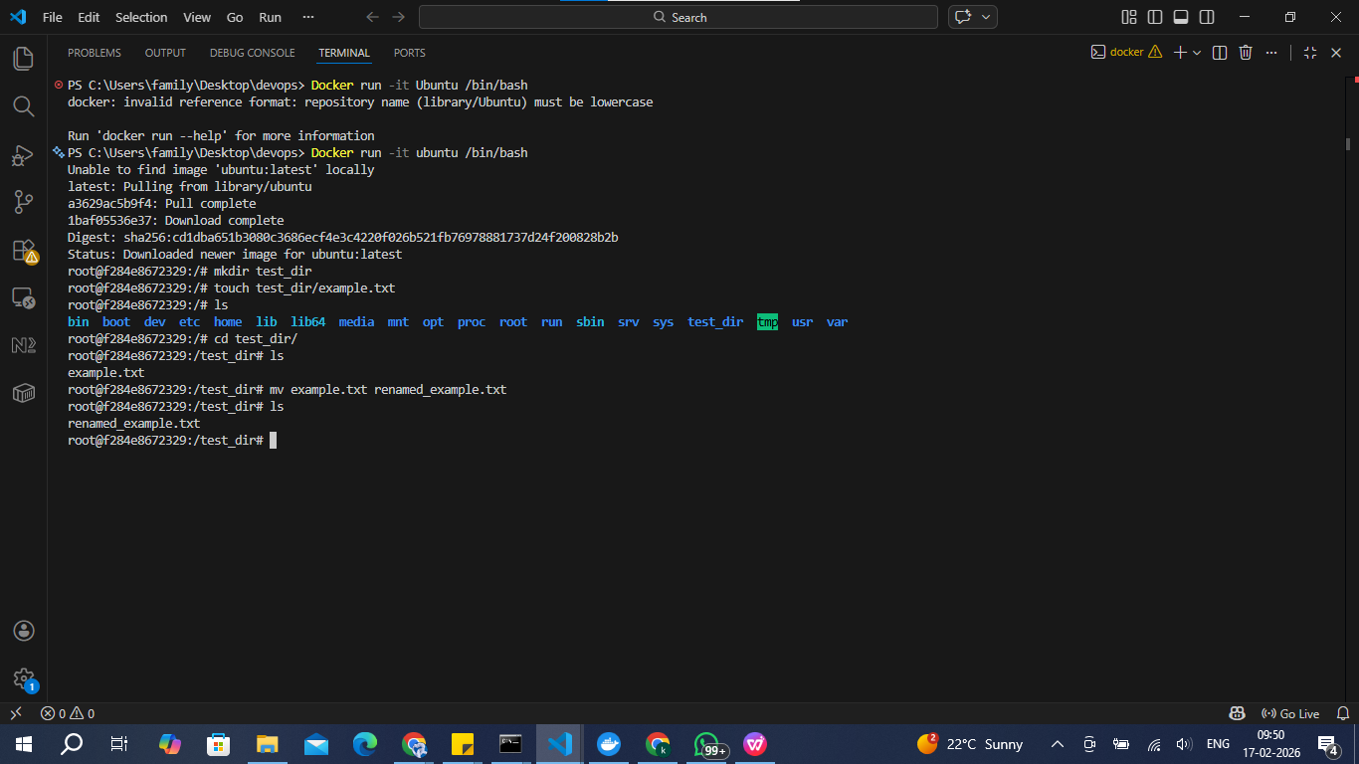

2. Viewing File Contents
Use cat to display the contents of /etc/passwd.
Display only the first 5 lines of /etc/passwd using head.
Display only the last 5 lines of /etc/passwd using tail.

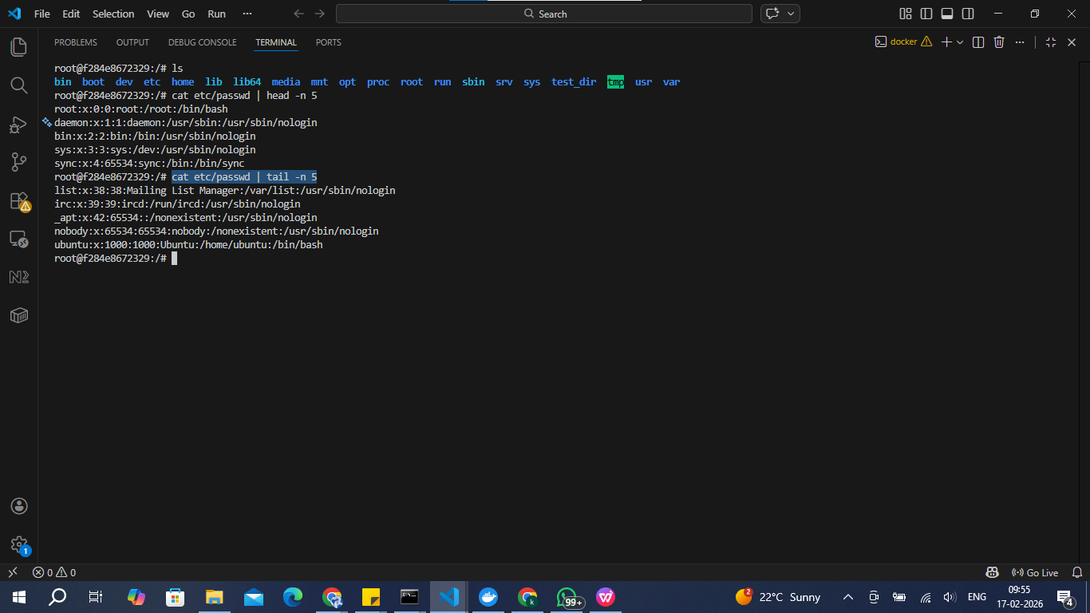

3.Searching for Patterns
Use grep to find all lines containing the word "root" in /etc/passwd.

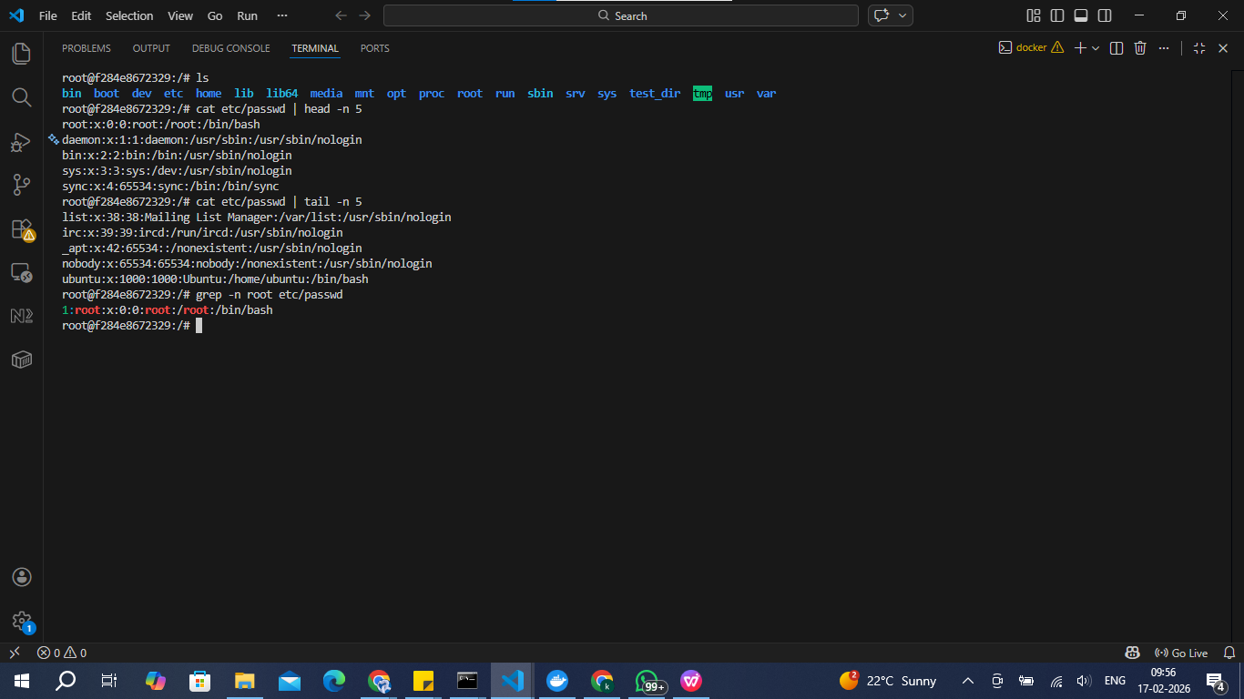

4. Zipping and Unzipping
Compress the test_dir directory into a file named test_dir.zip using zip.
Unzip test_dir.zip into a new directory named unzipped_dir.
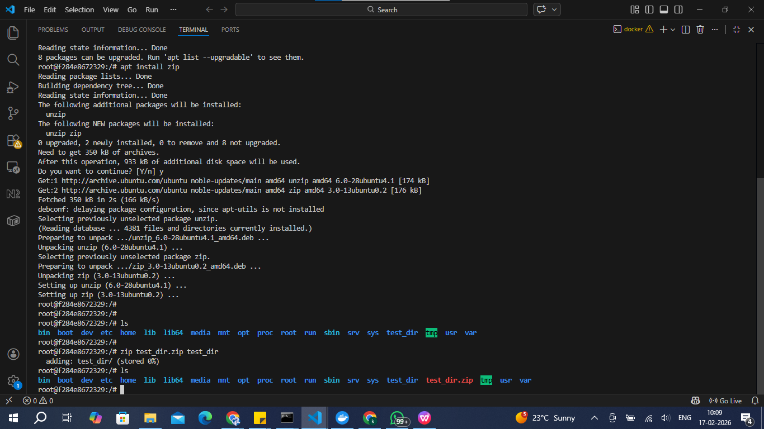

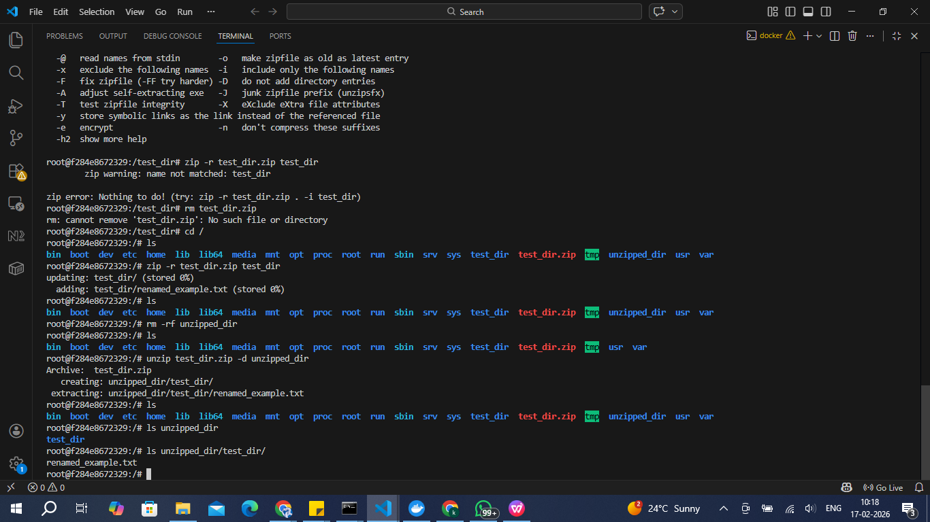

5. Downloading Files
Use wget to download a file from a URL (e.g., https://example.com/sample.txt).

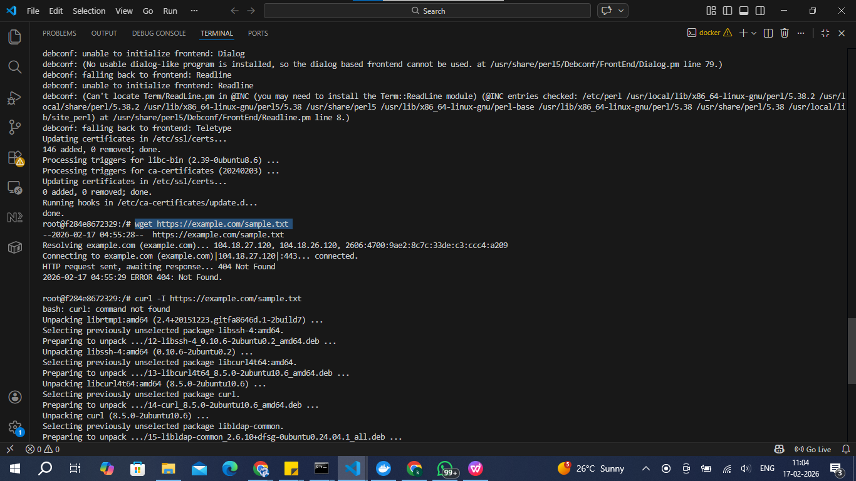
There is no file present in the link
to obtain the file as the response

6. Changing Permissions
Create a file named secure.txt and change its permissions to read-only for everyone using chmod.

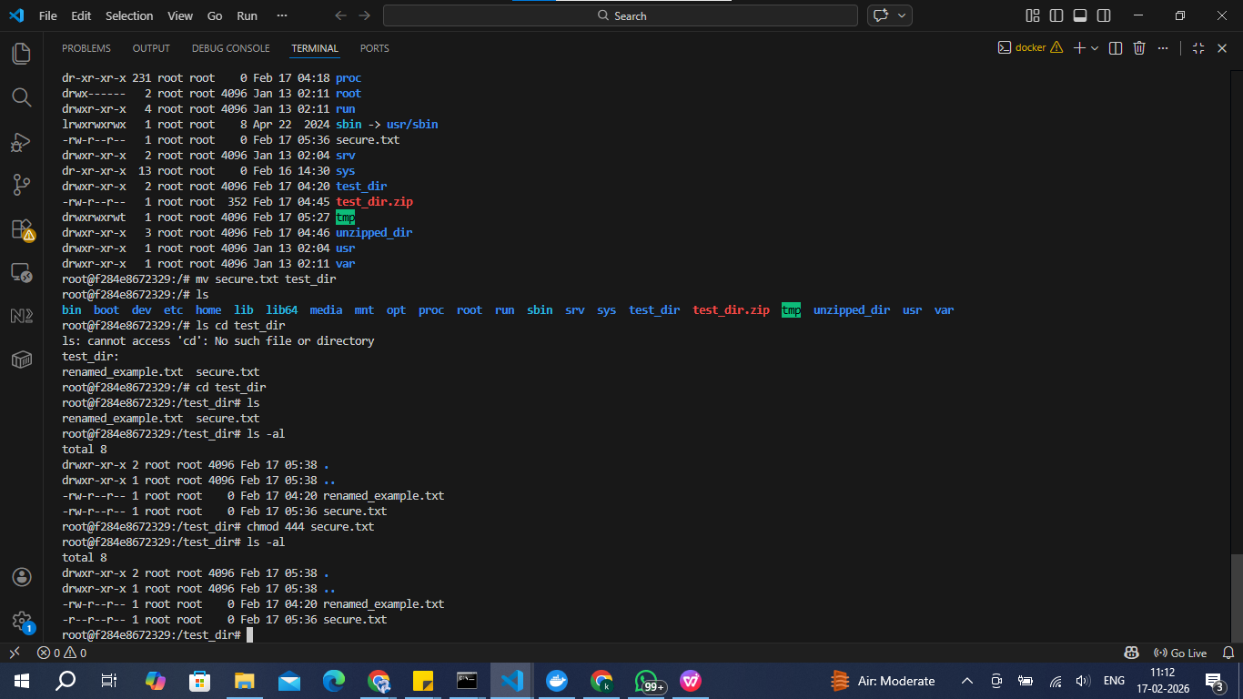

Chmod changes the permissions for users , groups and others
Rwx represents read write and executables
to make it read-only we need to keep 100(binary) as the permission
converting 100 to numerical is 4 , so executed chmod 444 <filename>

7. Working with Environment Variables
Use export to set a new environment variable called MY_VAR with the value "Hello, Linux!".

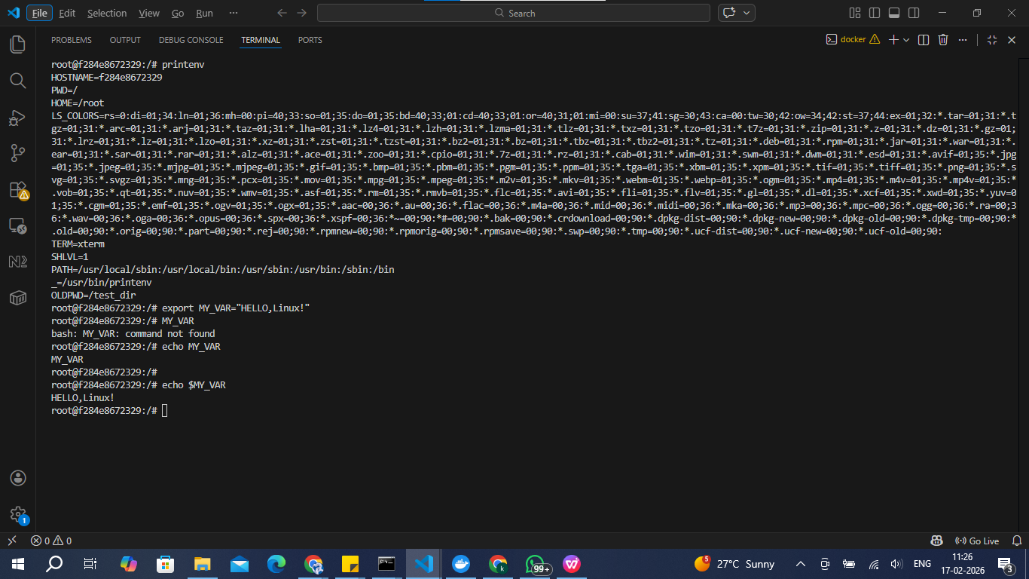

Export is used to define the parameters
And used echo to print (to identify as environment variables use $)

