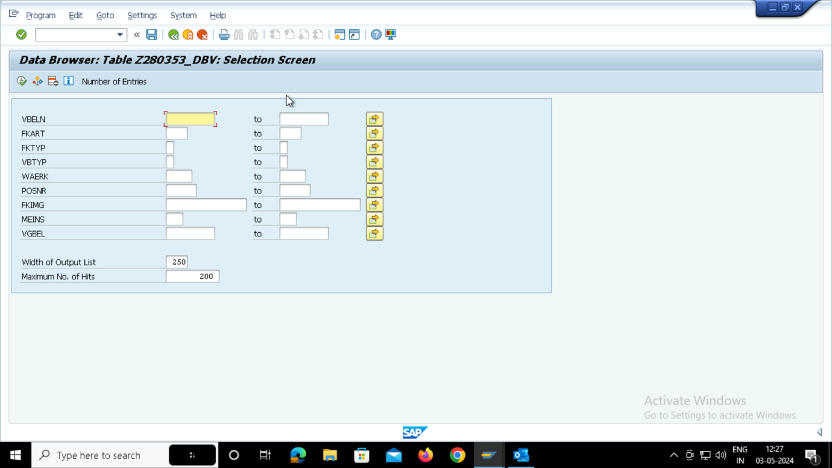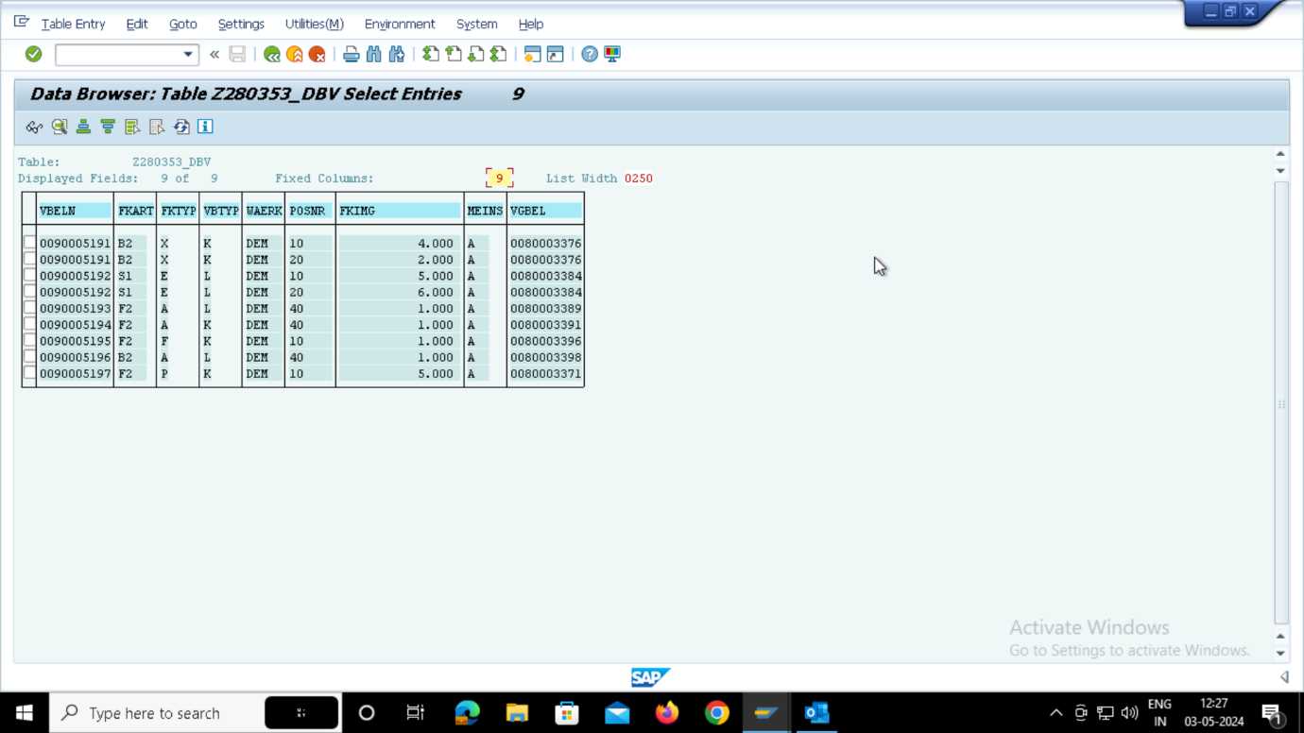

REPORT ON DATA BASE VIEW

*\*&---------------------------------------------------------------------\**  
*\*& Report Z280353_DBV_REPORT*  
*\*&---------------------------------------------------------------------\**  
*\*&*  
*\*&---------------------------------------------------------------------\**  
REPORT Z280353_DBV_REPORT NO STANDARD PAGE HEADING LINE-SIZE 500 MESSAGE-ID z353_messageclass.  
  
  
INCLUDE Z_INCLUDE.  
  
  
SELECT-OPTIONS S_VBELN FOR LV_VBELN.  
  
  
INITIALIZATION.  
s_vbeln-low = '0090005191'.  
s_vbeln-high = '0090005197'.  
append s_vbeln.  
  
at SELECTION-SCREEN.  
  perform init_valid.  
  
  
  
START-OF-SELECTION.  
 PERFORM GET_DATA.  
 END-OF-SELECTION.  
  
 PERFORM DISP_DATA.  
*\*&---------------------------------------------------------------------\**  
*\*& Form init_valid*  
*\*&---------------------------------------------------------------------\**  
*\*& text*  
*\*&---------------------------------------------------------------------\**  
*\*& -->  p1        text*  
*\*& <--  p2        text*  
*\*&---------------------------------------------------------------------\**  
FORM init_valid .  
  select single vbeln  
    into wa_tab-vbeln  
    from z280353vbrk  
    where vbeln in s_vbeln.  
  
    if sy-subrc = 0.  
      message s000.  
      else.  
        message e001.  
  
    endif.  
  
  
ENDFORM.  
*\*&---------------------------------------------------------------------\**  
*\*& Form GET_DATA*  
*\*&---------------------------------------------------------------------\**  
*\*& text*  
*\*&---------------------------------------------------------------------\**  
*\*& -->  p1        text*  
*\*& <--  p2        text*  
*\*&---------------------------------------------------------------------\**  
FORM get_data .  
  
  SELECT VBELN FKART FKTYP VBTYP WAERK POSNR FKIMG MEINS VGBEL  
    INTO TABLE IT_TAB  
    FROM Z280353_DBV  
    WHERE VBELN IN S_VBELN.  
  
  
ENDFORM.  
*\*&---------------------------------------------------------------------\**  
*\*& Form DISP_DATA*  
*\*&---------------------------------------------------------------------\**  
*\*& text*  
*\*&---------------------------------------------------------------------\**  
*\*& -->  p1        text*  
*\*& <--  p2        text*  
*\*&---------------------------------------------------------------------\**  
FORM disp_data .  
  
LOOP AT IT_TAB INTO WA_TAB.  
  WRITE : / WA_TAB-posnr,  
            WA_TAB-vbeln,  
            WA_TAB-fkimg,  
            WA_TAB-waerk,  
            WA_TAB-meins.  
  ENDLOOP.  
ENDFORM.

