TASK 1

Python File Handling & Automation

1. Project Title
Automated File Organizer using Python

2. Objective
The objective of this project is to develop a Python automation program that organizes files automatically based on their file extensions. The program identifies different types of files and moves them into separate folders, reducing manual file management effort.

3. Technologies Used
- Python 3.13
- OS Module
- Shutil Module
- Visual Studio Code

4. Project Description
This project demonstrates Python file handling and automation. The program checks files from a given folder, identifies their extensions, creates required folders, and automatically moves files into their respective categories such as Images, Documents, and Videos.

5. Implementation

Python Code
import os
import shutil

# 1. Dynamically get the absolute path of the folder where main.py is located
BASE_DIR = os.path.dirname(os.path.abspath(__file__))

# 2. Define the folder containing the messy files (sitting right next to main.py)
SOURCE_FOLDER = os.path.join(BASE_DIR, "files")

# 3. Define categories and their corresponding extensions
CATEGORIES = {
"Images": [".jpg", ".png", ".jpeg"],
"Documents": [".pdf", ".docx", ".txt"],
"Videos": [".mp4", ".mkv"]
}

def organize_files():
# Check if the source folder actually exists before running
if not os.path.exists(SOURCE_FOLDER):
print(f"Error: The folder '{SOURCE_FOLDER}' does not exist.")
print("Please create a folder named 'files' next to main.py and put your items there.")
return

# Create category folders inside SOURCE_FOLDER if they don't exist
for folder_name in CATEGORIES:
folder_path = os.path.join(SOURCE_FOLDER, folder_name)
if not os.path.exists(folder_path):
os.makedirs(folder_path)

# Track if any files were actually moved
files_moved = 0

# Scan and organize files
for item in os.listdir(SOURCE_FOLDER):
item_path = os.path.join(SOURCE_FOLDER, item)

# Make sure we are only looking at files, not the subfolders we just created
if os.path.isfile(item_path):
# FIXED: Correctly separating the extension first, then converting it to lowercase
_, extension = os.path.splitext(item)
extension = extension.lower()

# Find the correct category for this extension
for category, extensions in CATEGORIES.items():
if extension in extensions:
destination_folder = os.path.join(SOURCE_FOLDER, category)
destination_path = os.path.join(destination_folder, item)

# Move the file
shutil.move(item_path, destination_path)
print(f"Moved: {item} -> {category}/")
files_moved += 1
break # Stop checking other categories once a match is found

if files_moved == 0:
print("No loose files found to organize!")
else:
print(f"Success! Organized {files_moved} files.")

if __name__ == "__main__":
organize_files()
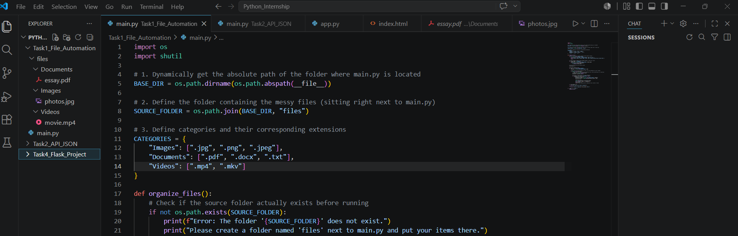

6. Working Process
- The program accesses the source folder.
- It checks the extension of each file.
- Based on the extension, files are categorized.
- Required folders are created automatically.
- Files are moved into their respective folders.

7. Output Screenshot

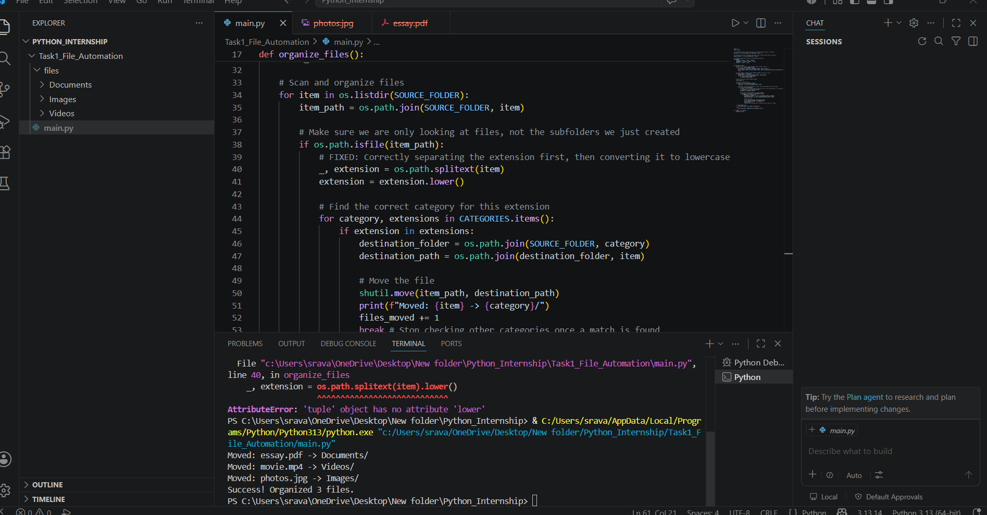

8. Result
The File Organizer Automation project was successfully developed using Python. The program automatically organizes files and reduces manual work.
Submitted By:
NAKIRTHI SRAVAN KUMAR
Internship Tasks Completed:
Task 1, Task 2, Task 4

