TASK 2

API Integration & JSON Handling

1. Project Title
Weather Information Application using API

2. Objective
The objective of this project is to integrate an external API with Python and process JSON data to display useful information.

3. Technologies Used
- Python 3.13
- Requests Library
- JSON
- API Integration
- Visual Studio Code

4. Project Description
This project connects with a weather API and retrieves weather information based on the user-entered city name. The API response is received in JSON format, which is processed using Python to extract temperature details.

5. Implementation

Python Code
import requests

city = input("Enter city name: ")

url = f"https://wttr.in/{city}?format=j1"

response = requests.get(url)

if response.status_code == 200:
data = response.json()

temperature = data["current_condition"][0]["temp_C"]

print("City:", city)
print("Temperature:", temperature, "°C")

else:
print("City not found")

6. Working Process
- User enters a city name.
- Python sends a request to the weather API.
- API returns data in JSON format.
- Python extracts temperature information.
- Weather details are displayed.

7. Output
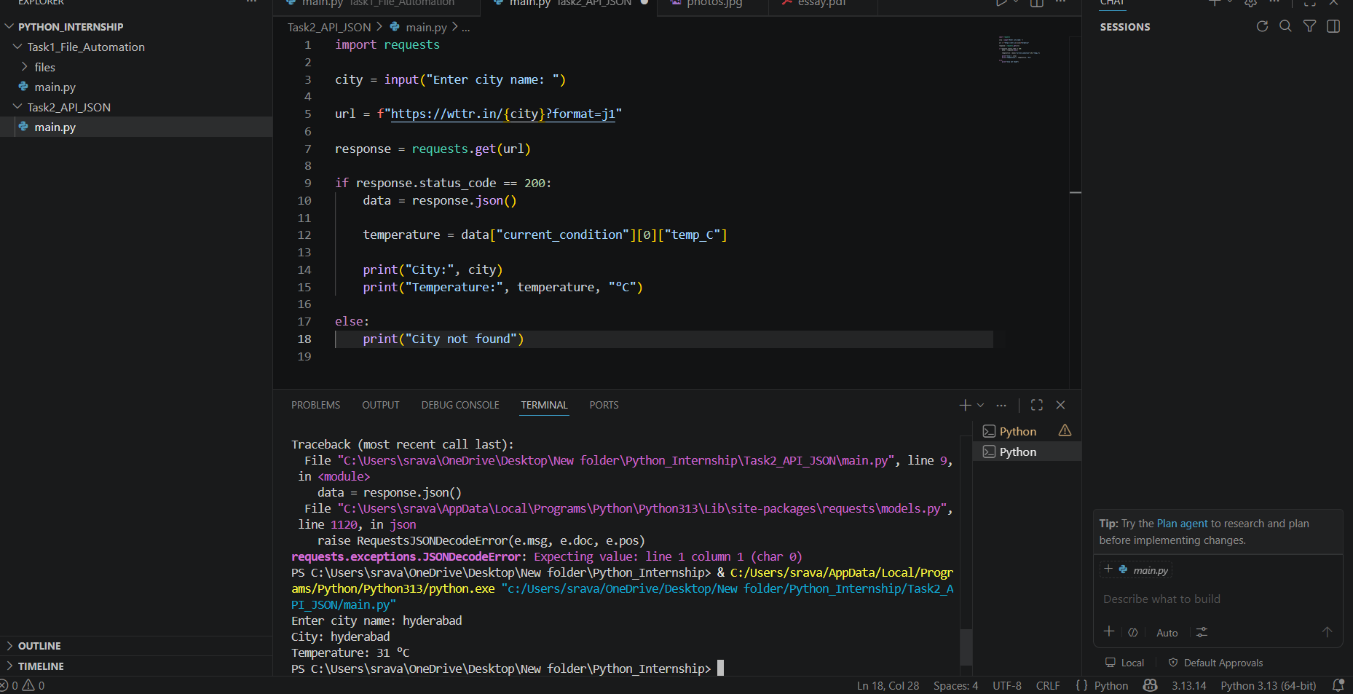

8. Result
The API Integration project was successfully completed. The application communicates with an external API and handles JSON data effectively.
Submitted By:
NAKIRTHI SRAVAN KUMAR
Internship Tasks Completed:
Task 1, Task 2, Task 4

