TASK 4

Student Management System using Flask

1. Project Title
Student Management System Web Application

2. Objective
The objective of this project is to develop a simple web application using Flask that allows users to add and display student details dynamically.

3. Technologies Used
- Python
- Flask Framework
- HTML
- Visual Studio Code

4. Project Description
This project is a beginner-level web application built using Flask. It contains a webpage where users can enter student information such as name and branch. The data is processed using Flask and displayed on the webpage.

5. Project Structure
Task4_Flask_Project
│── app.py
│── templates
└── index.html

6. Implementation

app.py Code
from flask import Flask, render_template, request

app = Flask(__name__)

students = []

@app.route("/")
def home():
return render_template("index.html", students=students)

@app.route("/add", methods=["POST"])
def add_student():

name = request.form["name"]
branch = request.form["branch"]

students.append({
"name": name,
"branch": branch
})

return render_template("index.html", students=students)

if __name__ == "__main__":
app.run(debug=True)

index.html Code
<!DOCTYPE html>
<html>
<head>
<title>Student Management</title>
</head>

<body>

<h1>Student Management System</h1>

<form action="/add" method="POST">

Name:
<input type="text" name="name">

<br><br>

Branch:
<input type="text" name="branch">

<br><br>

<button type="submit">Add Student</button>

</form>

<h2>Students List</h2>

<ul>

{% for student in students %}

<li>
{{ student.name }} - {{ student.branch }}
</li>

{% endfor %}

</ul>

</body>
</html>

7. Working Process
- Flask server is started.
- User opens the webpage.
- Student details are entered.
- Data is sent to Flask backend.
- Entered details are displayed on the webpage.

8. Output Screenshots
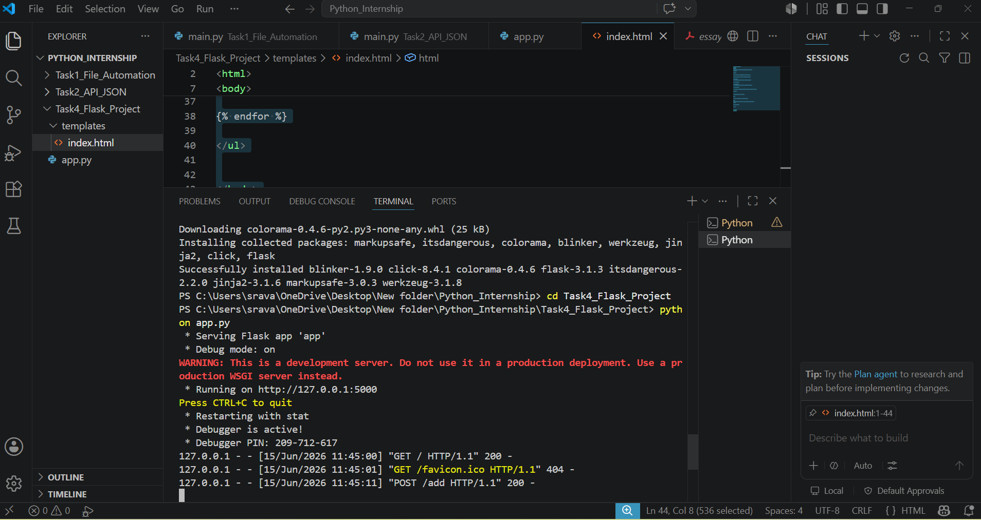
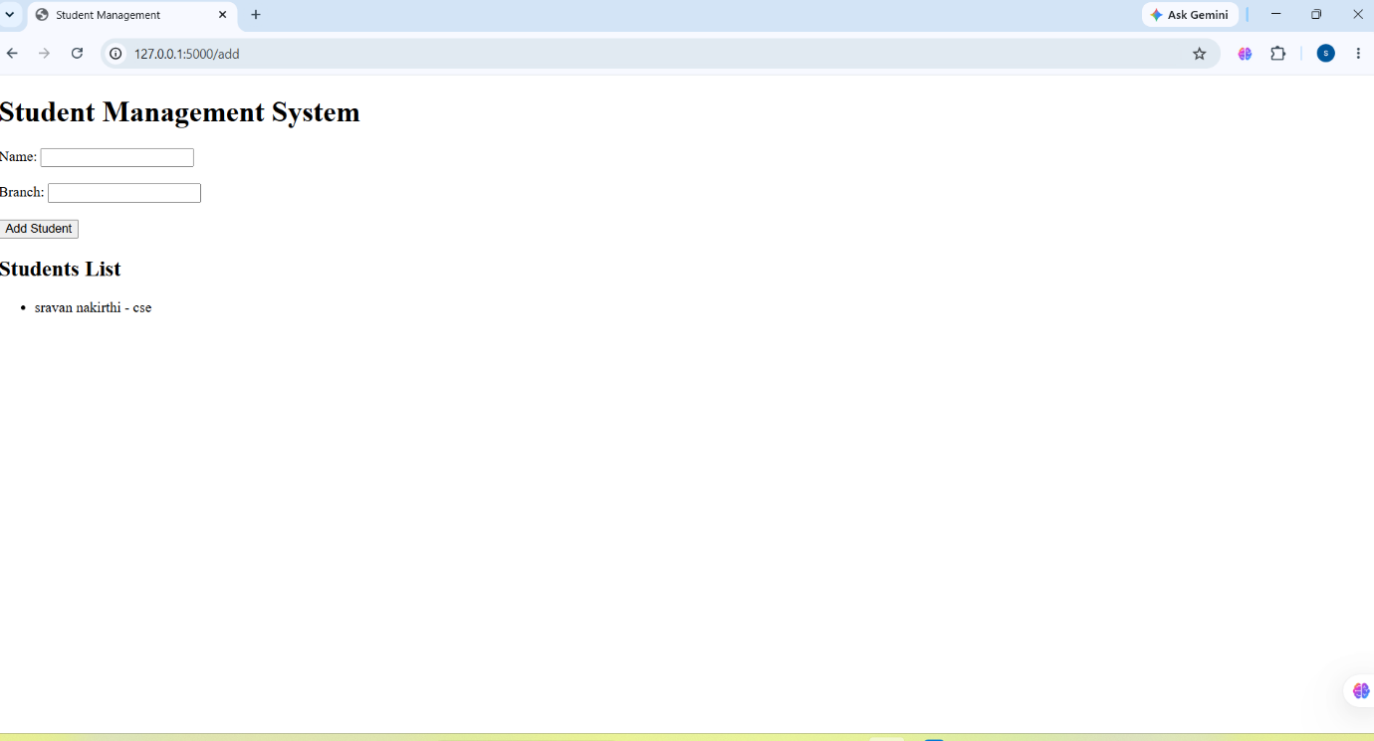

9. Result
The Student Management System was successfully developed using Flask. The application demonstrates basic web development concepts and backend communication.
Submitted By:
NAKIRTHI SRAVAN KUMAR
Internship Tasks Completed:
Task 1, Task 2, Task 4

