SETTING ZABBIX server on Ubuntu system

<https://www.digitalocean.com/community/tutorials/how-to-install-zabbix-on-ubuntu-configure-it-to-monitor-multiple-vps-servers>

reference link for the document.

Password used :zabbix

(these steps are used only when the link does not exist in atp so first try from step 22 as mentioned below)

* Steps 1-10 in the image tells us like everything that we install on Ubuntu links get saved in the atp file and if we are going to download anything that which not exist tin atp file need to be saved in that atp file using the command in steps 8,910.
* Steps 13 and 14 gives the key to install the application.

-----------------------------------------------------------------------

* As usual perform updates i.e, step 22 from image.
* Install zabbix server with packages using step 23 from image.
* **Configure :** edit the zabbix server file using the command in line 32.

1. We need to edit the file as shown in 34,35,36 lines.
2. To find something in vi editor just press Esc and type what you are looking for so that it will find that for you.
3. Provide DBName, DBUser and DBPassword as zabbix then save and exit by using (:wq!)

ONCE THE ZABBIX IS CONFIGURED THEN WE NEED TO CONFIGURE MYSQL

1. We can configure the mysql file by entering into it using the command in the line 44
2. So once we use the command in line 44 of the image will get into that directory, now using the command (ls -lrt ) see the files in it we can see all the files with .gz which means all are zipped files .
3. So to unzip them the best way is using the command in line 45 of the image.

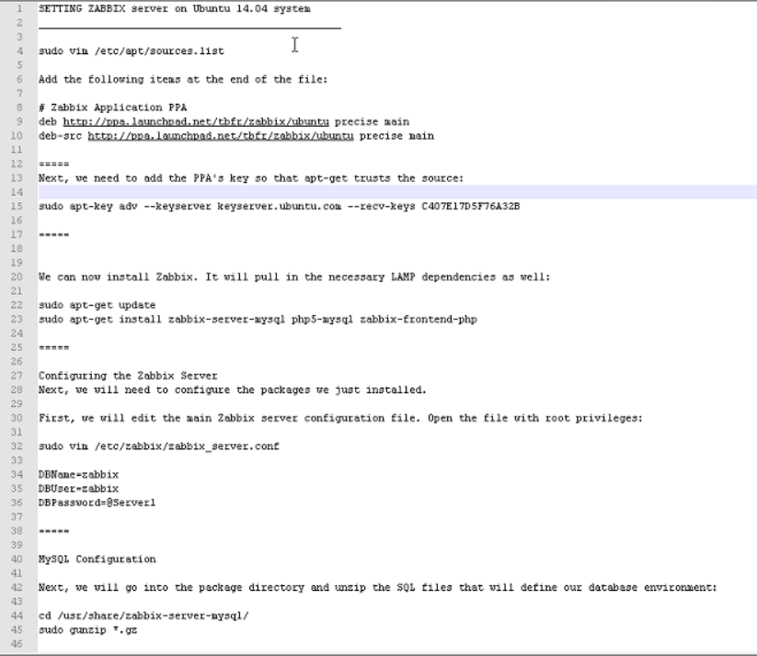

* Once unzipping is done you need to login into mysql database Use the command in line 51 img
* Now you need to create the zabbix user use the command in the line 54 img, you can set your own user and password credentials as we configured earlier zabbix file for DBUser ,DBName and DBPassword as zabbix lets go with it.

So the command in line 54 should be as follows

Create user ‘zabbix’@’localhost’ identified by ‘zabbix’;

* Once the user is created we need to create the zabbix DB, we need this Db because we need to keep the monitoring data into this database for this use command in line 57.
* Once the DB is created then you need to grant all the permissions using the command.

grant all privileges on zabbix.* to ‘zabbix’@’localhost’;

* Flush privilages using cmd in line 63 this should be done to avoid any privilages that where before we granted the permissions
* Now you can exit from the database we are done with the initial configuration of the mysql.

‘’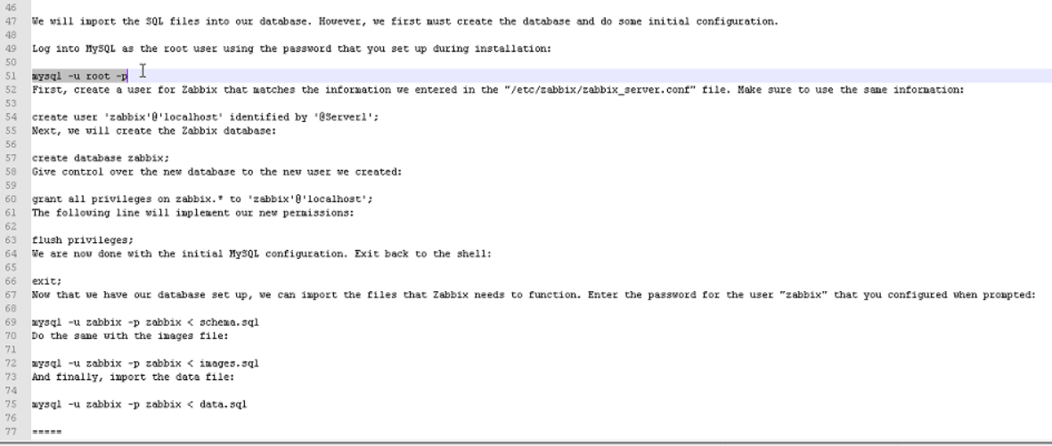

* Now that we have our database set up, we can import the files that Zabbix needs to function. Enter the password for the user "zabbix" that you configured when prompted: for this use command in the line 69

Rest of the steps follow from the following link

<https://www.digitalocean.com/community/tutorials/how-to-install-zabbix-on-ubuntu-configure-it-to-monitor-multiple-vps-servers>