**Linus for Devops & Cloud Engineers**

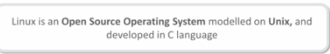

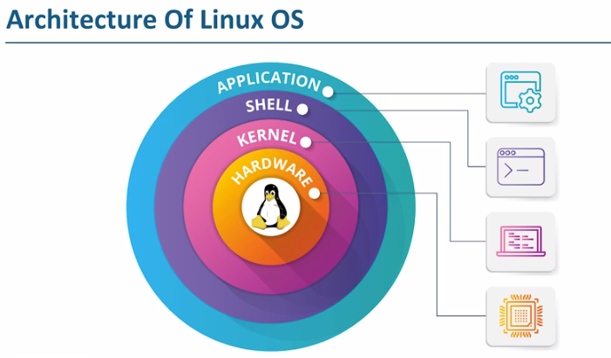

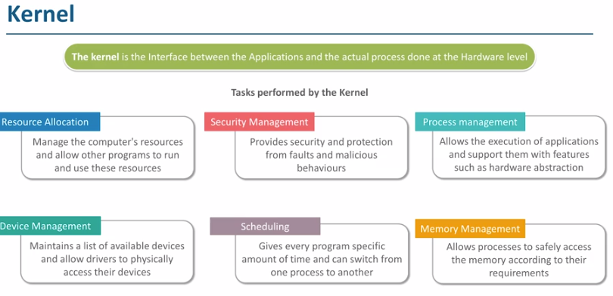

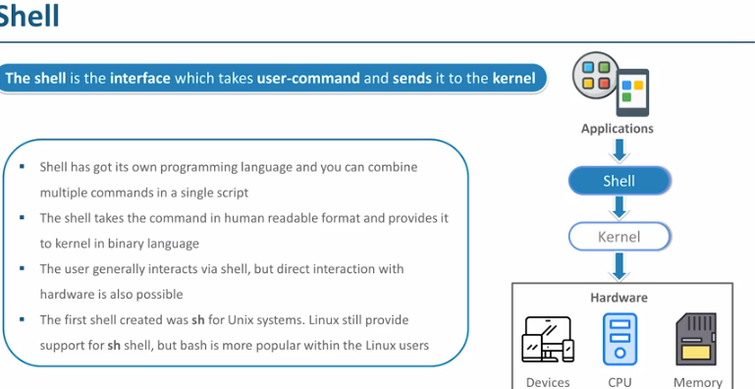

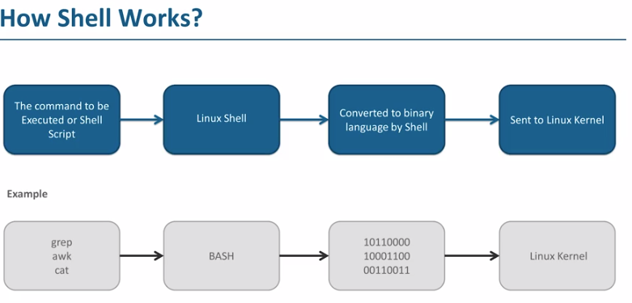

*Default shell in linux is Bash (bourne again shell)*

Using the **-i** argument with the command **helps to ignore the case sensitive**

**Sudo su -** ………. This is command is used to switch to root user, if we want to install anything then we can be done using only root user.



The sudo command **allows you to run programs with the security privileges of another user** (by default, as the superuser). It prompts you for your personal password and confirms your request to execute a command by checking a file, called sudoers , which the system administrator configures.

**$ represents user**

**# represent root user**



**Pwd** …. Which means print working directory which will tell the path of current working directory



**Whoami** : this will tells the who logged into the terminal (user or root)



**Hostname :** This will tells the hostname, if we want to change the hostname then command is ***hostname name***

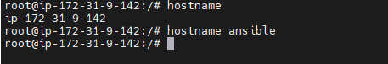

To check the file systems **ls /**



/ is the parent root directoy

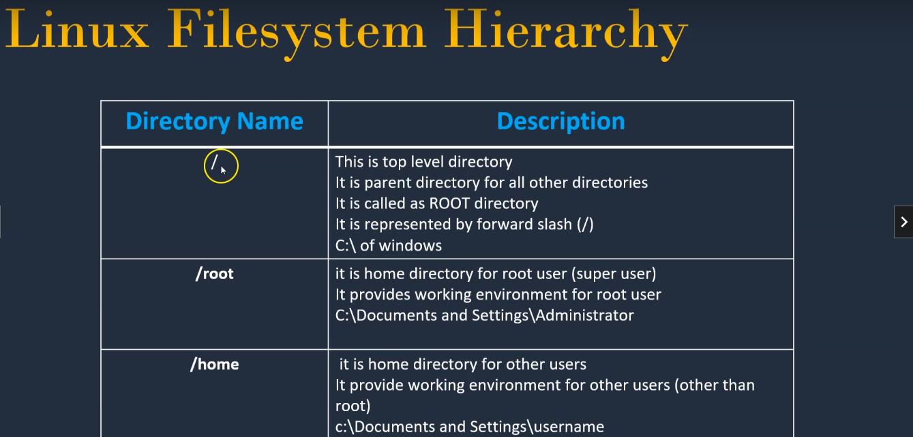

/root – this is home directory for root user

/home – this is home directory for other users

By default when you create a user in Linux, users default home directory is created under /home. If you noticed on Ubuntu and Debian derivated distribution useradd command won't create a home directory by default.

**Create default home directory for existing user**

Lets create one user by user add

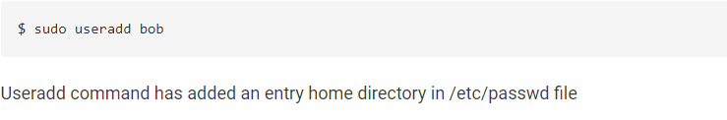

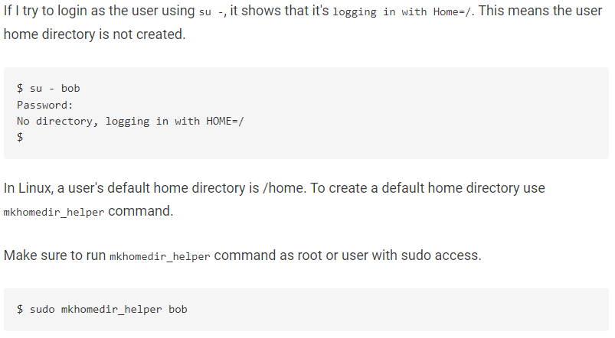

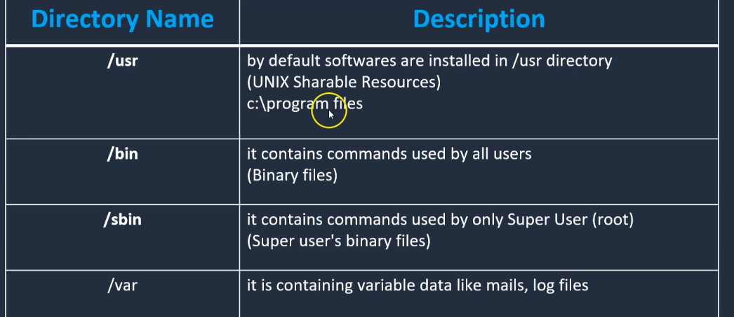

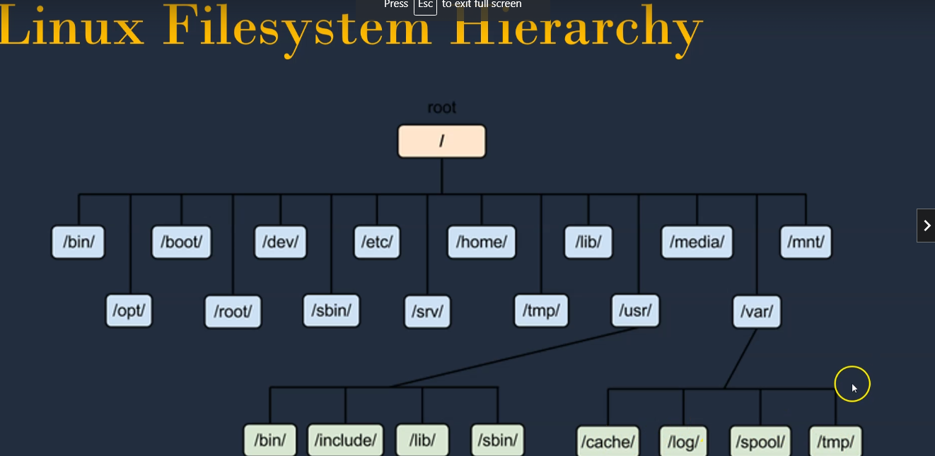

**Date** : this is used to display date (AWS machines will display UTC date)



**Cal** is the command used to display current month calendar

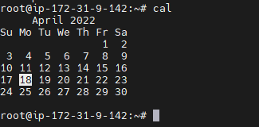

**Uptime** : to identify how long server is up and running

**Users**: tell the number of users added in the server

**Who**: will give the user and internet ip

**Clear** : to clear the page

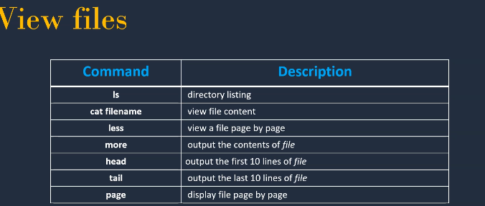

**Touch** – to create new file

**Mkdir** – to make directory

Mkdir –p(to create nested directories ) ----- **mkdir –P India/Telangana/Hyderabad**

**Ls – l** --- Long list

Ls –a to display hidden files

**Vi** – to add data into file

:wq (write and quit the file)

**Rm –rf :** to delete directory

**Rm** - to delet file

**Cd** to change one directory from another directory

**Cd ..** to move back to previous directory

**Cd ~** -- to go to root user

**Cp** – to copy one file to another file

**Cp file1 file2** --- file1 is source and file2 is target directory

**Mv** – to move content from one file to another file file (renaming file)

**Absolute path:** This path will always starts with / (complete path)

**Relative path:** this will not begin with /



**Cat – concatation : cat >file1.txt -- this will add some text in file1**

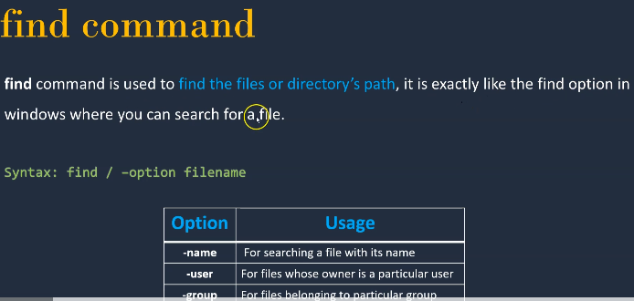

**Find / -option filename**

**Find /-name filename**

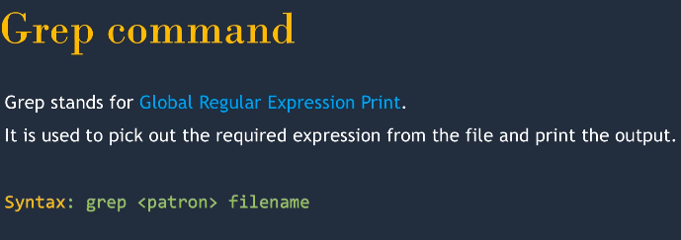

**Global regular expression print is grep**

**Grep Devops test.txt …**this command will search the Devops keyword in file test.txt, grep will work only on files and not on directories

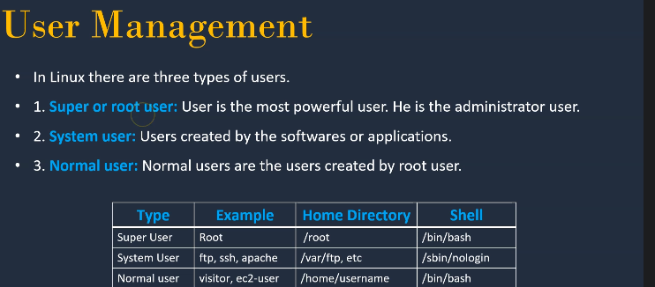

We can create new users only if we are on root user, with normal user we will not be allowed to create other user

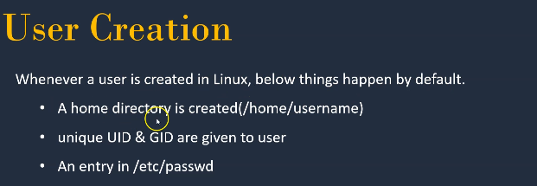

**Useradd** : this is used to create user

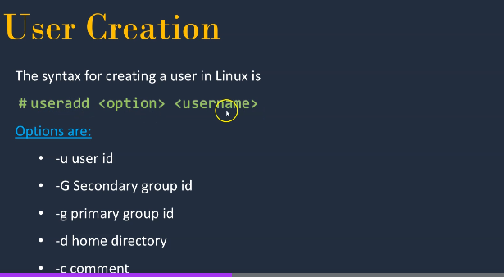

Once user is created then if we give command as **id username** then we can see the uid, gid, groups

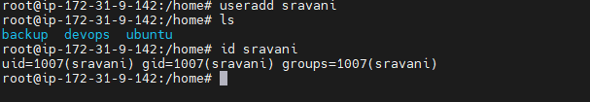

**Users are part of /etc/passwd ( cat /etc/passwd)**

**Groups are part of /etc/group(cat /etc/passwd)**

Every user on a Linux system, whether created as an account for a real human being or associated with a particular service or system function, is stored in a file called "**/etc/passwd**". The "/etc/passwd" file contains information about the users on the system.

**Usermod** is to change existing user to different group, adding one id to another group

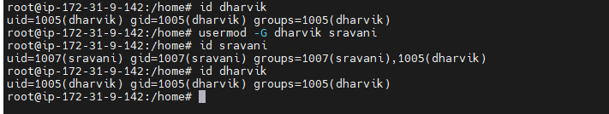

For setting password for users (**passwd username)**

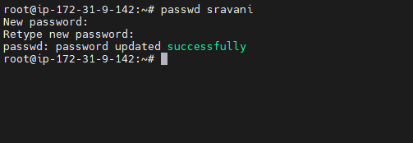

**Ls command**

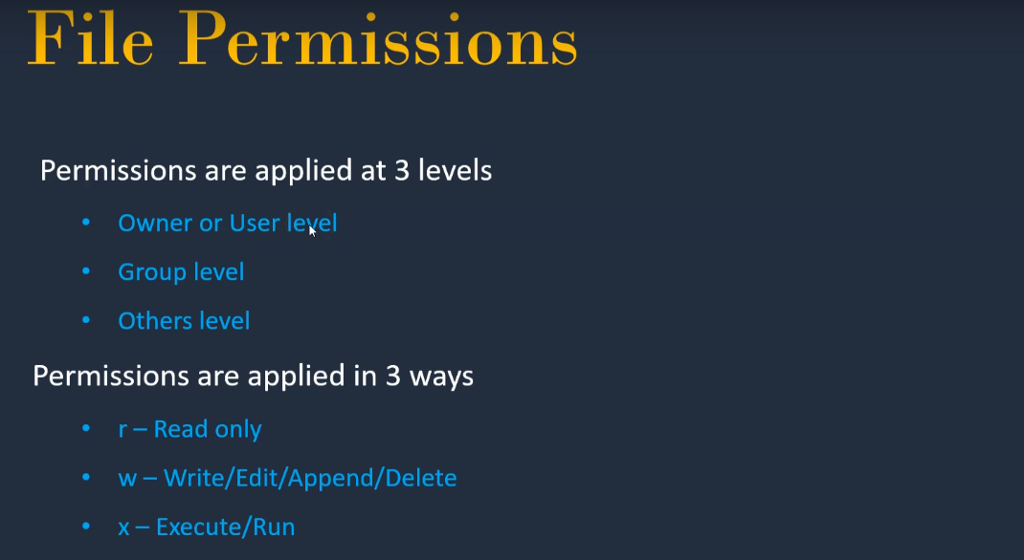

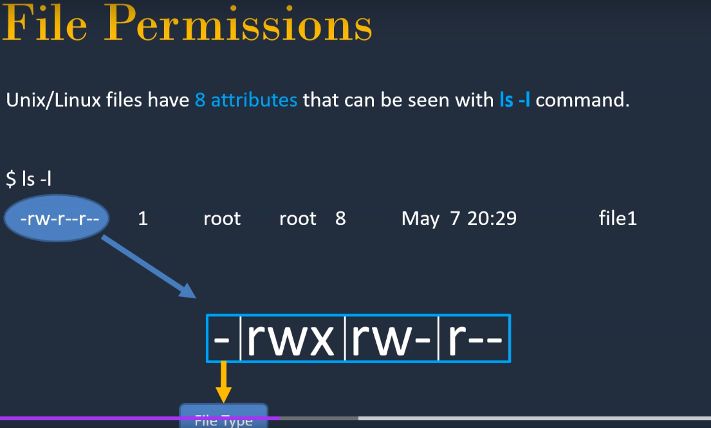

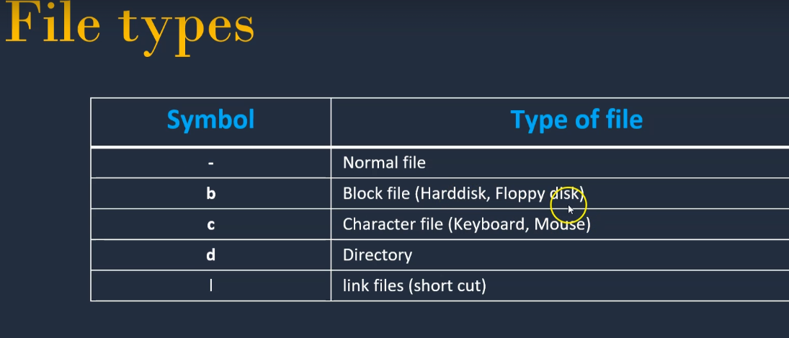

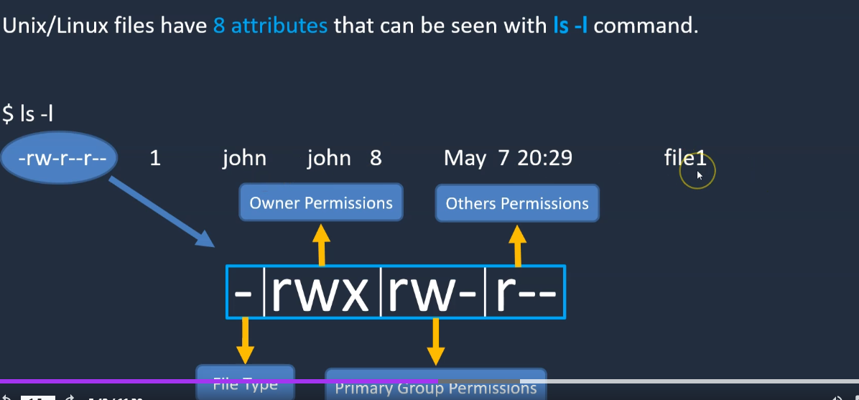

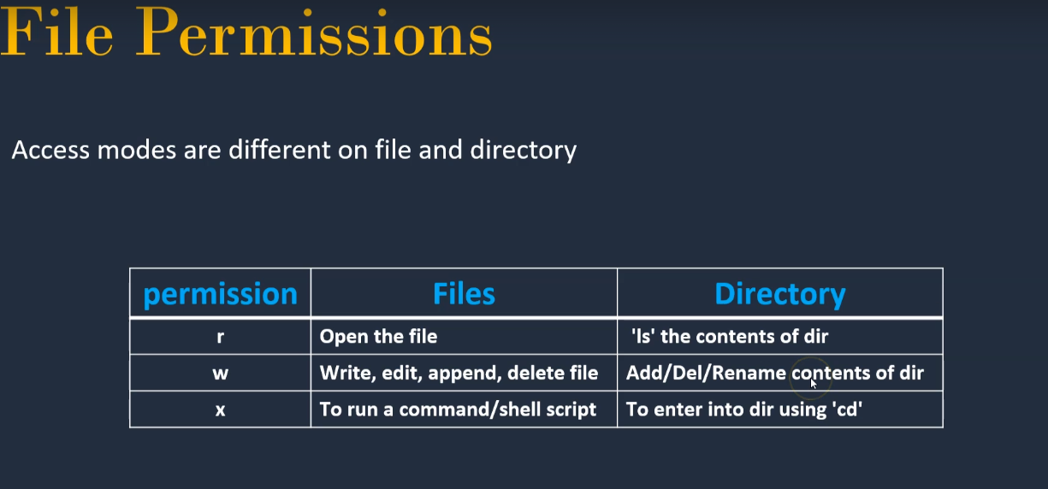

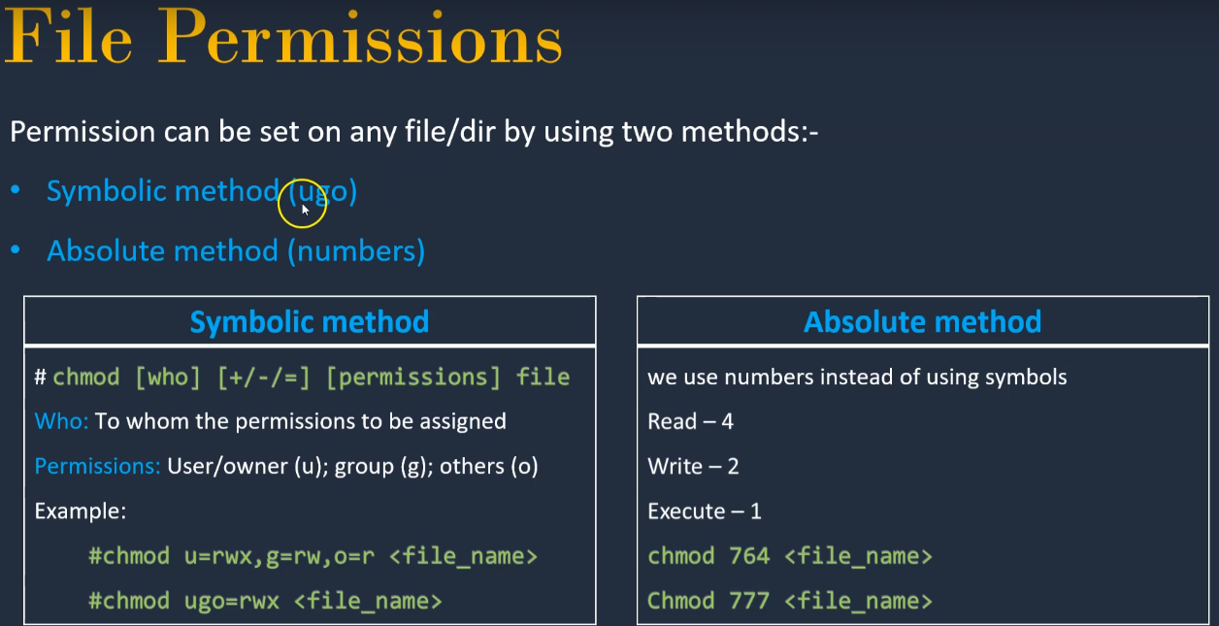

**Chmod – change the mode**

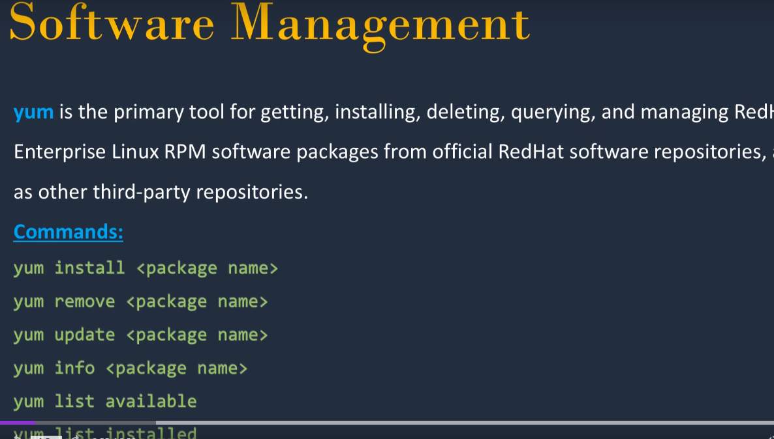

Installing is basically the same, you do 'yum install package' or 'apt-get install package' you get the same result. **Yum automatically refreshes the list of packages, whilst with apt-get you must execute a command 'apt-get update' to get the fresh packages**.

sh is **a command language interpreter that executes commands read from a command line string, the standard input, or a specified file**.

**Su-** - switch user (sudo su – to switch to root)

**Init 6** is the command to restart system

**Ping** – to check wether the target system is available or not

**Wget** – command to download packages.

**Shell Scripting :**

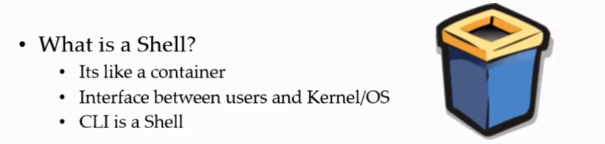



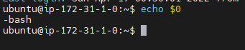

Shell script: if we have to install package on 100 servers then we need to write some automation code and push, this code is in shell script.

Shell script helps to execute sequence of steps (series of commands)

Sh --- this is the CLI shell (bourne shell)

Bash - Bourne Again Shell

**#! /bin/bash**

To execute any script sh **script name**

**Echo $? --** if it is 0 then successfully script is executed

There are two was to run any script

* Using absolute path (we need to give full path like /**home/project/sravan/xyz-script**)
* Using relative path ( **./xyz-script**) this command will execute the xyz-file but we need to be on the folder where xyz-script is present