Image Classification using ResNet34

# Image Dataset Setup

* Convert the TIFF file formatted images to JPG and zip them into a folder
* Extract the images into 38 different folders each representing a class label

# Initialization

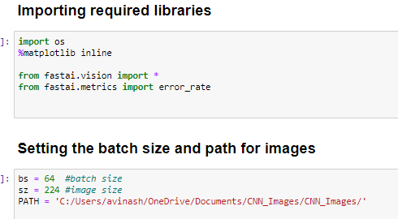

* PATH is the path containing all the class folders
* Convert the folder names into class label names from 1-38

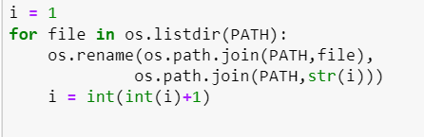

* Retrieve the image classes from the foldes

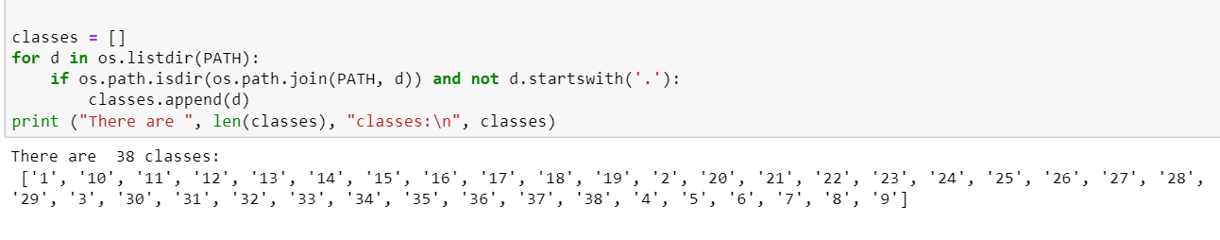

# Creating and training the classifier

* Let’s create our training and validation sets, 80% of the dataset will be used or training and 20% for validation
* Normalize the images to ensure that each pixel has a similar data distribution and visualizing some images from different classes



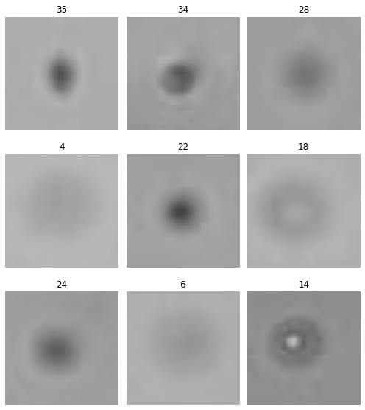

* Build the Deep Convolutional Neural Network (CNN) with using ResNet34 as the model architecture



* Training the model on the images

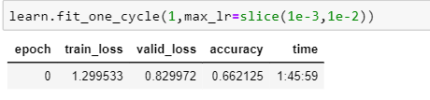

* As the run time is very large, only one epoch was run on the dataset and achieved an accuracy of **66.2%**

# Results Interpretation and Visualization

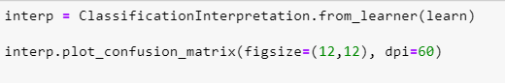

* The diagonal elements in a confusion matrix represent the number of images for which the predicted label is equal to the true label, while off-diagonal elements are those that are mislabeled by the classifier
* The confusion matrix below shows that most of the class labels were predicted correctly except few classes

