**HEALTH INSURANCE PREMIUM PREDICTION USING IBM AUTO AI SERVICE**

**INDEX**

**TOPICS PAGE NO.**

1. **Introduction 1**
   1. Overview
   2. Purpose
2. **Literature Survey 1**
   1. Existing problem
   2. Proposed solution
3. **Theoretical Analysis 3**
   1. Block Diagram
   2. Hardware/Software Designing
4. **Experimental Investigations 5**
5. **Flow Chart 6**
6. **Result 7**
7. **Advantages & Disadvantages 8**
8. **Applications 8**
9. **Conclusion 9**
10. **Future Scope 9**
11. **Bibliography 9**
12. **Appendix 10**
    1. Source Code
    2. UI output Screenshot

**1. INTRODUCTION**

**1.1 Overview:**

A health insurance premium is the amount typically billed monthly that the policyholders pay for health coverage. Policyholders must pay their premiums each month regardless of whether they visit a doctor or use any other healthcare service.

Now-a-days this health insurance is necessary for every individual. Factors that determine this insurance premium differ from one company to another. Some of the rural area people are unaware of these factors and they blindly listen to the insurance company employees by paying high amount.

So many people are being fooled or they are made to pay high premium every year.

**1.2 Purpose:**

By increasing in the private companies and policies, many people are unable to understand their factors for the health insurance premium. This makes the people being fooled and make them buy a private insurance policy.

This project helps people who are unaware about these factors. By giving their details like their age, body mass index (BMI), number of children they have, whether she/he is a smoker or not, what region they belong to and their gender helps to predict their health insurance premium.

Even though this project does not give the exact amount of health insurance premium but gives enough idea about the amount associated with an individual for his/her health insurance.

**2. LITERATURE SURVEY**

**2.1 Existing Problem:**

* In present years, the health insurance premium is calculated by the private companies based on their own factors.
* These factors differ from one company to another company.
* Based on the premium plans like silver, gold, platinum the amount is being calculated which makes the people to pay additional amount than their premium.
* Some people who are not aware of these details are being fooled.

**2.2 Proposed Solution:**

* This project provides an UI interface for the user which helps to calculate their premium based on the normal factors.
* This web-application only asks for the details like age, body mass index (BMI), region, number of children, whether the individual is smoker or not and their gender.
* It doesn't include any details about the premium plan, which helps the individual in paying the amount.
* Even though it doesn't predict the exact amount it gives an idea about the amount that an individual have to pay.
* We are going to use the IBM Auto AI service which automates all of the tasks involved in building predictive models.
* This AutoAI uses Machine Learning Service to create serval models and it picks up the best model which is having the highest accuracy.

**3. THEORETICAL ANALYSIS**

**3.1 Block Diagram:**

**(At the web-application)**

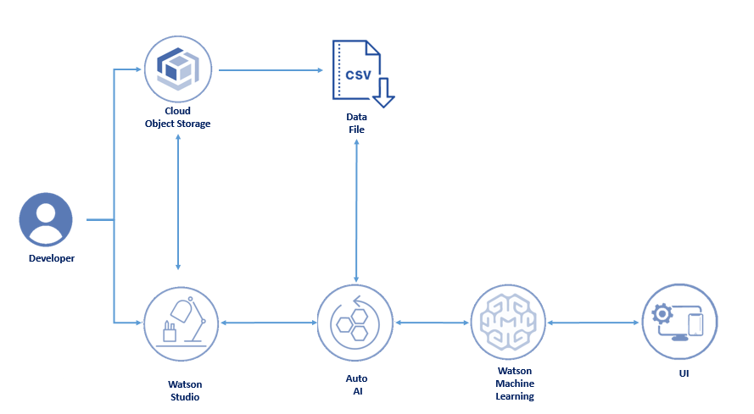

**3.2 Hardware/Software Requirements:**

**Software Requirements:**

* OS - Windows XP 7, 8, 10
* IBM Account
* Watson Studio
* Auto AI Service
* Node-Red Application
* Cloud Storage Space in IBM

**Hardware Requirements:**

* Processor - i3
* RAM - 1GB

**4. EXPERIMENTAL INVESTIGATIONS**

Now-a-days, good health is necessary for every person. Health Insurance Premium is the amount that a person pays every month even though he/she visits or doesn't visit a doctor. This premium will be helpful for any person in case of emergency health issues.

Health Insurance Premiums are offered by many private companies through their websites. They calculate the monthly paid amount is the premium based on some factors. Each company has its factors.

These private companies also include plan of premium such as silver, gold, and platinum. By these plans, many people who are unaware of it are being fooled and they pay high premiums every month.

Our project is about to predict the health insurance premium based on common factors such as:

* + - age
    - gender
    - BMI
    - number of children
    - smoker or not
    - region

This project helps the individual to know the estimated premium that she/he must have to pay and it also brings an awareness that how this health insurance premium will be calculated.

We collected the details of around 1300 people and their details that are related to calculate the premium and their monthly premium amount.

**5. FLOW CHART**

(at the UI Interface)

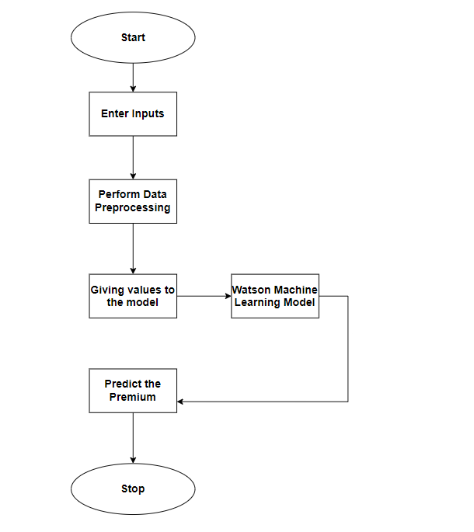

(Machine Learning Model)

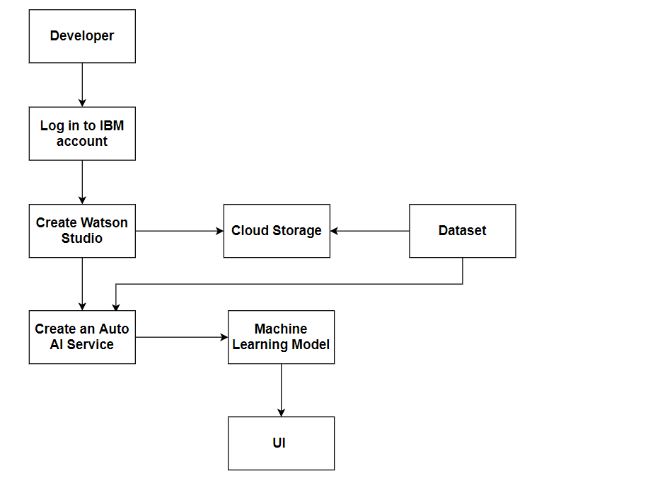

**6. RESULT**

This Health Insurance Premium Prediction constitutes of three steps after creating and deploying the machine learning model in the IBM Cloud.

* The user gives the input values from the UI interface which is created by using the Node-Red Application
* The user inputs are given to the Auto AI Service which consists of the machine learning model.
* This model performs the data pre-processing on the given input values and predicts the output.
* The output will be sent to the Node-Red application using an HTTP request and displays it to the user.

**7. ADVANTAGES & DISADVANTAGES**

**Advantages:**

* Individuals can calculate their Health Insurance Premium without the help of private companies.
* Based on the normal factors which does not include the premium plans of the private companies helps the individual to pay less amount.
* Easy access of the web-application.

**Disadvantages:**

* This project does not give the exact value of the premium.
* If the used dataset has more data with one common factor, it might affect the predicted output. The model can not be able to generate the output for the new value.

**8. APPLICATIONS**

* Useful for the companies that makes the individual to invest in health insurance.
* This project is also helpful for the banks to grant health insurance.

**9. CONCLUSION**

Various factors were used and their affect on the predicted amount was examined. It was observed that a persons age and smoking status affects the prediction most in every algorithm applied. Attributes which had no effect on the prediction were removed from the features.

The effect of various independent variables on the premium amount was also checked. The attributes also in combination were checked for better accuracy results.

**10. FUTURE SCOPE**

Premium amount prediction focuses on persons own health rather than other company's insurance terms and conditions. The models can be applied to the data collected in coming years to predict the premium. This can help not only people but also insurance companies to work in tandem for better and more health centric insurance amount.

**11. BIBLIOGRAPHY**

* https://www.ijert.org/health-insurance-amount-prediction
* https://www.ncsl.org/research/health/health-insurance-premiums.aspx
* https://coderspacket.com/health-insurance-premium-prediction
* https://developer.ibm.com/events/predict-your-health-insurance-premium-prediction-charges-with-autoai/

**12. APPENDIX**

**12.1 Source Code**

* Create an IBM account
* Create a Watson Studio Service
  + In IBM Dashboard, Go to Catalog
  + Search for Watson Studio
  + Select the region as "Dallas"
  + Plan as Lite
* Create a Project in Watson Studio
  + Open your Watson Studio Service from Dashboard
  + Click on "Get Started"
  + Go to Projects
  + Click on New Project
  + Give a name to your Project
  + To store your data set, we have to create a Cloud Storage Service. Click on Add
  + Give a name to your Cloud Object Service and click on Create and you will be redirected to the same pervious.
  + Click on Refresh to add your cloud object storage and click on create.
* Create an Auto AI service to build a model for your dataset
  + Go to your Watson Studio Project
  + Click on Add Project
  + Select Auto AI
  + Specify a name and description for your environment
  + Select a machine learning service instance and click Create
* Run your Auto AI Service
  + Upload your dataset to the service
  + Select your dependent variable
  + If you want change any settings, go to Experiment Settings, otherwise click on Run Experiment.
* Save your model
  + After your AutoAI has completed running, choose the model having the highest accuracy and click on Save.
  + Specify a name and description of your model
* Deploy your model
  + Go to your Watson Studio Project, there you can see your model
  + Click on the model and then click on "Promote Deployment space".
  + You have to create a space to store your model for deploying. Click on Add space.
  + Specify a name for your space and click on create.
  + Go to the deployments space in Watson Studio Service and click on the "deploy" icon
  + For the deployment, you have to add a machine learning service and deploy the model.

* Create a Node-Red Application for UI Interface
  + On Dashboard, search for node-red and create a node-red application
  + Create a flow for the UI interface
  + The model must be linked to the node-red nodes using a HTTP Request
  + Deploy your node-red application, so that the user can give the inputs and predict the health insurance premium.

**12.2. UI Output Screenshots**

