A Project Report on
IoT-Based Blockchain Evidence
Management for Post-Collision
in partial fulfilment for the award of the degree of
BACHELOR OF TECHNOLOGY
In
COMPUTER SCIENCE AND ENGINEERING (IOT & CYBERSEURITY INCLUDING BLOCKCHAIN TECHNOLOGY)
Submitted by
KANIGOLLA V V Sravanth Babu | 22B91A4725
CHEBROLU MAHALKSHMI | 23B95A4703
AITHA V Sri Sathwika | 22B91A4701
ALLURI N S R K Raju | 22B91A4702



DEPARTMENT OF COMPUTER SCIENCE AND ENGINEERING
S R K R ENGINEERING COLLEGE (A)
SRKR Marg, China Amiram, Bhimavaram-534204
[2025 – 2026]

A Project Report on
IoT-Based Blockchain Evidence
Management for Post-Collision
in partial fulfilment for the award of the degree of
BACHELOR OF TECHNOLOGY
In
COMPUTER SCIENCE AND ENGINEERING (IOT & CYBERSEURITY INCLUDING BLOCKCHAIN TECHNOLOGY)
Submitted by
KANIGOLLA V V Sravanth Babu | 22B91A4725
CHEBROLU MAHALKSHMI | 23B95A4703
AITHA V Sri Sathwika | 22B91A4701
ALLURI N S R K Raju | 22B91A4702

Under the Esteemed Guidance of
Mr. D.V.S.R.K.RAJU
Assistant Professor



DEPARTMENT OF COMPUTER SCIENCE AND ENGINEERING
S R K R ENGINEERING COLLEGE (A)
SRKR Marg, China Amiram, Bhimavaram-534204
[2025 – 2026]

SELF DECLARATION

We hereby declare that the project work entitled IoT-Based Blockchain Evidence Management for Post-Collision is a genuine work carried out by us in B.Tech., Computer Science and Engineering(IoT, Cybersecurity Including Blockchain Technology) at SRKR Engineering College(A), Bhimavaram and has not been submitted either in part or full for the award of any other degree or diploma in any other institute or University.

- KANIGOLLA V V Sravanth Babu | 22B91A4725
- CHEBROLU MAHALKSHMI | 23B95A4703
- AITHA V Sri Sathwika | 22B91A4701
- ALLURI N S R K Raju | 22B91A4702

DEPARTMENT OF COMPUTER SCIENCE AND ENGINEERING
SRKR ENGINEERING COLLEGE (A)
Chinna Amiram, Bhimavaram, West Godavari Dist., A.P.
[2025 – 2026]


BONAFIDE CERTIFICATE
This is to certify that the project work entitled “IoT-Based Blockchain Evidence Management for Post-Collision” is the bonafide work of KANIGOLLA V V Sravanth Babu (22B91A4725), CHEBROLU MAHALKSHMI (23B95A4703), AITHA V Sri Sathwika(22B91A4701), ALLURI N S R K Raju(22B91A4702) who carried out the project work under my supervision in partial fulfilment of the requirements for the award of the degree of Bachelor of Technology in COMPUTER SCIENCE ENGINEERING (IOT, CYBERSECURITY INCLUDING BLOCKCHAIN TECHNOLOGY)

SUPERVISOR  Mr. D.V.S.R.K.RAJU  Assistant Professor | HEAD OF THE DEPARTMENT  Dr. B.H.V.S.R.RAJU  Professor

ACKNOWLEDGEMENTS

I sincerely express my gratitude to SRKR Engineering College for providing me with the opportunity to undertake this final year project, “IoT-Based Blockchain Evidence Management for Post-Collision”.

I extend my heartfelt thanks to our Principal, Dr. K. V. Murali Krishna Raju, for fostering an academic environment that encourages research and innovation. I am also deeply grateful to Dr. Bh. V. S. Rama Krishnam Raju, Head of the Department of Computer Science & Engineering, for continuous support and motivation throughout this project.

A special thanks to my project supervisor, Mr.D.V.S.R.K.RAJU, Assistant Professor whose guidance, technical expertise, and invaluable feedback have been instrumental in shaping this work. His mentorship has provided me with both knowledge and confidence to tackle challenges effectively.

I also appreciate the support of faculty members, technical staff, project teammates, family, and friends, whose encouragement and insights have been invaluable.

- KANIGOLLA V V Sravanth Babu | 22B91A4725
- CHEBROLU MAHALKSHMI | 23B95A4703
- AITHA V Sri Sathwika | 22B91A4701
- ALLURI N S R K Raju | 22B91A4702

ABSTRACT
Vehicular accident investigations often rely on evidence collected after the incident, when the scene may have changed and key details may be lost. Digital evidence such as videos, timestamps, and sensor data can be altered or accessed without clear tracking, making it less reliable. This complicates post-collision analysis and can lead to disputes among drivers, investigators, insurers, and legal authorities. A more secure, traceable, and verifiable method is needed to capture and preserve evidence.

This project presents EvidenceChain, an IoT-based blockchain evidence management system designed for post-collision scenarios. The system combines embedded sensors, a backend server, decentralized storage, and blockchain technology to create a digital evidence pipeline. An ESP32 microcontroller, along with an MPU6050 accelerometer and NEO-6M GPS module, is used to detect collision events and collect impact and location data.

When a collision is detected, the system generates an evidence package and processes the related digital records. Since large files such as video are not suitable for direct blockchain storage, the project uses IPFS through Pinata to store bulky evidence in a decentralized manner. At the same time, the evidence hash and important metadata are recorded on the Sepolia Ethereum test network using a smart contract. This approach helps maintain evidence integrity without unnecessary blockchain storage overhead.

The system also includes features that improve trust and accountability in the evidence-handling process, including role-based access control, digital signature verification, and chain-of-custody tracking for authorized users. A React-based dashboard allows investigators to view cases, inspect accident locations, and verify whether the retrieved evidence matches the blockchain record.

The project is validated through prototype and simulation-based testing, since real crash testing is costly, risky, and difficult to repeat under controlled conditions. The results show that the proposed approach can support tamper-evident storage, reliable evidence verification, and transparent record handling. Overall, the project demonstrates that IoT, blockchain, and decentralized storage can work together to build a more trustworthy evidence management system for post-collision investigation.
Table of Contents

S. No | CONTENT | Page No
 | ABSTRACT
 | TABLE OF CONTENTS
 | LIST OF TABLES
 | LIST OF FIGURES
 | LIST OF SYMBOLS
 | INTRODUCTION | 1
 | LITERATURE SURVEY | 2
 | PROBLEM STATEMENT | 5
 | METHODOLOGY | 6
 | IMPLEMENTATON AND TESTING | 15
 | RESULT ANALYSIS | 20
 | CONCLUSION & FUTURE SCOPE | 21
 | REFERENCES | 22
 | APPENDIX I: SAMPLE CODE | 23
 | APPENDIX II: SCREENSHOTS | 26

TABLE NO | TABLE NAME | PAGE NO
2.1 | LITERATURE SURVEY | 2
4.1 | ACTORS DESCRIPTION | 11
5.1 | TEST CASES | 19

LIST OF TABLES

LIST OF FIGURES

FIG NO | FIG NAME | PAGE NO
4.1 | SYSTEM ARCHITECTURE | 8
4.2 | USE CASE DIAGRAM | 10
4.3 | SEQUENCE DIAGRAM | 12
4.4 | ACTIVITY DIAGRAM | 13
5.1 | SYSTEM WORK FLOW | 18

ABBREVIATIONS

- AI - Artificial Intelligence
- API - Application Programming Interface
- CID - Content Identifier
- DoS - Denial of Service
- ECDSA - Elliptic Curve Digital Signature Algorithm
- ESP32 - Low-power microcontroller with Wi-Fi and Bluetooth support
- ETH - Ether
- GPS - Global Positioning System
- HIL - Hardware-in-the-Loop
- HTTP - Hypertext Transfer Protocol
- HTTPS - Hypertext Transfer Protocol Secure
- IoT - Internet of Things
- IPFS - InterPlanetary File System
- JSON - JavaScript Object Notation
- MPU6050 - Microelectromechanical accelerometer and gyroscope sensor module
- RBAC - Role-Based Access Control
- SHA-256 - Secure Hash Algorithm 256-bit
- STA/LTA - Short-Term Average / Long-Term Average
- UI - User Interface
- URL - Uniform Resource Locator

CHAPTER - 1
INTRODUCTION

Road accidents often lead to serious legal, financial, and social consequences. One of the biggest challenges in accident investigation is the lack of reliable and verifiable evidence. In many cases, investigators depend on photographs, witness statements, CCTV footage, and manually prepared reports. Since this evidence is usually collected after the incident, important details may be missing, altered, or disputed. This often creates confusion during insurance claims, forensic examination, and legal decision-making.

With the growth of IoT devices and intelligent monitoring systems, it has become possible to capture accident-related data directly at the time of impact. Sensors such as accelerometers, GPS modules, and vehicle-mounted cameras can provide immediate information about collision events. However, collecting digital evidence alone is not enough. The evidence must also be stored and handled in a way that prevents tampering, unauthorized access, and poor chain-of-custody management. Without a trustworthy storage and verification mechanism, even digitally collected evidence may lose its value.

Blockchain technology provides a useful solution because it offers immutability, transparency, and traceability. Decentralized storage platforms such as IPFS can also be used to store large evidence files like video without placing excessive load on the blockchain. By combining IoT sensing, decentralized storage, and blockchain anchoring, a secure and trustworthy evidence management framework can be created for post-collision investigation. This approach helps preserve the integrity of evidence from the moment of capture to the point of verification.

This project, titled EvidenceChain, proposes an IoT-based blockchain evidence management system for post-collision scenarios. The system uses an ESP32 with MPU6050 and GPS support to detect accident events, collect relevant data, store evidence through IPFS, and anchor verification details on the Ethereum Sepolia test network using a smart contract. It also supports controlled access and verification for authorized users through a web-based dashboard. The project is developed and validated as a prototype through simulation-based testing, showing how these technologies can work together to support tamper-evident and verifiable accident evidence management.
  - OBJECTIVES
The main objective of this project is to develop a secure and reliable evidence management system for post-collision scenarios using IoT, blockchain, and decentralized storage.
The specific objectives of the project are as follows:
- To detect collision events using IoT-based sensors and collect important accident-related data such as impact information, time, and location.
- To design a digital evidence pipeline that securely stores evidence using IPFS and records its verification details on the blockchain.
- To improve the trustworthiness of evidence handling by including digital signature verification, role-based access control, and chain-of-custody tracking.
- To validate the proposed system through prototype and simulation-based testing for post-collision forensic applications.

  - SCOPE OF THE STUDY
This project focuses on the design and development of an IoT-based blockchain evidence management system for post-collision scenarios. The study covers collision detection using embedded sensors, collection of accident-related data, secure handling of digital evidence, decentralized storage of bulky files, and blockchain-based verification of evidence metadata. The system is intended to support tamper-evident evidence preservation and transparent record handling after an accident.

The scope of the work includes the use of an ESP32 microcontroller with sensor support, a backend server for evidence processing, IPFS for decentralized storage, and an Ethereum smart contract for immutable evidence anchoring. It also includes features such as digital signature verification, access control, and chain-of-custody tracking through the proposed system interface.

The project is limited to prototype-level implementation and simulation-based validation. It does not include full-scale real-world crash deployment, direct integration with government forensic databases, or production-grade legal adoption. The work is mainly intended to demonstrate the feasibility of combining IoT, blockchain, and decentralized storage for secure post-collision evidence management.

CHAPTER- 2
LITERATURE SURVEY
A detailed literature review was conducted to study existing research related to blockchain-based evidence management, IoT-driven forensic systems, and decentralized storage architectures. The objective of this review is to analyze existing solutions, understand how blockchain improves data integrity and chain-of-custody, and identify limitations and research gaps.
Table 2.1: Literature Survey
S.No | Paper Title | Authors | Publisher & Year | Limitations
1 | A blockchain-based digital evidence management system: Integrating forensic procedures and multi-party authorization | Park and Jeong | Information Processing & Management, 2026 | Primarily post-collection; does not address autonomous vehicular IoT evidence capture or real-time sensor-triggered workflows.
2 | An Analysis of Blockchain Solutions for Digital Evidence Chain of Custody | Lavín and Llanos | Springer, 2026 | Analytical rather than implementation-oriented; does not provide a deployable vehicular or IoT-specific system.
3 | ZAKON: A decentralized framework for digital forensic admissibility and justification | Kumar et al. | Information Processing & Management, 2025 | Not centered on vehicular sensing or post-collision multimedia evidence capture.
4 | PrivateBlockchain-Driven Digital Evidence Management Systems: A Collaborative Mining and NFT-Based Framework | Mbimbi et al. | MDPI Information, 2025 | Does not address IoT-triggered evidence acquisition or accident-specific forensic workflows.
5 | JudicBlock: Judicial Evidence Preservation Scheme Based on Blockchain Technology | Bhattacharjee et al. | MDPI Blockchains, 2025 | Targets judicial electronic records in general, not specifically vehicular collision evidence or embedded hardware.
6 | Chain of Custody and Evidence Integrity Verification Using Blockchain Technology | Miller and Singh | ICCWS, 2025 | Narrower in scope than an end-to-end accident evidence pipeline; no sensor or multimedia layer.
7 | Vehicle Accident Detection and Message Conveyor | Shrestha et al. | Sustainable Intelligent Infrastructure, 2025 | Stops at alerting; does not manage forensic evidence integrity, blockchain anchoring, or chain of custody.
8 | Blockchain Forensics: A Systematic Literature Review of Techniques, Applications, Challenges, and Future Directions | Atlam et al. | MDPI Electronics, 2024 | Broad survey; does not address vehicular evidence as a primary application case.
9 | Potential applicability of blockchain technology in the maintenance of chain of custody in forensic casework | Patil et al. | Egyptian Journal of Forensic Sciences, 2024 | A review paper without a concrete vehicular or IoT-driven implementation.
10 | A study of a blockchain-based judicial evidence preservation scheme | Liu and Zheng | Blockchain: Research and Applications, 2024 | Judicial-record oriented; does not include a real-time vehicular sensing or collision detection layer.
11 | A novel blockchain-based digital forensics framework for preserving evidence in industrial Internet of Things | Xiao et al. | Alexandria Engineering Journal, 2024 | Domain-specific to industrial environments rather than vehicular post-collision scenarios.
12 | Deep learning based enhanced secure emergency video streaming leveraging blockchain for Vehicular AdHoc 5G Networks | Awais et al. | Journal of Cloud Computing, 2024 | Focused on secure streaming only; does not address full forensic preservation, chain of custody, or IPFS-based storage.
13 | A Virtual Testing Framework for Real-Time Validation of Automotive Software Based on Hardware in the Loop and Fault Injection | Abboush et al. | MDPI Sensors, 2024 | Not a forensic system; supports testing methodology but does not address evidence management.
14 | A Bibliometric Analysis and Systematic Review of Blockchain-Based Chain of Custody for Digital Evidence | Onyeashie et al. | Springer/EAI, 2024 | Contributes synthesis rather than a practical forensic or vehicular system.
15 | Blockchain-based digital chain of custody multimedia evidence preservation framework for Internet of Things | Sakshi, Malik, and Sharma | Journal of Information Security and Applications, 2023 | Not specifically designed for post-collision vehicle evidence or embedded accident detection.
16 | Smart Contracts for Managing the Chain of Custody of Digital Evidence: A Practical Case Study | Santamaría et al. | MDPI Smart Cities, 2023 | Not focused on vehicle accidents or autonomous sensor-triggered evidence collection.
17 | Exploring Blockchain Technology for Chain of Custody Control in Physical Evidence: A Systematic Literature Review | Batista et al. | Journal of Risk and Financial Management, 2023 | Not an IoT or vehicular system study; remains at the literature review level.
18 | Blockchain and IPFS-Based Data Storage System for Vehicular Networks with Keyword Search Capability | Sangeeta and Nam | MDPI Electronics, 2023 | Does not integrate a collision detection hardware pipeline or embedded sensing layer.
19 | A Blockchain and IPFS-Based Anticounterfeit Traceable Functionality of Car Insurance Claims System | Chen et al. | MDPI Sensors, 2023 | Focused on insurance processing rather than direct forensic acquisition after vehicle impact.
20 | Blockchain enabled data security in vehicular networks | Sehar et al. | Scientific Reports, 2023 | Does not directly address chain of custody, forensic evidence architecture, or post-collision workflows.
21 | An IoT-based Framework of Vehicle Accident Detection for Smart City | Tasgaonkar et al. | IETE Journal of Research, 2023 | Uses centralized cloud-style monitoring; does not address forensic preservation or blockchain verification.
22 | Vehicle Accident Detection System using Accelerometer | Azlan and Salimin | Evolution in Electrical and Electronic Engineering, 2023 | Remains an emergency response tool; does not address evidence preservation or blockchain integration.
23 | ForensiBlock: A Provenance-Driven Blockchain Framework for Data Forensics and Auditability | Akbarfam et al. | IEEE TPS-ISA, 2023 | A general data forensics framework; not designed around vehicular IoT evidence capture or post-collision scenarios.
24 | BCFL Logging: An approach to acquire and preserve admissible digital forensics evidence in cloud ecosystem | Awuson-David et al. | Future Generation Computer Systems, 2021 | Evidence type is cloud logs rather than vehicle telemetry or crash multimedia.
25 | A systematic literature review of blockchain-based IoT forensic investigation process models | Akinbi et al. | Forensic Science International: Digital Investigation, 2022 | A review paper; does not provide a deployable vehicular forensic framework.
26 | A systematic analysis on the readiness of blockchain integration in IoT forensics | Khanji et al. | Forensic Science International: Digital Investigation, 2022 | Remains analytical; does not build or validate a concrete forensic system.
27 | A Hardware-in-the-Loop V2X Simulation Framework: CarTest | Wang and Zhu | MDPI Sensors, 2022 | Addresses V2X testing in general; not designed for forensic evidence management systems.
28 | LEChain: A blockchain-based lawful evidence management scheme for digital forensics | Li et al. | Future Generation Computer Systems, 2021 | Does not focus on vehicular accident sensing, multimedia collision evidence, or embedded IoT layers.
29 | Internet-of-Forensic (IoF): A blockchain based digital forensics framework for IoT applications | Kumar et al. | Future Generation Computer Systems, 2021 | A general IoT forensics framework rather than a post-collision vehicle-specific system.
30 | Block4Forensic: An Integrated Lightweight Blockchain Framework for Forensics Applications of Connected Vehicles | Cebe et al. | IEEE Communications Magazine, 2018 | Does not efficiently handle large multimedia storage and does not integrate IPFS-style off-chain evidence management.

SUMMARY

Park and Jeong [1] propose a blockchain-based digital evidence management system that supports the full evidence lifecycle, including registration, sharing, conditional access, and disposal. Their work is important because it brings procedural legitimacy and multi-party authorization into digital evidence handling, which makes blockchain useful beyond simple timestamping. However, the system mainly addresses post-collection evidence governance and does not include autonomous IoT-based collision detection or sensor-triggered evidence capture.

Lavín and Llanos [2] analyze blockchain solutions for digital evidence chain of custody using ISO 27037 as a reference framework. The study is valuable because it examines whether existing blockchain approaches actually satisfy forensic requirements such as traceability, auditability, and admissibility instead of only claiming immutability as a benefit. Its limitation is that it remains analytical and does not provide a deployable accident-forensics system.

Kumar et al. [3] present ZAKON, a decentralized framework aimed at improving the admissibility and justification of digital forensic evidence. The framework uses blockchain-based controls, privacy-preserving mechanisms, and structured query support to strengthen the legal standing of digital evidence in courtroom settings. However, it is not tailored to vehicular post-collision scenarios and does not address embedded sensing or accident-triggered media capture.

Mbimbi et al. [4] propose a private blockchain-driven evidence management framework that focuses on tamper resistance, controlled ownership, and permissioned access management. The paper is useful because it shows how private blockchain infrastructure can be used to govern sensitive evidence in restricted investigative environments. However, it does not consider IoT-triggered evidence acquisition or the practical challenges of post-collision forensic pipelines.

Bhattacharjee et al. [5] introduce JudicBlock, a judicial evidence preservation scheme that combines blockchain anchoring with IPFS-based off-chain storage. This work is especially relevant because it demonstrates how blockchain can preserve integrity while decentralized storage handles large evidence files efficiently. Its main limitation is that it targets judicial records in general and does not include real-time vehicular sensing or accident evidence generation.

Miller and Singh [6] focus on chain-of-custody verification and evidence integrity using blockchain technology. Their work shows that blockchain can formalize evidence logs, reduce dependence on manual records, and provide a tamper-evident audit history for custody events. However, the framework is narrower than a full post-collision evidence management system and does not include IoT sensing, video handling, or decentralized storage.

Shrestha et al. [7] develop a vehicle accident detection and message communication system using ESP32, MPU-6050, GPS, and GSM modules. This study is relevant because it validates the use of low-cost embedded hardware for real-time collision detection and incident reporting. However, the system ends at emergency notification and does not preserve evidence, maintain custody records, or anchor data to blockchain.

Atlam et al. [8] provide a systematic review of blockchain forensics, covering major techniques, applications, challenges, and future directions. The paper is helpful for situating blockchain-based forensic systems within the broader research landscape and for identifying where conceptual proposals still lack practical implementation. Its limitation is that vehicular evidence management is not treated as a primary use case.

Patil et al. [9] examine the applicability of blockchain for maintaining chain of custody in forensic casework. Their review emphasizes that blockchain can improve authenticity, transparency, and evidentiary trust by preserving a verifiable handling history. However, the study does not move beyond conceptual discussion into a concrete IoT-driven or vehicle-specific implementation.

Liu and Zheng [10] propose a blockchain-based judicial evidence preservation scheme that supports case registration, access control, evidence upload, retrieval, and selective sharing. The paper is strongly aligned with blockchain-plus-IPFS evidence architectures and shows how smart contracts can support structured evidence workflows. However, it is focused on judicial information management rather than autonomous post-collision evidence capture.

Xiao et al. [11] present a blockchain-based digital forensics framework for industrial Internet of Things environments. Their system addresses evidence preservation, accountability, and investigative support in decentralized IIoT settings, which makes it relevant to secure evidence handling in sensor-rich environments. Still, the application domain is industrial rather than vehicular, so it does not directly solve post-collision evidence management.

Awais et al. [12] study blockchain-assisted secure emergency video streaming in vehicular 5G networks. This work is relevant because it highlights the importance of protected vehicular multimedia transmission in time-sensitive settings and strengthens the case for handling accident-related video carefully. However, it focuses on secure streaming rather than evidence preservation, IPFS-backed storage, or chain-of-custody management.

Abboush et al. [13] propose a hardware-in-the-loop testing framework with fault injection for validating automotive software systems. Although the paper is not about forensics directly, it provides strong methodological support for simulation-based validation in safety-critical systems where physical testing is risky, costly, and difficult to repeat. This makes it highly relevant to the testing strategy adopted in the present project.

Onyeashie et al. [14] conduct a bibliometric and systematic review of blockchain-based chain-of-custody systems for digital evidence. Their work identifies common design patterns, research trends, and unresolved issues such as scalability and real-world adoption. The paper is useful for mapping the field, but it does not contribute a practical vehicular or IoT-based implementation.

Sakshi, Malik, and Sharma [15] propose a blockchain-based multimedia evidence preservation framework for IoT environments. The study is valuable because it evaluates latency, gas consumption, and throughput while preserving multimedia integrity, which closely aligns with concerns in digital evidence systems. However, it is not designed specifically for vehicle accident evidence or real-time collision-triggered acquisition.

Santamaría et al. [16] present a practical smart-contract prototype for managing the chain of custody of digital evidence. Their work shows that separating evidence records from evidence content improves scalability and allows smart contracts to manage custody transitions more efficiently. However, the system is not focused on accident scenarios or autonomous sensor-triggered evidence generation.

Batista et al. [17] review blockchain technology for chain-of-custody control in physical evidence. The paper broadens the discussion by showing that tamper resistance and transparent transfer records are equally important for physical and digital evidence. Its limitation is that it remains a review study and is not centered on IoT, blockchain implementation, or vehicular forensics.

Sangeeta and Nam [18] propose a blockchain and IPFS-based storage system for vehicular CCTV and black-box records. This paper is particularly relevant because it directly addresses the challenge of storing large vehicular multimedia files without placing them on-chain, while still preserving integrity through blockchain references. However, it does not include a hardware collision detection layer or automated evidence triggering.

Chen et al. [19] develop a blockchain and IPFS-based traceable architecture for car insurance claims. The work is relevant because it shows how decentralized storage and immutable records can improve trust in traffic-related data handling and reduce the risk of manipulation. However, the focus is on insurance claims processing rather than direct forensic evidence acquisition after a crash.

Sehar et al. [20] investigate blockchain-enabled data security in vehicular networks. Their study strengthens the argument that blockchain can improve integrity, authenticity, confidentiality, and non-repudiation in connected transportation systems. However, it does not specifically address evidence handling workflows, post-collision record preservation, or chain-of-custody logging.

Tasgaonkar et al. [21] propose an IoT-based accident detection framework for smart-city environments using accelerometers, GPS, and communication modules. The paper is useful because it shows how connected sensing can improve response time and situational awareness during traffic incidents. Its limitation is that it relies on a centralized monitoring model and does not preserve accident evidence in a forensic manner.

Azlan and Salimin [22] develop an accident detection system using ESP32, MPU6050, GPS, and GSM. Their work confirms that low-cost embedded platforms can reliably detect collision-related events and communicate essential location data. However, the system is intended for emergency response and lacks blockchain integration, decentralized storage, and evidence verification features.

Akbarfam et al. [23] present ForensiBlock, a provenance-driven blockchain framework for data forensics and auditability. The paper is useful because it emphasizes traceable histories and provenance records, both of which are essential to evidence credibility. However, it is a general data forensics framework and is not tailored to vehicular IoT evidence or accident-specific workflows.

Awuson-David et al. [24] propose BCFL Logging, a blockchain-based cloud forensic logging framework for preserving admissible digital evidence in cloud environments. The work shows how blockchain can be used to preserve immutability, transparency, and handling history for distributed evidence sources. However, its evidence model is centered on cloud logs rather than vehicle telemetry, crash metadata, or dashcam video.

Akinbi et al. [25] review blockchain-based IoT forensic investigation process models. Their study covers integrity, provenance, privacy, transparency, and verification, and it helps identify what current IoT forensic frameworks do well and where they still fall short. However, it remains a review and does not provide a complete vehicular post-collision implementation.

Khanji et al. [26] analyze the readiness of blockchain integration in IoT forensics. The paper highlights major adoption requirements such as distributed storage, authenticity, integrity, transparency, and legal acceptability, which are directly relevant to designing a trustworthy forensic framework. Its limitation is that it is evaluative rather than implementation-based.

Wang and Zhu [27] propose CarTest, a hardware-in-the-loop V2X simulation framework for connected vehicle applications. This paper is important for the present work because it supports the use of controlled simulation to evaluate dangerous, rare, or hard-to-repeat vehicular scenarios before real deployment. However, it addresses V2X application testing in general and not forensic evidence management specifically.

Li et al. [28] present LEChain, a blockchain-based lawful evidence management scheme for digital forensics. The framework supports evidence collection, upload, access, and court-related workflows while combining blockchain transparency with privacy-aware access control. Although it is highly relevant to lawful evidence management, it does not focus on vehicular accident sensing or multimedia crash evidence.

Kumar et al. [29] propose Internet-of-Forensic, a blockchain-based digital forensics framework for IoT applications. This is one of the most relevant foundational works because it directly connects IoT-based evidence gathering with blockchain-backed evidence integrity and chain-of-custody management. However, it remains a general IoT forensics framework and does not specialize in post-collision vehicle evidence.

Cebe et al. [30] present Block4Forensic, a foundational blockchain framework for forensic applications in connected vehicles. The work is particularly important because it explicitly addresses on-board vehicular forensics, blockchain-backed post-accident integrity, and the need to preserve connected vehicle evidence. Its limitation is that it does not solve the storage problem of bulky multimedia evidence through IPFS-style off-chain handling.

2.2 RESEARCH GAP
The reviewed literature shows that considerable progress has been made in blockchain-based digital forensics, IoT-based accident detection, and decentralized storage of digital records. Several studies show that blockchain is effective for maintaining evidence integrity, improving transparency, and supporting chain-of-custody management. Other works demonstrate that embedded devices such as ESP32, accelerometers, and GPS modules can detect accident events and transmit alerts in real time. Similarly, studies on IPFS and other off-chain storage methods confirm their suitability for storing large data objects that cannot be handled efficiently on the blockchain.
Despite these contributions, the existing research remains fragmented. Most blockchain-based forensic frameworks focus on evidence only after it has been collected and do not address how trustworthy evidence is captured at the moment of the incident. In contrast, many IoT-based accident detection systems are limited to emergency notification and do not preserve the generated data as reliable forensic evidence. Likewise, blockchain and IPFS-based systems mainly address secure storage and retrieval, but generally assume that the evidence has already been generated.
Another gap lies in access control and evidence handling. Some studies propose blockchain-based role management or chain-of-custody logging, but these are usually treated separately from real-time sensing and decentralized storage. As a result, there is still no unified framework that can detect a collision, generate evidence automatically, store bulky data securely, anchor verification details on-chain, and maintain controlled access and custody records in a single pipeline. This limitation is especially important in post-collision scenarios, where even small doubts about authenticity can affect forensic investigation, insurance claims, and legal review.
A further limitation is the lack of practical validation approaches for such systems. Physical crash testing is costly, risky, and difficult to repeat, while blockchain-based vehicular forensic studies rarely integrate HIL or simulation-based validation in a clear and methodical manner.
Therefore, the main research gap is the absence of an end-to-end, IoT-driven, blockchain-supported forensic evidence management system for post-collision investigation. The proposed EvidenceChain system addresses this gap by combining collision detection, evidence generation, IPFS-based storage, blockchain anchoring, digital verification, and controlled evidence access into a single framework validated through prototype and simulation-based testing.

2.3 PROBLEM STATEMENT
Post-collision investigation depends greatly on the availability of reliable and verifiable evidence. In many real-world situations, evidence is collected only after the accident has occurred, by which time the scene may already have changed and some important details may have been lost. This makes it difficult to reconstruct the actual sequence of events and often leads to conflicting interpretations of the incident.

In most accident cases, investigators rely on witness statements, photographs, CCTV footage, and manually prepared reports. Although these sources can be useful, they are often incomplete, delayed, or open to dispute. In some cases, the collected digital records may also be questioned because there is no clear proof that they remained unchanged after capture. This reduces the overall reliability of the investigation.

Another major issue is the way digital evidence is stored and managed. Traditional centralized systems are vulnerable to unauthorized modification, deletion, or access without a transparent record. When there is no verifiable chain of custody, even genuine evidence may lose its forensic value. This becomes a serious concern in insurance processing, forensic review, and legal proceedings where evidence authenticity is critical.

Existing IoT-based accident detection systems can capture useful collision-related information such as impact, time, and location, but most of them are designed mainly for alert generation rather than secure evidence preservation. On the other hand, blockchain-based forensic systems improve integrity and transparency, but they are not suitable for storing large multimedia files such as accident videos directly on-chain. As a result, current solutions address only parts of the problem and do not provide a complete evidence management workflow.

Therefore, the main problem addressed in this project is the absence of an integrated framework for secure post-collision evidence management. A practical system is needed that can automatically detect collision events, generate digital evidence, store large evidence files efficiently, verify integrity through blockchain anchoring, and maintain controlled access with a transparent chain of custody. Without such a framework, accident evidence remains vulnerable to tampering, poor traceability, and reduced forensic reliability.

CHAPTER- 3
Methodology
3.1 EXISTING SYSTEM
In most accident investigation systems, evidence is collected only after the incident has occurred. Investigators usually depend on witness statements, photographs, CCTV footage, police reports, and insurance records to understand what happened. Although these sources can be useful, they are often incomplete and may not fully represent the actual conditions at the time of the collision.
In many existing systems, digital evidence is stored in centralized databases, local servers, or third-party platforms. This creates problems related to tampering, deletion, unauthorized access, and weak chain-of-custody handling. In some cases, even when IoT-based accident detection is used, the system is mainly designed to send emergency alerts and location details rather than preserve data as reliable forensic evidence.
Because of these limitations, existing approaches do not provide a complete solution for post-collision evidence management. They do not securely integrate accident detection, evidence generation, storage, verification, and custody tracking in a single framework. This creates the need for a more secure and verifiable system for handling accident-related digital evidence.

3.2 PROPOSED SYSTEM
To overcome the limitations of existing approaches, this project proposes EvidenceChain, an IoT-based blockchain evidence management system for post-collision scenarios. The system is designed to capture accident-related data automatically, preserve its integrity, and maintain a transparent record of evidence handling. It combines IoT sensing, backend processing, decentralized storage, and blockchain verification into a single evidence management pipeline.
In the proposed system, an ESP32-based sensing unit with accelerometer and GPS support is used to detect collision events and collect important data such as impact information, time, and location. Once an impact is detected, the data is sent to the backend server, where the evidence package is prepared. Large files such as video are stored using IPFS, while the corresponding hash and metadata are anchored on the Ethereum blockchain through a smart contract.
The system also includes digital signature verification, role-based access control, and chain-of-custody tracking to improve the trustworthiness of evidence handling. A web-based dashboard is provided for authorized users to view cases, verify records, and inspect stored evidence. Thus, the proposed system offers a more secure and verifiable approach to post-collision evidence management.
3.3 REQUIREMENTS
3.3.1 Software Requirements
- Operating System: Windows 10/11 or Linux (Ubuntu preferred)
- Programming Languages: JavaScript for frontend and backend, Solidity for smart contracts, and C++ for ESP32 firmware
- Blockchain Platform: Ethereum compatible network using Sepolia Testnet via Alchemy RPC
- Blockchain Tools: Hardhat, MetaMask, and Ethers.js
- Web Technologies: React.js for frontend and Node.js with Express.js for backend
- Storage Services: IPFS through Pinata and Firebase Firestore
- Video Processing Tool: FFmpeg
- Authentication: Firebase Authentication with role based access control
- IoT Development Platform: Arduino IDE
- Development Environment: Visual Studio Code and Google Chrome

3.3.2 Hardware Requirements
- ESP32 Microcontroller
- MPU6050 Accelerometer and Gyroscope Sensor
- NEO-6M GPS Module
- Camera or Video Source for forensic recording
- Personal Computer or Laptop for system development and testing

3.4 SYSTEM ARCHITECTURE
The architecture of EvidenceChain is designed as a set of interconnected layers that work together to capture accident evidence, process it securely, store it efficiently, and make it available for verification. This layered approach improves clarity and ensures that each component performs a specific function without affecting the overall evidence flow. As a result, the system supports post-collision evidence management in a structured and reliable manner.

The first layer is the IoT sensing layer, which serves as the entry point of the system. It includes the ESP32 microcontroller, the MPU6050 accelerometer, and the NEO-6M GPS module. The ESP32 continuously monitors sensor data to detect abnormal impact conditions that may indicate a collision. When such an event is detected, the system captures relevant accident data, including impact details, time, and location, and forwards it to the backend server.
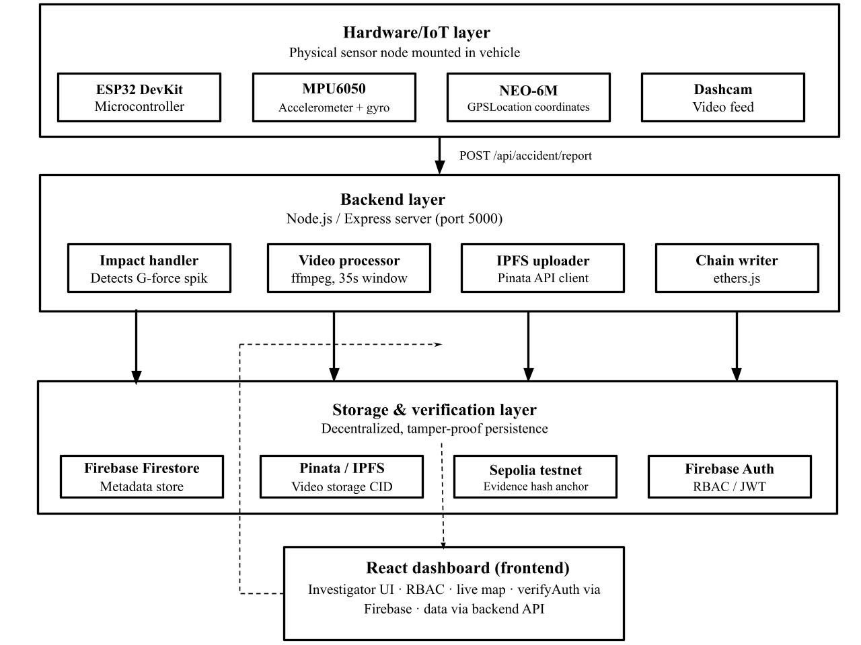
Fig.3.1 System Architecture

The second layer is the backend processing layer, developed using Node.js and Express.js. This layer functions as the core controller of the forensic pipeline. It receives accident data from the IoT layer, prepares the evidence package, coordinates video processing, manages uploads to decentralized storage, and communicates with the blockchain network for evidence anchoring. It also organizes metadata and supports verification-related operations.

The third layer is the decentralized storage layer, where large evidence files such as videos are stored using IPFS through Pinata. Since multimedia data is not suitable for direct blockchain storage, these files are stored off-chain and assigned a unique content identifier. This ensures storage efficiency while maintaining data integrity, as any modification results in a different identifier.

The fourth layer is the blockchain and access control layer. In this layer, the evidence hash and associated metadata are anchored to a smart contract deployed on the Ethereum Sepolia test network. This ensures immutability, transparency, and tamper-evident verification. The layer also supports role-based access control and chain of custody tracking. User authentication is managed through Firebase Authentication to restrict access to authorized users.

The final layer is the frontend layer, implemented as a React-based dashboard. It enables authorized users to view accident cases, examine evidence details, verify stored records, and interact with the system through a user-friendly interface. Together, these layers form a secure and verifiable framework for post-collision evidence management.

3.5 CORE SYSTEM MODULES
The proposed system is divided into several functional modules, each responsible for a specific task in the post-collision evidence management pipeline. These modules work together to ensure that accident-related data is captured, processed, stored, verified, and made accessible to authorized users in a secure manner.
1. Collision Detection Module:
This module is responsible for identifying possible collision events using the ESP32 microcontroller and MPU6050 accelerometer. The system continuously monitors sensor readings to detect abnormal impact conditions. When the measured values exceed the defined threshold, the module identifies the event as a potential accident and triggers the next stage of processing.
2. Data Acquisition Module:
Once a collision event is detected, this module collects relevant accident data such as impact details, time, and location from the connected sensors. The ESP32 and GPS module work together to generate the initial accident report, which is then transmitted to the backend server for further processing.
3. Evidence Processing Module:
This module organizes the collected accident data into a structured evidence package. It prepares the necessary metadata for storage and verification, including case-related details and evidence references. It acts as a bridge between raw sensor input and the secure evidence management system.
4. Video Processing Module:
This module handles the preparation of accident-related video evidence. It coordinates with the video source and uses FFmpeg to generate the required forensic video segment. This enables the inclusion of multimedia evidence as part of the complete evidence package.
5. IPFS Storage Module:
This module stores large evidence files, such as video, in decentralized storage using IPFS through Pinata. Instead of storing large files directly on the blockchain, the system uploads them to IPFS and receives a unique content identifier. This improves storage efficiency while maintaining data integrity.
6. Blockchain Anchoring Module:
This module records the hash and associated metadata of the evidence package on the Ethereum Sepolia test network using a smart contract. This ensures immutability and enables tamper-evident verification of stored evidence, forming the trust layer of the system.
7. Access Control Module:
This module manages user authentication and access control within the system. Firebase Authentication and role-based permissions ensure that only authorized users can view, verify, or manage evidence records. This maintains security and accountability during evidence handling.
8. Investigator Dashboard Module:
This module provides the frontend interface through which users interact with the system. The React-based dashboard allows authorized users to view accident cases, examine evidence details, verify records, and monitor evidence-related information in a clear and user-friendly manner.

3.6 Design Diagrams
A. Use Case Diagram
The Use Case Diagram presents the high level interactions between the main actors and the EvidenceChain system. The system involves three primary actors: the IoT Sensor Node, the Administrator, and the Investigator. The IoT Sensor Node is responsible for detecting collision related events and initiating the evidence collection process. The Administrator supervises system level operations such as user access management, configuration related tasks, and monitoring of audit related functions. The Investigator uses the dashboard to access forensic records, examine evidence, and verify integrity through the available system interfaces. The diagram provides a conceptual view of how different actors interact with the system during evidence generation, management, and review.

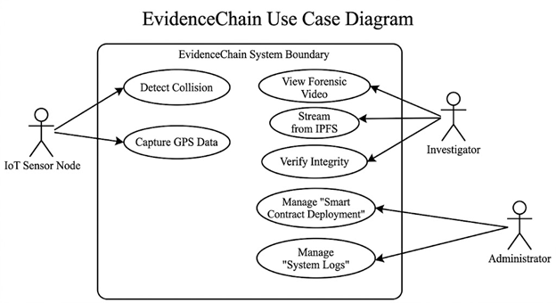
Fig. 3.2– Use Case Diagram

Table 3.1: Actors Description
Actor | Use Cases | Description
IoT Sensor Node | Detect Collision, Send Accident Data, Generate Evidence Package | The ESP32 based sensing unit detects abnormal impact conditions, collects accident related data, and initiates the evidence generation process.
Administrator | Manage User Roles, Manage Evidence Records, Configure System | The administrator controls access related operations, supervises the configuration of the system, and monitors evidence management functions.
Investigator | View Evidence, Verify Integrity, View Custody History, Manage Cases | The investigator accesses the dashboard to review forensic records, verify evidence authenticity, and examine case related information.

Actors
- IoT Sensor Node
- Administrator
- Investigator
SYSTEM USE CASES
1. Detect Collision
This use case represents the automatic monitoring of sensor readings by the IoT node. When abnormal impact conditions are detected, the system identifies the event as a possible collision.
2. Send Accident Data
After detecting a collision, the sensing node forwards the accident related data such as impact details, location, and time to the backend server for further processing.
3. Generate Evidence Package
The backend organizes the received sensor information and related evidence into a structured package for storage and verification.
4. View Evidence
The investigator accesses the dashboard to view the available accident related evidence, including stored records and associated files.
5. Verify Integrity
The investigator checks whether the stored evidence matches the blockchain linked metadata and confirms that the evidence has not been altered.
6. View Custody History
This use case allows authorized users to examine the handling history of the evidence and review related chain of custody information.
7. Manage User Roles
The administrator assigns and manages user permissions so that access to system functions remains controlled and secure.
8. Manage Evidence Records
The administrator monitors evidence related information and system level records required for proper forensic management.
These use cases collectively show how the proposed system supports automatic evidence capture, secure storage, controlled access, and later verification in a post collision investigation environment.

B. Sequence Diagram
The Sequence Diagram illustrates the time ordered interaction between the IoT sensor node, backend server, decentralized storage layer, blockchain network, and investigator dashboard. The process begins when the sensing unit detects an accident related event and sends the corresponding report to the backend server. The backend validates the incoming information, prepares the evidence package, coordinates evidence storage, and initiates blockchain anchoring. This sequence highlights how each component participates in the secure handling of evidence from the moment of capture to final confirmation.

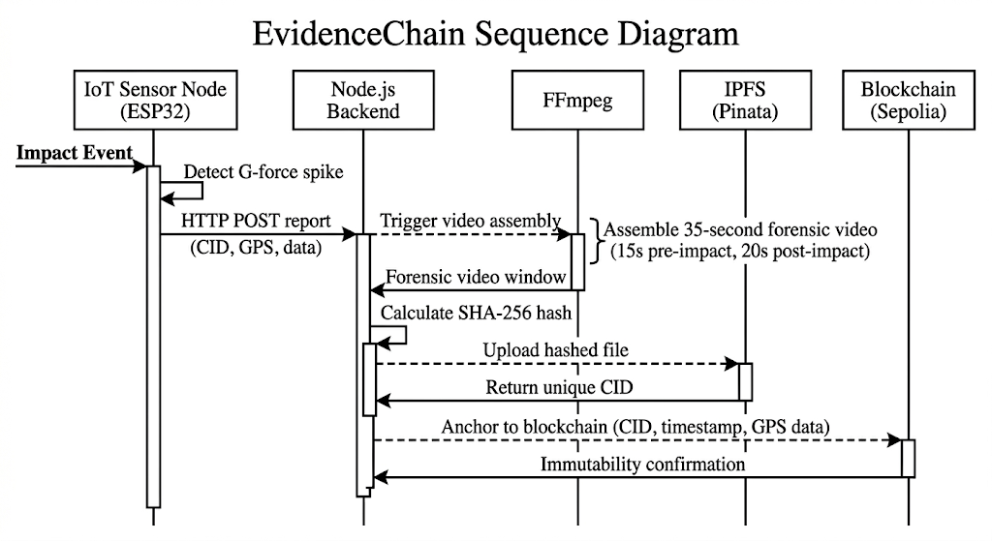
Fig. 3.3 – Sequence Diagram
Step by Step Interaction Flow
- The IoT sensor node detects a collision related event and sends an accident report to the backend server.
- The backend receives the report and validates the incoming accident data.
- The backend prepares the evidence package and generates the required verification data.
- The evidence package is uploaded to IPFS through Pinata for decentralized storage.
- IPFS returns a unique content identifier for the uploaded evidence.
- The backend signs the evidence related data and invokes the smart contract to anchor the evidence metadata on the blockchain.
- The smart contract verifies the submitted information and records it immutably on the Ethereum Sepolia test network.
- The blockchain confirms the transaction and returns a permanent transaction record.
- The system updates the associated evidence information so that it can be accessed later through the dashboard.
- During verification, the investigator retrieves the stored record, fetches the evidence from IPFS, and verifies its integrity by comparing it with the blockchain linked information.
Security Enforcement in Sequence
- Evidence validation occurs before storage and anchoring.
- Decentralized storage is completed before blockchain metadata anchoring.
- Blockchain confirmation occurs before evidence becomes available for later verification.
- Verification by the investigator is based on both stored evidence and blockchain linked records.
This layered sequence ensures:
- Secure evidence preparation
- Tamper evident storage
- Immutable blockchain anchoring
- Controlled and verifiable access to forensic records
The Sequence Diagram clearly represents the interaction between the major components of the proposed EvidenceChain system. It shows how the sensing layer, backend layer, storage layer, blockchain layer, and dashboard work in coordination to support a secure forensic pipeline. By presenting the communication flow in a time ordered manner, the diagram demonstrates how evidence is generated, preserved, and verified without relying solely on manual intervention.

C. Activity Diagram

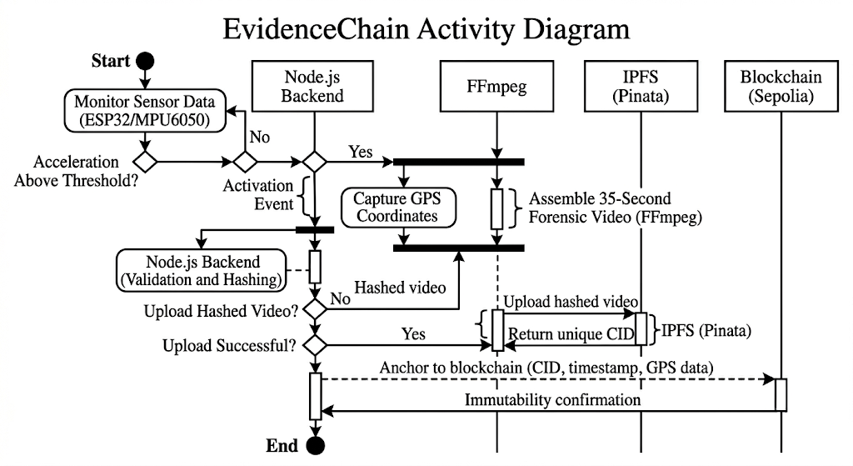
Fig. 3.4 – Activity diagram

The Activity Diagram represents the complete workflow of the proposed system from the initial detection of a collision event to the final verification of evidence. It shows how sensor monitoring, backend processing, decentralized storage, blockchain anchoring, and user level verification are connected in a structured operational sequence. The diagram helps explain how each stage depends on the successful completion of the previous stage, ensuring that only valid and traceable evidence proceeds through the forensic pipeline.
Workflow Description
The workflow begins when the IoT sensor node continuously monitors vehicle movement using accelerometer data. When the sensed values exceed the defined threshold, the system identifies the event as a possible collision and captures the related accident information. This data is then forwarded to the backend server for validation and evidence preparation.
In the next stage, the backend organizes the incoming information into a structured evidence package and generates the required verification data. If multimedia evidence is available, the system processes it so that it can be included as part of the complete evidence package. The prepared evidence is then uploaded to IPFS, which returns a unique content identifier for future retrieval.
After storage is completed, the backend anchors the evidence related metadata on the blockchain through a smart contract. Once the blockchain transaction is confirmed, the evidence record becomes immutable and suitable for later verification. The system then makes the evidence available to authorized users through the dashboard interface.
Finally, the investigator accesses the dashboard, retrieves the stored record, and verifies the evidence using the blockchain linked information. In this way, the workflow ensures that evidence remains structured, traceable, and tamper evident from the point of capture to the point of review.
Key Control Points in the Activity Diagram
- Decision node for impact threshold detection
- Validation step before evidence preparation
- Successful decentralized storage before blockchain anchoring
- Blockchain confirmation before evidence review
- Authorized access before verification by the investigator
These use cases show how the proposed system supports collision detection, evidence generation, secure storage, and later verification. They also reflect the role based interaction of administrators and investigators within the system. Together, they present the overall functional scope of the proposed EvidenceChain framework.

