1. Create a script that, when run, will display the following environment variables to the console:

USER

HOME

HISTCONTROL

TERM

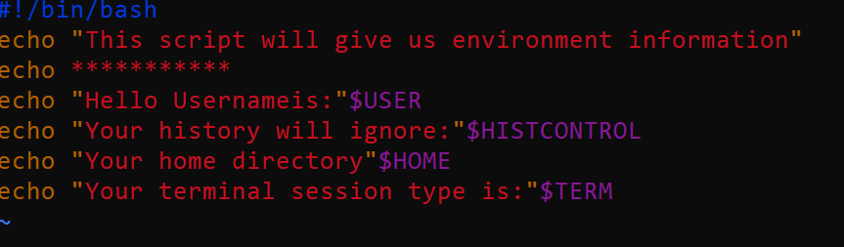

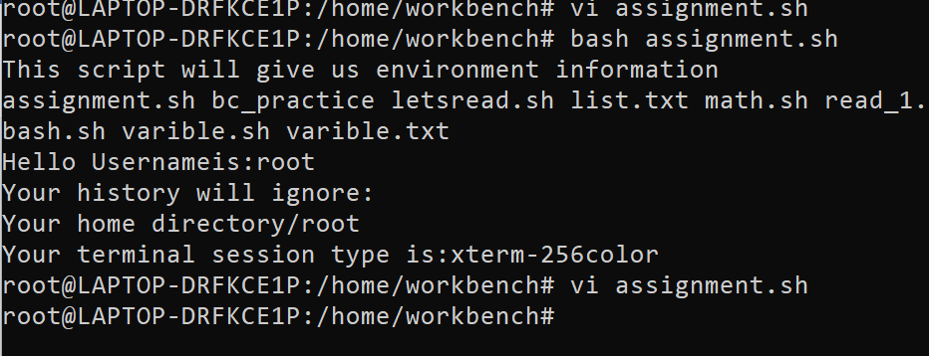

1. Write a script that sets FOUR variables:

MY USERNAME

PASSWORD

STARTOFSCRIPT

ENDOFSCRIPT

Populate the first two with some default values and use command redirection to set the third and fourth values to the date/time of when the script was started and completed. Within the script, be sure to display the values to the terminal when run.2

