**Unix Exercises From Coursera**

**Exercises**

1. Print your name to the terminal.
2. Clear your terminal after completing #1.

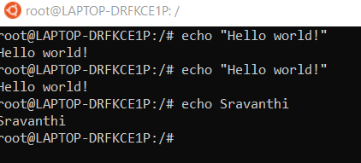

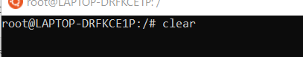

## Exercises

1. Set your working directory to the root directory.
2. Set your working directory to your home directory using three different commands.
3. Find a folder on your computer using your file and folder browser, and then set your working directory to that folder using the terminal.
4. List all of the files and folders in the directory you navigated to in #3.

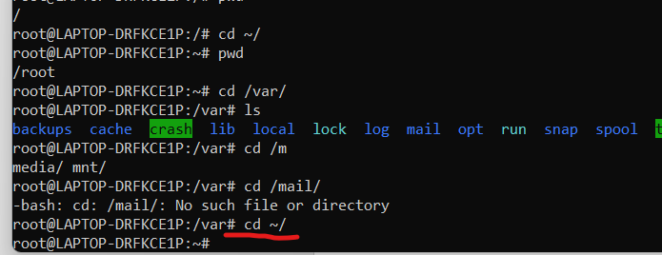

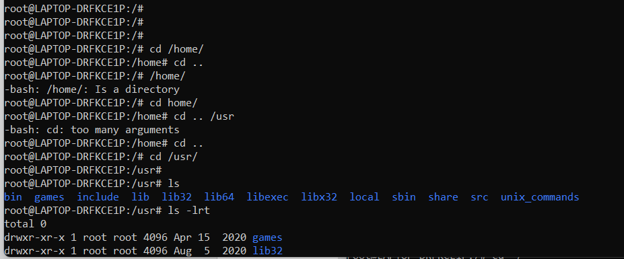

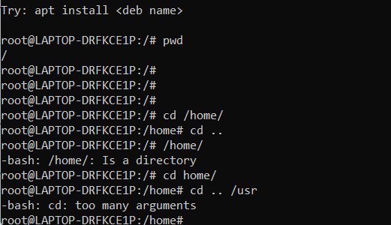

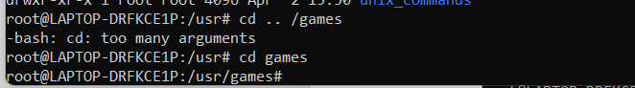

## Exercises

1. Create a new directory called workbench in your home directory.
2. Without changing directories create a file called readme.txt inside of the workbench.
3. Append the numbers 1, 2, and 3 to readme.txt so that each number appears on its own line.
4. Print readme.txt to the command line.
5. Use output redirection to create a new file in the workbench directory called list.txt which lists the files and folders in your home directory.
6. Find out how many characters are in list.txt without opening the file or printing it to the command line.

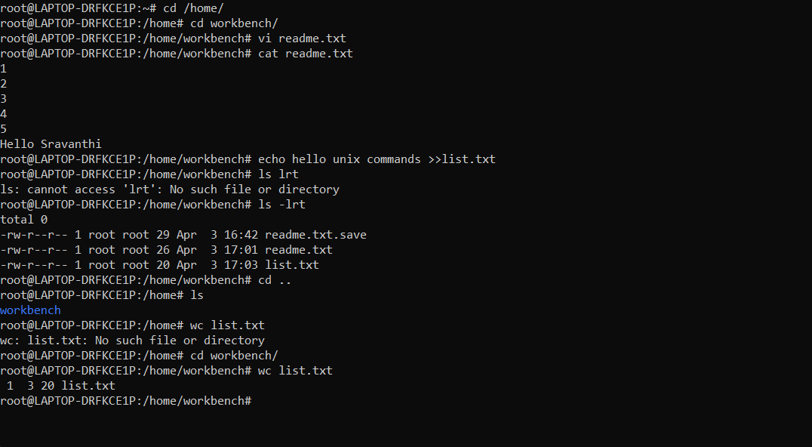

## Exercises

1. Create a file called message.txt in your home directory and move it into another directory.
2. Copy the message.txt you just moved into your home directory.
3. Delete both copies of message.txt. Try to do this without using rm.

# **Self-Help Exercises**

1. Use man to look up the flag for human-readable output from ls.
2. Get help with a man by typing man into the console.
3. Wouldn’t it be nice if there was a calendar command? Use apropos to look for such a command, then use man to read about how that command works.

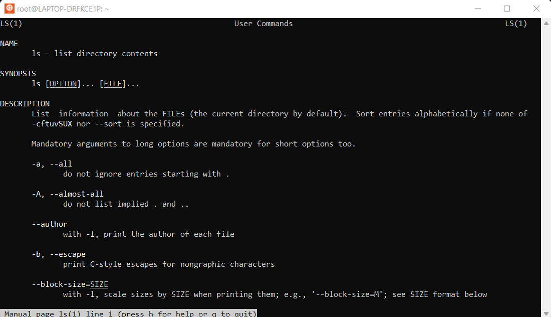

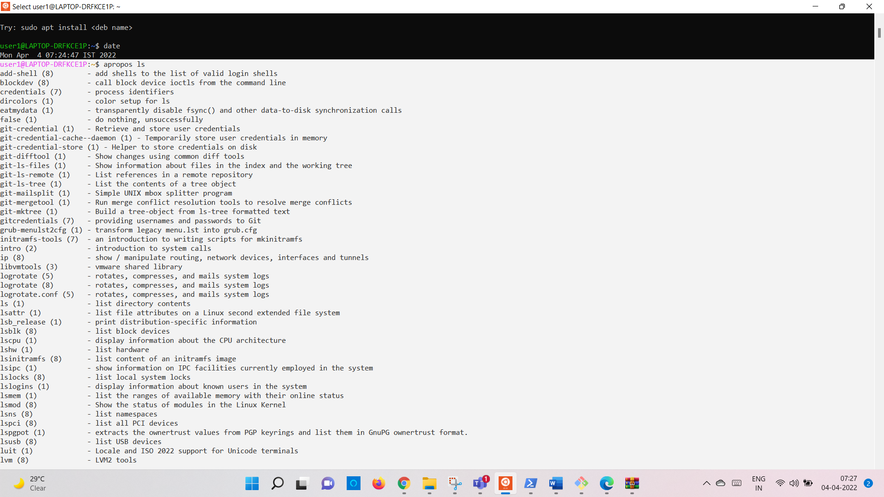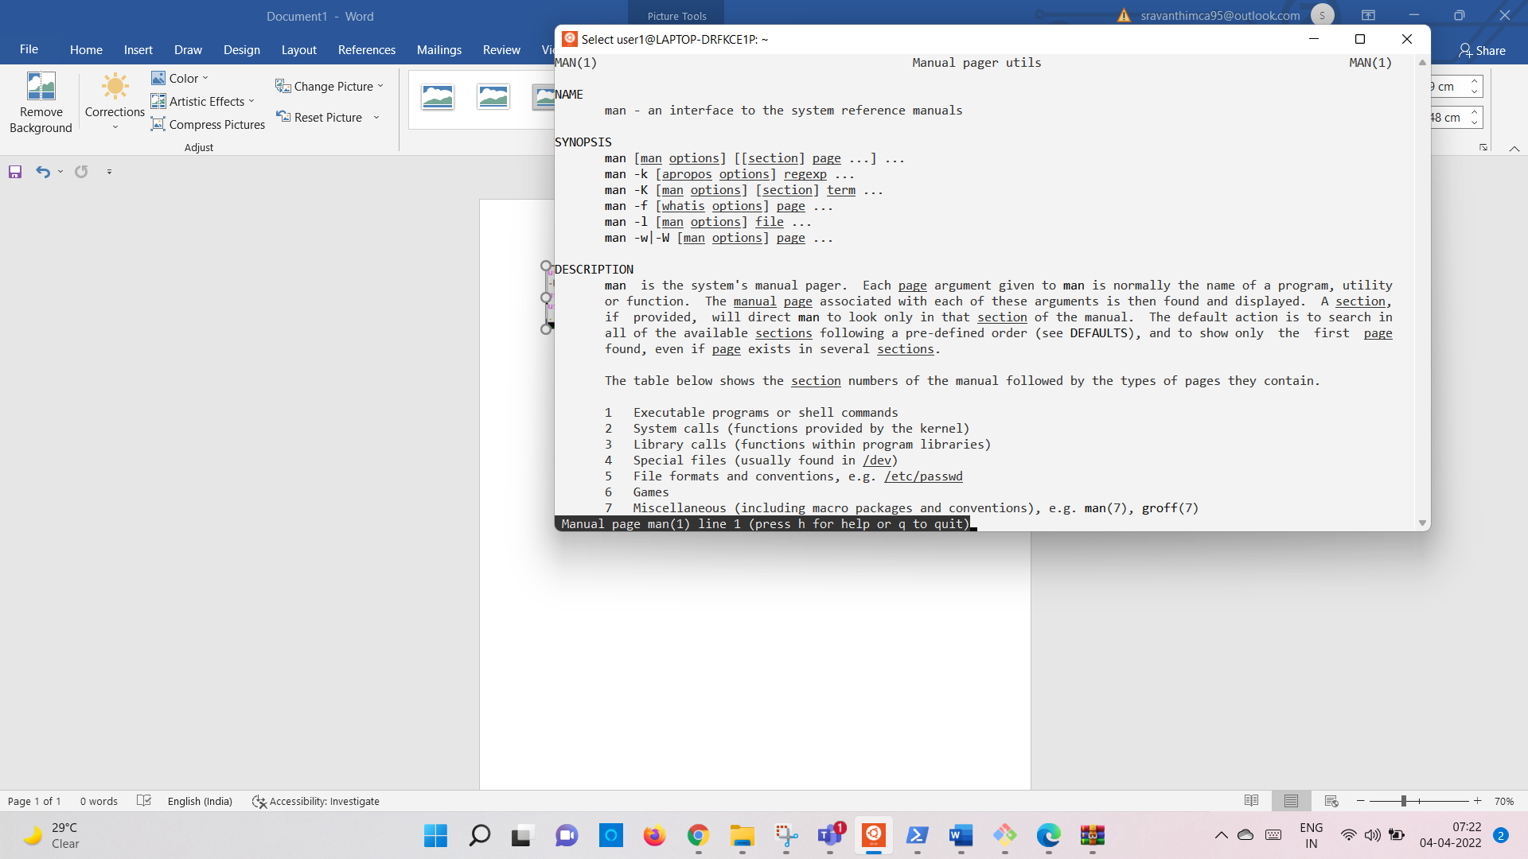

# **Get Wild Exercises**

1. Before I organized the photos by year, what command would have listed all of the photos of type .png?
2. Before I organized the photos by year, what command would have deleted all of my hiking photos?
3. What series of commands would you use in order to put my figures for a data science course and the pictures I took in the lab into their own folders?

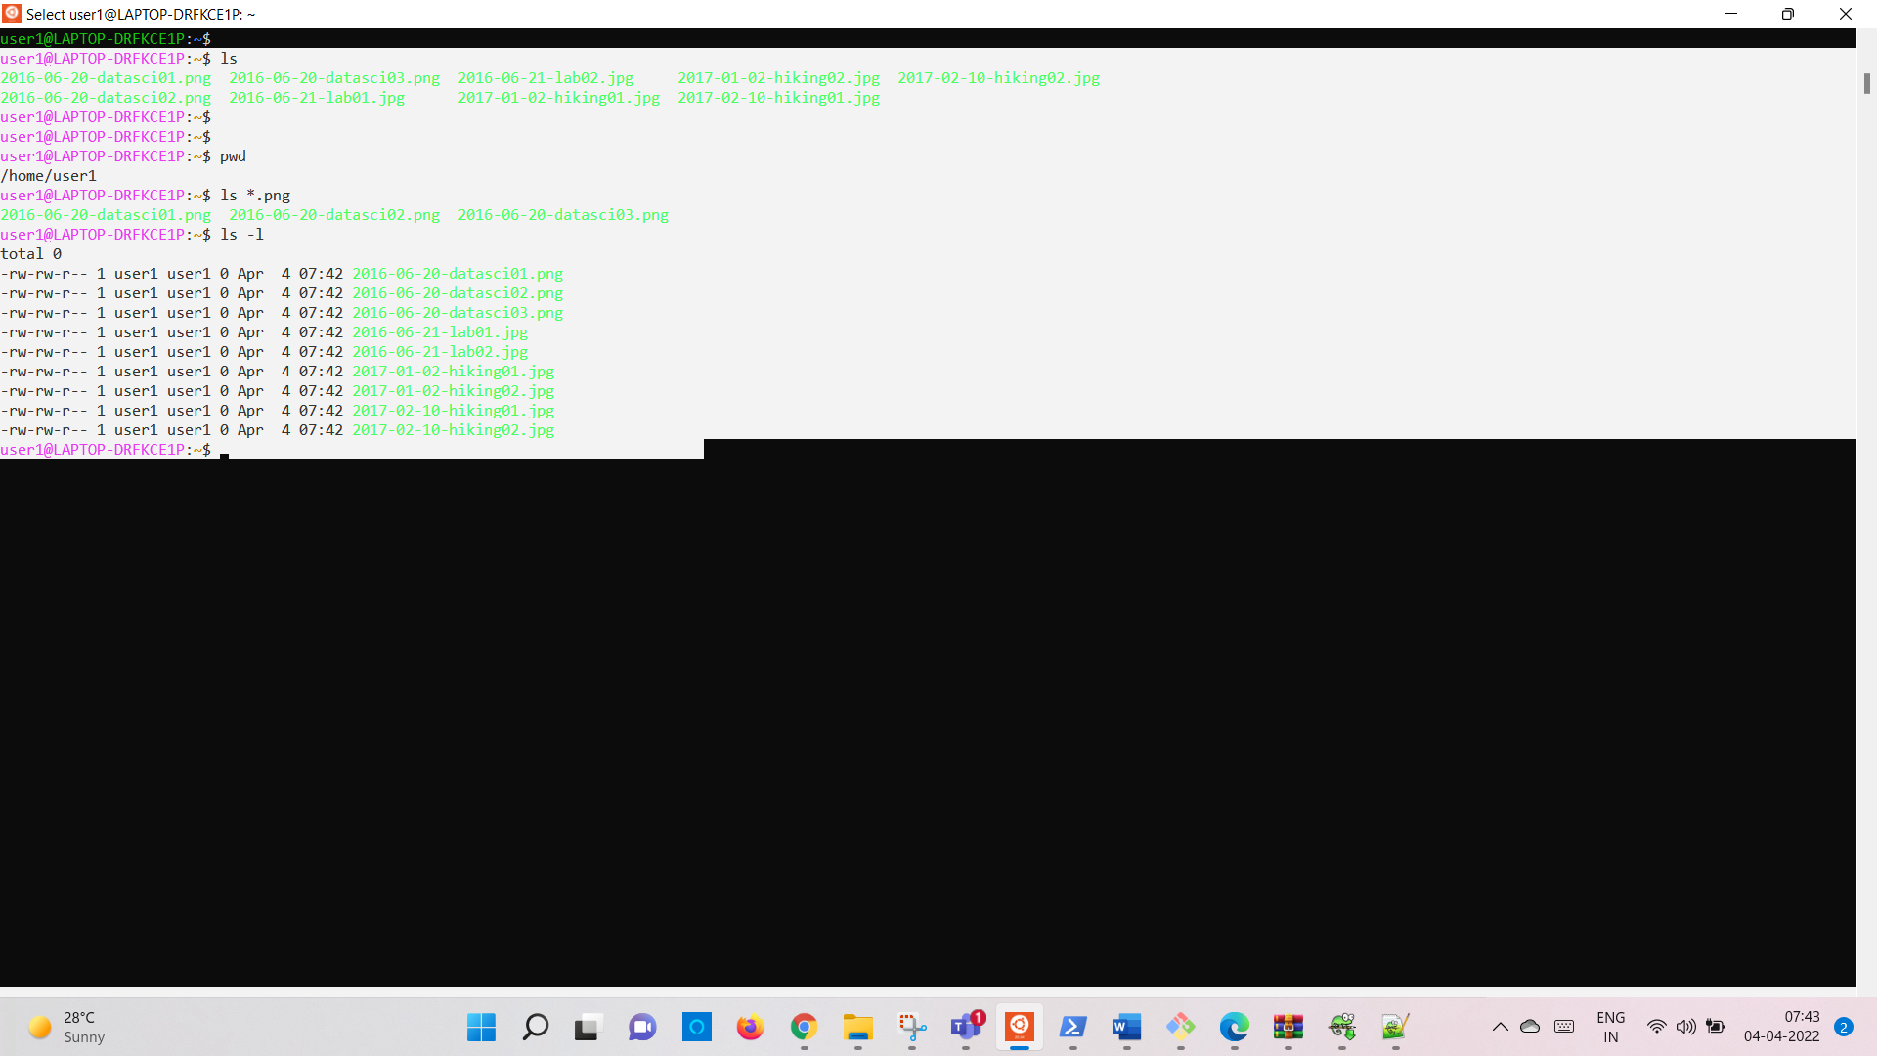 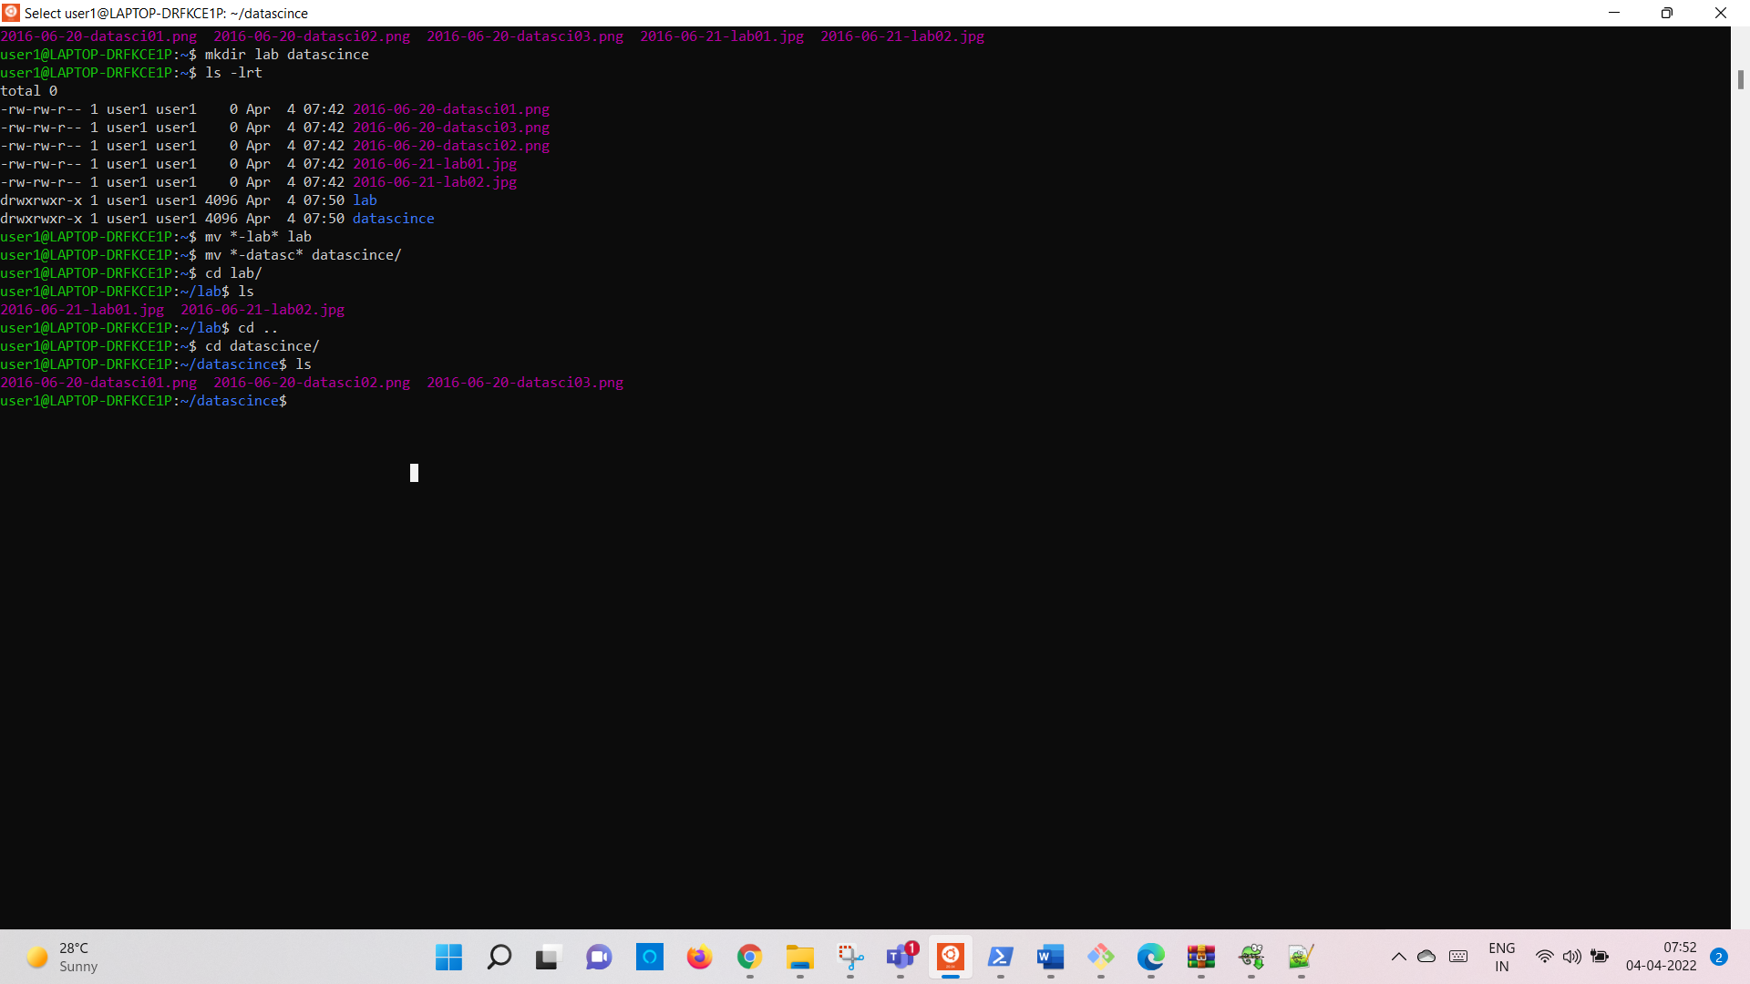

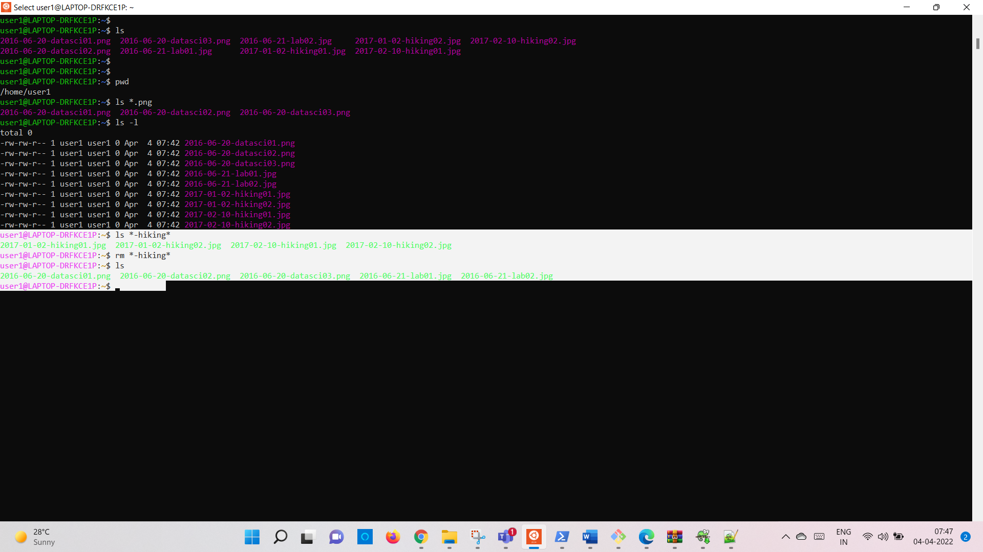

# **Math Exercises**

1. Look at the man pages for bc.
2. Try doing some math in bc interactively.
3. Try writing some equations in a file and then provide that file as an argument to bc.

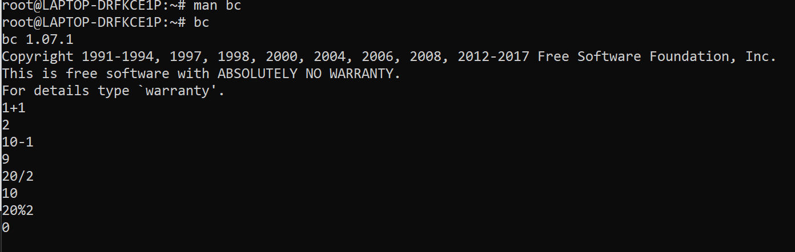

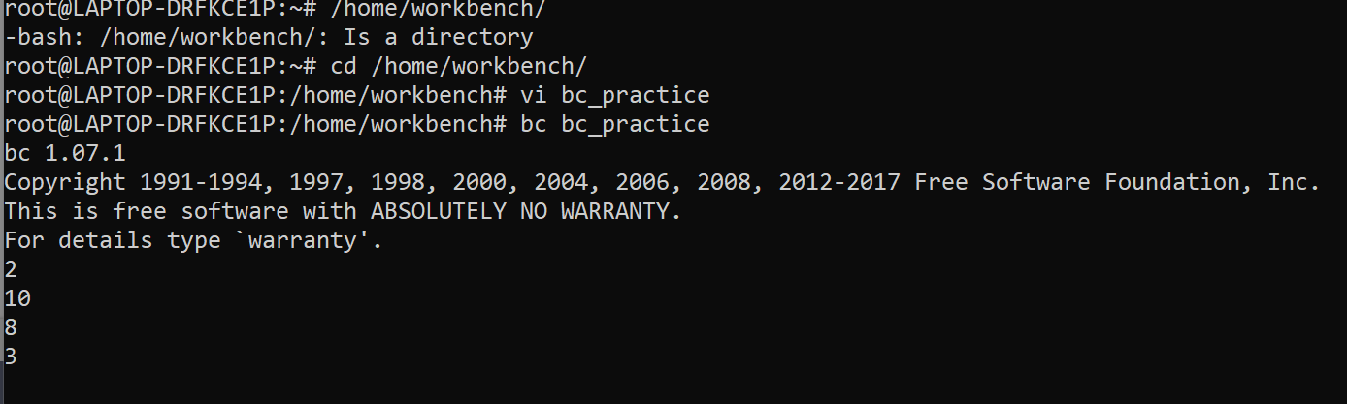

# **Variables Exercises**

1. Write a Bash program where you assign two numbers to different variables, and then the program prints the sum of those variables.

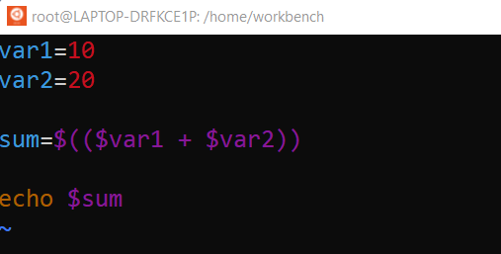

1. Write another Bash program where you assign two strings to different variables, and then the program prints both of those strings. Write a version where the strings are printed on the same line, and a version where the strings are printed on different lines.

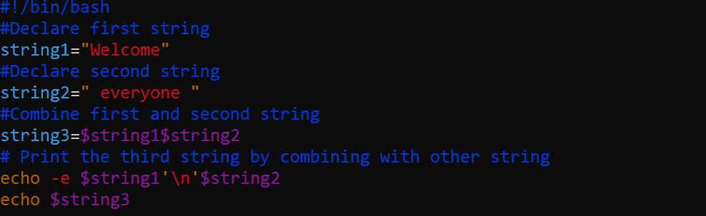

1. Write a Bash program that prints the number of arguments provided to that program multiplied by the first argument provided to the program.

# **User Input Exercise**

Write a script that asks the user for an adjective, a noun, and a verb, and then use those words in a sentence (like Mad Libs).

