# SQL query’s

Create a database & tables for an social app each table should minimum 5 rows of values

1. Profile_status
2. User_profile
3. Friends
4. Comments
5. Likes
6. User_login_details
7. Posts

Queries need to be executed:

1. In the friends table list the data which are matched with user_profile_id.

SELECT * FROM socialappdb.friends as f

INNER JOIN socialappdb.user_profile as u ON f.friend_id=u.friend_id;

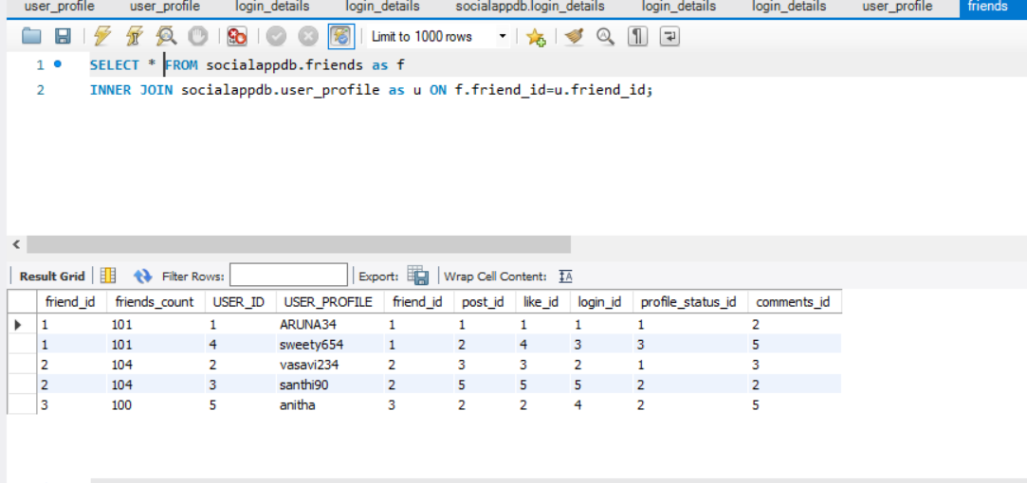

1. Display all posts of user_id 5.

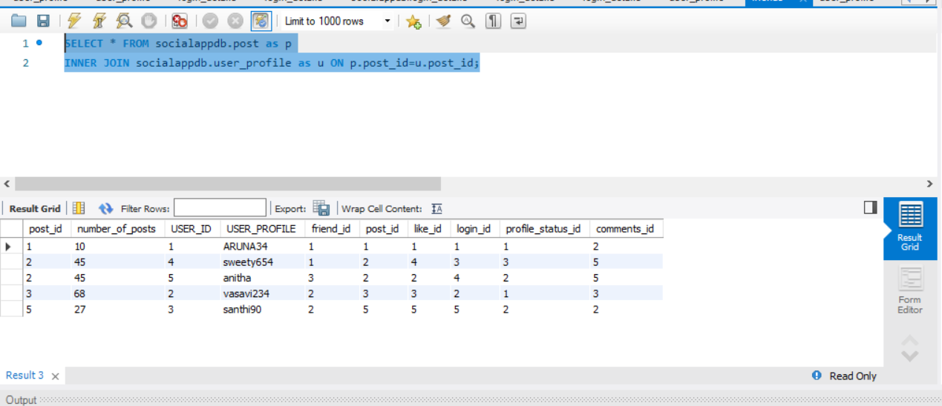

1. Write the query that matching the words or character with %gmail%.

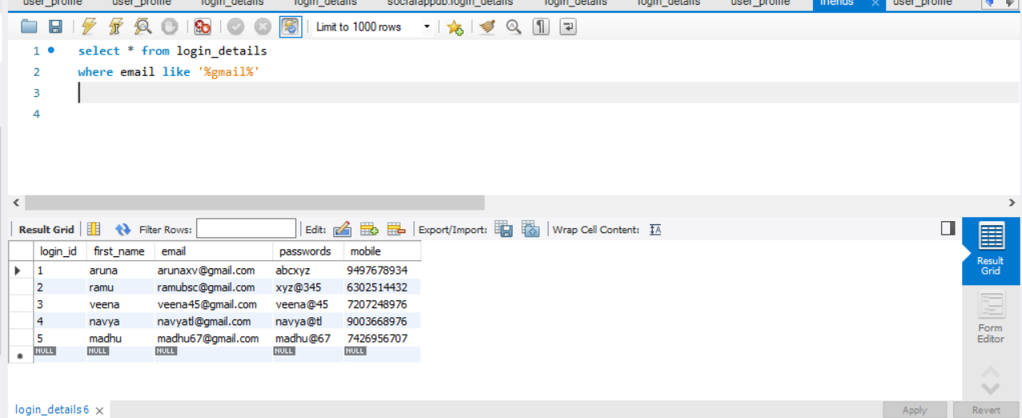

1. Limit the display data from table comments 5 which belongs to the user 3.
2. Combine profile_status and user_profile and user_login_details display matching records.