# 1. INTRODUCTION

**1.1 Project Overview**

**1.2 Purpose**

# 2. IDEATION PHASE

**2.1 Problem Statement**

**2.2 Empathy Map Canvas**

**2.3 Brainstorming**

# 3. REQUIREMENT ANALYSIS

**3.1 Customer Journey Map**

**3.2 Solution Requirements**

**3.3 Data Flow Diagram**

**3.4 Technology Stack**

# 4. PROJECT DESIGN

**4.1 Problem-Solution Fit**

**4.2 Proposed Solution**

**4.3 Solution Architecture**

# 5. PROJECT PLANNING & SCHEDULING

**5.1 Project Planning**

# 6. FUNCTIONAL AND PERFORMANCE TESTING

**6.1 Performance Testing**

# 7. RESULTS

**7.1 Output Screenshots**

1. **ADVANTAGES & DISADVANTAGES**
2. **CONCLUSION**
3. **FUTURE SCOPE**
4. **APPENDIX**

**GitHub & Project Demonstration Link**

# 1. INTRODUCTION

## 1.1Project Overview

The *Laptop Request Catalog Item* project in ServiceNow involves creating a user-friendly and automated form that allows employees to request laptops through the organization’s ServiceNow platform. This item streamlines the hardware request process, ensuring faster approvals, accurate tracking, and better inventory management.

## 1.2 Purpose

The primary goal of this project is to simplify and digitalize the laptop requisition process. By implementing this catalog item, the organization can improve service delivery, reduce manual intervention, and ensure a transparent, traceable workflow for IT hardware provisioning.

# 2. IDEATION PHASE

## 2.1 Problem Statement

|  |  |
| --- | --- |
| Date | 16 June 2025 |
| Team ID | LTVIP2025TMID28660 |
| Project Name | laptop request catalog item |
| Maximum Marks | 2 Marks |

Employees face delays and inefficiencies when requesting laptops through manual or email-based systems. Lack of standardized processes leads to confusion, approval delays, and inventory mismanagement. There is a need for a centralized and automated solution to manage laptop requests effectively.

## 2.2 Empathy Map Canvas

|  |  |
| --- | --- |
| Date | 16 June 2025 |
| Team ID | LTVIP2025TMID28660 |
| Project Name | laptop request catalog item |
| Maximum Marks | 4 Marks |

### Section Description

**Think & Feel** Captures the user's internal thoughts, worries, aspirations, and priorities.

**Hear** Reflects what the user hears from friends, colleagues, influencers, or media.

**See** Describes the user's environment, what they observe, and what competitors offer.

**Say & Do** Outlines the user's behavior, public attitude, and how they interact with others.

**Pain** Identifies fears, frustrations, and obstacles the user faces.

**Gain** Highlights the user's goals, needs, and what success looks like to them.

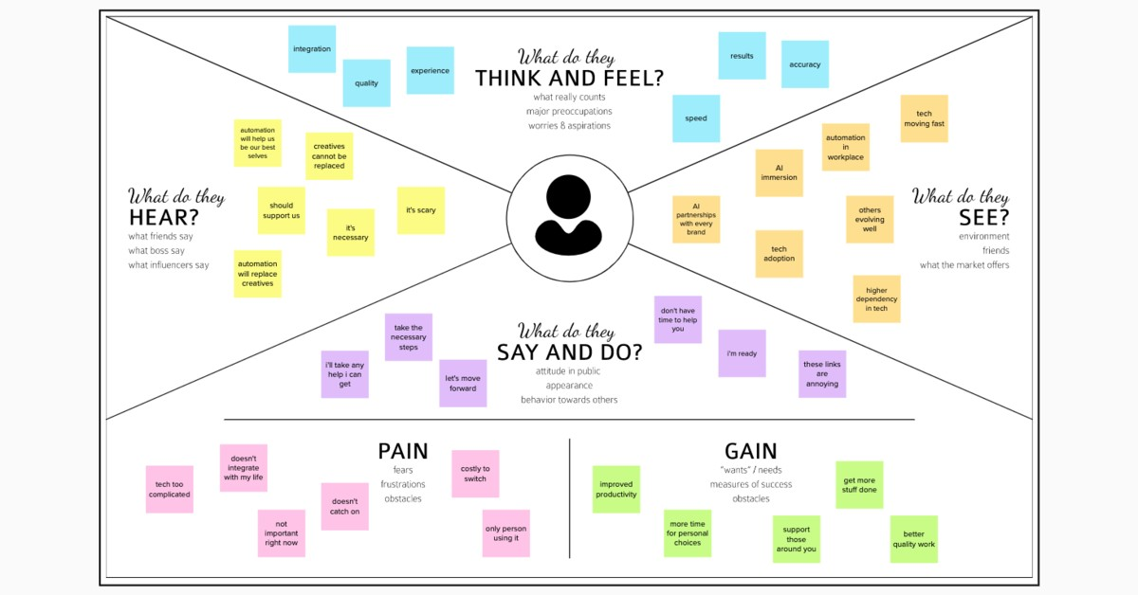

## 2.3 Brainstorming

|  |  |
| --- | --- |
| Date | 16 June 2025 |
| Team ID | LTVIP2025TMID28660 |
| Project Name | laptop request catalog item |
| Maximum Marks | 4 Marks |

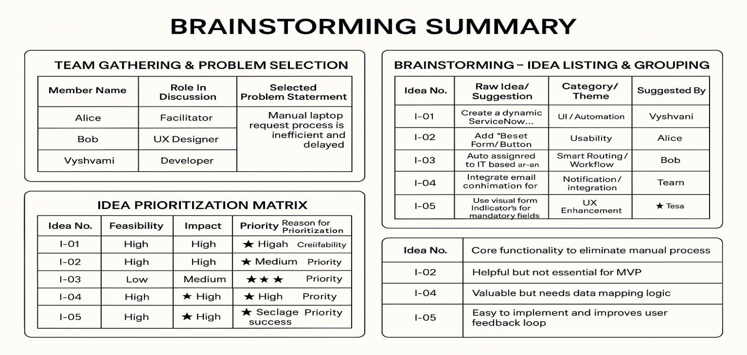

# 3. REQUIREMENT ANALYSIS

## 3.1 Customer Journey map

This visualizes the end-to-end experience of an employee requesting a laptop:

**Awareness**: Employee realizes the need for a laptop.

**Access**: Logs into the ServiceNow portal and navigates to the Hardware Catalog.

**Interaction**: Fills out the dynamic Laptop Request form (selects model, RAM, processor, accessories).

**Approval**: Request is routed to the manager for approval.

**Fulfillment**: Upon approval, a task is assigned to the Hardware team.

**Closure**: Laptop is delivered and the request is marked complete.

**Pain Points Addressed**: Manual delays, lack of clarity, and inconsistent data entry.

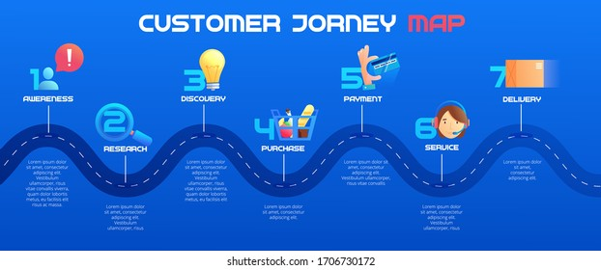

**3.2 Solution Requirement**

|  |  |
| --- | --- |
| Date | 16 June 2025 |
| Team ID | LTVIP2025TMID28660 |
| Project Name | laptop request catalog item |
| Maximum Marks | 4 Marks |

**Functional Requirements:**

Following are the functional requirements of the proposed solution.

**FR Functional Requirement**

**Sub Requirement (Story / Sub-Task)**

### No. (Epic)

- Registration through Form <br> - Registration via Gmail <br> -

FR-1 User Registration

Registration via LinkedIn

FR-2 User Confirmation - Confirmation via Email <br> - Confirmation via OTP

**Non-functional Requirements:**

Following are the non-functional requirements of the proposed solution.

### NFR Non-Functional No. Requirement

**Description**

NFR-1 Usability The system should have an intuitive and user-friendly interface.

|  |  |  |
| --- | --- | --- |
| NFR-2 | Security | Implement secure login, data encryption, and access controls. |
| NFR-3 | Reliability | The application should operate without failures or data loss. |
| NFR-4 | Performance | System should process requests and responses within 2 seconds. |
| NFR-5 | Availability | The application should be accessible 99.9% of the time. |
| NFR-6 | Scalability | The solution should support increasing users and request volumes efficiently. |

## 3.3 Data Flow Diagram

|  |  |
| --- | --- |
| Date | 18 June 2025 |
| Team ID | LTVIP2025TMID28660 |
| Project Name | laptop request catalog item |
| Maximum Marks | 4 Marks |

**Level 1 DFD** might include:

**External Entities**: Employee (requestor), Manager, Hardware Team.

**Processes**:

1. Submit Laptop Request
2. Approve Request
3. Fulfill Request

**Data Stores**: Request Table, User Table, Approval Logs

**Data Flows**: Request details, approval status, task assignment, fulfillment status

This diagram shows how data moves from the user to the system and back, ensuring transparency and traceability.

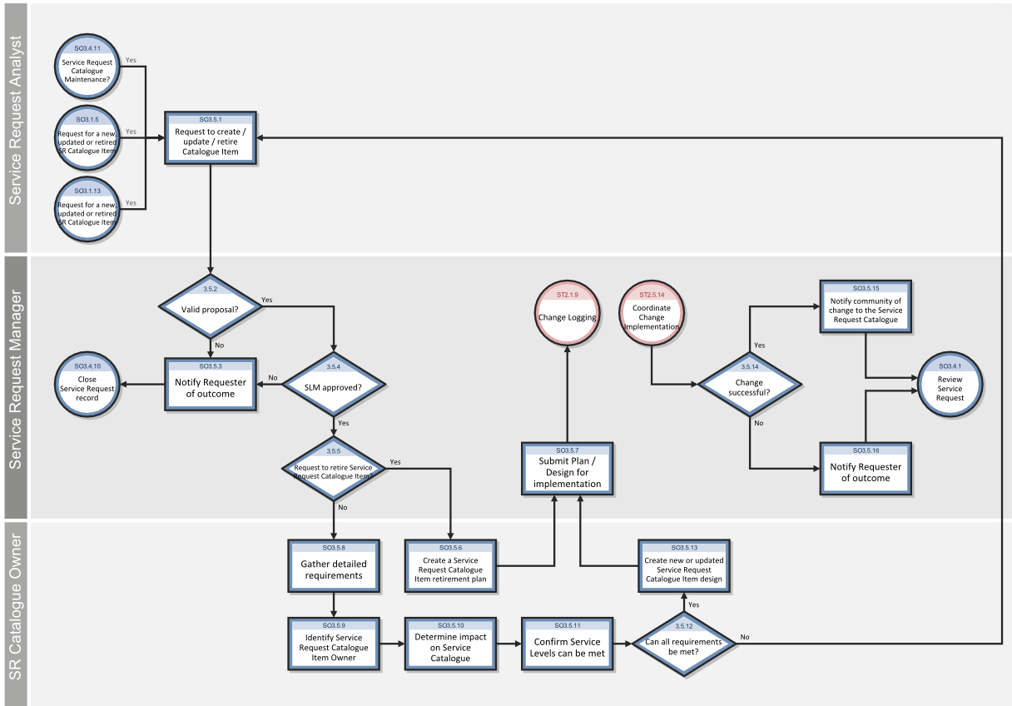

**User Stories Related to Data Flow (DFD Perspective)**

### Customer (Mobile User)

**Functional**

|  |  |
| --- | --- |
| **User Type** | **Requirement (Epic)** |
| Customer (Mobile user)  Customer | Laptop Request Submission |
| (Mobile user) | Status Tracking |

**Customer (Web User)**

**Functional**

### User Type Requirement

**(Epic)**

Customer Laptop Request (Web user) Form Access

**Customer Care Executive User**

**Story User Story / Task Acceptance Criteria Priority Release**

### Number

|  |  |
| --- | --- |
| As a user, I can submit a Laptop request is laptop request with all captured and  DF-US-1  required configuration forwarded for  details manager approval | Sprint-  High  1 |
| As a user, I can track the Status updates are  DF-US-2 current status of my visible in my laptop request dashboard | Sprint-  Medium  2 |
| **User Story Acceptance**  **User Story / Task** | **Priority Release** |

### Number Criteria

As a web user, I can

Laptop form loads

access the same dynamic Sprint-

DF-US-3 with conditional Medium laptop request form as 2

fields

mobile users

### Functional

|  |  |  |
| --- | --- | --- |
| **User Type Requirement**  **(Epic)** | **User Story**  **User Story / Task Acceptance Criteria Priority Release Number** | |
| Customer  Request  Care  Validation  Executive  **Administrator** | As a CCE, I can verify Validated request  Sprint- | |
| DF-US-4 laptop request details before fulfillment | moves to hardware High  2  dispatch team |
| **Functional**  **User Type Requirement**  **(Epic)** | **User**  **Story User Story / Task Number** | **Acceptance Criteria Priority Release** |
| Administrator Audit Logging | As an admin, I can view audit logs of  DF-US-5 request creation and fulfillment flows | All user actions are  logged with Sprint-  High  timestamps for audit 2  reference |
| System  Administrator  Configuration | As an admin, I can configure workflows  DF-US-6 for approval and fulfillment logic | Changes reflect in  form behavior and Sprint-  High  task routing across 3  modules |

## 3.4 Technology Stack

|  |  |
| --- | --- |
| Date | 18 June 2025 |
| Team ID | LTVIP2025TMID28660 |
| Project Name | laptop request catalog item |
| Maximum Marks | 4 Marks |

**Table-1: Components & Technologies**

### S.No Component Description Technology

Web-based interface where users HTML, CSS, JavaScript, ServiceNow

1. User Interface

request laptops and view status Catalog UI, GlideForm APIs

Dynamic form logic, field visibility,

1. Application Logic-1 ServiceNow Client Scripts, UI Policies

validations

ServiceNow Flow Designer, Approval

1. Application Logic-2 Workflow automation and approvals

Rules, Script Actions

ServiceNow Business Rules, Catalog

1. Application Logic-3 Request routing and task assignment

Task Workflows

ServiceNow Tables (sc_req_item,

1. Database Stores request data, user profiles, tasks sc_task, sys_user)

Native cloud data storage provided by

1. Cloud Database ServiceNow (built on MySQL backend)

platform

Attachments like ID proof or approval ServiceNow Attachments API,

1. File Storage

docs Encrypted file storage

1. External API-1 Email notifications integration SMTP / Outlook API

|  |  |
| --- | --- |
| **S.No Component** | **Description Technology** |
| 9 External API-2 | Optional future integration (e.g., asset  REST APIs / MID Server scripts  validation via vendor APIs) |
| Machine Learning  10  Model | Optional future enhancement (e.g., Not currently used, possible integration predictive asset assignment) via AI Search |
| Infrastructure  11  (Server/Cloud) | Cloud-based deployment of Hosted on ServiceNow Cloud (SaaS); ServiceNow platform no local setup needed |

**Table-2: Application Characteristics**

### S.No Characteristics Description Technology / Notes

Open-Source Scripted APIs and web standards used in ECMAScript, Bootstrap (within

1

Frameworks UI logic ServiceNow components)

Security Role-based access, data encryption, audit ACLs, SHA-256 Hashing, RBAC,

2

Implementations logging ServiceNow Security Policies

Scalable Modular service catalog structure, 3-tier architecture using ServiceNow

3

Architecture reusable workflows platform layers

Platform maintained on enterprise-grade 99.9% uptime via ServiceNow SaaS

1. Availability

infrastructure with clustering and failover

Caching used in workflows, indexed GlideRecord optimizations,

1. Performance database queries, asynchronous tasks ServiceNow Performance Analytics

# 4. PROJECT DESIGN

## 4.1 Problem Solution Fit

|  |  |
| --- | --- |
| Date | 19 June 2025 |
| Team ID | LTVIP2025TMID28660 |
| Project Name | laptop request catalog item |
| Maximum Marks | 4 Marks |

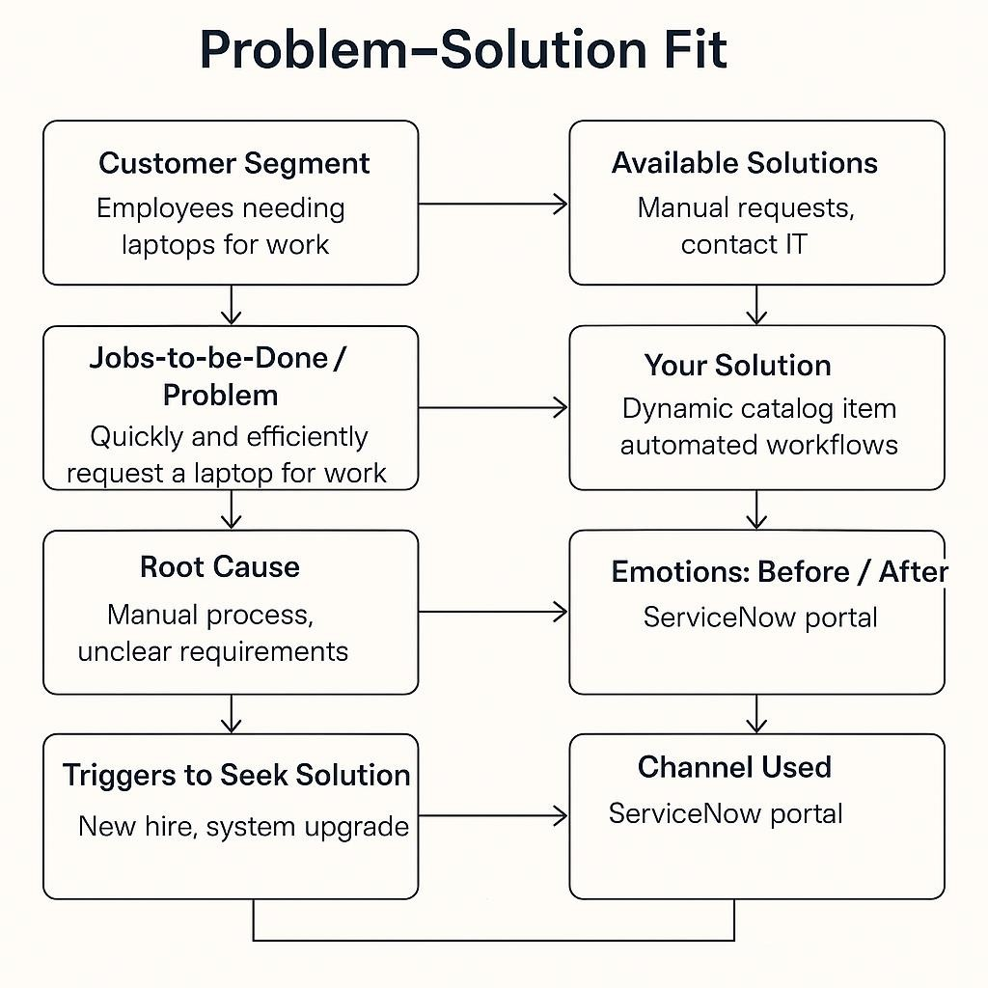

|  |  |
| --- | --- |
| **Section** | **Insight** |
| **Customer Segment (CS)** | Defines your target users – for example, employees needing laptops for work. |
| **Customer Constraints (CC)** | Barriers like lack of time, unfamiliar forms, or manual delays. |
| **Available Solutions (AS)** | Existing manual request methods or contacting IT directly. |
| **Jobs-to-be-Done / Problems**  **(J&P)** | The core need: quickly and efficiently request a laptop for work. |
| **Root Cause (RC)** | Manual process, unclear requirements, lack of self-service tools. |
| **Customer Behavior (BE)** | Users ask peers or IT manually; unaware of digital request options. |
| **Triggers (TR)** | New hire onboarding, system upgrades, or broken devices. |

A dynamic ServiceNow catalog item with automated workflows and form

**Your Solution (SL)** validation.

**Channels (CH)** ServiceNow portal, internal emails, onboarding documentation.

**Emotions: Before / After (EM)** *Before*: Frustrated, delayed. <br>*After*: Confident, satisfied, empowered.

## 4.2 Proposed Solution

**S.No. Parameter Description**

Employees currently face delays and inconsistencies due to the manual

### 1 Problem Statement

laptop request process, lacking dynamic guidance, validation, and tracking.

Design and deploy a dynamic ServiceNow Catalog Item for Laptop **Idea / Solution**

1. Requests with conditional fields, validation rules, workflow automation,

**Description** and audit trail.

Integrates dynamic form logic, real-time validation, reset functionality,

1. **Novelty / Uniqueness** approval workflows, and task automation — all within a single self-service portal.

**Social Impact /** Reduces manual workload, minimizes errors, and improves turnaround

4

**Customer Satisfaction** time, leading to higher employee satisfaction and streamlined IT operations.

5 **Business Model** As an internal organizational tool, the model supports operational

|  |  |  |
| --- | --- | --- |
|  | **(Revenue Model)** | efficiency. Optionally, the solution can be packaged as a module for enterprise clients. |
| 6 | **Scalability of the Solution** | The catalog item can be extended to include other hardware or software requests, additional workflows, and integrations with asset management systems. |

## 4.3 Solution Architecture

|  |  |
| --- | --- |
| Date | 19 June 2025 |
| Team ID | LTVIP2025TMID28660 |
| Project Name | laptop request catalog item |
| Maximum Marks | 4 Marks |

|  |  |
| --- | --- |
| **Aspect** | **Description** |
| **Objective** | Bridge the gap between business needs (e.g., laptop requests) and technical implementation using ServiceNow. |
| **Key Goals** | Identify the best-fit tech solution, define system behavior, outline development phases, and provide implementation specs. |
| **Core**  **Components** | - **User Interface**: ServiceNow Catalog Item<br>- **Business Logic**: Client Scripts, UI Policies, Flow Designer<br>- **Data Layer**: ServiceNow Tables (sc_req_item, sc_task)<br>- **Integration**: Email Notifications, Approval Workflows<br>- **Governance**: Audit Logs, Update Sets |
| **Stakeholders** | Employees, Managers, IT Fulfillment Team, Admins |

**Development** 1. Requirement Gathering<br>2. Catalog Item Design<br>3. Workflow Automation<br>4. **Phases** Testing & Deployment

**Delivery Specs** Defined via update sets, version control, and role-based access policies

# 5. PROJECT PLANNING & SCHEDULING

## 5.1 Project Planning

|  |  |
| --- | --- |
| **Element** | **Description** |
| **Project Scope** | Develop a ServiceNow Catalog Item for laptop requests with dynamic fields, approval workflows, and audit tracking. |
| **Project Goals** | - Streamline laptop request process<br>- Improve user experience<br>- Ensure governance and traceability |
| **Stakeholders** | Employees, Managers, IT Fulfillment Team, ServiceNow Admins |
| **Project Phases** | 1. Requirement Gathering<br>2. Design & Prototyping<br>3. Development<br>4.  Testing<br>5. Deployment<br>6. Feedback & Optimization |
| **Deliverables** | - Dynamic Catalog Item<br>- Approval Workflow<br>- Task Assignment Logic<br>- Audit Logs<br>- User Documentation |
| **Element** | **Description** |
| **Tools &**  **Technologies** | ServiceNow, Flow Designer, Client Scripts, UI Policies, Update Sets |
| **Team Roles** | - Developer: Form logic, scripting<br>- Admin: Workflow & access control<br>- QA:  Testing & validation<br>- Project Lead: Coordination & reporting |
| **Timeline** | Estimated 4–6 weeks (adjustable based on sprint planning and feedback loops) |

# 6. FUNCTIONAL AND PERFORMANCE TESTING

## 6.1 Performance Testing

|  |  |
| --- | --- |
| Date | 21 June 2025 |
| Team ID | LTVIP2025TMID28660 |
| Project Name | laptop request catalog item |
| Maximum Marks | 4 Marks |

### Test Type Purpose

**Load Testing** Assess system behavior under normal and peak user loads.

**Stress Testing** Determine system limits by pushing beyond expected load.

**Spike Testing** Evaluate how the system handles sudden surges in traffic.

**Soak Testing** Check for memory leaks or degradation over extended usage periods.

**Performance Metrics**

### Metric Description

**Response Time** Time taken to load the catalog form or submit a request.

**Throughput** Number of requests processed per second/minute.

**Error Rate** Percentage of failed requests under load.

**Resource Usage** CPU, memory, and database utilization during test cycles.

**Tools & Environment**

### Component Details

**Test Tool** JMeter or LoadRunner (for simulating user load)

**Monitoring Tools** ServiceNow Performance Analytics, built-in logs

**Test Environment** Pre-production ServiceNow instance with production-like configuration

**Test Data** Simulated user accounts, request payloads, and approval workflows

# 7. RESULTS

## 7.1 Output Screenshots

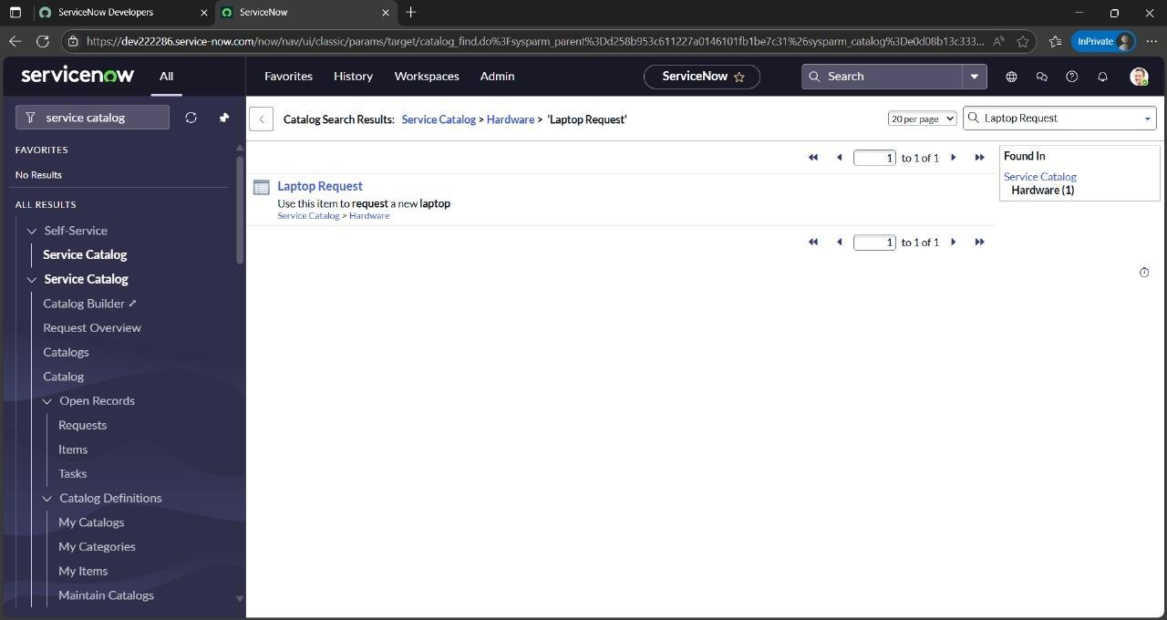

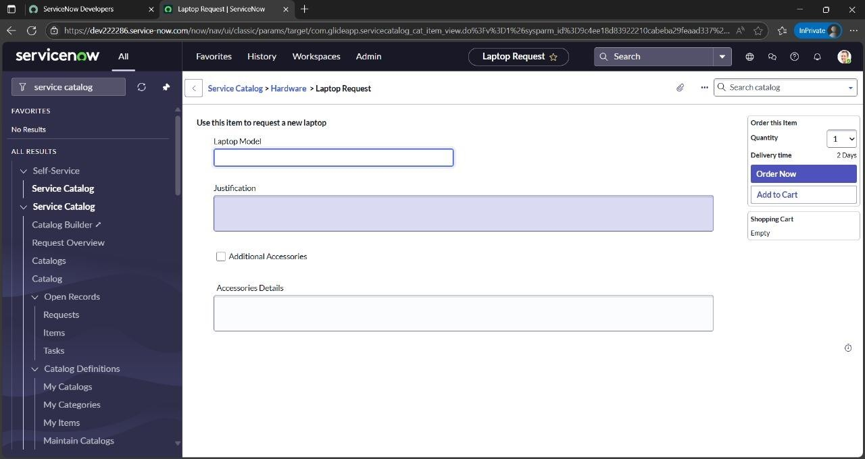

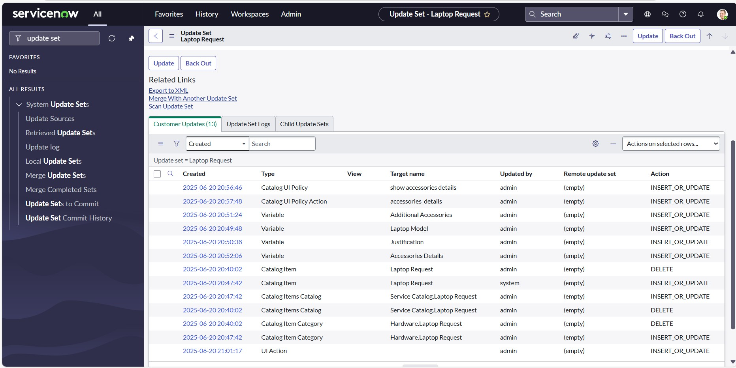

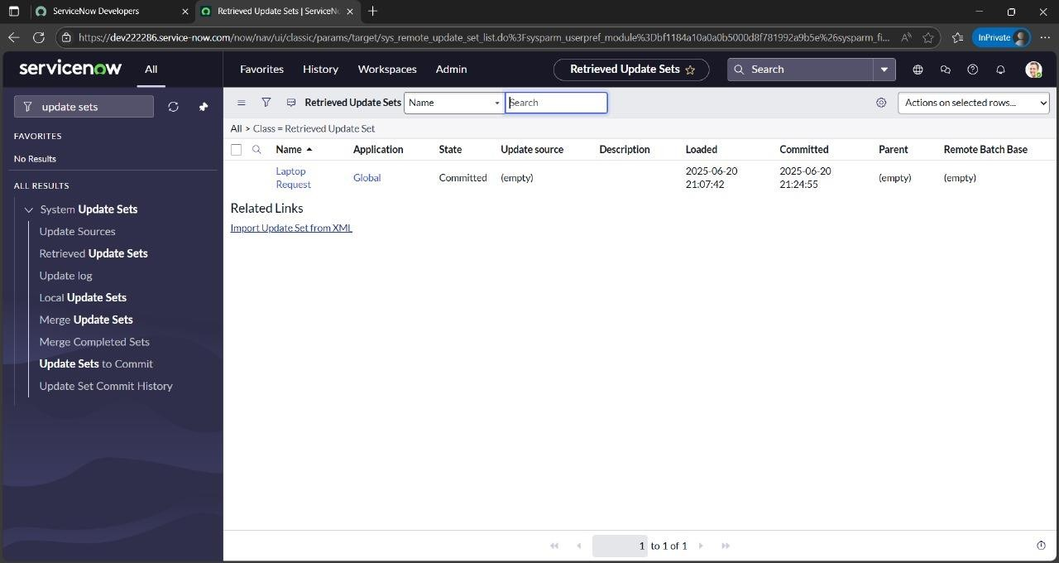

# 8. ADVANTAGES & DISADVANTAGES

# Advantages:

# Simplified Request Process: A catalog item for a laptop streamlines the request process, making it easy for users to request a laptop without needing to specify all the details manually.

# Standardization: It ensures a consistent approach to laptop requests, making it easier to manage and fulfill them.

# Centralized Management: Catalog items are typically managed within a service catalog, which provides a centralized platform for managing requests, approvals, and fulfillment.

# Improved User Experience: A well-designed catalog item provides a user-friendly interface for requesting laptops, increasing user satisfaction.

# Cost Reduction: By standardizing the process and potentially offering pre-configured options, catalog items can help reduce costs associated with laptop procurement.

# Disadvantages:

# Limited Customization: Catalog items may not accommodate every specific need or configuration that a user might require.

# Potential for Over- or Under-Specification: Users might select a laptop that doesn't perfectly match their needs, leading to either over-specified hardware or inadequate performance.

# Dependency on Workflow: The fulfillment of a catalog item relies on the defined workflow, which may not always be flexible enough to handle unique situations.

# Requires Maintenance: Catalog items need to be maintained and updated to reflect changes in laptop models, specifications, or pricing.

## 

# 9. CONCLUSION

The proposed solution transforms a traditionally manual and error-prone process into an intelligent, userfriendly workflow using ServiceNow. By combining dynamic forms, automated approvals, role-based access, and backend tracking, it not only streamlines laptop provisioning but also improves stakeholder satisfaction. The project demonstrates how thoughtful digital transformation can enhance internal IT services while aligning with governance and usability goals.

# 10. FUTURE SCOPE

* **Multi-Device Support**: Extend the catalog to include mobile phones, monitors, or accessories.
* **Asset Inventory Integration**: Auto-check availability and assign pre-registered asset tags.
* **Analytics Dashboard**: Generate real-time reports on request trends and SLA metrics.
* **AI Recommendations**: Suggest devices based on user role or department history.
* **Multi-language Support**: Enhance accessibility for a diverse global workforce.
* **Self-Help Chatbot**: Guide users through the request process via a conversational assistant (could even use NLP concepts you're exploring!).

# 11. APPENDIX

**GitHub :-** https://github.com/sravanthi62212/Laptop-Request-Catalog-Item

**Project Demonstration Link**  :- https://drive.google.com/file/d/1_fMw3RRLfVYYMxuQ9Jv5citkJ6jGyHrd/view?usp=drivesdk