MS.NET
Mini Project
Online Movie Ticket Booking System
(OMTBS)

Document Revision History

Date | Revision No. | Author | Summary of Changes
27th Feb 2017 | 1 | Vijay Vishwakarma | Initial Draft

Table of Contents
Introduction 4
Setup Checklist 4
Instructions 4
Problem Statement 5
Objective 5
Abstract of the project 5
Functional components of the project 6
Technology used: 7
Implementation 8
Summary of the functionality to be built: 8
Guidelines on the functionality to be built: 9
Evaluation and assessment parameters 13

Introduction
This document outlines a mini project for the .NET Line of Technology (LOT). The project is to develop an Online Movie Ticket Booking System (OMTBS). This document contains the work flow of the system and gives guidelines on how to build the functionality gradually in each of the course modules of the .NET LOT.

Setup Checklist
Minimum System Requirements
- Intel Pentium 4 and above Windows XP, 2000 and 2003
- Memory 1 GB
- Internet Explorer 6.0 or higher
- SQL Server 2012 client and access to SQL Server 2012 server
- Visual Studio 2013

Instructions
- The code modules in the mini project should follow all the coding standards.
- Create a directory by your name in drive <drive>. In this directory, create a subdirectory MiniProject. Store your Project here.
- You can refer to your course material.
- You may also look up the help provided in the MSDN
- Since this project work will span over couple of months, you will need to take care of maintaining the code

Problem Statement

Objective
Development of an online Movie Ticket Booking System (OMTBS)

Abstract of the project
This project is aimed at developing an Online Movie Ticket Booking System (OMTBS).

CineStar is a new launched Multiplex. They want to develop an online application which will help their viewer to book movies tickets online. This will help the viewer to view the details of the movie like its schedule, ticket price and availability of the tickets. The user can simply register himself with the application and book tickets online. The payment of the tickets can be done online or viewers can pay the amount at the ticketing window while collecting the tickets. The viewers can also provide feedback for their ticketing experience.This will also help the Administrator to maintain the details of movie and screens at the Multiplex. Using this system Administrator can easily generate reports.

The System will have Two Users: - Admin and Customer/Viewer

Role of Admin:-
- Managing Screens Details
- Managing Movie Details
- Manage Ticket Details
- Generating Reports

Role of Customer/Viewer:-
- Registering to the System
- Searching for a movie based on Genre , Time
- Booking Tickets
- Online Payments
- Providing Feedback

Functional components of the project
Application Architecture:
Distributed web applications traditionally to be designed and built across three logical tiers:
- Database Access Layer (DAL)
- Business Logic Layer (BLL)
- Presentation Layer

The DAL refers to the database itself, the stored procedures, and the component that provides an interface to the database. The BLL refers to the component that encapsulates all the business logic of the application. And, the Presentation layer refers to the web application pages.

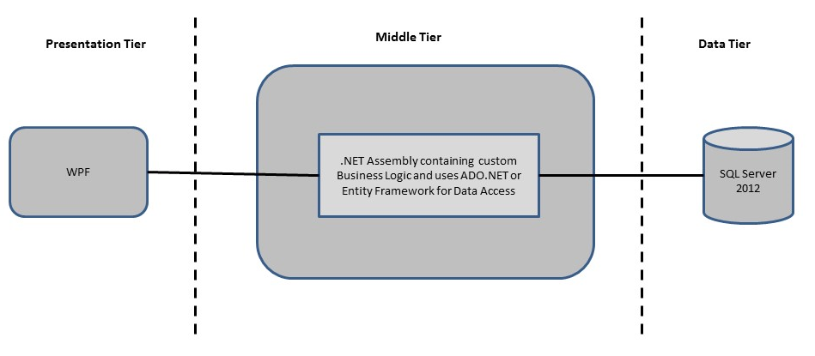

Design guidelines
- All the exceptions/errors to be captured and user friendly message to be displayed on the Common Error page (to be done during PLP).
- Data access layer Data access layer Use ADO.NET. Make use of stored procedures. All the database interaction would be performed using Data Access Component. Most common methods in Data Access Component would be –
- Create Connection to the Database
- Create Command Object
- Set Command Type to Stored Procedure
- Create and Populate Parameters
- Execute the Command
- Close the Connection

Technology used:
    - Presentation Layer
        - WPF 4.5

    - Business Layer
      - Business Logic Components and Services :-
        - C# 5.0
    - Database Layer
      - Databases:-
        - SQL Server 2012

Sr. No | Course | Duration | Functionality to be built
Sr. No | Course | (in PDs) | Functionality to be built
1 | MS SQL Server 2012 | 4 | Creating relevant database tables and stored procedures
2 | NET Framework 4.5 + C# 5.0 | 7.5 | Developing Business components (C# classes)
3 | ADO.NET 4.5 | 3 | Integrating the DAL ,BLL and PL
4 | LINQ and Entity Framework | 2 | Creating data model and data context and using LINQ to Entities
5 | WPF 4.5 | 2 | Incorporating advanced UI functionality with WPF 4.5
6 | Mini Project Presentation | 1 | The Mini Project Presentation day

Note: Saturday half day will be devoted for mini project

Implementation

Summary of the functionality to be built:
The participants need to develop the Online Movie Ticket Booking System by building the functionality incrementally in each of the course modules of .NET LOT.

Guidelines on the functionality to be built:

The functionality and components to be built in each of the course modules of .NET LOT is as follows:

1) Course: SQL Server 2012

This section describes some of the basic steps involved in designing and creation of the database for the application.

Create Data Model - identify the different tables and fields that we will need, which would later be used for building the rest of the application.

Database Schema - Create the following database tables (make your assumptions incase you require few more fields)

- Genre :- GenreID, GenreName , Description
- Movies :- MovieID, MovieName, ReleaseDate, GenreID, Description
- Screens:- ScreenID, ScreeName, Capacity
- Shows :- ShowID, ScreenID, MovieID, Showtime, Price
- Viewers :- ViewersID,FirstName,LastName,Mobileno,Email, Username,Password
- Tickets :- TicketID,TransactionDate, ViewersID, ShowID, NoOfTickets
- Users :- ID,Username,Password

2. Course: Winforms 4.5, WPF 4.5

a. Develop the prototypes for following functionalities:
i. Home Page :- This will allow the user with the details of latest movie releases and option for user to register or login to the system.
ii. Movie Detail :- This will allow the user with the detailed information of movie from he or she can proceed for ticket booking.
iii. Ticket Booking Page: - This will allow the User to select the movie, show date, show time and No of Tickets and proceed for payment.
iv. Transaction history :- This will help the user to view all the ticket purchase done in the past.
v. Profile Page :- This will help the user to view his or hers profile information where they are able to change their password and contact no.
vi. Admin Login :- This will help to administrator to authenticate himself or herself against the database table to they can access the system to do administrative work.
vii. Maintain Information of the Multiplex: - This page will allow the administrator to maintain details of Movies, Show and Screen at the Multiplex

b. In this course you need to develop the user interface using Winforms and WPF. The screens should include the fields as per the functionality mentioned above. Include Validations where ever required.

3. Course: C# 5.0 and ADO.NET 4.5

- Develop business components (C# classes) for the above functionality:

- Genre Class:- This class will contain methods for managing Genre Information
- Movies Class:- This class will contain methods for managing Movies Information
- Screens Class:- This class will contain methods for managing Screens Information
- Shows Class:- This class will contain methods for managing Shows Information
- Viewers Class:- This class will contain method for managing Viewers Information
- Tickets Class:- This class will contains method for managing Tickets information
- Users Class:- This class will contains method for managing Users Information

You need to create Layered Architecture which comprises of Presentation Layer (WPF),Business Logic Layer (C# Classes) and DAL Layer(Using ADO.Net 4.5 or LINQ and Entity Framework)

DAL Layer of ADO.NET 4.5 will include all the required code snippets for CRUD Operations.

All the CRUD operations should use SQL Server Stored Procedures (For Insert, Update, Delete & Search).

The connectionString should be stored in the configuration file only.

OR

4.Course: LINQ and EF
a) using the Datbase first approach of Entity framework create a entity data model form the database created in earlier steps.The Entity data model should consist of the following entities

- Genre Class:- This class/entity will hold Genre Information
- Movies Class:- This class/entity will hold Movies Information
- Screens Class:- This class/entity will hold Screens Information
- Shows Class:- This class/entity will hold Shows Information
- Viewers Class:- This class/entity will hold Viewers Information
- Tickets Class:- This class/entity will hold Tickets information
- Users Class:- This class/entity will hold Users Information

b) Using DataContext to perform CRUD operations and use LINQ to implement the required business logic in the application (like retrieving data, sorting data, searching data etc).

5. Course: ADO.NET 4.5 and WPF 4.5
  - Integrate all screens (ssWPF ) with business components (C# classes) to complete the entire functionality.

Project Evaluation Guidelines
The project it is to be evaluated based on the following five parameters:

- Proper Database Structure and UI designing as per the specifications –(15 Marks)
  - Proper Database Design and Stored Procedure
  - Visual look and feel of the UI
- Project Completion – (20 Marks)
  - Timely Completion of the project
  - Integration of all component of the system
- Defect free execution – (30 Marks)
  - Error free execution of individual modules and the whole system
  - Validation
  - Functionality as per the specified requirements
- Compliance of standard and guidelines – (15 Marks)
  - Appropriate comments entries
  - Adherence to naming conventions for classes, functions, variables and files
  - Simplicity of user interface and screen layouts
  - Maintainability of codes (for example, no one function should be more than 100 lines)
- Group Presentation and Query handling – (20 Marks)
  - Participants (Group of 3 to 4) to present the project with UML Diagrams(use case diagram and one of the sequence or activity diagram) and PPT

