**SRM UNIVERSITY -AP**

**Introduction to Programming Using C**

**Project Report On**

**“LIBRARY MANAGEMENT SYSTEM”**

Submitted in partial fulfilment for the award of the degree

IN

**BACHELOR OF TECHNOLOGY**

**IN**

**COMPUTER SCIENCE AND ENGINEERING**

**Submitted by**

**GROUP - 5**

1. Srinivas Surasani |AP21110010143

2.Sravanthi Murukonda |AP21110010144

3.Divyansh Shahi |AP21110010145

**Under the guidance of**

**Mrs. Vidya V**

**ABSTRACT**

Library management system is a project which aims in developing a computerized system to maintain all the daily work of library. This project has many features which are generally not available in normal library management system like facility of user login and a facility of teacher login.

It also has a facility of admin login through which the admin can monitor the whole system. It also designed to computerize and automate the operations performed over the information about the members, book issues and returns.

Overall, the project of ours is being developed to help the students as well as staff of library

|  |  |  |
| --- | --- | --- |
| **Chapter no.** | **Chapter name** | **Page no.** |
| 1 | Introduction | 04 |
| 2 | Objective | 05 |
| 3 | System Requirement Specifications | 06 |
| 3.1 Software requirements | 06 |
| 3.2 Hardware requirements | 06 |
| 4 | System Design | 07 |
| 4.1 Algorithm | 07-09 |
| 4.2 Block Diagram | 10 |
| 5 | System Implementation | 11-16 |
| 6 | Results | 17-20 |

**CONTENTS**

**CHAPTER 1**

**INTRODUCTION**

The project titled Library Management System is Library Management software for monitoring and controlling the transactions in a library. The project **“Library Management System’’** is developed in C which mainly focuses on basic operations in a library like adding new books and updating new information, searching books.

This project of **“LIBRARY MANAGEMENT”** gives us the complete information about the library. We can enter the record of new books and retrieve the details of books available in the library. Our software is so easy to use for both beginners and advanced users.

We can issue the books to the students and maintain their records and can also check how many books are issued and stock available in the library.

Throughout the project focus has been on presenting the information and comments in an easy manner. Our project is very useful for those who want to know about Library Management System.

**CHAPTER 2**

**OBJECTIVE**

* The main objective of library management system is to handle the entire activity of a library.
* To provide easy system circulation using computers rather than writing system.
* There will be a student login page and admin login page.
* Student login page can find the books whether it is available in library or not.
* Admin login page can add any events being organized in school, college and universities and other important suggestions regarding books.
* There will be a separate column to search the availability of books.

**Chapter 3**

**SYSTEM REQUIREMENTS**

**3.1. SOFTWARE REQUIREMENTS:**

Language used: C

Operating System: Windows 7 (minimum)

**3.2. HARDWARE REQUIREMENTS:**

Hard Disk: 512 Gb (minimum)

Processor: i3 (minimum)

**Chapter 4**

**SYSTEM DESIGN:**

**4.1. ALOGORITHM:**

**Step 1:** Start.

**Step 2:** Press any key to continue.

**Step 3:** Select your option.

1.Main menu

2.Exit

**Step 4:** Selecting Main menu we can see 2 login pages. Selecting exit, we will go back to starting page.

**Step 5:** main menu:

1. Admin login page

2. Student login page

3. Exit

**Step 6**: Admin login page can be able to see by the user only and student login page can be able to see by both user and student.

**Step 7:** By entering the proper credentials user can view further steps if we enter improper credentials, it shows invalid.

**Step 8:** Admin login page:

1) Add book

2) Search book

3) View all books

4) Exit

**Step 9:** By selecting 1 user can Add a new book

**Step 10:** Add book:

1) Book name

2) Book author

3) No of pages

4) Cost of book

5) Rent of book per day

**Step 11:** By selecting 2, user can be able to search book.

**Step 12:** In search book if user enter a book name if the book is there in the library, then it displays the book author, no of pages in book , cost of the book. If the book is not there, then it displays "search results are not found".

**Step 13:** By selecting 3 user can be able to see all the books which are available in the library.

**Step 14:** By selecting 4 user can go to main menu

**Step 15:** In main menu by selecting 2, student can go to student login page

**Step 16:** Student login page:

1) Search book

2) View all books

3) Exit

**Step 17:** By selecting 1 student can be able to Search book

**Step 18:** In search book by entering book name student can find the details of the book. If book is not there it shows "search results are not found"

**Step 19:** By selecting 2, student can be able to see all books, which are available in library.

**Step 20: After by** selecting Exit student can leave the page

**Step 21:** Stop.

**4.2. Block Diagram**

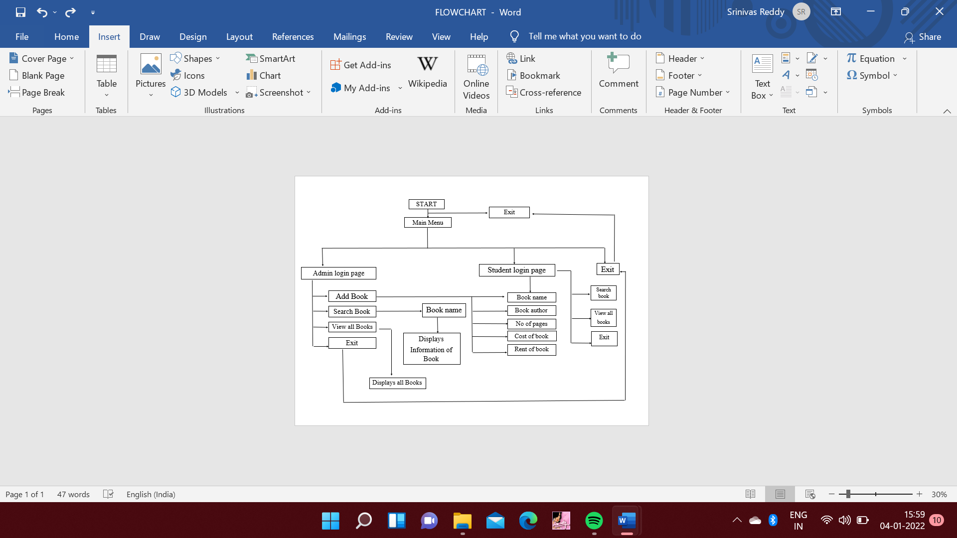

**Chapter 5**

**SYSTEM IMPLEMENTATION**

**CODING**:

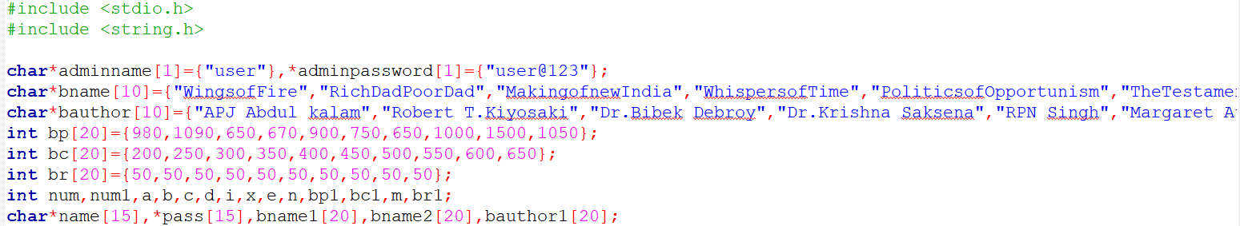

**Fig 5.1.**

* In this case we used datatypes, arrays, pointers for given information of books.
* The given data of books will be used in further implementations.



**Fig 5.2. Main Menu.**

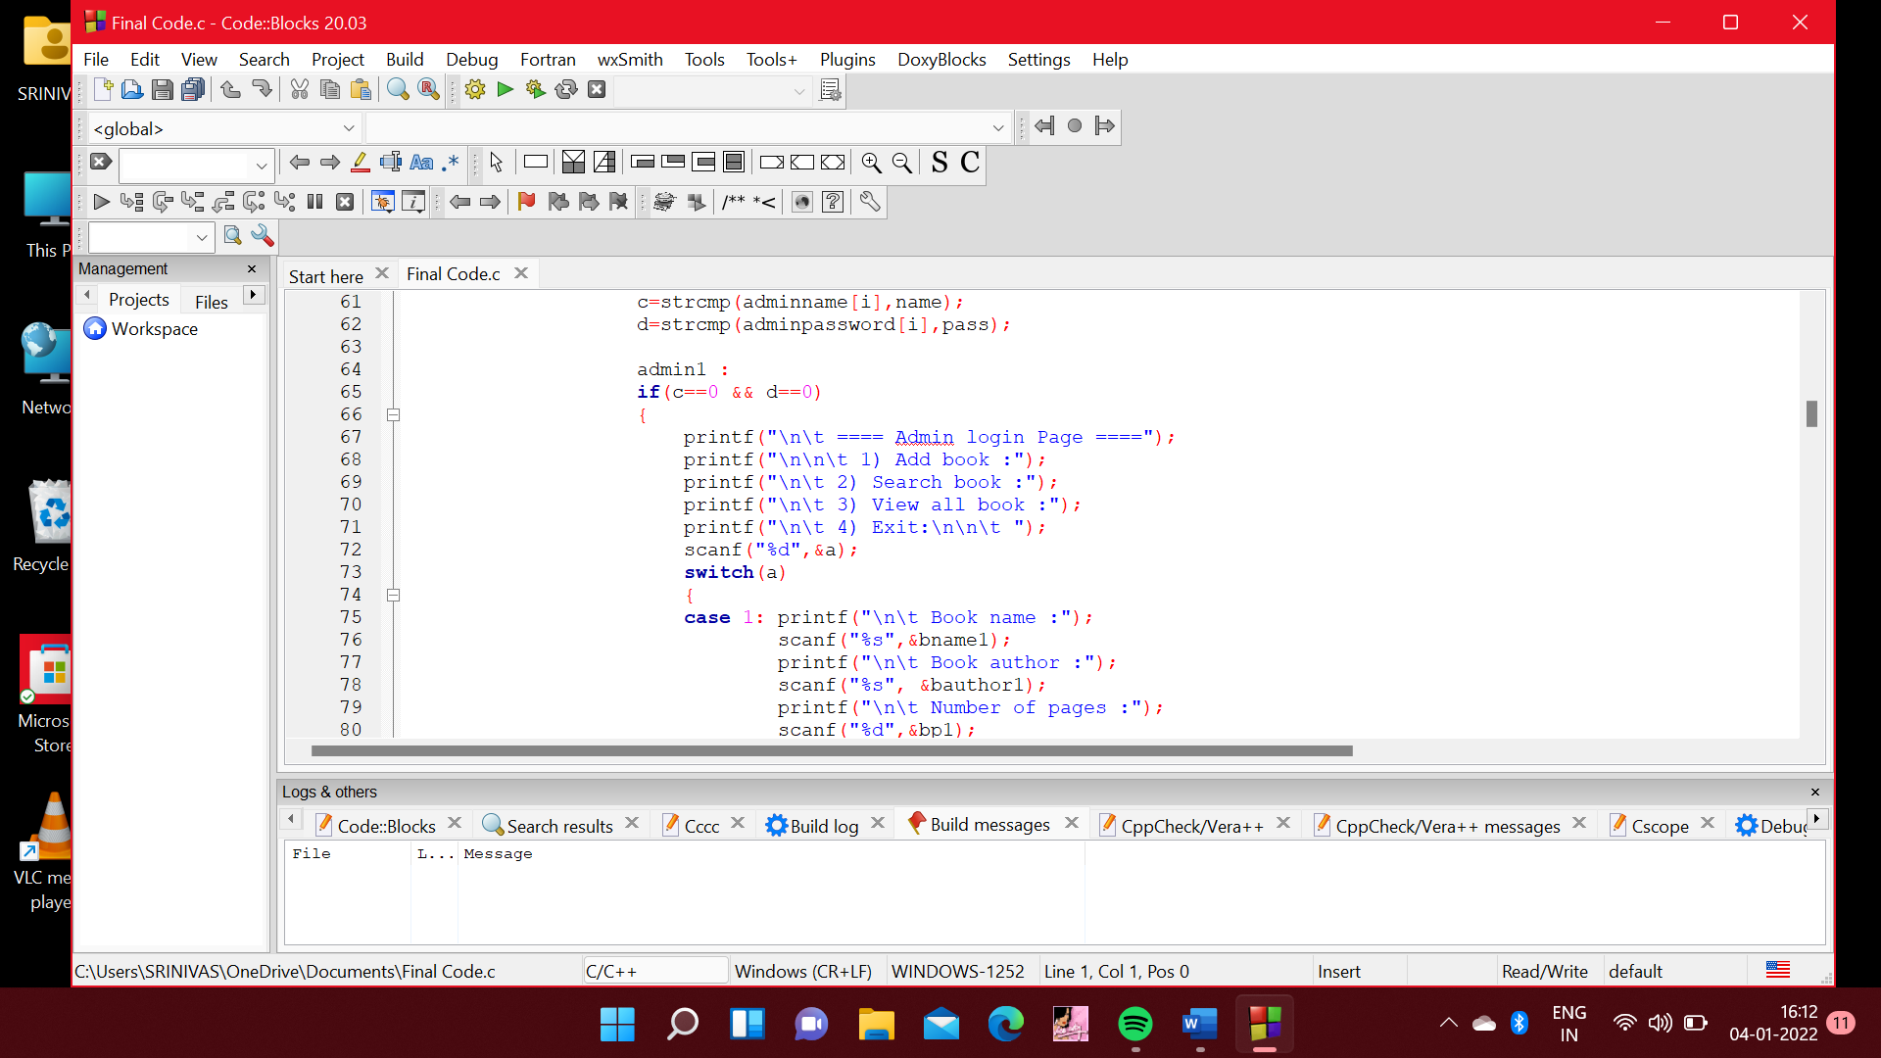

**Fig 5.3 Admin login page.**

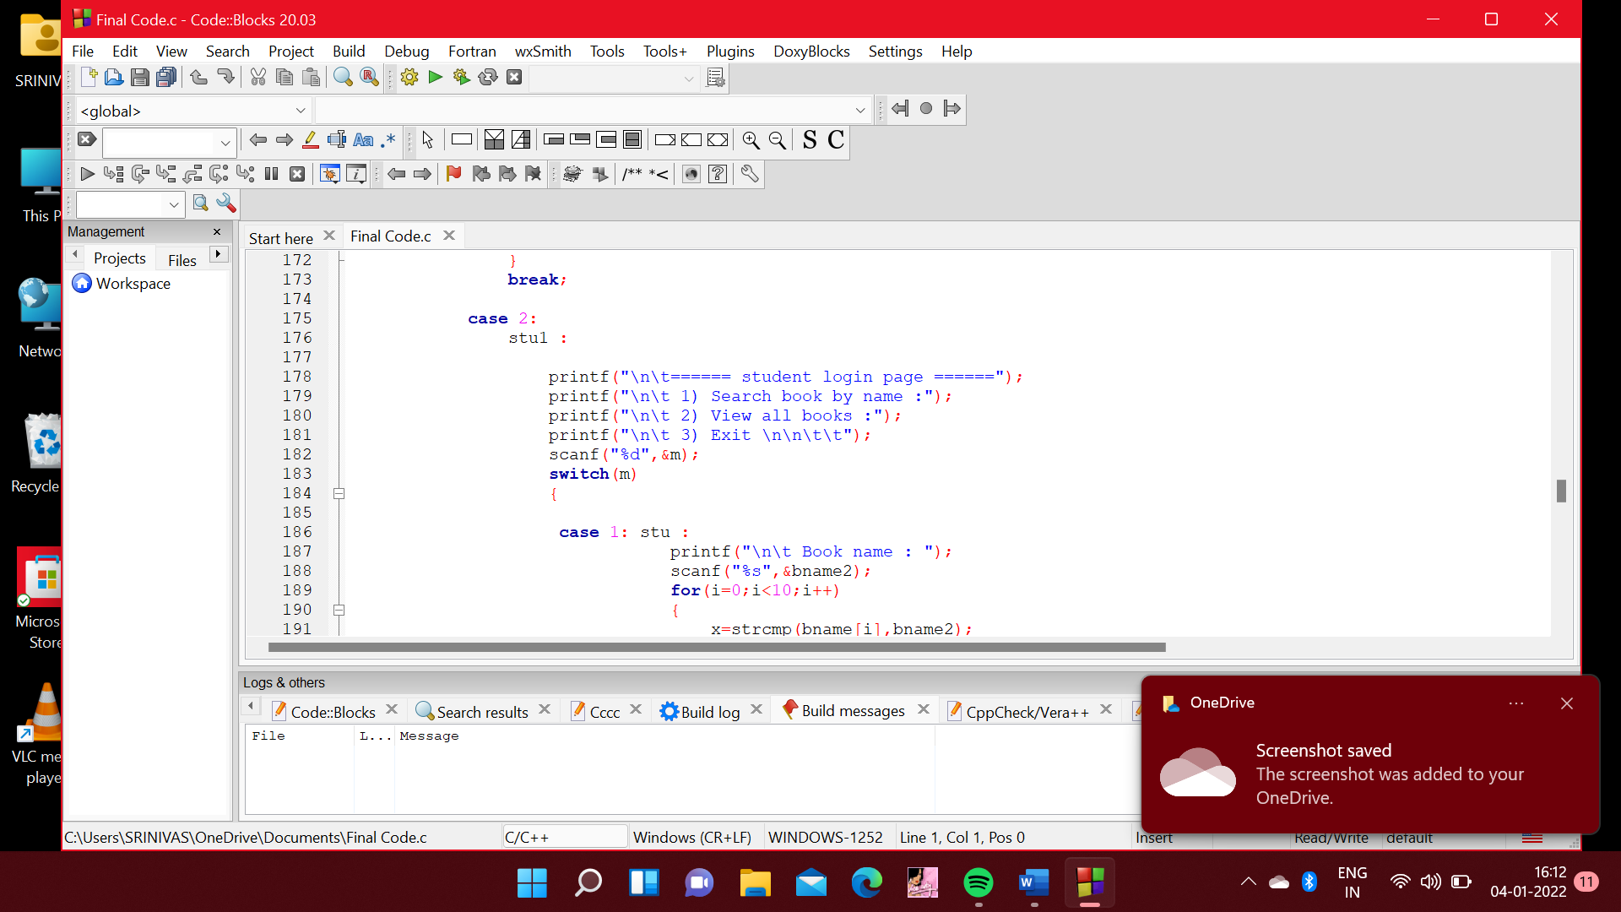

**Fig 5.4 Student login page.**

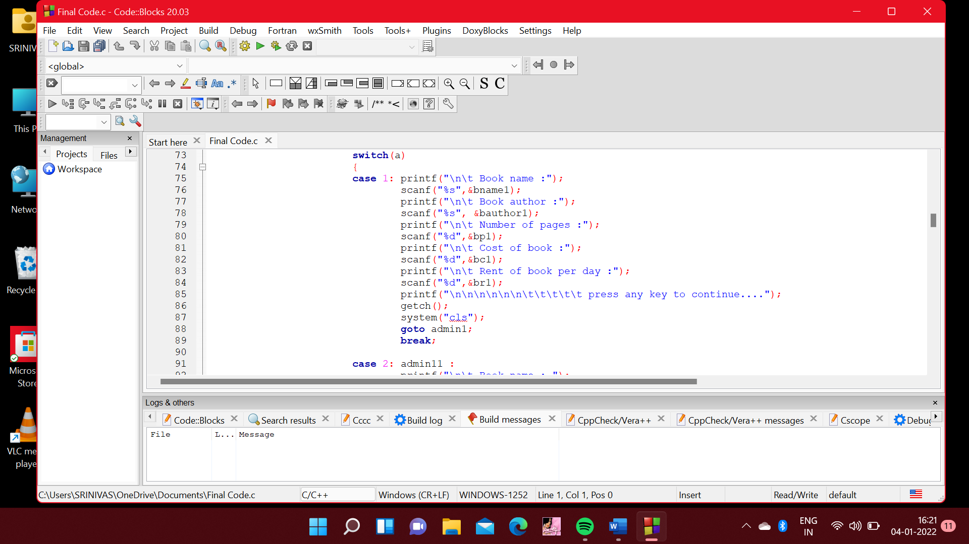

**Fig 5.5 Add book**

In add we can add a book by entering Book name, Book author, no.of.pages, cost of book, rent of book.

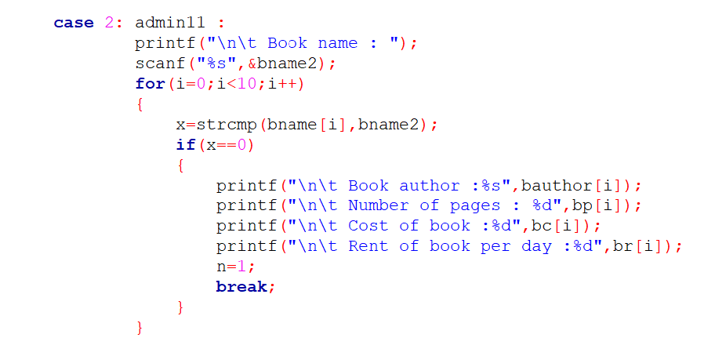

**Fig 5.6 Search book**

In search book we can find the details of the book by entering book name.

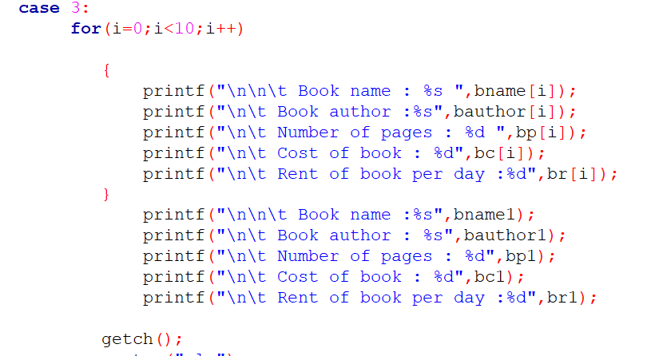

**Fig 5.7 View all books**

In view all books user can be able to find all the books which are available in the library.

**Chapter 7**

**RESULTS:**

**Sample input and output:**

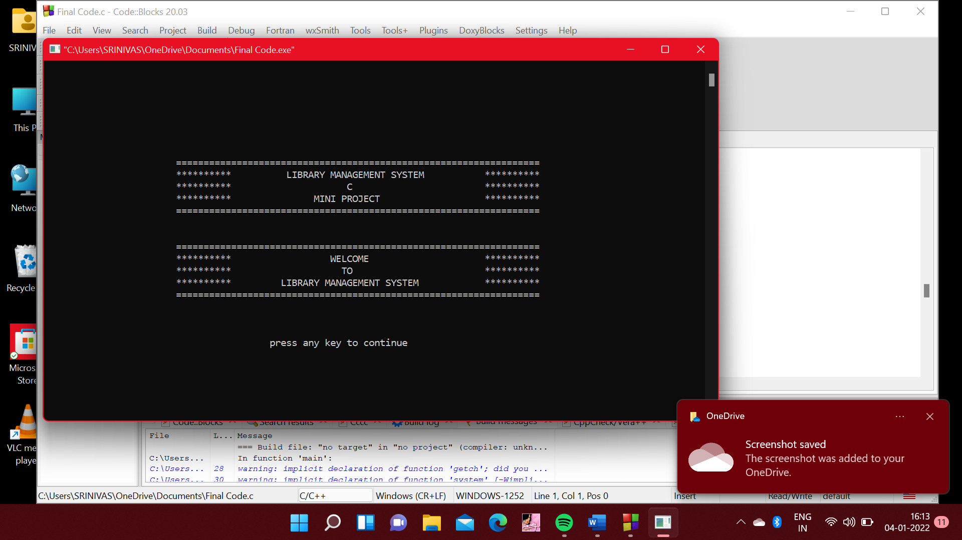

Fig 6.1. Starting page.

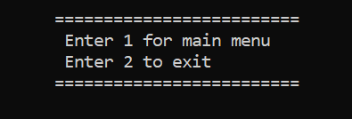

Fig 6.2. Menu.

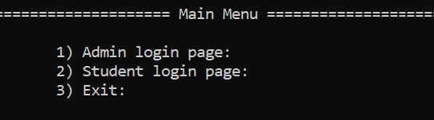

Fig 6.3. Main Menu.

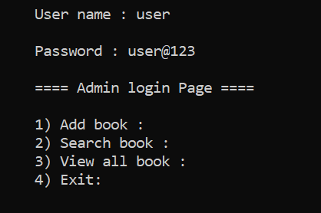

Fig 6.4. Admin Login page.

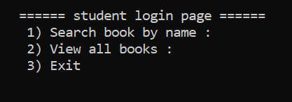

Fig 6.5. Student login page.

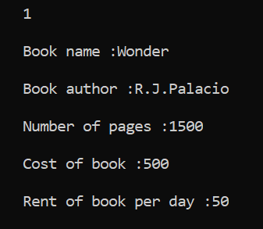

Fig 6.6. Add book.

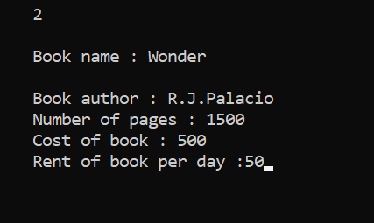

Fig 6.7. Search book.

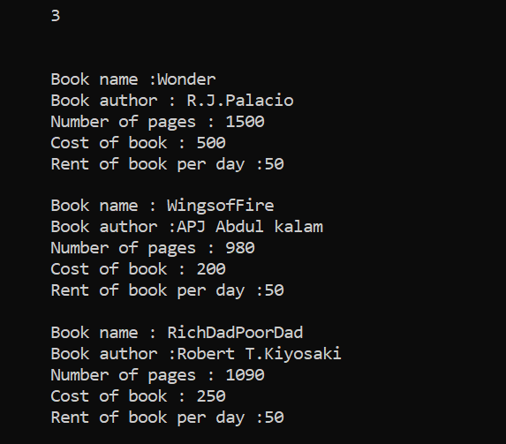

Fig 6.8. View all books.