SIMATS ENGINEERING
ASSESSMENT TOOL 2

NAME: P. Sravanthi

REG NO:1923111272

COURSE NAME: INTERNET PROGRAMMING

COURSE CODE: CSA4303

CO1-AT-02

Code of Conduct:

I ____________________ (P. Sravanthi / 192311272) certify that this submission is my original work and that I have adhered to the guidelines specified for this assessment.
I understand that any violation of academic integrity rules will result in disciplinary action.

Signature of the student:P. Sravanthi

Output:

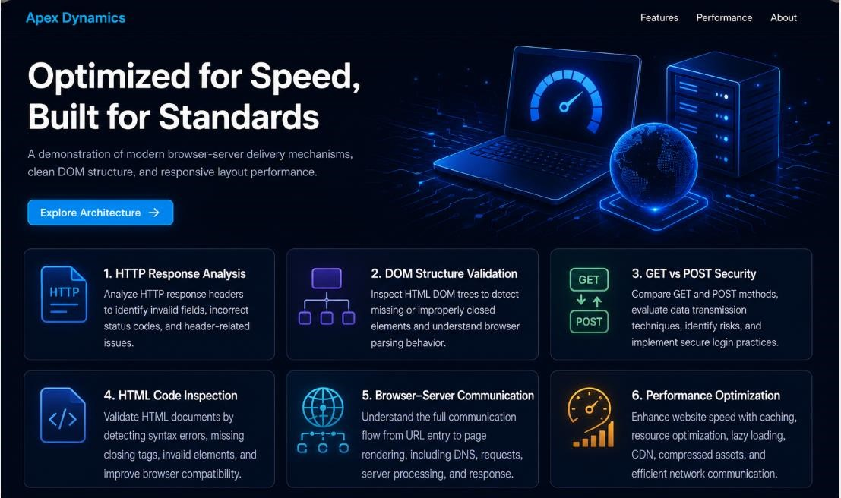

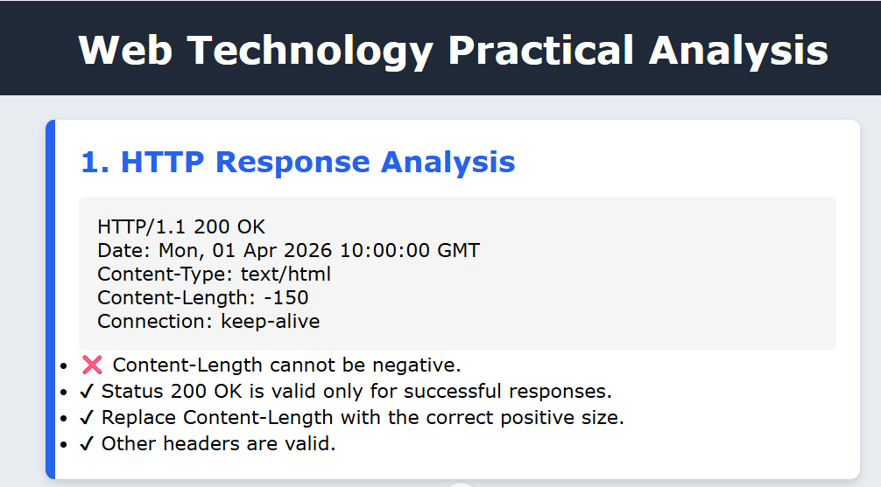

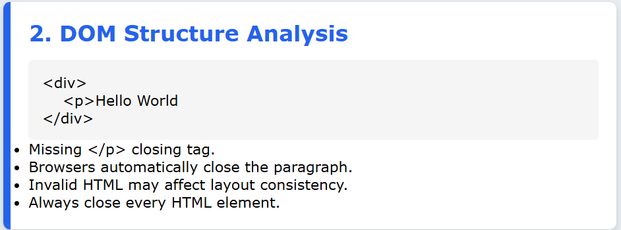

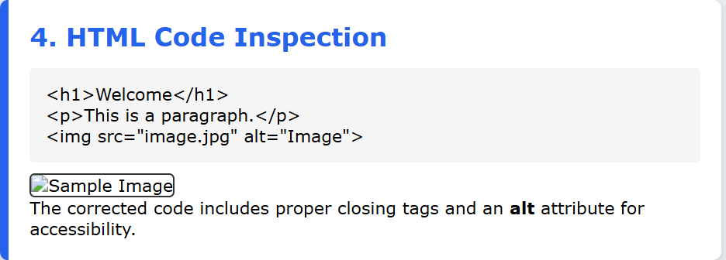

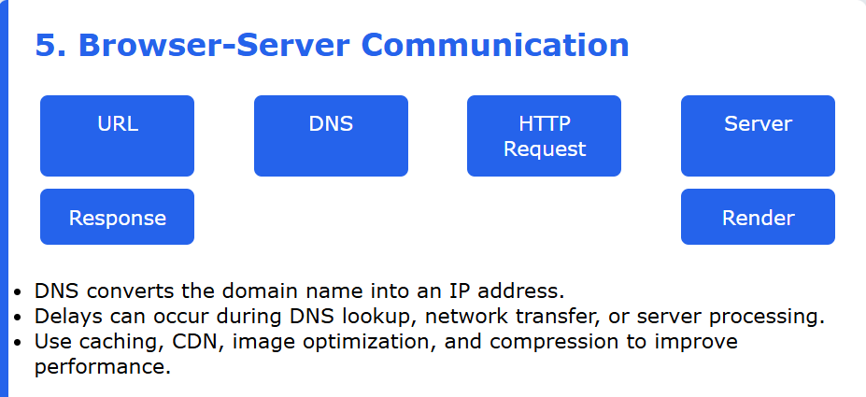

RUBRICS FOR CALCULATION:

Criteria | Weightage | Level 4 (Exemplary) | Level 3 (Proficient) | Level 2 (Developing) | Level 1 (Beginning)
Understanding of Data | 25% | Accurately interprets all data patterns, trends, and relationships | Interprets data correctly with minor  gaps | Partial understanding; misses key trends | Misinterprets or fails to  understand data
Analysis | 25% | Provides deep analysis with strong logical  reasoning and justification | Provides reasonable analysis with some  justification | Basic analysis with weak reasoning | No meaningful analysis provided
Application of Concepts | 20% | Effectively applies relevant concepts/tools to interpret data accurately | Applies concepts with minor errors | Limited application; requires guidance | Unable to apply  concepts to data
Conclusion | 20% | Draws clear, meaningful  conclusions with strong insights and implications | Provides valid conclusions with moderate insights | Conclusions are vague or weak | No clear or valid  conclusions
Clarity | 10% | Presents interpretation clearly using proper  structure, visuals, and terminology | Generally clear with minor issues | Lacks clarity or  proper structure | Poor presentation  and difficult to understand

