SIMATS ENGINEERING
ASSESSMENT TOOL 1 — SOLUTIONS
COURSE: CSA1612 — DATA WAREHOUSING AND DATA MINING
CO3: Evaluate the effectiveness of classification techniques on real-time data for accurate prediction.

Q1. Age and Photograph Preference — Covariance and Correlation
Given preference data:
Age group | A | B | C
5–6 years | 18 | 22 | 20
7–8 years | 2 | 28 | 40
9–10 years | 20 | 10 | 40
Let B = (22, 28, 10) and C = (20, 40, 40).
1. Sample covariance between B and C
Mean of B = (22 + 28 + 10)/3 = 20
Mean of C = (20 + 40 + 40)/3 = 33.333
B | C | B − 20 | C − 33.333 | Product
22 | 20 | 2 | -13.333 | -26.667
28 | 40 | 8 | 6.667 | 53.333
10 | 40 | -10 | 6.667 | -66.667
Σ(B − B̄)(C − C̄) = −40
Sample covariance = −40/(3−1) = −20
Final: Cov(B,C) = −20. Therefore B and C have a weak inverse relationship.
2. Sample covariance matrix
 | A | B | C
A | 97.333 | −74.000 | −46.667
B | −74.000 | 84.000 | −20.000
C | −46.667 | −20.000 | 133.333
The diagonal values are the sample variances of A, B, and C; off-diagonal values are the sample covariances.
3. Sample correlation between B and C
r(B,C) = Cov(B,C) / √[Var(B)Var(C)]
Var(B) = 84 and Var(C) = 133.333
r(B,C) = −20 / √(84 × 133.333) ≈ −0.189
Final: Cor(B,C) ≈ −0.189, indicating a weak negative linear relationship.
4. Sample correlation matrix
 | A | B | C
A | 1.000 | −0.818 | −0.410
B | −0.818 | 1.000 | −0.189
C | −0.410 | −0.189 | 1.000
R commands
B <- c(22,28,10)
C <- c(20,40,40)
cov(B,C)
cov(cbind(A,B,C))
cor(B,C)
cor(cbind(A,B,C))
Conclusion: The study shows an association between age group and photograph preference, but this alone does not establish causation. The covariance/correlation between B and C is negative and weak.
Q2. Box Plot for Tennis Players' Points Scored
Points scored: 12, 15, 14, 10, 18, 20, 22, 13, 11, 35, 16, 17, 19, 21, 23
Sorted data: 10, 11, 12, 13, 14, 15, 16, 17, 18, 19, 20, 21, 22, 23, 35
Statistic | Value
Minimum | 10
Q1 | 13
Median | 17
Q3 | 21
Maximum (non-outlier) | 23
IQR | 8
Lower fence | 1
Upper fence | 33
Outlier | 35
Since 35 > 33, Player J (35 points) is an outlier.
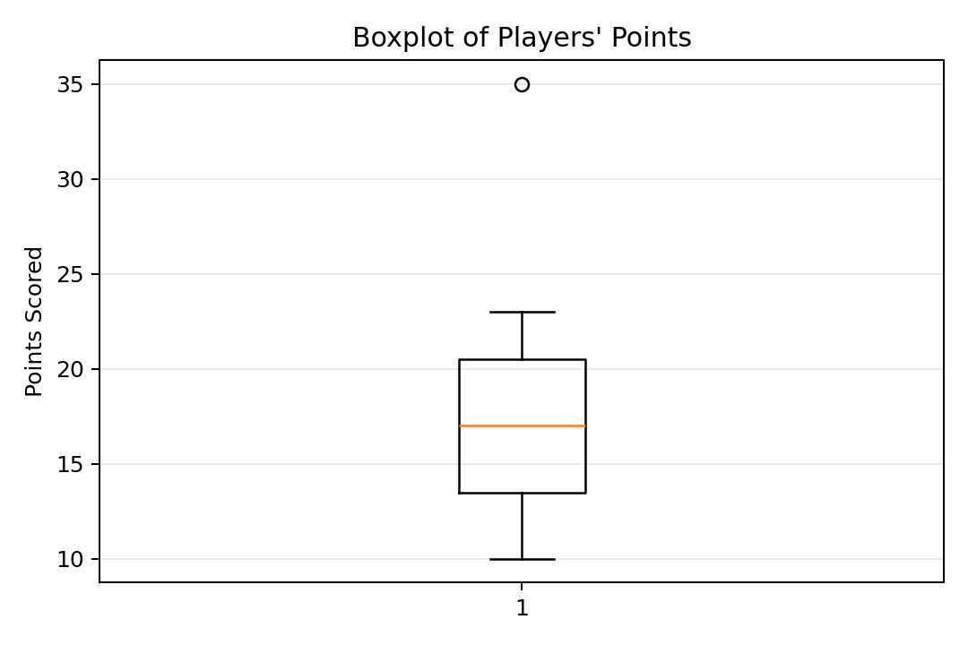
Inference: Most players scored between about 13 and 23 points. Player J's 35 points lies above the upper whisker and is an outlier.
R command: boxplot(points, main='Points Scored by Players', ylab='Points')
Q3. Decision Tree Classifier for Loan Approval
A decision tree is built using Age, Income, Employment Status, and Credit Score as predictors and Loan Approval as the target.
Using information gain, Credit Score gives the highest gain (approximately 0.730), so it is selected as the root node.
Credit Score | Observed outcome | Decision
good | All 5 = Yes | Yes
poor | All 5 = No | No
average | 4 Yes, 1 No | Split further by Age
For Credit Score = average, Age gives a pure split: young → Yes, middle → Yes, old → No.
Decision Tree:
Credit Score
├── good → Loan = YES
├── poor → Loan = NO
└── average → Age
├── young → YES
├── middle → YES
└── old → NO
This tree correctly classifies all 15 training records, giving 100% training accuracy on the supplied dataset.
R-style implementation:
library(rpart)
model <- rpart(LoanApproval ~ Age + Income + Employment + CreditScore, data=train, method='class')
rpart.plot(model)
prediction <- predict(model, train, type='class')
mean(prediction == train$LoanApproval)
Conclusion: Credit Score is the strongest first-level predictor in this dataset. Good credit scores lead to approval, poor scores lead to rejection, while average scores are resolved using Age.
Q4. Comparison of Year 9 Class Results
Measure | Class A | Class B | Higher
Mean | 65.78 | 62.11 | Class A
Median | 66.00 | 60.00 | Class A
Range | 60.00 | 34.00 | Class A
Class A mean = 65.78, median = 66, range = 60.
Class B mean = 62.11, median = 60, range = 34.
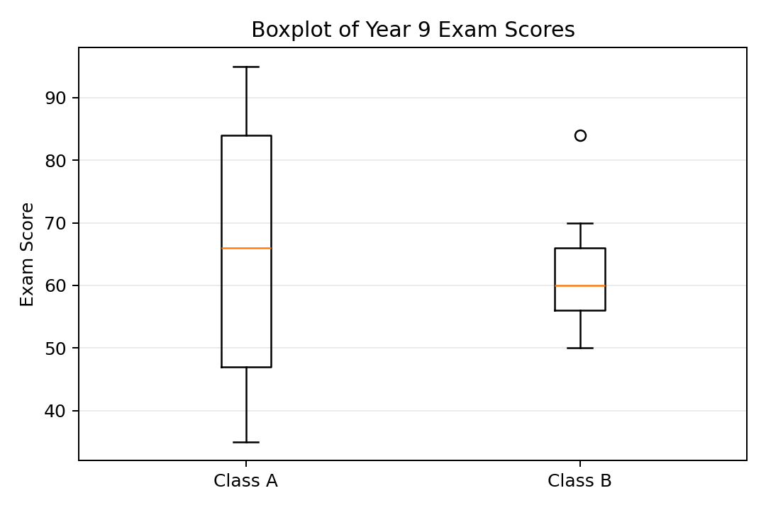
Inference: Class A performed better on both mean and median. Class A also has a larger spread (range 60), while Class B is more consistent (range 34). Neither class shows a Tukey outlier in the boxplot.
Q5. Hospital Age and Body Fat Analysis
Age | % Fat
23 | 9.5
23 | 26.5
27 | 7.8
27 | 17.8
39 | 31.4
41 | 25.9
47 | 27.4
49 | 27.2
50 | 31.2
52 | 34.6
54 | 42.5
54 | 28.8
56 | 33.4
57 | 30.2
58 | 34.1
58 | 32.9
60 | 41.2
61 | 35.7
Using the standard-deviation convention matching the supplied Data Mining exercise (population SD):
Variable | Mean | Median | Standard Deviation
Age | 46.44 | 51.00 | 12.85
% Fat | 28.78 | 30.70 | 8.99
Thus, Age: mean = 46.44, median = 51, SD ≈ 12.85.
% Fat: mean = 28.78, median = 30.7, SD ≈ 8.99.
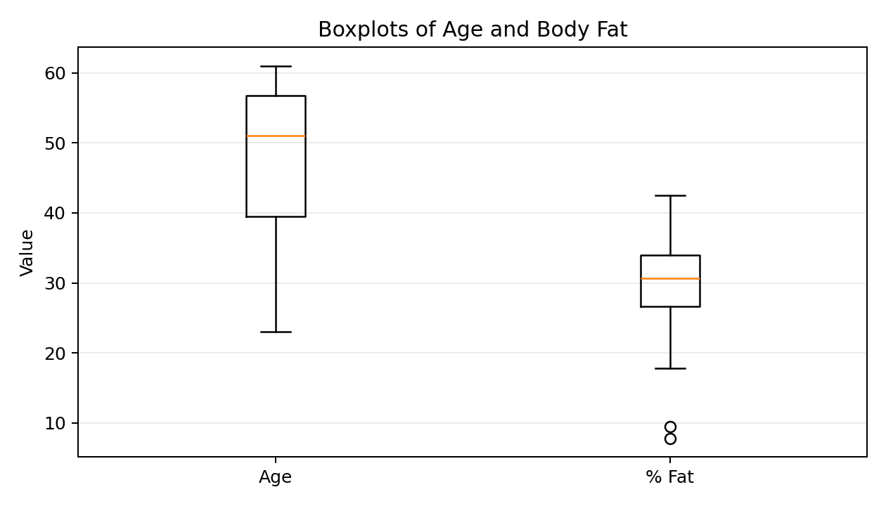
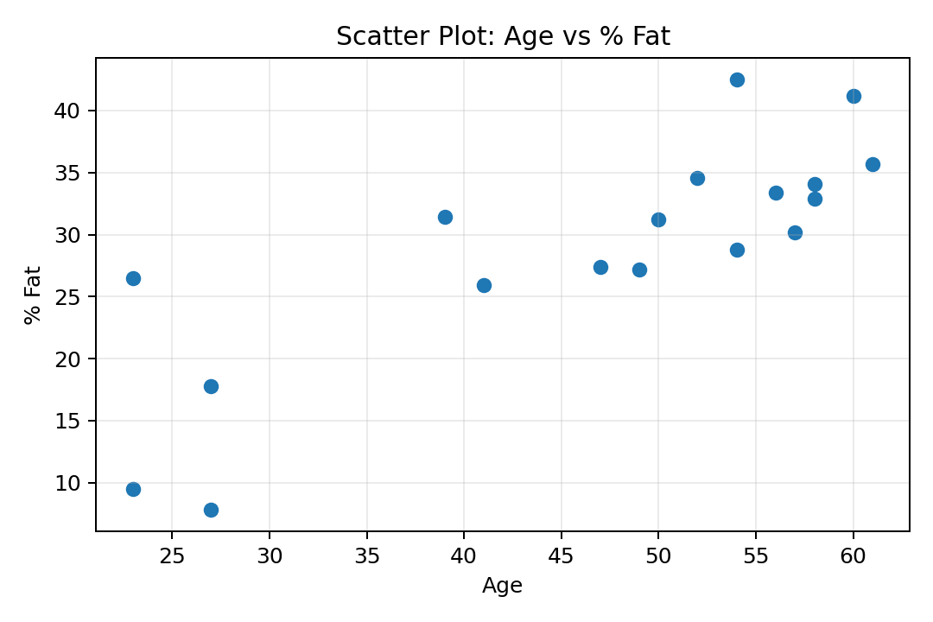
Scatter-plot inference: Age and body fat show a positive association in this sample (Pearson correlation r ≈ 0.818); older participants generally tend to have higher body-fat percentages, although the relationship is not perfect.
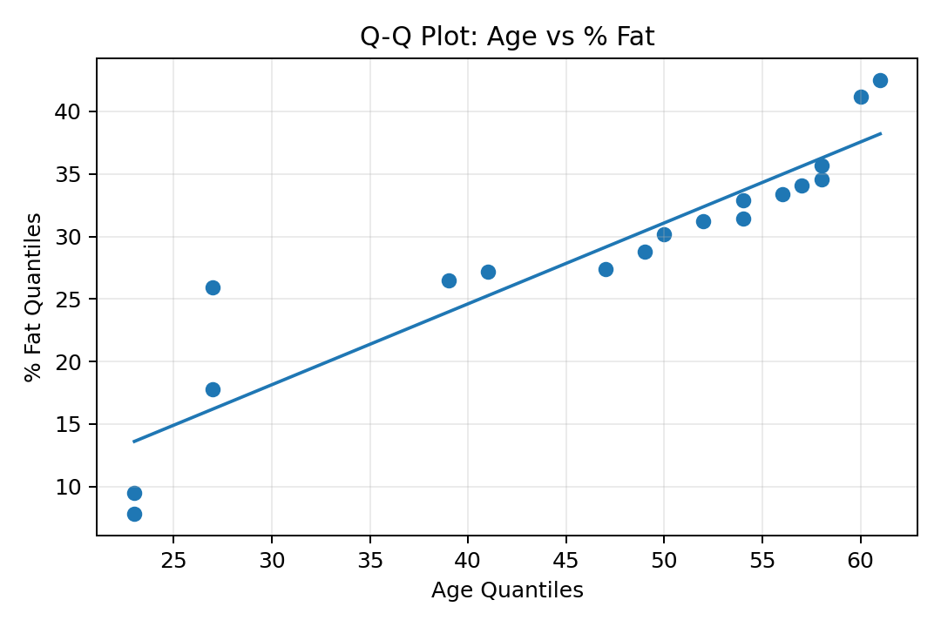
Q-Q plot inference: The points show how corresponding ordered quantiles of age and body-fat percentage compare. Because the variables are on different scales, the plot is interpreted by its overall pattern rather than closeness to the y = x line.
R Commands for Q5
age <- c(23,23,27,27,39,41,47,49,50,52,54,54,56,57,58,58,60,61)
fat <- c(9.5,26.5,7.8,17.8,31.4,25.9,27.4,27.2,31.2,34.6,42.5,28.8,33.4,30.2,34.1,32.9,41.2,35.7)
mean(age); median(age); sd(age)
mean(fat); median(fat); sd(fat)
boxplot(age, fat, names=c('Age','%Fat'))
plot(age, fat, main='Scatter Plot', xlab='Age', ylab='% Fat')
qqplot(age, fat, main='Q-Q Plot: Age vs % Fat'); abline(lm(sort(fat) ~ sort(age)))
Overall Conclusions
• Q1: B and C have sample covariance −20 and weak negative correlation ≈ −0.189.
• Q2: Player J, with 35 points, is identified as an outlier by the boxplot.
• Q3: Credit Score is the strongest root predictor; the resulting decision tree achieves 100% training accuracy on the supplied data.
• Q4: Class A has the higher mean and median; Class B has the smaller range and is therefore more consistent.
• Q5: Age and body fat have means 46.44 and 28.78 respectively; the scatter plot indicates a positive association.

