DarshanEase – Temple Darshan Ticket Booking Web Application
Project Documentation
- Introduction
Project Title:
DarshanEase – Temple Darshan Ticket Booking Web Application
Team Members:
Name | Role
Mohammad Tanzeela | Frontend Development
Alajingi Naga Pratyusha | Backend Development
Sravanthi Rachuri | Database Administrator
Neelam Prabhu Pragna Pauline | Authentication & API Developer
Thota Nagaraju | Testing and Documentation

Project Overview
Purpose: DarshanEase is a full-stack MERN-based web application developed to provide a convenient and efficient platform for booking temple darshan tickets online. The application allows devotees to register, securely log in, browse available temples, select suitable darshan slots, book tickets, and view their booking details through an interactive user interface.
The main objective of DarshanEase is to simplify the traditional manual temple ticket booking process by providing a digital platform where users can access temple information and manage their darshan bookings easily.
The system is developed using modern MERN stack technologies including React.js, Node.js, Express.js, and MongoDB. It provides secure authentication, efficient data management, and smooth communication between frontend and backend through RESTful APIs.
The application helps reduce waiting time, improves accessibility, and provides a better experience for devotees by enabling online darshan slot management.
Features: The DarshanEase application provides the following major features:
- User registration and login system.
- Secure authentication using JWT (JSON Web Token).
- Password encryption using bcryptjs.
- Browse available temples.
- View temple details.
- Select and book available darshan slots.
- Manage user bookings.
- View previously booked darshan tickets.
- RESTful API communication between frontend and backend.
- MongoDB database integration for storing application data.
- Responsive and user-friendly interface.
- Secure user data management.

3. Architecture
DarshanEase follows a three-layer architecture consisting of:
- Frontend Architecture
- Backend Architecture
- Database Architecture
This architecture improves scalability, maintainability, and efficient communication between different modules.
3.1 Frontend Architecture
The frontend of the DarshanEase application is developed using React.js with Vite. It provides an interactive and responsive interface for users to access different functionalities of the application.
React Router is used for navigation between different pages, while Axios is used for communication with backend REST APIs.
The frontend handles user interactions such as:
- User registration
- User login
- Temple browsing
- Slot selection
- Ticket booking
- Viewing booking history
- Managing user information
The frontend communicates with the backend server through HTTP requests and displays the received data dynamically.
Frontend Components:
The major frontend components include:
- Home Page
- User Registration Page
- Login Page
- Temple Listing Page
- Temple Details Page
- Darshan Slot Booking Page
- Booking History Page
- User Profile Page
- Dashboard
3.2 Backend Architecture
The backend of DarshanEase is developed using Node.js and Express.js.
The backend manages application logic, handles client requests, validates user data, communicates with MongoDB, and provides RESTful API services.
The backend provides services for:
- User authentication
- User management
- Temple information management
- Darshan booking operations
- Database communication
Middleware is used for authentication, authorization, and request validation.
Backend Components:
The backend consists of:
- Express Server
- API Routes
- Controllers
- Middleware
- Authentication Module
- Database Models
- Configuration Files
3.3 Database Architecture
DarshanEase uses MongoDB, a NoSQL database, for storing and managing application data.
Mongoose is used as the Object Data Modeling (ODM) library to define database schemas and interact with MongoDB.
The database stores information related to:
- Users
- Temples
- Darshan Slots
- Bookings
- Authentication Data
MongoDB provides flexible data storage and efficient retrieval of application records.
Main Collections:
Users Collection
Stores user information such as:
- Name
- Email
- Password
- User details
Temples Collection
Stores temple-related information:
- Temple name
- Location
- Description
- Available slots
Bookings Collection
Stores booking information:
- User details
- Temple details
- Selected darshan slot
- Booking status
3.4 Architecture Summary
DarshanEase follows a layered MERN architecture where React handles the user interface, Express and Node.js manage application logic, and MongoDB stores application data.
The frontend communicates with the backend using REST APIs. The backend interacts with MongoDB using Mongoose for database operations.
JWT authentication ensures secure access to protected resources, while bcryptjs provides password encryption.
This architecture makes the application secure, scalable, maintainable, and suitable for future enhancements.

4. Setup Instructions
Prerequisites:
Before running the DarshanEase application, ensure that the following software is installed on the system:
- Node.js (Version 16 or above)
- Node Package Manager (npm)
- MongoDB Database
- Visual Studio Code
- Git
- Postman (for API testing)
- Google Chrome or any modern web browser
These tools are required to install project dependencies, manage the database, run the application, and test API communication between frontend and backend.
Installation:
Follow the below steps to install and run the DarshanEase project:
Step 1: Clone Repository
Download or clone the project repository to your local system.
git clone https://github.com/sravanthirachuri28-gif/DarshanEase.git
Step 2: Open Project
Open the project folder in Visual Studio Code.
The project contains two major parts:
- Client (Frontend)
- Server (Backend)
Step 3: Install Frontend Dependencies
Navigate to the client folder:
cd client
Install required packages:
npm install
Start the frontend application:
npm run dev
Step 4: Install Backend Dependencies
Navigate to the server folder:
cd server
Install backend dependencies:
npm install
Start the backend server:
npm start
Step 5: Configure Database
Ensure that MongoDB is running locally or connect using MongoDB Atlas.
Create a configuration file containing:
- MongoDB connection URL
- Server port
- JWT secret key
Example:
MONGO_URI = your_mongodb_connection_string
JWT_SECRET = your_secret_key
PORT = 5000
After completing these steps, the DarshanEase application will be ready to use.

5. Folder Structure
The DarshanEase project follows a modular folder structure that separates frontend and backend components.
This separation improves code organization, readability, maintenance, and future scalability.
5.1 Client
The client side is responsible for providing the user interface and handling user interactions.
It is developed using React.js with Vite.
The frontend manages:
- User interface components
- Navigation
- API communication
- User input handling
- Data presentation
The client folder contains:
Components/
Contains reusable React components used throughout the application.
Examples:
- Navbar
- Forms
- Cards
- Booking components
Pages/
Contains different application pages.
Examples:
- Home Page
- Login Page
- Registration Page
- Temple Page
- Booking Page
- Profile Page

Assets/
Stores static resources such as:
- Images
- Icons
- Logos
- Other media files
Routes/
Handles navigation between different pages using React Router.
Services/
Contains API communication logic using Axios.
5.2 Server
The server side is developed using Node.js and Express.js.
It handles:
- Business logic
- Authentication
- API requests
- Database operations
The server contains the following folders:
config/
Stores configuration files such as:
- Database connection settings
- Environment configurations
controllers/
Contains functions that process API requests.
Controllers handle operations such as:
- User registration
- User login
- Temple data retrieval
- Booking operations
models/
Defines MongoDB schemas using Mongoose.
Main models include:
- User Model
- Temple Model
- Booking Model
routes/
Contains API route definitions.
Routes manage requests related to:
- Authentication
- Users
- Temples
- Bookings
middleware/
Contains middleware functions for:
- JWT verification
- Authentication checking
- Error handling
server.js
The main entry point of the backend application.
It:
- Creates Express server
- Connects MongoDB
- Registers routes
- Starts the application
package.json
Contains:
- Project information
- Dependencies
- Scripts required to execute the application
The project uses dependencies including:
- bcryptjs
- jsonwebtoken
- mongoose

6. Running the Application
6.1 Running the Frontend
Follow these steps:
- Open the client folder in Visual Studio Code.
- Open the terminal inside the client directory.
- Install dependencies:
npm install
- Start the React application:
npm run dev
- The frontend application will start successfully.
The application can be accessed using the Vite development URL:
http://localhost:5173
6.2 Running the Backend
Follow these steps:
- Open the server folder.
- Open terminal in the server directory.
- Install dependencies:
npm install
- Ensure MongoDB is running.
- Start the backend server:
npm start
or
npm run dev
- The backend server will start and listen for API requests on the configured port.
Example:
http://localhost:5000

7. API Documentation
The DarshanEase application uses RESTful APIs for communication between the frontend and backend.
These APIs handle user authentication, temple management, and darshan booking operations.
The APIs exchange data in JSON format.
Authentication APIs
1. User Registration
Method:
POST
Endpoint:
/api/auth/register
Purpose:
Creates a new user account by storing user details securely in MongoDB.
2. User Login
Method:
POST
Endpoint:
/api/auth/login
Purpose:
Authenticates registered users and generates a JWT token.
User APIs
Get User Profile
Method:
GET
Endpoint:
/api/users/profile
Purpose:
Retrieves logged-in user information.
Update User Profile
Method:
PUT
Endpoint:
/api/users/profile
Purpose:
Updates user profile details.
Temple APIs
Get Temples
Method:
GET
Endpoint:
/api/temples
Purpose:
Retrieves available temple information.
Get Temple Details
Method:
GET
Endpoint:
/api/temples/:id
Purpose:
Retrieves details of a specific temple.
Booking APIs
The booking APIs handle darshan ticket reservations and booking management operations.
1. Create Darshan Booking
Method:
POST
Endpoint:
/api/bookings
Purpose:
Creates a new darshan ticket booking by storing user booking details in the database.
Request Data:
{
"templeId": "12345",
"date": "2026-07-20",
"slot": "10:00 AM",
"numberOfPersons": 2
}
Response:
{
"message": "Booking created successfully",
"bookingId": "67890"
}
2. Get User Bookings
Method:
GET
Endpoint:
/api/bookings
Purpose:
Retrieves all darshan bookings associated with the logged-in user.
3. Get Booking Details
Method:
GET
Endpoint:
/api/bookings/:id
Purpose:
Retrieves complete information about a specific booking.
4. Cancel Booking
Method:
DELETE
Endpoint:
/api/bookings/:id
Purpose:
Cancels or removes an existing darshan booking.

8. Authentication
The DarshanEase application implements secure authentication using JSON Web Token (JWT) and bcryptjs password encryption.
These security mechanisms ensure that user information remains protected and only authorized users can access restricted features.
User Registration
New users can create an account by entering required details such as:
- Name
- Email
- Password
During registration:
- User information is validated.
- Password is encrypted using bcryptjs.
- Encrypted password is stored in MongoDB.
- User account is created successfully.
User Login
Registered users can log into the system using their email and password.
During login:
- User credentials are verified.
- Password is compared using bcrypt validation.
- A JWT token is generated after successful authentication.
- Token is used for accessing protected routes.
JWT Authentication
JSON Web Token provides secure communication between frontend and backend.
The authentication process works as follows:
- User logs in successfully.
- Server generates a JWT token.
- Token is sent to the client.
- Client sends the token with protected API requests.
- Server verifies the token before processing requests.
Authorization
Protected routes are secured using authentication middleware.
Only authenticated users can:
- Access their profile
- Book darshan slots
- View booking history
- Manage personal information
Security Features
The application provides:
- Password encryption using bcryptjs.
- JWT-based authentication.
- Protected API routes.
- Secure user data storage.
- Validation of user requests.

9. User Interfaces
The DarshanEase application provides a simple, responsive, and user-friendly interface that allows devotees to access all features easily.
The major screens of the application are:
9.1 Home Page
The Home Page acts as the landing page of the application.
It provides:
- Application introduction
- Navigation options
- Temple booking information
- User access options
9.2 Registration Page
The Registration Page allows new users to create an account.
Users enter:
- Name
- Email
- Password
The entered information is securely stored after password encryption.
9.3 Login Page
The Login Page allows existing users to securely access their accounts.
Features:
- Email verification
- Password authentication
- JWT token generation
9.4 Temple Listing Page
This page displays available temples with relevant details.
Users can view:
- Temple name
- Location
- Description
- Available darshan options
9.5 Temple Details Page
This page provides complete information about a selected temple.
Information includes:
- Temple description
- Darshan timings
- Available booking slots
9.6 Darshan Booking Page
The booking page allows users to reserve their darshan tickets.
Users can select:
- Temple
- Date
- Time slot
- Number of visitors
After confirmation, booking details are stored in the database.
9.7 Booking History Page
This page allows users to view previous bookings.
It displays:
- Temple name
- Booking date
- Darshan slot
- Booking status
9.8 User Profile Page
The profile page allows users to view and manage their personal information.
Features:
- View profile details
- Update user information
- Manage account details

10. Testing
The DarshanEase application was tested to ensure that all modules work correctly and efficiently.
The following testing methods were performed:
Functional Testing
Functional testing was performed to verify major application features:
- User registration
- User login
- Temple browsing
- Slot booking
- Booking history
- Profile management
All major functions were tested successfully.
API Testing
REST APIs were tested using tools such as Postman.
Testing included:
- Request validation
- Response verification
- Authentication verification
- Error handling
Database Testing
MongoDB operations were tested to ensure:
- Correct data storage
- Data retrieval
- Updating records
- Deleting records
Mongoose models were verified for proper database communication.
Authentication Testing
Authentication testing was performed to verify:
- JWT token generation
- Protected route access
- Password encryption
- Invalid login handling
Testing Outcome
All major functionalities of the DarshanEase application were tested successfully.
The application provides:
- Secure authentication
- Reliable database operations
- Smooth user experience
- Efficient booking management

11. Screenshots / Demo
The DarshanEase application consists of multiple user interface pages that provide a smooth and interactive experience for devotees. The screenshots below can be replaced with actual screenshots of your application during the final submission.
Home Page:
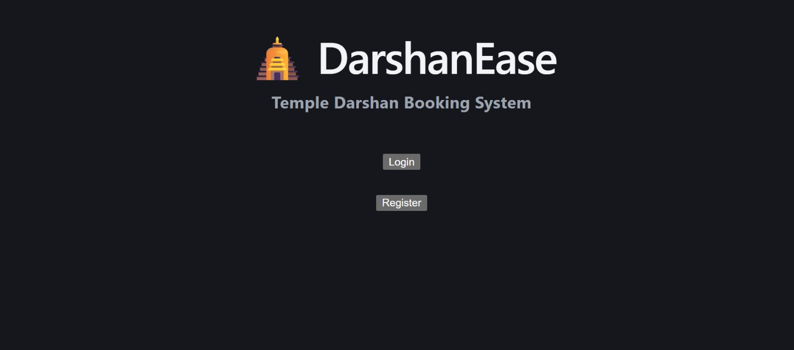

Registration Page:
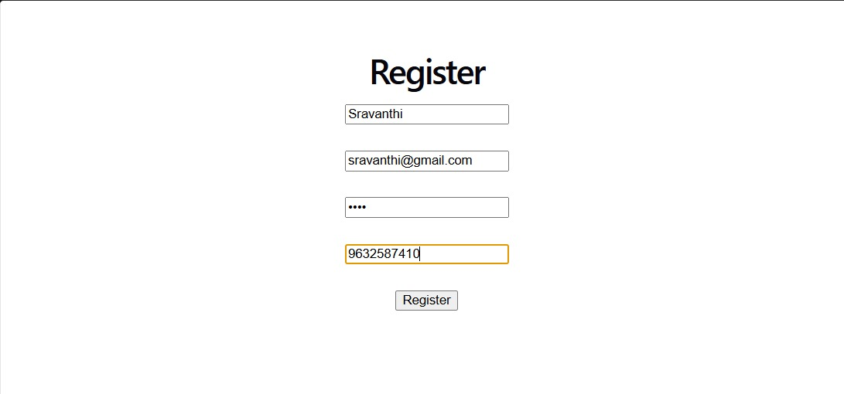
Login Page:
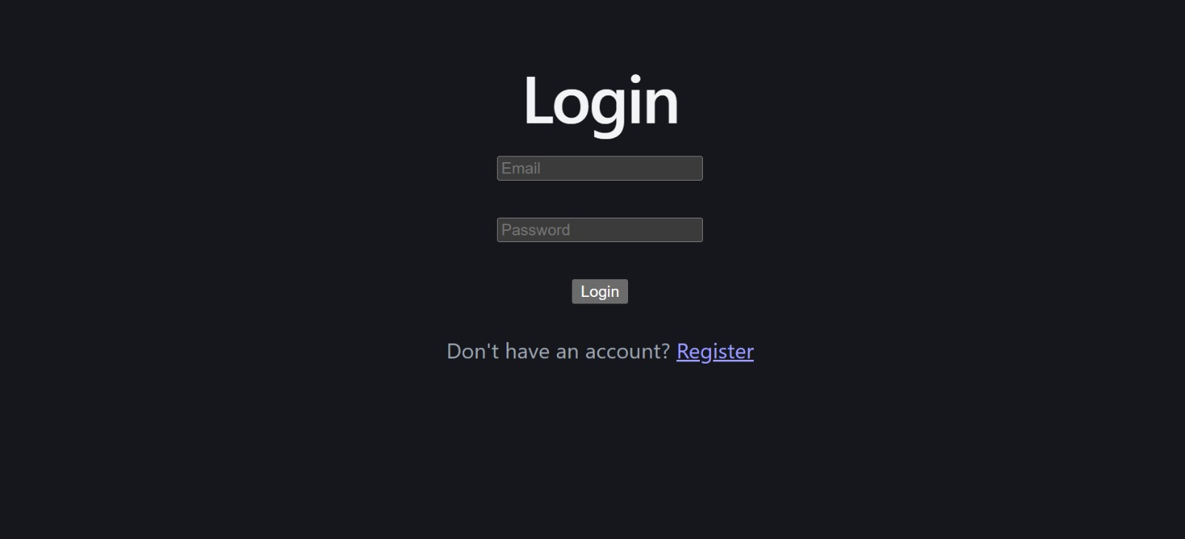

Temple Details Page:
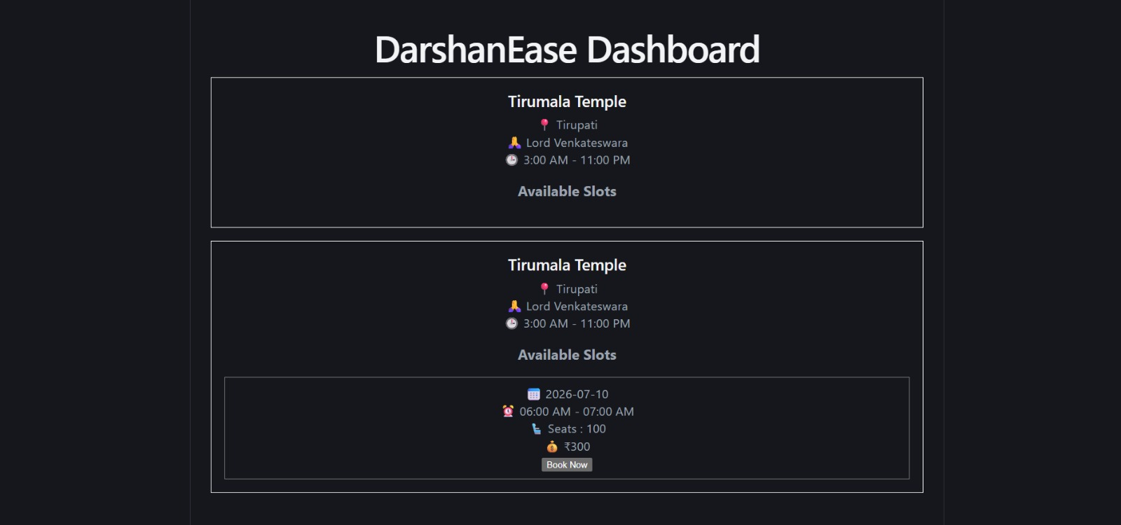
Darshan Booking Page: 

Booking History Page:


12. Known Issues
Although the DarshanEase application performs efficiently, a few limitations currently exist:
- A stable internet connection is required to access the application.
- MongoDB must be running locally or connected through MongoDB Atlas for proper database operations.
- Online payment integration has not yet been implemented.
- Email or SMS notifications for booking confirmation are currently unavailable.
- The application is designed primarily for web browsers and does not include a dedicated Android or iOS mobile application.
- During high traffic, simultaneous booking requests may require additional optimization to improve performance.
These limitations can be addressed in future versions of the application.

13. Future Enhancements
The DarshanEase application can be enhanced by implementing the following features:
- Online Payment Gateway: Integrate secure payment options such as Razorpay, Stripe, or UPI to enable online ticket payments.
- QR Code-Based Darshan Tickets: Generate QR codes for booked tickets to facilitate faster entry verification at temples.
- Email and SMS Notifications: Send booking confirmations, reminders, and cancellation updates to users.
- Admin Dashboard: Develop a dedicated admin panel to manage temples, bookings, users, and darshan slots.
- Live Slot Availability: Display real-time updates on available darshan slots to prevent overbooking.
- Temple Search and Filters: Allow users to search temples by name, city, state, or category.
- Digital Donation Facility: Enable devotees to make online donations directly through the application.
- Multi-language Support: Provide interfaces in multiple regional languages to improve accessibility for users across India.
- Mobile Application: Develop Android and iOS versions of DarshanEase for greater convenience.
- Analytics Dashboard: Implement reporting and analytics features to help administrators monitor bookings, user activity, and temple popularity.

Conclusion
The DarshanEase – Temple Darshan Ticket Booking Web Application successfully demonstrates the implementation of a secure, scalable, and user-friendly web application using the MERN Stack. The project simplifies the traditional temple darshan booking process by enabling devotees to register, browse temples, reserve darshan slots, and manage their bookings through an intuitive online platform.
By integrating React.js for the frontend, Node.js and Express.js for the backend, MongoDB for data storage, and JWT with bcryptjs for secure authentication, the application ensures reliable performance and strong security. The modular architecture also makes the system easy to maintain and extend.
Overall, DarshanEase achieves its primary objective of providing a convenient digital solution for temple darshan ticket booking. With future enhancements such as online payments, QR code tickets, notifications, and a mobile application, it has the potential to evolve into a comprehensive platform suitable for real-world deployment.

