**HOSTEL MANAGEMENT SYSTEM**

***A Project Report submitted in partial fulfillment of the requirements for the award of the degree of***

**BACHELOR OF TECHNOLOGY IN**

**COMPUTER SCIENCE AND ENGINEERING**

**Submitted by**

**SRAVANTHI.T 121810307010**

**NANDA VARDHAN.R 121810307026**

**CHANDANA.P 121810307029**

**SAI RUCHITH.R 121810307060**



**DEPARTMENT OF COMPUTER SCIENCE AND ENGINEERING**

**GITAM INSTITUTE OF TECHNOLOGY**

**GITAM (Deemed to be University)**

**VISAKHAPATNAM**

**DECEMBER 2020**

**INSTITUTE OF TECHNOLOGY**

GITAM (Deemed to be University)

**VISHAKAPTNAM**



**DECLARATION**

I, hereby declare that the project report entitled “HOSTEL MANAGEMENT SYSTEM” is an original work done through XAAMP and provide this opportunity by the Department of Computer Science and Engineering, GITAM Institute of Technology, GITAM (Deemed to be University), Visakhapatnam submitted in partial fulfillment of the requirements for the award of the degree of B.Tech. in Computer Science and Engineering. The work has not been submitted to any other college or University for the award of any degree or diploma.

**Registration No Name of the Student Student Signature**

121810307010 SRAVANTHI .T

121810307026 NANDA VARDHAN .R

121810307029 CHANDANA .P

121810307060 SAI RUCHITH .R

INSTITUTE OF TECHNOLOGY

**GITAM** (Deemed to be University)

VISHAKAPATNAM



**CERTIFICATE**

This is to certify that the project report entitled “HOSTEL MANAGEMENT SYSTEM” is a Bonafide record of work carried out by “121810307010-Sravanthi , 121810307026-Nanda Vardhan.R ,121810307029-Chandana.P , 121810307060-Sai Ruchith” submitted in partial fulfillment of requirement for the award of degree of Bachelor of Technology in Computer Science and Engineering.

**INTERNSHIP GUIDE Prof.K.Thammi Reddy**

**INTERNSHIP REVIEWER-1 Yashwanth Amanapu**

**INTERNSHIP REVIEWER-2 Komal Kashyap**

**TABLE OF CONTENTS**

|  |  |  |
| --- | --- | --- |
| 01 | Abstract | 1 |
| 02 | Introduction | 2 |
| 03 | **Course-1:** System Environment and Database connectivity | 3 |
| 04 | **Course-2:** ER Diagram | 4 |
| 05 | **Course-3:** Flowchart | 6 |
| 06 | **Course-4**: Database structure | 7 |
| 07 | Sql Queries | 18 |
| 08 | Conclusion | 24 |

**ABSTRACT**

As the name specifies “HOSTEL MANAGEMENT SYSTEM” is a software developed for managing various activities in the hostel. For the past few years the number of educational institutions are increasing rapidly. Thereby the number of hostels are also increasing for the accom-modation of the students studying in this institution. And hence there is a lot of strain on the person who are running the hostel and software’s are not usually used in this context. This particular project deals with the problems on managing a hostel and avoids the problems which occur when carried manually.

Identification of the drawbacks of the existing system leads to the designing of computerized system that will be compatible to the existing system with the system Which is more user friendly and more GUI oriented. We can improve the efficiency of the system, thus overcome the drawbacks of the existing system.

* Less human error
* Strength and strain of manual labour can be reduced
* High security
* Data redundancy can be avoided to some extent
* Data consistency
* Easy to handle
* Easy data updating
* Easy record keeping

**INTRODUCTION**

**Problem definition**

We have got many hostels in our university. All these hostels are presently managed manually by the hostel office. The Registration form verification to the different data processing are done manually.

Thus there are a lot of repetitions which can be easily avoided. And hence there is a lot of strain on the person who are running the hostel and software’s are not usually used in this context. This particular project deals with the problems on managing a hostel and avoids the problems which occur when carried manually

Identification of the drawbacks of the existing system leads to the designing of computerized system that will be compatible to the existing system with the system which is more user friendly and more GUI oriented. We can improve the efficiency of the system, thus overcome the drawbacks of the existing system.

**1.Admin Panel**

1. Admin Login

Admin can login through login form.

1. Admin Profile

Admin can manage his own profile. Admin can also change his password

1. Courses

Admin can create add course, edit courses and also delete the course

1. Rooms

Admin can create rooms and allots seater to particular rooms and assign the fees.

1. Registration

Admin can create student profile and allot the rooms

6.Manage the Registration

Admin can manage the all the student Profile. Take a print out of all profiles.

7.Forgot Password

Admin can also retrieve the password if admin forgot the password

**2.User Panel**

* 1. **User Registration** User can register through user registration form
  2. **User Login--** User can login through login form
  3. **Forgot Password—**user can retrieve password through forgot password link
  4. User Dashboard
  5. **User Profile—**User can manage own profile
  6. **Book Hostel** – User can book hostel
  7. **Room Details-** Booked Room Details
  8. **Change Password-** User Can change own password
  9. **User access log-** User can watch last login details

**SYSTEM ENVIRONMENT**

**Software Configuration**

1.OS : Windows XP

2.PHP Triad (PHP5.6, MySQL, Apache, and PHPMyAdmin)

**Create a connection to a database**

Before you can access data in a database, you must create a connection to the database.In PHP, this is done with the mysqli_connect() function.

**Syntax**



**DATABASE CONNECTION**

In the following php code we store the server name localhost in host variable, by default the user name is root which we store in dbuser, and database password is “” by default which we store in dbpass and database name is hostel which we store in db.

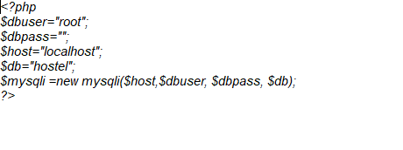

**ER Diagram**

**An Entity Relation(ER) Diagram is a specialized graphics that illustrates the interrelationship between entities in a database. ER diagrams often use symbols to represent 3 different types of information. Boxes are commonly used to represent entities. Diamonds are normally used to represent relationships and ovals are used to represent attributes.**

An Entity Relationship Model (ERM), in software engineering is an abstract and conceptual representation of data. Entity Relationship modeling is a relational schema database modeling method, used to produce a type of conceptual schema or semantic data model of a system, often a relation database, and its requirements in a top-down fashion

**Entity:**

Entity is the thing which we want to store information. It is an elementary basic building block of storing information about business process. An entity represents an object defined within the information system about which you want to store information. Entities are distinct things in the enterprise.

**Relationships:**

A relationship is a named collection or association between entities or used to relate two or more entities with some common attributes or meaningful interaction between the objects

**Attributes:**

Attributes are the properties of the entities and relationship, Descriptor of the entity. Attributes are elementary pieces of information attached to an entity.

**Hostel management system-Er diagram**

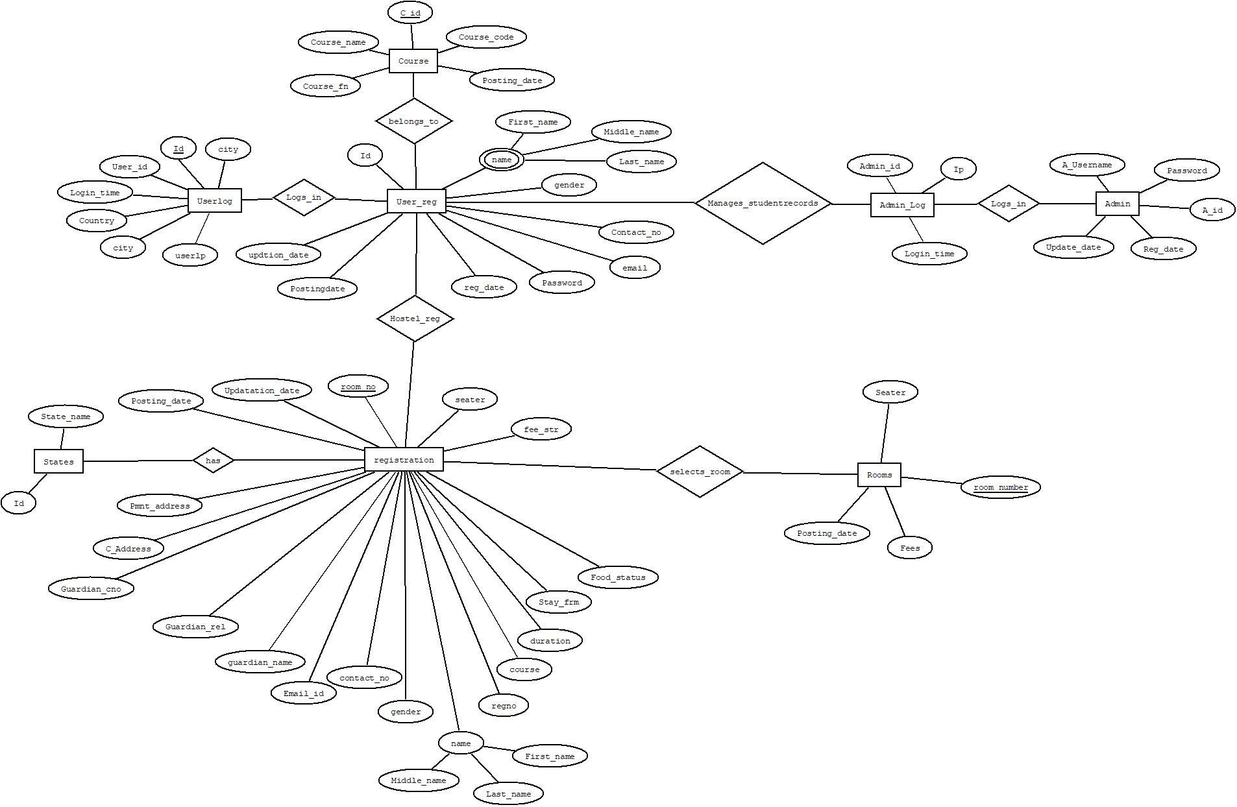

**Flow Chart**

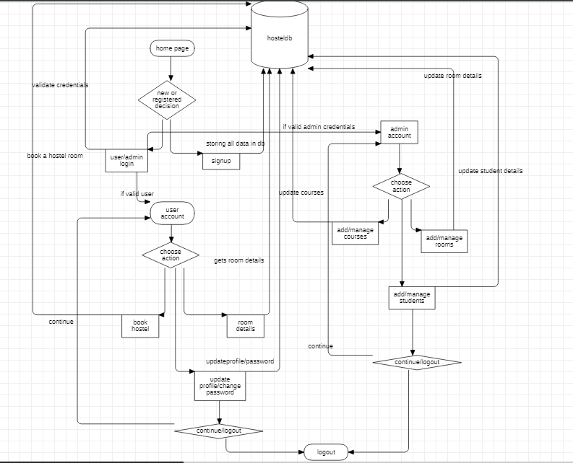

**Database Design**

The data in the system has to be stored and retrieved from database. Designing the database is part of system design. Data elements and data structures to be stored have been identified at analysis stage. They are structured and put together to design the data storage and retrieval system.

A database is a collection of interrelated data stored with minimum redundancy to serve many users quickly and efficiently. The general objective is to make database access easy, quick, inexpensive and flexible for the user. Relationships are established between the data items and unnecessary data items are removed. Normalization is done to get an internal consistency of data and to have minimum redundancy and maximum stability. This ensures minimizing data storage required, minimizing chances of data inconsistencies and optimizing for updates. The MS Access database has been chosen for developing the relevant databases.

**Admin Table Structure**

Admin table stores the information regarding admin login and will be used at validating admin login .Here the entity is Admin and attributes are id,username,email,password,reg_date,updation_date.

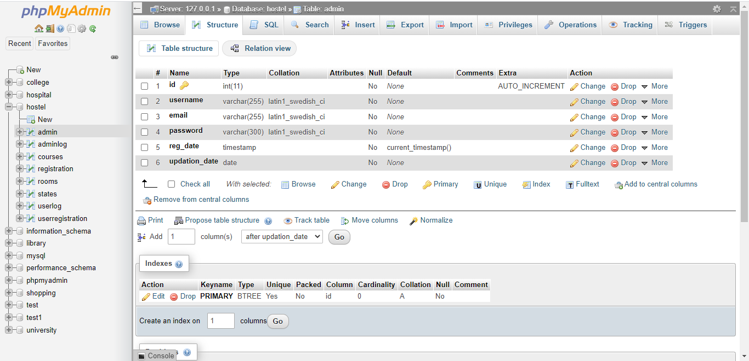

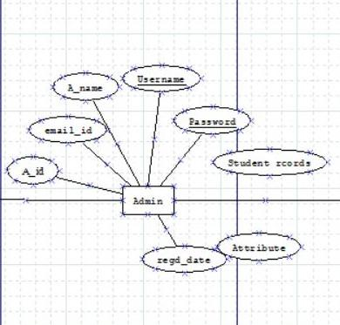

**-- Table structure for table `admin`--**

CREATE TABLE `admin` (

`id` int(11) NOT NULL,

`username` varchar(255) NOT NULL,

`email` varchar(255) NOT NULL,

`password` varchar(300) NOT NULL,

`reg_date` timestamp NOT NULL DEFAULT current_timestamp(),

`updation_date` date NOT NULL

);

**--Insering values into admin table----**

INSERT INTO `admin` (`id`, `username`, `email`, `password`, `reg_date`, `updation_date`) VALUES

(1, 'admin', 'sravanthithukivakam@gmail.com', 'Test@1234', '2020-12-12 20:31:45', '2020-12-12');

**Adminlog Table Structure**

This table stores the data of admin log ,which contains attributes such as id,adminid,ip,logintime.

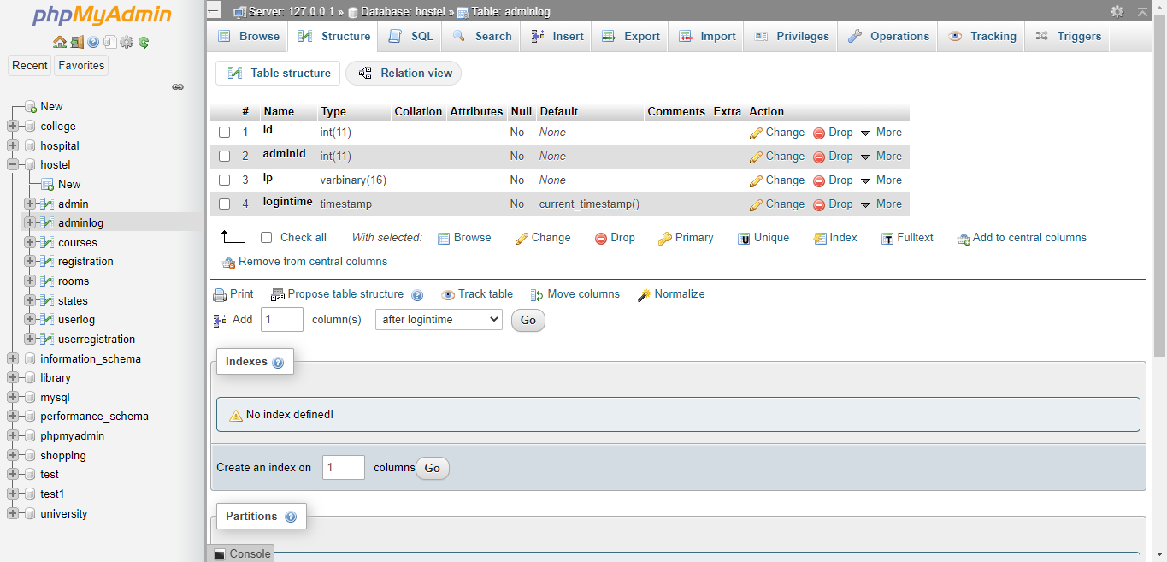

**-- Table structure for table `adminlog`--**

CREATE TABLE `adminlog` (

`id` int(11) NOT NULL,

`adminid` int(11) NOT NULL,

`ip` varbinary(16) NOT NULL,

`logintime` timestamp NOT NULL DEFAULT current_timestamp()

);

**--Insering values into adminlog table----**

INSERT INTO `adminlog` (`id`, `adminid`, `ip`, `logintime) VALUES

(1, '1', ‘234', '20:31:45');

**Courses Table Structure**

Courses table stores the information regarding student courses in which they are studying and will be used at hostel registration time.

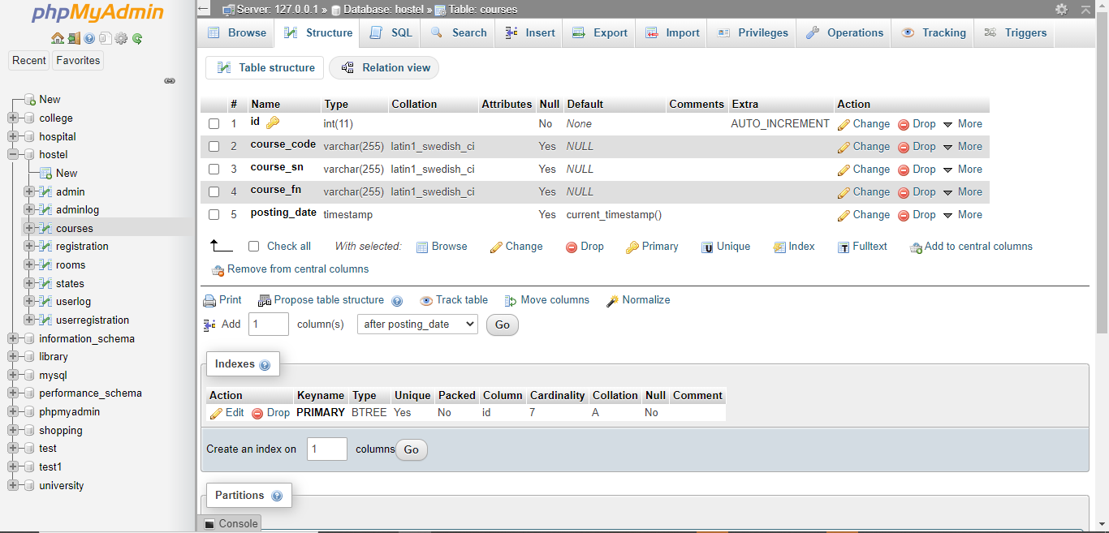

**-- Table structure for table `courses`**

CREATE TABLE `courses` (

`id` int(11) NOT NULL,

`course_code` varchar(255) DEFAULT NULL,

`course_sn` varchar(255) DEFAULT NULL,

`course_fn` varchar(255) DEFAULT NULL,

`posting_date` timestamp NULL DEFAULT current_timestamp()

) ;

**-- Inserting values into table `courses`**

INSERT INTO `courses` (`id`, `course_code`, `course_sn`, `course_fn`, `posting_date`) VALUES

(1, 'B10992', 'B.Tech', 'Bachelor of Technology', '2020-12-12 19:31:42'),

(2, 'BCOM1453', 'B.Com', 'Bachelor Of commerce ', '2020-12-12 19:31:42'),

(3, 'BSC12', 'BSC', 'Bachelor of Science', '2020-12-12 19:31:42'),

(4, 'BC36356', 'BCA', 'Bachelor Of Computer Application', '2020-12-12 19:31:42'),

(5, 'MCA565', 'MCA', 'Master of Computer Application', '2020-12-12 19:31:42'),

(6, 'MBA75', 'MBA', 'Master of Business Administration', '2020-12-12 19:31:42'),

(7, 'BE765', 'BE', 'Bachelor of Engineering', '2020-12-12 19:31:42');

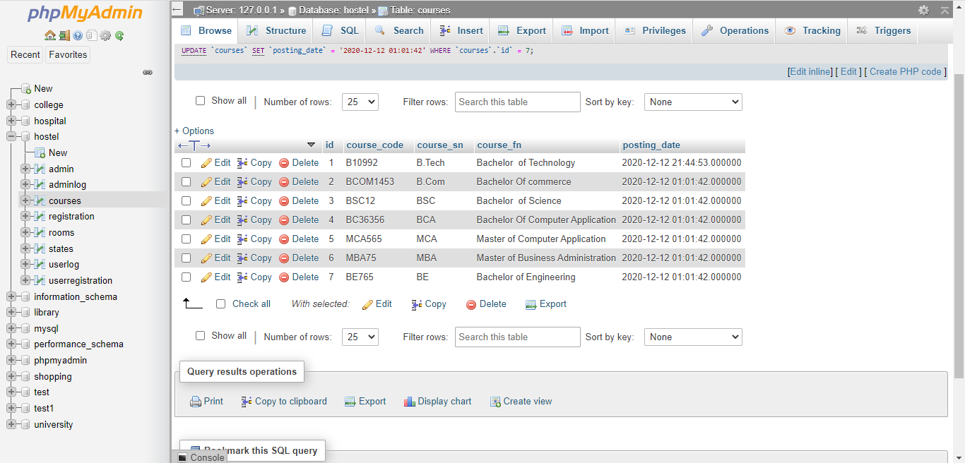

**Registeration Table Structure**

Registeration table stores the information regarding student courses,regno,all personal information along with room details and guardian details

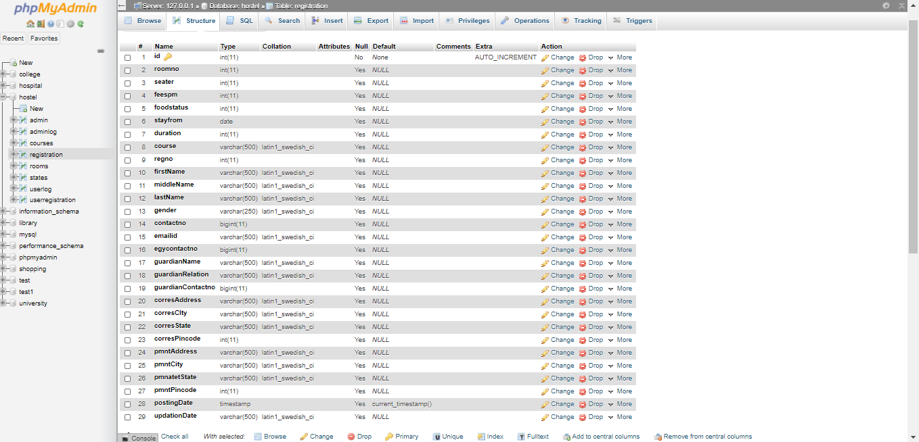

**-- Table structure for table `registration`**

CREATE TABLE `registration` (

`id` int(11) NOT NULL,

`roomno` int(11) DEFAULT NULL,

`seater` int(11) DEFAULT NULL,

`feespm` int(11) DEFAULT NULL,

`foodstatus` int(11) DEFAULT NULL,

`stayfrom` date DEFAULT NULL,

`duration` int(11) DEFAULT NULL,

`course` varchar(500) DEFAULT NULL,

`regno` int(11) DEFAULT NULL,

`firstName` varchar(500) DEFAULT NULL,

`middleName` varchar(500) DEFAULT NULL,

`lastName` varchar(500) DEFAULT NULL,

`gender` varchar(250) DEFAULT NULL,

`contactno` bigint(11) DEFAULT NULL,

`emailid` varchar(500) DEFAULT NULL,

`egycontactno` bigint(11) DEFAULT NULL,

`guardianName` varchar(500) DEFAULT NULL,

`guardianRelation` varchar(500) DEFAULT NULL,

`guardianContactno` bigint(11) DEFAULT NULL,

`corresAddress` varchar(500) DEFAULT NULL,

`corresCIty` varchar(500) DEFAULT NULL,

`corresState` varchar(500) DEFAULT NULL,

`corresPincode` int(11) DEFAULT NULL,

`pmntAddress` varchar(500) DEFAULT NULL,

`pmntCity` varchar(500) DEFAULT NULL,

`pmnatetState` varchar(500) DEFAULT NULL,

`pmntPincode` int(11) DEFAULT NULL,

`postingDate` timestamp NULL DEFAULT current_timestamp(),

`updationDate` varchar(500) DEFAULT NULL

) ENGINE=InnoDB DEFAULT CHARSET=latin1;

**-- Inserting values into table `registration`**

INSERT INTO `registration` (`id`, `roomno`, `seater`, `feespm`, `foodstatus`, `stayfrom`, `duration`, `course`, `regno`, `firstName`, `middleName`, `lastName`, `gender`, `contactno`, `emailid`, `egycontactno`, `guardianName`, `guardianRelation`, `guardianContactno`, `corresAddress`, `corresCIty`, `corresState`, `corresPincode`, `pmntAddress`, `pmntCity`, `pmnatetState`, `pmntPincode`, `postingDate`, `updationDate`) VALUES

(3, 100, 5, 8000, 0, '2020-12-06', 3, 'Bachelor of Technology', 12154, 'sravanthi', 'thukivakam', 'reddy', 'female', 367262, 'srav@gmail.com', 45644, 'abc', 'uncle', 5644, 'vizag', 'vizag', 'Andhra pradesh',517501, 'tirupati', 'chittor', 'Andhra pradesh', 517501, '2020-12-05 14:58:26', NULL);

**Rooms Table Structure**

Rooms table store information regarding the booked rooms by student and the fee it costs for the stay.

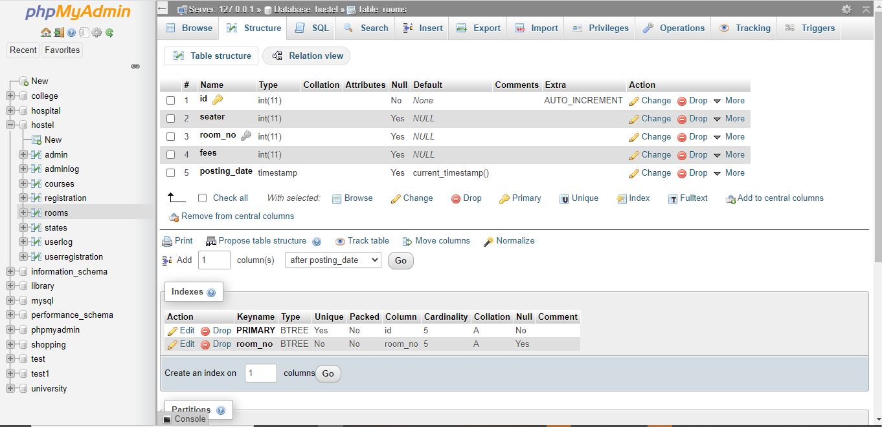

**-- Table structure for table `rooms`**

CREATE TABLE `rooms` (

`id` int(11) NOT NULL,

`seater` int(11) DEFAULT NULL,

`room_no` int(11) DEFAULT NULL,

`fees` int(11) DEFAULT NULL,

`posting_date` timestamp NULL DEFAULT current_timestamp()

);

**-- Inserting values into table `rooms`**

INSERT INTO `rooms` (`id`, `seater`, `room_no`, `fees`, `posting_date`) VALUES

(1, 5, 100, 8000, '2020-04-11 22:45:43'),

(2, 2, 201, 6000, '2020-04-12 01:30:47'),

(3, 2, 200, 6000, '2020-04-12 01:30:58'),

(4, 3, 112, 4000, '2020-04-12 01:31:07'),

(5, 5, 132, 2000, '2020-04-12 01:31:15');

**States Table Structure**

Stable store information regarding the states in which the student belongs to.

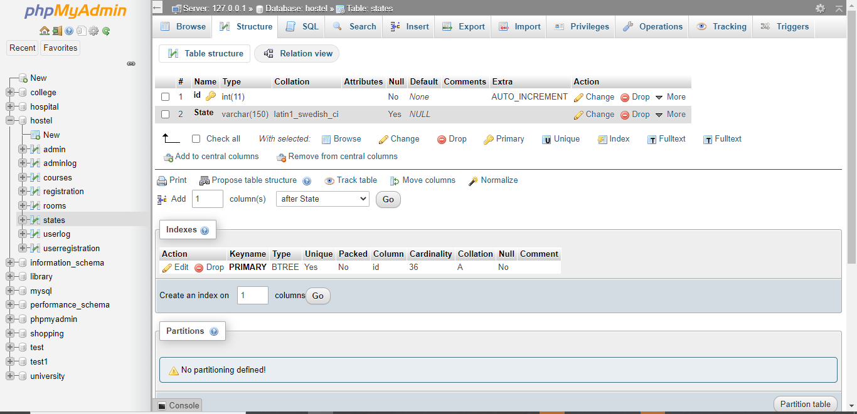

**-- Table structure for table `states`**

CREATE TABLE `states` (

`id` int(11) NOT NULL,

`State` varchar(150) DEFAULT NULL

);

**-- Inserting values into table `states`**

INSERT INTO `states` (`id`, `State`) VALUES

(1, 'Andaman and Nicobar Island (UT)'),

(2, 'Andhra Pradesh'),

(3, 'Arunachal Pradesh'),

(4, 'Assam'),

(5, 'Bihar'),

(6, 'Chandigarh (UT)'),

(7, 'Chhattisgarh'),

(8, 'Dadra and Nagar Haveli (UT)'),

(9, 'Daman and Diu (UT)'),

(10, 'Delhi (NCT)'),

(11, 'Goa'),

(12, 'Gujarat'),

(13, 'Haryana'),

(14, 'Himachal Pradesh'),

(15, 'Jammu and Kashmir'),

(16, 'Jharkhand'),

(17, 'Karnataka'),

(18, 'Kerala'),

(19, 'Lakshadweep (UT)'),

(20, 'Madhya Pradesh'),

(21, 'Maharashtra'),

(22, 'Manipur'),

(23, 'Meghalaya'),

(24, 'Mizoram'),

(25, 'Nagaland'),

(26, 'Odisha'),

(27, 'Puducherry (UT)'),

(28, 'Punjab'),

(29, 'Rajastha'),

(30, 'Sikkim'),

(31, 'Tamil Nadu'),

(32, 'Telangana'),

(33, 'Tripura'),

(34, 'Uttarakhand'),

(35, 'Uttar Pradesh'),

(36, 'West Bengal');

**Userlog Table Structure**

Userlog store information regarding the user login details.

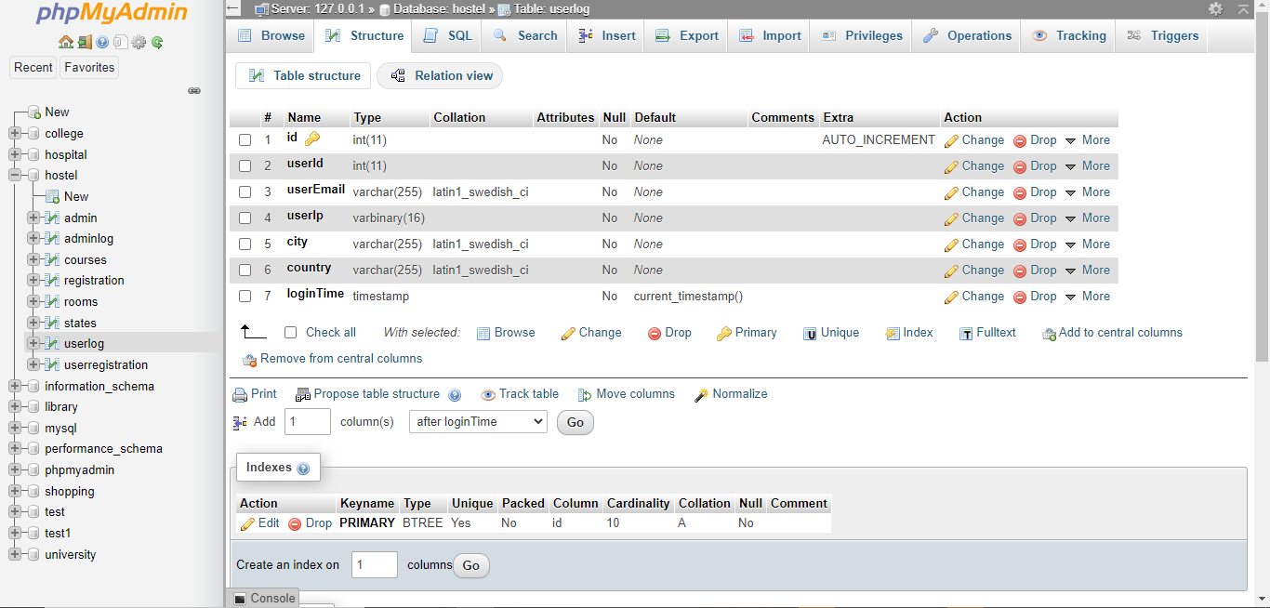

**-- Table structure for table `userlog`**

CREATE TABLE `userlog` (

`id` int(11) NOT NULL,

`userId` int(11) NOT NULL,

`userEmail` varchar(255) NOT NULL,

`userIp` varbinary(16) NOT NULL,

`city` varchar(255) NOT NULL,

`country` varchar(255) NOT NULL,

`loginTime` timestamp NOT NULL DEFAULT current_timestamp()

);

**-- Inserting values into table `userlog`**

INSERT INTO `userlog` (`id`, `userId`, `userEmail`, `userIp`, `city`, `country`, `loginTime`) VALUES

(6, 3, '10806121', 0x3a3a31, '', '', '2020-07-20 14:56:45');

**Userregistration Table Structure**

Userregistration table stores information regarding student register details and are used when vaidating the user login credentials.

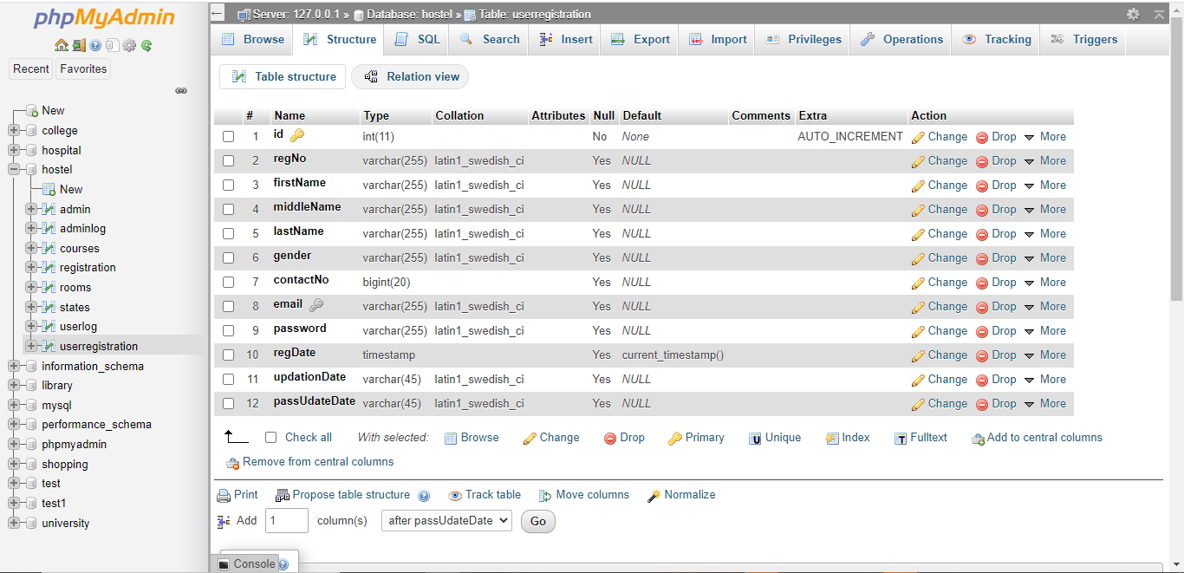

**-- Table structure for table `userregistration`**

CREATE TABLE `userregistration` (

`id` int(11) NOT NULL,

`regNo` varchar(255) DEFAULT NULL,

`firstName` varchar(255) DEFAULT NULL,

`middleName` varchar(255) DEFAULT NULL,

`lastName` varchar(255) DEFAULT NULL,

`gender` varchar(255) DEFAULT NULL,

`contactNo` bigint(20) DEFAULT NULL,

`email` varchar(255) DEFAULT NULL,

`password` varchar(255) DEFAULT NULL,

`regDate` timestamp NULL DEFAULT current_timestamp(),

`updationDate` varchar(45) DEFAULT NULL,

`passUdateDate` varchar(45) DEFAULT NULL

);

**-- Inserting values into table `userregistration`**

INSERT INTO `userregistration` (`id`, `regNo`, `firstName`, `middleName`, `lastName`, `gender`, `contactNo`, `email`, `password`, `regDate`, `updationDate`, `passUdateDate`) VALUES

(3, '10806121', 'Anuj', '', 'kumar', 'male', 1234567890, 'test@gmail.com', 'Test@123', '2020-07-20 14:56:18', NULL, NULL);

**SQL QUERIES**

**1)To view the students who have name starting with h in userregistration table we run the sql query.**

[**SELECT**](http://localhost/phpmyadmin/url.php?url=https://dev.mysql.com/doc/refman/5.5/en/select.html)**\* FROM `userregistration` WHERE firstname**[**like**](http://localhost/phpmyadmin/url.php?url=https://dev.mysql.com/doc/refman/5.5/en/string-comparison-functions.html#operator_like)**"h%"**;

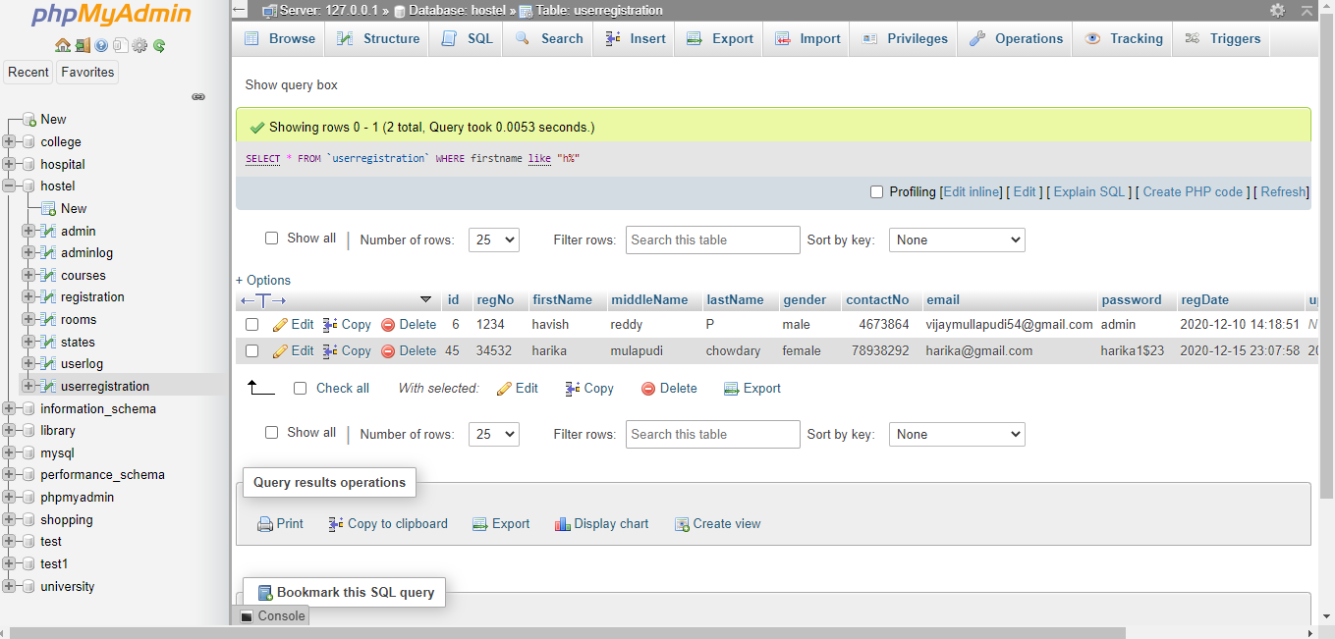

**2)To view the students who have highest room rent and lowest rent in room table we run the sql query.**

[**SELECT**](http://localhost/phpmyadmin/url.php?url=https://dev.mysql.com/doc/refman/5.5/en/select.html)[**MIN**](http://localhost/phpmyadmin/url.php?url=https://dev.mysql.com/doc/refman/5.5/en/group-by-functions.html#function_min)**(`fees`),**[**MAX**](http://localhost/phpmyadmin/url.php?url=https://dev.mysql.com/doc/refman/5.5/en/group-by-functions.html#function_max)**(`fees`) FROM `rooms` WHERE 1**

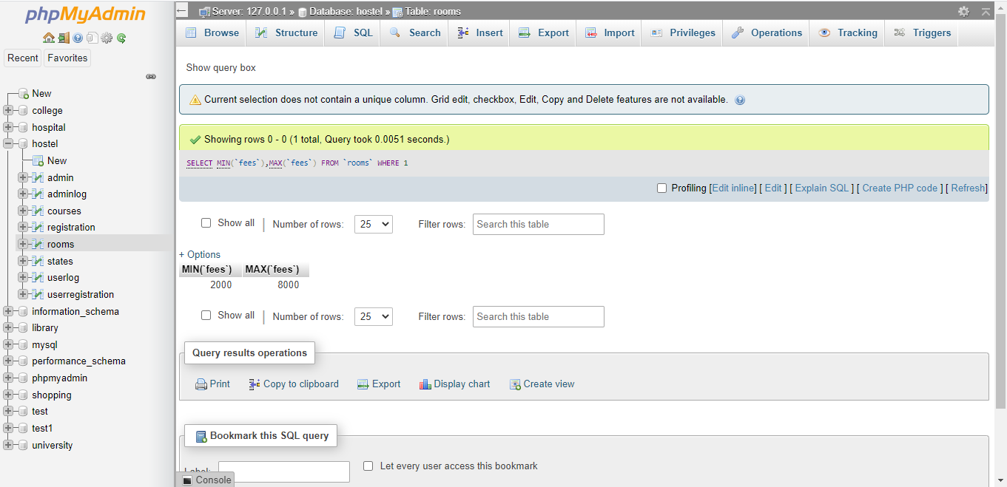

**3)To view the students who have user account and registered as well in hostel we run the sql query.**

[**SELECT**](http://localhost/phpmyadmin/url.php?url=https://dev.mysql.com/doc/refman/5.5/en/select.html)**registration.id,userregistration.firstName FROM `registration` INNER JOIN userregistration ON registration.id=userregistration.id**

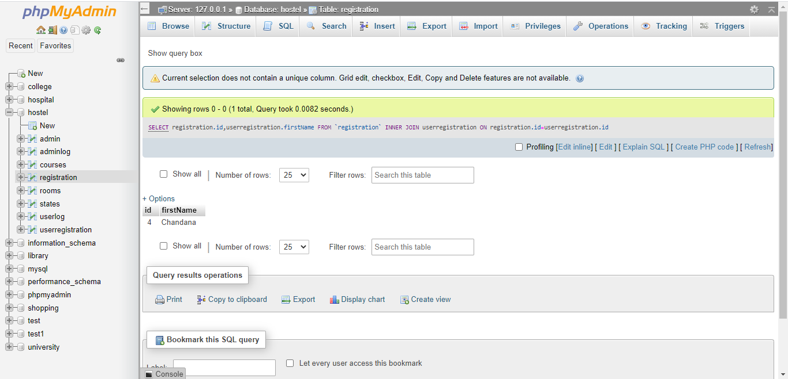

**4)For the admin to update the fees of a particular room we run the sql query**

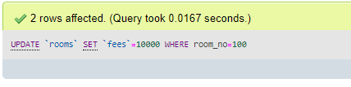

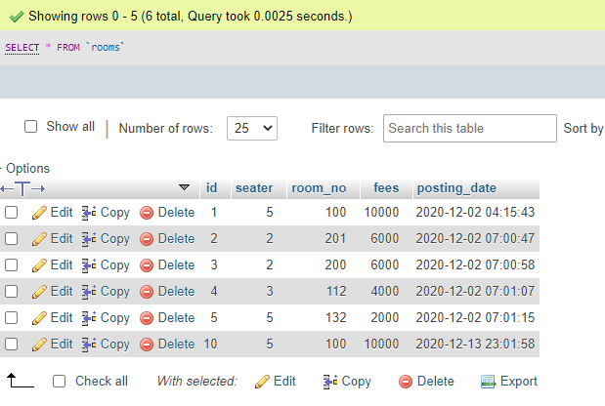

**5)To view the students who have exists in the states of India we run the sql query.**

[**SELECT**](http://localhost/phpmyadmin/url.php?url=https://dev.mysql.com/doc/refman/5.5/en/select.html)**id,roomno,firstName,corresState FROM `registration` WHERE EXISTS(**[**SELECT**](http://localhost/phpmyadmin/url.php?url=https://dev.mysql.com/doc/refman/5.5/en/select.html)**state FROM states WHERE registration.corresState=states.State)**

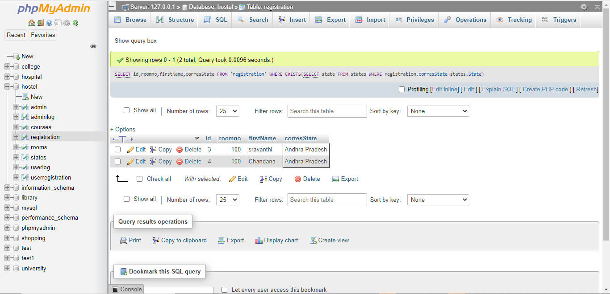

**6)To view the students who study BBAwe run the sql query.**

[**SELECT**](http://localhost/phpmyadmin/url.php?url=https://dev.mysql.com/doc/refman/5.5/en/select.html)**id,roomno,firstName,course FROM `registration` WHERE course='BBA'**[**AND**](http://localhost/phpmyadmin/url.php?url=https://dev.mysql.com/doc/refman/5.5/en/logical-operators.html#operator_and)**corresCIty='vizag'**

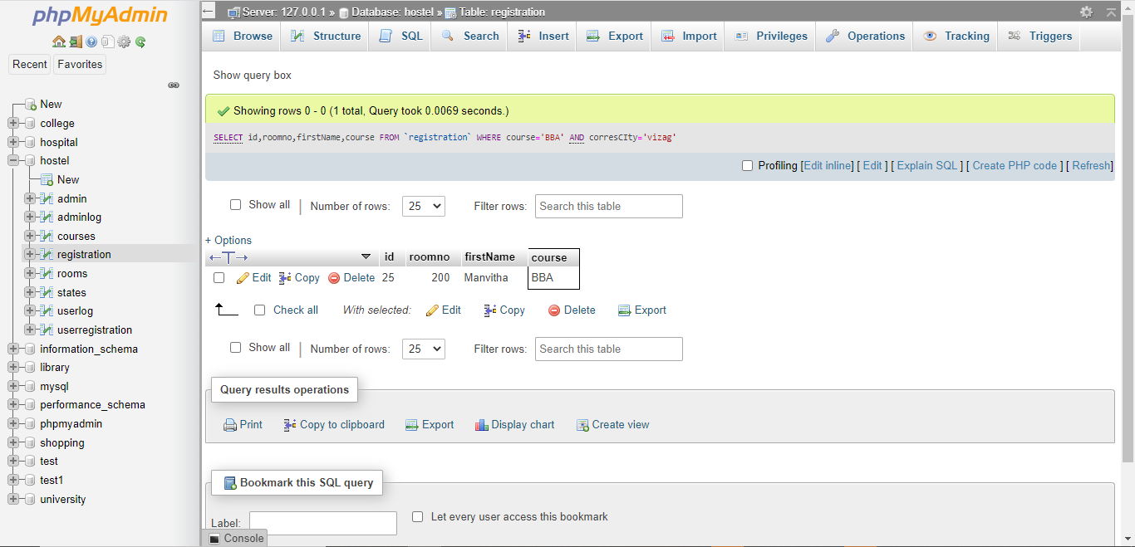

**7)To view the students by ascending name order we run the sql query.**

[**SELECT**](http://localhost/phpmyadmin/url.php?url=https://dev.mysql.com/doc/refman/5.5/en/select.html)**\* FROM `userregistration` ORDER BY firstName ASC**

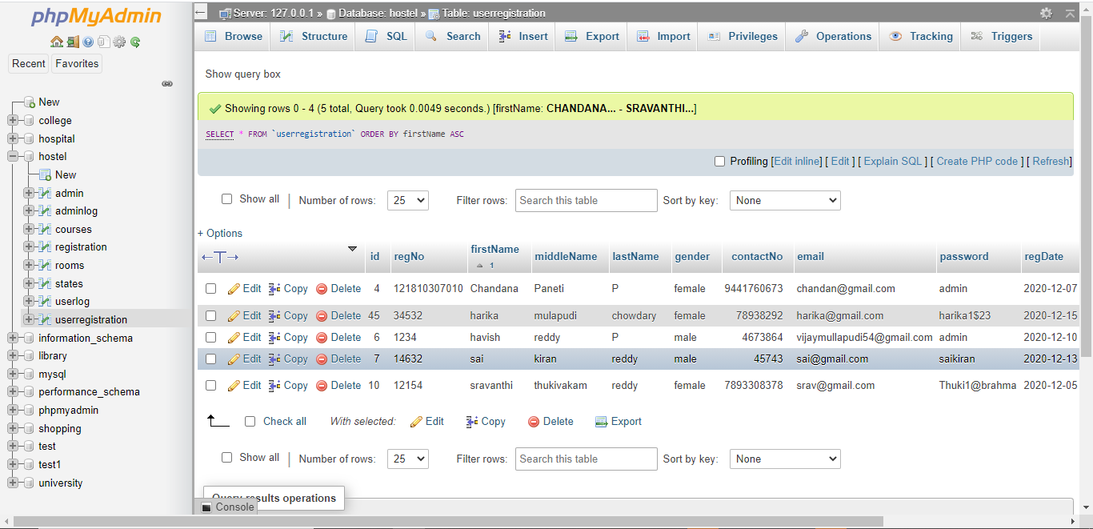

**8)To count the students who are having roomrent more than 5000 we run the sql query.**

[**SELECT**](http://localhost/phpmyadmin/url.php?url=https://dev.mysql.com/doc/refman/5.5/en/select.html)[**COUNT**](http://localhost/phpmyadmin/url.php?url=https://dev.mysql.com/doc/refman/5.5/en/group-by-functions.html#function_count)**(id) FROM `registration` WHERE feespm>5000**

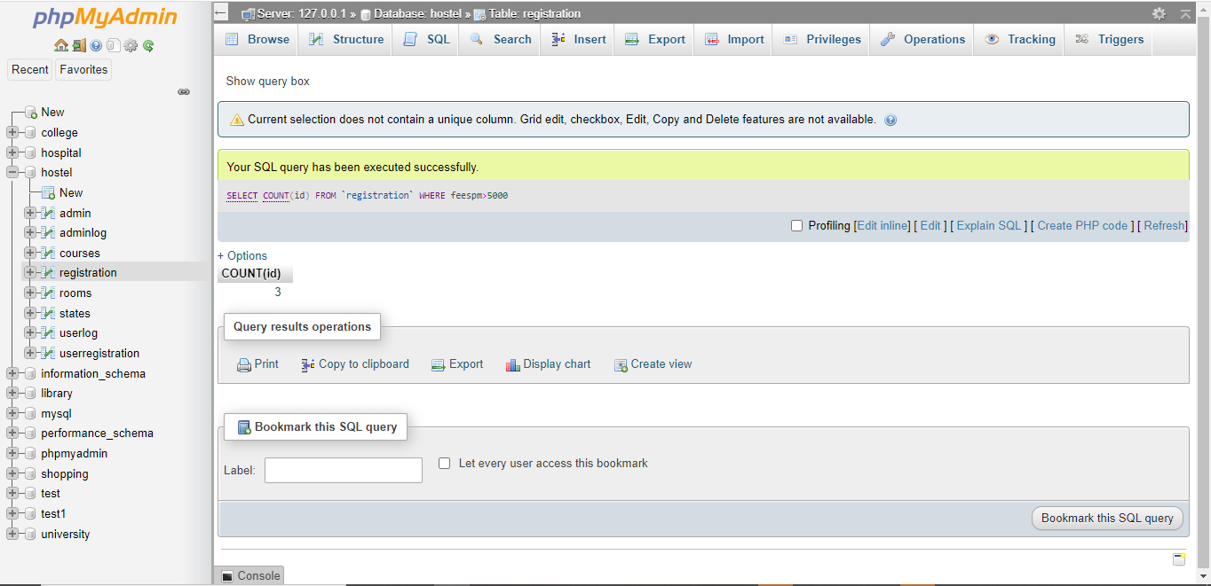

**9)To create a view of students whose lastname is reddy we run the sql query.**

**CREATING A VIEW**

**CREATE VIEW lname AS SELECT id,firstname,lastname FROM ‘userregistration’ WHERE lastname=’reddy’**

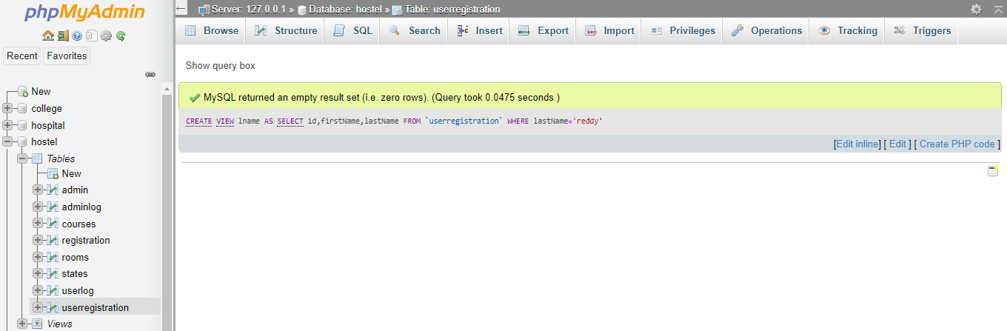

**VIEWING THE VIEW LNAME**

[**SELECT**](http://localhost/phpmyadmin/url.php?url=https://dev.mysql.com/doc/refman/5.5/en/select.html)**\* FROM `lname`**

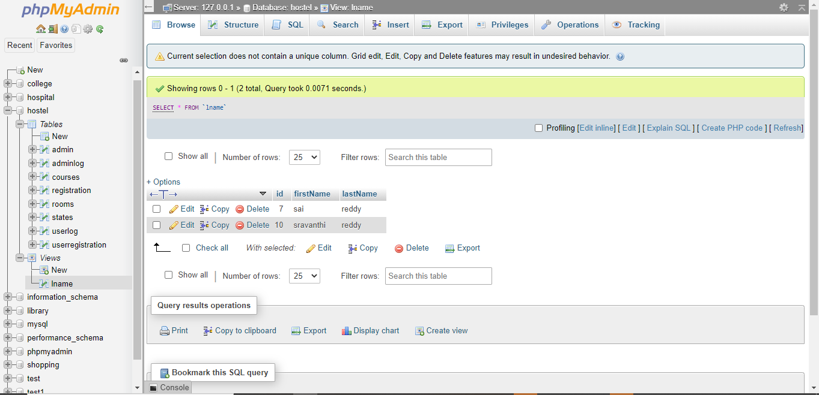

**10)To drop a view we run the sql query.**

**DROP VIEW lname**

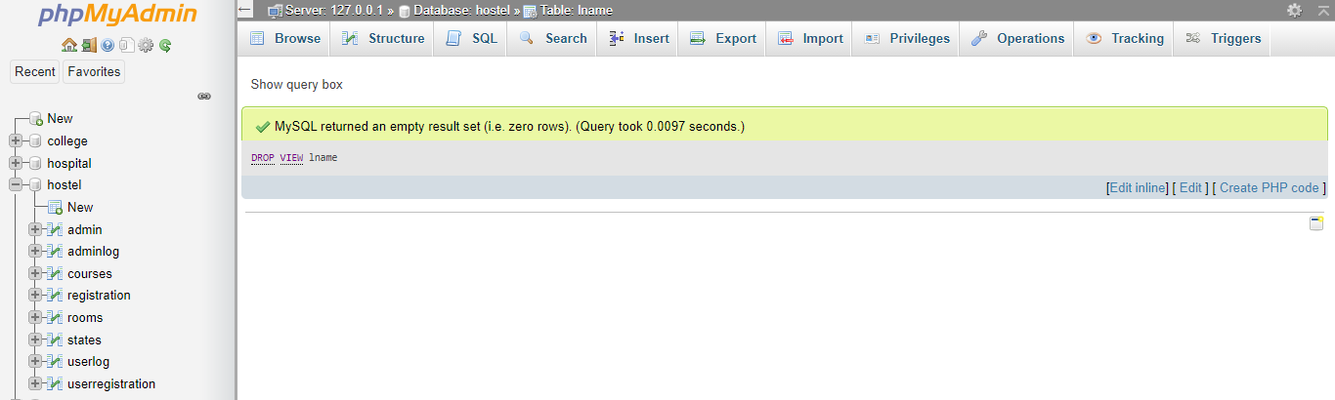

**CONCLUSION**

To conclude the description about the project : The project, developed using PHP and MySQL is based on the requirement specification of the user and the analysis of the existing system, with flexibility for future enhancement.

The expanded functionality of today’s software requires an appropriate approach towards software development. This hostel management software is designed for people who want to manage various activi- ties in the hostel. For the past few years the number of educational institutions are increasing rapidly.

Thereby the number of hostels are also increasing for the accommodation of the students studying in this institution. And hence there is a lot of strain on the person who are running the hostel and software’s are not usually used in this context. This particular project deals with the problems on managing a hostel and avoids the problems which occur when carried manually.

Identification of the drawbacks of the existing system leads to the designing of computerized system that will be compatible to the existing system with the system which is more user friendly and more GUI oriented.

**BIBILIOGRAPHY**

1. [www.w3schools.com](http://www.w3schools.com/)
2. *in.****php****.net*
3. *en.wikipedia.org/wiki/****PHP***

4 . [www.hotscripts.com/category/**php**/](http://www.hotscripts.com/category/php/)

1. [www.**apache**.org/](http://www.apache.org/)
2. [www.**mysql**.com/click.php?e=35050](http://www.mysql.com/click.php?e=35050)