CO-2_Assessment Tool-3

Debugging and Optimization
CSA0712-Computer Networks
Name: C. Sravanthi
Reg No.:192525463

ANSWERS:Part-1
1Q.
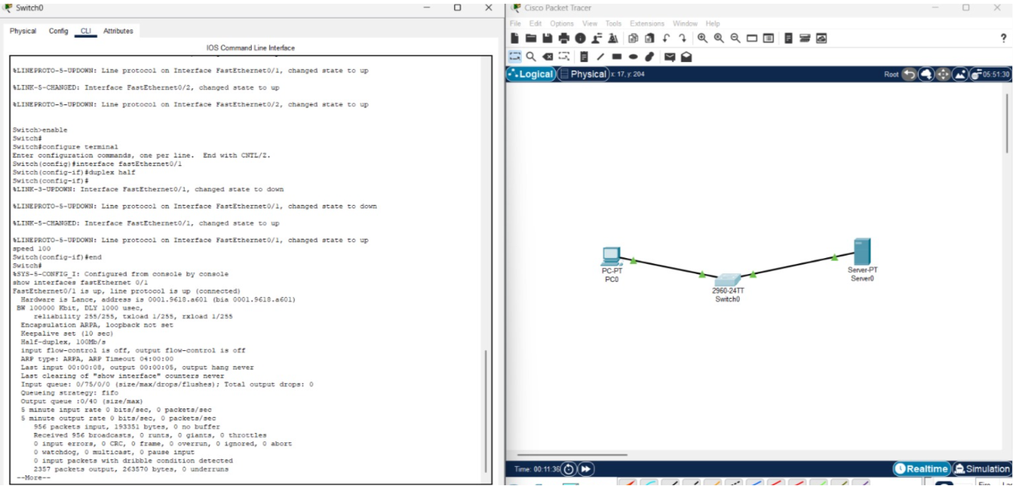

2Q.
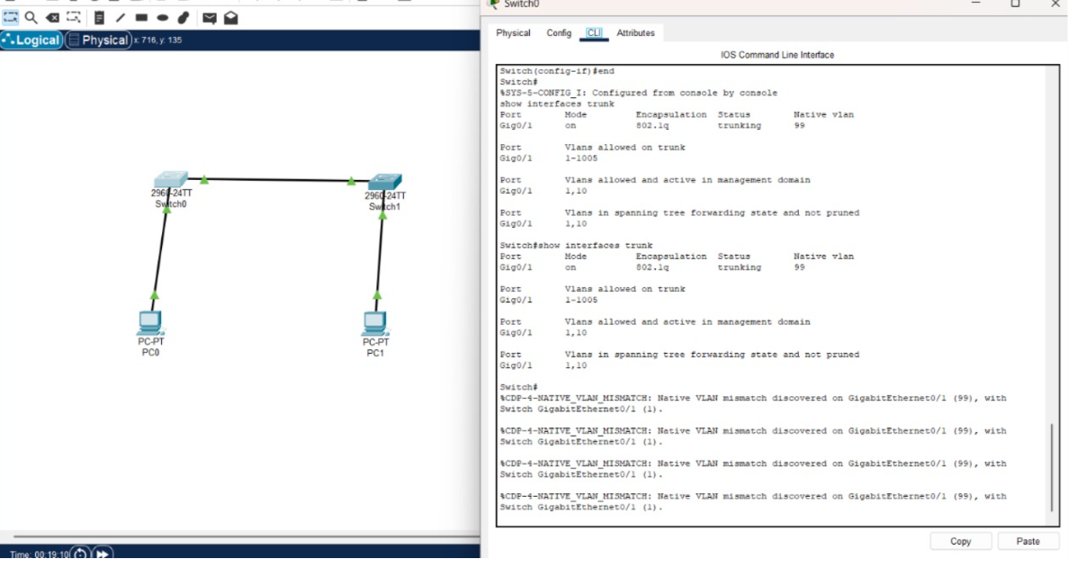
3Q.
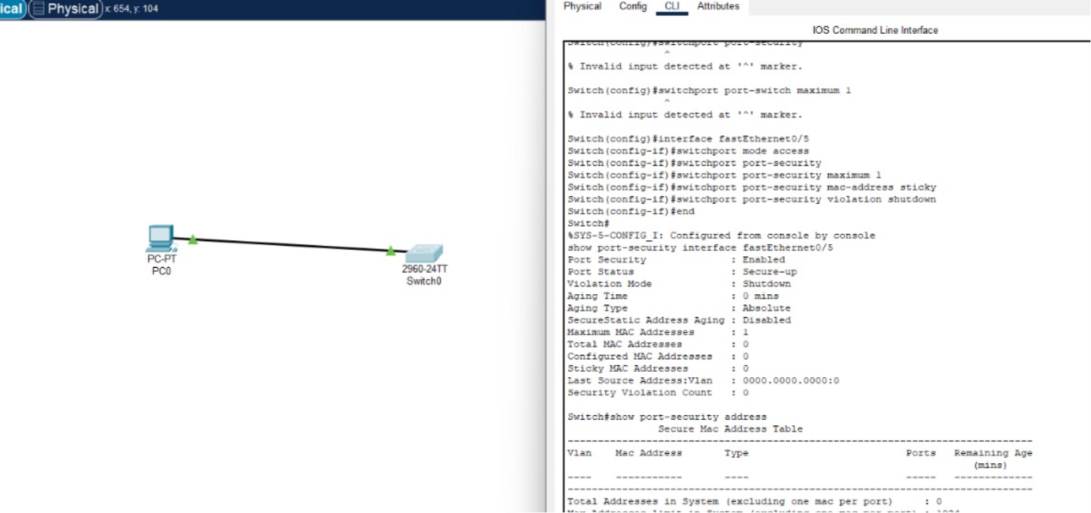

Part-2
6Q.
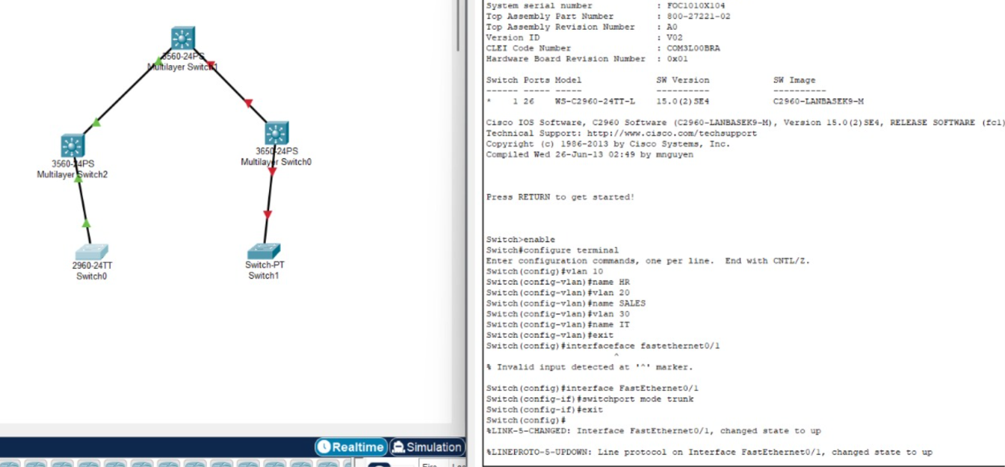 7Q.
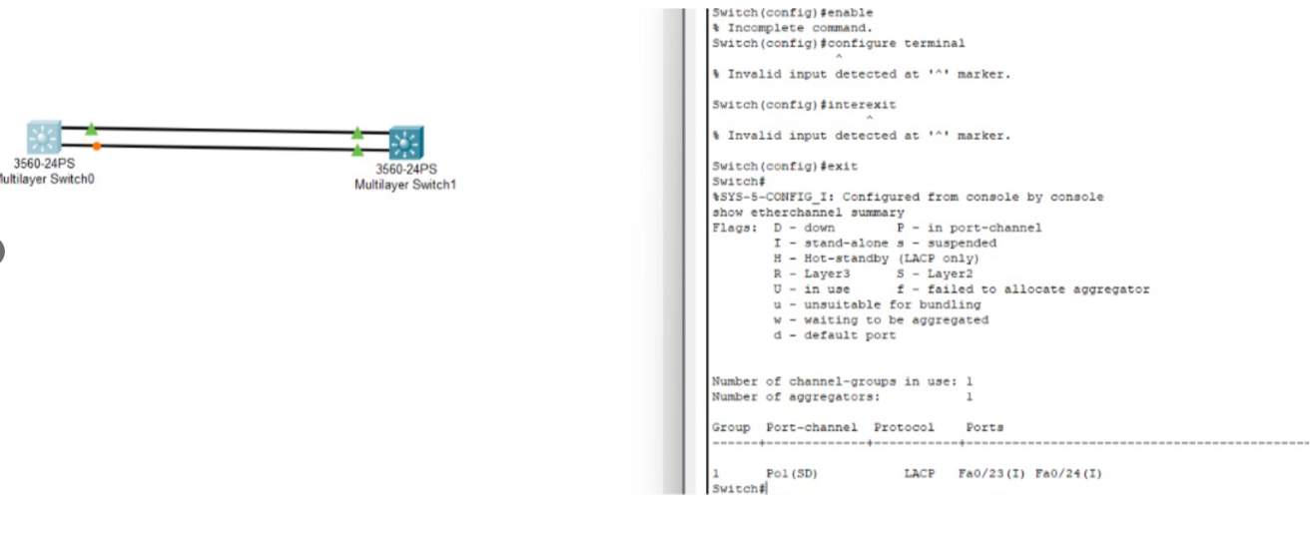
8Q.
