Integrating MuleESB with the Magento Online Store

Mule ESB can be integrated on cloud based applications like Sales force CRM, Mobile Applications etc. But there are many other applications which are very interesting. So we thought why don’t we use Magento with Mule to create my own online store? Here we go..! We have a connector ready. All we need to do is play with it the way we need.

With the Magento connector, we can access all the basic functionality and features to create a successful online store including a shopping cart, product catalog, Inventory Updated, options for payment, shipping methods and many more.

**How do we use it?**

All we need is a Magento Connector and the standard components of Mule. 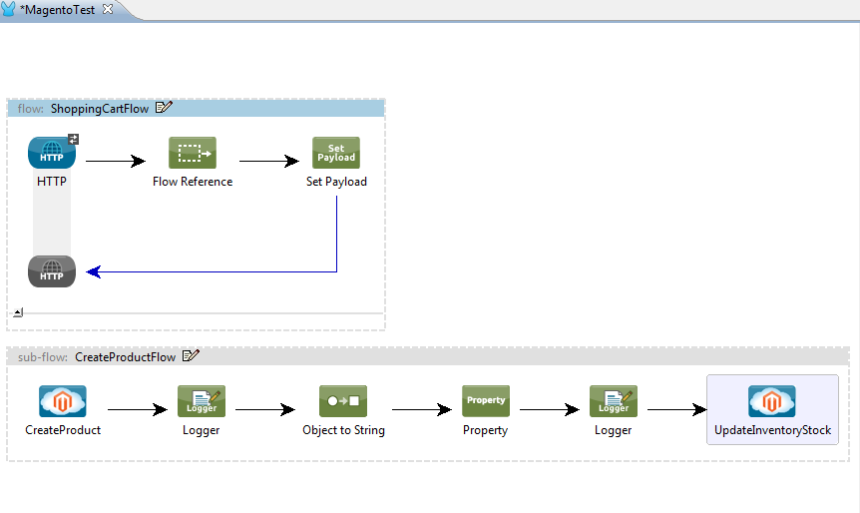  
**Fig: 1.1 Demonstration of using Magento connector to create a product and update its Inventory.**

Use a Magento Cloud Connector to create a product in Magento. Here we need to make sure we have to give a **unique SKU Id** while creating a product. This will create a product in Magento and return a reference **ID** as an Object for that product.

Convert this reference ID Object to a string and set it as a property in Mule message.

To update the inventory in a product, we need a unique ID for that product. Hence we can make use of the ID which was set in the property.

When the HTTP is triggered, the flow will be invoked and the product will be created with a unique id which will then be used for updating the inventory of that product.

Hence when the update Inventory Stock method is called, the details of the inventory would be updated for that product.

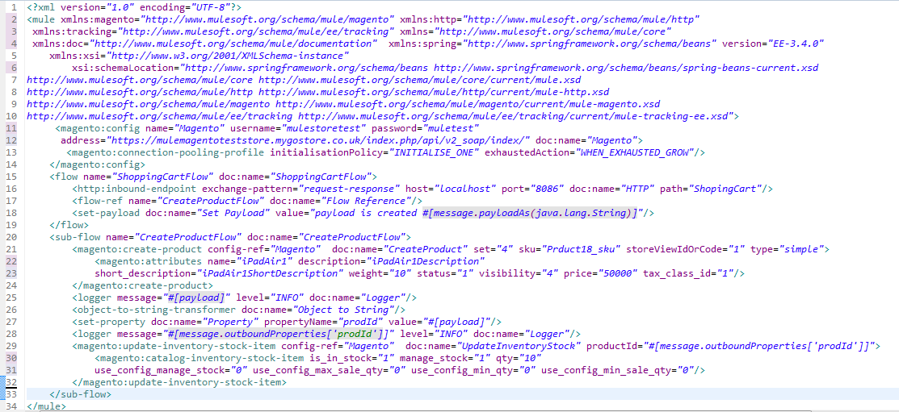  
**Fig: 1.2 Code Snippet**

With the Integration of Magento through Mule ESB the response time is less than a moment which is amazing.

**References:**

[**https://mulesoftpartners.bloomfire.com/posts/772636-magento-connector-tutorial**](https://mulesoftpartners.bloomfire.com/posts/772636-magento-connector-tutorial)

[**http://blogs.mulesoft.org/announcing-magento-e-commerce-connector-for-mule/**](http://blogs.mulesoft.org/announcing-magento-e-commerce-connector-for-mule/)

[**http://www.mulesoft.org/connectors/magento-cloud-connector**](http://www.mulesoft.org/connectors/magento-cloud-connector)

[**http://mulesoft.github.io/magento-connector/guide/install.html**](http://mulesoft.github.io/magento-connector/guide/install.html)

[**http://www.mulesoft.com/cloud-connectors/magento-integration-connector**](http://www.mulesoft.com/cloud-connectors/magento-integration-connector)

[**http://forum.mulesoft.org/mulesoft/topics/where_to_find_magento_soap_url**](http://forum.mulesoft.org/mulesoft/topics/where_to_find_magento_soap_url)

[**http://forum.mulesoft.org/mulesoft/topics/magento_connector_in_mule_3_5_demo**](http://forum.mulesoft.org/mulesoft/topics/magento_connector_in_mule_3_5_demo)