Lab Assignment – 2

***Android Application to get the details of country using RestCountry API***

* The application consists of two activities namely Login and HomeScreen.
* The user have to enter the username and password to login to the application.
* Hardcoded details are:

Username: Admin

Password: Admin

* The home page consists of fields like TextField to enter partial name of any country and a button to start interacting with the server
* Text length must be 3 characters and should be given. Ex: ind-India, usa-United States of America.
* Details of the country like Country, it's capital, region where it is located and population are populated on the screen.

***Screenshots***

* Login Screen – After opening the app

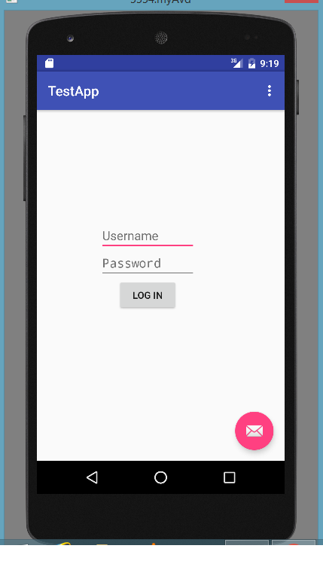

* Login Screen – Wrong details

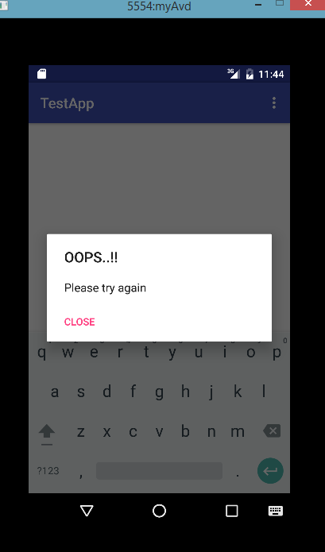

* Home Screen -before giving input

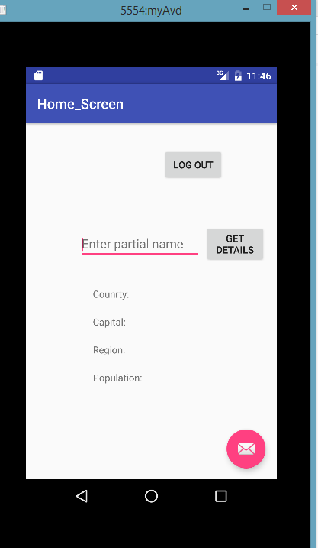

* Home Screen – After giving input & Get Details button is clicked.

