

**Name:  
Link:** https://www.kaggle.com/datasets/willianoliveiragibin/fatalities-in-the-israeli-palestinian/data

**Introduction:**

The Israeli-Palestinian conflict has been a deeply entrenched issue, with far-reaching consequences for the lives of individuals caught in the crossfire. This paper presents an analysis of fatalities that occurred during this conflict from 2000 to 2023. I have created visualizations that provide insights into the geographical distribution, gender disparity, and causes of fatalities in this war.

1. **Fatalities Over the Years by Region: A line plot**

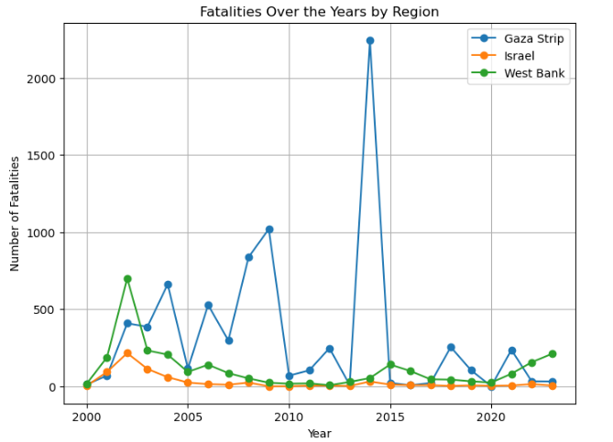

This line plot provides an overview of the distribution of fatalities over the years by region. Notably, the Gaza Strip has the highest number of fatalities across the investigated period, often peaking in specific years. Israel comes in second, with the second-highest number of fatalities, showing the complexities of the region's war. Despite being severely affected, the West Bank had fewer fatalities than the Gaza Strip and Israel.

1. **Fatalities by Gender: A bar chart**

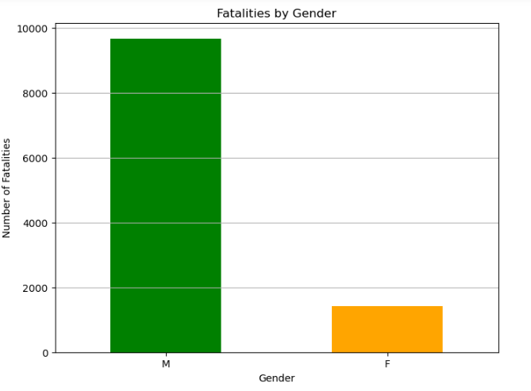

The second visualization, presented as a bar chart, portrays the distribution of fatalities by gender. This observation highlights the conflict's enormous gender inequality, with males being the bulk of fatalities, stressing a large gap as compared to females.

1. **Distribution of Deaths by Ammunition Type: A pie chart**

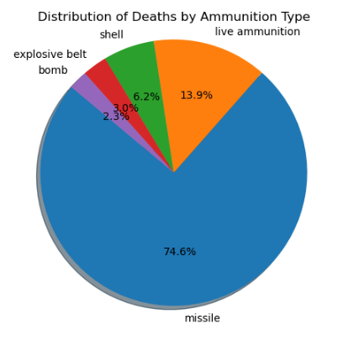

This pie chart shows the distribution of fatalities based on the type of ammunition used, and it is clear that missiles are the leading cause of fatalities, accounting for the largest proportion. Live ammunition is the second most common cause of fatalities, with shells accounting for the third-largest proportion.

**Conclusion:**

The Israeli-Palestinian conflict is firmly entrenched and has resulted in huge casualties. The above visuals provide vital insights into the developing dynamics of this war. More research and analysis are needed to understand the components that contribute to these trends. This report recommends for greater efforts in the region to promote peace, discussion, and diplomacy, as well as to address gender disparities and the deployment of strong weapons in densely populated areas.