VISVESVARAYA TECHNOLOGICAL UNIVERSITY

"Jnana Sangama", Belagavi-590 018
Report on

“AI Mini Project Routiq”

Bachelor of Engineering
in

Artificial Intelligence and Machine Learning
Submitted by

JUDE ANDREW PRENIN 1AY24AI049

ASHISH THAZHAKKANDY 1AY24AI013

KATIKAM SRAVAN KUMAR REDDY 1AY24AI054

ABHISHEK V KRISHNA 1AY24AI002
Under the Guidance of Mr. Sanjay P Assistant Professor Department of Computer
Science and Engineering (Data Science)




Abstract

AI Route Technology is an intelligent route optimization system designed to find the shortest, fastest, and most efficient path between two locations. The system uses Artificial Intelligence and graph-based pathfinding algorithms such as A*, Dijkstra's Algorithm, and heuristic search techniques to analyze road networks and generate optimal routes.

The application considers multiple factors including distance, travel time, traffic congestion, road conditions, and route safety to provide accurate navigation recommendations. By continuously analyzing route data, the system can dynamically adjust paths when obstacles, traffic jams, or road closures occur.

The project demonstrates how AI can improve transportation efficiency, reduce travel time, minimize fuel consumption, and enhance navigation accuracy. It also follows Human-Centered AI (HCAI) principles by providing transparent route explanations, user control, and real-time feedback

Introduction to AI Tool

Which AI Tool is Used

Tool Name: AI Route Technology

Programming Language: Python

Framework: Streamlit

Core Algorithms: A* Search Algorithm, Dijkstra's Algorithm

Libraries Used: NetworkX, NumPy, Pandas, Folium, Streamlit

Platform: Web-based Route Planning System

Purpose of the Tool
- Find the shortest path between source and destination.


- Provide efficient route recommendations. Reduce travel time and fuel consumption.
- Handle dynamic traffic conditions.
- Demonstrate AI-based path optimization techniques.
- Improve navigation accuracy and user experience.



Basic Working of the Tool
- User enters source and destination locations.
- The road network is represented as a graph.
- Nodes represent locations and edges represent roads.
- AI algorithms calculate the optimal route.
- Traffic and road conditions are analyzed.
- The shortest and safest route is displayed.
- The route is visualized on an interactive map.
  - Users can compare alternative routes

HCAI Concepts Used

Transparency

The system displays how the route is selected.

Distance, travel time, and traffic information are shown.

Alternative routes are presented for comparison.

Route calculation steps are visible to users


Explainability

The AI explains why a route was chosen.

Users can view estimated travel time.

Traffic conditions affecting the route are highlighted.

Decision factors are displayed clearly

Human Supervision

Users can modify route preferences.

Source and destination can be changed anytime.

Users can choose shortest, fastest, or safest routes



Reliability & Safety

Road closures and blocked routes are avoided.

Traffic congestion is considered.

Safer routes are prioritized when necessary.

Real-time updates improve navigation reliability

User-Friendly Interface

Interactive map visualization.

Simple source and destination inputs.

Clear route information display.

Easy-to-understand navigation interface.

Feedback System

Estimated arrival time is displayed.

Route performance metrics are shown.

Users can provide route feedback.

Alternative suggestions are generated automatically

Accessibility

Runs in any web browser.

Mobile and desktop compatible.

Easy navigation controls.

Minimal system requirements



Features Implemented

Core AI Features

A* Search Algorithm for shortest path calculation.

Dijkstra's Algorithm for route optimization.

Dynamic route recalculation.

Traffic-aware path selection.

Multiple route generation.

Distance and time estimation.

HCAI / UX Features

Interactive route visualization.

Real-time route explanation panel.

Travel statistics dashboard.

Alternative route comparison.

User preference customization.

Route history tracking

Configuration & Control

Source location selection.

Destination location selection.

Route preference settings.

Traffic consideration toggle.

Fastest/Shortest/Safest route options.

Route refresh controls



Working of the System

  - User enters source and destination locations.
  - The road network is loaded into the system.
  - Locations are converted into graph nodes.
  - AI algorithms analyze possible paths.
  - Distance and travel time are calculated.
  - Traffic and road conditions are evaluated.
  - The optimal route is selected.
  - Alternative routes are generated.
  - Route information is displayed on the map.
  - The system continuously updates route recommendations when conditions change.


User Interaction Design

Interface Layout
- Sidebar for route inputs.

- Interactive map in the main display area.
- Route details panel.
- Statistics and analytics section.

Controls & Buttons
Control | Action
Find Route | Calculates optimal route
Clear Route | Resets route data
Refresh | Updates route information
Source Input | Select starting location
Destination Input | Select ending location
Route Type | Choose shortest, fastest, or safest route



User Experience Improvements
- Instant route calculation.
- Interactive map navigation.
- Real-time traffic visualization.
- Multiple route comparison.
- Easy-to-read route summaries
- ER Diagram
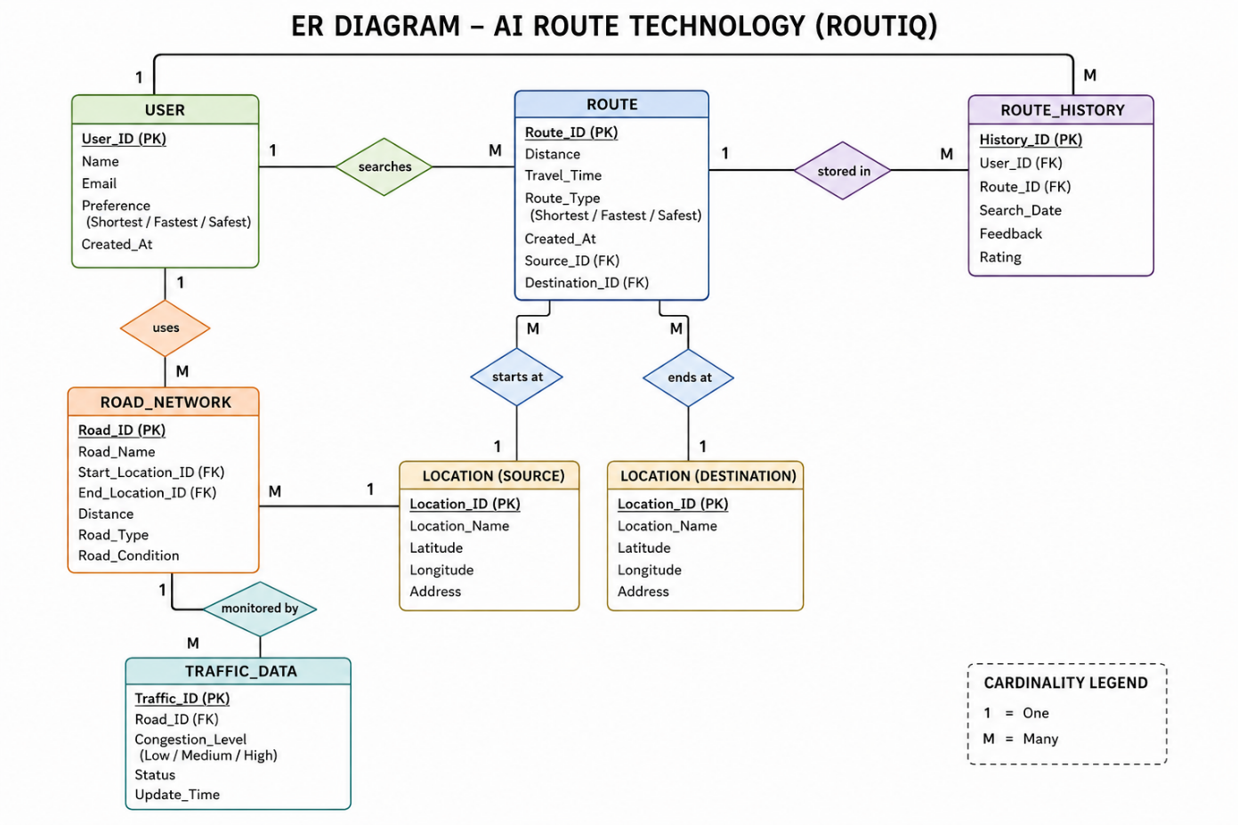

Fig 1 ER diagram of AI route technology


ER Diagram Description – AI Route Technology (Routiq)
The ER Diagram represents the database structure of the AI Route Technology (Routiq) system. It shows how users interact with the route optimization system and how route, location, road, and traffic information are stored and connected.
1. USER Entity
The USER entity stores information about users who search for routes.
- Attributes: User_ID (PK), Name, Email, Preference, Created_At.

- A user can search for multiple routes.

2. ROUTE Entity
The ROUTE entity contains details of the generated route.
- Attributes: Route_ID (PK), Distance, Travel_Time, Route_Type, Source_ID (FK), Destination_ID (FK), Created_At.
- Each route is generated based on the user's selected source and destination.
- Route types include Shortest, Fastest, and Safest routes.
3. LOCATION Entity
The system uses two location entities:
- Location (Source)
- Location (Destination)

Attributes:
- Location_ID (PK)
- Location_Name
- Latitude
- Longitude
- Address

These entities store geographical information about cities or locations involved in route planning.

4. ROAD_NETWORK Entity


The ROAD_NETWORK entity represents roads connecting different locations.
- Attributes: Road_ID (PK), Road_Name, Start_Location_ID, End_Location_ID, Distance, Road_Type, Road_Condition.
- It models the road graph used by A* and Dijkstra's algorithms.
5. TRAFFIC_DATA Entity

The TRAFFIC_DATA entity stores traffic-related information.
- Attributes: Traffic_ID (PK), Road_ID (FK), Congestion_Level, Status,

- ROUTE_HISTORY Entity

The ROUTE_HISTORY entity keeps track of previously searched routes.
- Attributes: History_ID (PK), User_ID (FK), Route_ID (FK), Search_Date, Feedback, Rating.
- This allows route tracking and future analysis.
Relationships
User ↔ Route
Relationship: Searches
- One User can search many Routes.
- One Route belongs to one User.
Cardinality: 1 : M
Route ↔ Route History

Relationship: Stored In
- Each generated route can be stored in route history.
- A user may have multiple route history records.
Cardinality: 1 : M

Route ↔ Location
Relationships:


- Starts At (Source)
- Ends At (Destination)
A route starts from one source location and ends at one destination location.
Road Network ↔ Location
Roads connect different locations.
- One location can be connected to multiple roads.

Road Network ↔ Traffic Data
Relationship: Monitored By
- One road can have multiple traffic updates.
- Traffic information is continuously updated.
Cardinality: 1 : M



Screenshots and Outputs 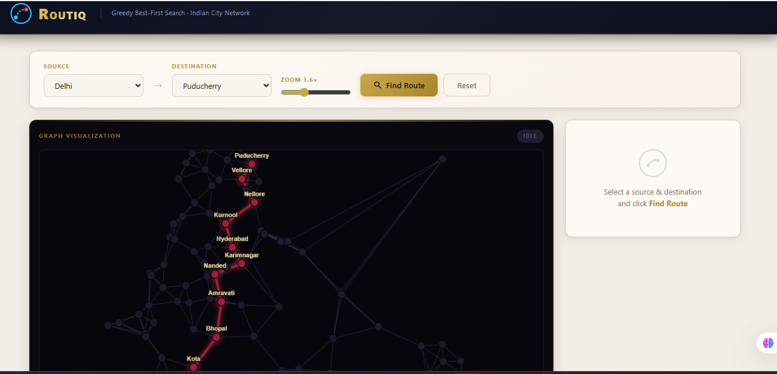

Fig 2 Frontend of application

This is the overall frontend view of our application.

Here you can enter the source and destination city and find the shortest path.

For ex:- A path from Bangalore to Kannur is displayed below(fig 2.1):

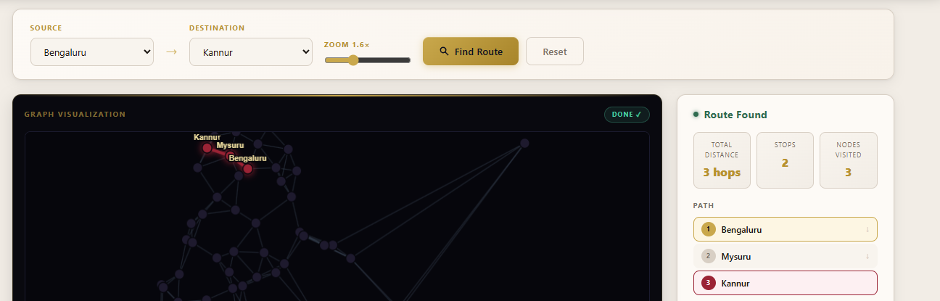

Fig 2.1 Path Finder



Fig 2.1.1


Fig 2.2 Indicators used
These are the indicators used on the map to identify the city node.(fig 2.2)

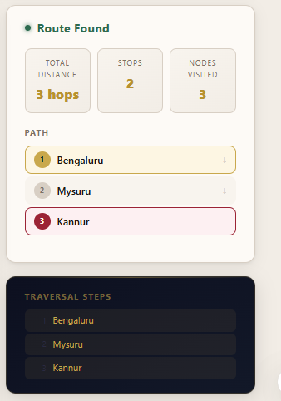
This displays the source and destination city along with the intermediate visited cities covered in between to reach the destination.
Fig 2.3


Fig 2.3 Route Found



Advantages
- Finds shortest and most efficient routes.
- Reduces travel time.
- Saves fuel and transportation costs.
- Supports real-time route optimization.
- Easy-to-use interface.
- Scalable for smart city applications.
- Improves navigation accuracy.
- Supports dynamic traffic analysis.
- Can be integrated with GPS systems.

Demonstrates practical AI applications in transportation



Limitations
  - Depends on the accuracy of map data.
  - Real-time traffic information may not always be available.
  - Performance may decrease with extremely large road networks.
  - Requires internet connectivity for live map services.
  - Unexpected road conditions may affect recommendations.

- Conclusion

The AI Route Technology project successfully demonstrates the use of Artificial Intelligence in intelligent route planning and navigation. By utilizing pathfinding algorithms such as A* and Dijkstra's Algorithm, the system efficiently identifies the shortest and most suitable routes between locations. The integration of traffic analysis, route optimization, and interactive visualization enhances the overall navigation experience. The project highlights the practical application of AI in transportation systems and smart city development while promoting efficient, reliable, and user-friendly route management.



  - GitHub: https://github.com/sravreddy23/Routiq
  - Live App: https://routiq--skreddykatikam.replit.app

References

Research Papers
  - Hart, P. E., Nilsson, N. J., & Raphael, B. (1968). A formal basis for the heuristic determination of minimum cost paths. IEEE Transactions on Systems Science and Cybernetics, 4(2), 100–107
  - Amershi, S., et al. (2019). Software engineering for machine learning: A case study. ICSE-SEIP, Microsoft Research
  - Shneiderman, B. (2020). Human-Centered Artificial Intelligence: Reliable, Safe & Trustworthy. International Journal of Human–Computer Interaction, 36(6), 495–504

Documentation
  - Streamlit Documentation — https://docs.streamlit.io
  - Python heapq module — https://docs.python.org/3/library/heapq.html
  - NumPy Documentation — https://numpy.org/doc
  - Pandas Documentation — https://pandas.pydata.org/docs

Websites
  - Red Blob Games — A* Pathfinding Explained: https://www.redblobgames.com/pathfinding/a-star/introduction.html


  - Wikipedia — A* Search Algorithm: https://en.wikipedia.org/wiki/A*_search_algorithm
  - Google PAIR — People + AI Guidebook: https://pair.withgoogle.com/guidebook

