RECRUITMENT

SEQUENCE DIAGRAM

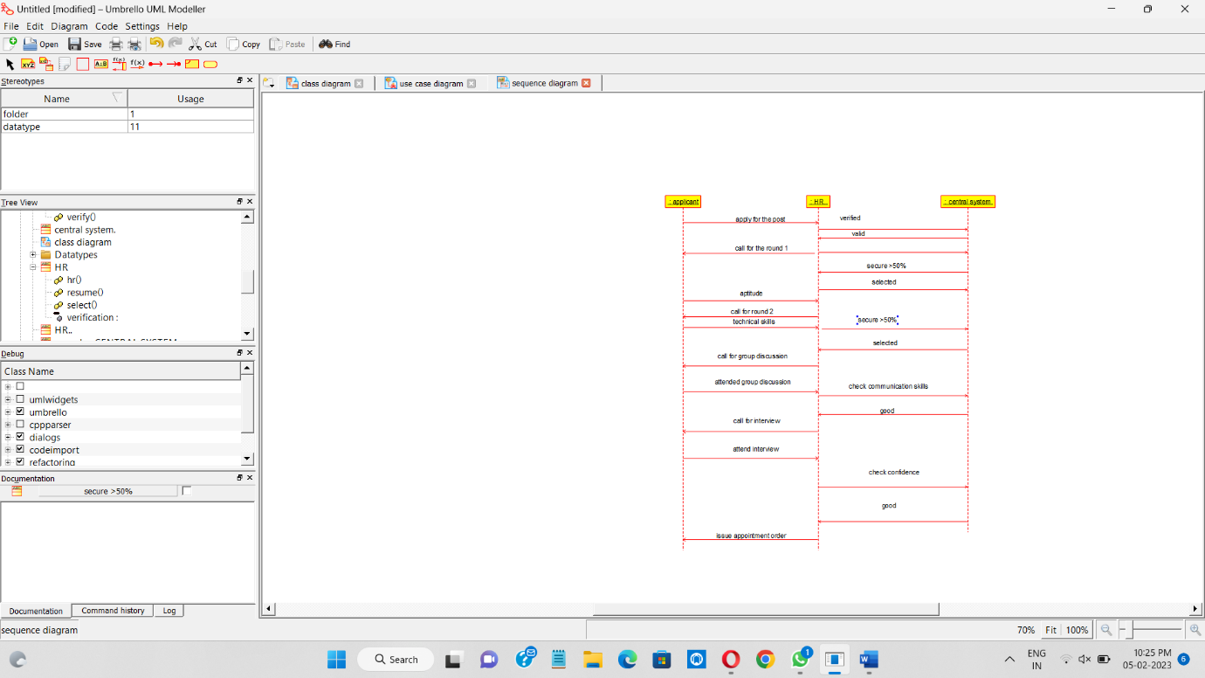

COLLABORATION DIAGRAM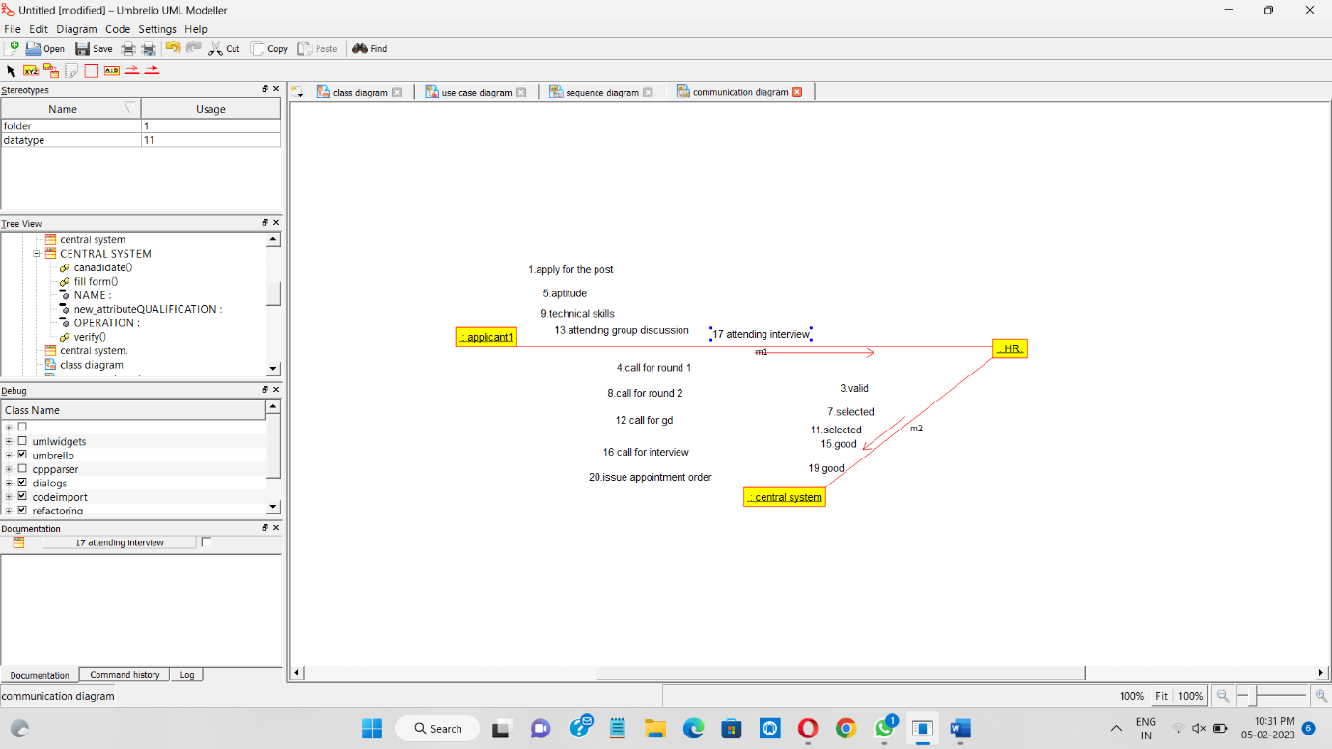

USE CASE DIAGRAM

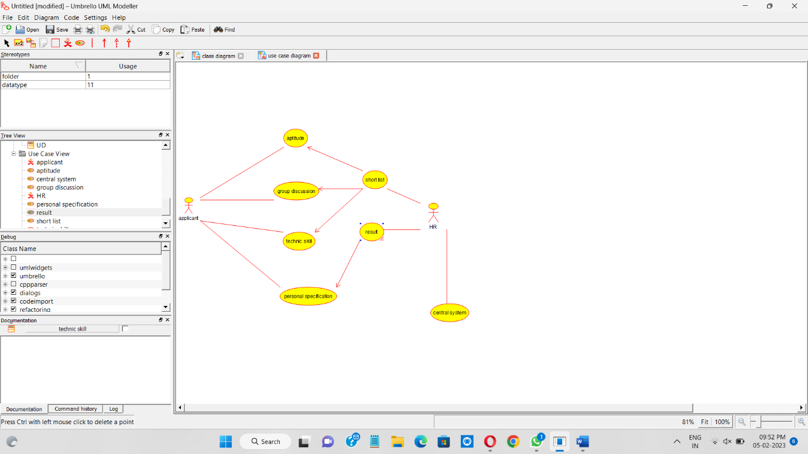

CLASS DIAGRAM

