Create a Gradle project

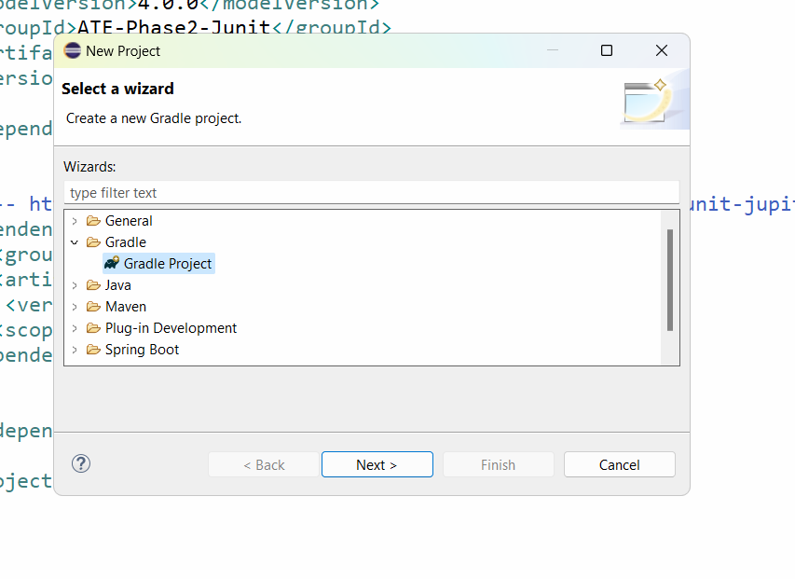

Press Next button

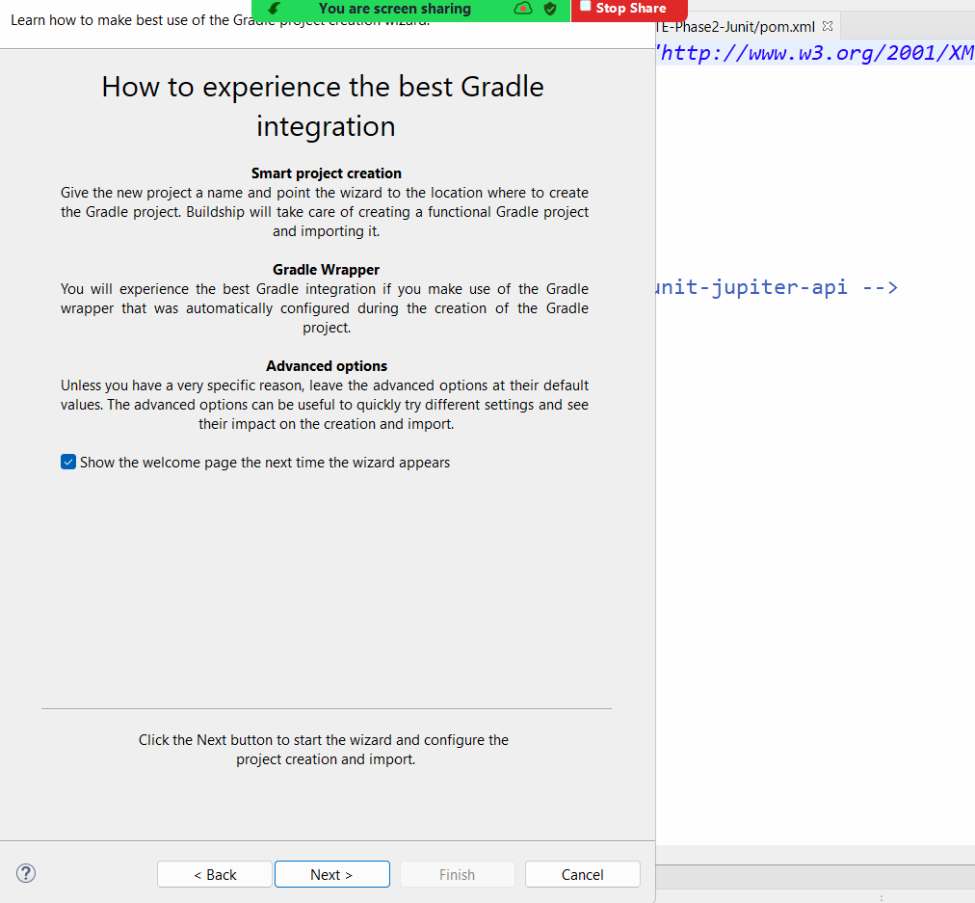

Press Next button and give a name to the project and click on Finish

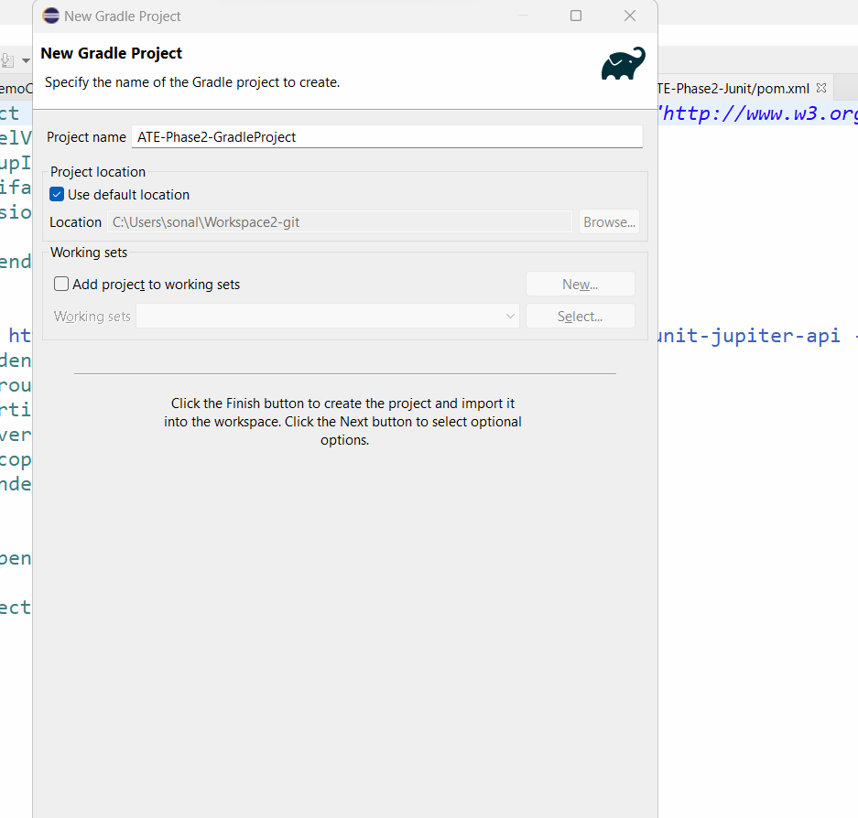

After Finish, it will create 2 projects

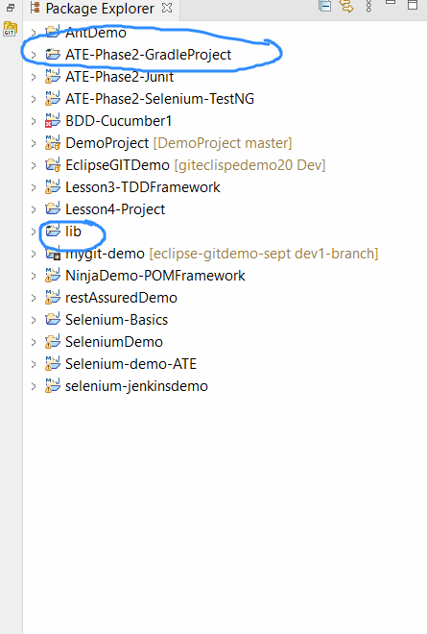

We have to fix the issue of lib folder should be inside the main gradle project

So go to properties of your gradle project and get the path of the project created on your local machine

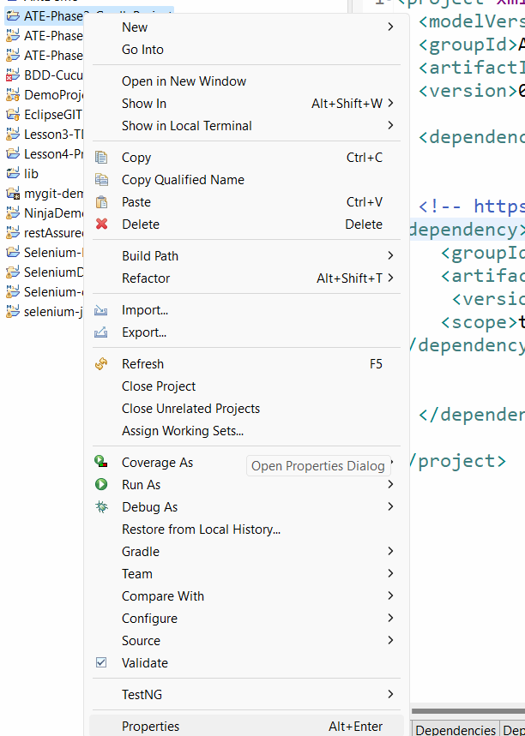

Copy the location of project on your local machine:

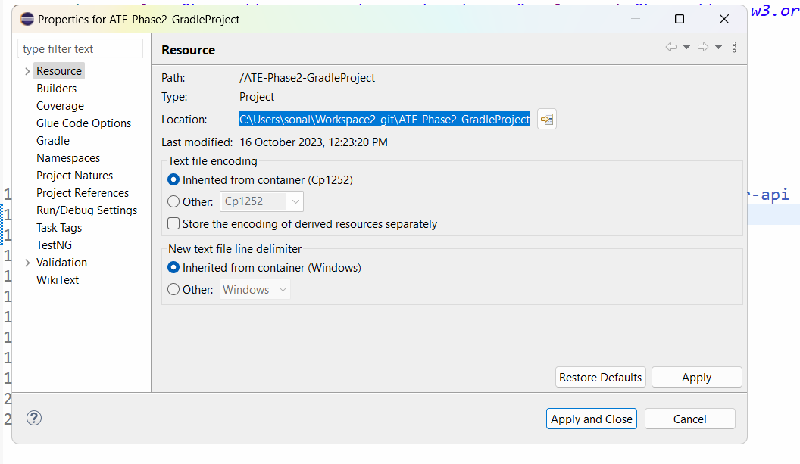

Open the folder in your local machine by pasting the path of workspace:

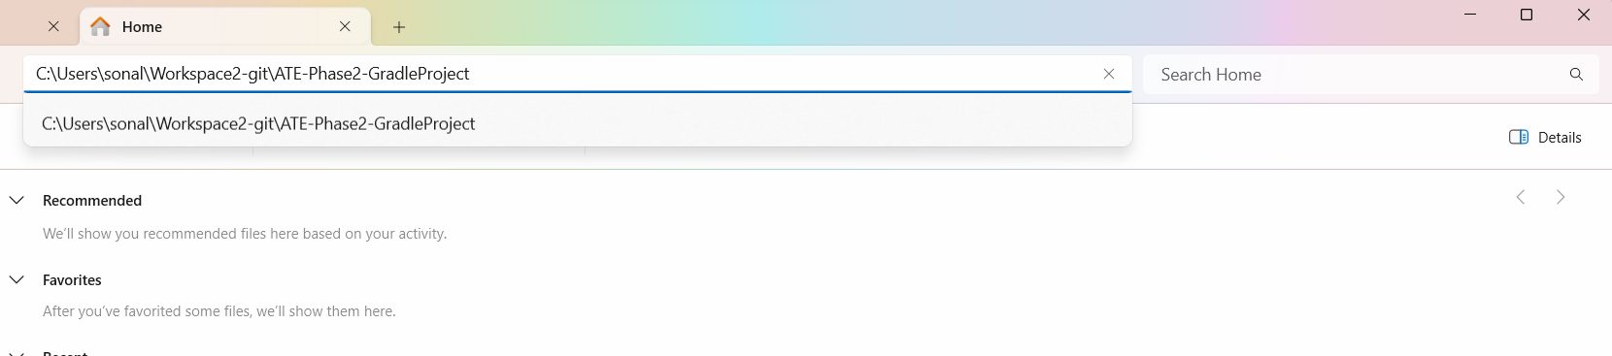

Now the project is open in your local machine

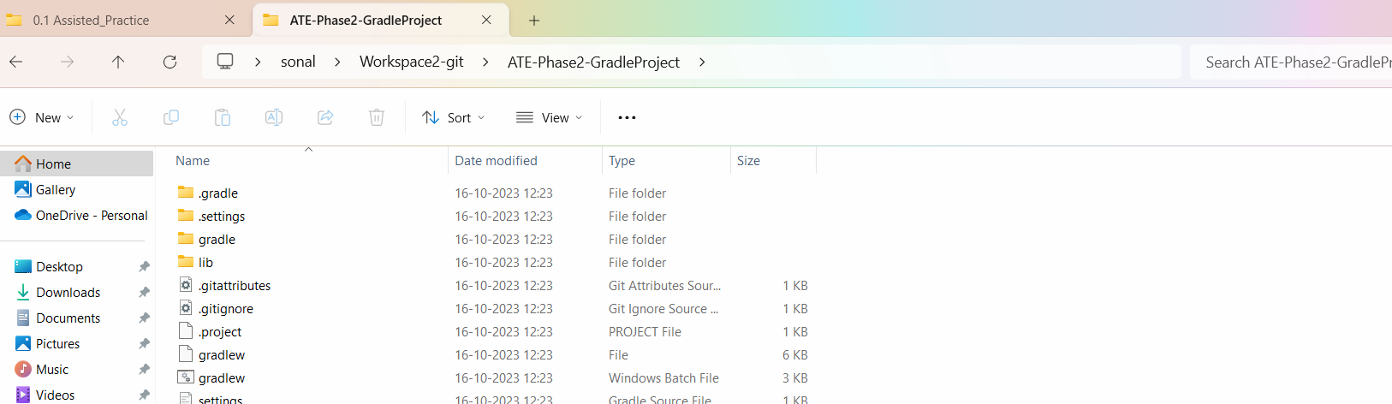

Go inside the lib folder

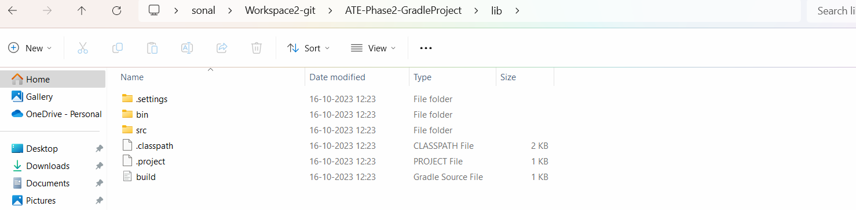

Select All the items in the lib folder and press CTL X (cut them)

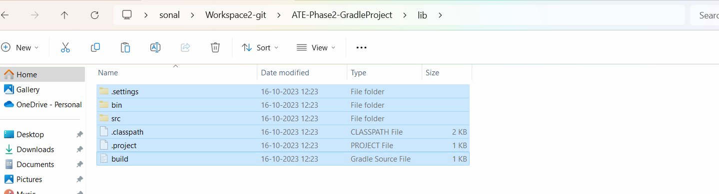

Now go back to your gradle project directory and paste the contents of lib folder.

It may ask for replace the files in the destination.

Select the option of Replace files in the destination

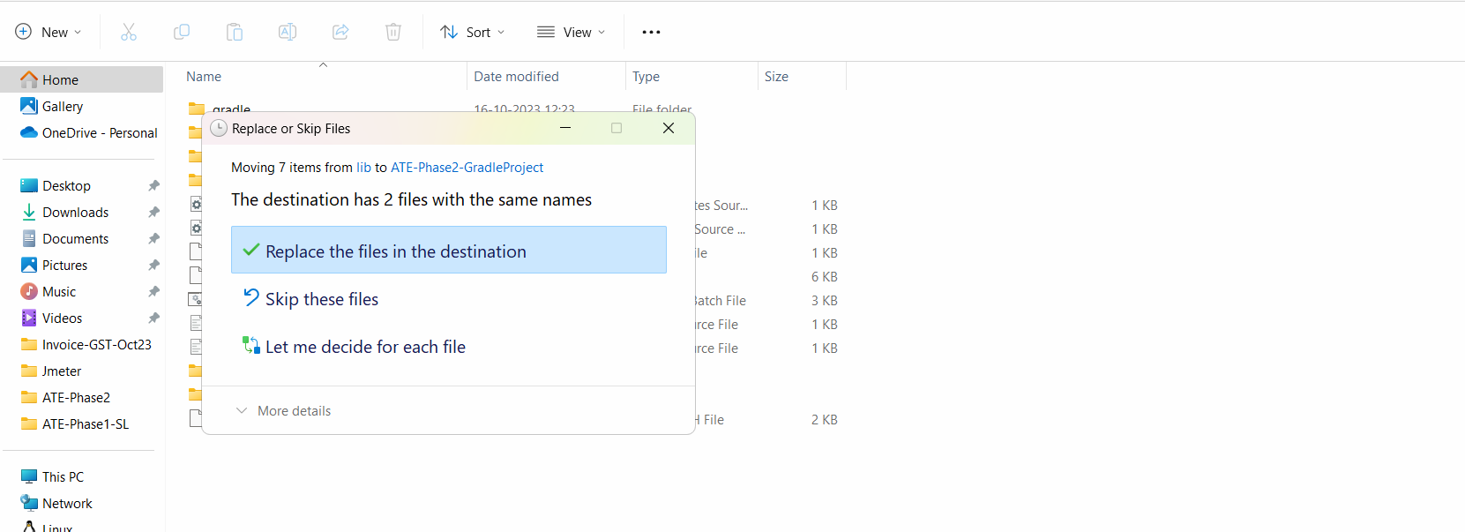

After this if you will go to lib folder, it will be empty:

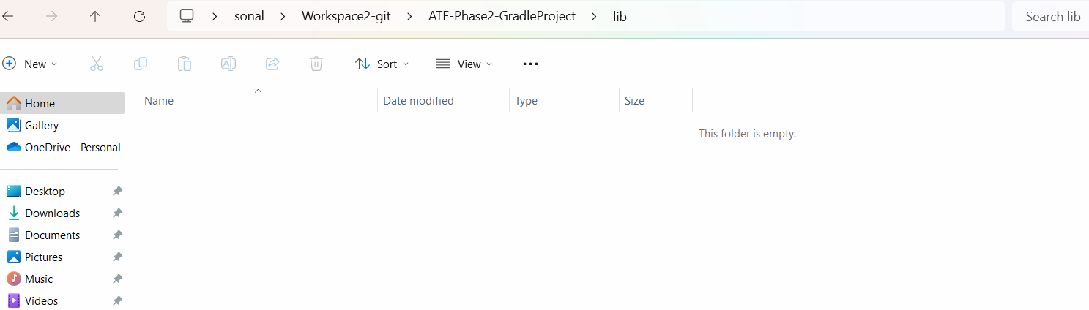

Delete the Lib folder from gradle folder directory

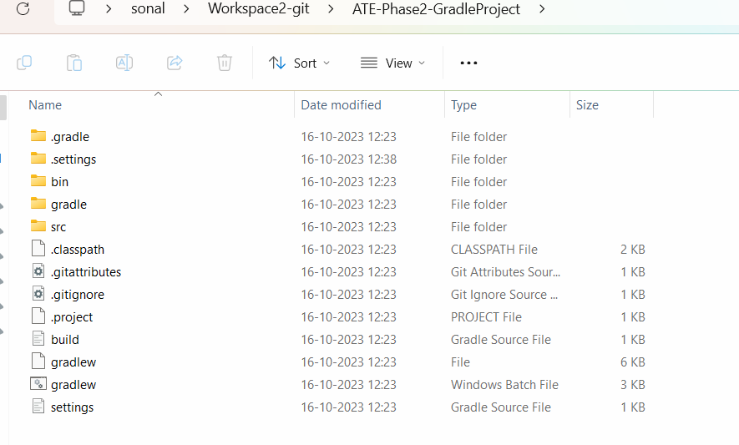

Now go to eclipse and delete the gradle project and lib project

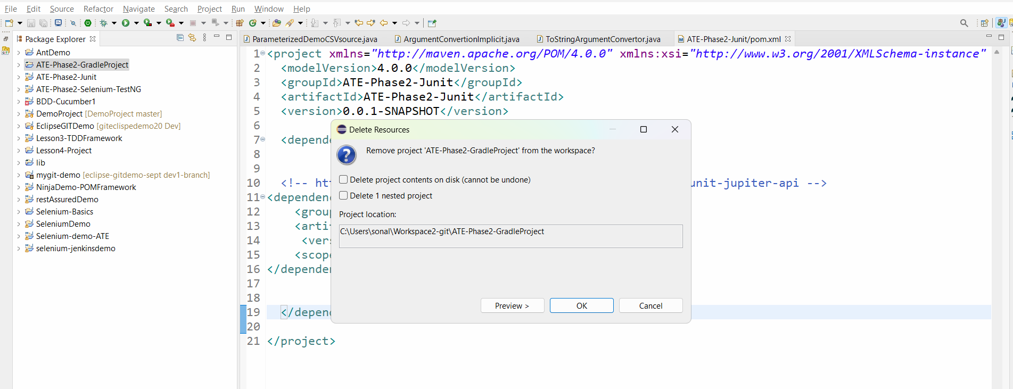

Press OK

Delete the lib folder

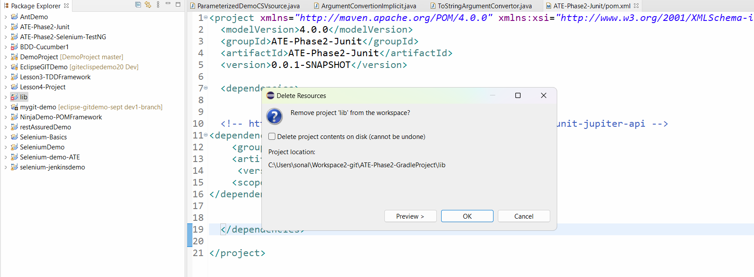

The gradle project are not there in eclipse but they are present in our local system

We need to import them to eclipse

Click on File in eclipse🡪 click on Import

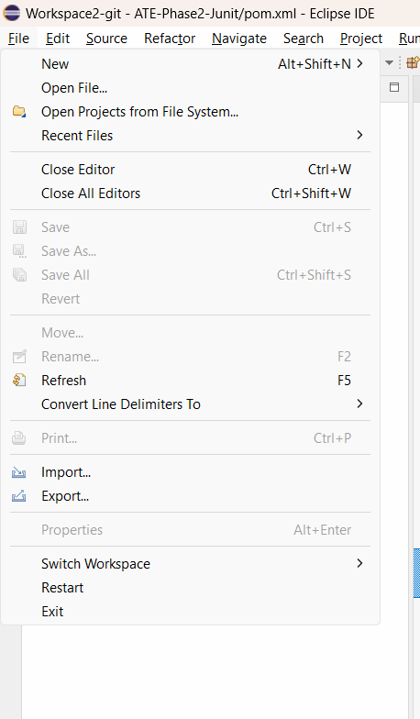

Select Gradle🡪 importing Exisitng gradle project

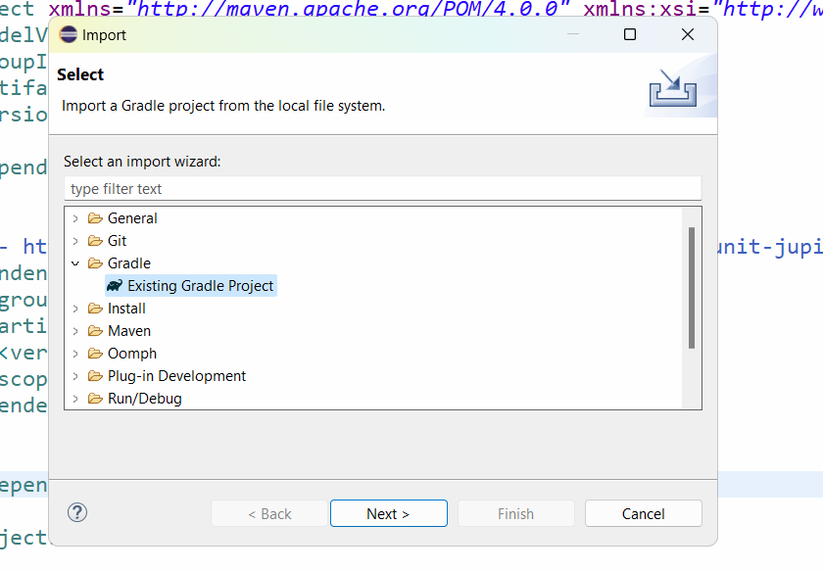

Press next

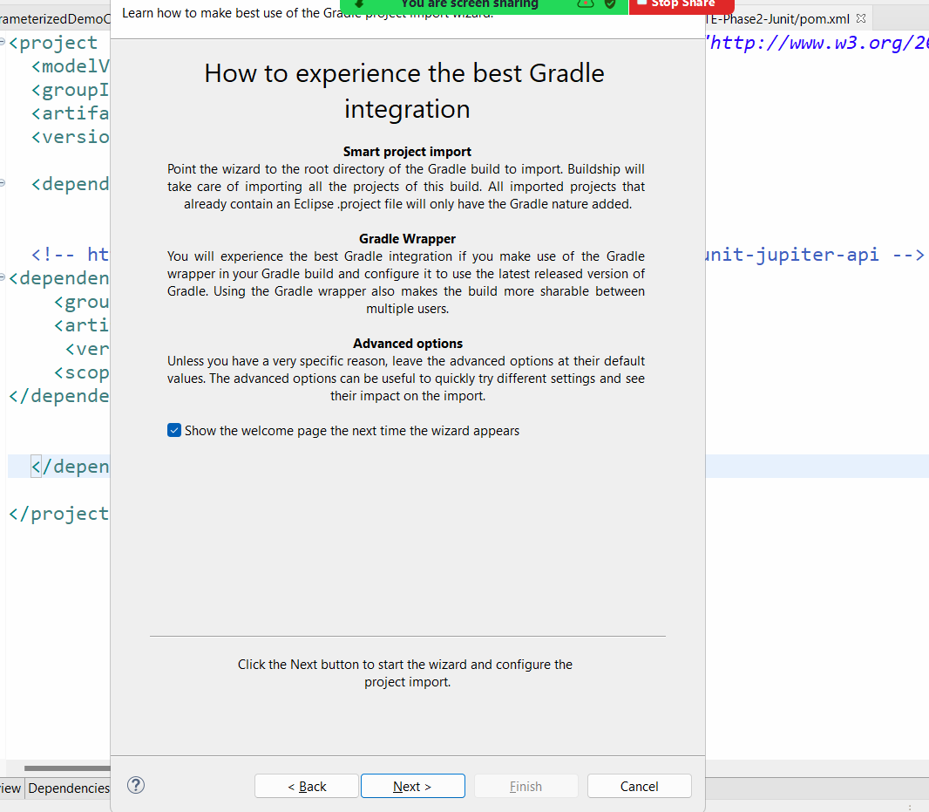

Press next

Click on browse button and go to the workspace path >> go to your project folder

You will have the path of your project populated automatically

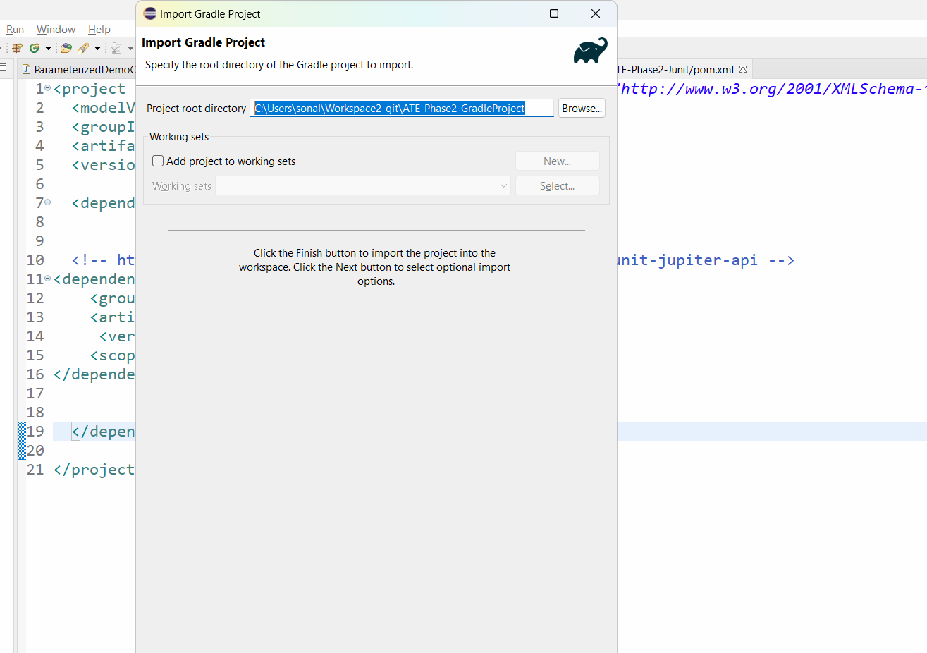

Press Next and Again press next and click on finish

