Decide the class on your maven project to be executed via the command line

Right click on the java class file🡪Go to Properties 🡪 copy the path of the file location

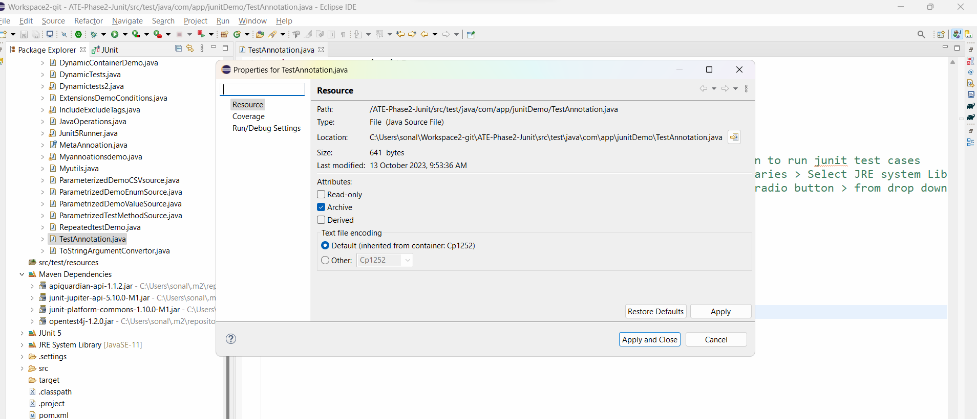

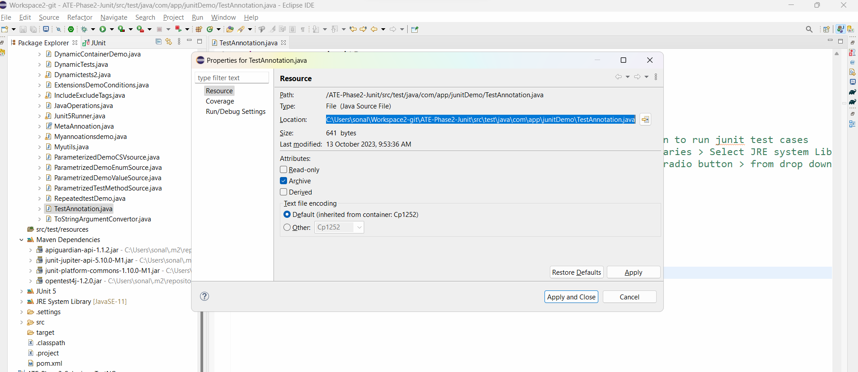

Open the command prompt in your laptop and copy the path but remove the filename at the end

Like this cd C:\Users\sonal\Workspace2-git\ATE-Phase2-Junit\src\test\java\com\app\junitDemo

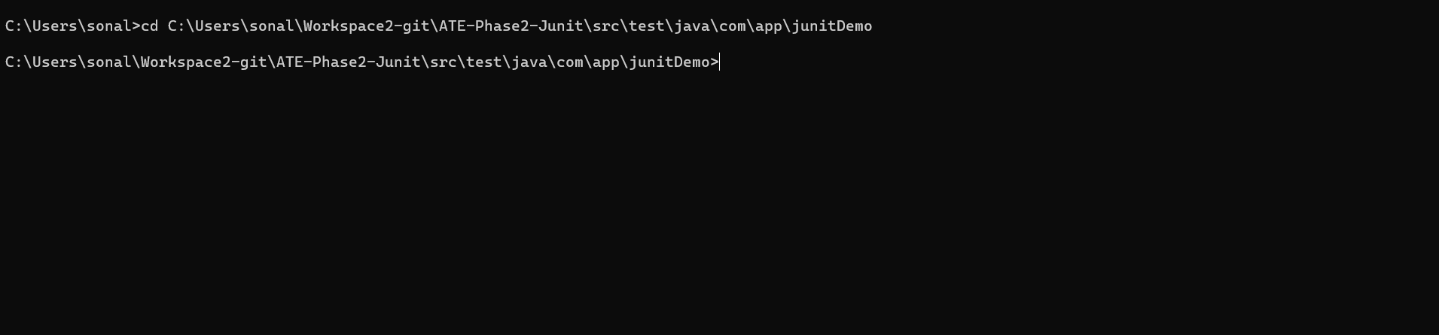

We also need the path of Junit Jar file on your project. We need to get that path from eclipse project

Right click on mavane depency folder > right click on junit jar and go to properties

Go to java source attachment and copt the path as show below

For me it is:

C:/Users/sonal/.m2/repository/org/junit/jupiter/junit-jupiter-api/5.10.0-M1/junit-jupiter-api-5.10.0-M1-sources.jar

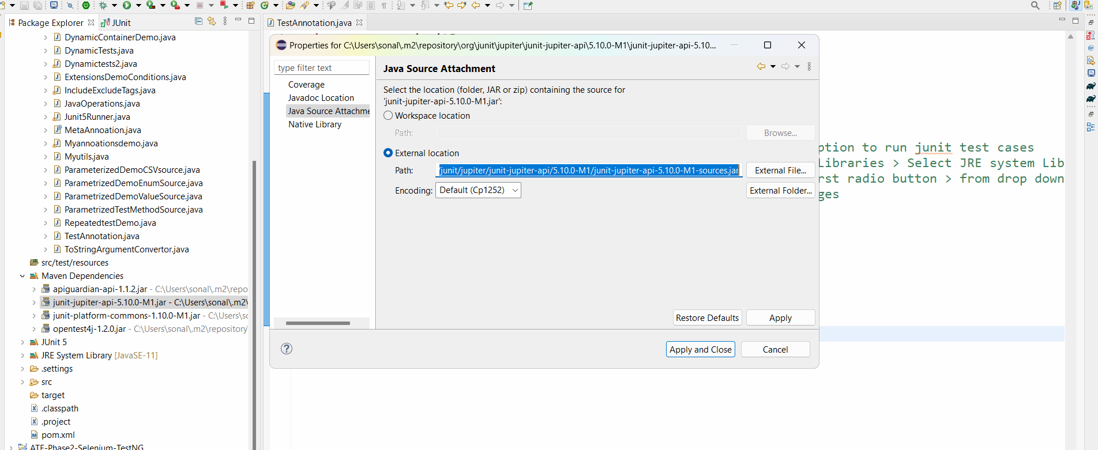

Execute below command on your command line now:

# javac -cp C:/Users/sonal/.m2/repository/org/junit/jupiter/junit-jupiter-api/5.10.0-M1/junit-jupiter-api-5.10.0-M1-sources.jar;. TestAnnotation.java



You will get error, ignore them

# java -cp C:/Users/sonal/.m2/repository/org/junit/jupiter/junit-jupiter-api/5.10.0-M1/junit-jupiter-api-5.10.0-M1-sources.jar TestAnnotation.java

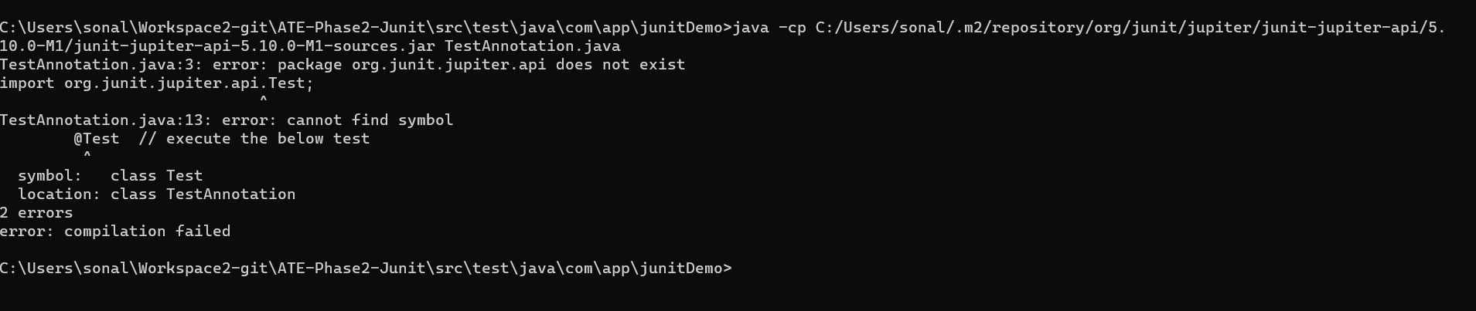

You will get error. Submit the same