Samplers: SMTP Sampler

SMTP sampler will allow JMeter to send a request to a SMTP server, the server will then send an email to the destination and will also send response as success to JMeter.

Threadgrup🡪 Add 🡪 Sampler🡪 SMTP sampler

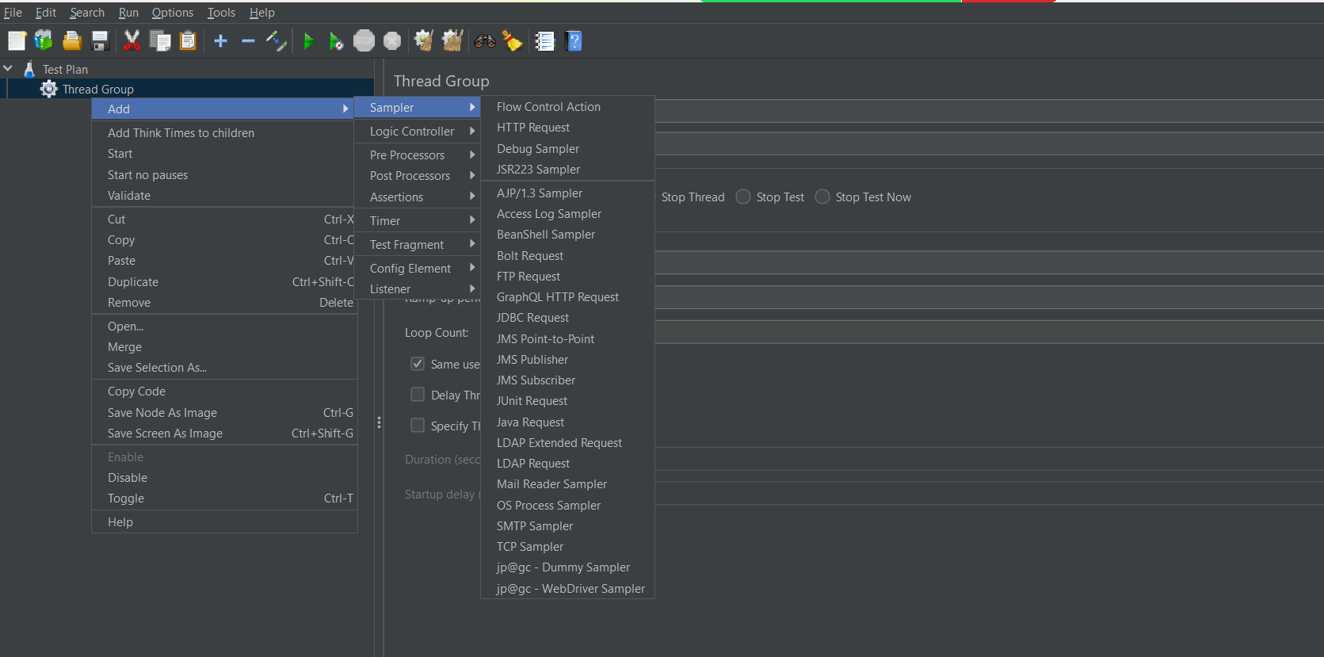

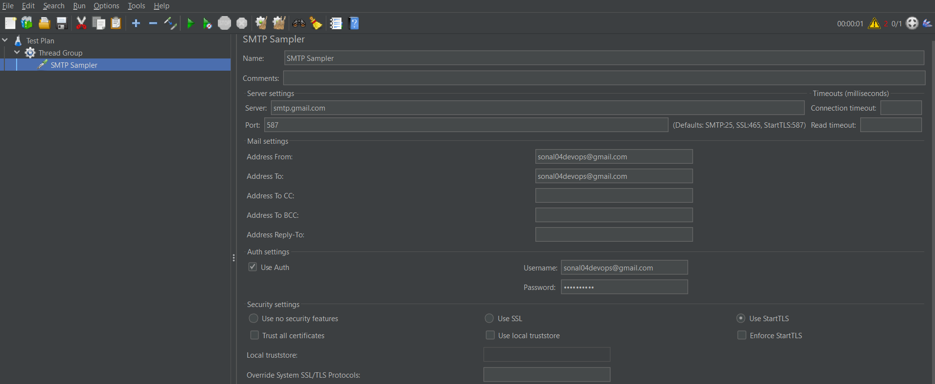



Execute the Sampler. The request will fail as username and password is incorrect.

That is alright. It is because gmail SMTP server is not allowing third party tools to use it and send emails.

You can submit assignment with failed requests.

However you can activate 2 step verification on your gmail account 🡪 and generate app password on Gmail account

Then give that app password in the SMTP sampler, then your request will be successful.

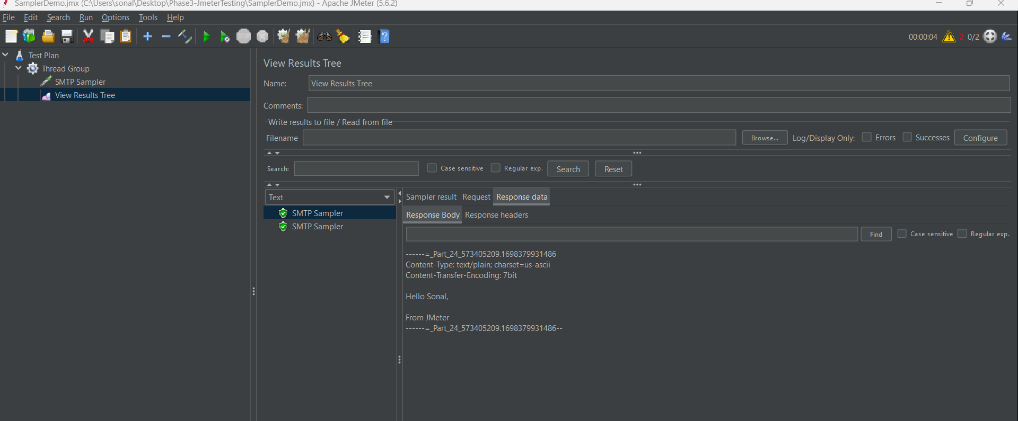

JDBC Sampler:

Download the JDBC connector jar file

Open the browser of the lab and open this URL

https://dev.mysql.com/downloads/connector/j/

In the drop down select platform independent

Select the second option : Platform Independent (Architecture Independent), ZIP

Click on download button

on next page click on => No thanks, just start my download.

Zip file will be downloaded.

Now go to downloads folder of lab

and right click on zip file and clickon extract here

In the folder there will be a JDBC connector.jar file

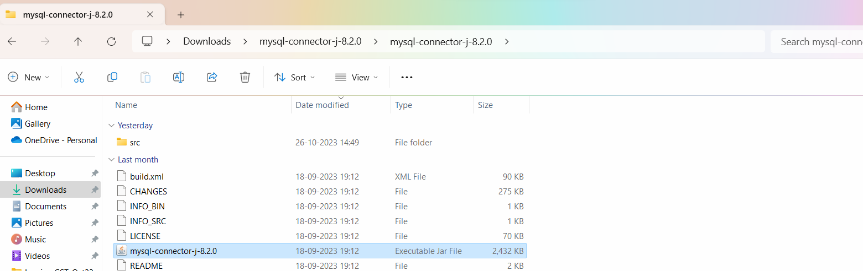

This Jar file has to be copied and pasted in your Jmeter folder 🡪lib folder

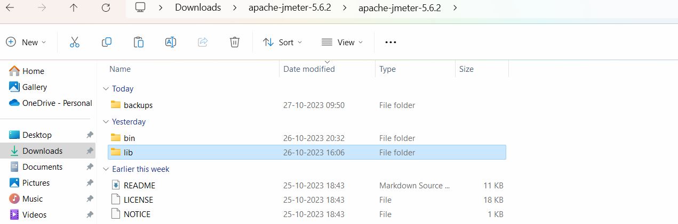

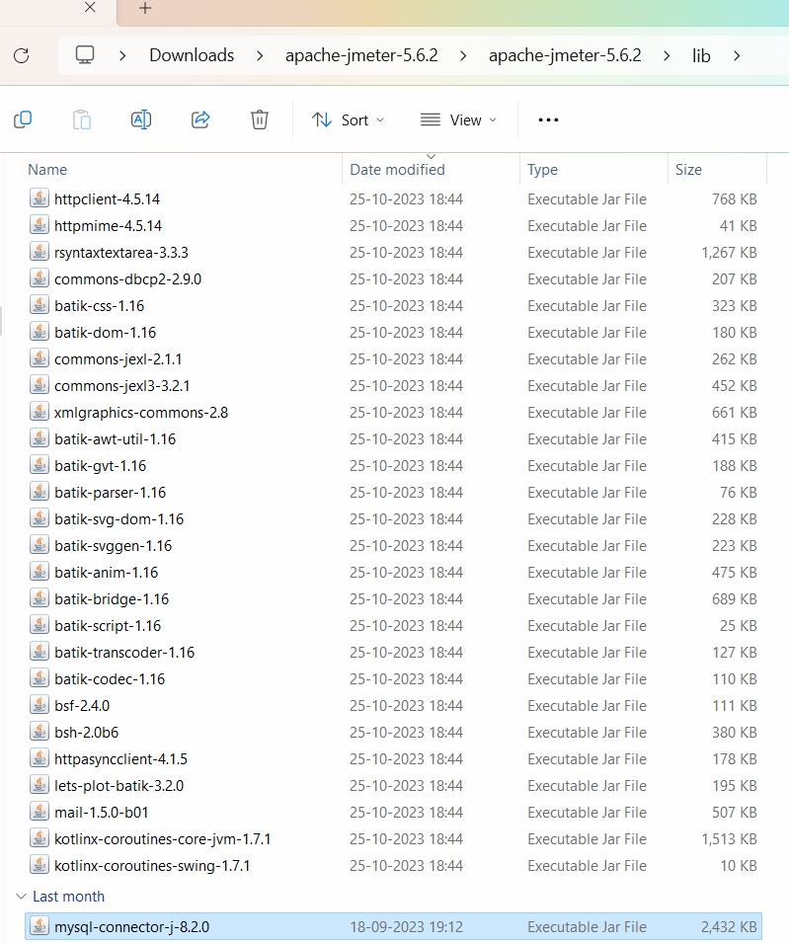

After copying the jar file in LIB folder🡪 restart your apache Jmeter (close it and start it again).

In JMeter🡪 create a Thread group -🡪 Add 🡪 Config Element🡪 JDBC connection Configuration

Add the variable pool name and add DB connection details.

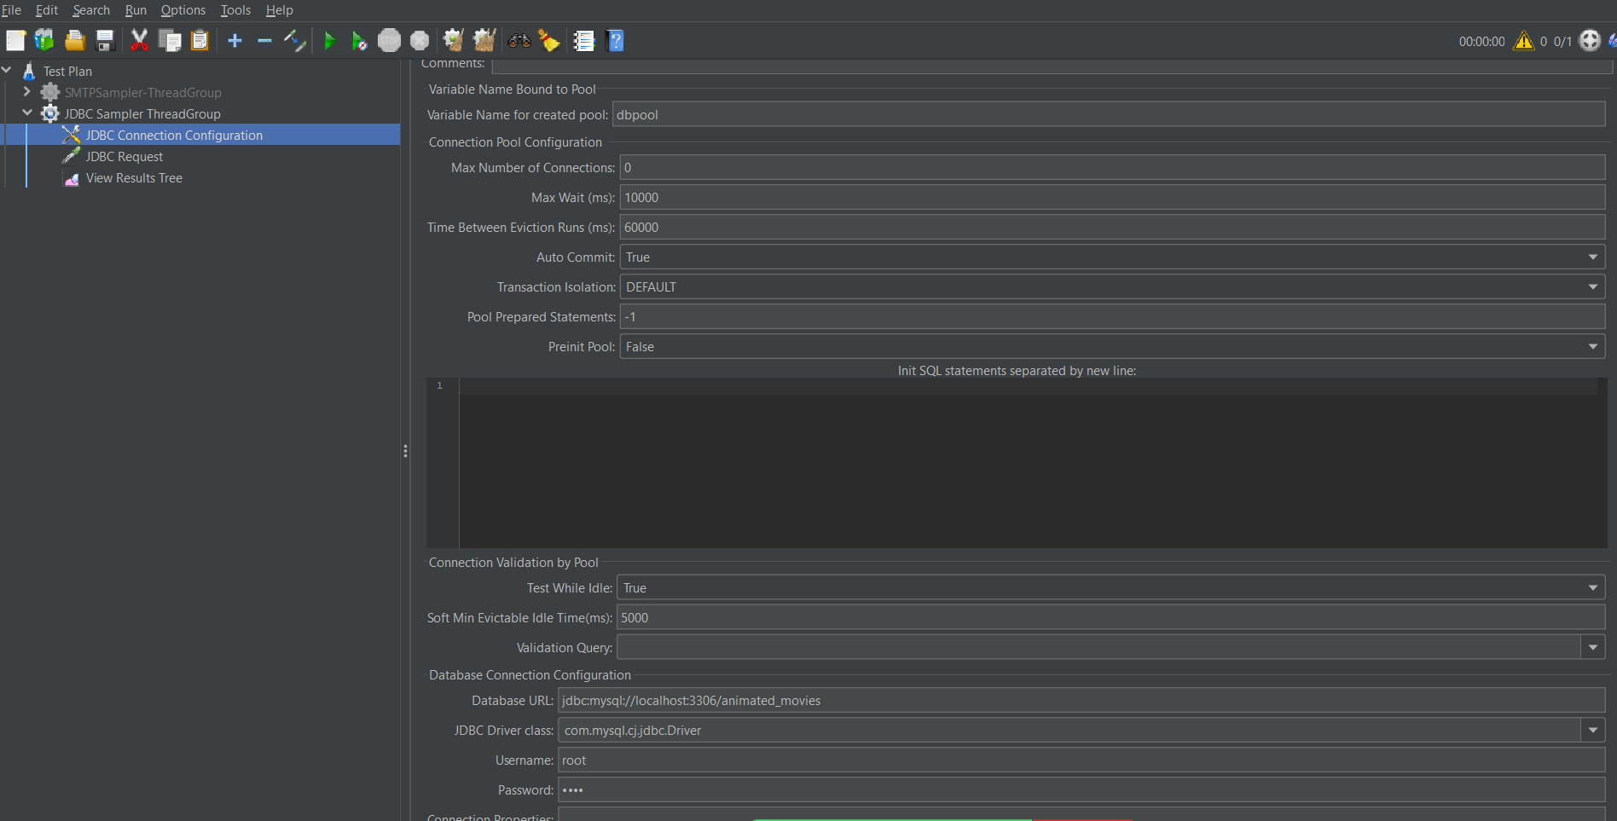

Thread group 🡪Add the JDBC request 🡪 Add the variable name as given in JDBC configuration🡪 Add the query to be executed.

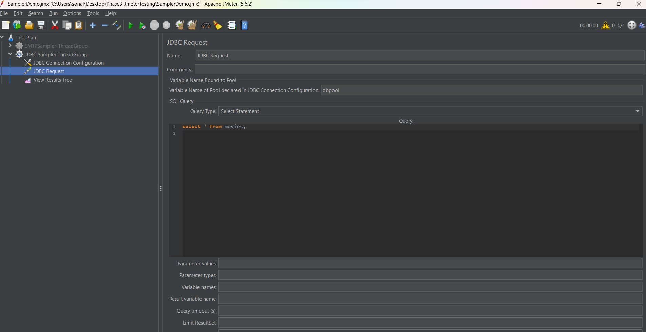

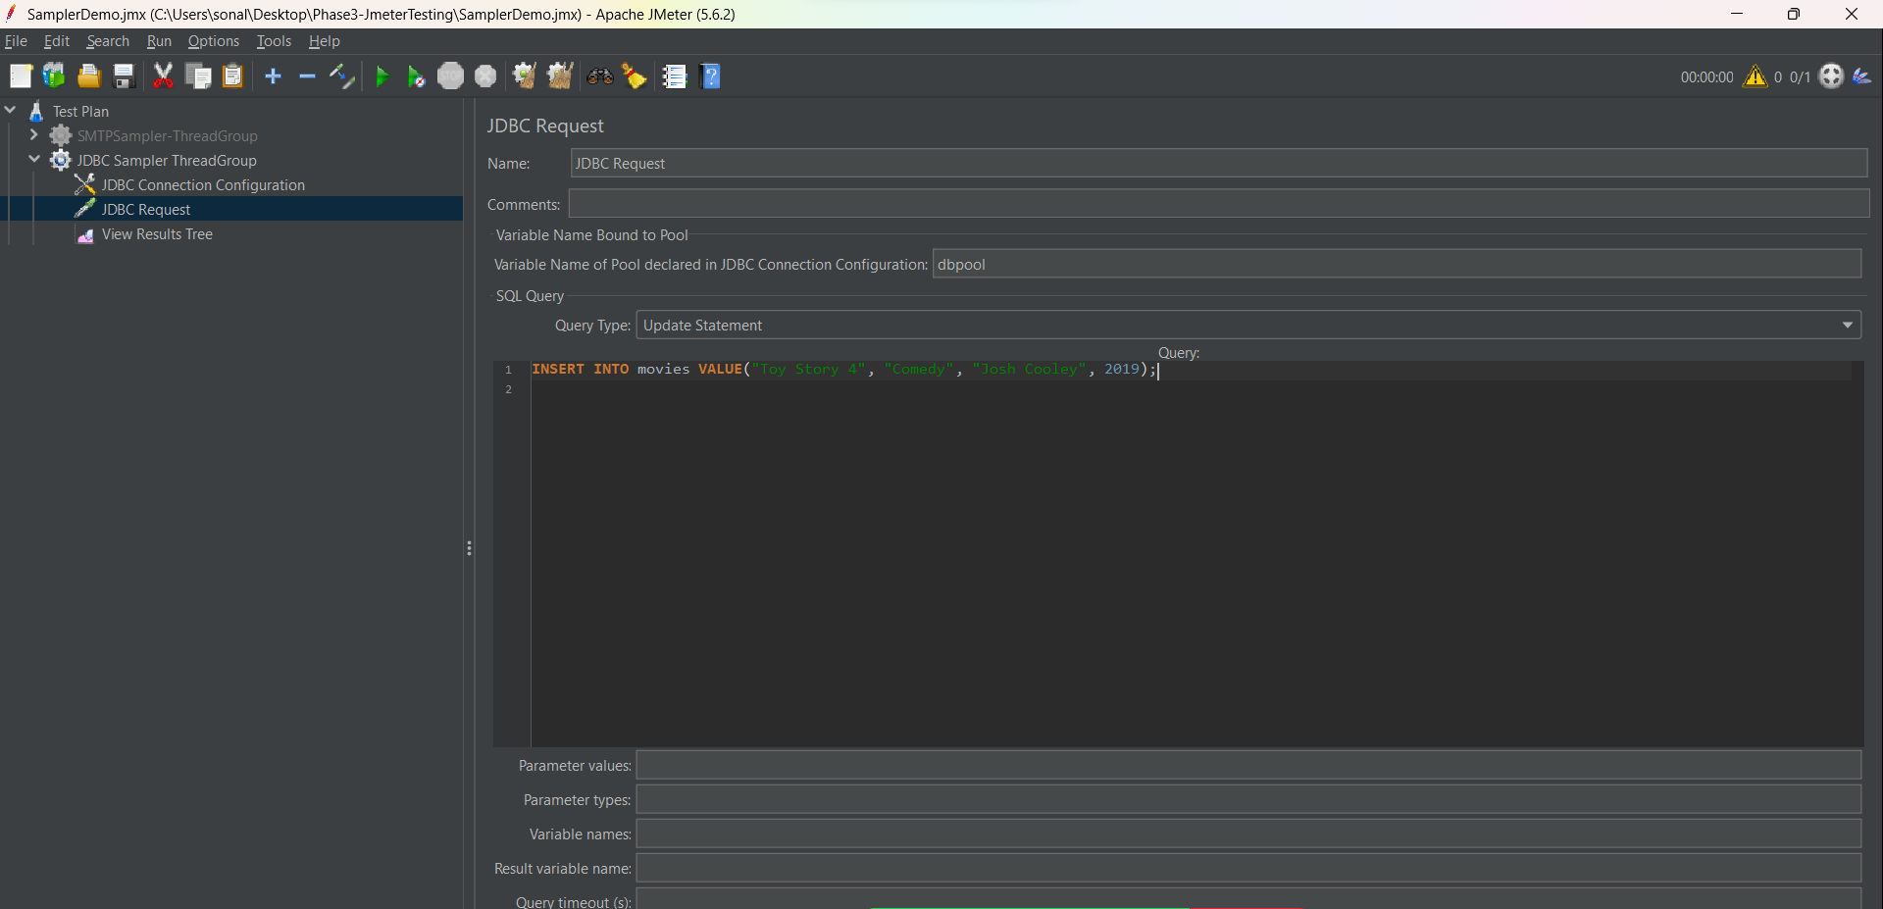

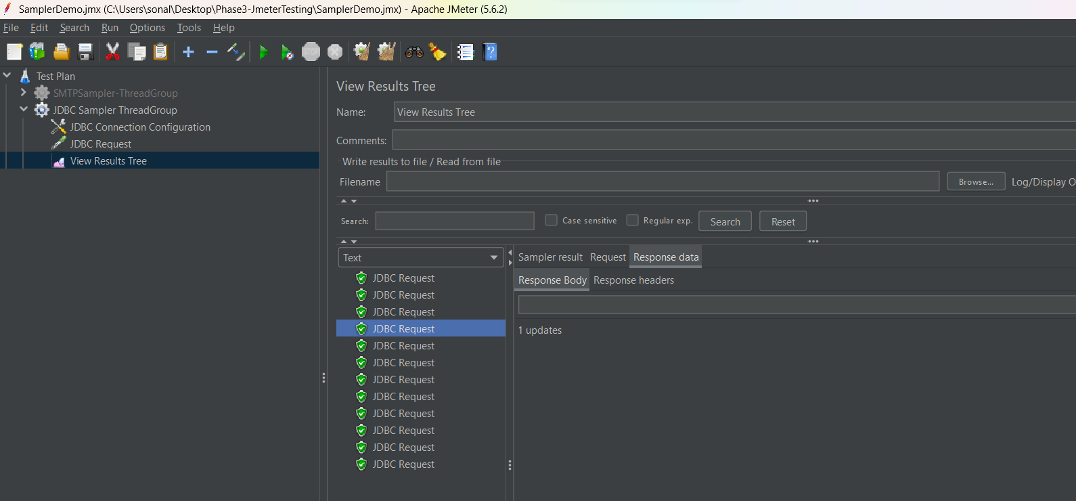

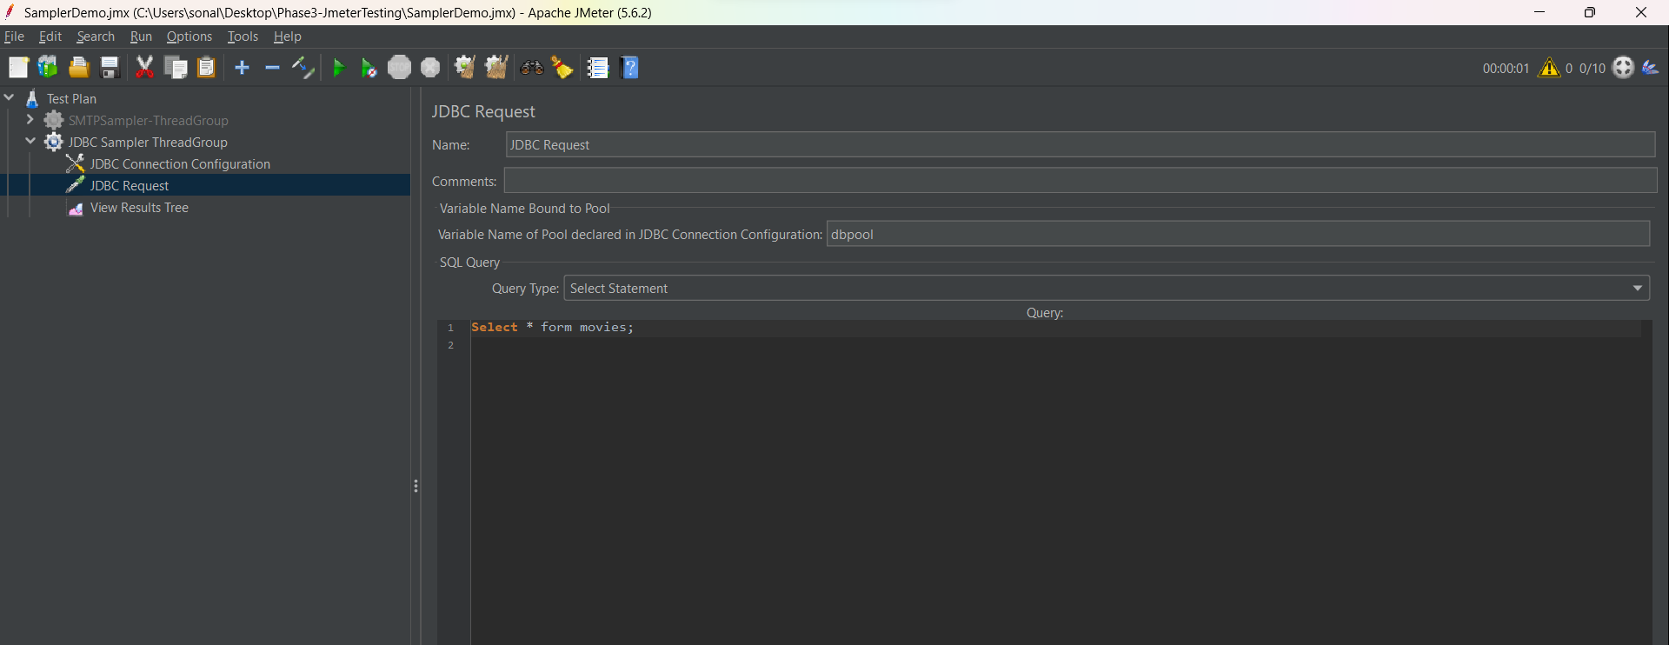

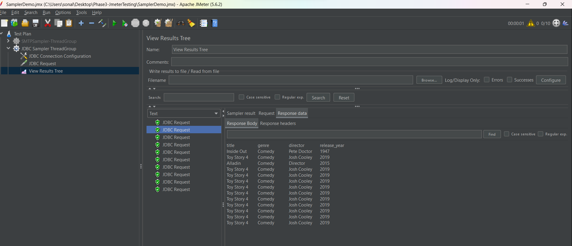

JUNIT Sampler

Create a Java package in eclipse🡪 create a Junit class and add Junit test annotation🡪 create a junit method.

Add Junit 4 library in the java project.

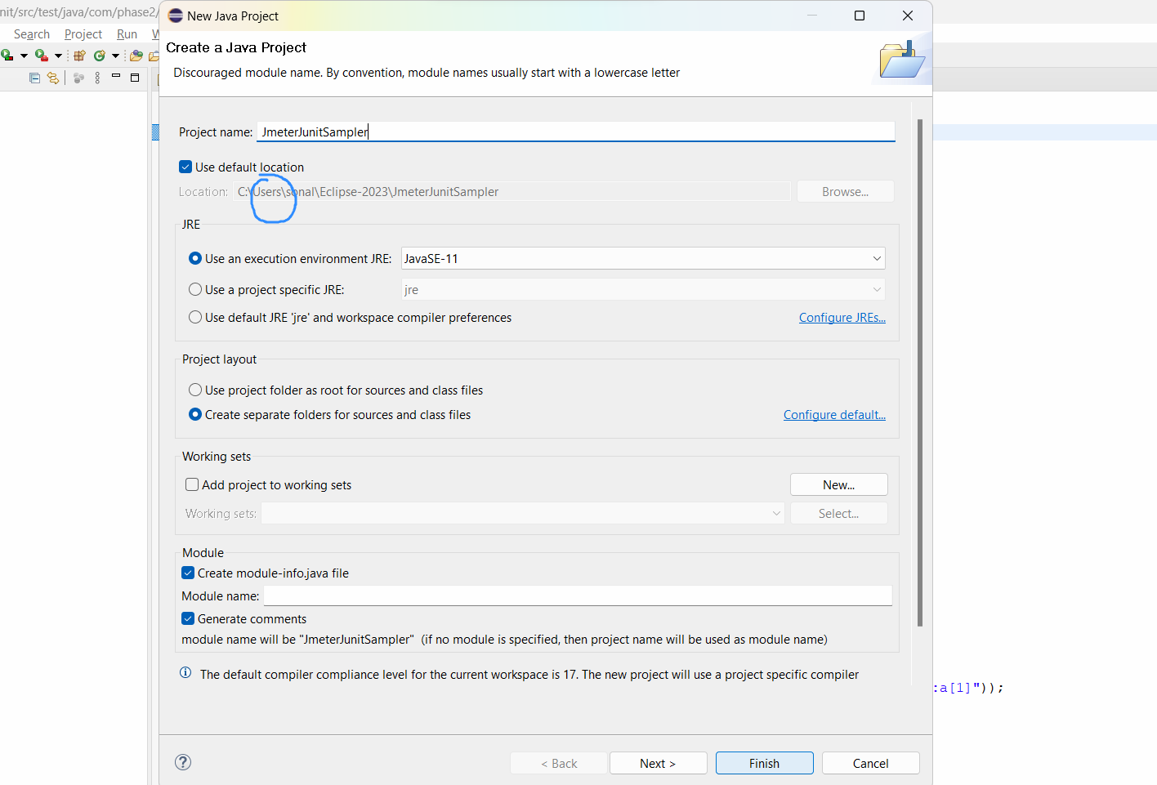

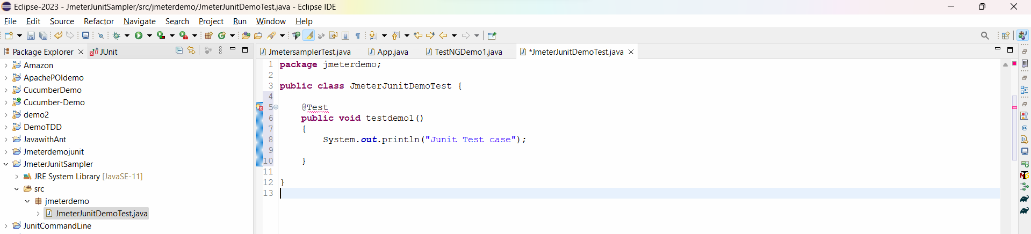

Select Junit 4 library

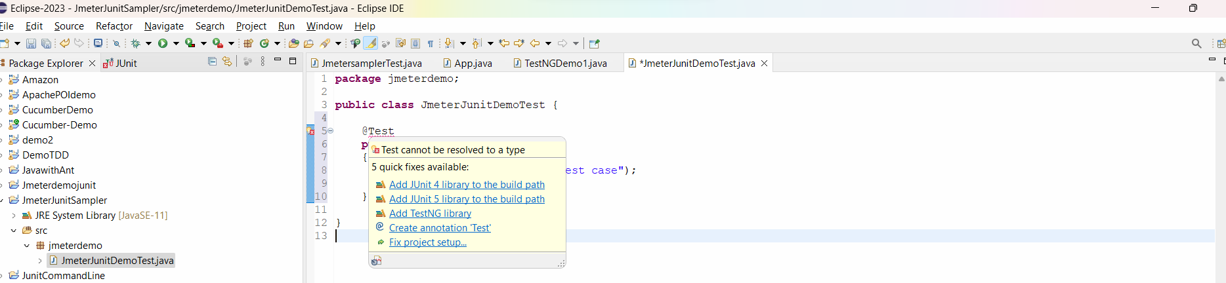

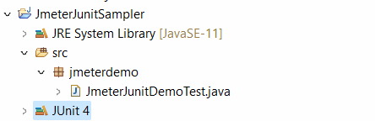

Next we have to export this Porject of junit into a Jar file, so that jmeter can execute it.

Right click on project🡪 select export 🡪 select Jar

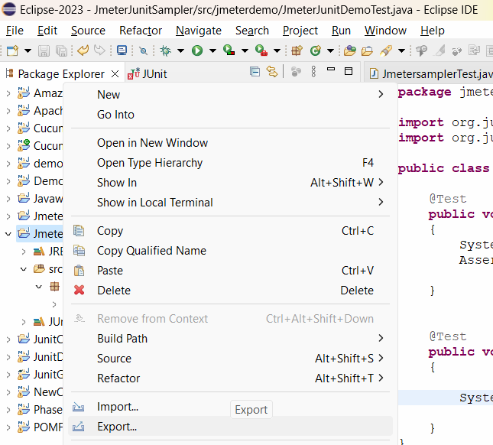

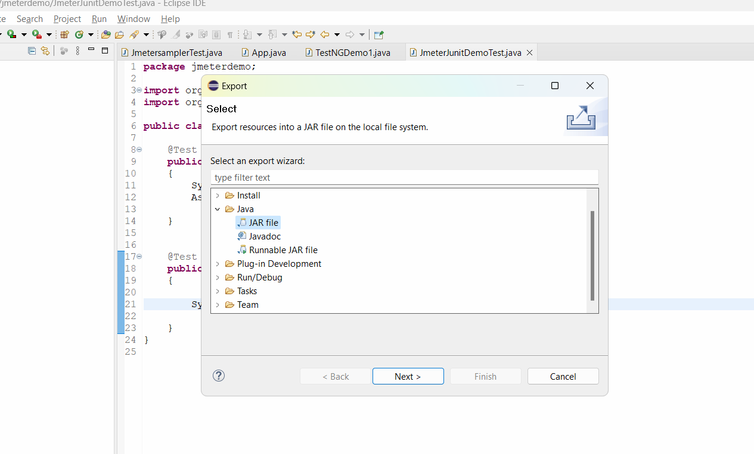

Press next and select the export destination 🡪 Click on browse🡪 the path with jmeter/lib/junit folder -> C:\Users\sonal\Downloads\apache-jmeter-5.6.2\apache-jmeter-5.6.2\lib\junit

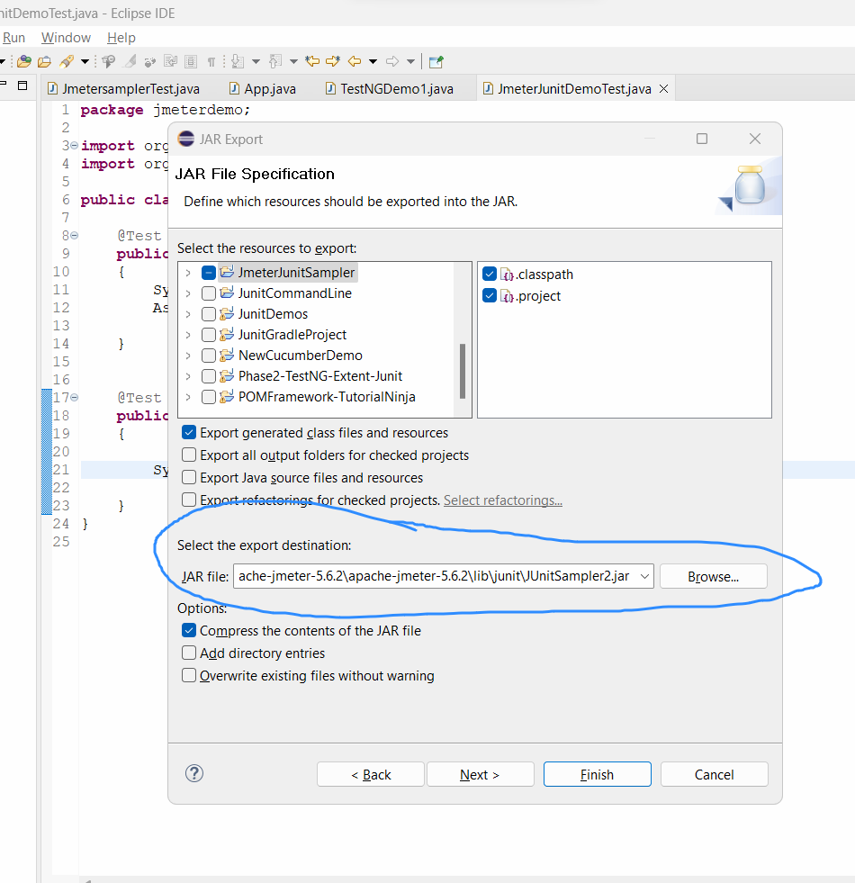

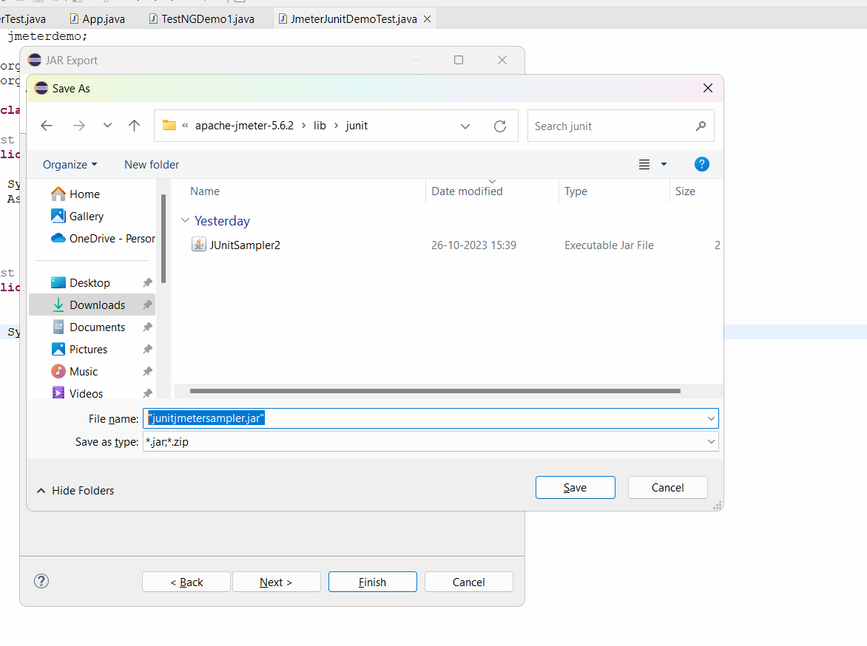

Click on save and finish button.

Close and restart jmeter.

ThreadGroup🡪 add🡪 junit request sampler🡪 in the smapler select below details

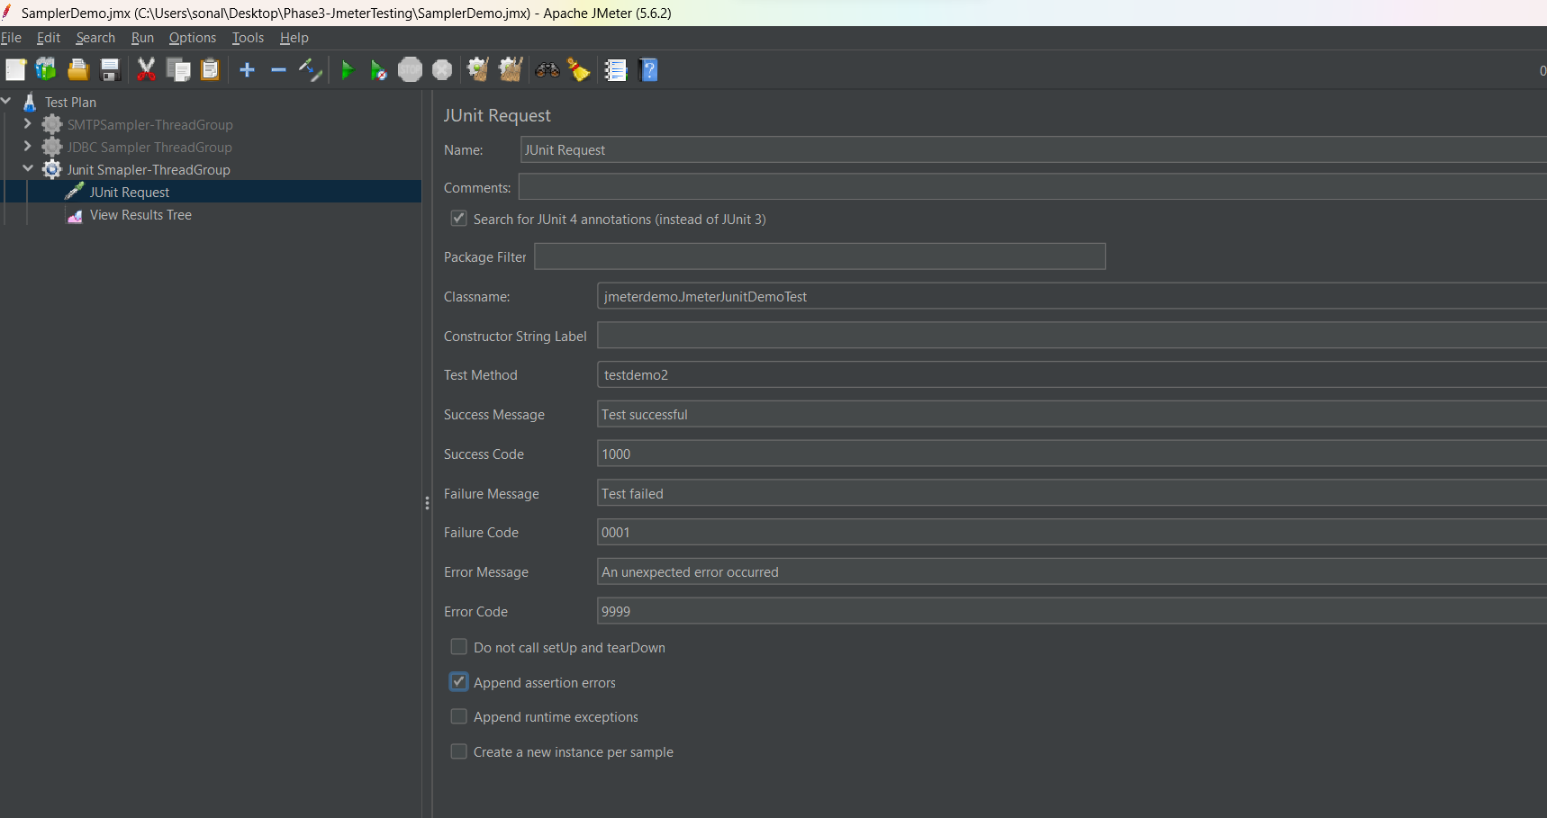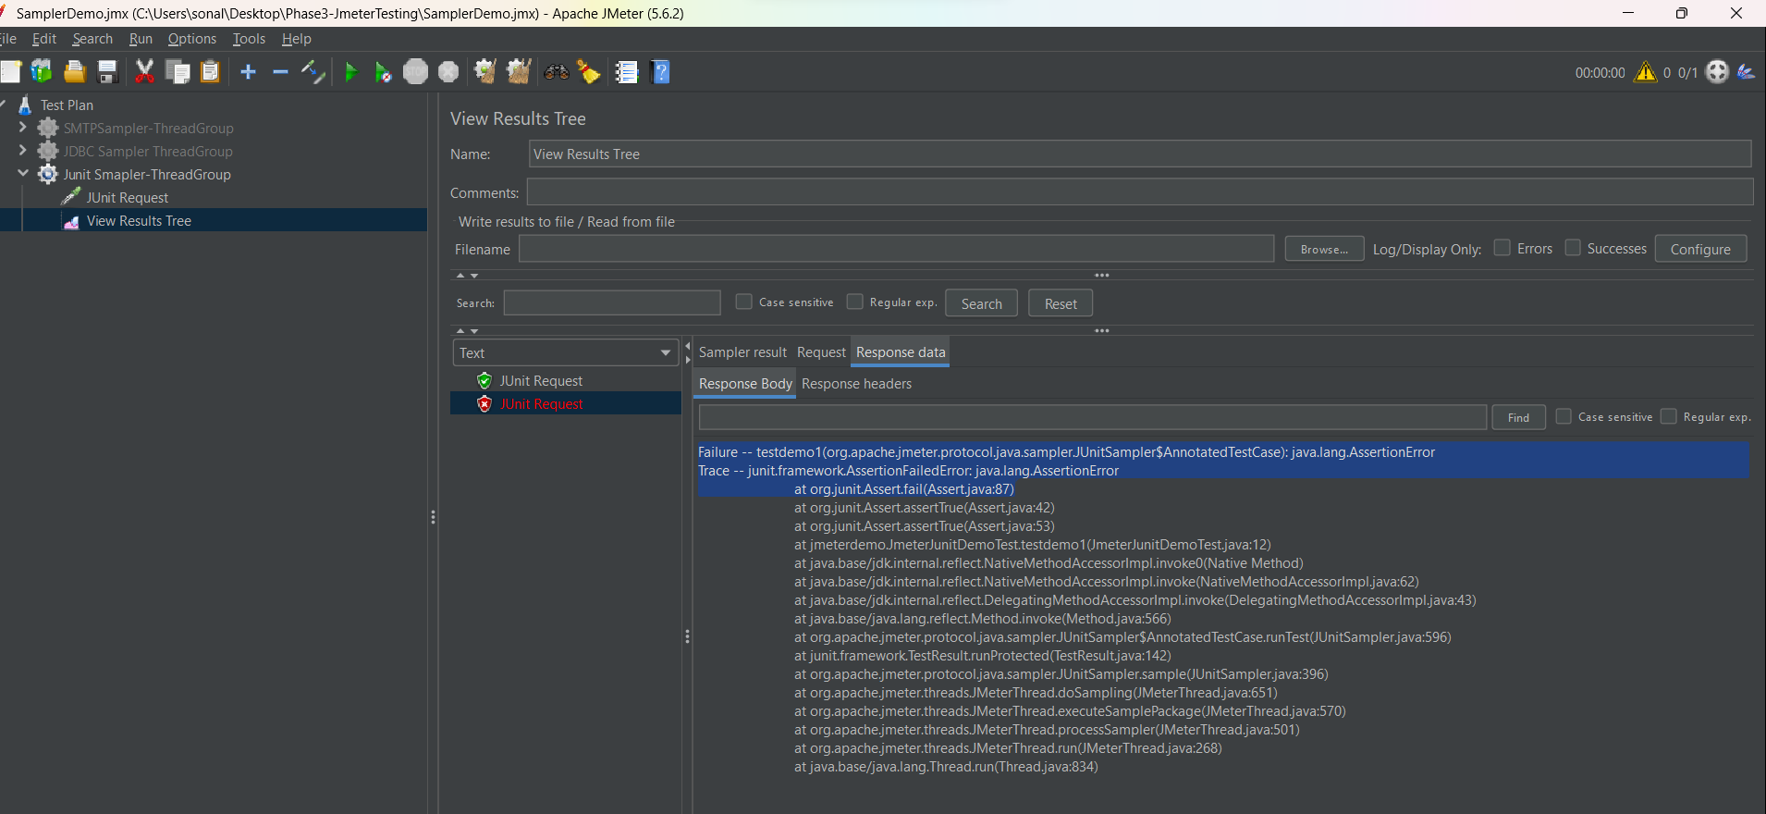

Selenium Sampler

We have to download plugin manager jar file for jmeter and add plugin manager to jmeter.

Installation and Usage

Download the Plugins Manager [JAR file](https://jmeter-plugins.org/get/) and put it into JMeter's lib/ext directory

<https://jmeter-plugins.org/wiki/PluginsManager/>

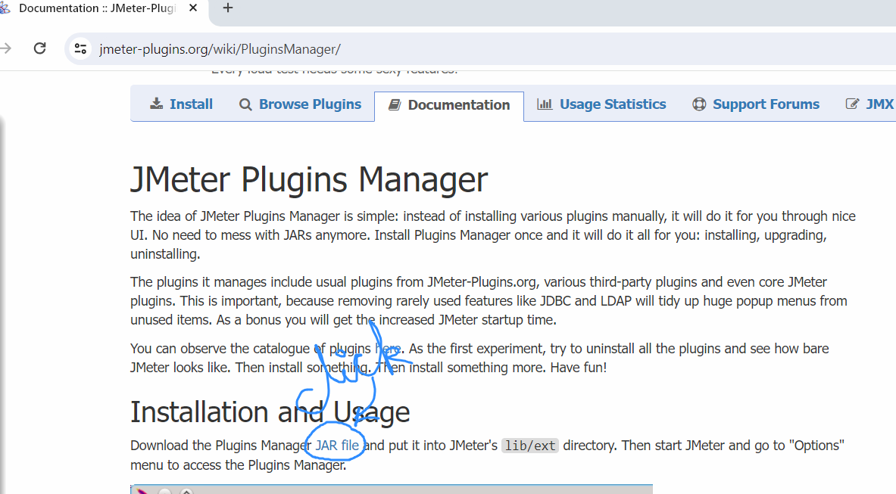

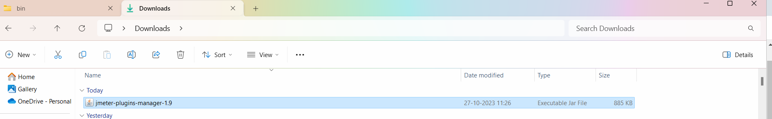

Copy this in jmeter folder🡪 lib->ext folder

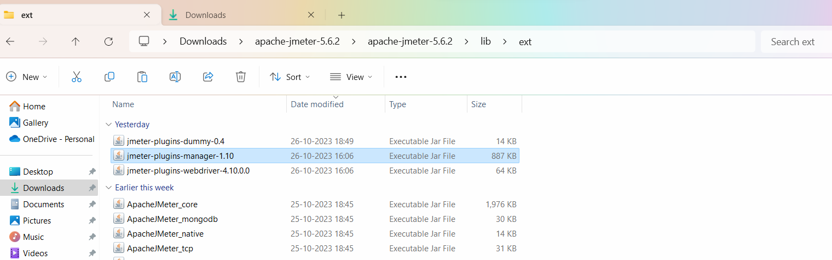

Stop and restart jmeter

In Jmeter 🡪 go to Options -> you will see the Plugin Manager

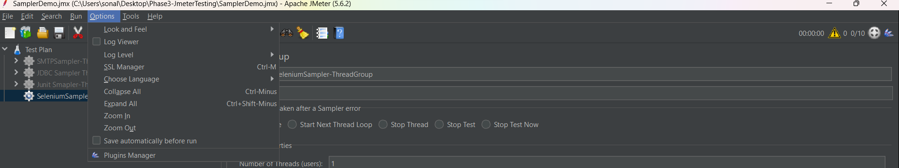

Click on plugin manager🡪 go to available plugins 🡪 search for selenium webdriver support plugin

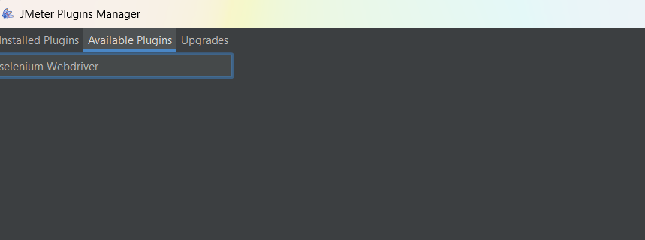

Click on Apply changes and restart jmeter

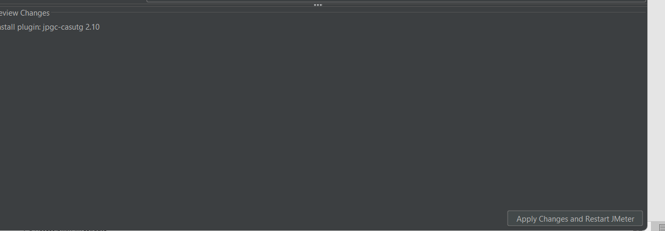

After this we can now add selenium configuration in jmeter

1. Add the threadGroup 🡪 add the config element🡪 select the element jp@gc chromeDriver Config

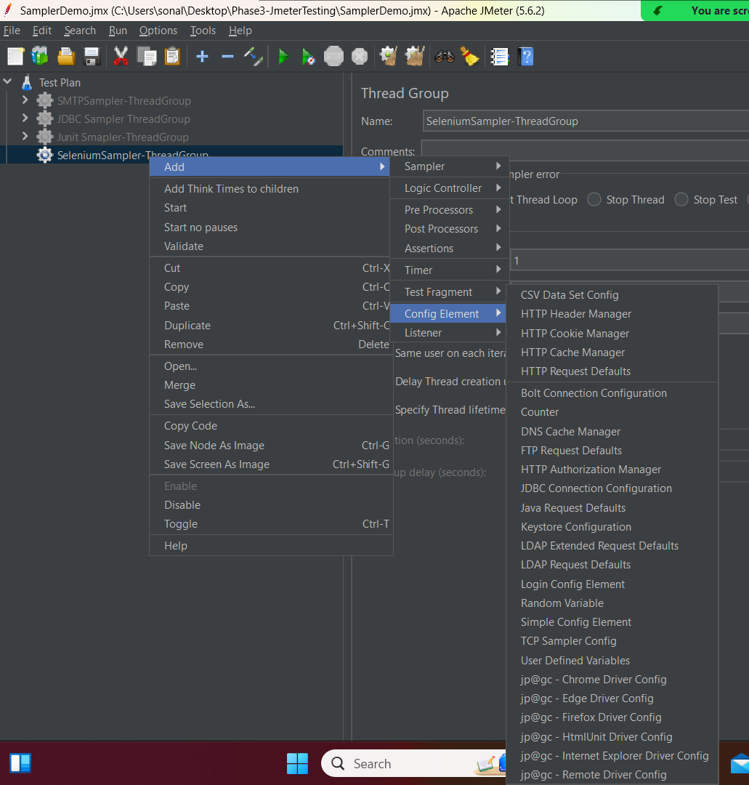

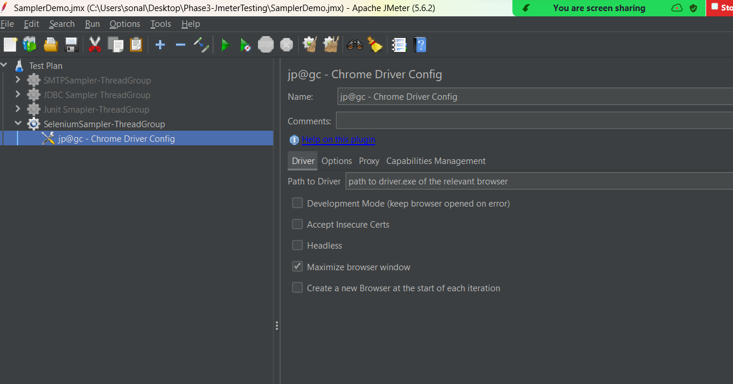

For Jmeter to create a session with your chrome browser, we have to download chromedriver.exe

This has to be downloaded from selenium downloads website.

We have to give path of chromedriver.exe in ChromeDriver config

To download the chromedriver.exe use the below url:

https://googlechromelabs.github.io/chrome-for-testing/

Download that version of chromedriver which is same as that of your chrome browser version

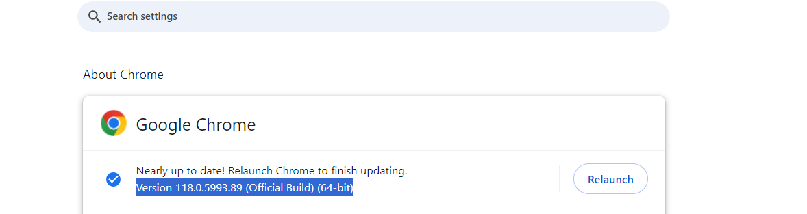

Chrome version in 118, download chromedriver.exe for 118 version only.

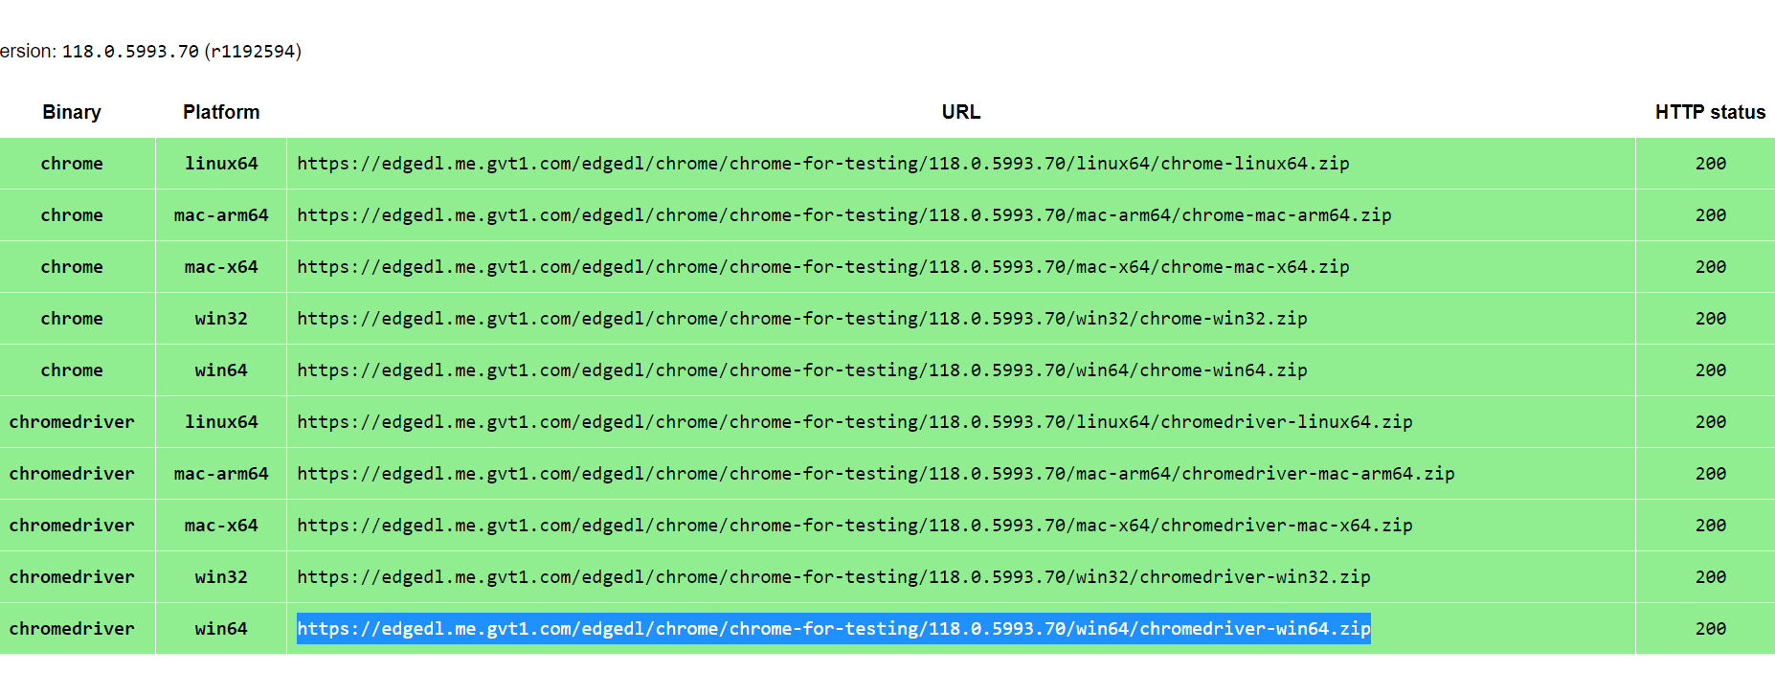

Click on chromedriver win64 link.. it will download the driver zip

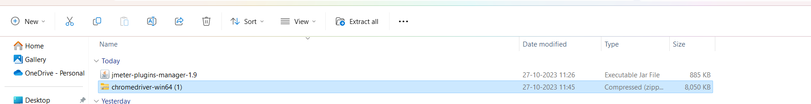

Extract the contents fot he zip file.

Rename the zip folder if needed. No space should be there in the folder name

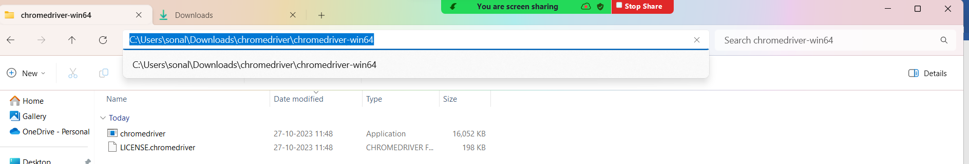

Copy the path of chromedriver folder and give it in Jmeter. Pls add the file name also at the end as chromedriver.exe

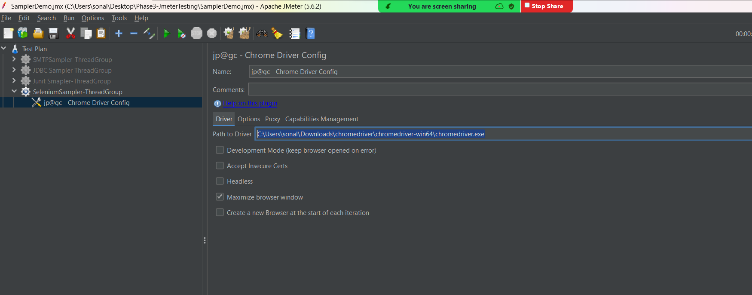

Now in the thread group add the webdriver sampler

