1. Write a Python program for Water Jug Problem
Aim
To solve the Water Jug Problem using Breadth-First Search (BFS) and obtain the target quantity of water.
Algorithm
- Start with both jugs empty.
- Generate all possible states by filling, emptying, or pouring water.
- Mark visited states.
- Continue until the target quantity is reached.
- Display the solution path.
Program
from collections import deque
def water_jug(jug1, jug2, target):
visited = set()
queue = deque([((0, 0), [])])
while queue:
(a, b), path = queue.popleft()
if (a, b) in visited:
continue
visited.add((a, b))
path = path + [(a, b)]
# Check if target is reached
if a == target or b == target:
print("Solution Steps:")
for step in path:
print(step)
return
# Possible operations
next_states = [
(jug1, b), # Fill Jug 1
(a, jug2), # Fill Jug 2
(0, b), # Empty Jug 1
(a, 0), # Empty Jug 2
(max(0, a - (jug2 - b)), min(jug2, b + a)), # Pour Jug1 -> Jug2
(min(jug1, a + b), max(0, b - (jug1 - a))) # Pour Jug2 -> Jug1
]
for state in next_states:
if state not in visited:
queue.append((state, path))
print("No solution exists.")
# Input
jug1 = int(input("Enter capacity of Jug 1: "))
jug2 = int(input("Enter capacity of Jug 2: "))
target = int(input("Enter target amount: "))
water_jug(jug1, jug2, target)
Sample Input
Jug 1 Capacity = 4
Jug 2 Capacity = 3
Target = 2
Sample Output
Solution Steps:
(0,0)
(0,3)
(3,0)
(3,3)
(4,2)
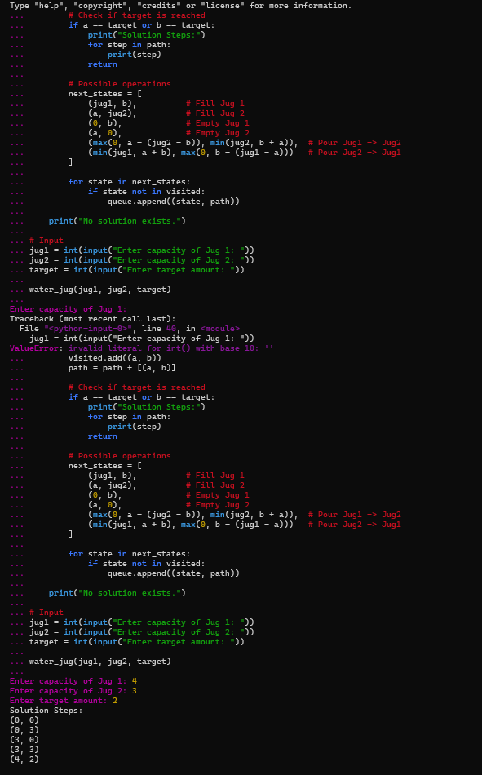
Result
Thus, the Water Jug Problem was solved successfully using BFS.

